**HREC SUPPORTING DOCUMENT CHECKLIST & TEMPLATE**

**for submission via InfoHub**

This checklist and template is intended to aid your submission to the HREC for a full ethical review by providing you with a reminder of all the documents you *might* submit in one file. All supporting documents should be inserted into this document where indicated. **Please note that your submission cannot be reviewed without the relevant Information Sheet(s) and Consent/Assent Form(s).**

***Please tick the documents you have provided for review only***

|  |  |  |
| --- | --- | --- |
| 1 | Information Sheet for Participants | Yes |
| 2 | Information Sheet for Parents/Guardians | Yes |
| 3 | Information Sheet for Children | Yes |
| 4 | Consent form for Participants | Yes |
| 5 | Consent Form for Parents/Guardians | Yes |
| 6 | Assent Form for Children | Yes |
| 7 | Interview Schedule for Interviews/focus groups | Yes |
| 8 | Questionnaires/Surveys | Yes |
| 9 | Advertisement/Poster/flyers for recruitment of participants | Yes |
| 10 | Letter(s) of permission from external organization(s) granting access to their business/school/charity/database etc., | Yes |
| 11 | Any other relevant supporting documents specifically required for your study | Yes |
| 12 | Cover Letter Responding to Decision Points *(not required for a new submission but will be required for your response to the committee after the review)* | Yes |

***Insert all Information Sheets here*** *and ensure that they following the correct format – see Question12 in the HREC Application Form (HR1) – please confirm that you will print this document on your School Headed Paper*

## Information Sheet

**Title:** Emotional Response Language Education E-learning Platform

**Topic:** Second Language Acquisition, Computational Linguistics, Multimodal Communication

**Institution:**  UCD Computer Science

**Researcher:**  John Sloan

**What is this research about?**

ERLE is a language learning website which uses the emotions of an avatar to give feedback. I am interested in how users interact with the website and the avatar.

**Why are you doing this research?**

I believe facial expressions are a very important means of non-verbal communication. I want to understand how language learners feel about interacting with an avatar who displays different emotions when they make correct and incorrect sentences.

**Why have I been invited to take part?**

You are an intermediate English language learner who is over 18 and have been chosen by your teacher/professor as suitable for this project.

**What will happen if I decide to take part in this research study?**

If you decide to participate, you will choose a username and password and be allowed to log in and practice your English with the avatar for 30 minutes each day. You may choose to type or speak to input sentences.

**How will the data be used?**

The sentences you type and speak will be used to understand how you change your language pronunciation and production after receiving feedback. The recordings from the sentences you speak will be saved and used to train a pronunciation model.

**How will you protect my privacy?**

You will choose a username which has no connection to your real name. In the study you will be referred to only by the basic demographic information you provide: age, sex and nationality.

**How is this research funded?**

This project is funded by UCD Computer Science.

**What are the benefits of taking part in this research study?**

You will be able to practice your English. You may find it enjoyable to interact with an avatar who responds to your sentences.

**What are the risks of taking part in this research study?**

If you see negative expressions from the avatar you may feel bad. When using the speech recognition, it may be frustrating to see a different result from what you expect. The sentences you input by speech or text may be identifiable.

**Can I change my mind at any stage and withdraw from the study?**

Yes. You can change your mind anytime and withdraw with no disadvantage.

**Has this research project received ethical approval?**

Yes.

**How will I find out what happens with this project?**

You can email - john.sloan.1@ucdconnect.ie.

***Insert all consent forms here*** *– the format can vary as researchers may want to itemize everything that they need a participant to consent to involved in the current study and may anticipate further research such as future publications, archiving or re-using the de-identified data at a later stage. Please confirm that you will print this document on your School Headed Paper*

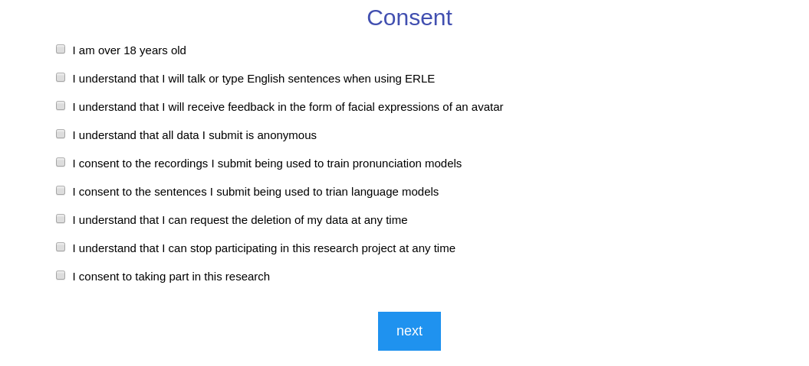

*Insert* ***Children’s Assent Form****, if applicable here*

*Insert* ***Interview schedule*** *and any instructions for interviewing here*

*Insert* ***Questionnaires/Surveys/scales*** *and any associated evaluation document here*

*Insert* ***Recruitment Advertisement/Poster or flyers here*** *– if the document is not in Word please insert the text only*

*Insert* ***External Letters of Permissions here*** *– such as letters from School Principals, Company CEOs, Charity Directors, Copyright permission for use of questionnaire if applicable*

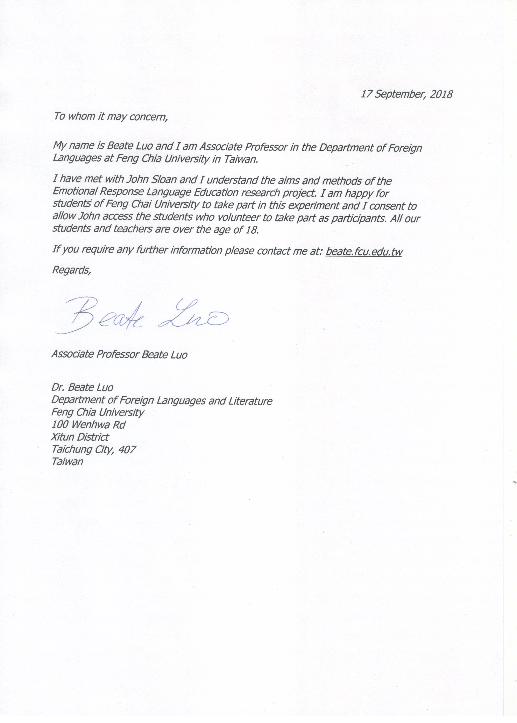

*Insert* ***Local Research Ethics Approval******Letters or Letters of Permissions to access databases****– such as letters from Hospitals, Nursing Homes, HSE Health Boards, Prisons, or any other body or organization that has a Research Ethics Committee)*

*Insert any other supporting documentation that is not listed above here but is relevant to your study: For Example: a listing of support groups, a training programme for researchers, a debriefing doc, or a protocol for dealing with stressed participants*

**Cover Letter Responding to Decision Points** *(not required for a new submission)*