**HREC SUPPORTING DOCUMENT CHECKLIST & TEMPLATE**

**for submission via InfoHub**

This checklist and template is intended to aid your submission to the HREC for a full ethical review by providing you with a reminder of all the documents you *might* submit in one file. All supporting documents should be inserted into this document where indicated. **Please note that your submission cannot be reviewed without the relevant Information Sheet(s) and Consent/Assent Form(s).**

***Please tick the documents you have provided for review only***

|  |  |  |
| --- | --- | --- |
| 1 | Information Sheet for Participants | Yes |
| 2 | Information Sheet for Parents/Guardians | Yes |
| 3 | Information Sheet for Children | Yes |
| 4 | Consent form for Participants | Yes |
| 5 | Consent Form for Parents/Guardians | Yes |
| 6 | Assent Form for Children | Yes |
| 7 | Interview Schedule for Interviews/focus groups | Yes |
| 8 | Questionnaires/Surveys | Yes |
| 9 | Advertisement/Poster/flyers for recruitment of participants | Yes |
| 10 | Letter(s) of permission from external organization(s) granting access to their business/school/charity/database etc., | Yes |
| 11 | Any other relevant supporting documents specifically required for your study | Yes |
| 12 | Cover Letter Responding to Decision Points *(not required for a new submission but will be required for your response to the committee after the review)* | Yes |

***Insert all Information Sheets here*** *and ensure that they following the correct format – see Question12 in the HREC Application Form (HR1) – please confirm that you will print this document on your School Headed Paper*

**Information Sheet**

**Title:** Pilot Study for Emotional Response Language Education E-learning Platform

**Topic:** Second Language Acquisition, Computational Linguistics, Multimodal Communication

**Institution:** UCD Computer Science

**Researcher:** John Sloan

**What is this research about?**

ERLE is a language learning website which uses the emotions of an avatar to give feedback. I am interested in how users interact with the website and the avatar.

**Why are you doing this research?**

I believe facial expressions are a very important means of non-verbal communication. I want to understand how language learners feel about interacting with an avatar who displays different emotions when they make correct and incorrect sentences.

**Why have I been invited to take part?**

This study is open to all intermediate level English learners in Dublin over 18 years old.

**What will happen if I decide to take part in this research study?**

You will be invited to UCD to receive a demonstration of the website and instruction on how to use it. If you decide to participate, you will be given a username and password and allowed to log in and practice your English with the avatar for 30 minutes each day. You will be asked some questions on the website when you finish a session. After 4 weeks, you will be invited to come back to UCD for an interview where you will be asked questions about your experience with the website.

**How will the data be used?**

I will use your answers from the questions to understand what you think of the avatar and the website. I will use the sentences you typed to understand how you change your language production after seeing various expressions.

**How will you protect my privacy?**

You will be provided with a username which has no connection to your real name. In the study you will be referred to only by the basic demographic information you provide: age, sex and nationality.

**How is this research funded?**

This project is funded by UCD Computer Science.

**What are the benefits of taking part in this research study?**

You will be able to practice your English. You may find it enjoyable to interact with an avatar who responds to your sentences.

**What are the risks of taking part in this research study?**

If you see negative expressions from the avatar you may feel bad.

**Can I change my mind at any stage and withdraw from the study?**

Yes. You can change your mind anytime and withdraw with no disadvantage. If you choose to stop, you can inform the research team at the email address given below. If you wish to stop and do not want to inform the research team, you are free to do so also. You will be sent an email asking for feedback on your experience, but you ar under no obligation to complete it.

**Has this research project received ethical approval?**

Yes.

**How will I find out what happens with this project?**

*You can email - john.sloan.1@ucdconnect.ie*

*\* I confirm that I will print this document on School Headed Paper*

***Insert all consent forms here*** *– the format can vary as researchers may want to itemize everything that they need a participant to consent to involved in the current study and may anticipate further research such as future publications, archiving or re-using the de-identified data at a later stage. Please confirm that you will print this document on your School Headed Paper*

**Consent Form**

I am over 18 years old.   
I have read the information sheet and understand the purpose and content of this study.

I understand that I will use a computer to write sentences in English

I understand that I will use a computer to answer questions in English

I understand that the data I provide will be stored on a secure database  
I understand that I may see positive and negative expressions of an avatar.

I understand that I can use the website as frequently as I wish.

I understand that I may be asked questions on my experience with the website.  
I understand that my answers and sentences may be used in scientific publications.

I understand that I can stop this experiment at any time.   
I consent to taking part in this study.

*Signature ………………………………………. Date ……………...*

*\* I confirm that I will print this document on School Headed Paper*

*Insert* ***Children’s Assent Form****, if applicable here*

*Insert* ***Interview schedule*** *and any instructions for interviewing here*

Participants will complete 4 weeks of ERLE before having the final interview. Recruitment will begin at the end of January 2018. The timing of interviews will depend on when the participants began using the platform. It is not necessary that participants are interviewed exactly 28 days after beginning. An interview time and date will be set based on convenience to the researcher and participant (ideally within one week of finishing).

As the final interviews will be semi-structured, the questions asked are intended to elicit qualitative information based on the user’s experience. The participants are English learners and may be anxious about speaking in English to the researcher. Additionally, participants may be hesitant to be critical of the research project or researcher, particularly if from a culture which emphasises politeness to those in positions of authority. The questions asked will include those stated in the next section, but the path of conversation will depend on the participant (e.g. how talkative, honest, confident, nervous). The researchers first goal will be to make the participant feel at ease and open to giving subjective feedback before asking the following pre-determined questions.

**Final Interview questions**

* How was your experience of ERLE?
* What did you enjoy?
* What did you not enjoy?
* What changes would you like to see?
* Do you think using ERLE has been beneficial for your English?
* Do you think using ERLE for a long time would improve your English?

*If the participant’s behaviour changes during the 4-weeks of usage:*

* Why did you increase/decrease/stop using ERLE in week X?

*Insert* ***Questionnaires/Surveys/scales*** *and any associated evaluation document here*

**Web-based questionnaires (Likert scale: 1-5)**

* I enjoyed interacting with the avatar.
* I understand the avatar’s expressions.
* The feedback I received was useful.
* I want to use ERLE again.

*Insert* ***Recruitment Advertisement/Poster or flyers here*** *– if the document is not in Word please insert the text only*

*Insert* ***External Letters of Permissions here*** *– such as letters from School Principals, Company CEOs, Charity Directors, Copyright permission for use of questionnaire if applicable*

*Insert* ***Local Research Ethics Approval******Letters or Letters of Permissions to access databases****– such as letters from Hospitals, Nursing Homes, HSE Health Boards, Prisons, or any other body or organization that has a Research Ethics Committee)*

*Insert any other supporting documentation that is not listed above here but is relevant to your study: For Example: a listing of support groups, a training programme for researchers, a debriefing doc, or a protocol for dealing with stressed participants*

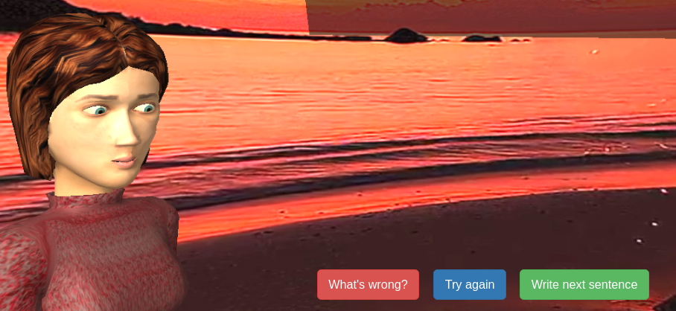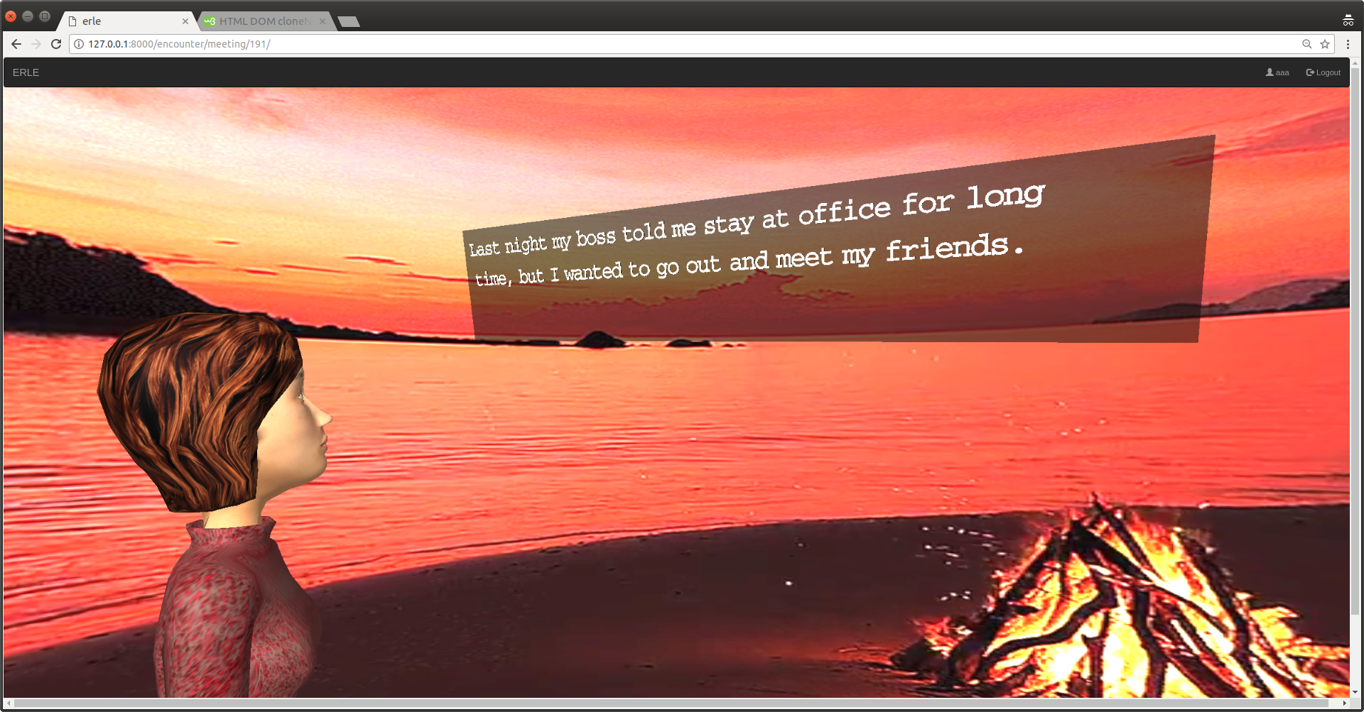

Example of the User Interface with the avatar simulating reading a sentence input by a user.

Example of the avatar’s expression after an incorrect sentence

Example fo the researcher’s interface for providing feedback. Wrong sentences prompt the researcher to click on the ‘X’ to the left and then type a correction. Correct sentences prompt the researcher to click on one of the central buttons which is linked to an emotion to be displayed by the avatar.

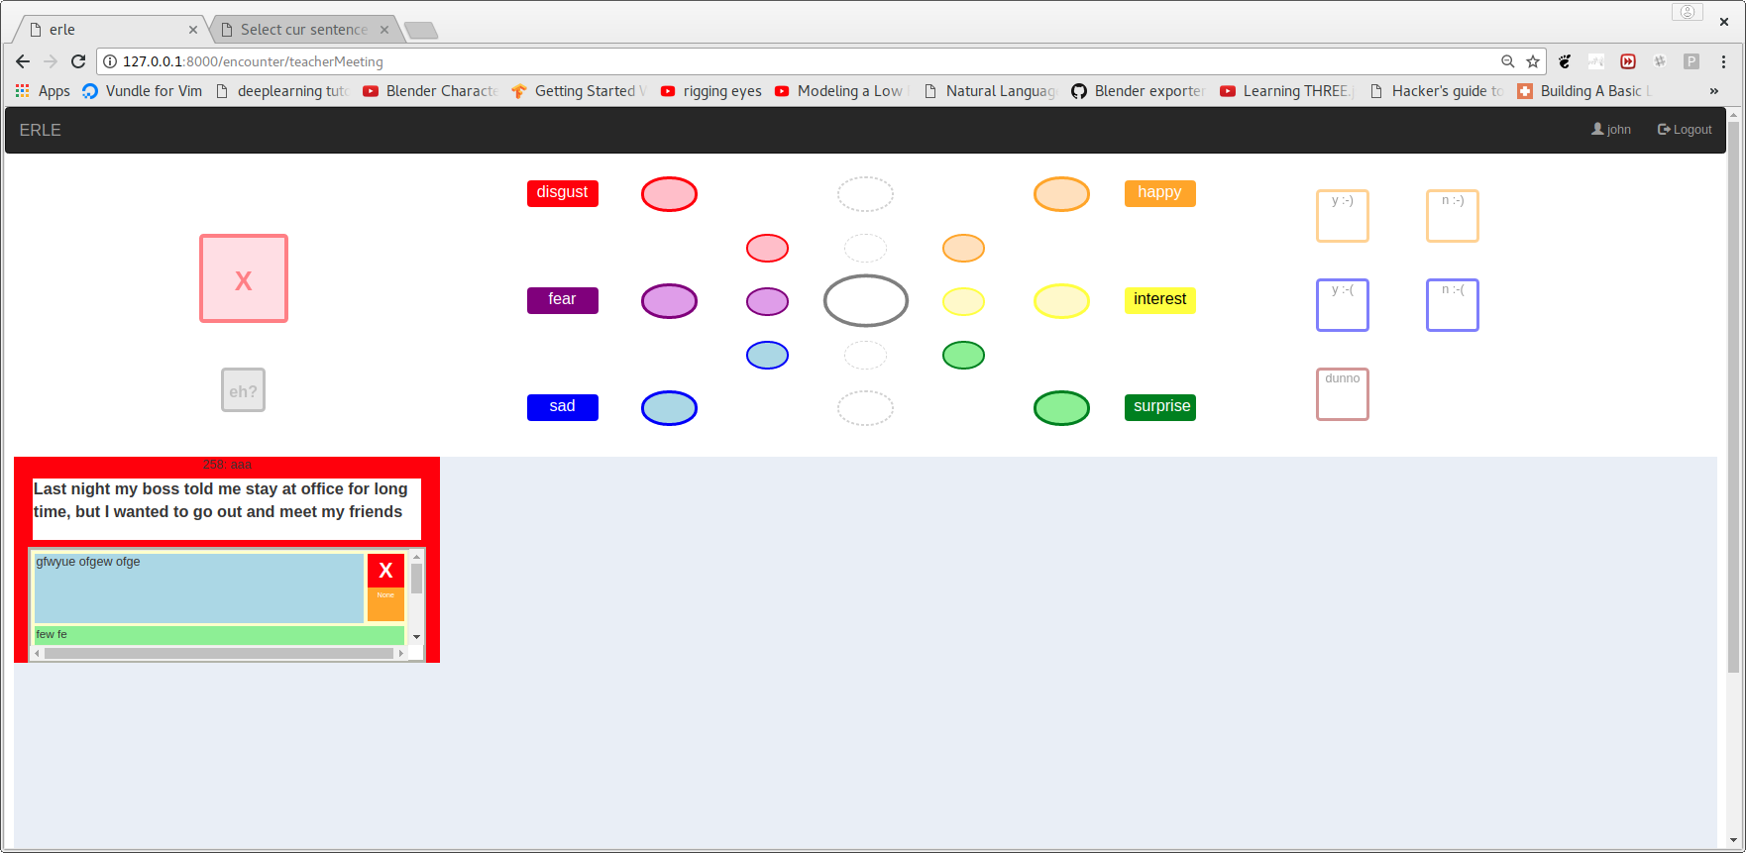

**Cover Letter Responding to Decision Points** *(not required for a new submission)*