Metadata: NO2 Emission Reduction during the response to
COVID19, in the State of California, US
By Linda, July 2020

Three types of data were collected:
- Model Data & Parameters
- Analysis Data, Response to COVID
- Baseline Data

- Model Data & Parameters
Field Name = ‘ID’ is the unique identifier of the row for each of the the 16 Ground-Level Monitoring Station as per https://www.epa.gov/outdoor-air-quality-data/air-quality-index-daily-values-report & https://epa.maps.arcgis.com/apps/webappviewer/index.html?id=5f239fd3e72f424f98ef3d5def547eb5&extent=-146.2334,13.1913,-46.3896,56.5319 on 8 July, 2020 and is a subset of the Model Data. Measurements were collected by the listed “TE Source & ID”. The data was used in the model development: MetaData [Three types of data were Collected & Created, July 2020: 1. Model Data & Parameters 2. Analysis Data, Response to COVID 3. Baseline Data] by, Linda Angulo Lopez @lindangulopez

Field Name = ‘CBSA’ is the core based statistical areas of each of the the 16 Ground-Level Monitoring Station as per https://www.epa.gov/outdoor-air-quality-data/air-quality-index-daily-values-report & https://epa.maps.arcgis.com/apps/webappviewer/index.html?id=5f239fd3e72f424f98ef3d5def547eb5&extent=-146.2334,13.1913,-46.3896,56.5319 on 8 July, 2020 and is a subset of the Model Data. Measurements were collected by the listed “TE Source & ID”. The data was used in the model development: MetaData [Three types of data were Collected & Created, July 2020: 1. Model Data & Parameters 2. Analysis Data, Response to COVID 3. Baseline Data] by, Linda Angulo Lopez @lindangulopez

Field Name = ‘Latitude’ is the Latitude of the 16 Ground-Level Monitoring Station as per https://www.epa.gov/outdoor-air-quality-data/air-quality-index-daily-values-report & https://epa.maps.arcgis.com/apps/webappviewer/index.html?id=5f239fd3e72f424f98ef3d5def547eb5&extent=-146.2334,13.1913,-46.3896,56.5319 on 8 July, 2020 and is a subset of the Model Data. Measurements were collected by the listed “TE Source & ID”. The data was used in the model development: MetaData [Three types of data were Collected & Created, July 2020: 1. Model Data & Parameters 2. Analysis Data, Response to COVID 3. Baseline Data] by, Linda Angulo Lopez @lindangulopez

Field Name = ‘Longitude’ is the Longitude of the 16 Ground-Level Monitoring Station as per https://www.epa.gov/outdoor-air-quality-data/air-quality-index-daily-values-report & https://epa.maps.arcgis.com/apps/webappviewer/index.html?id=5f239fd3e72f424f98ef3d5def547eb5&extent=-146.2334,13.1913,-46.3896,56.5319 on 8 July, 2020 and is a subset of the Model Data. Measurements were collected by the listed “TE Source & ID”. The data was used in the model development: MetaData [Three types of data were Collected & Created, July 2020: 1. Model Data & Parameters 2. Analysis Data, Response to COVID 3. Baseline Data] by, Linda Angulo Lopez @lindangulopez

Field Name = ‘County’ is the County of the 16 Ground-Level Monitoring Station as per https://www.epa.gov/outdoor-air-quality-data/air-quality-index-daily-values-report & https://epa.maps.arcgis.com/apps/webappviewer/index.html?id=5f239fd3e72f424f98ef3d5def547eb5&extent=-146.2334,13.1913,-46.3896,56.5319 on 8 July, 2020 and is a subset of the Model Data. Measurements were collected by the listed “TE Source & ID”. The data was used in the model development: MetaData [Three types of data were Collected & Created, July 2020: 1. Model Data & Parameters 2. Analysis Data, Response to COVID 3. Baseline Data] by, Linda Angulo Lopez @lindangulopez

Field Name = ‘Source_ID’ is the name of the Authority who collected the data and data station, when given, as per https://www.epa.gov/outdoor-air-quality-data/air-quality-index-daily-values-report & https://epa.maps.arcgis.com/apps/webappviewer/index.html?id=5f239fd3e72f424f98ef3d5def547eb5&extent=-146.2334,13.1913,-46.3896,56.5319 on 8 July, 2020 and is a subset of the Model Data. Measurements were collected by the listed “TE Source & ID”. The data was used in the model development: MetaData [Three types of data were Collected & Created, July 2020: 1. Model Data & Parameters 2. Analysis Data, Response to COVID 3. Baseline Data] by, Linda Angulo Lopez @lindangulopez

Field Name = ‘TE_ppb’ is the Median* Annual NO2 Emissions for 16 Ground-Level Monitoring Station Annual NO2 Emissions for 2019 in Particles Per Billion, ppb from https://www.epa.gov/outdoor-air-quality-data/air-quality-index-daily-values-report & https://epa.maps.arcgis.com/apps/webappviewer/index.html?id=5f239fd3e72f424f98ef3d5def547eb5&extent=-146.2334,13.1913,-46.3896,56.5319 on 8 July, 2020 and is a subset of the Model Data. Measurements were collected by the listed “TE Source & ID”. *The source used both the NO2 1-hour and NO2 Annual 1971 methods, the average of two medians and/or 50th percentile was recorded. The data was used in the model development: MetaData [Three types of data were Collected & Created, July 2020: 1. Model Data & Parameters 2. Analysis Data, Response to COVID 3. Baseline Data] by, Linda Angulo Lopez @lindangulopez

Field Name = ‘stdTE_ppb’ is the Standard Deviation* of the Daily NO2 Emissions for 16 Ground-Level Monitoring Station Annual NO2 Emissions for 2019 in Particles Per Billion, ppb from https://www.epa.gov/outdoor-air-quality-data/air-quality-index-daily-values-report & https://epa.maps.arcgis.com/apps/webappviewer/index.html?id=5f239fd3e72f424f98ef3d5def547eb5&extent=-146.2334,13.1913,-46.3896,56.5319 on 8 July, 2020 and is a subset of the Model Data. Measurements were collected by the listed “TE Source & ID”. *The source used both the NO2 1-hour and NO2 Annual 1971 methods, the average of two Standard Deviations was recorded. The data was used in the model development. MetaData [Three types of data were Collected & Created, July 2020: 1. Model Data & Parameters 2. Analysis Data, Response to COVID 3. Baseline Data] by, Linda Angulo Lopez @lindangulopez

Field Name = ‘aveTE_ppb’ is the Average* Annual NO2 Emissions for 16 Ground-Level Monitoring Station Annual NO2 Emissions for 2019 in Particles Per Billion, ppb from https://www.epa.gov/outdoor-air-quality-data/air-quality-index-daily-values-report & https://epa.maps.arcgis.com/apps/webappviewer/index.html?id=5f239fd3e72f424f98ef3d5def547eb5&extent=-146.2334,13.1913,-46.3896,56.5319 on 8 July, 2020 and is a subset of the Model Data. Measurements were collected by the listed “TE Source & ID”. *The source used both the NO2 1-hour and NO2 Annual 1971 methods, the average of two averages was recorded. The data was used in the model development. MetaData [Three types of data were Collected & Created, July 2020: 1. Model Data & Parameters 2. Analysis Data, Response to COVID 3. Baseline Data] by, Linda Angulo Lopez @lindangulopez

Field Name = ‘minTE_ppb’ is the Minimum* Annual NO2 Emissions for 7 of the 16 Ground-Level Monitoring Station Annual NO2 Emissions for 2019 in Particles Per Billion, ppb from https://www.epa.gov/outdoor-air-quality-data/air-quality-index-daily-values-report & https://epa.maps.arcgis.com/apps/webappviewer/index.html?id=5f239fd3e72f424f98ef3d5def547eb5&extent=-146.2334,13.1913,-46.3896,56.5319 on 8 July, 2020 and is a subset of the Model Data. Measurements were collected by the listed “TE Source & ID”. *Not all the sources recorded the datum, when recorded the source used both the NO2 1-hour and NO2 Annual 1971 methods, the average of two minimums was recorded. The data was used in the model development. MetaData [Three types of data were Collected & Created, July 2020: 1. Model Data & Parameters 2. Analysis Data, Response to COVID 3. Baseline Data] by, Linda Angulo Lopez @lindangulopez

Field Name = ‘maxTE_ppb’ is the Maximum* Annual NO2 Emissions for 15 of the 16 Ground-Level Monitoring Station Annual NO2 Emissions for 2019 in Particles Per Billion, ppb from https://www.epa.gov/outdoor-air-quality-data/air-quality-index-daily-values-report & https://epa.maps.arcgis.com/apps/webappviewer/index.html?id=5f239fd3e72f424f98ef3d5def547eb5&extent=-146.2334,13.1913,-46.3896,56.5319 on 8 July, 2020 and is a subset of the Model Data. Measurements were collected by the listed “TE Source & ID”. *Not all the sources recorded the datum, when recorded the source used both the NO2 1-hour and NO2 Annual 1971 methods, the average of two maximums was recorded. The data was used in the model development. MetaData [Three types of data were Collected & Created, July 2020: 1. Model Data & Parameters 2. Analysis Data, Response to COVID 3. Baseline Data] by, Linda Angulo Lopez @lindangulopez

Field Name = ‘PD’ is the population density of the town where the monitoring station was located, data was collected form https://en.wikipedia.org/wiki/Demographics_of_California in people per kilometer squared, on 8 July 2020. The data was used in the model development. MetaData [Three types of data were Collected & Created, July 2020: 1. Model Data & Parameters 2. Analysis Data, Response to COVID 3. Baseline Data] by, Linda Angulo Lopez @lindangulopez

Field Name = ‘F’ is a factor used in Model Development, the Foreign Anthropogenic Impacts in percent of total NO2, sourced from Atmos. Chem. Phys., 12, 4539–4554, 2012 https://www.atmos-chem-phys.net/12/4539/2012/acp-12-4539-2012.pdf 2012 © Author(s) 2012. CC Attribution 3.0 License. Collected, July 2020: 1. Model Data & Parameters 2. Analysis Data, Response to COVID 3. Baseline Data] by, Linda Angulo Lopez @lindangulopez

Field Name = ‘NE’ is a factor used in Model Development, Natural Background Emissions in percent of total NO2, sourced from Atmos. Chem. Phys., 12, 4539–4554, 2012 https://www.atmos-chem-phys.net/12/4539/2012/acp-12-4539-2012.pdf 2012 © Author(s) 2012. CC Attribution 3.0 License. Collected, July 2020: MetaData [Three types of data were Collected & Created, July 2020: 1. Model Data & Parameters 2. Analysis Data, Response to COVID 3. Baseline Data]by, Linda Angulo Lopez @lindangulopez

Field Name = ‘INRIX_C’ is a factor created by INRIX ( https://www2.inrix.com/l/171932/2020-03-06/45lh8p/171932/120396/2019_INRIX_Traffic_Scorecard_Infographic__US_Version_.pdf ) it estimates the time spent in congestion Collected , July 2020: MetaData [Three types of data were Collected & Created, July 2020: 1. Model Data & Parameters 2. Analysis Data, Response to COVID 3. Baseline Data] by, Linda Angulo Lopez @lindangulopez

Field Name = ‘T’ is a factor used in Model Development, To Estimate the Extend of Commuting to work. It was calculated as a tenth of the INRIX ( https://www2.inrix.com/l/171932/2020-03-06/45lh8p/171932/120396/2019_INRIX_Traffic_Scorecard_Infographic__US_Version_.pdf ) estimates of time spent in congestion, field = ‘INRIX_C’, and a thousandth of the population density, field = ?PD’ MetaData [Three types of data were Collected & Created, July 2020: 1. Model Data & Parameters 2. Analysis Data, Response to COVID 3. Baseline Data] Collected & Created , July 2020: 1. Model Data & Parameters 2. Analysis Data, Response to COVID 3. Baseline Data] by, Linda Angulo Lopez @lindangulopez

Field Name = ‘FZ’ is a factor used in Model Development, to Estimate the Extent of Fertilization, at the county level, data was merged from the study, https://www.ucdavis.edu/news/smog-forming-soils/ where Maya Almaraz samples soils for NOx emissions in Palm Springs in January 2018 and county boundaries of the point sources. https://en.wikipedia.org/wiki/List_of_counties_in_California MetaData [Three types of data were Collected & Created, July 2020: 1. Model Data & Parameters 2. Analysis Data, Response to COVID 3. Baseline Data] Collected 6 Created , July 2020: 1. Model Data & Parameters 2. Analysis Data, Response to COVID 3. Baseline Data] by, Linda Angulo Lopez @lindangulopez

Field Name = ‘NG’ is a factor used in Model Development, to Estimate the Extent of Natural Gas produced NO2 emissions, based on data from as the (ratio of the residential to Other) over the total Natural gas use) from https://www.eia.gov/dnav/ng/ng_sum_lsum_dcu_SCA_a.htm = 0.56 times the field ‘PD’ as NO2 concentrations were greater than 50 ppb during some tests with the gas range and averaged 400ppb during the 5-hr oven cleaning test, exceeding the ARB Indoor Air Quality (IAQ) Guideline of 250 ppb over one hour, and representing a significant source of exposure, during cooking MetaData [Three types of data were Collected & Created, July 2020: 1. Model Data & Parameters 2. Analysis Data, Response to COVID 3. Baseline Data] Collected 6 Created , July 2020: 1. Model Data & Parameters 2. Analysis Data, Response to COVID 3. Baseline Data] by, Linda Angulo Lopez @lindangulopez

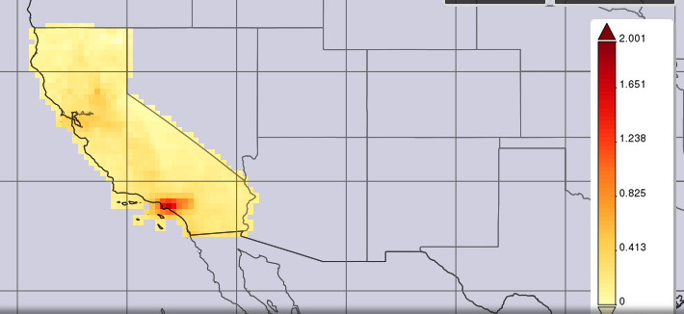
- Analysis Data, Response to COVID
Field Name = ‘OMI_JAN_2020’ is the NO2 Emissions for 16 Ground-Level Monitoring Station Monthly value obtained from the Time Averaged Map of NO2 Tropospheric Column (30% Cloud Screened) daily 0.25 deg. [OMI OMNO2d v003] 1/cm2
over 2020-01-01 - 2020-01-31, Shape California, Region 133.5937W, 1.5234N, 90.7031W, 45.1172N data from the file ‘GIOVANNI-g4.timeAvgMap.OMNO2d_003_ColumnAmountNO2TropCloudScreened.20200101-20200131.133W_1N_90W_45N.tif’ downloaded from https://giovanni.gsfc.nasa.gov/giovanni/#service=TmAvMp&starttime=2020-01-01T00:00:00Z&endtime=2020-01-31T23:59:59Z&shape=tl_2014_us_state/shp_13&bbox=-133.5937,1.5234,-90.7031,45.1172&data=OMNO2d_003_ColumnAmountNO2TropCloudScreened and viewed on ArcMap, the data was rescaled. MetaData [Three types of data were Collected , July 2020: 1. Model Data & Parameters 2. Analysis Data, Response to COVID 3. Baseline Data] Collected , July 2020: 1. Model Data & Parameters 2. Analysis Data, Response to COVID 3. Baseline Data] by, Linda Angulo Lopez @lindangulopez
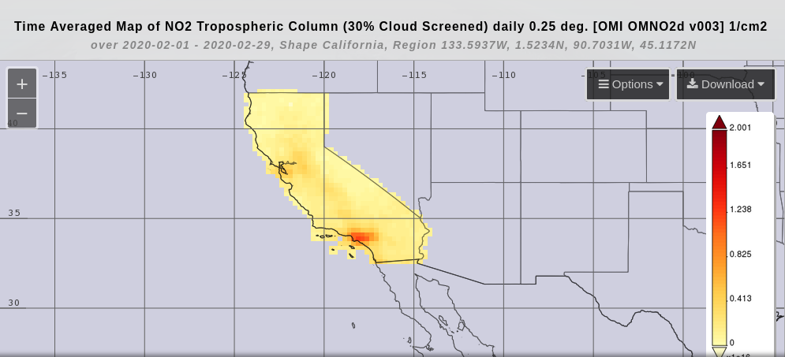
Field Name = ‘OMI_FEB_2020’ is the NO2 Emissions for 16 Ground-Level Monitoring Station Monthly value obtained from theTime data from the file ‘GIOVANNI-g4.timeAvgMap.OMNO2d_003_ColumnAmountNO2TropCloudScreened.20200201-20200229.133W_1N_90W_45N.tif’ downloaded from https://giovanni.gsfc.nasa.gov/giovanni/#service=TmAvMp&starttime=2020-02-01T00:00:00Z&endtime=2020-02-29T23:59:59Z&shape=tl_2014_us_state/shp_13&bbox=-133.5937,1.5234,-90.7031,45.1172&data=OMNO2d_003_ColumnAmountNO2TropCloudScreened&variableFacets=dataFieldDiscipline%3AAtmospheric%20Chemistry%3B and viewed on ArcMap, the data was rescaled. MetaData [Three types of data were Collected, July 2020: 1. Model Data & Parameters 2. Analysis Data, Response to COVID 3. Baseline Data] Collected , July 2020: 1. Model Data & Parameters 2. Analysis Data, Response to COVID 3. Baseline Data] by, Linda Angulo Lopez @lindangulopez

Field Name = ‘OMI_Jan_2019’ is the NO2 Emissions for 16 Ground-Level Monitoring Station Monthly value obtained from theTime data from the file ‘’ downloaded from and viewed on ArcMap, the data was rescaled. MetaData [Three types of data were Collected & Created, July 2020: 1. Model Data & Parameters 2. Analysis Data, Response to COVID 3. Baseline Data] Collected , July 2020: 1. Model Data & Parameters 2. Analysis Data, Response to COVID 3. Baseline Data] by, Linda Angulo Lopez @lindangulopez
Field Name = ‘OMI_Jan_2019’ is the NO2 Emissions for 16 Ground-Level Monitoring Station Monthly value obtained from theTime data from the file ‘’ downloaded from and viewed on ArcMap, the data was rescaled. MetaData [Three types of data were Collected & Created, July 2020: 1. Model Data & Parameters 2. Analysis Data, Response to COVID 3. Baseline Data] Collected , July 2020: 1. Model Data & Parameters 2. Analysis Data, Response to COVID 3. Baseline Data] by, Linda Angulo Lopez @lindangulopez

Field Name = ‘OMI_Jan_2019’ is the NO2 Emissions for 16 Ground-Level Monitoring Station Monthly value obtained from theTime data from the file ‘’ downloaded from and viewed on ArcMap, the data was rescaled. MetaData [Three types of data were Collected & Created, July 2020: 1. Model Data & Parameters 2. Analysis Data, Response to COVID 3. Baseline Data] Collected , July 2020: 1. Model Data & Parameters 2. Analysis Data, Response to COVID 3. Baseline Data] by, Linda Angulo Lopez @lindangulopez

- Baseline Data
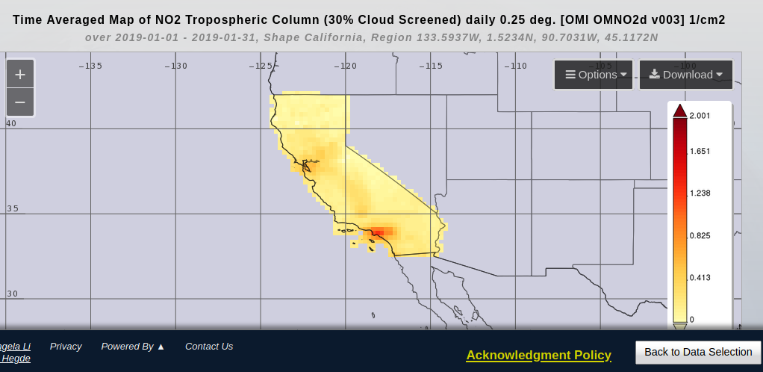
Field Name = ‘OMI_Jan_2019’ is the NO2 Emissions for 16 Ground-Level Monitoring Station Monthly value obtained from theTime Averaged Map of NO2 Tropospheric Column (30% Cloud Screened) daily 0.25 deg. [OMI OMNO2d v003] 1/cm2
over 2019-01-01 - 2019-01-31, Shape California, Region 133.5937W, 1.5234N, 90.7031W, 45.1172N data from the file ‘GIOVANNI-g4.timeAvgMap.OMNO2d_003_ColumnAmountNO2TropCloudScreened.20190101-20190131.133W_1N_90W_45N.tif’ downloaded from https://giovanni.gsfc.nasa.gov/giovanni/#service=TmAvMp&starttime=2019-01-01T00:00:00Z&endtime=2019-01-31T23:59:59Z&shape=tl_2014_us_state/shp_13&bbox=-133.5937,1.5234,-90.7031,45.1172&data=OMNO2d_003_ColumnAmountNO2TropCloudScreened&variableFacets=dataFieldDiscipline%3AAtmospheric%20Chemistry%3B and viewed on ArcMap, the data was rescaled. MetaData [Three types of data were Collected, July 2020: 1. Model Data & Parameters 2. Analysis Data, Response to COVID 3. Baseline Data] Collected 6 Created , July 2020: 1. Model Data & Parameters 2. Analysis Data, Response to COVID 3. Baseline Data] by, Linda Angulo Lopez @lindangulopez

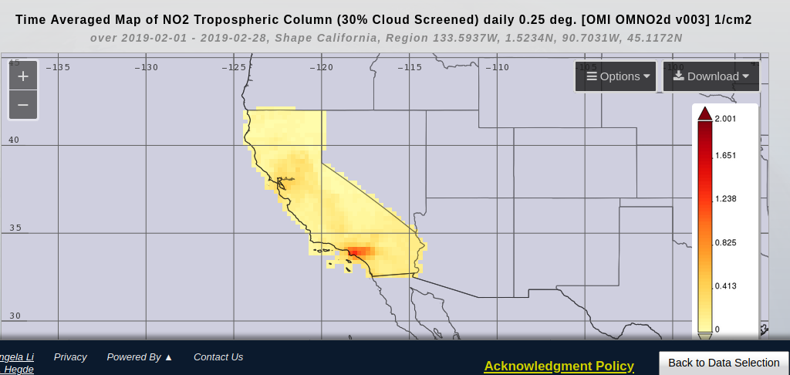
Field Name = ‘OMI_Feb_2019’ is the NO2 Emissions for 16 Ground-Level Monitoring Station Monthly value obtained from theTime Time Averaged Map of NO2 Tropospheric Column (30% Cloud Screened) daily 0.25 deg. [OMI OMNO2d v003] 1/cm2
over 2020-02-01 - 2020-02-29, Shape California, Region 133.5937W, 1.5234N, 90.7031W, 45.1172N data from the file ‘ GIOVANNI-g4.timeAvgMap.OMNO2d_003_ColumnAmountNO2TropCloudScreened.20190201-20190228.133W_1N_90W_45N.tif’ downloaded from https://giovanni.gsfc.nasa.gov/giovanni/#service=TmAvMp&starttime=2020-02-01T00:00:00Z&endtime=2020-02-29T23:59:59Z&shape=tl_2014_us_state/shp_13&bbox=-133.5937,1.5234,-90.7031,45.1172&data=OMNO2d_003_ColumnAmountNO2TropCloudScreened&variableFacets=dataFieldDiscipline%3AAtmospheric%20Chemistry%3B and viewed on ArcMap, the data was rescaled. MetaData [Three types of data were Collected, July 2020: 1. Model Data & Parameters 2. Analysis Data, Response to COVID 3. Baseline Data] Collected , July 2020: 1. Model Data & Parameters 2. Analysis Data, Response to COVID 3. Baseline Data] by, Linda Angulo Lopez @lindangulopez

Field Name = ‘OMI_Jan_2019’ is the NO2 Emissions for 16 Ground-Level Monitoring Station Monthly value obtained from theTime data from the file ‘’ downloaded from and viewed on ArcMap, the data was rescaled. MetaData [Three types of data were Collected & Created, July 2020: 1. Model Data & Parameters 2. Analysis Data, Response to COVID 3. Baseline Data] Collected , July 2020: 1. Model Data & Parameters 2. Analysis Data, Response to COVID 3. Baseline Data] by, Linda Angulo Lopez @lindangulopez

Field Name = ‘OMI_Jan_2019’ is the NO2 Emissions for 16 Ground-Level Monitoring Station Monthly value obtained from theTime data from the file ‘’ downloaded from and viewed on ArcMap, the data was rescaled. MetaData [Three types of data were Collected , July 2020: 1. Model Data & Parameters 2. Analysis Data, Response to COVID 3. Baseline Data] Collected 6 Created , July 2020: 1. Model Data & Parameters 2. Analysis Data, Response to COVID 3. Baseline Data] by, Linda Angulo Lopez @lindangulopez

Field Name = ‘OMI_Jan_2019’ is the NO2 Emissions for 16 Ground-Level Monitoring Station Monthly value obtained from theTime data from the file ‘’ downloaded from and viewed on ArcMap, the data was rescaled. MetaData [Three types of data were Collected , July 2020: 1. Model Data & Parameters 2. Analysis Data, Response to COVID 3. Baseline Data] Collected 6 Created , July 2020: 1. Model Data & Parameters 2. Analysis Data, Response to COVID 3. Baseline Data] by, Linda Angulo Lopez @lindangulopez

Field Name = ‘OMI_Jan_2019’ is the NO2 Emissions for 16 Ground-Level Monitoring Station Monthly value obtained from theTime data from the file ‘’ downloaded from and viewed on ArcMap, the data was rescaled. MetaData [Three types of data were Collected & Created, July 2020: 1. Model Data & Parameters 2. Analysis Data, Response to COVID 3. Baseline Data] Collected 6 Created , July 2020: 1. Model Data & Parameters 2. Analysis Data, Response to COVID 3. Baseline Data] by, Linda Angulo Lopez @lindangulopez

Field Name = ‘OMI_Jan_2019’ is the NO2 Emissions for 16 Ground-Level Monitoring Station Monthly value obtained from theTime data from the file ‘’ downloaded from and viewed on ArcMap, the data was rescaled. MetaData [Three types of data were Collected & Created, July 2020: 1. Model Data & Parameters 2. Analysis Data, Response to COVID 3. Baseline Data] Collected 6 Created , July 2020: 1. Model Data & Parameters 2. Analysis Data, Response to COVID 3. Baseline Data] by, Linda Angulo Lopez @lindangulopez

Field Name = ‘OMI_Jan_2019’ is the NO2 Emissions for 16 Ground-Level Monitoring Station Monthly value obtained from theTime data from the file ‘’ downloaded from and viewed on ArcMap, the data was rescaled. MetaData [Three types of data were Collected & Created, July 2020: 1. Model Data & Parameters 2. Analysis Data, Response to COVID 3. Baseline Data] Collected 6 Created , July 2020: 1. Model Data & Parameters 2. Analysis Data, Response to COVID 3. Baseline Data] by, Linda Angulo Lopez @lindangulopez

The data was used in the model development: MetaData [Three types of data were Collected & Created, July 2020: 1. Model Data & Parameters 2. Analysis Data, Response to COVID 3. Baseline Data] by, Linda Angulo Lopez @lindangulopez

This is a factor, MetaData [Three types of data were Collected & Created , July 2020: 1. Model Data & Parameters 2. Analysis Data, Response to COVID 3. Baseline Data] by, Linda Angulo Lopez @lindangulopez

•[data sources; date retrieved]
•[analysis steps]
•[data description]
•[names and meanings of any fields of the attribute table]
•[your name, date analysis was completed]
•[other relevant information that would be required for someone to use yourdataset or to reproduce the results]

