[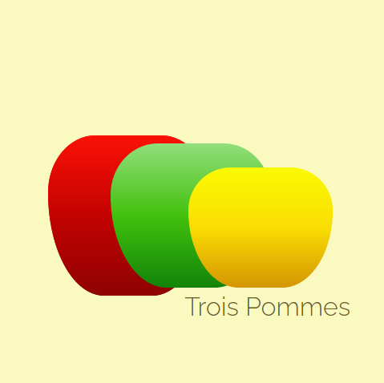](https://codepen.io/lindangulopez/pen/LYZQjVM)

[](https://codepen.io/lindangulopez/pen/QWEQvOz)

[](https://codepen.io/lindangulopez/pen/QWEQvOz)

[](https://codepen.io/lindangulopez/pen/QWEQvOz)

[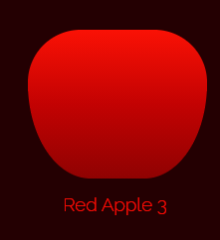](https://codepen.io/lindangulopez/pen/OJXQpPy)

[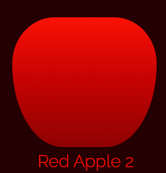](https://codepen.io/lindangulopez/pen/OJXQpPy)

[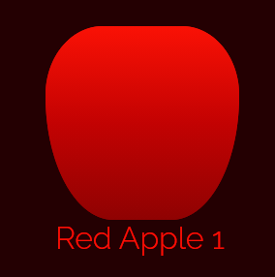](https://codepen.io/lindangulopez/pen/OJXQpPy)

[](https://codepen.io/lindangulopez/pen/VwjQabp)

[](https://codepen.io/lindangulopez/pen/VwjQabp)

[](https://codepen.io/lindangulopez/pen/VwjQabp)