## **CMPE 283 – Assignment 2**

**Student ID: 015293460 Name: Parvathi Pai**

**Student ID:015304393 Name: Shreya Ghotankar**

**The Assignment**

Your assignment is to modify the CPUID emulation code in KVM to report back additional information

when a special CPUID “leaf function” is called.

• For CPUID leaf function %eax=0x4FFFFFFF:

◦ Return the total number of exits (all types) in %eax

◦ Return the high 32 bits of the total time spent processing all exits in %ebx

◦ Return the low 32 bits of the total time spent processing all exits in %ecx

▪ %ebx and %ecx return values are measured in processor cycles

**Questions**

1. For each member in your team, provide 1 paragraph detailing what parts of the lab that member implemented / researched. (You may skip this question if you are doing the lab by yourself).

**Shreya Ghotankar**:

* Revisited the video lecture 5

* Compiled the code with modifications

* Made changes to fix the errors occurred while compiling

* Created nested VM to run the test program

* Created documentation.

**Parvathi Pai:**

* Revisited the video lecture 5

* Modified the cupid.c and vmx.c modules

* Looked up how to perform testing for kernel code

* Wrote a test program

* Updated documentation

2. Describe in detail the steps you used to complete the assignment.

Steps:

**Initial Setup of the VM**

1. Clone the Kernel code from GitHub: git clone https://github.com/torvalds/linux.git

2. Kernel Code Compilation:

* Perform all the actions in the root mode using the command - sudo bash

* Install the build-essential kernel-package, bison package (parser generator) and flex libelf-dev (parser package).

apt-get install build-essential kernel-package fakeroot libncurses5-dev libssl-dev ccache bison flex libelf-dev

* uname -a

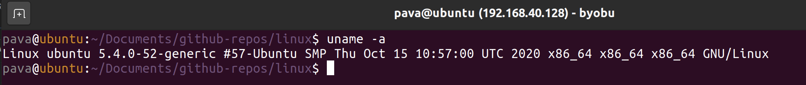

* Change the .Config file

cp -v /boot/config-5.4.0-52-generic ./.config

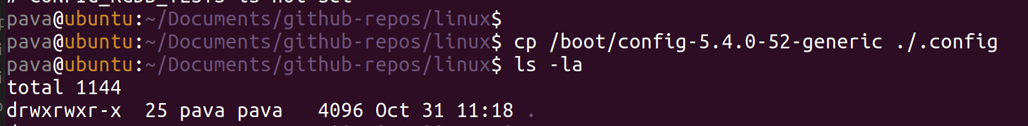

* make -j

* sudo make modules

* sudo make install

* sudo make modules_install

* reboot

* Verify the updated Linux version - uname -a



**Setup KVM**

1. We followed the instructions in this manual to set up the KVM in our Ubuntu –

<https://help.ubuntu.com/community/KVM/Installation>

2. In the Installation section of the KVM guide we made use of Cosmic (18.10) or later packages.

sudo apt-get install qemu-kvm libvirt-daemon-system libvirt-clients bridge-utils

3. Installed the virt-manager using- sudo apt-get install virt-manager

**Starting the nested virtual machine using KVM**

1) Downloaded ubuntu iso

2) Created new VM from Virtual Machine Manager application

3) Created a test program and compiled it.

**Result**:

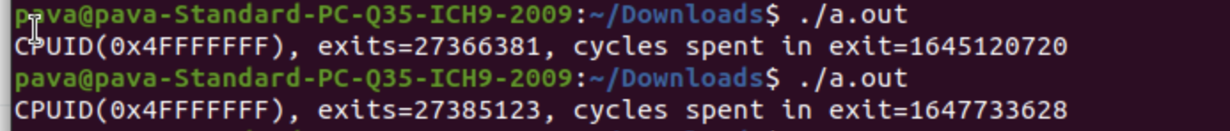From host VM kern.log – tail -n20 /var/log/kern.log

**Comment on the frequency of exits –**

**1. Does the number of exits increase at a stable rate? Or are there more exits performed during certain VM operations?**

No, the number of exits increase is not at stable rate. There are other VM instructions/operations because of which the exits are performed like EPT violation, RDRAND, I/O instruction, RDTSCP etc.

**2. Approximately how many exits does a full VM boot entail?**

The number of exits after the first build, reboot and enter nested VM using the KVM is 187,420. This is not very accurate as there might have been a shutdown period and hardware interrupts in-between.

**References**

1. https://help.ubuntu.com/community/KVM/Installation

2. https://elixir.bootlin.com/linux/v5.10-rc2/source/include/asm-generic/atomic-instrumented.h

3. https://www.kernel.org/doc/html/v4.12/core-api/atomic_ops.html

4. https://lwn.net/Kernel/