

SOFTWARE REQUIREMENTS

Huarong Path System

Group X

Author

Table of Contents

System Objective 2

Domain Analysis 2

System Architecture 4

Use Cases 5

Software Requirements 5

R1: GameUI 6

R2: Controller 6

R3: Chess 6

R4: Validate 6

# System Objective

In this project, we are developing a software that simulates the classical game Huarong Path. The software will take care of the graphic interface, ensure valid movements and determine whether the goal is achieved, which offers the users a chance to play Huarong Path on computer. Also a UPPAAL model will be provided to check whether a game state has a solution or not, and if it has, it will provide the solution.

# Domain Analysis

The participants of activities of the system can be categorized into the outside and inside.

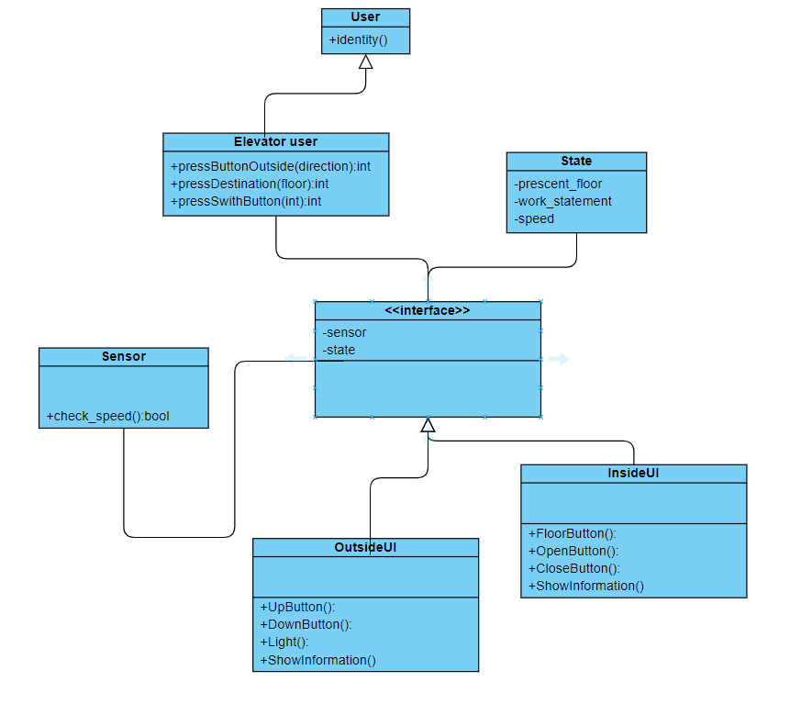

Here is the sequence of events for playing a standard game:

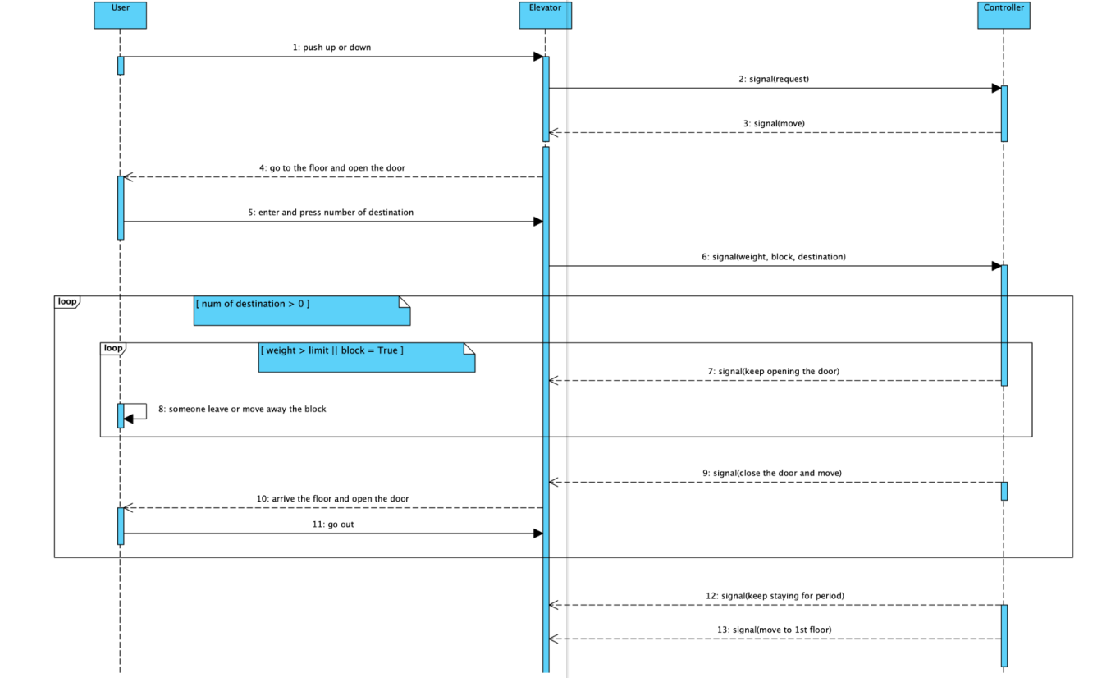

System Architecture

Phase

From the information above, we will design a software system that simulates the game process: prepare the chessboard, allow player to move the chess, decide whether it reaches the goal state. It also allows the player to place the chess in random mode.

The system architecture is shown below:



# Use Cases

The system can achieve the following use cases from the player’s perspectives:

# Software Requirements

## R1: InterfaceUI

* R1.1: FloorButton:
  + R1.1.1: add task to go
* R1.2: OpenButton:open the door asap
* R1.3: CloseButton:close the door immediately
* R1.4: information Window
  + R1.4.1:contain information :door,id,speed,height,position

## R2: OutsideUI

* R2.1: Interface:add task to go
  + R2.1.1: UpButton call elevator
  + R2.1.2: DownButton call elevator
* R2.2: Information window
  + R2.2.1: light
  + R2.2.2: elevators run independently:open and close

## R3: Validate

* R4.1: The system should be able to validate in any state.
  + R4.1.1: