

TRACEABILITY REPORT

Elevator

Group 25

Chuyi Zhao

Table of Contents

System Architecture 2

Software Traceability 2

# System Architecture

The system architecture is shown below:

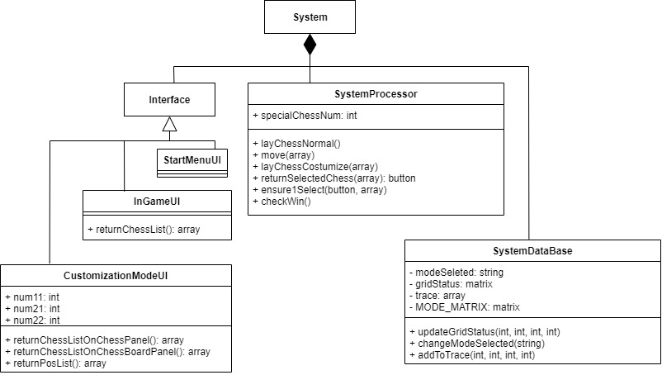

# Software Traceability

|  |  |  |
| --- | --- | --- |
|  | Is implemented by | Is validated by |
| R1 (Game UI) | S1, S2.1, S2.2, S2.3,  S2.5, S3.1, S3.2, S3.3 | T1.1, T1.2, T1.3 |
| R1.1 | S1 | T1.1, T1.2, T1.3 |
| R1.1.1 | S1.1, S2.5 | T1.1 |
| R1.1.2 | S1.2, S2.5 | T1.2 |
| R1.1.3 | S1.3, S2.5 | T1.3 |
| R1.2 | S1.1 | T1.1 |
| R1.3 | S1.2 | T1.3 |
| R1.4 | S3.1, S3.2, S3.3 | T1.2 |
| R1.4.1 | S3.1 | T1.2 |
| R1.4.2 | S3.3 | T1.2 |
| R1.5 | S2.1, S2.2 | T1.1 |
| R1.5.1 | S2.1, S2.2 | T1.1 |
| R1.5.2 | S2.1, S2.2 | T1.1 |
| R1.6 | S2.3 | T1.2 |
| R2(Controller) | S2.1, S2.2, S2.3, S2.4,  S3.1, S3.2, S3.3 | T1.1, T1.2 |
| R2.1 | S3.1, S3.2, S3.3 | T1.2 |
| R2.1.1 | S3.1, S3.2 | T1.2 |
| R2.1.2 | S3.1 | T1.2 |

|  |  |  |
| --- | --- | --- |
| R2.1.3 | S3.1 | T1.2 |
| R2.1.4 | S3.3 | T1.2 |
| R2.1.5 | S3.1.2 | T1.2 |
| R2.2 | S2.1, S2.2, S2.3, S2.4 | T1.1, T1.2 |
| R2.2.1 | S2.1 | T1.1 |
| R2.2.2 | S2.2.1 | T1.1 |
| R2.2.3 | S2.1 | T1.1 |
| R2.2.4 | S2.2.1 | T1.1 |
| R2.2.5 | S2.2.2 | T1.1 |
| R2.2.6 | S2.3 | T1.2 |
| R2.2.7 | S2.4 | T1.1 |
| R3(Chess) | S2.2.2 | T1.1 |
| R3.1 | S2.2.2 | T1.1 |
| R3.1.1 | S2.2.2 | T1.1 |
| R3.1.2 | S2.2.2 | T1.1 |
| R4(Validate) | P1.3  Refer to model checking in validation document. | |
| R4.1 |
| R4.1.1 |
| R4.1.2 |