

USER MANUAL

Elevator

Group 25

Chuyi Zhao

Table of Contents

System Architecture 2

User Manual 3

Elevator Inside UI 3

Elevator Inside UI Components 3

Go to certain floor 3

Open/ close door 3

Elevator OutsideUI 3

Elevator OutsideUI Components 8

Call elevator from certain floor 3

Enter elevator safely 3

# System Architecture

The system architecture is shown below:

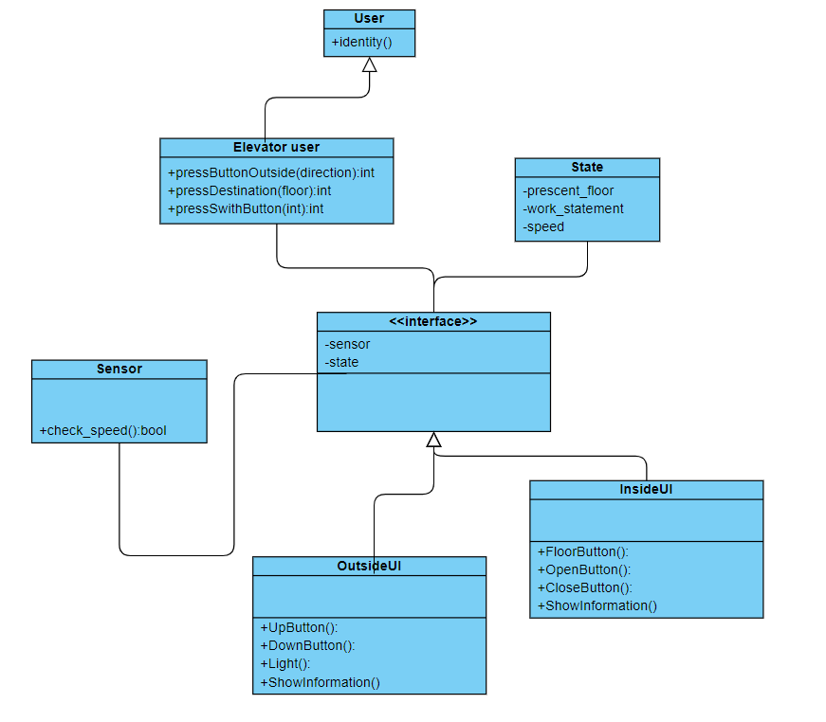

# User Manual

## Elevator Inside UI

*Elevator Inside UI components*

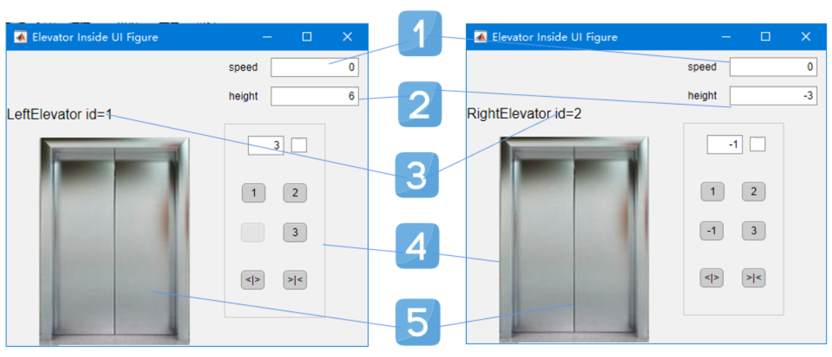

①elevator speed. Each elevator has a max speed 3m/s, with an acceleration of 3 m/s², showing in the right up part of the wall, in float form.

②elevator height. It shows the current height of the elevator lowest point in meter unit, shown on the right up part of the wall, just bellow the speed box, in float form.

③elevator index(id). 1 for left and 2 for right.

④elevator interface panel.

⑤elevator door. Which opens only when stable and speed = 0.

*Go to certain floor*

For each elevator, there are three/ four floor buttons on the panel right to door. Bellow take Floor Button 3 for an example.

1. Push Button 3.
2. Button 1 is set unabled, meaning the elevator recieved the instruction signal.
3. Elevator 1 goes to Floor 3.(assume elevator 1 not at 3F now)

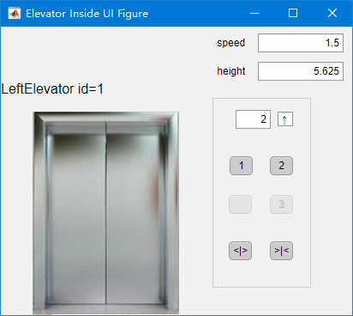

* 1. Speed scceleratd from 0.
  2. Direction turns up.
  3. Speed slows down to 0 from max speed when needed.

1. Once Reach Floor 3 and speed equils 0, door opens.(figure bellow)
2. Button 3 is set enabled.

*Open/ close door*

## Elevator Outside UI

*Elevator outside UI components*

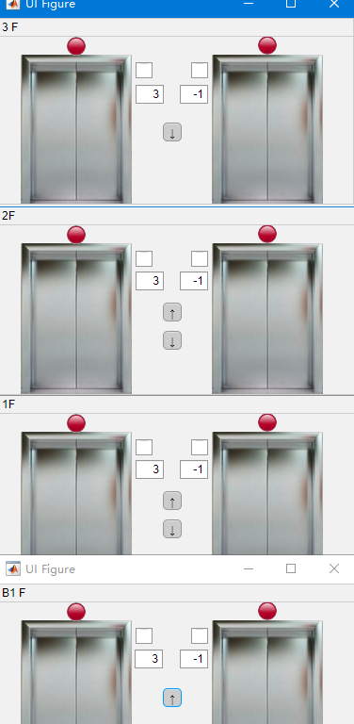

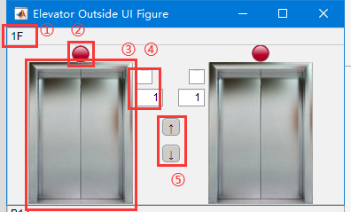

①Floor label, indicating the floor index of the UI panel.

②Safety light, which turns green only when the door is open and turns red otherwise. The purpose is to give user a safety signal to enter the elevator.

③Elevator door. Opens only when the elevator is stable.

④Elevator state box, which contains direction and current position of the elevator.

⑤Up/ down button.

*Call elevator from certain floor*

User can give instruction to the elevators by pushing the up/ down buttons outside. Take F2 as destination foe example, which has up and down two buttons:

1. Push the up/ down button at F2.
2. If certain elevator is at F2:

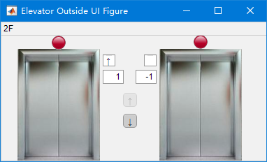

* 1. The pushed button is set inactive.
  2. Ask elevatorController to move any elevator to floor F2.
  3. Once any elevator reaches F2, open the door.
  4. Button is enabled.

1. Else:
   1. Open the door
   2. If the button at F2 is pushed again, open time delays
2. Once elevator reaches F2, it stays open for a while(open period, which can be reset inside the program). If push the button again:
   1. If the door is open, if opens for a longer time(open period).
   2. If the door is close, if opens again.
   3. If the door os closed from inside, it is primitively closed.

*Enter elevator safely*

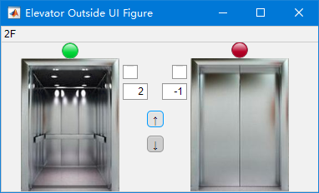

There is one light② over every elevator door. It turns green only when the door is open and turns red otherwise. Also there are elevator state boxes④ beside the door, containing the elevator direction and position. To safely enter the elevator, user should:

1. pay attention to both the elevator state and the light color
2. enter the elevator only when the light is green.
3. If the light turns red, the user should either not enter the elevator or push the up/ down button again to longer the opening time.

This way the user’s entering the elevator is always during the safety time.