

SOFTWARE SPECIFICATIONS

Elevator

Group 25

Miao Li

Table of Contents

System Architecture 3

T1: Unit Test 3

T1.1: SystemProcessor Unit Test 3

T1.1.1: Test pressButton() 3

T1.1.2: Test open/ coseDoor() 4

T1.1.3: Test longerOpen() 5

T1.2: Controller Unit Test 8

T1.2.1: Test mixedTest() 8

T1.2.19: Test changeTimer() 20

T1.3: MainBoardUI Unit Test 20

T1.3.1: Test show() 20

T2: Integration Test 22

T2.1: SystemProcessor+SystemDB+mainBoardUI Integration 22

T2.2: SystemProcessor+SystemDB+mainBoardUI+PasswordUI+SettingUI Integration 23

T3: Functional Test 24

T3.1: Use Case “Get basic information” 24

T3.1.2: Test ‘Get changed information’ 24

T4: Model Checking 26

Full UPPAAL Model 26

Customer 27

Elevator1 27

Elevator2 28

Check Properties 28

# System Architecture

The system architecture is shown below:

I write test functions in file `test.m`.

# T1: Unit Test

## T1.1: SystemProcessor Unit Test

### *T1.1.1: Test updateInjectionSpeed ()*

classdef test < matlab.uitest.TestCase

properties

inUI_1

inUI_2

outUI_0

outUI_1

outUI_2

outUI_3

end

methods (TestMethodSetup)

function launchApp(testCase)

% init properties

f = 3; % floorHeight f:[-f, 0, f, 2f] -> [-1, 1, 2, 3]

t = 0.5;%Timer Period

openTime = 3;%time pperiod openning the door

ele_1=Elevator(1);% 1: 0 1 2

ele_2=Elevator(2);% 2: -1 0 1 2

control=ElevatorController(f, openTime);

testCase.inUI_1=ElevatorInsideUI(control, ele_1, 1);

testCase.inUI_2=ElevatorInsideUI(control, ele_2, 2);

testCase.outUI_0=ElevatorOutsideUI_B1;

testCase.outUI_1=ElevatorOutsideUI_F1_F2("1");

testCase.outUI_2=ElevatorOutsideUI_F1_F2("2");

testCase.outUI_3=ElevatorOutsideUI_F3;

% set ElevatorController's properties

control.elevator_1 = ele_1;

control.elevator_2 = ele_2;

control.elevatorInUI_1 = testCase.inUI_1;

control.elevatorInUI_2 = testCase.inUI_2;

control.elevatorOutUI_0 = testCase.outUI_0;

control.elevatorOutUI_1 = testCase.outUI_1;

control.elevatorOutUI_2 = testCase.outUI_2;

control.elevatorOutUI_3 = testCase.outUI_3;

%set ElevatorOutUI's properties

testCase.outUI_0.Process=control;

testCase.outUI_1.Process=control;

testCase.outUI_2.Process=control;

testCase.outUI_3.Process=control;

%set the .mlapp files' properties

testCase.f1app.control=c;

testCase.f2app.control=c;

testCase.f3app.control=c;

testCase.e1app.control=c;

testCase.e1app.fSensor=fS;

testCase.e2app.control=c;

testCase.e2app.fSensor=fS;

%set the timer

control.Timer = timer('ExecutionMode', 'fixedRate', ... % Run timer repeatedly

'Period', t, ... % Period is 1 second

'TimerFcn', @control.timerFcn); % Specify callback function

testCase.addTeardown(@delete,testCase.inUI_1);

testCase.addTeardown(@delete,testCase.inUI_2);

testCase.addTeardown(@delete,testCase.outUI_0);

testCase.addTeardown(@delete,testCase.outUI_1);

testCase.addTeardown(@delete,testCase.outUI_2);

testCase.addTeardown(@delete,testCase.outUI_3);

end

end

methods (Test)

function tc1(testCase)

% press 3 and B1 at the same time from outside

% ele1 goes to 3 and ele2 goes to B1

testCase.press(testCase.outUI_3.DownButton);

testCase.press(testCase.outUI_0.UpButton);

pause(6);

% press again leads to a longer time

testCase.press(testCase.outUI_3.DownButton);

pause(3);

end

function tc2(testCase)

% Then press 1 and 3 inside

% ele1 goes to 1 and ele2 goes to 3, almost the same time

testCase.press(testCase.inUI_1.Button_1);

testCase.press(testCase.inUI_2.Button_3);

pause(6);

% press OpenButton leads to longer time delay

testCase.press(testCase.inUI_1.OpenButton);

pause(2);

% press OpenButton leads immediate dlose

testCase.press(testCase.inUI_1.CloseButton);

end

end

end

# T4: Model Checking

A UPPAAL model of this Elevator built for model checking.

## Full UPPAAL Model

### *Customer*

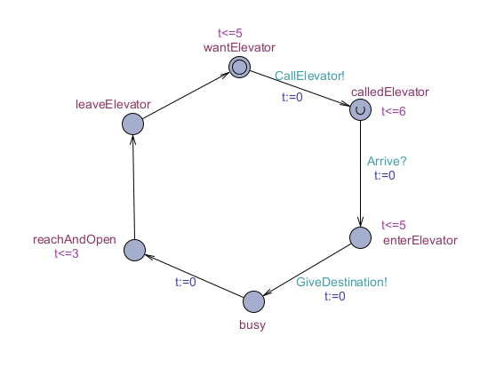

### *Elevator1*

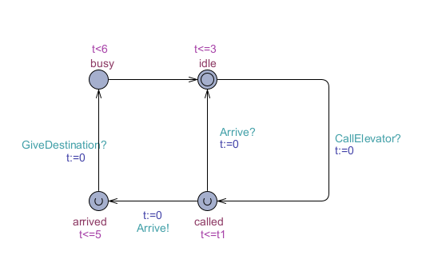

### Just the same as the previous file.

### *Elevator2*

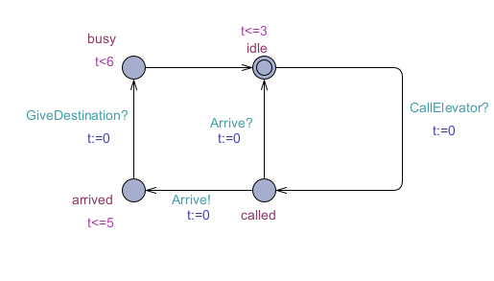

### *Check Properties*

### The process can last with no deadlock.