Andrew Lindberg
Introduction
The Great Recession was a period of economic contraction that began in December 2007 and ended in June 2009 (NBER). Prevailing narratives lay blame on an industry-wide breakdown of mortgage lending and securitization practices (Adelson, 2020) which enabled a speculative bubble in U.S. residential real estate contributing to record levels of household debt and over-valuation of capital assets. As individual borrowers modified and/or defaulted on loans, mortgage-backed securities realized losses – exposing their overvaluation and the risky loans they contained. An equivalent of bank run on investment banks facilitated significant losses and bankruptcy for many well established and large banks, both commercial and investment.
The fallout of this systemic collapse led to a peak of 9.9% unemployment in November 2009 that slowly meandered downward over the next 7 years, finally matching the pre-recession levels in late 2016 (FRED). Some economic and political pundits cite The Great Recession and its handling as an important contributor to political unrest – particularly lifting populist sentiments such as those espoused by Bernie Sanders or the election of Donald Trump (Schnurer). This project looks at the shape of the recession across four states: California, Florida, North Carolina, and Massachusetts. It identifies potential discrepancies with the sub-prime narrative, considers the possibility of novel lead indicators, evaluates the impact on education and entrepreneurship, investigates the socio-economic structures of the post-recession era, and offers a hopeful consideration around the influence of education.
Methodology
Data was retrieved through GEOFRED which is hosted by the Federal Reserve Bank of St. Louis and visualized using Tableau to create several dashboards and one story. The following data sources were used:
Data | Seasonally Adjusted
90% Confidence Interval Lower Bound Estimate of Median Household Income | No
Accommodations and Food Service Earnings by State (Thousands of Dollars) | Yes
All Employees: Leisure and Hospitality: Food Services and Drinking Places | No
High School Graduate or Higher | No
Bachelor’s Degree or Higher | No
People 25 Years and Over Who Have Completed a Graduate or Professional Degree | No
Home Vacancy Rates | No
Home Ownership Rates | No
New Private Housing Units Authorized by Building Permits | No
Business Applications | No
Business Formations (Within 4 Quarters) | No

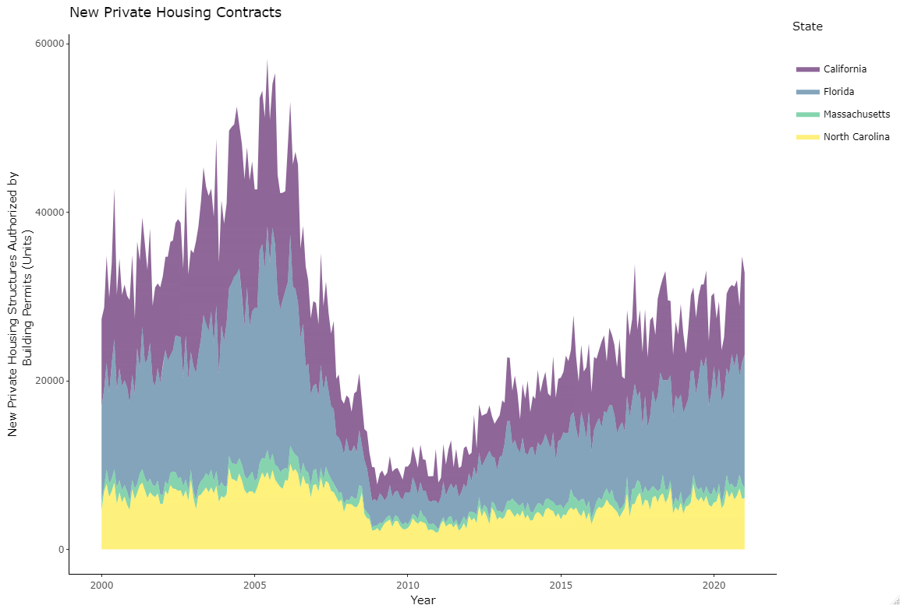
Overview:
Signs of changes in the housing market were as early as 2005 in California, while North Carolina and Massachusetts saw a delayed collapse.

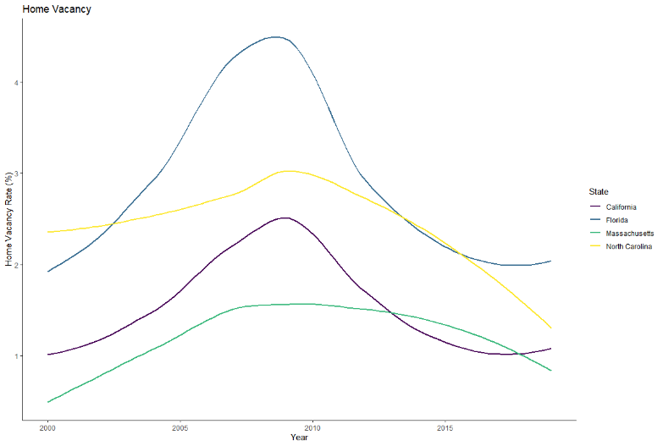
Discrepancies between the fluctuation in home ownership rates and home vacancy rates support the idea that the economic bubble and collapse were primarily caused by investors, suggesting better regulation may prevent future crises.

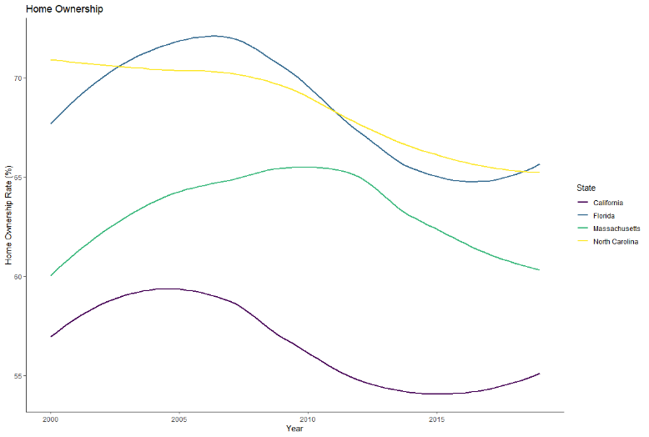

The sharp change in earnings for food service workers in 2009 might support writer, Hugo Lindgren of New York Magazine’s, Hot Waitress Index. Further research is necessary to validate these claims; however, if tall, thin, and white are the definition of attractiveness, this research would fall flat by not considering the socio-economic implications of this index and the depicted change in earnings.
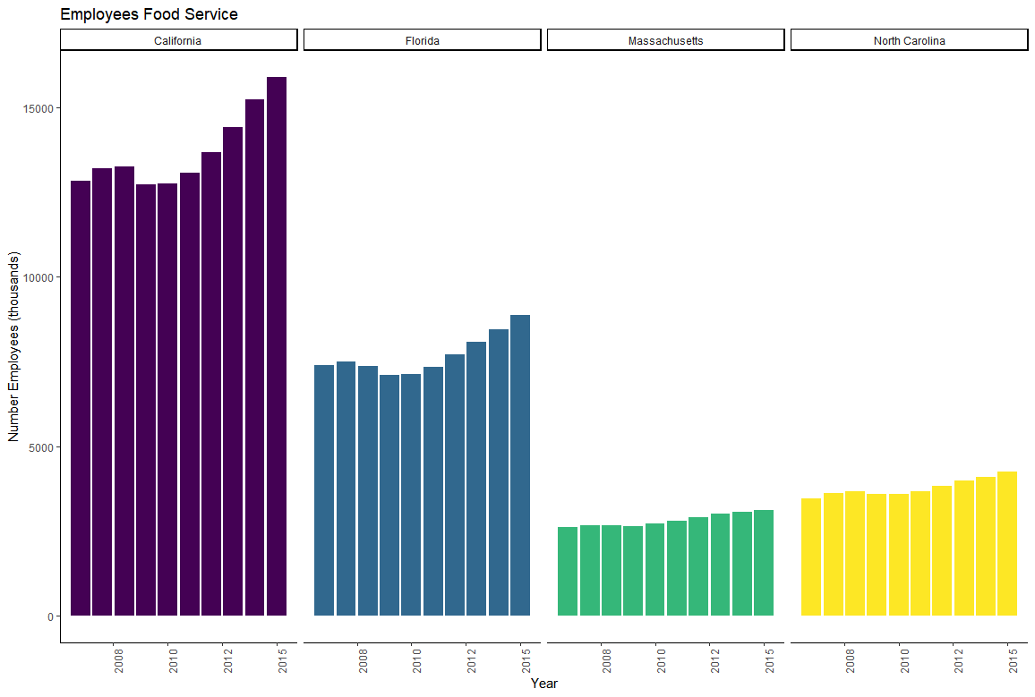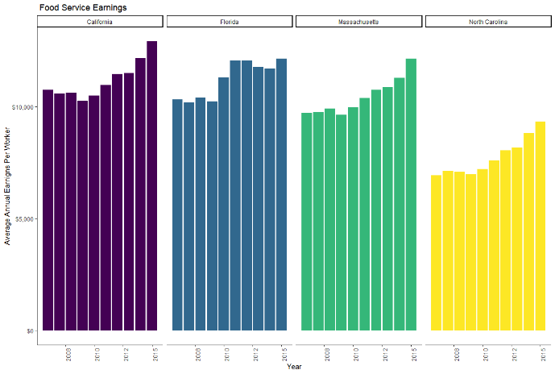

Promisingly, high school graduate rates continued a steady incline during the economic downturn. Interestingly, while Tableau did not suggest an uptick in the pursuit of higher education, visual analysis through R suggests that North Carolina, and Massachusetts both saw a significant increase in the percentage of people with a graduate or professional degree around 2012, and all states showed an increase in bachelor’s degrees around the same time.
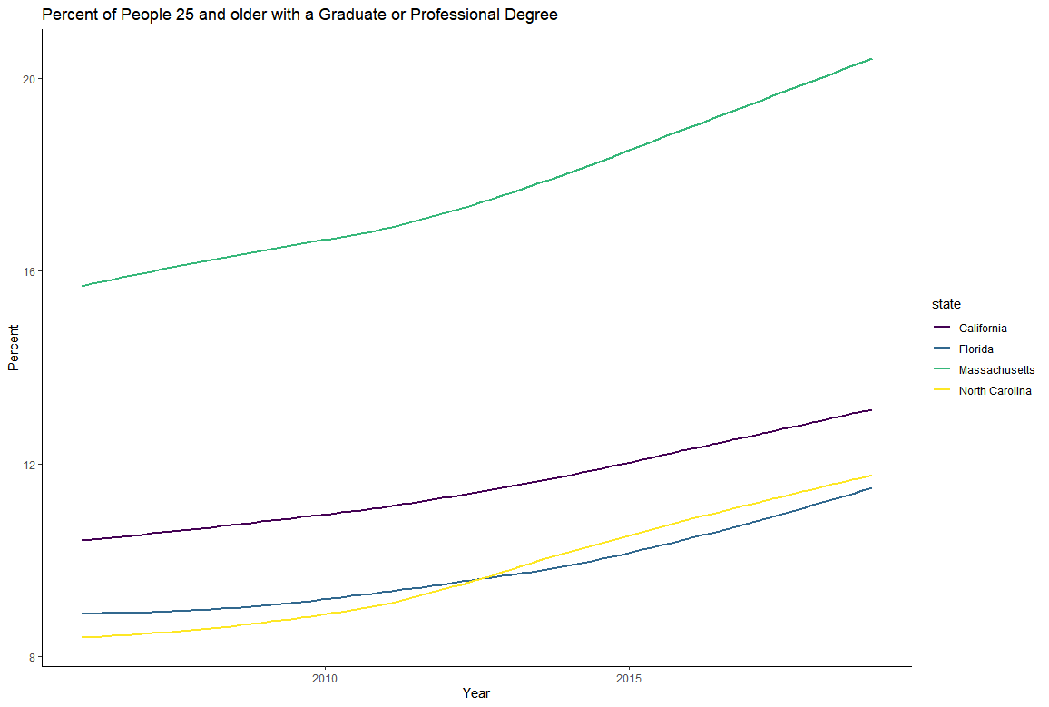
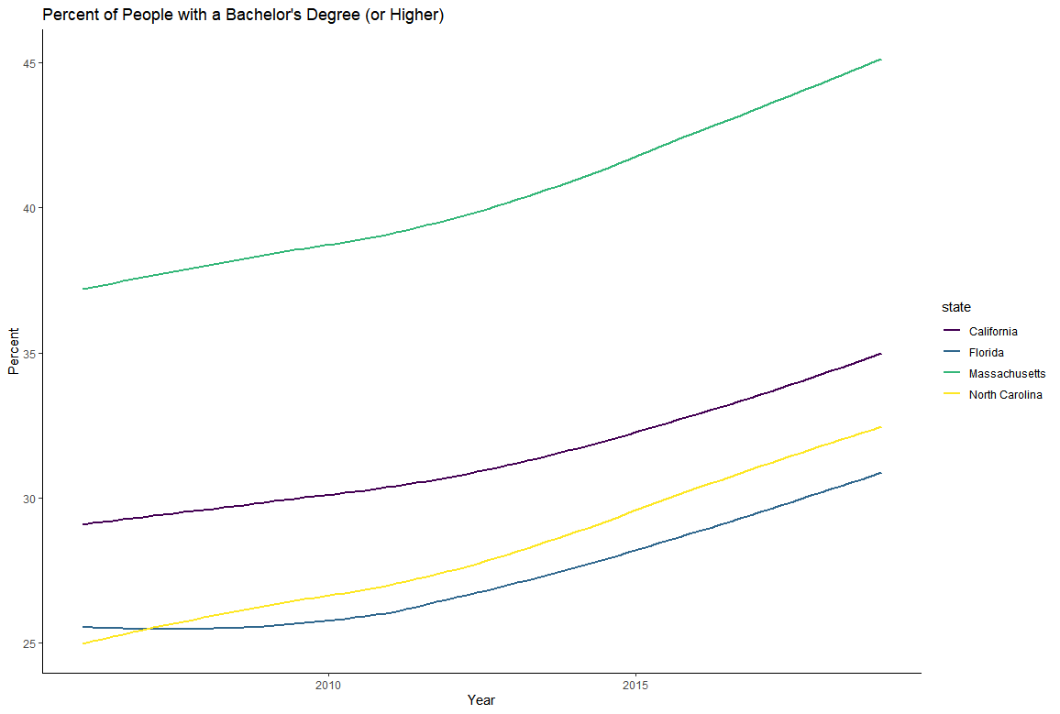
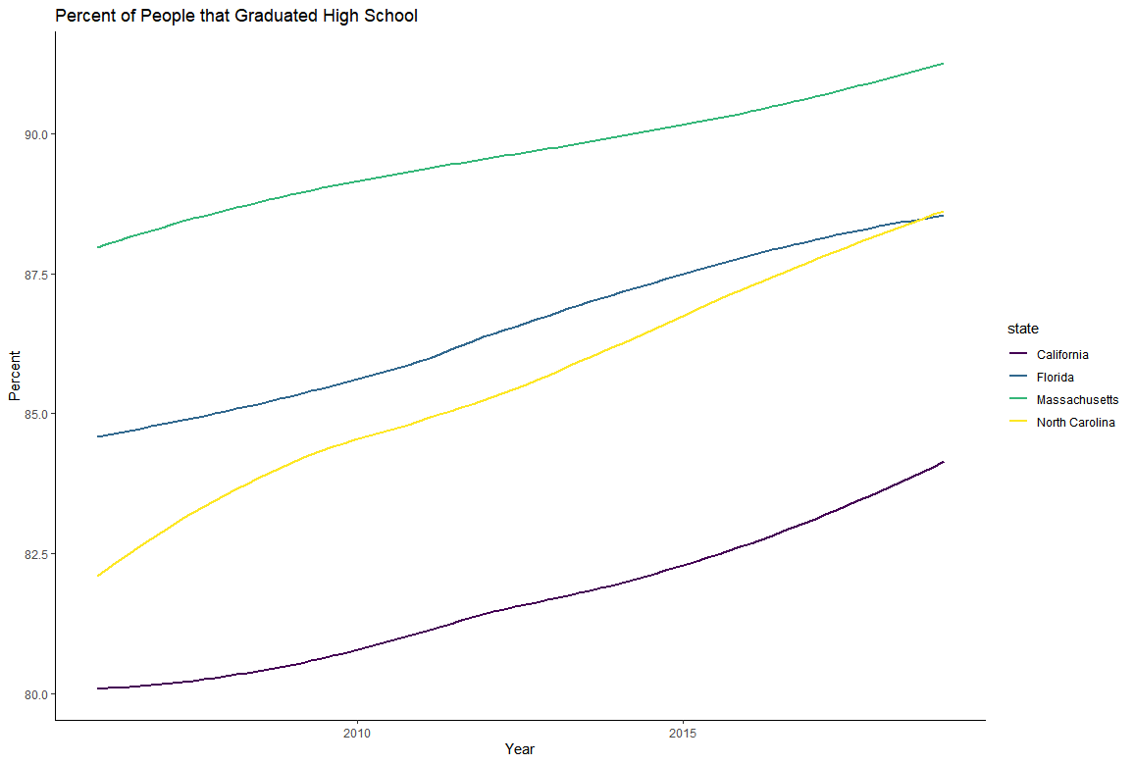

The number of new businesses started during the Great Recession dramatically decreased. While applications have returned to pre-Recession numbers, formation continues to remain low.

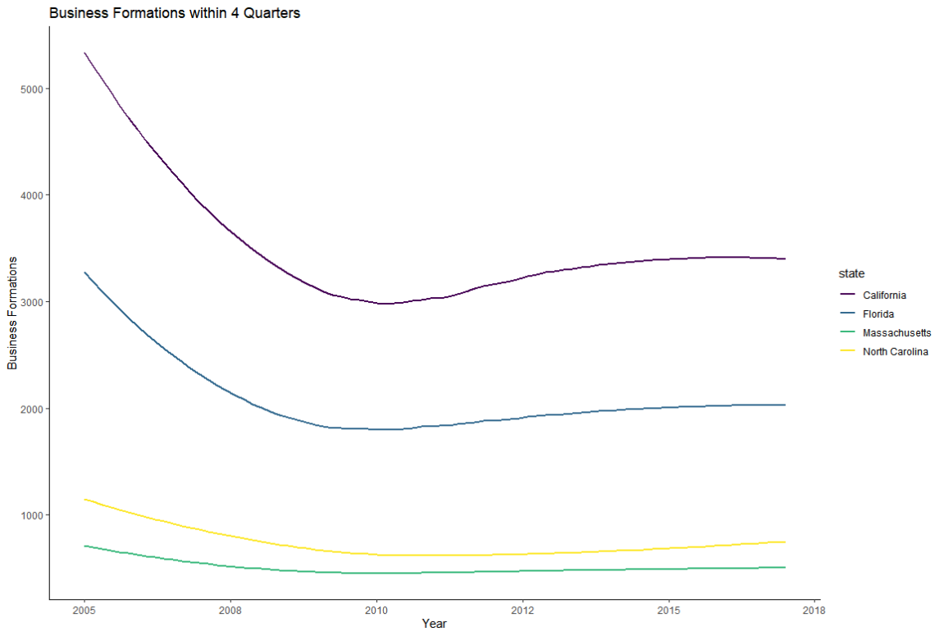
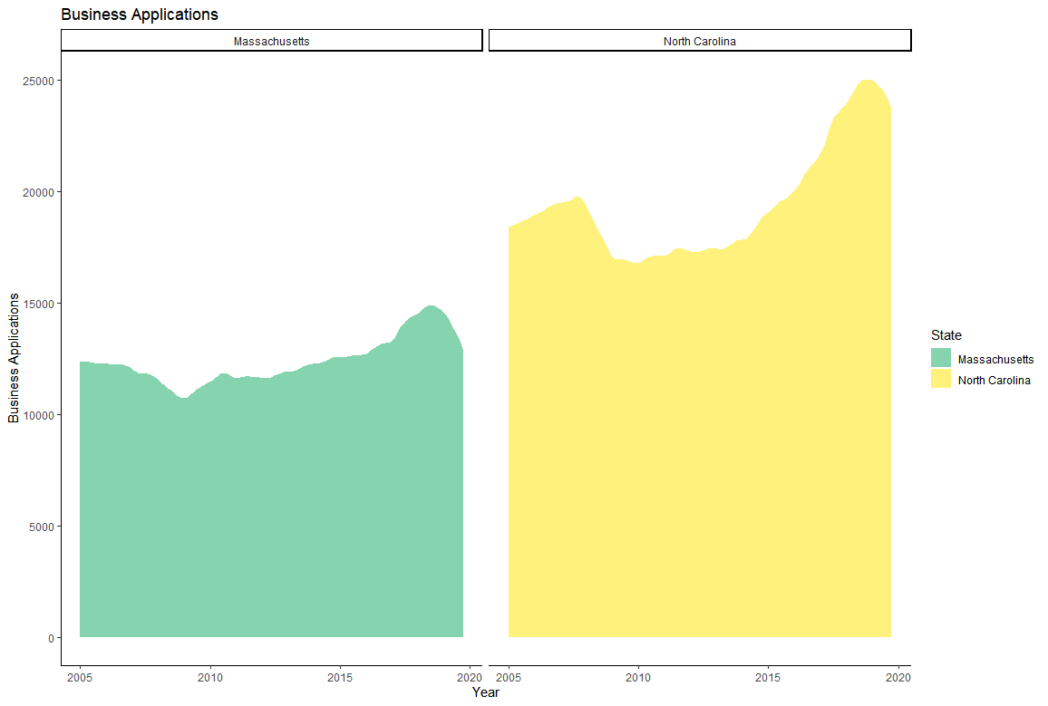
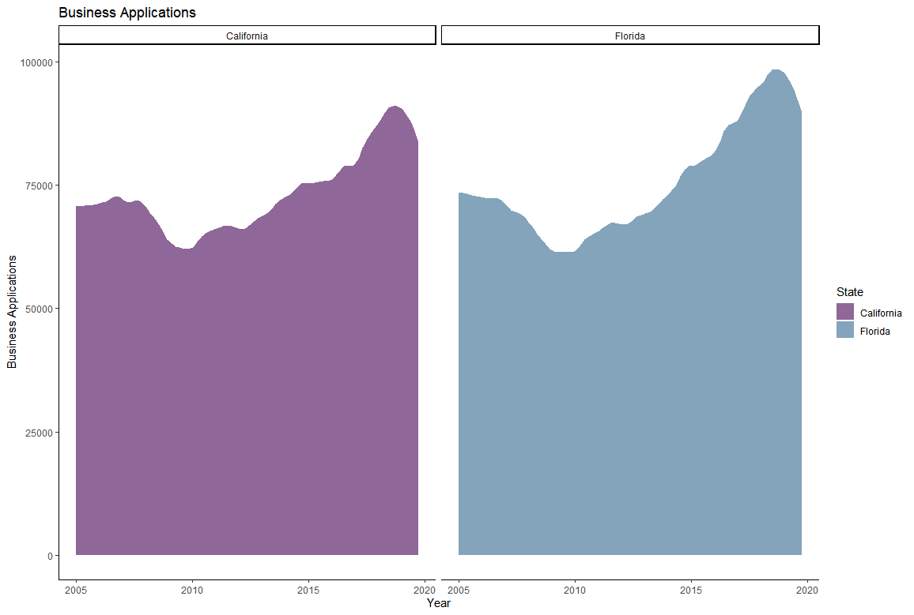

The Shape of the recovery varied across different states, notably, Massachusetts had the highest percentage of people over 25 with a graduate or professional degree and had a relatively stable recovery. Supporting individual’s efforts to achieve higher levels of education may help mitigate the impacts of future economic contractions. Further research is necessary.

Opinion on the Differences between R and Tableau:
Working through the same dataset, trying to reproduce the same charts, and attempting to build on the ideas I generated in the initial Tableau project was a fun and interesting challenge. With R, the possibilities felt limitless, so much so, that most of my charts were finished because I realized the idea that I was trying to accomplish was possible, just outside of my knowledge, and finding how could take several more hours. For example, I wanted to create an interactive heat map of home vacancy rates that changed based on the year (ideally set on some sort of slider). After spending several hours reading, learning, and trying to figure that idea out, I settled on using the pre, during, and post model that I submitted. I also found it interesting that some of the visualizations seemed to indicate a different result from those I generated in Tableau (especially around education).
Using R reminds me of playing with blocks as a kid. I had several sets with specific directions to build specific things, and the world of things became infinitely more possible as I learned of new shapes that I could mix and match to create new things.

References:
Adelson, M. (2020). The mortgage meltdown and the failure of investor protection. The Journal of Structured Finance, 26(1), 63-86. doi:10.3905/jsf.2020.1.095
NBER. (n.d.). US business Cycle expansions and contractions. Retrieved March 02, 2021, from https://www.nber.org/research/data/us-business-cycle-expansions-and-contractions
Schnurer, E. (n.d.). Politics are not recession-proof. Retrieved March 02, 2021, from https://www.usnews.com/opinion/articles/2016-06-02/the-great-recession-wrought-donald-trumps-rise
U.S. Bureau of Labor Statistics, Unemployment Rate [UNRATE], retrieved from FRED, Federal Reserve Bank of St. Louis; https://fred.stlouisfed.org/series/UNRATE, March 2, 2021

