
APPLICATION FOR CONFIRMATION OF STATUS AS A STUDENT
FOR THE DEGREE OF DOCTOR OF PHILOSOPHY

Staff notice: This form contains personal data and may contain sensitive information. Please ensure that downloaded or printed copies are stored securely. Please retain information only for as long as you need it and then dispose of it confidentially. Further advice about handling student data can be found here: (https://academic.admin.ox.ac.uk/student-data).

This form and any subject-specific supporting documentation required, should be sent to the relevant Graduate Studies Assistant (please refer to www.ox.ac.uk/students/academic/guidance/graduate/contacts/ for contact details).
Please complete SECTION 1, SECTION 2 and SECTION 3, and then ensure that SECTION 4 and SECTION 5 are completed by your supervisor and college. You should make sure that you are aware of the maximum fee liability you will incur in your proposed new status, and consult your college or Graduate Studies Assistant if in doubt.
Students who require adjustments to the assessment arrangements for Confirmation of Status due to disability, under Section 6 of the General Regulations for Research Degrees (https://examregs.admin.ox.ac.uk/Contents) should also complete the GSO.19 Application for Adjustment to Assessment Arrangements form available at: https://www.ox.ac.uk/students/academic/guidance/graduate/progression. Guidance for Directors of Graduate Studies on such adjustments is available in Annex C of the Policy and Guidance on Research Degrees at https://academic.admin.ox.ac.uk/research-degrees.

Please use BLOCK CAPITALS (unless typed), and refer to the current edition of the Examination Regulations, or departmental or divisional guidance notes or handbooks that you have received, where full details of the relevant confirmation requirements are given.
SECTION 1 – Declaration of consent (to be signed by the student)
I understand that the information and any materials that I supply in support of this application will be processed by the University in accordance with the Student Privacy Policy https://compliance.admin.ox.ac.uk/student-privacy-policy. I consent to my information being used for the purposes of this application.
I consent to disclosure within the above limits |  | ❑ Yes ❑ No
Signature of Student: | 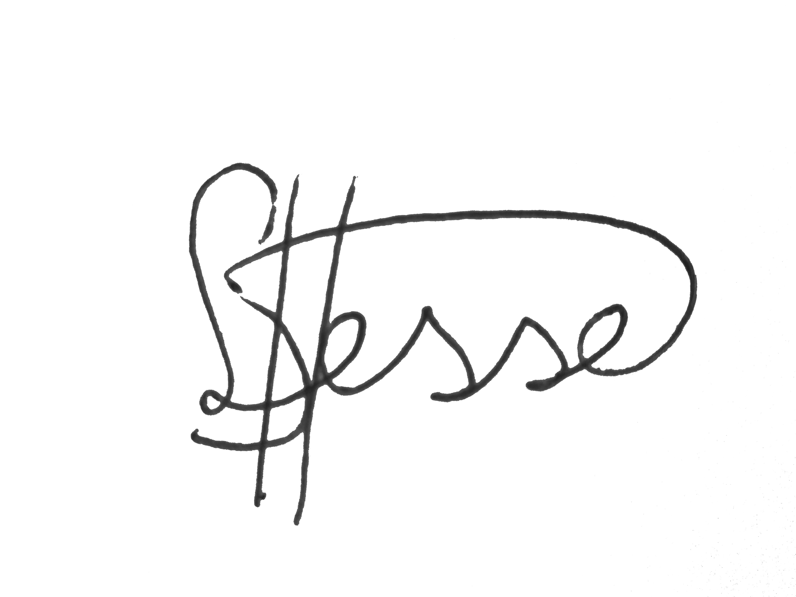

SECTION 2 – to be completed by the student. Please use BLOCK CAPITALS (unless typed).
Surname: | Hesse |  |  |  |  |  | Title (Mr/Mrs/Miss/Ms/etc.): |  | Ms
First Name (in full): | Linde |  |  |  |  |  | Student Number: |  | 1246308
College: | St. Edmund Hall |  | Department: |  |  |  | Department of Engineering
Address for Communication:
11 Littlehay Road
OX43EG Oxford
Telephone Number: | 07840552196 |  | Email Address: |  | Linde.hesse@seh.ox.ac.uk
Term Transferred to D.Phil. Status: |  |  | Michaelmas 2020
Title of thesis proposed or branch of study: |  | NOTE: For students admitted in or after October 2007(please tick box);  I am aware that I must deposit a digital copy of my thesis following successful completion of my degree, and am aware of copyright issues (http://www.bodleian.ox.ac.uk/ora/oxford_etheses) |  |  |  |  |  |  |  | ❑
Interpretable Deep Learning for the Quantification of Fetal Brain Development

Initial term of entry to course: | Michaelmas 2019 |  |  | OFFICE USE ONLY |  | Final Term:

Signature: |  | Date: | 15-03-2022

RESEARCH INTEGRITY
Students are reminded that they need to have completed the University’s online research integrity training. This should normally have been completed before applying for transfer of status, but must be completed before applying for confirmation of status. The training is available at https://weblearn.ox.ac.uk/portal/hierarchy/skills/ricourses

The University’s research integrity policies may be found here: https://researchsupport.admin.ox.ac.uk/governance/integrity/policy. The University takes seriously any concerns raised about research practice, and those found to have engaged in research misconduct may face disciplinary action.

I confirm that I have completed the online research integrity training and attach the emailed certificate of completion as evidence of this. [You do not need to provide this if it has already been provided at Transfer of Status.]  If you have not yet completed the training, please do so before submitting this form. | ❑ Yes

RESEARCH ETHICS APPROVAL (Please tick one box only)

❑ | I confirm that no human participants were involved and no personal data was used in my research and therefore ethical approval was not required.
❑ | I confirm that my completed CUREC1/1A was approved by the appropriate REC.
❑ | I confirm that my completed CUREC2 (or NHS REC or OXTREC application) was approved by the appropriate REC.
SECTION 3 – to be completed by the student
Progress report:
(i) | Please give a brief indication of the nature and progress of your research to date (please refer to any departmental or divisional guidance notes or handbooks that you have received for additional requirements):
This is outlined in Confirmation Report submitted separately.

(ii) | Your proposed timetable for submission:
This is outlined in Confirmation Report submitted separately.

SECTION 4 – to be completed by the supervisor
Comments (please include a comment on the progress of the student’s research and the proposed timetable for submission – if you wish to do so, this may be sent directly to the relevant Graduate Studies Assistant (please refer to www.ox.ac.uk/students/academic/graduates/contacts/ for contact details).
In addition to the comments above, please tick one of the following options:
❑ | I have no concerns regarding this student’s readiness to apply to confirm status.
❑ | I have mild concerns regarding this student’s readiness to apply to confirm status, and have discussed these with the student.
❑ | I have serious concerns regarding this student’s readiness to apply to confirm status, and have discussed these with the student.

Signature: |  | Date:
Full Name:

SECTION 5 – to be completed by the college’s Tutor for Graduates
Does the college support the application: |  |  | ❑ Yes ❑ No
Comments on behalf of the college:
Signature: |  |  | Date:
Full Name:
Position (if not Tutor for Graduates):
College Stamp:

SECTION 6 – to be completed by the Director of Graduate Studies (or equivalent)
I certify that this application has the approval of the candidate’s department |  |  | ❑ Yes ❑ No
Comments:
Signature of DGS (or equivalent): |  | Date:
Full Name:

NOTES
Confirmation of D.Phil. status was introduced to give faculties and departments an opportunity to monitor the direction and progress of a D.Phil. student’s work in the period between transfer of status and submission of thesis. It is intended both to assess the progress of the research work and to support the work of a student and their supervisor(s) by ensuring that other members of the faculty or department with a responsibility for graduate students are aware of the state of the research in progress, and the likely timetable for submission.
While all candidates seeking confirmation of status are required to complete the form in full, further detailed requirements vary from subject to subject. You should find the specific requirements relating to your subject set out in the Examination Regulations or in the relevant departmental or divisional guidance notes or handbooks.
For candidates admitted to the status of Probationer Research Student, it is the University’s expectation that a D.Phil. thesis will be submitted within twelve terms (the work representing ‘what may reasonably expected of a capable and diligent student after three or at most four years of full-time study’). Candidates may apply for extensions of time beyond twelve terms, within a maximum of six further terms. Faculty/department boards or other committees will require such applications to include full explanation of the reasons for the request, as well as the support of the student’s supervisor and college. Approval of applications is not automatic, and most bodies will give not more, and may give less, than three terms’ extension at any one time.
Candidates who are in receipt of Research Council awards must ensure that they know the date by which they are expected to submit. It is essential for the award of studentships to future generations of graduate students that every effort is made to submit by this date, or, if there are good reasons for suspension of status or extensions of time, these are always approved by the Research Council concerned as well as by the faculty or department. Such approval is necessary within the required submission period even if a student is no longer receiving financial support.
SUPPLEMENTARY INFORMATION TO BE PROVIDED BY THE STUDENT
The University recognises that the identification of particular areas of skills training and development is a regular aspect of a student’s work with their supervisor(s). It regards confirmation of status as an appropriate point at which to ask the student, with the help of their supervisor(s), to:
- record those subject-specific and personal and professional skills which the student has already acquired;
- identify any such skills which might require further development or refinement;
- note any other related activities, e.g. presentation of posters, attendance at conferences, etc., which have made a contribution to the development of the student’s work.
In making this record available to confirmation assessors and to those responsible for approving applications for confirmation, the University does not wish to make this a formal aspect of the confirmation process, but to acknowledge the importance of such activities in a research student's training and to provide assessors and others with a fuller picture of an individual student’s progress. It also aims to help individual students cope with the increasing expectation on the part of research councils and other funding bodies that, in conjunction with their supervisor(s), they will maintain a record of such skills and achievements throughout the course of their career as a research student.

Supplementary Information to be provided by the student:
A | Please describe briefly any subject specific research skills that you have developed or improved in the course of your time as a research student. For example, these might include: research methodology; data analysis and management; record keeping; bibliographical skills; presentation of research.
Skills that I have improved during my time as PhD student:
- Collaborating with colleagues on projects
- Collaborating with other research teams on a project
- Theoretical understanding of methods
- Finding new, interesting research directions
- Python programming
- Presentation of work on conferences
- Paper writing
- Making research figures using Inkscape

- B | Please describe briefly any personal and professional skills in which you have received training or which you have enhanced during the course of your time as a research student. For example, these might include: time management; language skills; IT skills; team work; problem solving; presentation skills; teaching skills; career planning.
Career planning
- Attended SeedWISE: a 7-week 7-week program for STEM Dphil students exploring careers in enterprise and industry. The course was organised by the MLPS division and included sessions on several skills necessary to succesfully transfer to industry (personal branding, pitching your research, effective communication)

Organisational Skills (leading a team, charing meetings, organising events etc.)
- President of Oxford Women in Computer Science (2021-2022); during my time as President of the society I have learned and improved many skills related to this role

Teaching
- Teacher and Organiser of GirlsWhoML: I actively took part in GirlsWhoML, an initiative to promote more women into machine learning subjects. We offered a 5 week online ‘Introduction to Machine Learning’ program that was very successful and had a large number of sign-ups. I prepared content for and taught two sessions on ‘Multi Layer Perceptrons’ and ‘Convolutional Neural Networks’, improving my teaching skills.

C | Please identify any subject-specific or personal and professional skills in which you (and your supervisor(s)) foresee the need for further development or training.
Subject Specific
- Better GitHub usage
- Improved theoretical foundations of deep learning
- Organising data from different datasets well

Personal and Professional Skills
- Reviewing academic papers
- How to apply for grants and Fellowships
- How to keep updated with new literature

D | Please list any other activities which have contributed to the development of your work. For example, these might include courses attended, conference presentations given, publications, opportunities to undertake teaching etc.
A list of all publications, conference presentations and teaching is included in the confirmation report Chapter 3.

GSO.14. (2) Updated Oct 2021

For students who are admitted to DPhil status (whether having passed Transfer of Status or been admitted direct following progression from an MPhil) from Michaelmas term 2021 onwards this is mandatory. It is also strongly recommended for students who were admitted to DPhil status before that date.

