**500 sims using a gam s(depth, k=4) + s(x,y, k=30): poisson model**

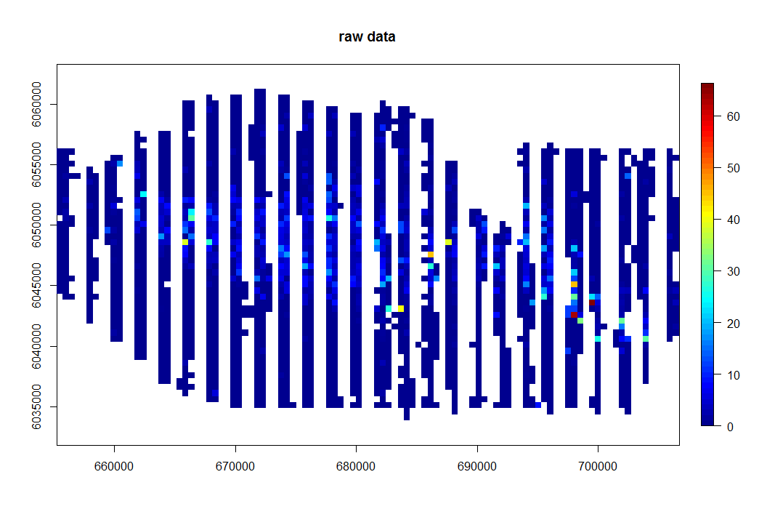

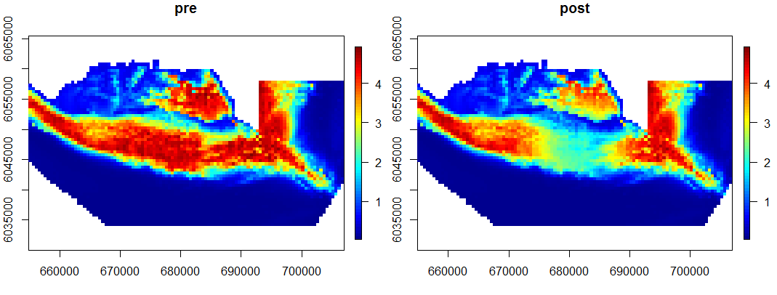

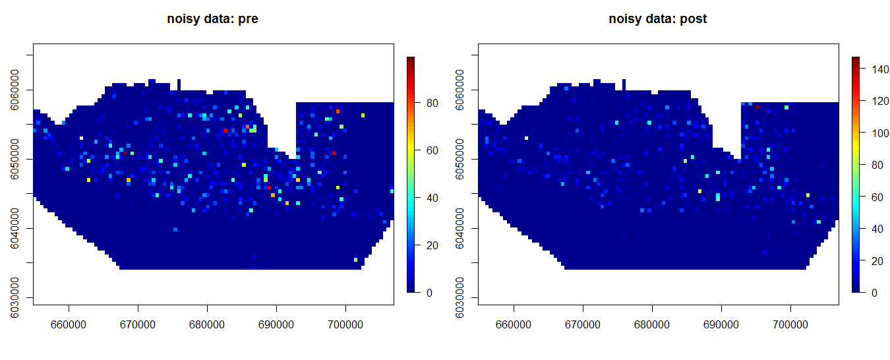

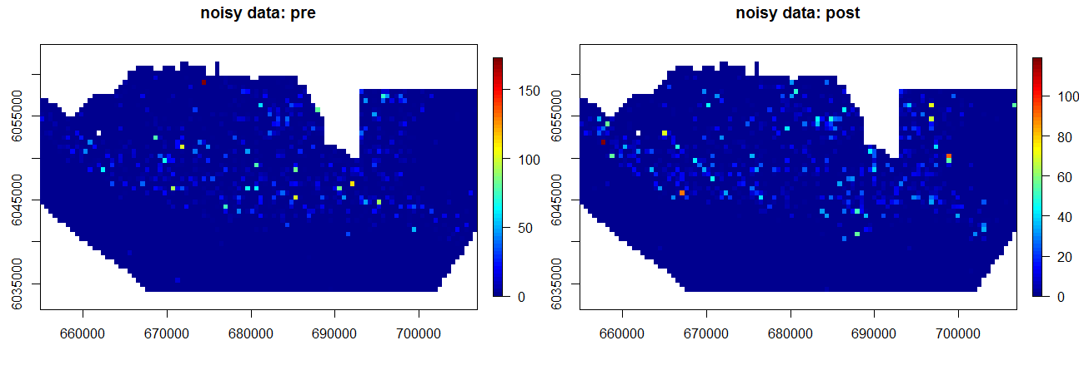

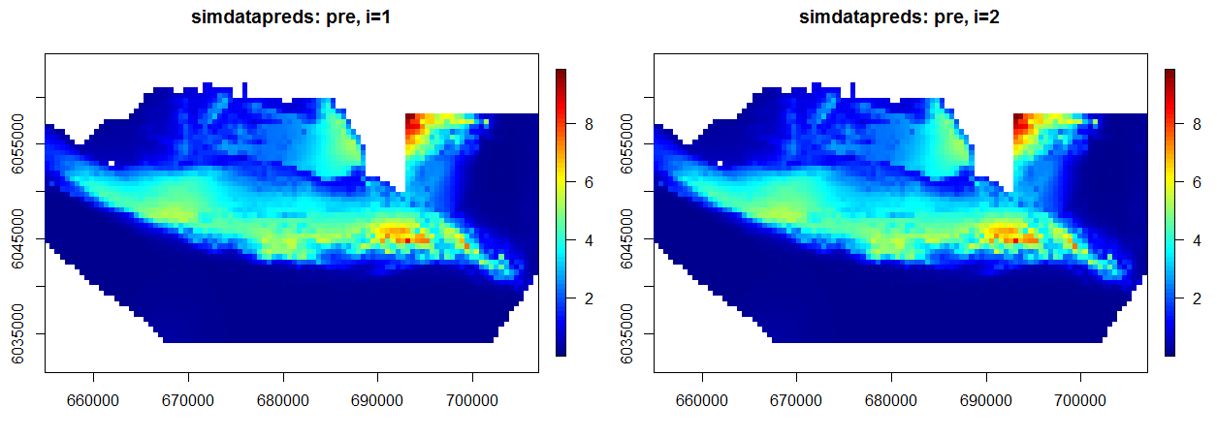

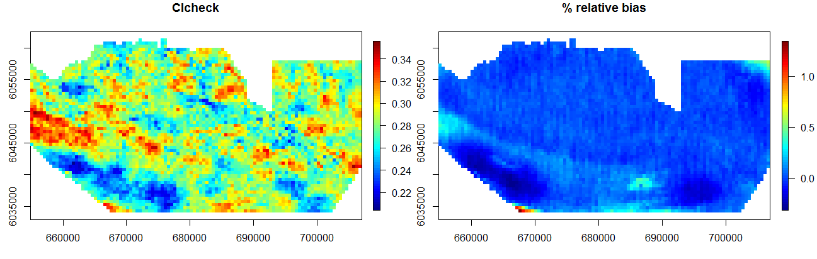

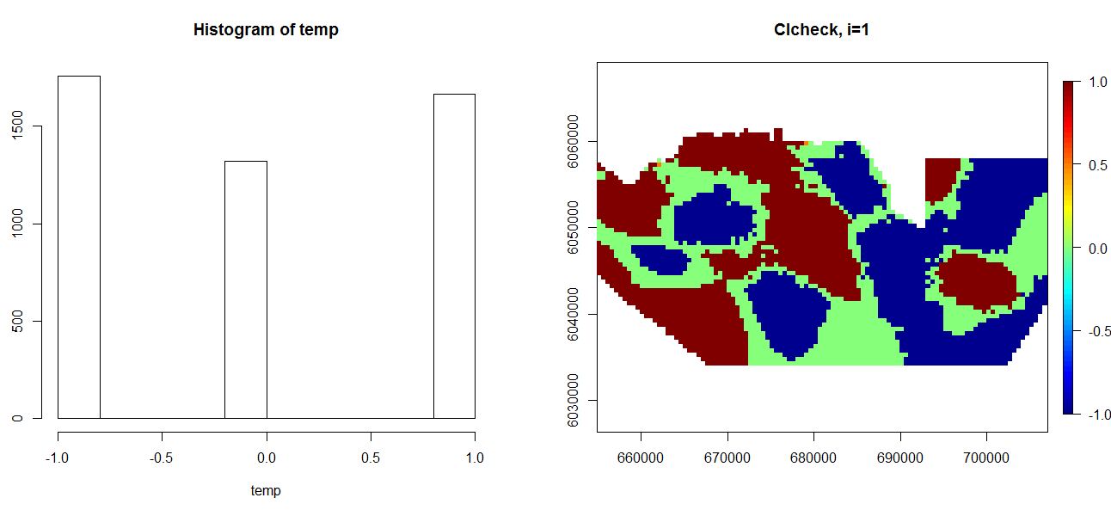

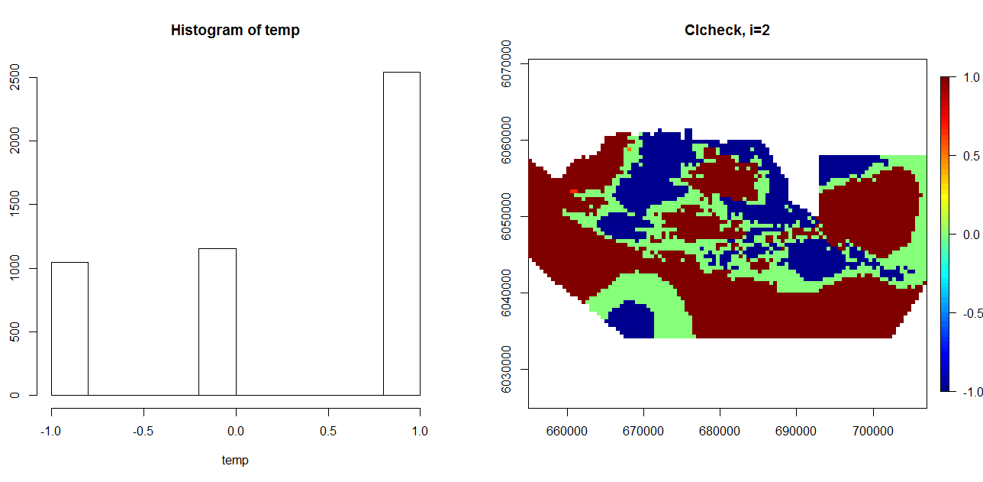

**500 sims using a gam s(depth, k=4) + s(x,y, k=10): quasipoisson model, noise scale=30**

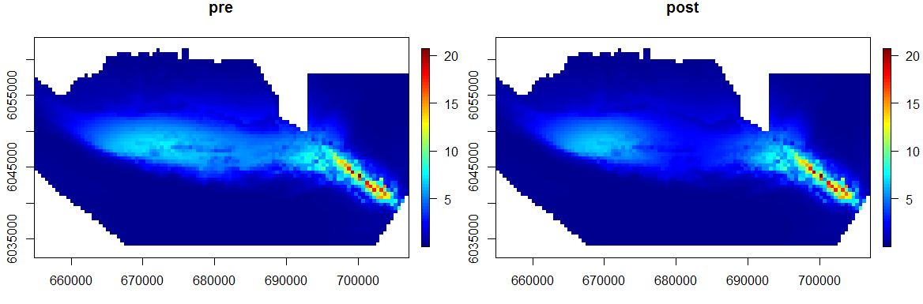

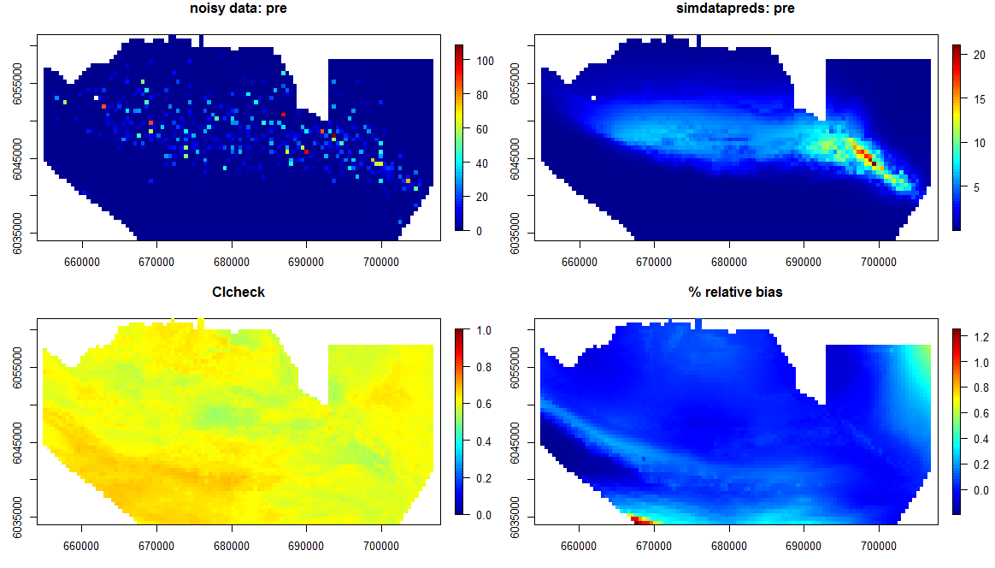

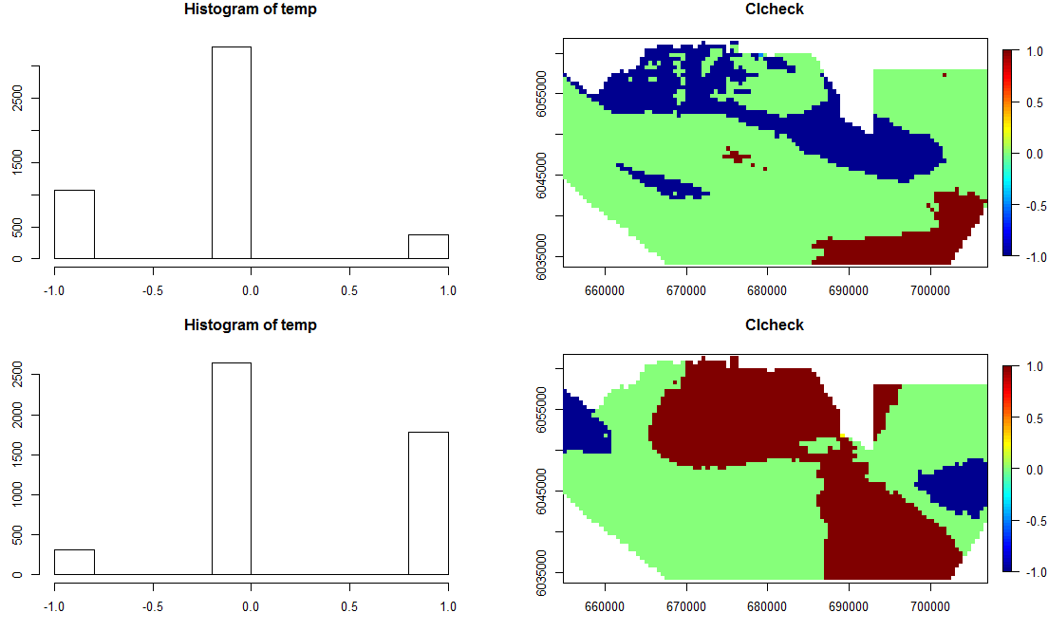

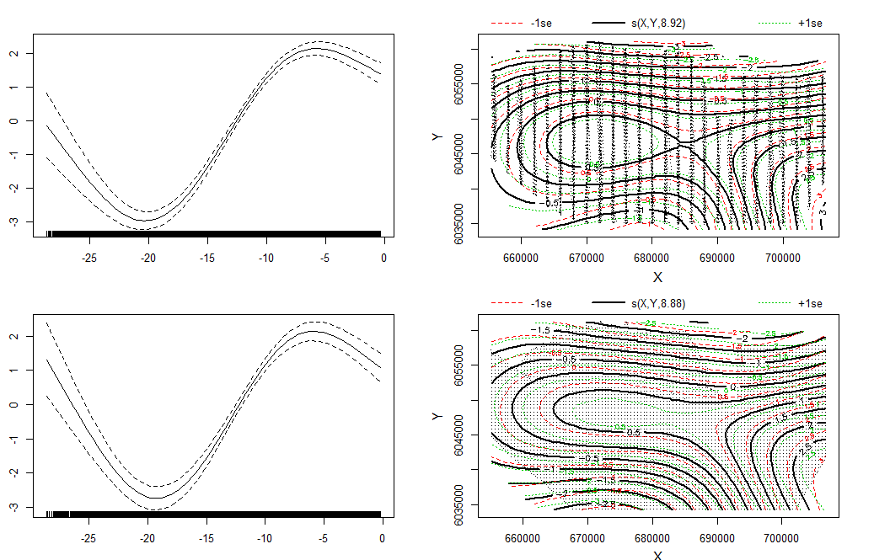

**Dispersion parameters:**

summary(baseModel)$dispersion

[1] 7.070319

> summary(dataObj$fit)$dispersion

[1] 6.163624

|  |  |  |
| --- | --- | --- |
|  | **Mean** | **Variance** |
| **Raw Data** | 1.684755 | 115.1356 |
| **Preds of raw data:** | 1.586201 | 5.497868 |
| **Simulated Data (mean across all 500):** | 1.582825 | 53.04407 |
| **Preds of simulated Data:** | 1.582825 | 5.750279 |

If you make d=90, then mean, var of simulated data are more similar to raw. Also dispersion params of two models are more similar. However, ci check is worse.

**500 sims using bs and cress:**

bs(depth, knots=(three quantiles), boundaryknots=bd)

LocalRadialFunction(rep(1,10), dist, 10619, idof10knots)

quasipoisson model

noise scale=30

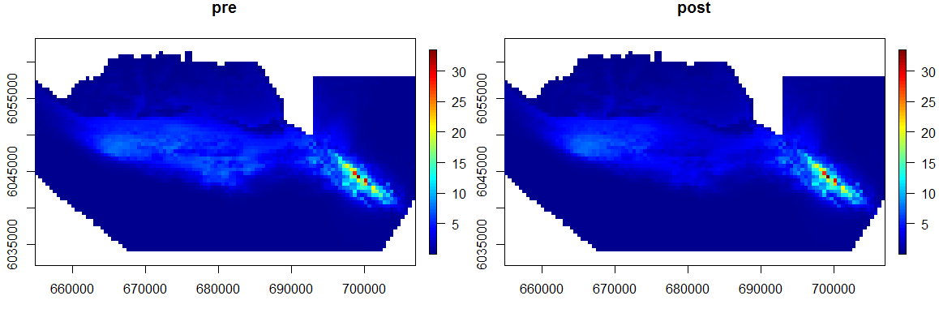

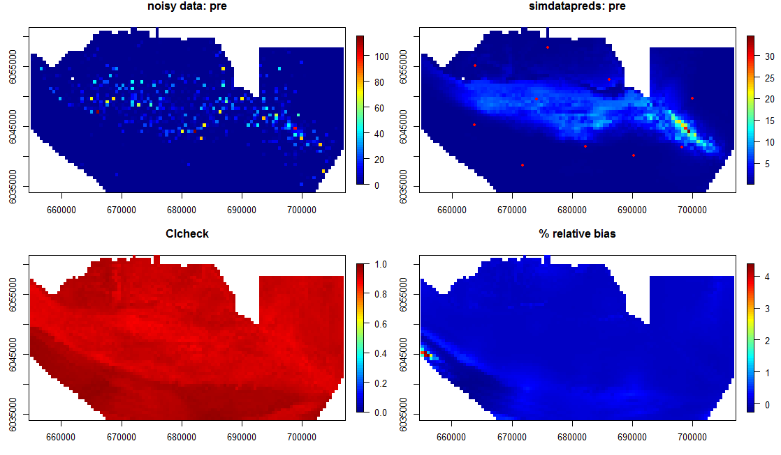

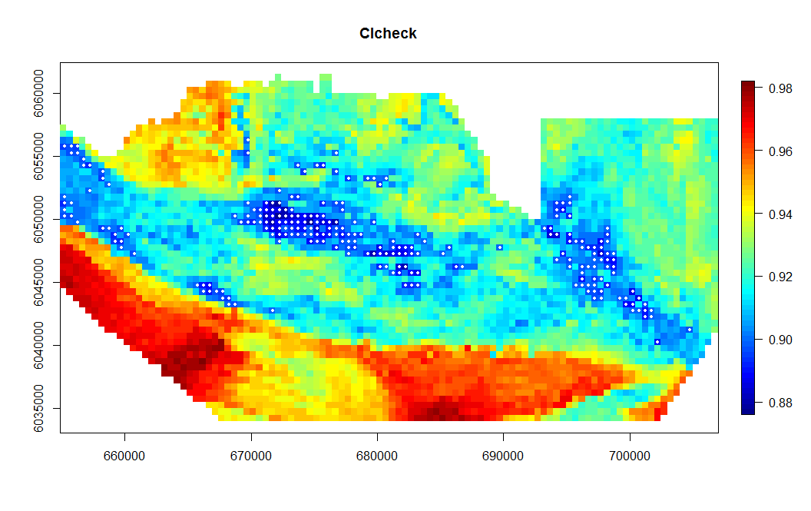

93% cells have >90% inclusion rate, however, confidence intervals are huge!

Issue far left on bias plot could be from Depth?? Its where depth is greatest in the surface.

Need to check partial plot to be sure? However, st.err of depth coeffs is very small so unlikely to be source

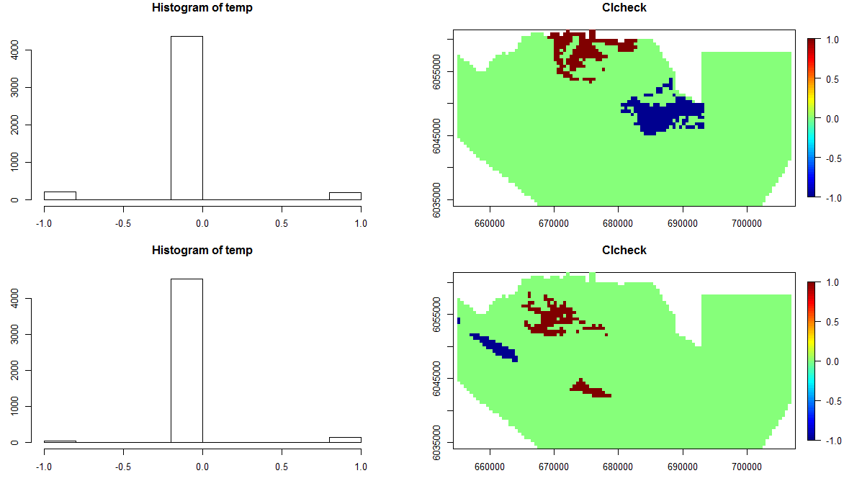

**Dispersion parameters:**

summary(baseModel)$dispersion

[1] 37.1973

> summary(dataObj$fit)$dispersion

[1] 18.32163

|  |  |  |
| --- | --- | --- |
|  | **Mean** | **Variance** |
| **Raw Data** | 1.684755 | 115.1356 |
| **Preds of raw data:** | 1.574871 | 6.1697 |
| **Simulated Data (mean across all 500):** | 1.570583 | 52.9999 |
| **Preds of simulated Data:** | 1.570583 | 6.52136 |

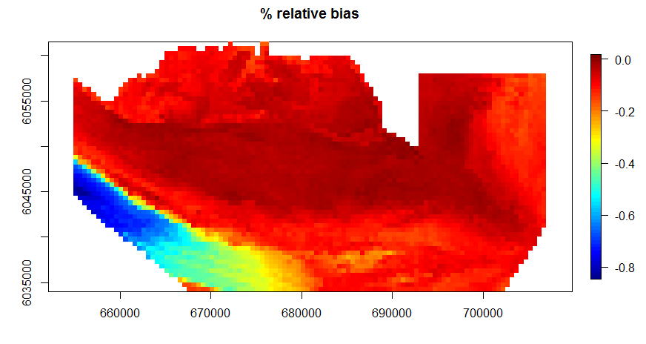

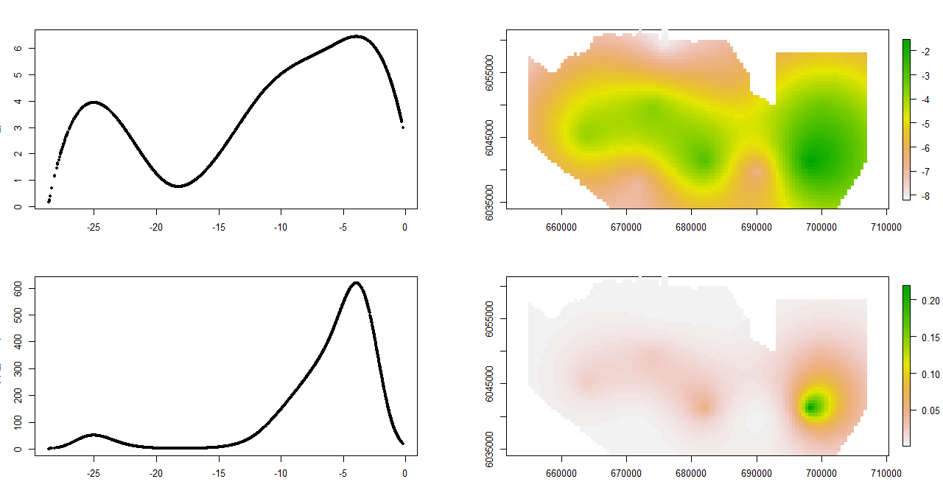

Partial residuals:

$$E_{i}^{(j)}=E_{i}+ e^{β_{j}X_{ij}}$$

