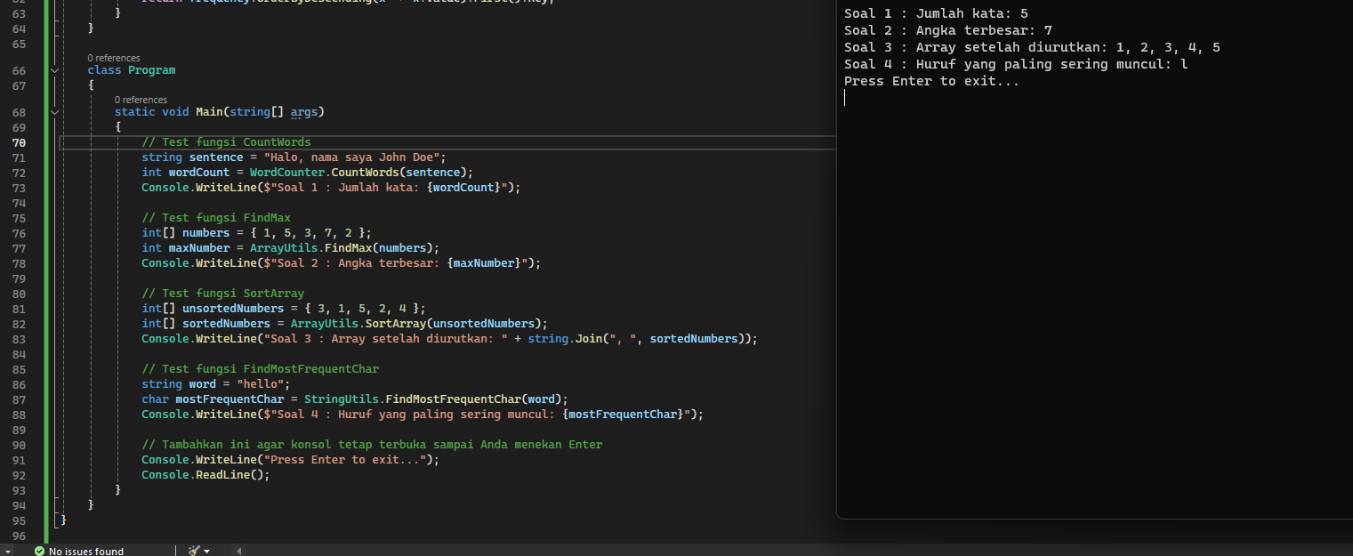

using System;

using System.Collections.Generic;

using System.Linq;

namespace MyConsoleApp

{

public class WordCounter

{

public static int CountWords(string sentence)

{

if (string.IsNullOrWhiteSpace(sentence))

return 0;

string[] words = sentence.Split(new char[] { ' ', '\t', '\n', '\r' }, StringSplitOptions.RemoveEmptyEntries);

return words.Length;

}

}

public class ArrayUtils

{

public static int FindMax(int[] numbers)

{

if (numbers == null || numbers.Length == 0)

throw new ArgumentException("Array tidak boleh kosong");

int max = numbers[0];

foreach (int number in numbers)

{

if (number > max)

max = number;

}

return max;

}

public static int[] SortArray(int[] numbers)

{

if (numbers == null || numbers.Length == 0)

throw new ArgumentException("Array tidak boleh kosong");

Array.Sort(numbers);

return numbers;

}

}

public class StringUtils

{

public static char FindMostFrequentChar(string word)

{

if (string.IsNullOrEmpty(word))

throw new ArgumentException("Kata tidak boleh kosong");

Dictionary<char, int> frequency = new Dictionary<char, int>();

foreach (char c in word)

{

if (frequency.ContainsKey(c))

frequency[c]++;

else

frequency[c] = 1;

}

return frequency.OrderByDescending(x => x.Value).First().Key;

}

}

class Program

{

static void Main(string[] args)

{

// Test fungsi CountWords

string sentence = "Halo, nama saya John Doe";

int wordCount = WordCounter.CountWords(sentence);

Console.WriteLine($"Soal 1 : Jumlah kata: {wordCount}");

// Test fungsi FindMax

int[] numbers = { 1, 5, 3, 7, 2 };

int maxNumber = ArrayUtils.FindMax(numbers);

Console.WriteLine($"Soal 2 : Angka terbesar: {maxNumber}");

// Test fungsi SortArray

int[] unsortedNumbers = { 3, 1, 5, 2, 4 };

int[] sortedNumbers = ArrayUtils.SortArray(unsortedNumbers);

Console.WriteLine("Soal 3 : Array setelah diurutkan: " + string.Join(", ", sortedNumbers));

// Test fungsi FindMostFrequentChar

string word = "hello";

char mostFrequentChar = StringUtils.FindMostFrequentChar(word);

Console.WriteLine($"Soal 4 : Huruf yang paling sering muncul: {mostFrequentChar}");

// Tambahkan ini agar konsol tetap terbuka sampai Anda menekan Enter

Console.WriteLine("Press Enter to exit...");

Console.ReadLine();

}

}

}