**Sentence Enumeration eXpert (SEX)**

**Test Plan**

Version 1.0

25 February 2017

Wai Chu

Yael Hyde

Asher Lindo-Fondo

Lead Program Engineer: Wai Chu

**Prepared for Instructor: Jessica Cruz, (Winter 2016)**

**Revision History**

|  |  |  |  |
| --- | --- | --- | --- |
| **Date** | **Description** | **Author** | **Comments** |
| **2/22/17** | **Version 1.0** | Wai Chu (Lead Programmer); Yael Hyde; Asher Lindo-Fondo | Beta |
|  |  |  |  |
|  |  |  |  |
|  |  |  |  |

**Document Approval**

The following Program Specification has been accepted and approved by the following:

|  |  |  |  |
| --- | --- | --- | --- |
| **Signature** | **Printed Name** | **Title** | **Date** |
|  |  |  |  |
|  |  |  |  |
|  |  |  |  |

**Table of Contents**

**REVISION HISTORY** 3

**DOCUMENT APPROVAL** 3

**1. INTRODUCTION** 5

1.1 References 5

1.2 Test Items 5

**2. Features** 5

2.1 Features being tested 5

2.2 Features not being tested 5

2.3 Type of testing 5

**3. Test Cases** 5

3.1 Test Case 1 6

3.2 Test Case 2 7

3.3 Test Case 3 8

3.4 Test Case 4 9

**4. Time Line** 10

4.1 Schedule for testing 10

**5. Testing Environment** 10

**6. Staff** 11

**7. Risks/Assumptions** 11

**8. Approvals** 11

**1. Introduction**

This test plan will detail methods to evaluate the functionality of the Sentence Enumeration eXpert (SEX) program. It will explain elements relevant to the evaluation of SEX and provide instructions for software testers in the sections that follow. The goal of the test plan is to outline factors of and methods for the evaluation of SEX. Its objective it to inform stakeholders and to provide software testers with a guide to evaluate SEX accurately**. If there are limitations or constraints make sure to list them here. [TO DO]**

* 1. **References**

The Software Requirements Specification (Requirements Document) that corresponds to this Test Plan is available by contacting any member of the SEX software development team.

* 1. **Test Items**

The software to be tested is the **Sentence Enumeration eXpert (SEX)**. It operates from the Windows® Command Prompt. The version of SEX to be tested is Version 1.0.

**2. Features**

**2.1 Features being tested**

SEE **SEX Requirements Document** §2.2; §2.2.1; §2.2.2; §3.1.1.1; §3.1.1.2; §3.2.4; §3.4.1.2; and §3.4.1.3. Also, SEE §3 of the **SEX Test Plan**. These features were chosen in this round of testing because they are fundamental aspects of the function and User Interface of SEX.

**2.2 Features not being tested**

SEE **SEX Requirements Document** §3.1.1.3; §3.1.1.4; §3.1.1.6; §3.2.1; §3.2.2; §3.4.1.1; §3.4.2; and §3.4.3. These features were not selected for testing in this round because they are relatively less integral to SEX than the features being tested. The developers of SEX intend to test these aspects of SEX in future rounds of software testing.

**2.3 Type of testing**

The test performed on SEX will be *manual* and *gray box*. The tester will access the program and follow the instruction per each test case, performing tests manually. For this Test Plan version, the tester will be someone associated with the development team, so the tester will have access to the programming code of SEX; hence the testing is gray box.

**3. Test Cases**

Criteria for success differs for each test case. Generally, a test is successful if SEX performs as intended, in terms of accessibility and functionality (SEE **SEX Requirements Document** §2.2; §3.2.4; §3.4.1.2; §3.4.1.3; §3.5.1; §3.5.2. SEE **SEX Test Plan** §2.1; §2.2). SEX must recognize only permitted file types and permit users to customize the *Minimum Number of Words*. Any results other than this are “failures”.

**3.1 Test Case 1: Recognition of Proper File Type (.txt)**

|  |  |
| --- | --- |
| **Component** | **Purpose/Definition** |
| Test Case Author | Wai Chu (Lead Tester), Yael, Hyde, Asher Lindo-Fondo |
| Creation Date | 25 February 2017 |
| Test Suite ID | Sentence Enumeration eXpert (SEX) Program Tests |
| Test Case ID | Valid File Path Test |
| Test Case Summary | To ensure that SEX accesses and evaluates target *.txt* files when valid file path is entered. |
| Requirement ID | SEX Requirements Document §2.1; §2.2.1; §3.1.1.1; §3.2; §3.4.1.2 |
| Prerequisites | Microsoft Windows 7 or higher; Python 3.5.2 |
| Test Procedure | Execute SEX and wait to be prompted by the program to enter the path of a file to be evaluated (e.g. C:/Users/Tester/Documents/*TEST1.txt*).  Input a path for a .txt file. Record results.  Re-run SEX and enter a path for a different .txt file. Record the results. |
| Expected Result | Valid file paths will be recognized by SEX. |
| Actual Result | TBD |
| Status of Test | Pending |
| Date of execution | TBD |
| Executed by | SEX Team |
| Testing Environment | See SEX Test Plan §5. |
| Notes | (Testing will be conducted once SEX developers refine the program) |

**3.2 Test Case 2: Exclusion of Improper File Type (.txt)**

|  |  |
| --- | --- |
| **Component** | **Purpose/Definition** |
| Test Case Author | Wai Chu (Lead Tester), Yael, Hyde, Asher Lindo-Fondo |
| Creation Date | 25 February 2017 |
| Test Suite ID | Sentence Enumeration eXpert (SEX) Program Tests |
| Test Case ID | Exclusion of Improper File Types |
| Test Case Summary | SEX will not acknowledge improper files (paths/types) when user inputs them |
| Requirement ID | SEX Requirements Document §2.2.1; §3.2; §3.4.1.2 |
| Prerequisites | Microsoft Windows 7 or higher; Python 3.5.2 |
| Test Procedure | Execute SEX and wait to be prompted by the program to enter the path of a file to be evaluated (e.g. C:/Users/Tester/Documents/*TEST1.txt*).  Input a path for the following and record results for each:  a file folder; a *.docx* file; a .*pdf* file; a .*png*, *.gif*, or *.jpeg* file; an *.html* file; an *.exe* file |
| Expected Result | SEX will not recognize invalid file paths/types. |
| Actual Result | TBD |
| Status of Test | Pending |
| Date of execution | TBD |
| Executed by | SEX Team |
| Testing Environment | See SEX Test Plan §5. |
| Notes | (Testing will be conducted once SEX developers refine the program) |

**3.3 Test Case 3: Users Get All Interactive Prompts from SEX**

|  |  |
| --- | --- |
| **Component** | **Purpose/Definition** |
| Test Case Author | Wai Chu (Lead Tester), Yael, Hyde, Asher Lindo-Fondo |
| Creation Date | 25 February 2017 |
| Test Suite ID | Sentence Enumeration eXpert (SEX) Program Tests |
| Test Case ID | User Receives Prompts from SEX |
| Test Case Summary | Test to see if SEX prompts user to 1, enter file path, and 2, to configure the Minimum Number of Words that determine a sentence. |
| Requirement ID | SEX Requirements Document §1.3.2; §2.2; §3.2.3; §3.4.1.2; §3.5.2 |
| Prerequisites | A Microsoft Windows 7 or higher; Python 3.5.2 |
| Test Procedure | Execute SEX and wait to be prompted by the program to enter a file path. This is the first of TWO interactive prompts  Input the path of a valid (*.txt*) file.The program will present with another prompt which offers the user the option to change the minimum number of words that determine a sentence |
| Expected Result | The user will receive both prompts. |
| Actual Result | TBD |
| Status of Test | Pending |
| Date of execution | TBD |
| Executed by | SEX Team |
| Testing Environment | See SEX Test Plan §5. |
| Notes | (Testing will be conducted once SEX developers refine the program) |

**3.4 Test Case 4: *Minimum Number of Words* Configuration**

|  |  |
| --- | --- |
| **Component** | **Purpose/Definition** |
| Test Case Author | Wai Chu (Lead Tester), Yael, Hyde, Asher Lindo-Fondo |
| Creation Date | 25 February 2017 |
| Test Suite ID | Sentence Enumeration eXpert (SEX) Program Tests |
| Test Case ID | Minimum Word Count Configuration |
| Test Case Summary | Test whether users can successfully configure the Minimum Word Count of SEX. |
| Requirement ID | SEX Requirements Document §2.2.2; §3.1.1.2; §3.1.1.5; §3.4.1.3 |
| Prerequisites | A Microsoft Windows 7 or higher; Python 3.5.2 |
| Test Procedure | Using a single test *.txt* file, execute SEX and respond to the *Minimum Number of Words* prompt.  Select 3 as the *Minimum Number of Words* then record results.  Re-run SEX then select 4 as the *Minimum Number of Words*. Record results.  Re-run SEX then select the default (5) as the *Minimum Number of Words*. Record results then compare with previous configurations. |
| Expected Result | Customizations of the Minimum Word Count will evaluate target .txt file differently and accordingly produce different output values (SEE Requirements Documents §1.2; §2.1; §3.2.1; §3.2.2; §3.4.1.1) |
| Actual Result | TBD |
| Status of Test | Pending |
| Date of execution | TBD |
| Executed by | SEX Team |
| Testing Environment | See SEX Test Plan §5. |
| Notes | (Testing will be conducted once SEX developers refine the program) |

**4. Test Line**

A 3-4 hour window will be set aside for the running of the tests, allotting roughly an hour for each test case. Appropriate time will be set aside after testing to prepare testing reports. Testing will be aborted if critical errors in the program are repeatedly encountered, or if the failure rate exceeds 75% (i.e. if 3 of the 4 run test cases result in failure). In such a case, testing will resume once the developers review the code and address relevant issues; the tests will resume within 72 hours of the aborted tests.

The testing will run as follows: (SCHEDULE)

|  |  |  |  |  |  |  |
| --- | --- | --- | --- | --- | --- | --- |
| **TIME** | 1st Hour | 2nd Hour | 3rd Hour | 4th Hour | 5th Hour | 6th Hour* |
| **TASK** | Test Case #1 | Test Case #2 | Test Case #3 | Test Case #4 | *REPORTING* | *REPORTING* |

**5. Testing Environment**

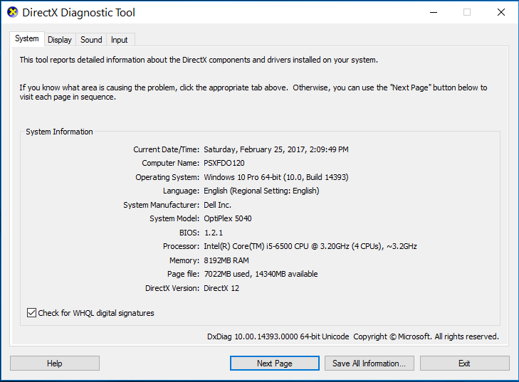

**6. Staff**

Fundamentally, the tester must only be able to follow directions and properly document his/her findings. If the tester possesses knowledge of Python coding, this is a plus. However, knowledge of Python is not necessary to perform the tests on SEX. Accordingly, there is no need for additional training. And since the initial software tests of SEX will be performed by members of the development team there is no need for additional hiring.

**7. Risk**

There are no risks in the tests set forth above. Testing will occur in a *live* but *controlled* environment, chiefly in the computer lab of Per Scholas. The testers assume that:

1. All *.txt* files will be provided in English and,

2. A character is any symbol made from a standard keyboard

**8. Approvals**

Approval can be obtained from Wai Chu, Lead Developer, and Jessica Cruz, Instructor/Client.