Configure Oracle Database

Create Listener
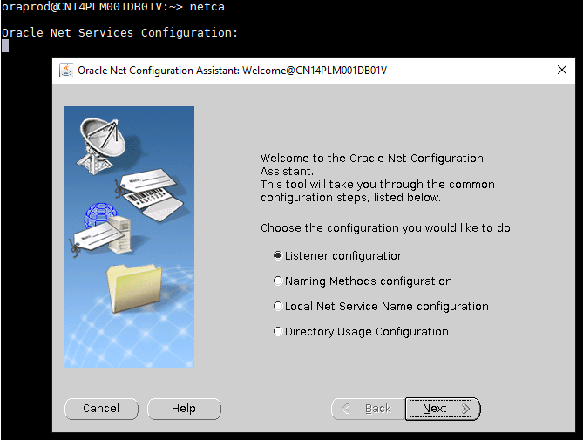
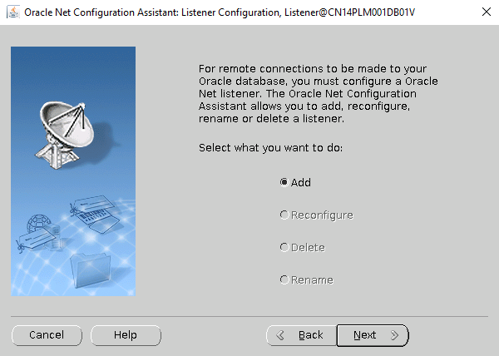
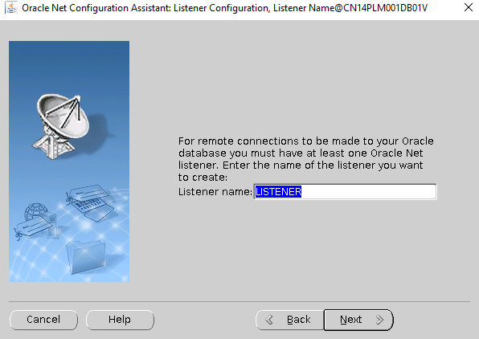
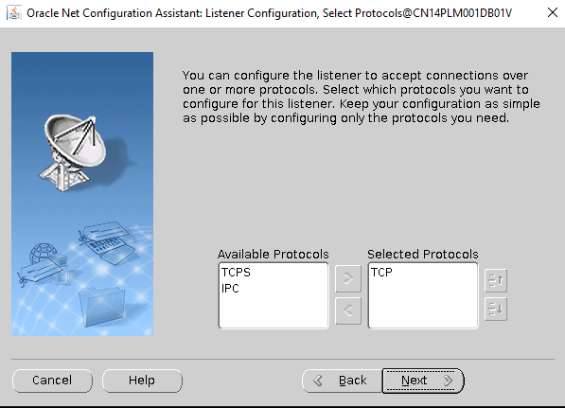
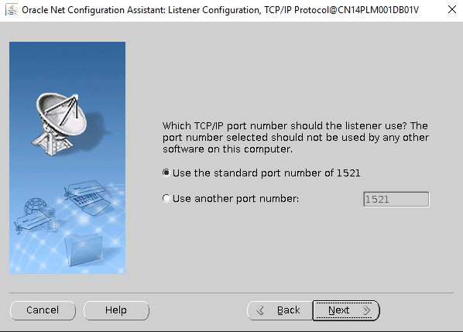
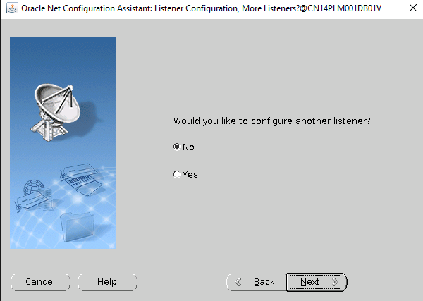
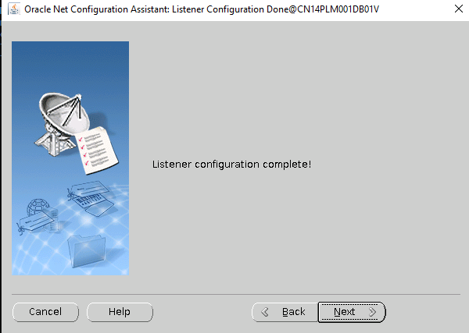
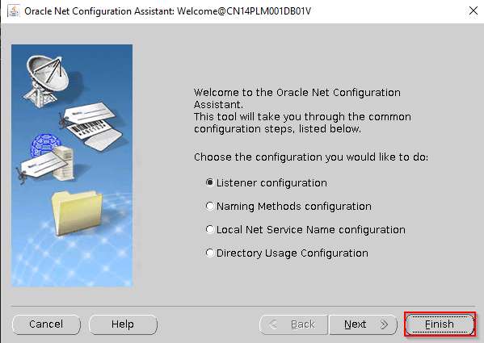

Create Database Instance
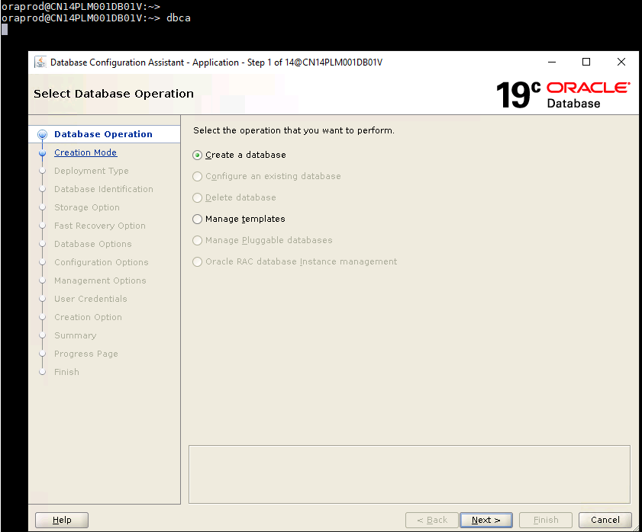
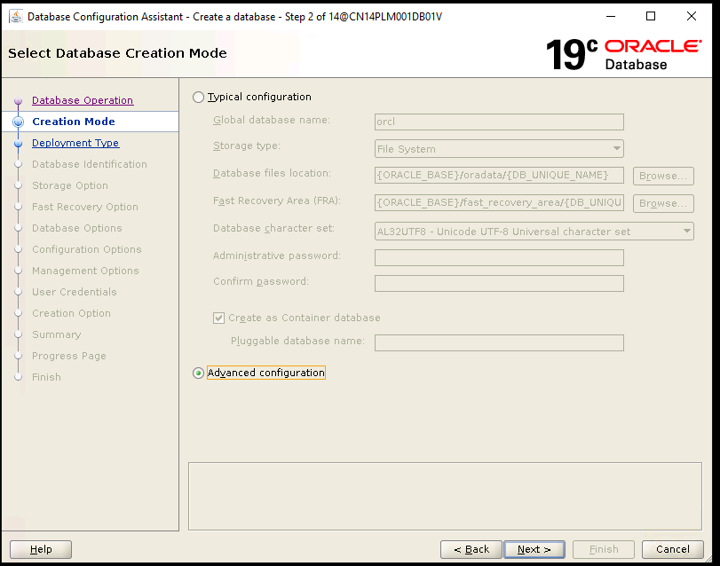
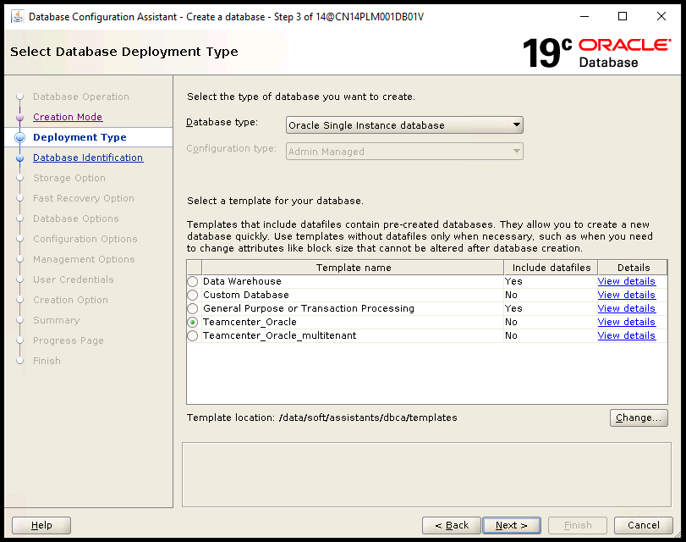
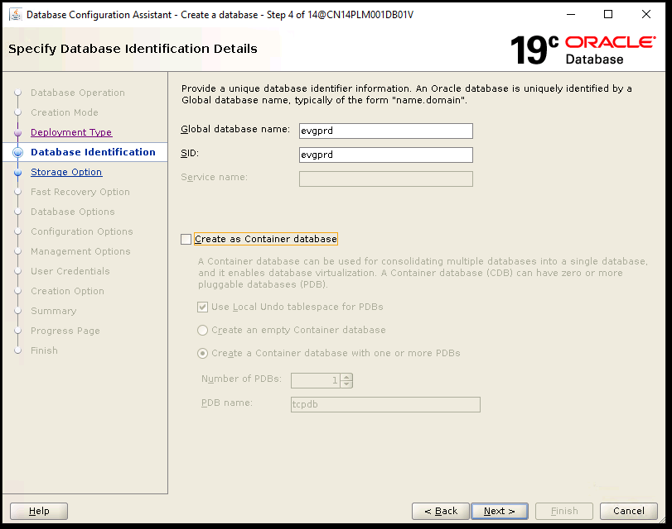
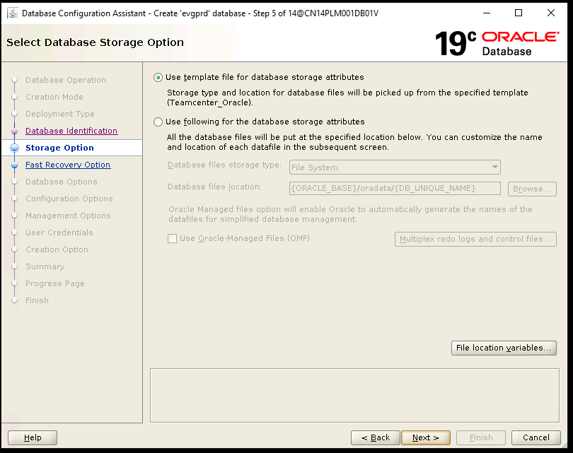
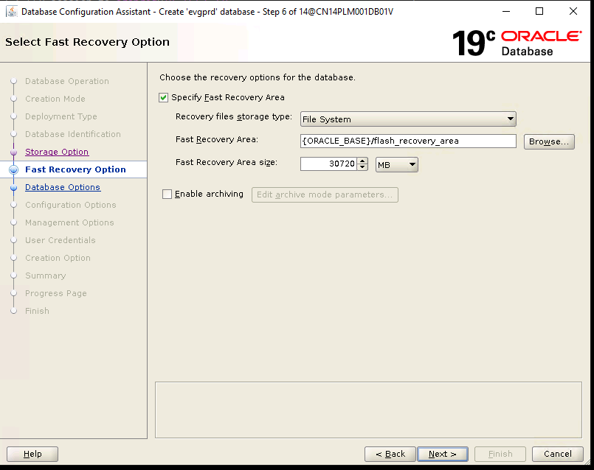
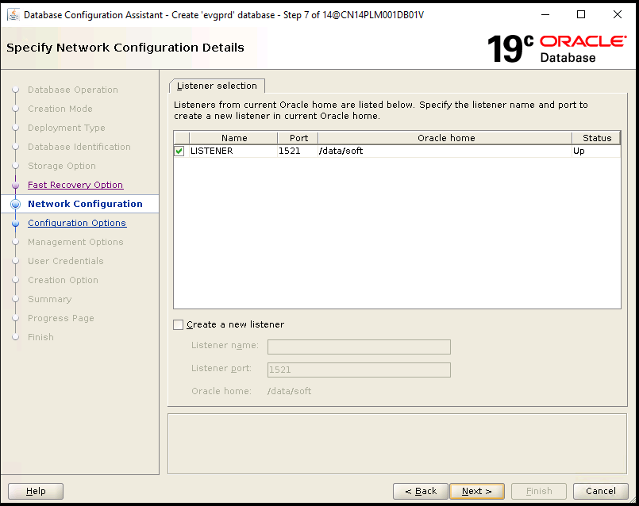
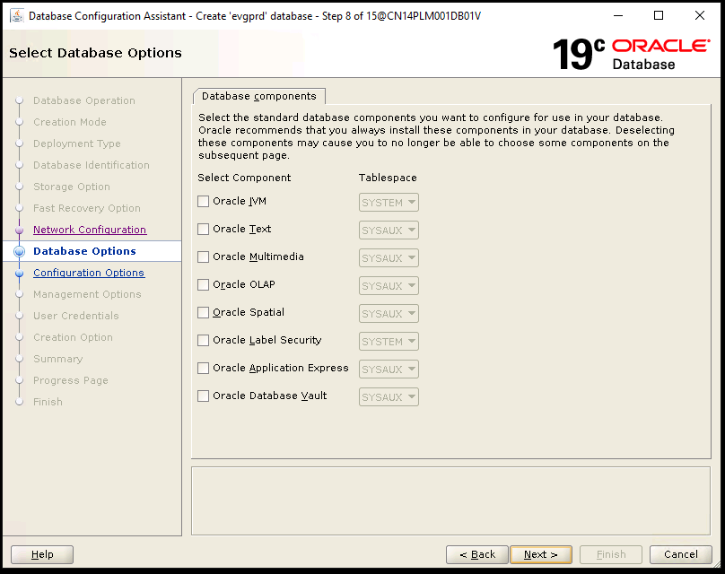
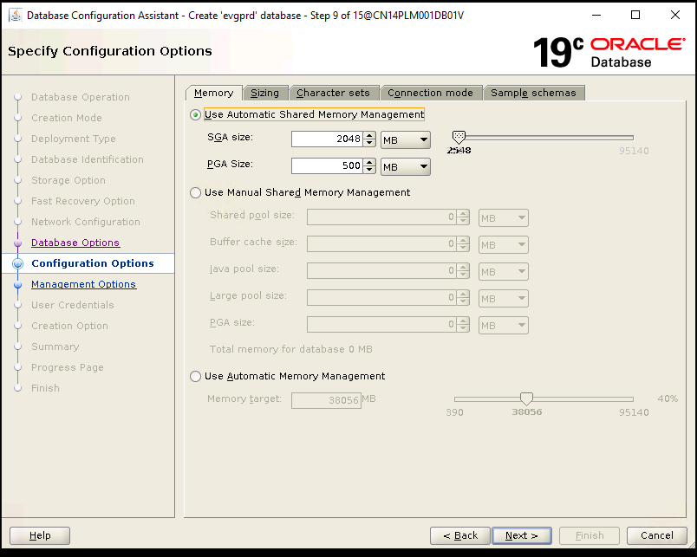
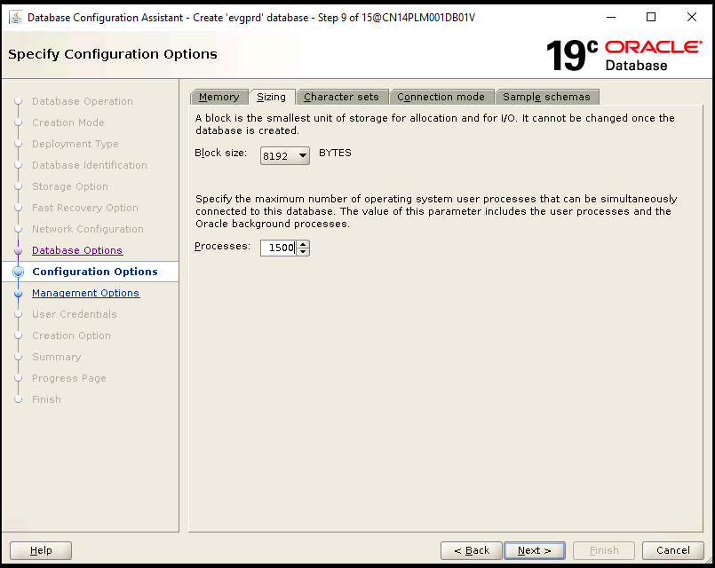
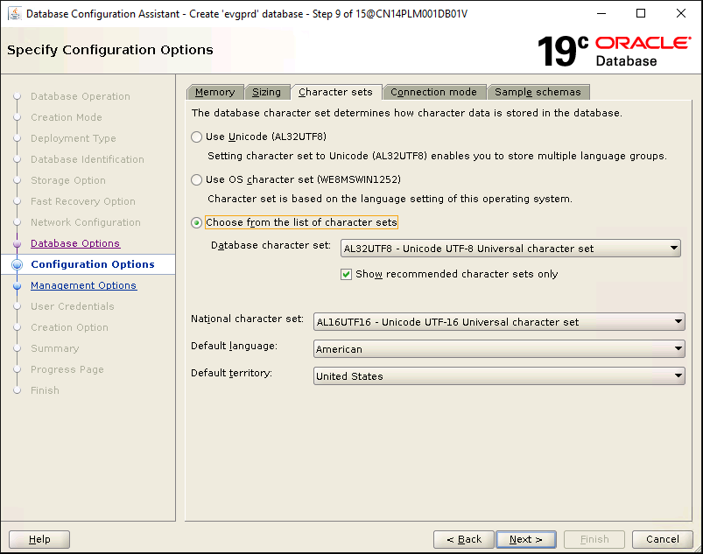
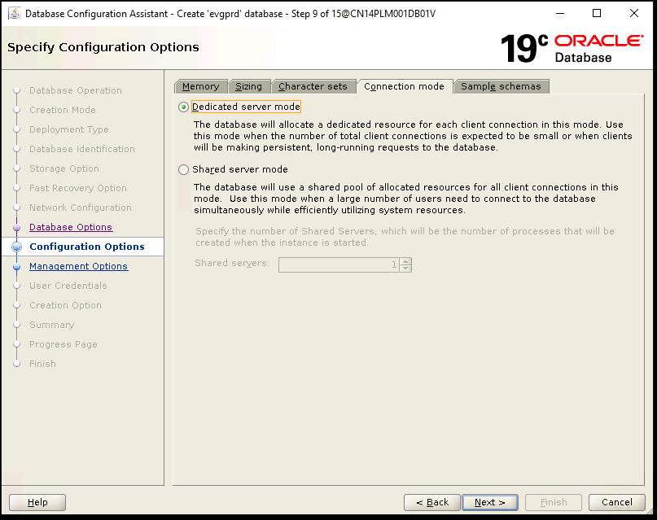
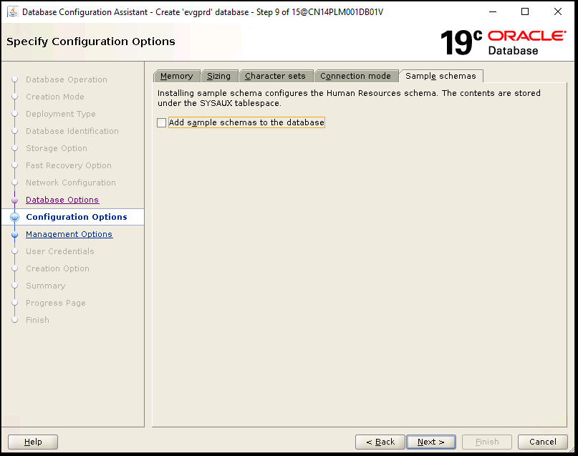
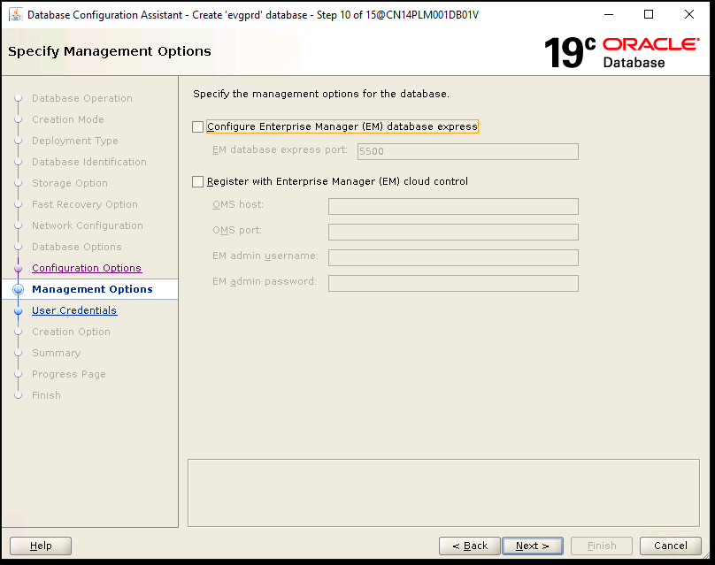
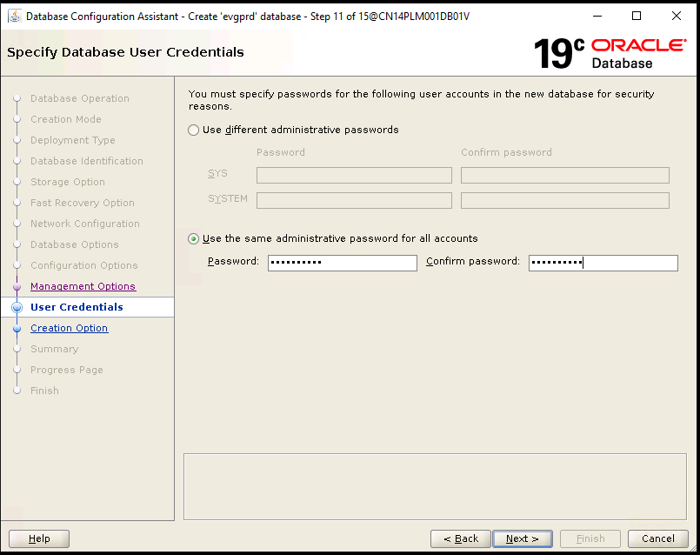
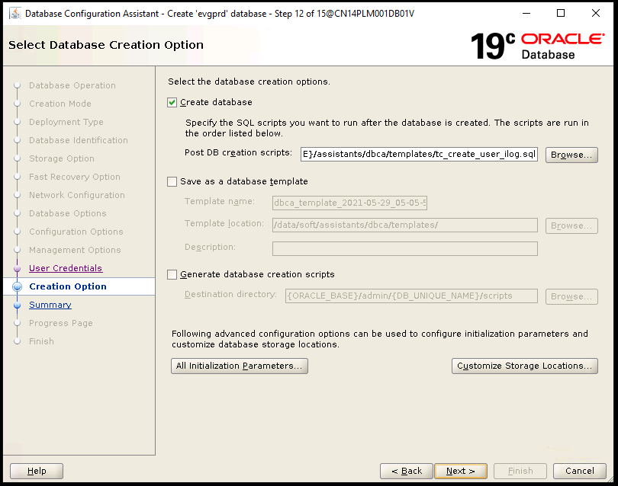
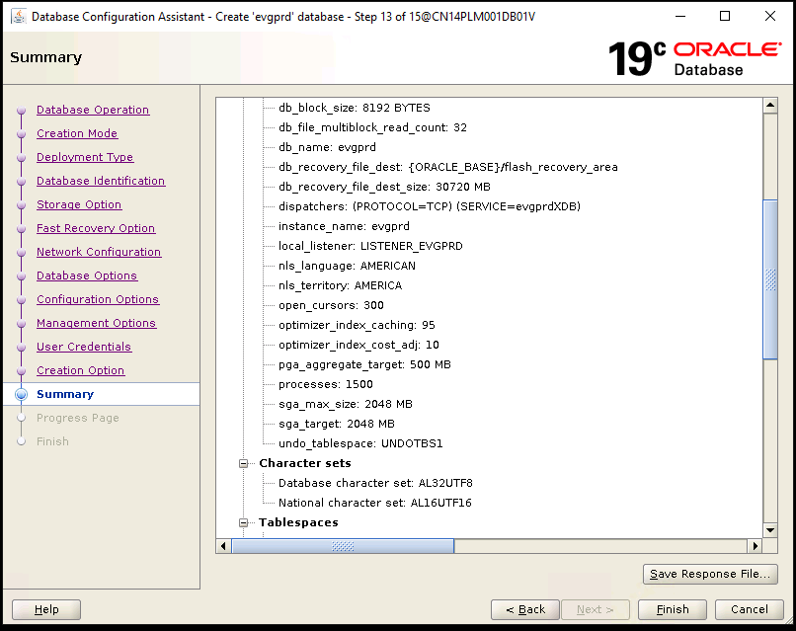
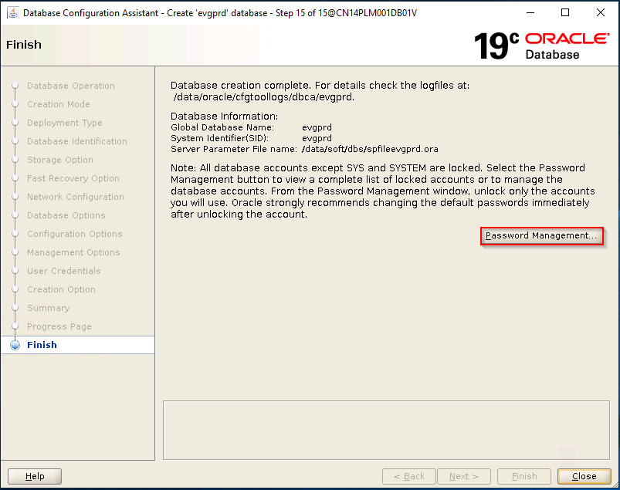
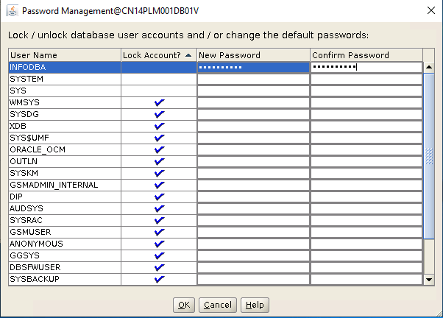
infodba/Infodba123

Install SolidWorks JT Translator on Dispatcher
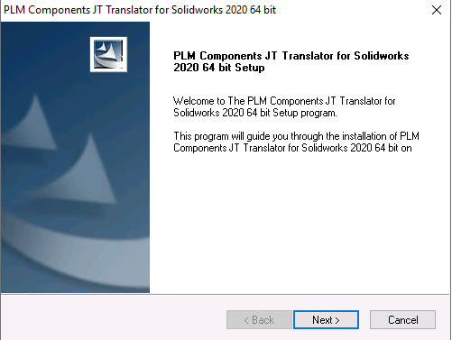
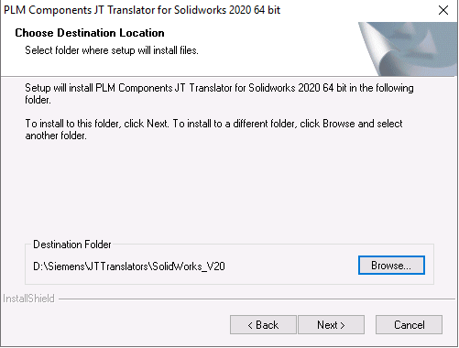
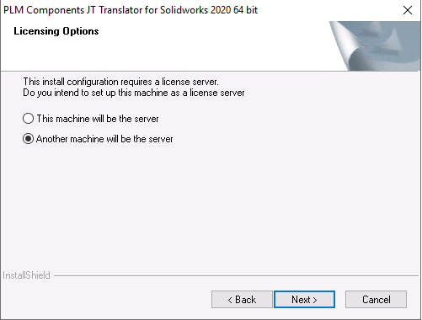
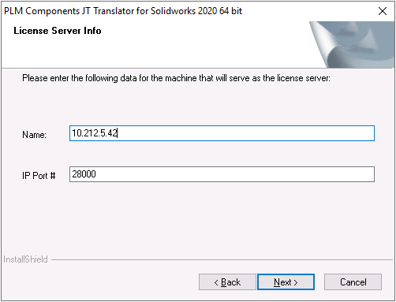
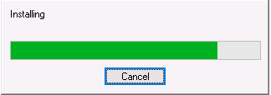
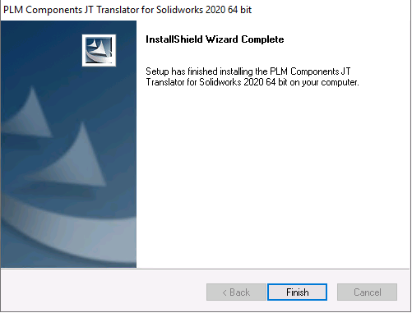

Define PRD ENV in DC

Check Software Repo
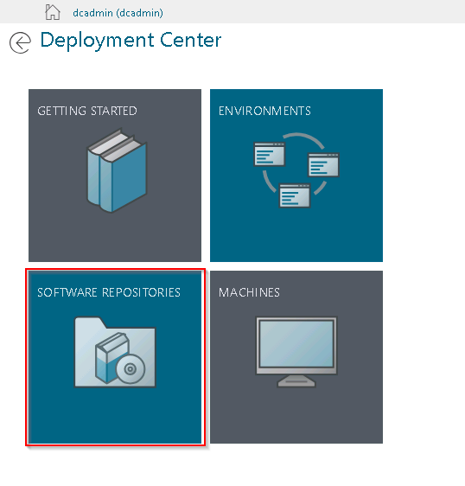
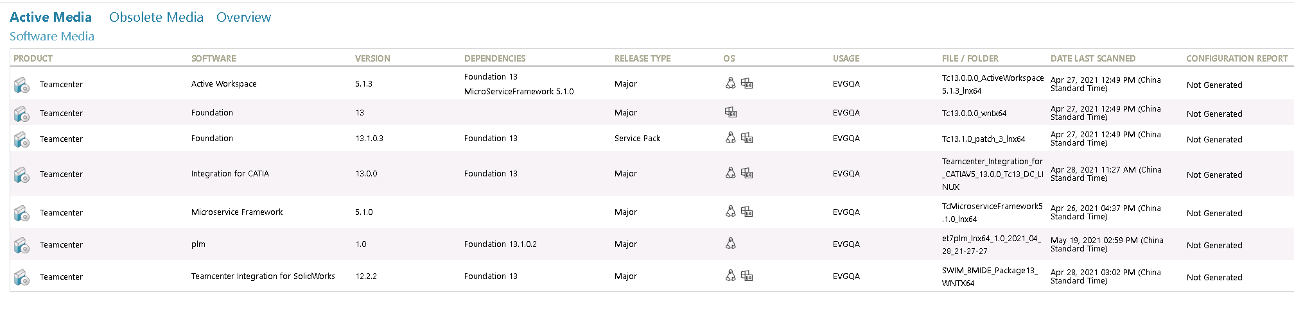

Define PRD Env
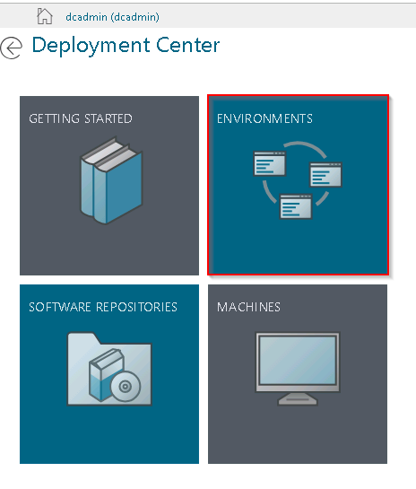
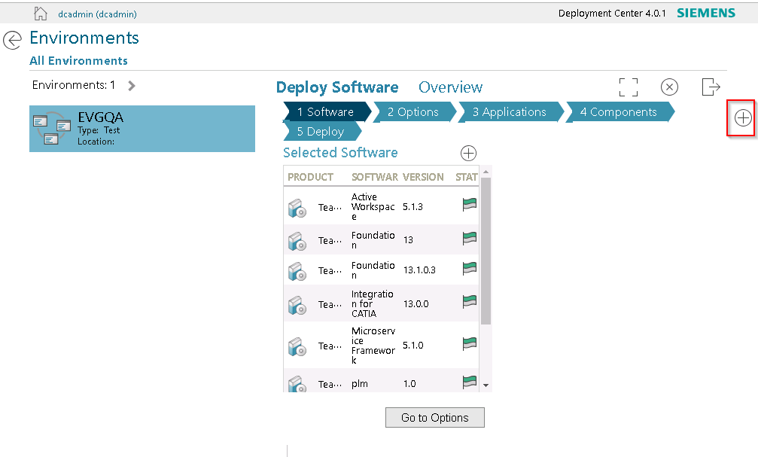
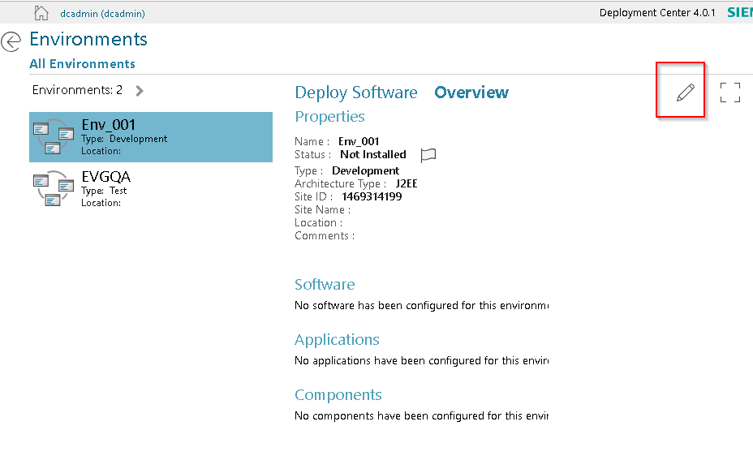
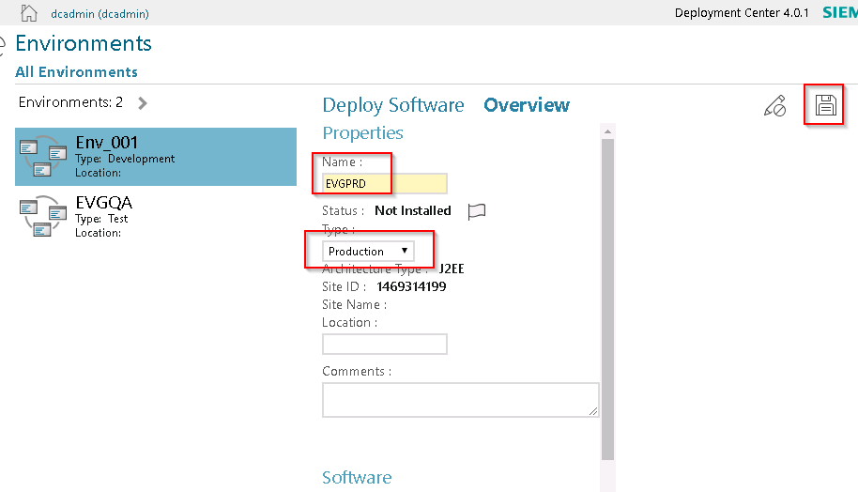

Define Software to Install
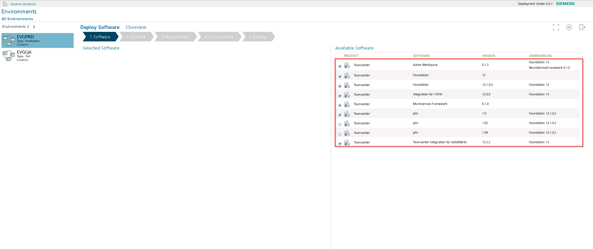
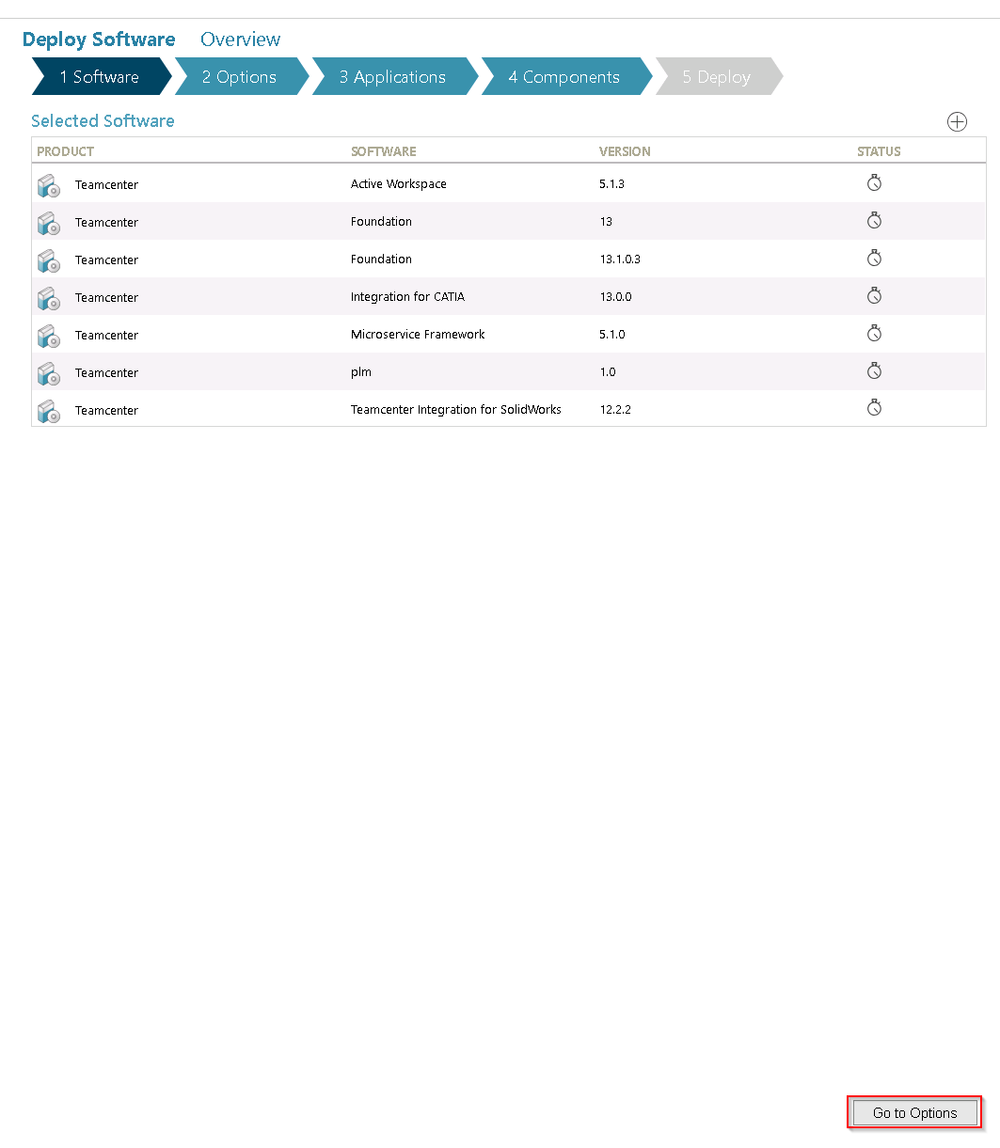

Define Env Options
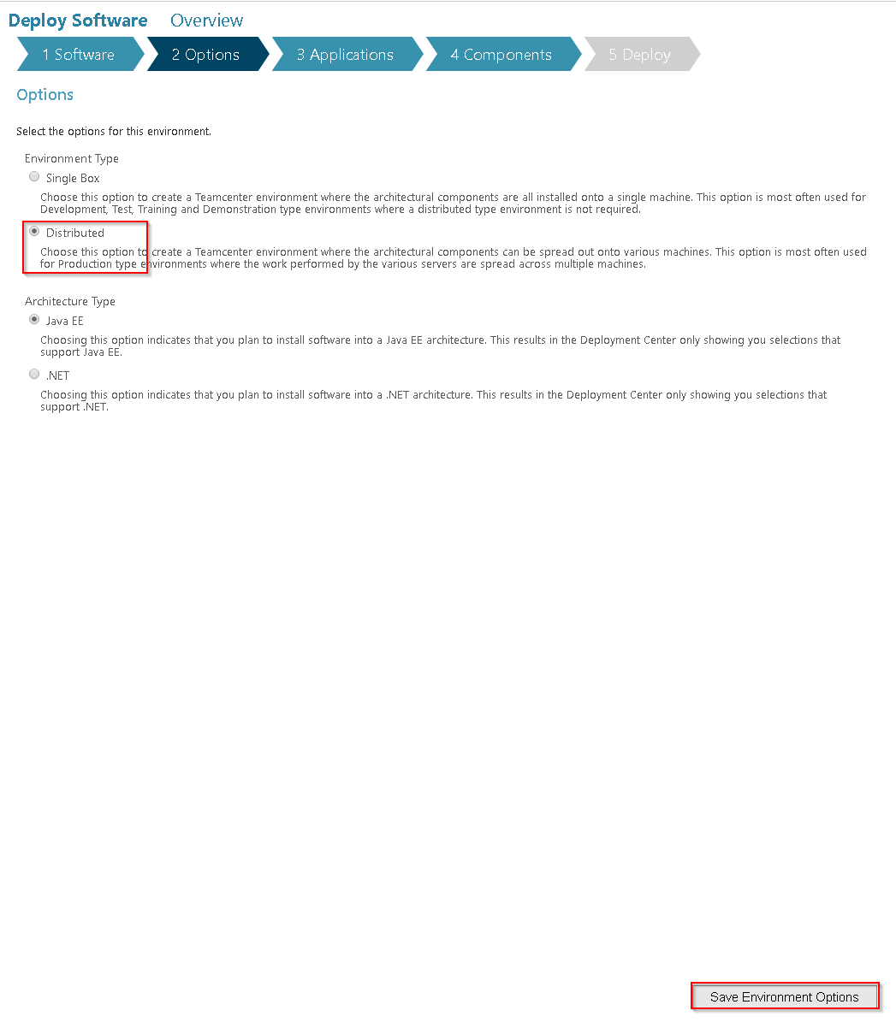Define Applications to Install
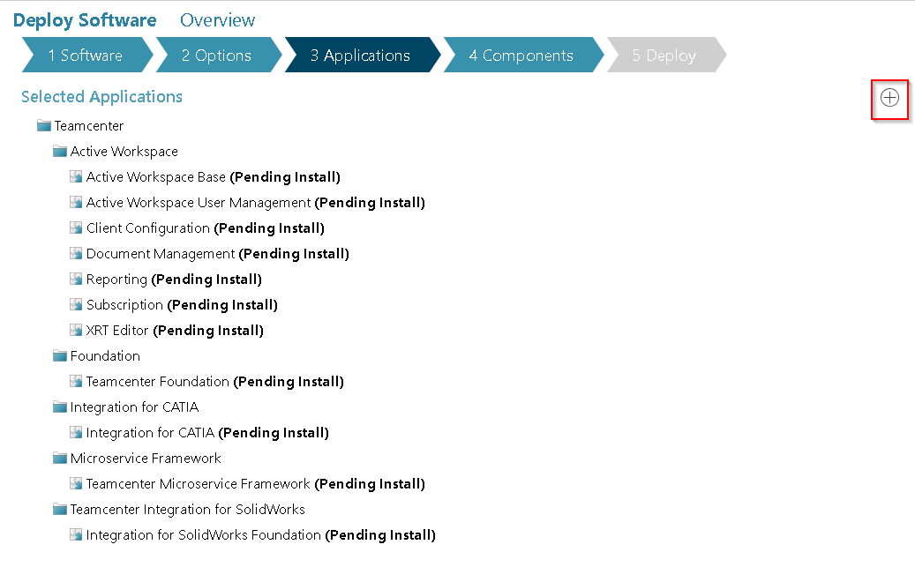
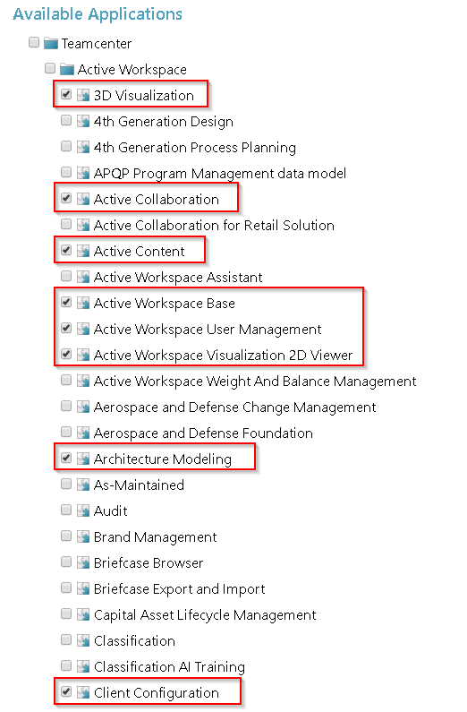
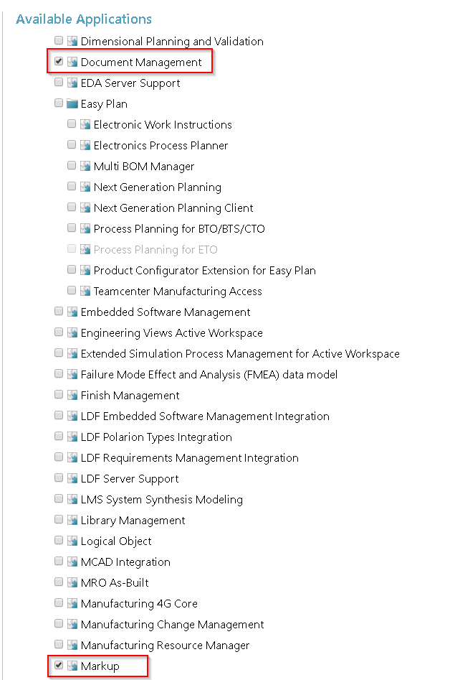
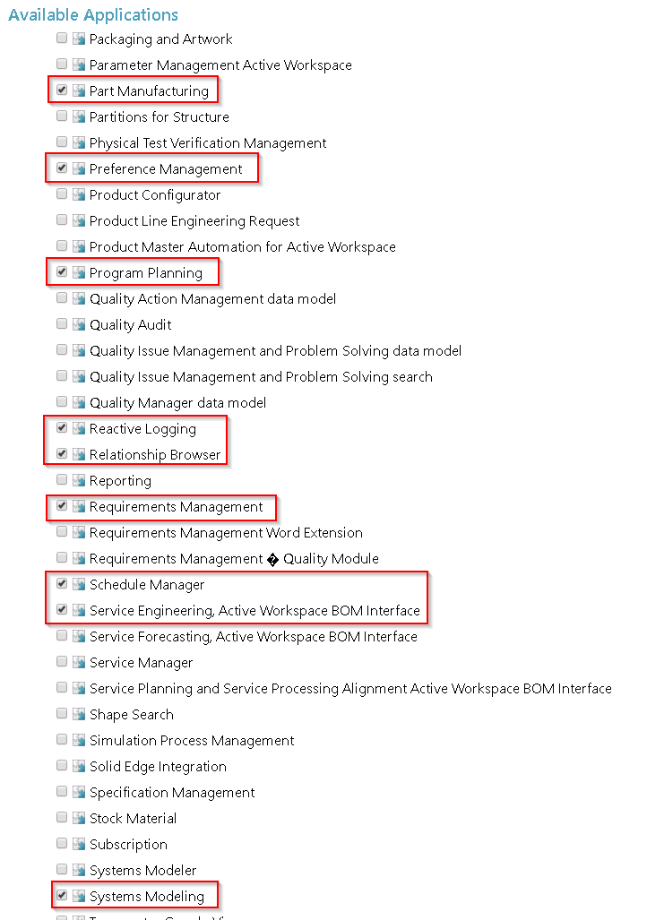
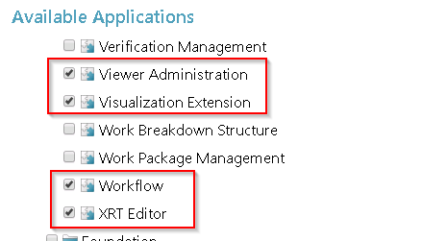
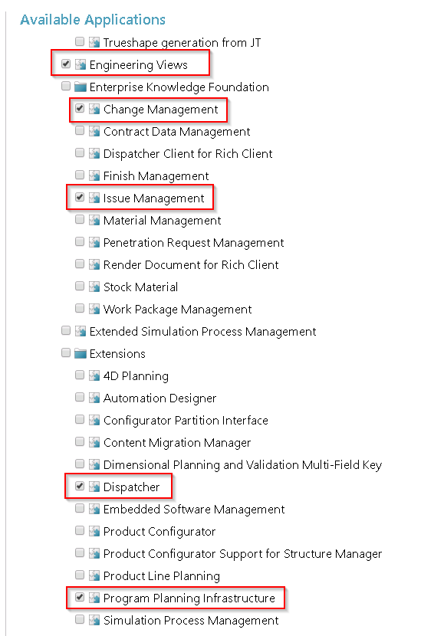
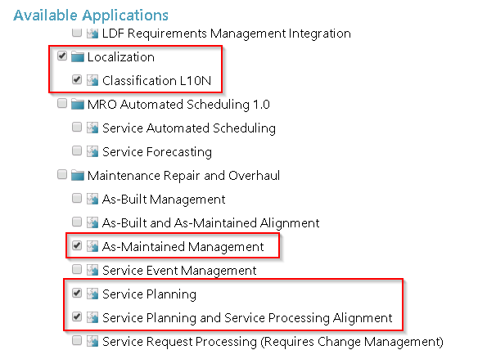
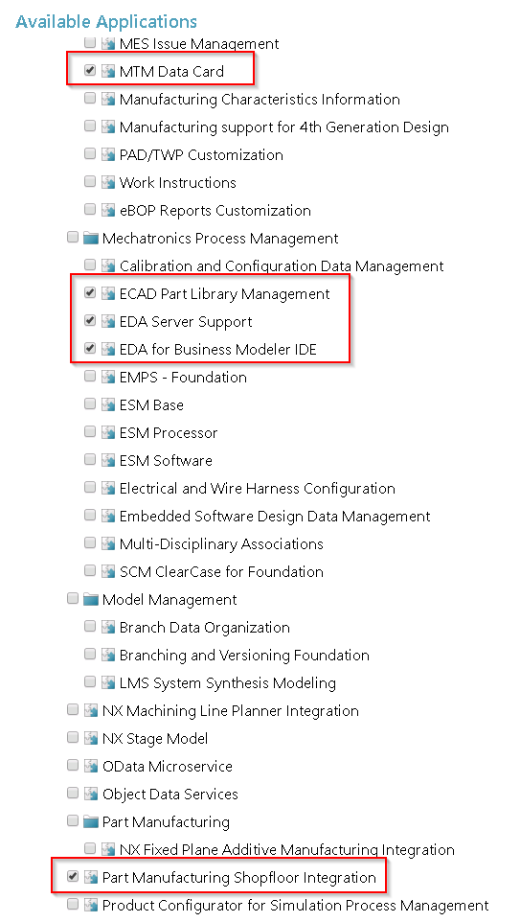
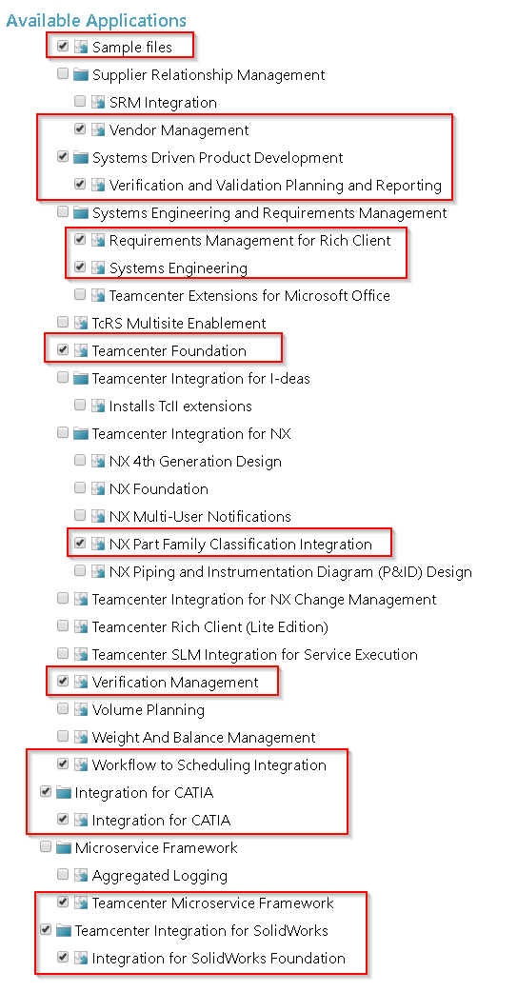
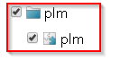
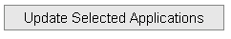
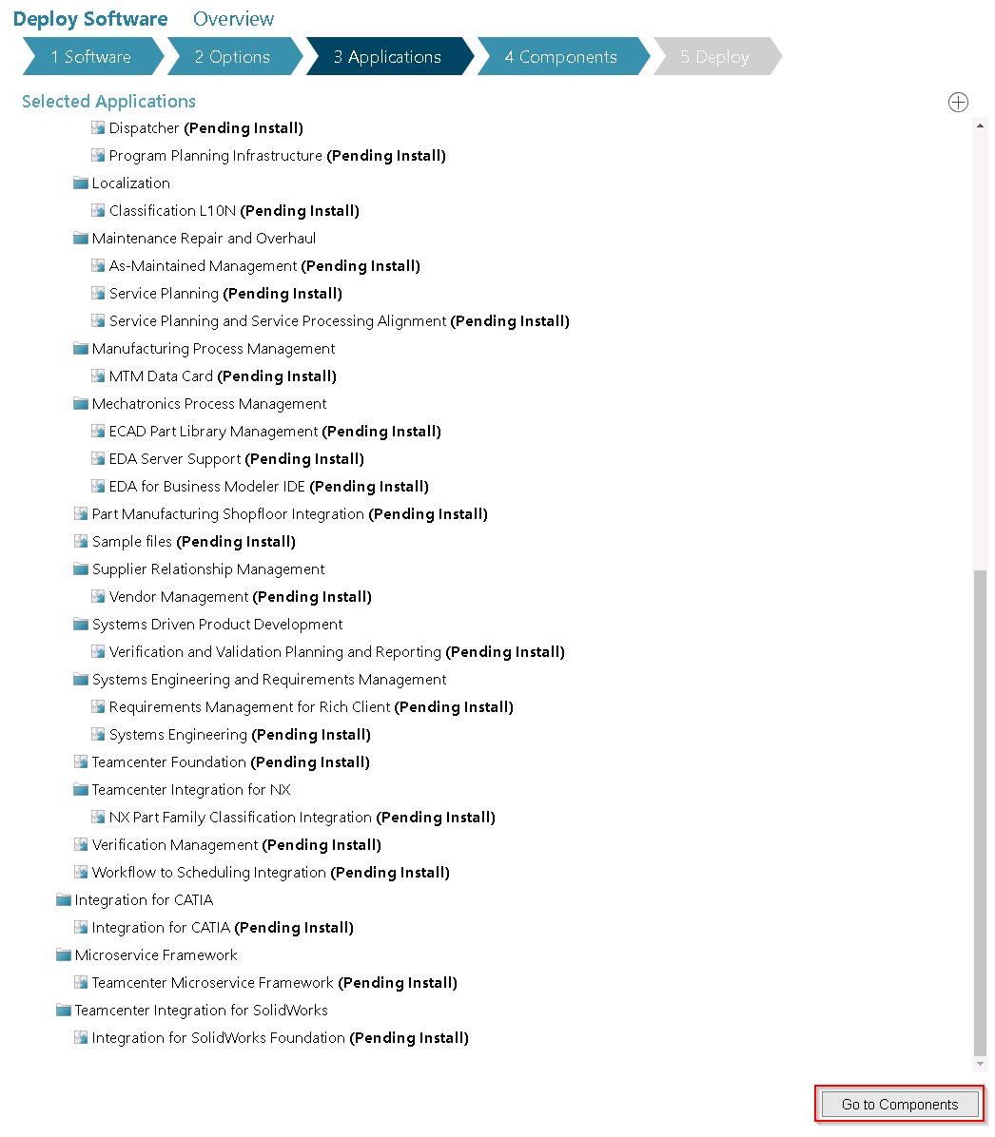

Define Components

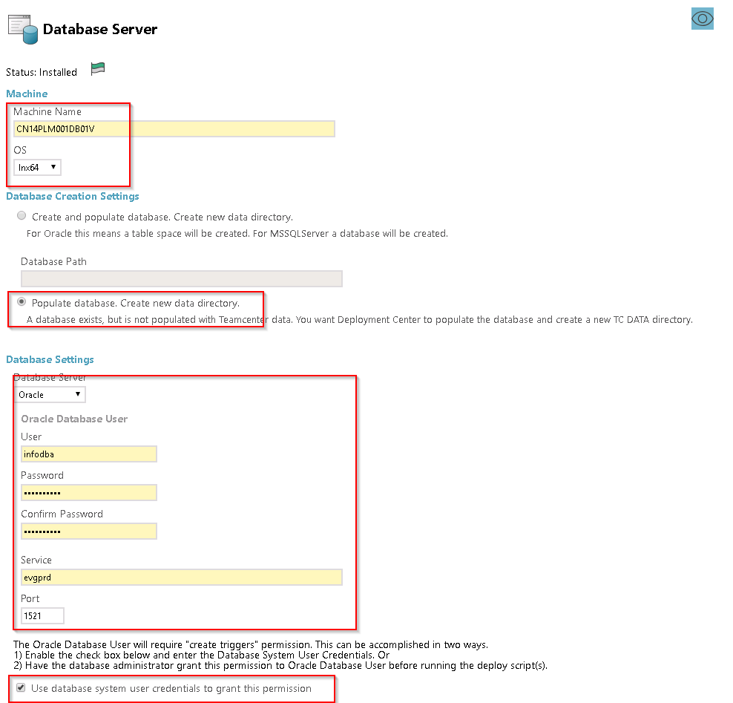
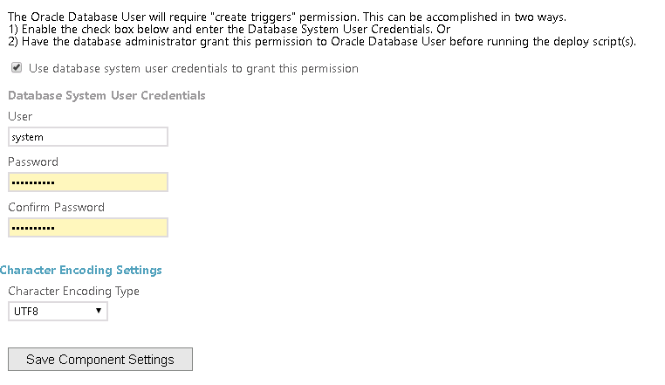
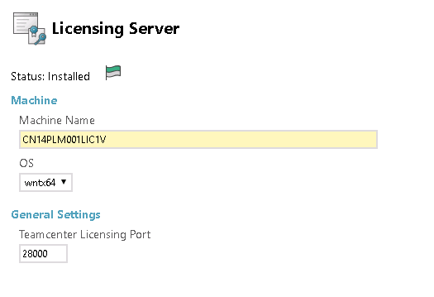
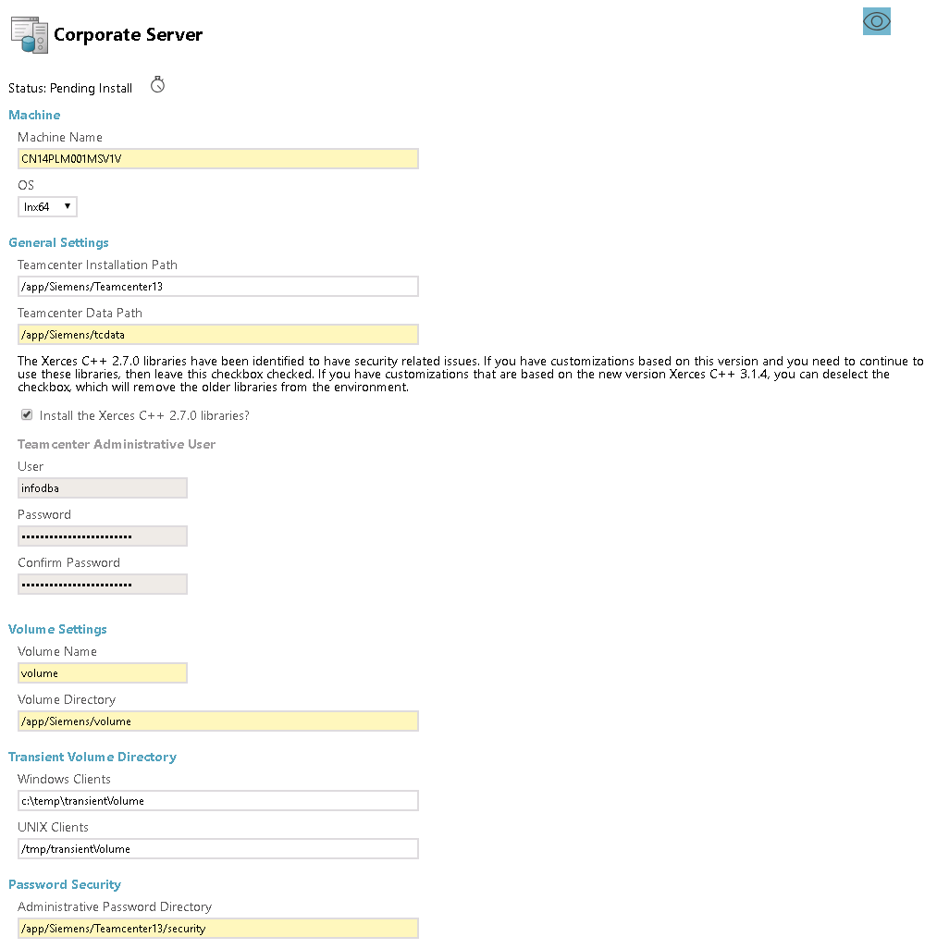
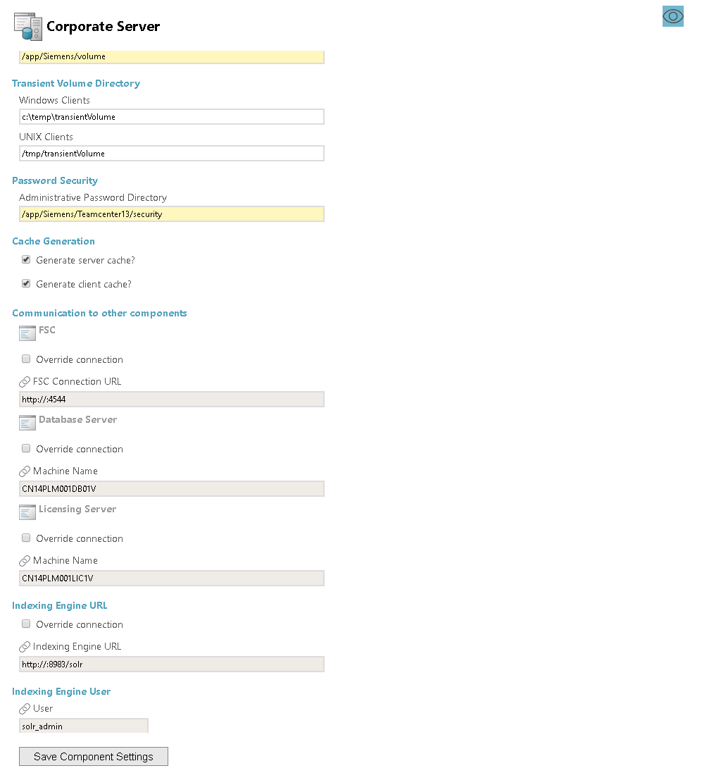

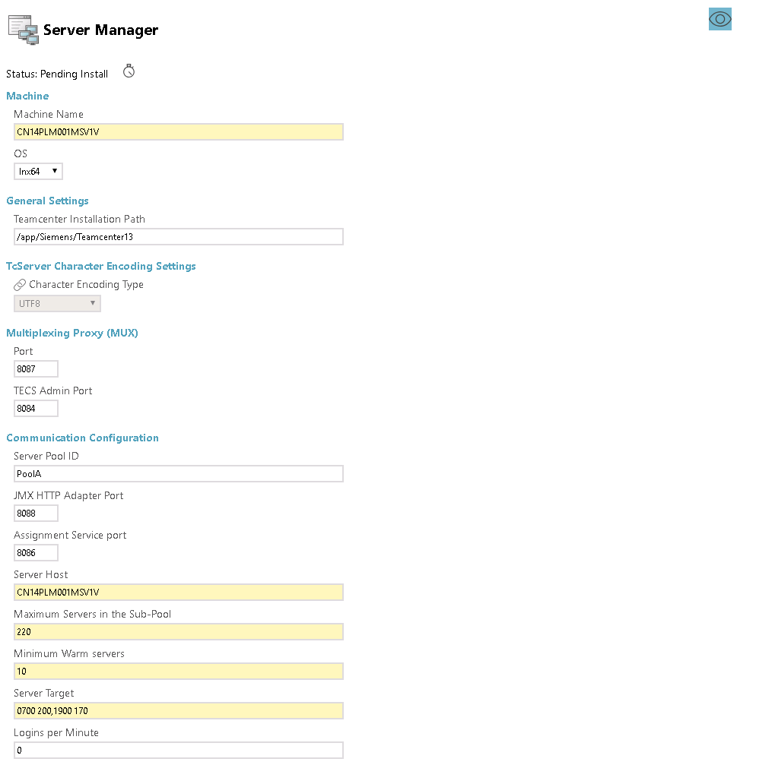

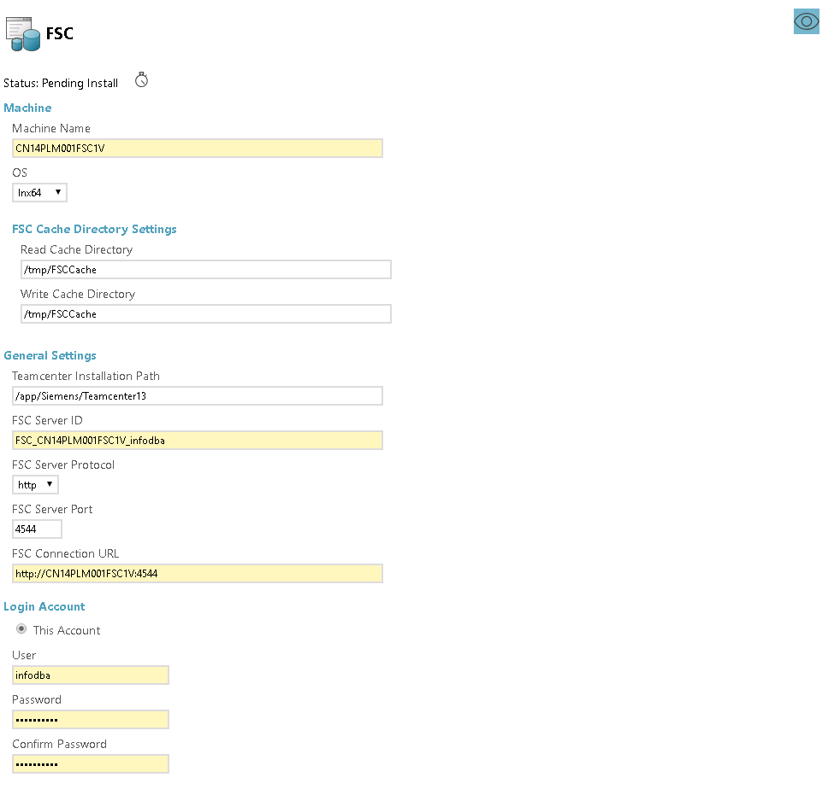
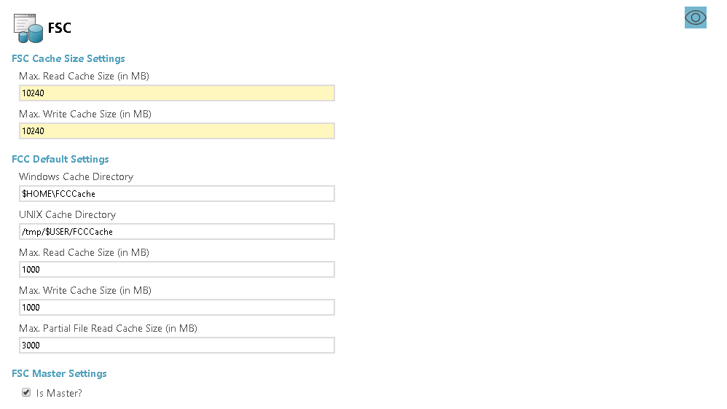
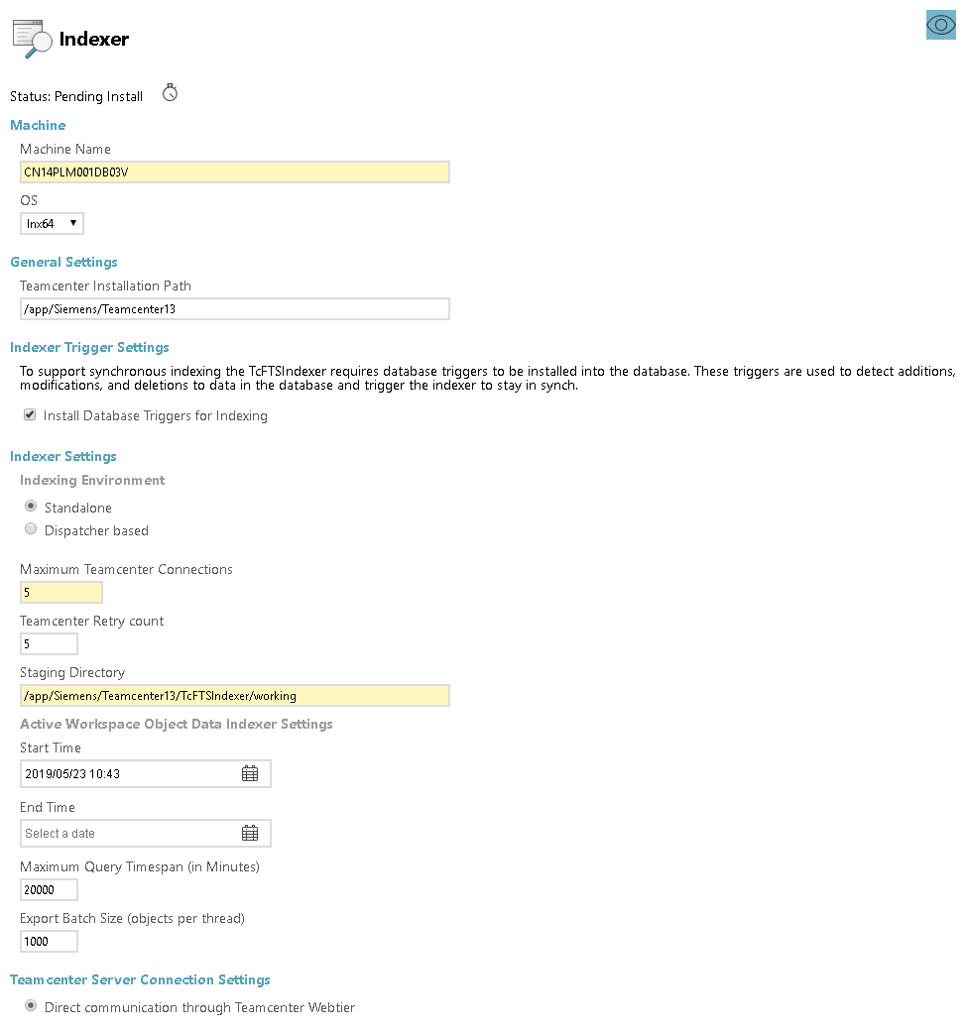
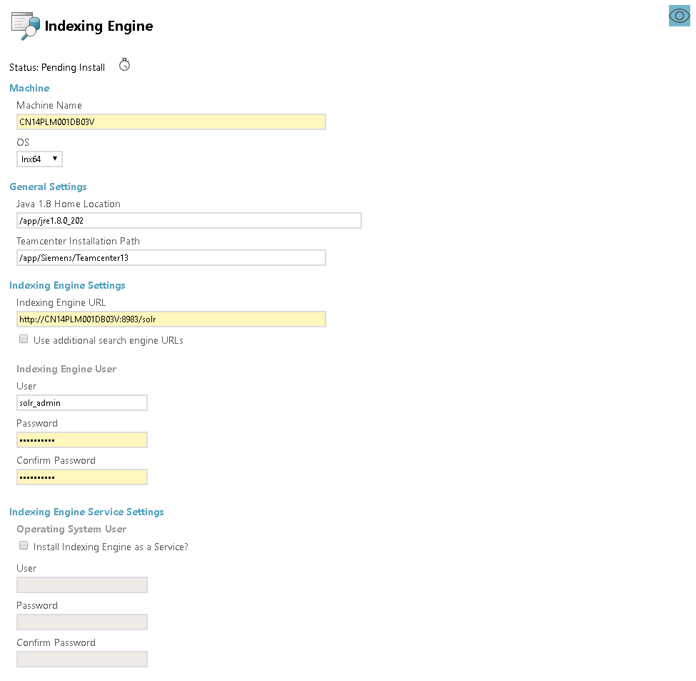
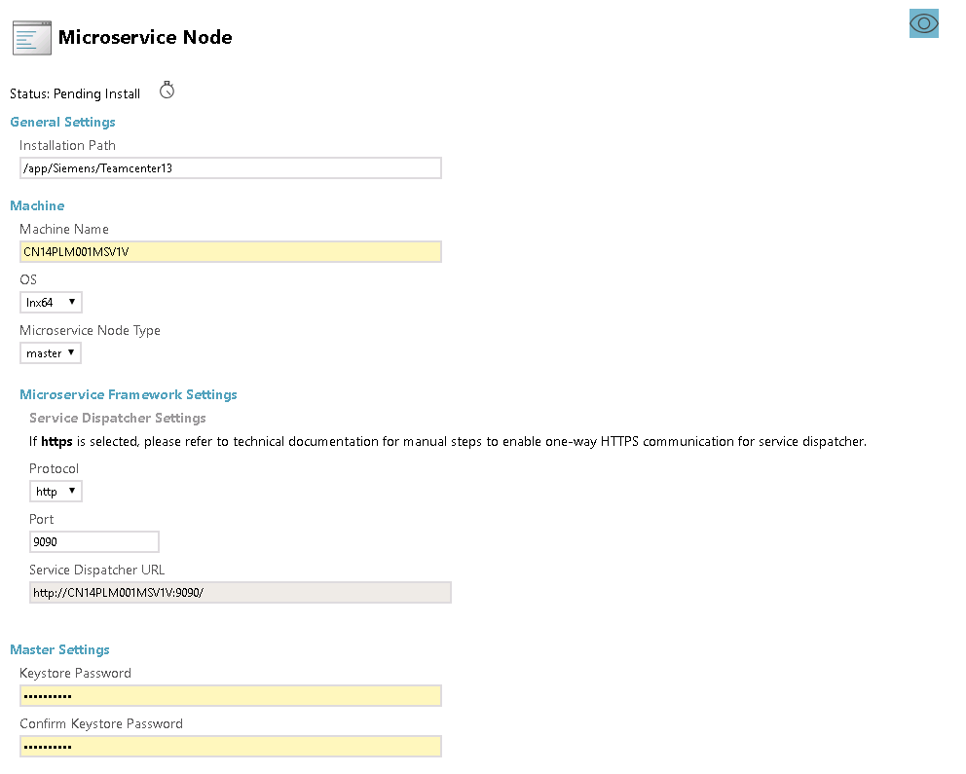
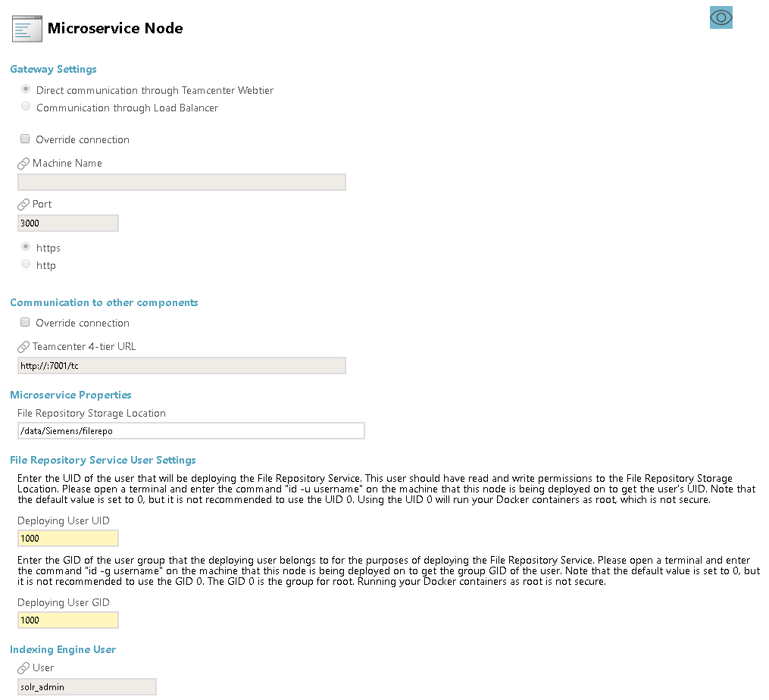
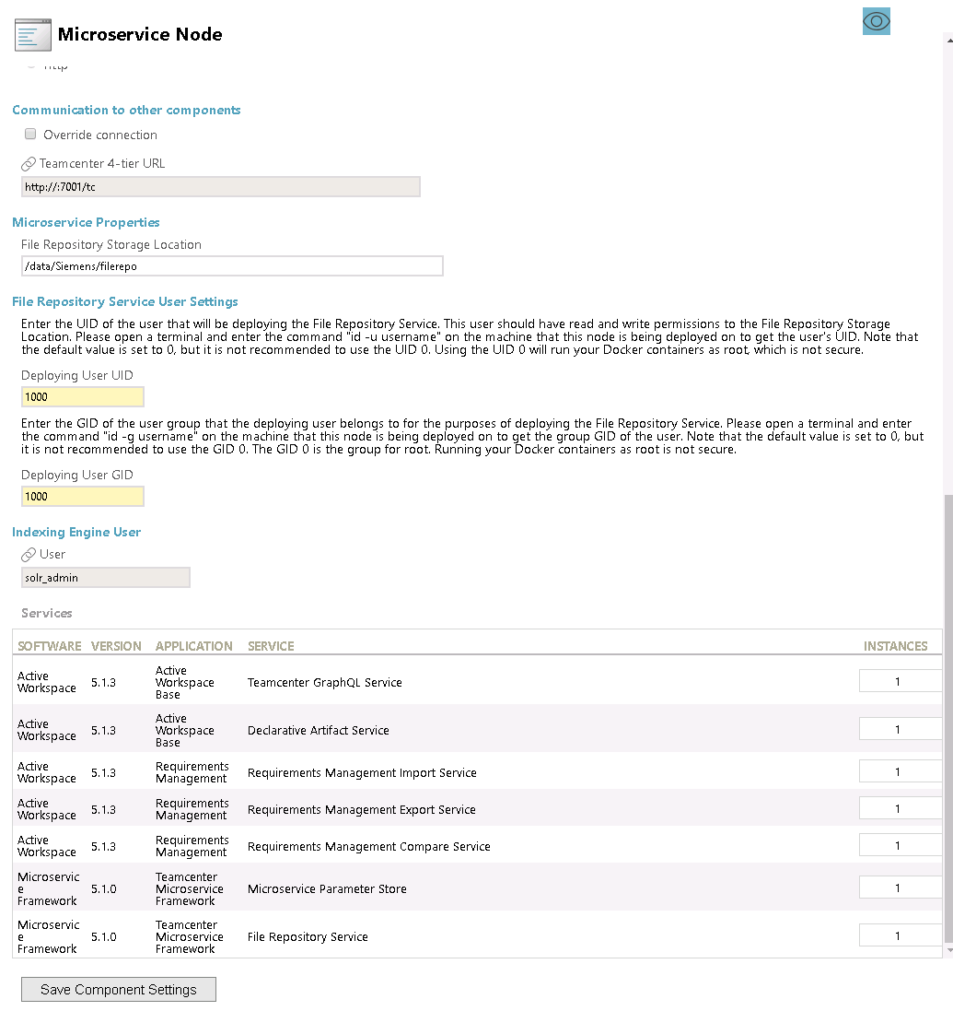
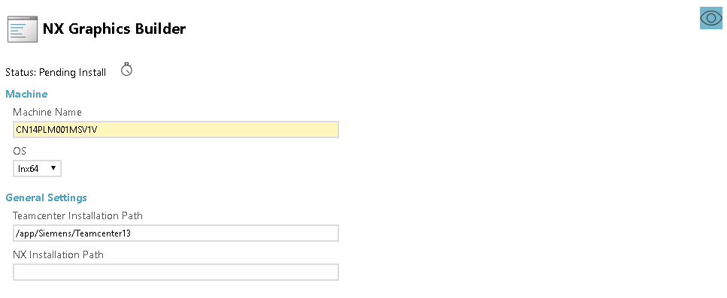
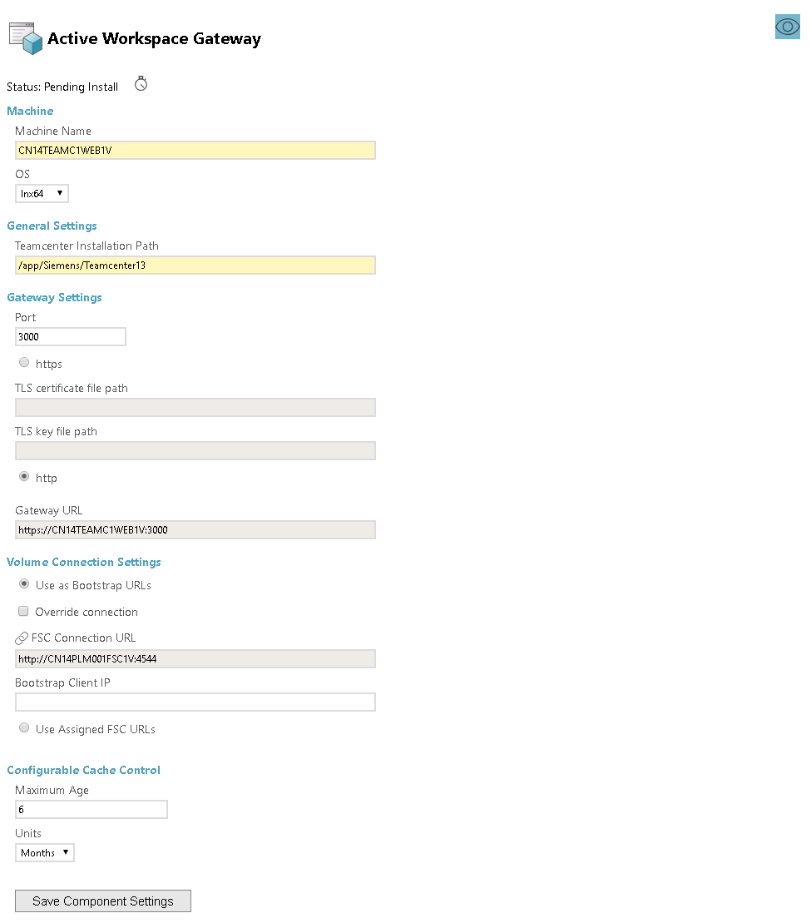
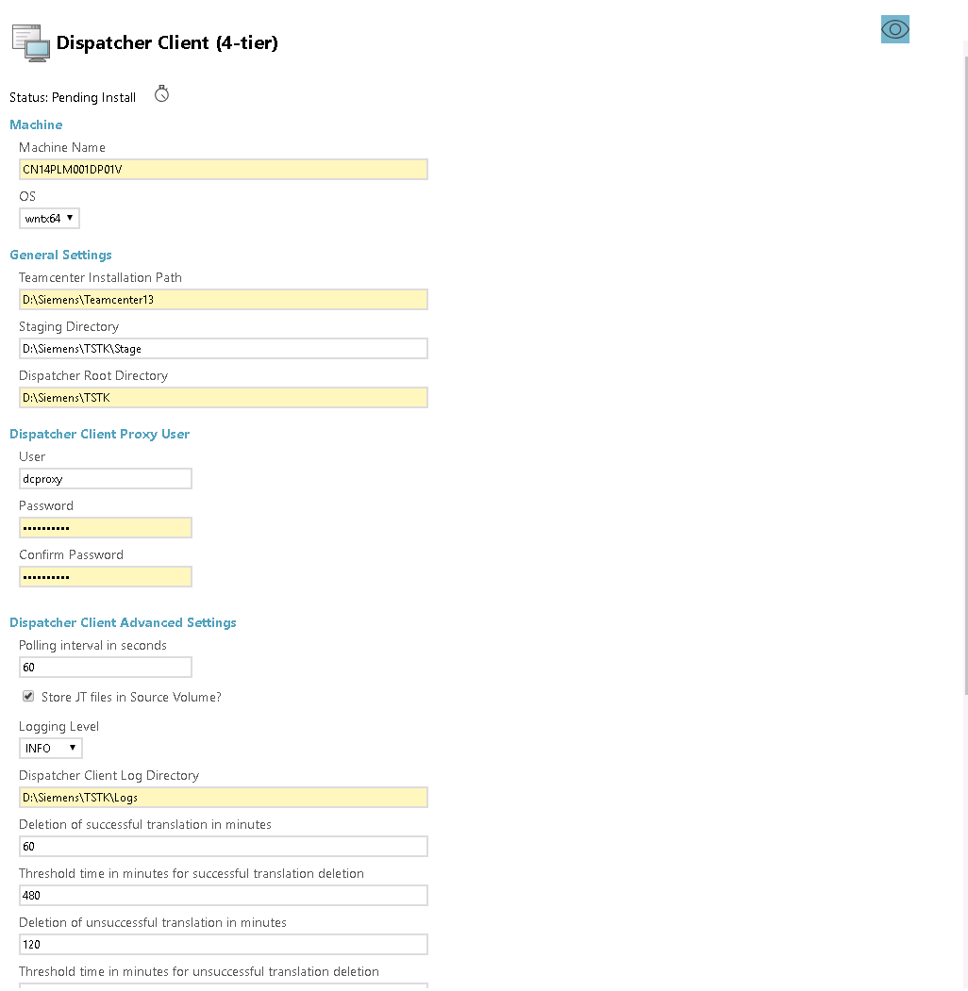
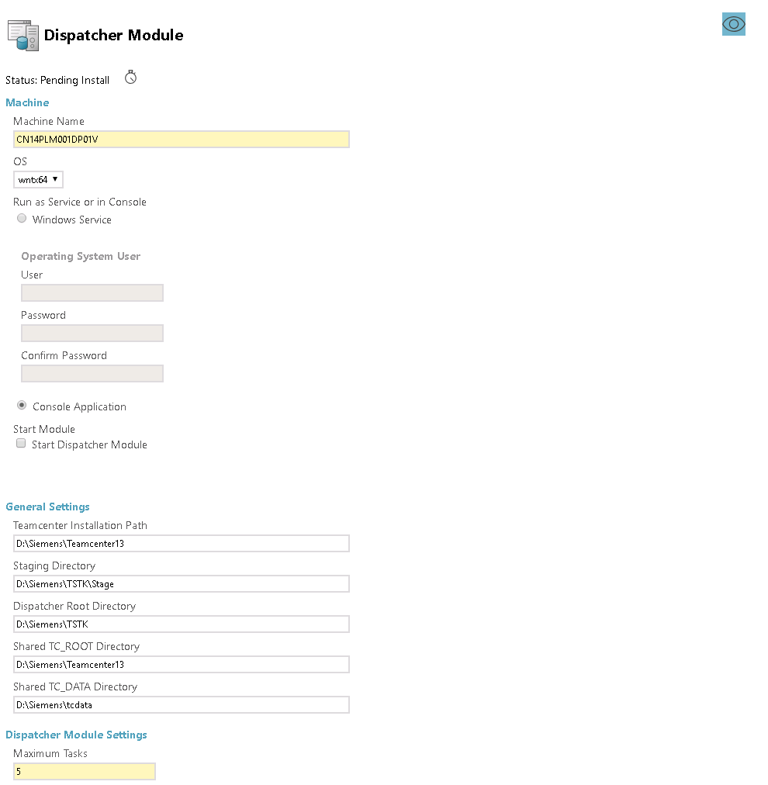
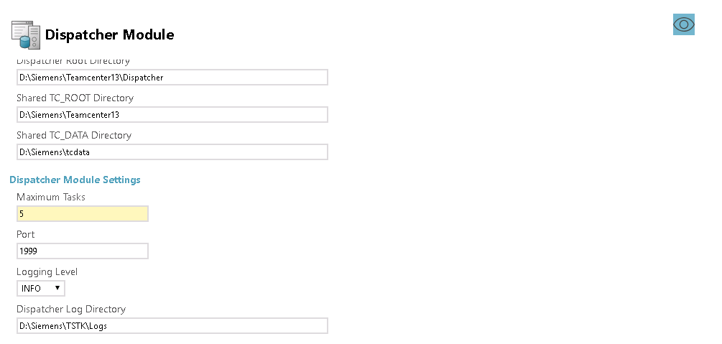
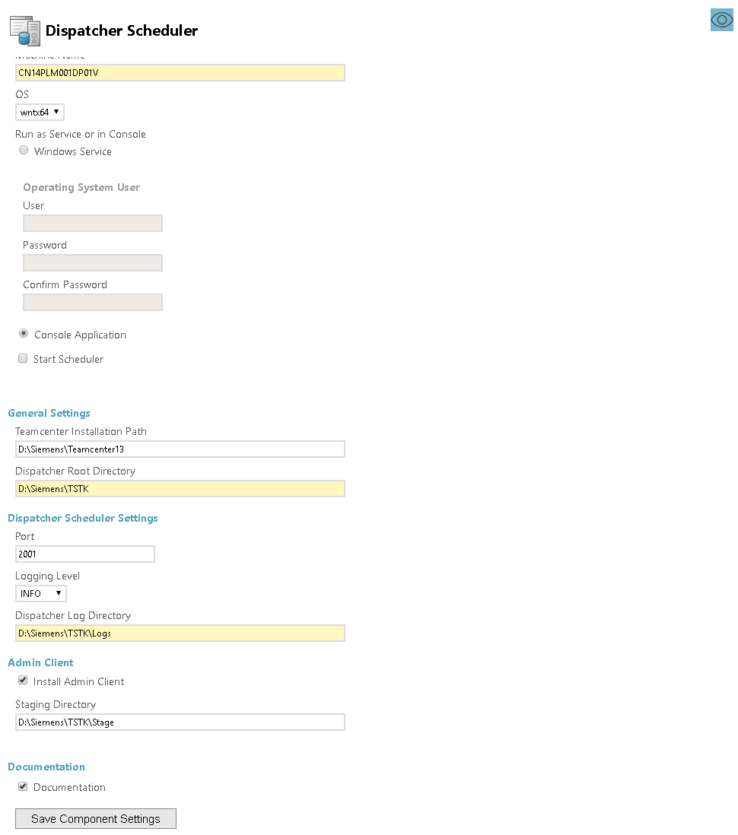
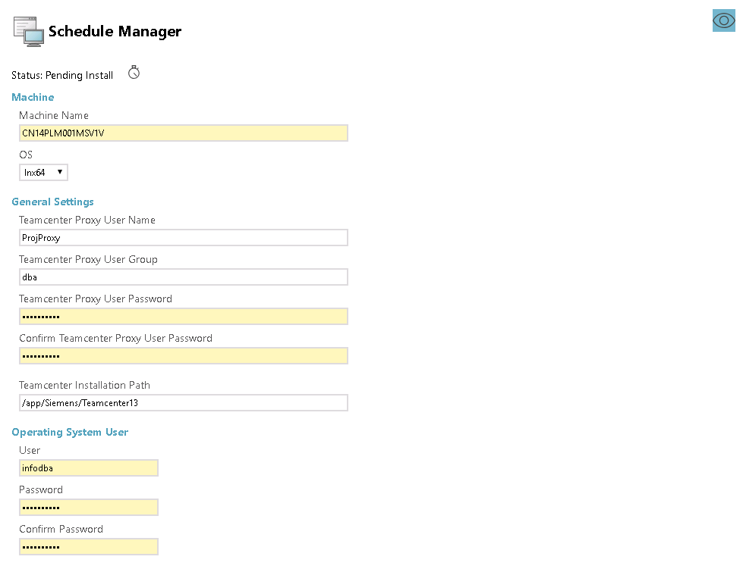
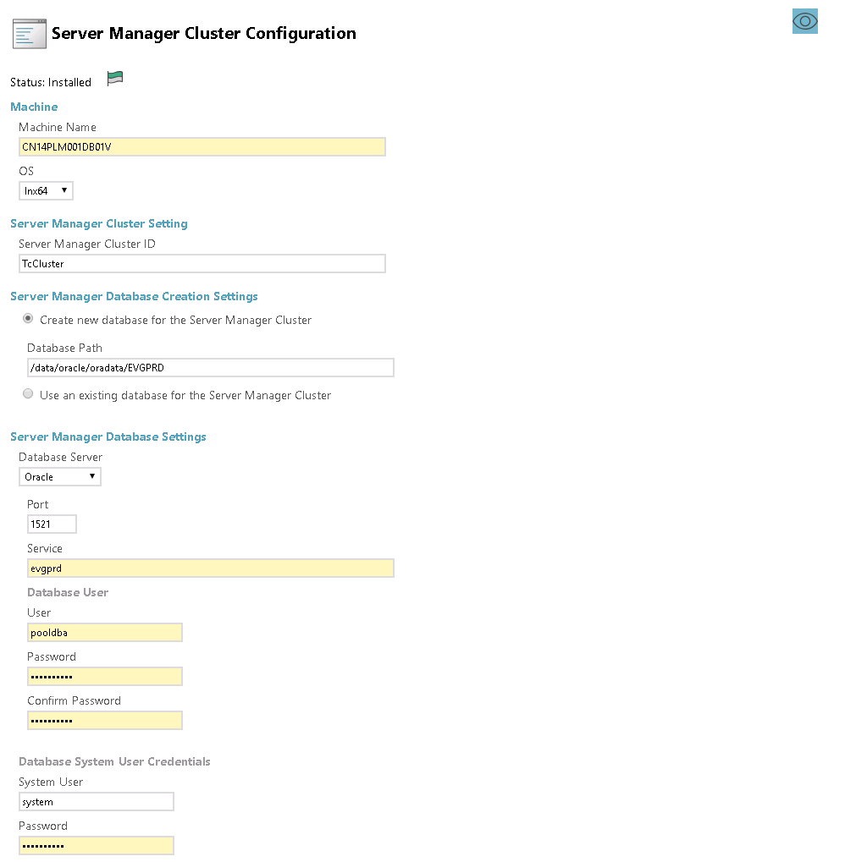
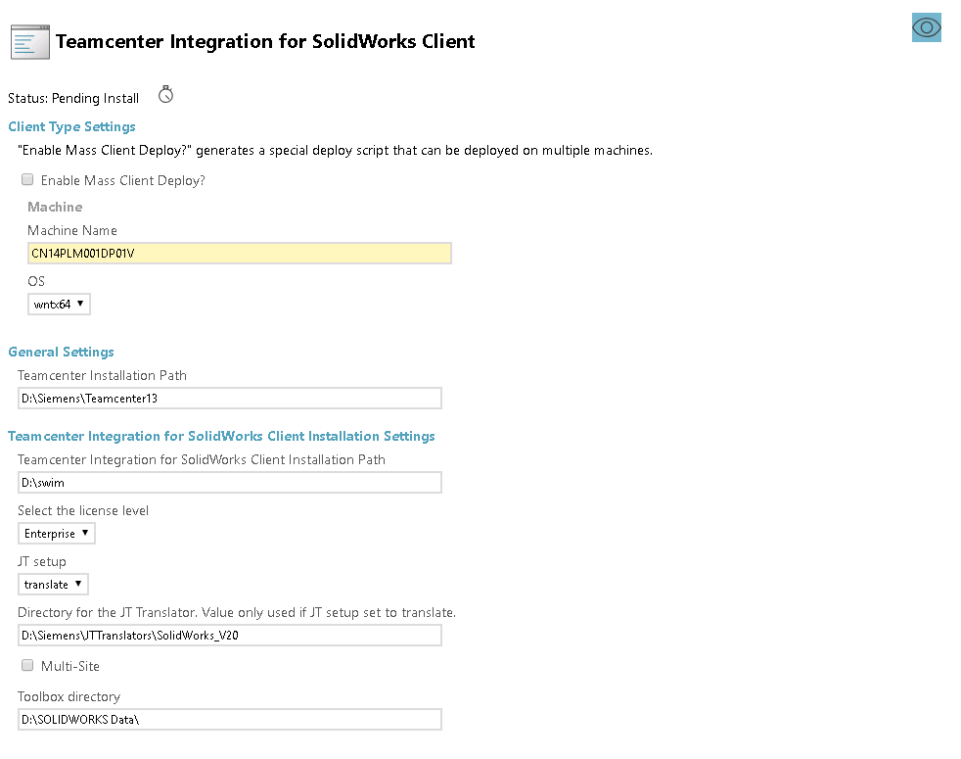
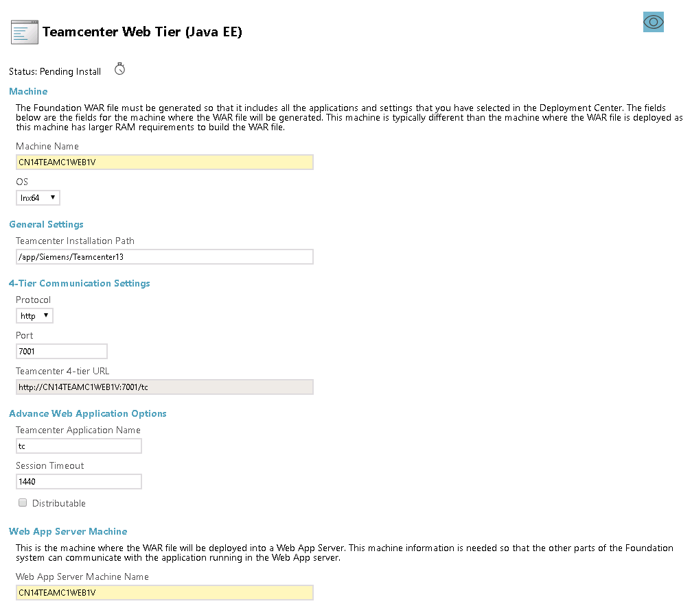
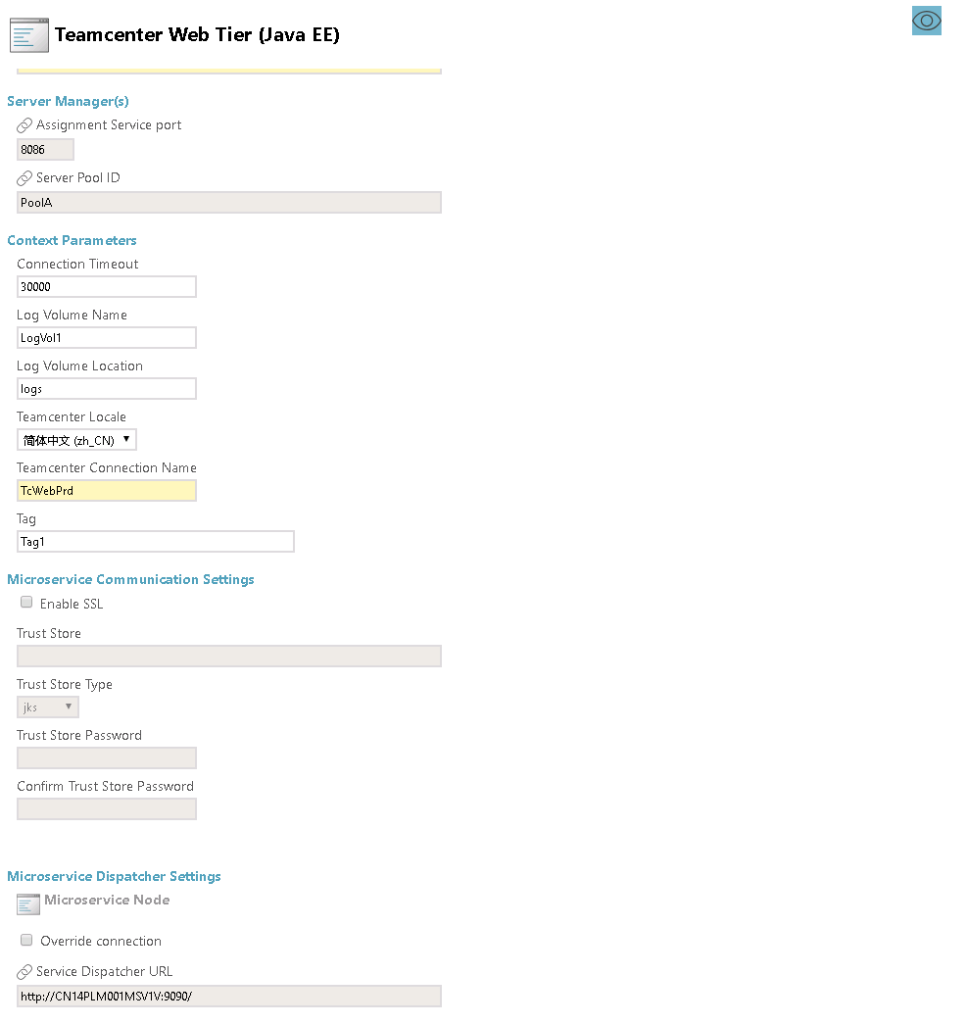
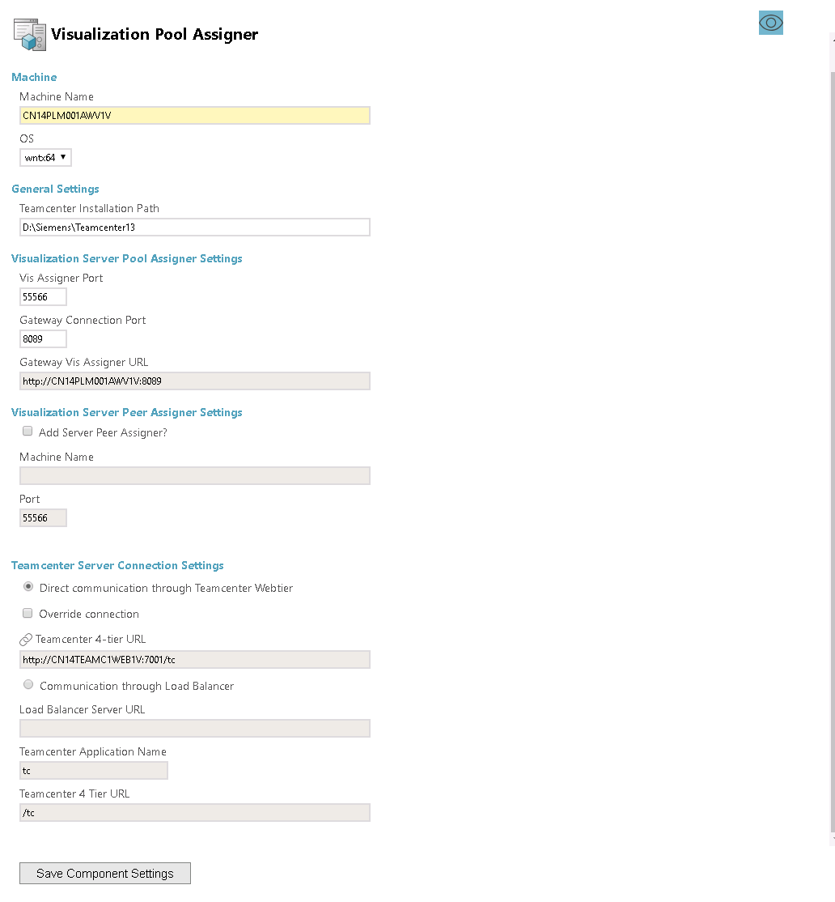
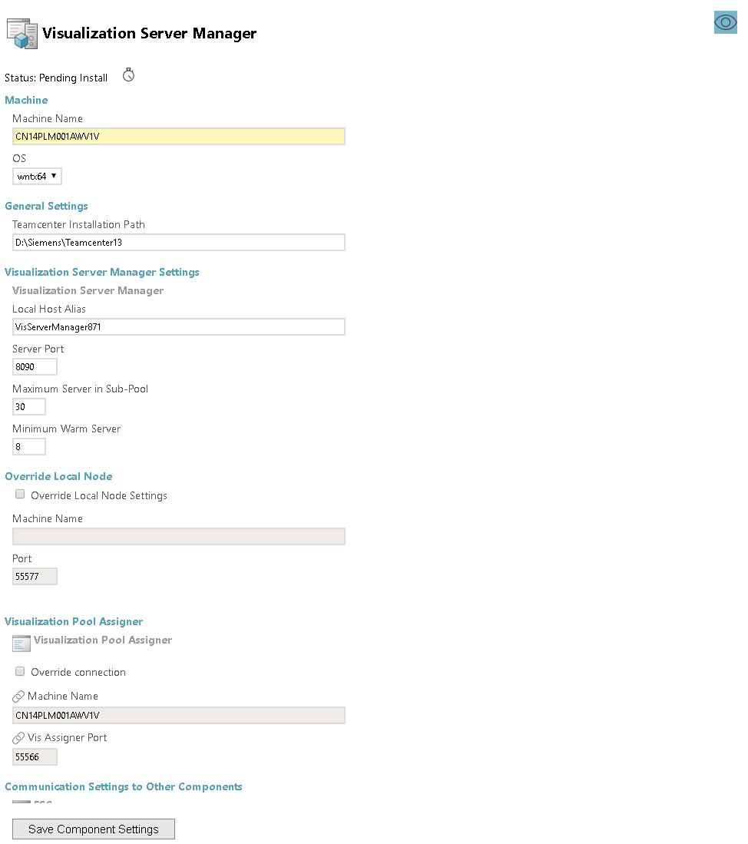
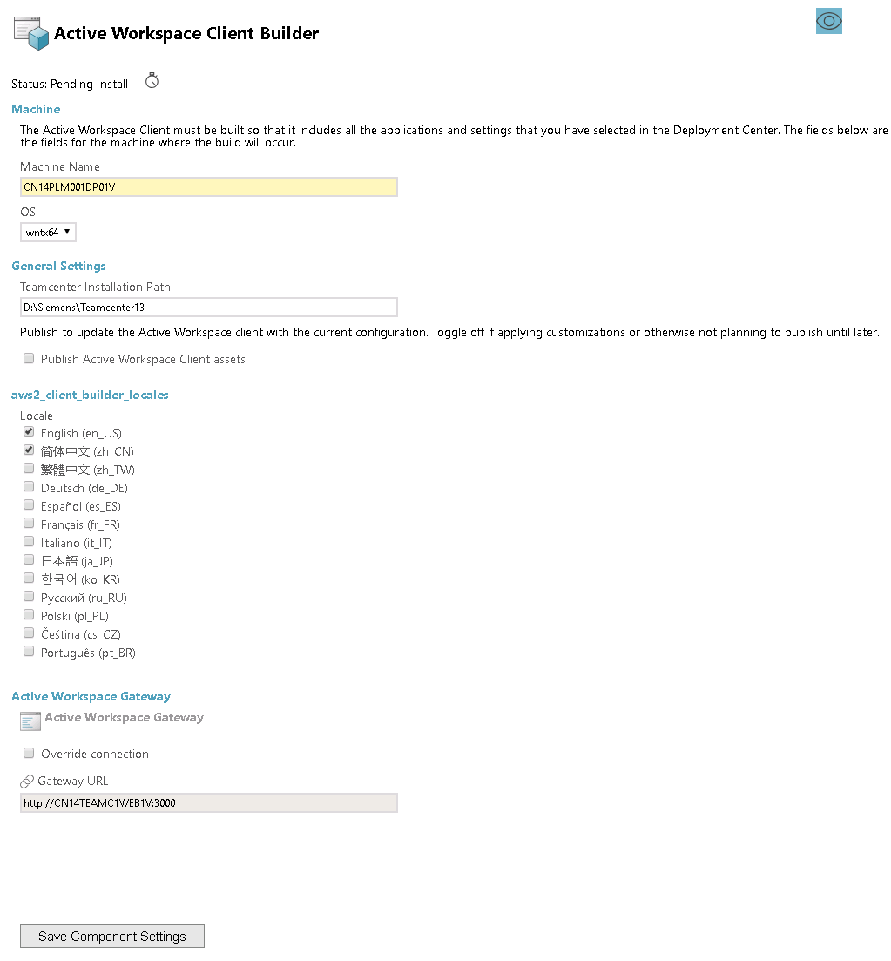
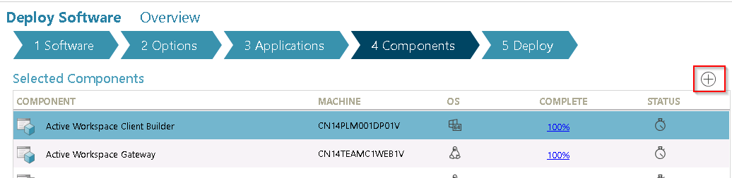
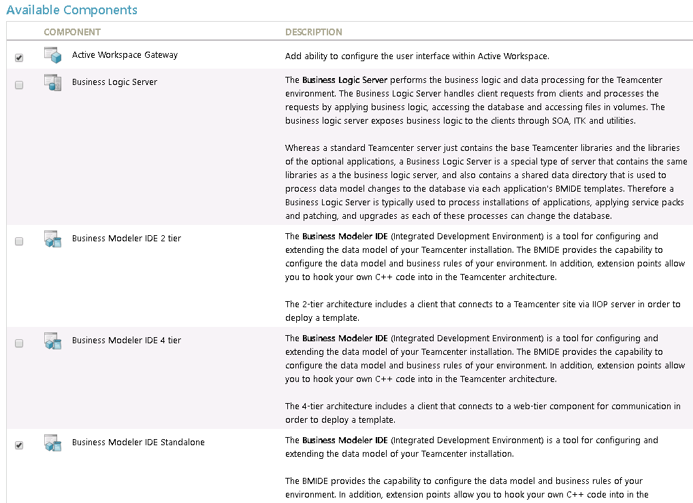
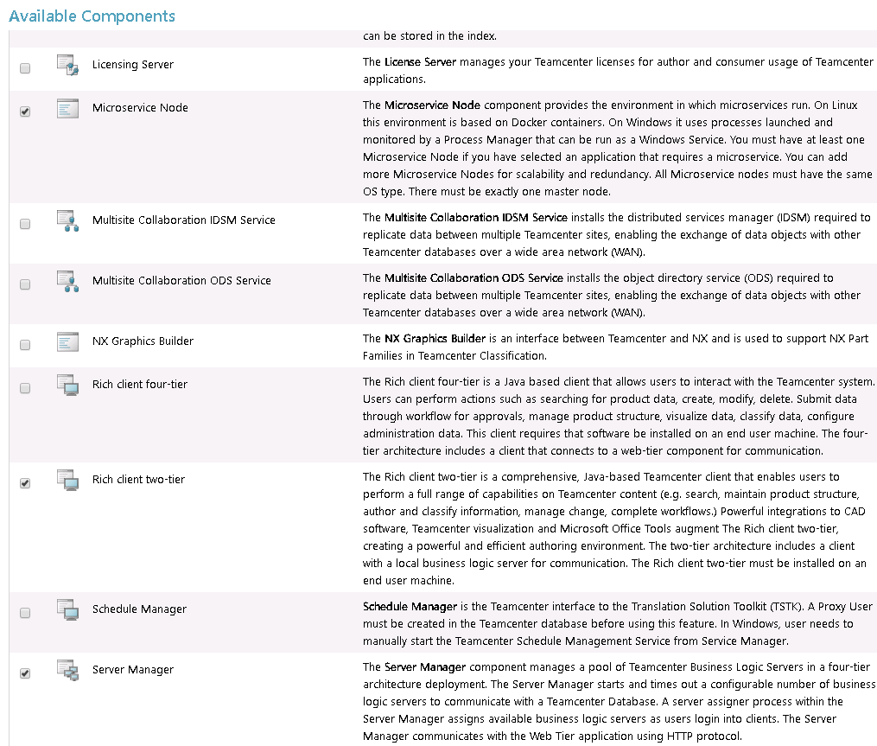
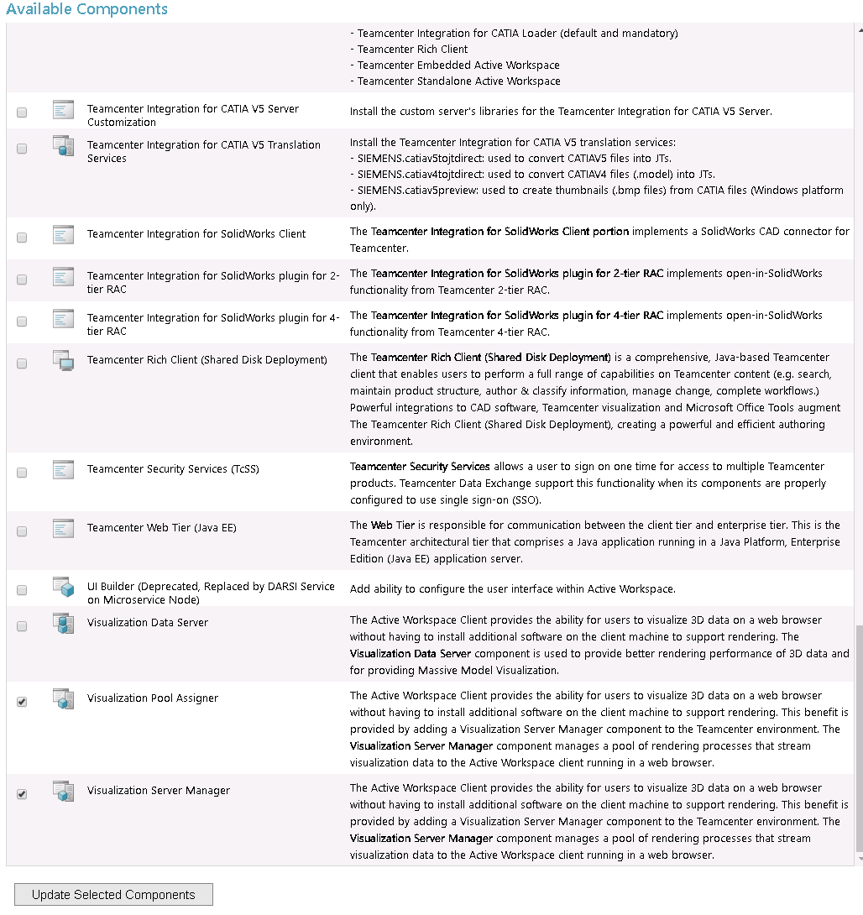
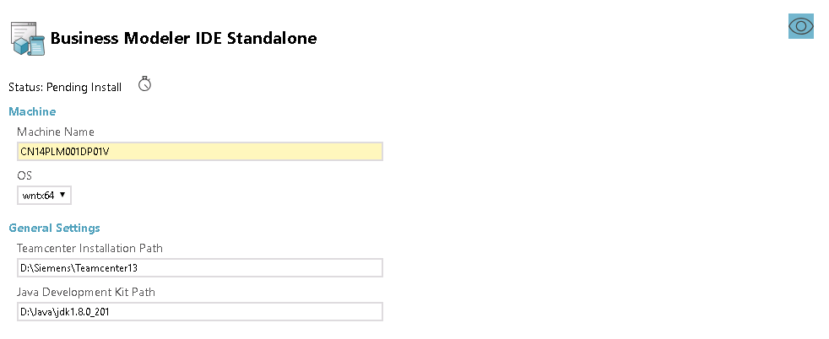
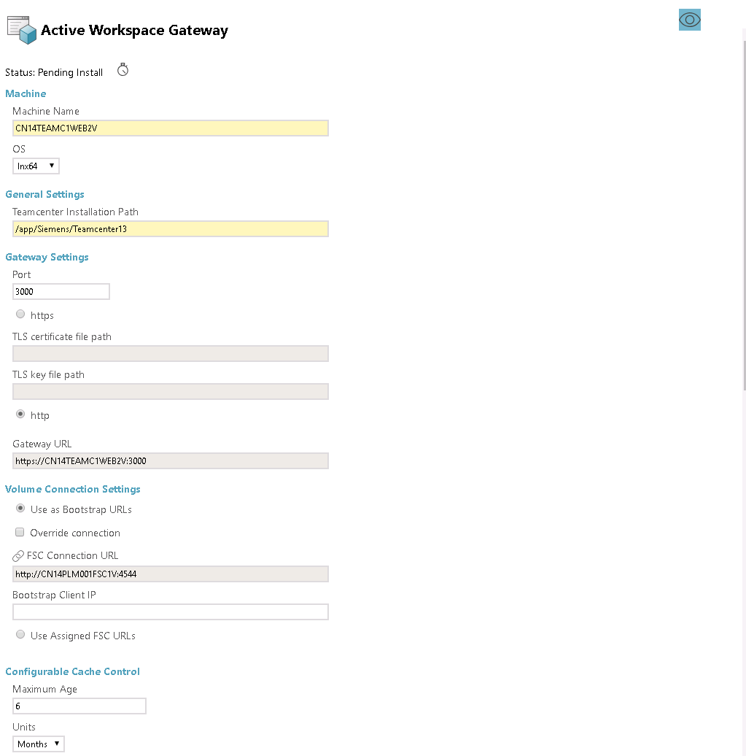
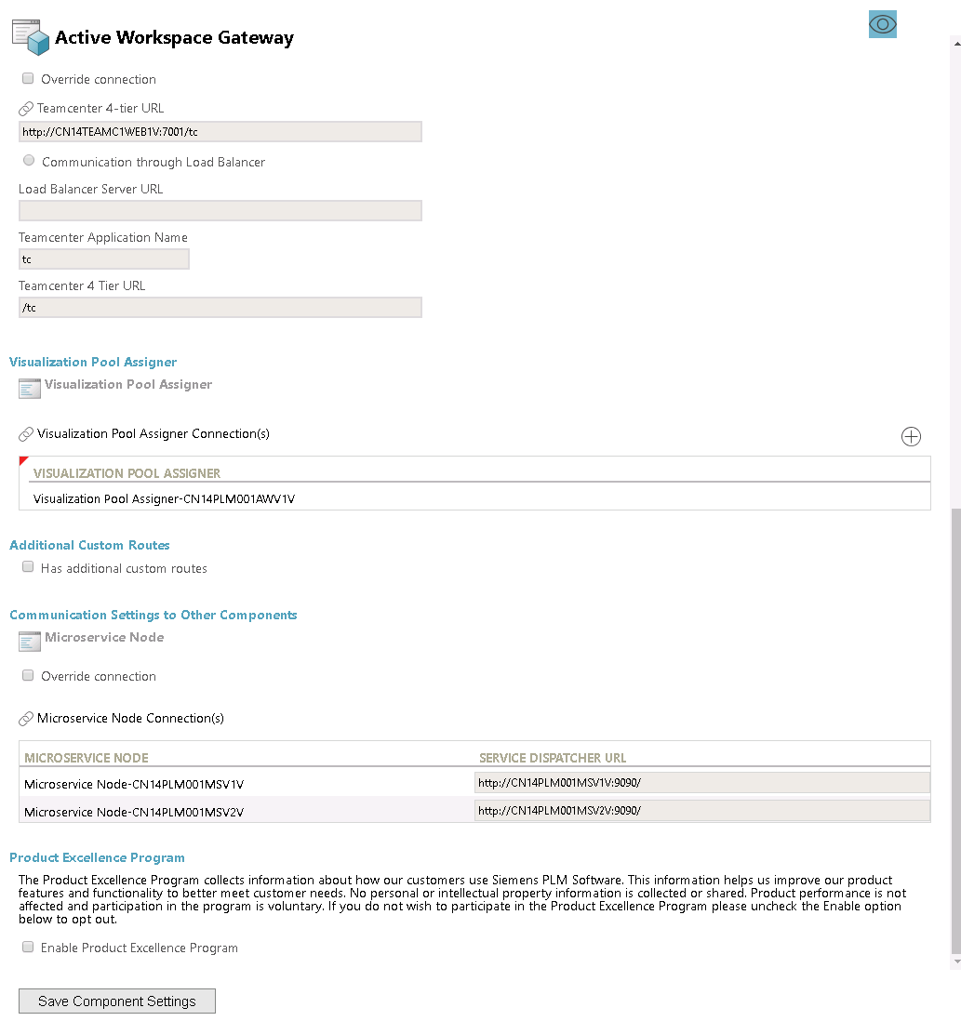
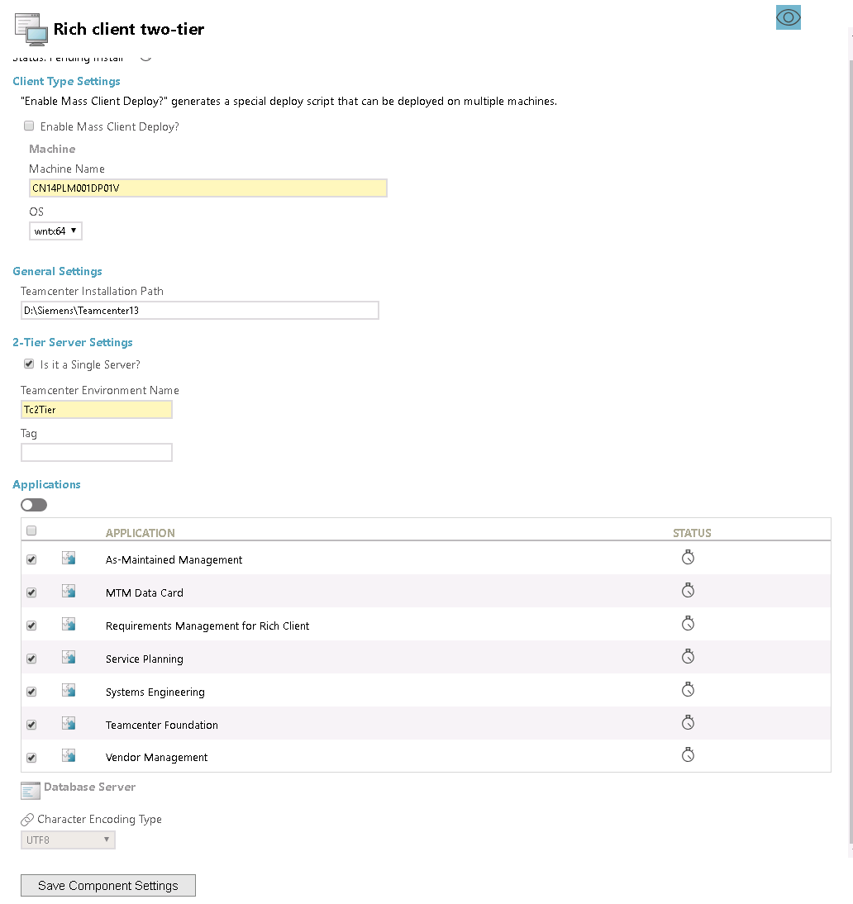
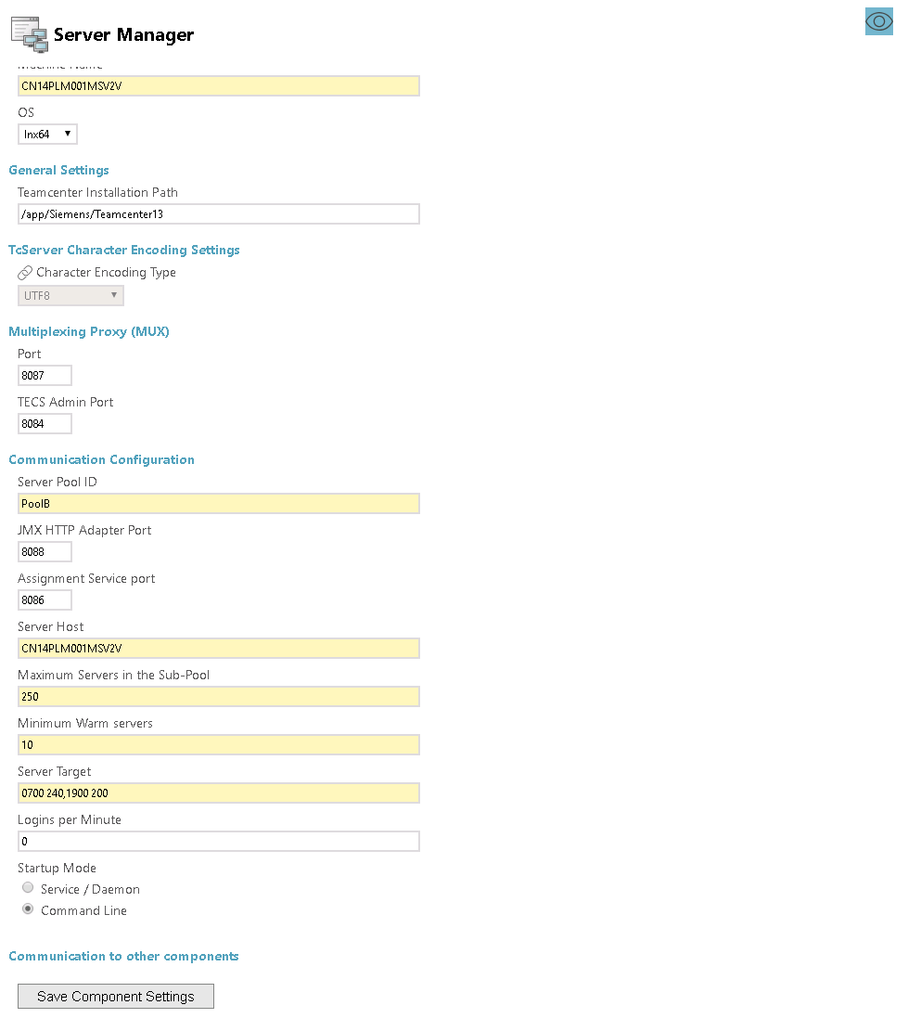
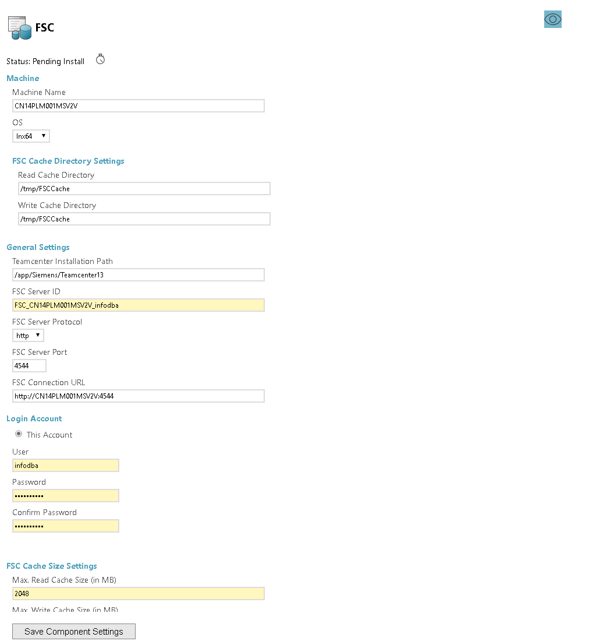
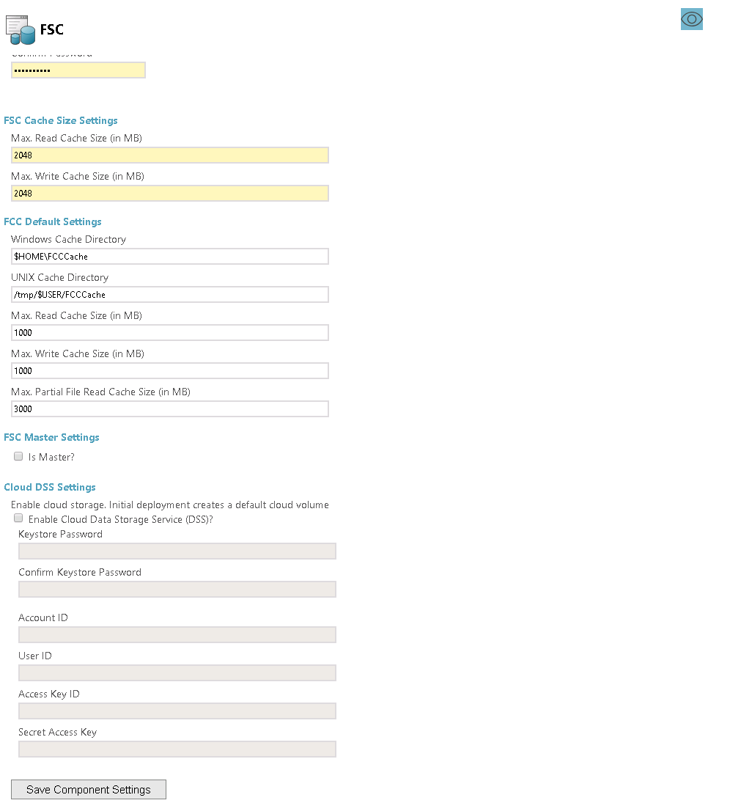
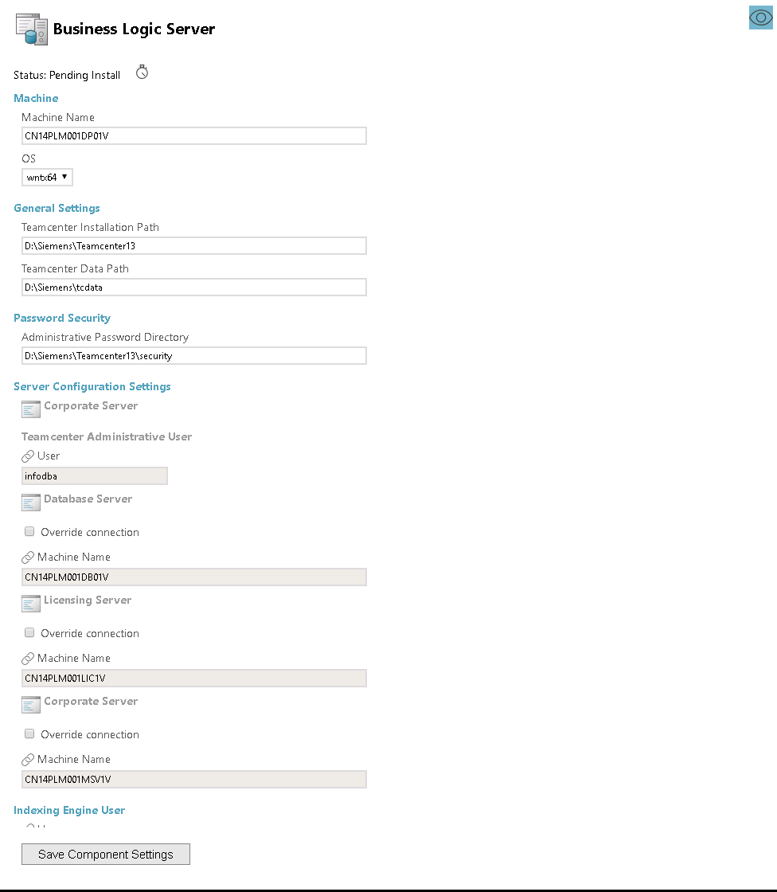
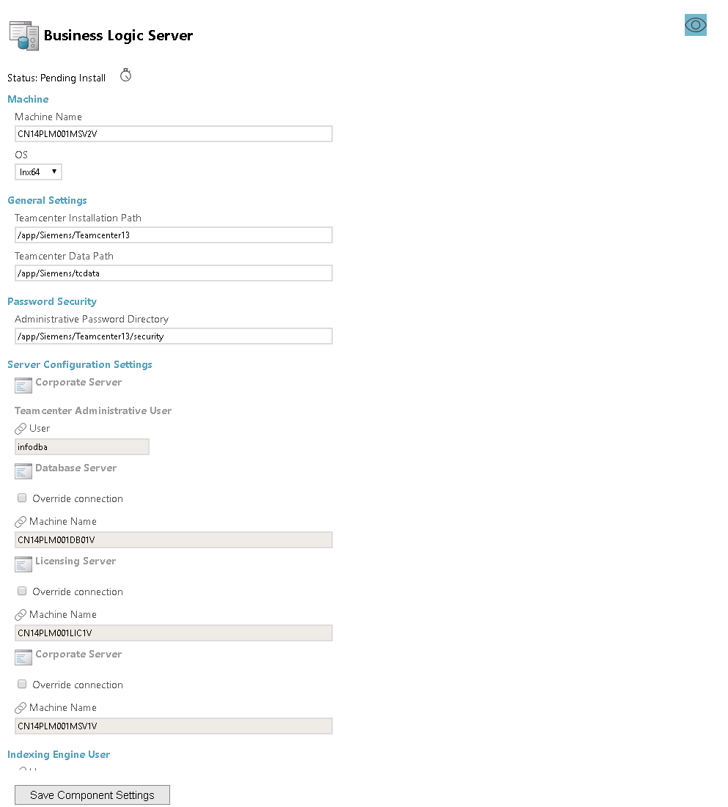
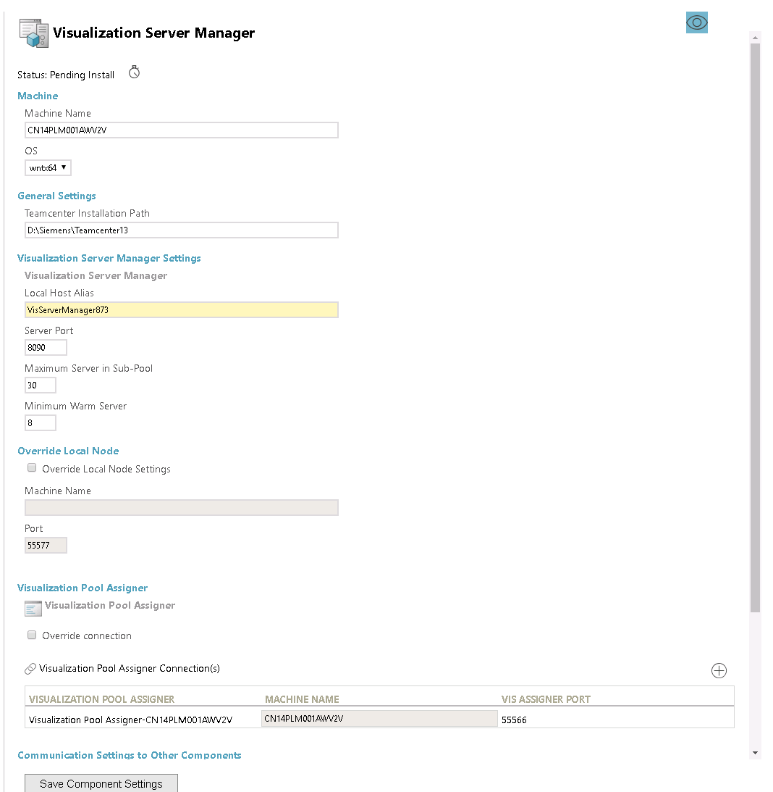
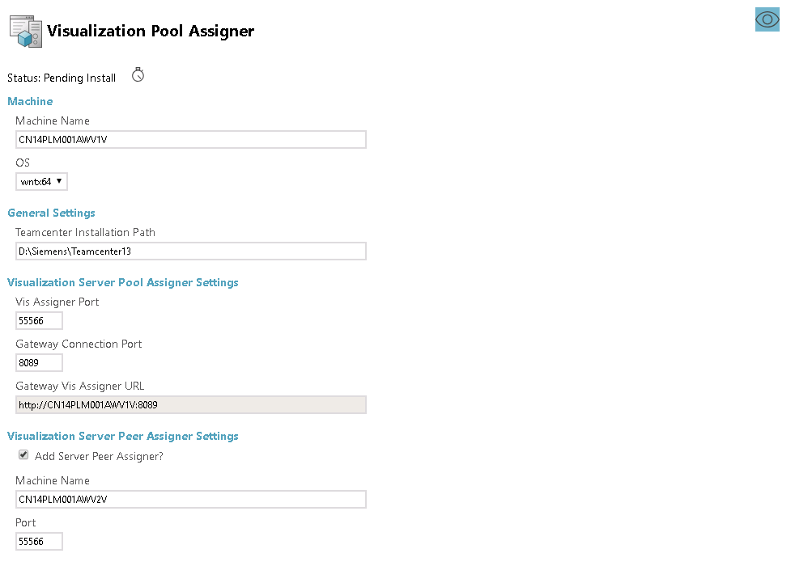
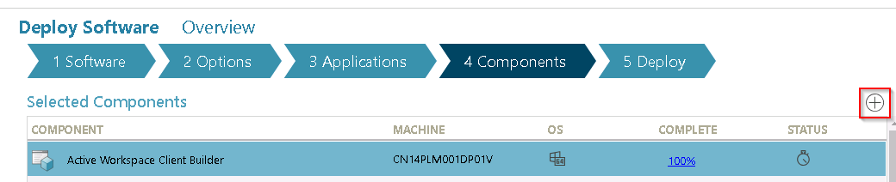
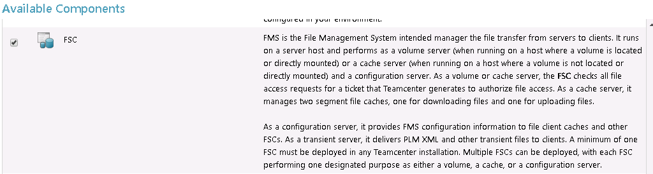
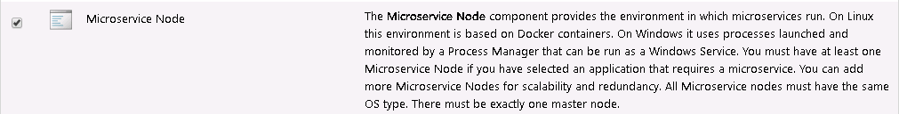
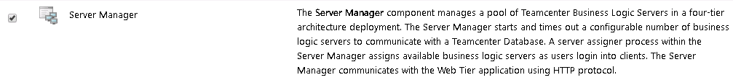
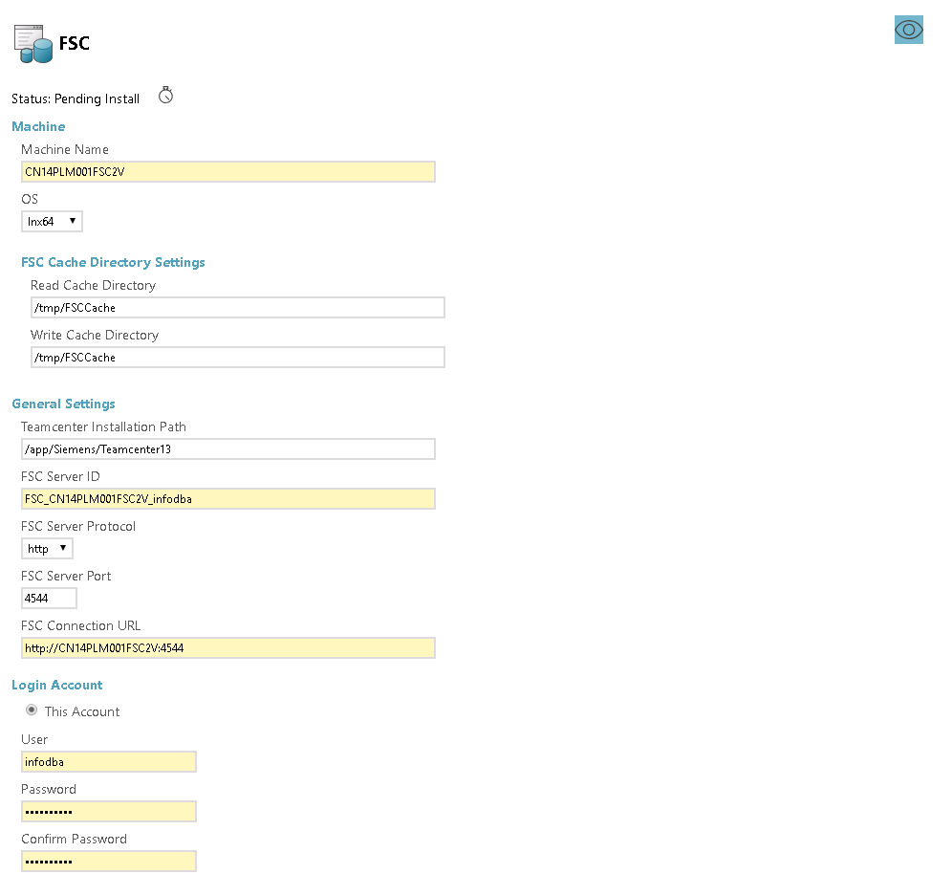
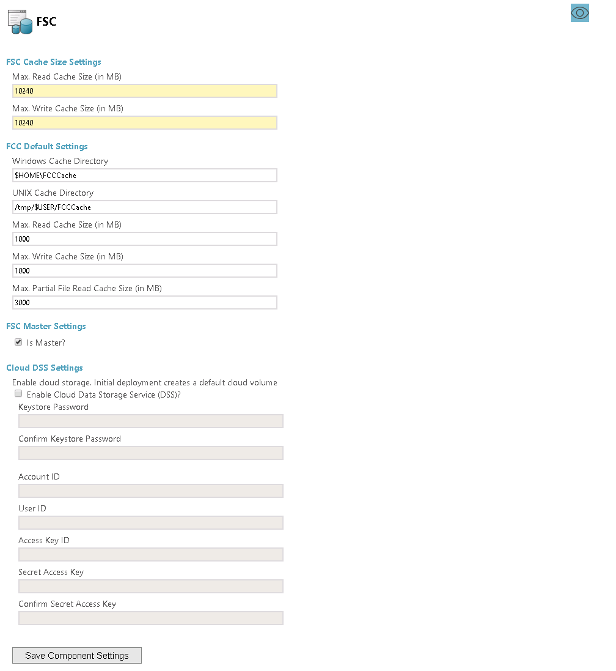
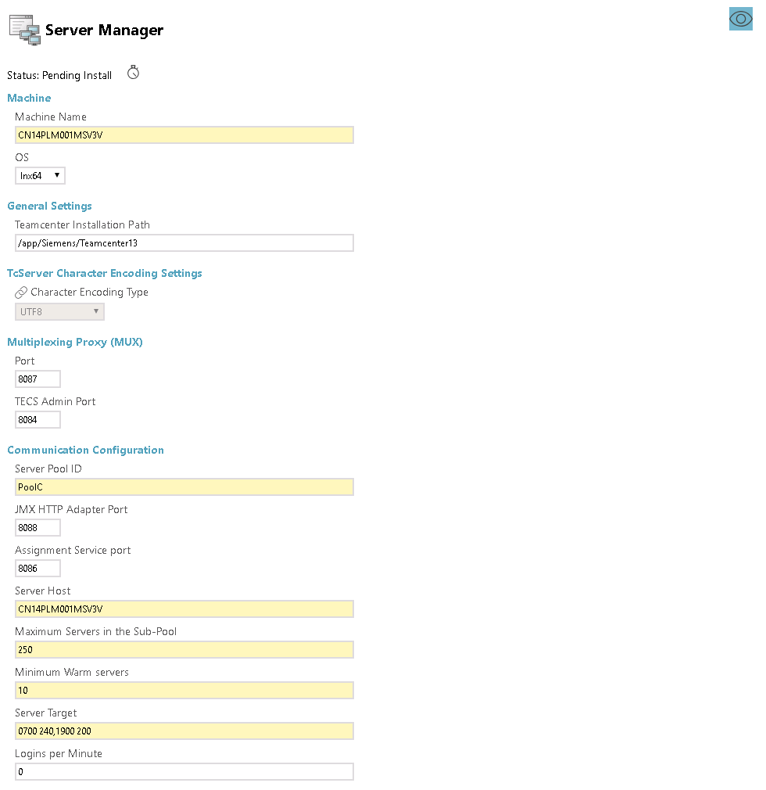
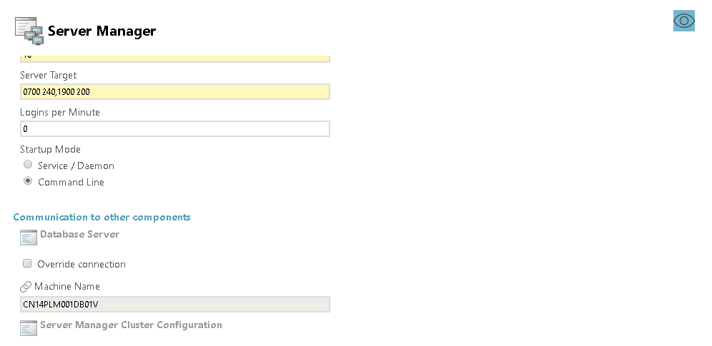
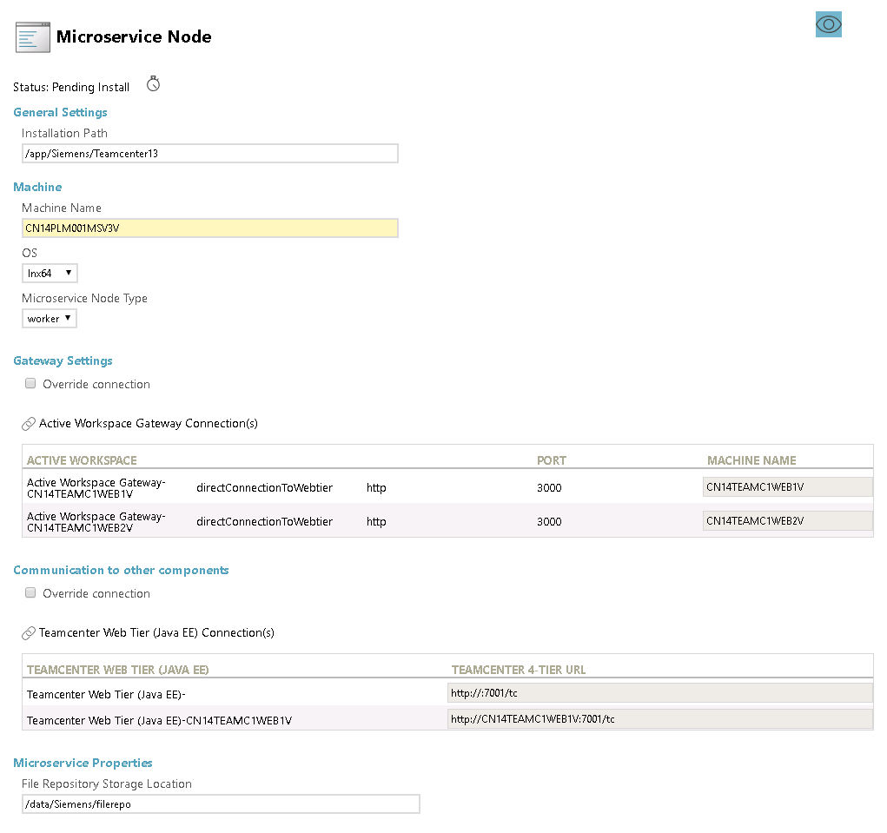
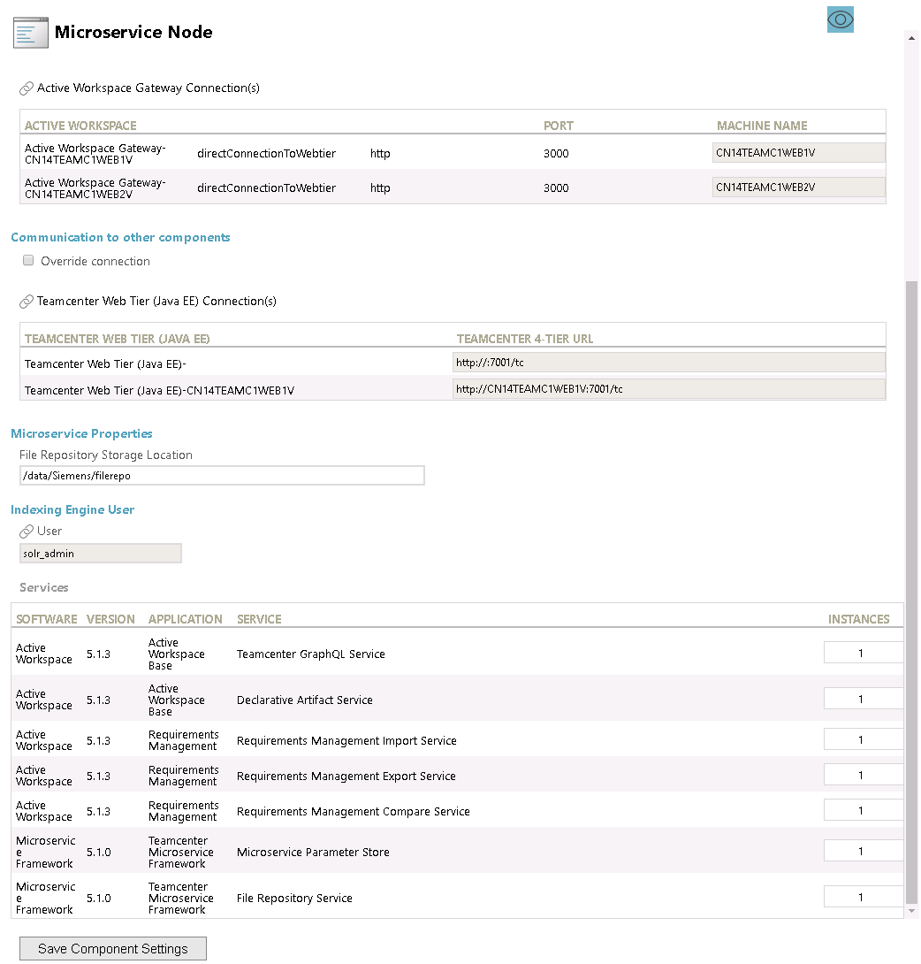
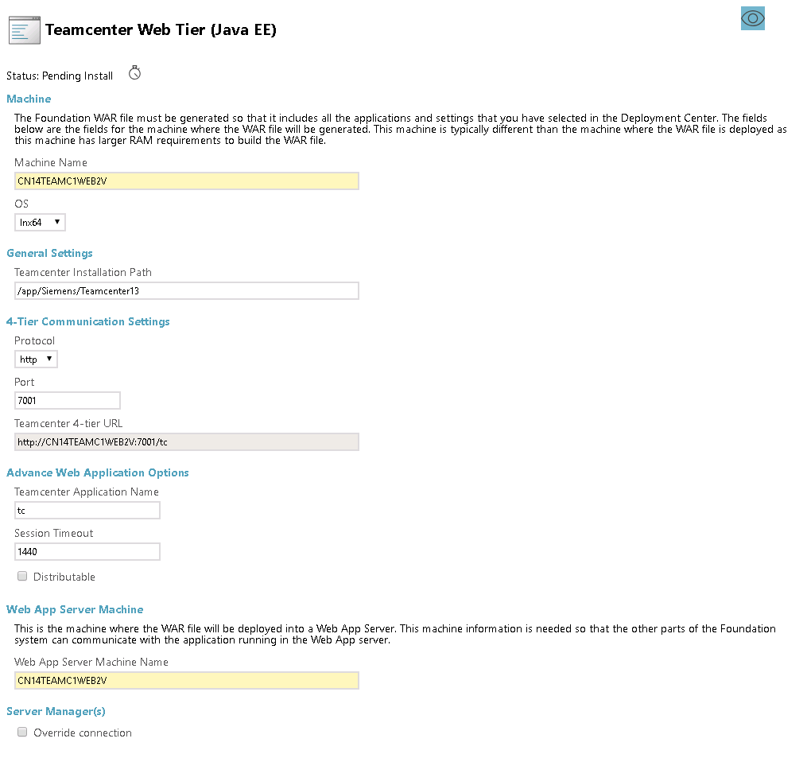
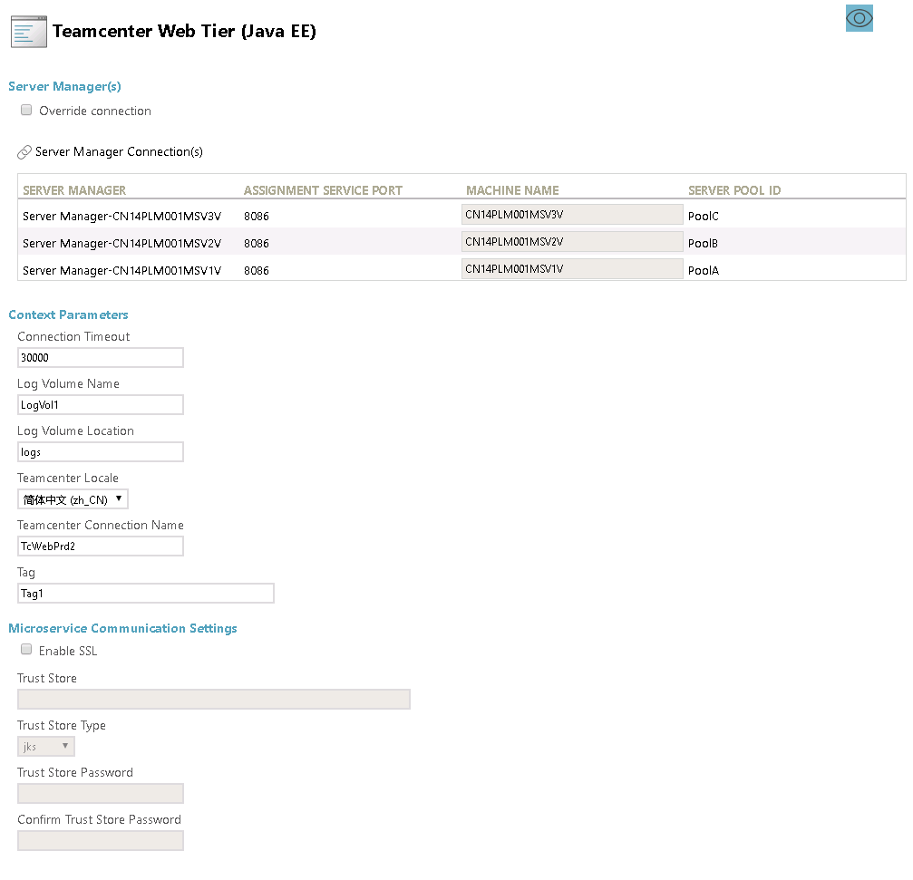
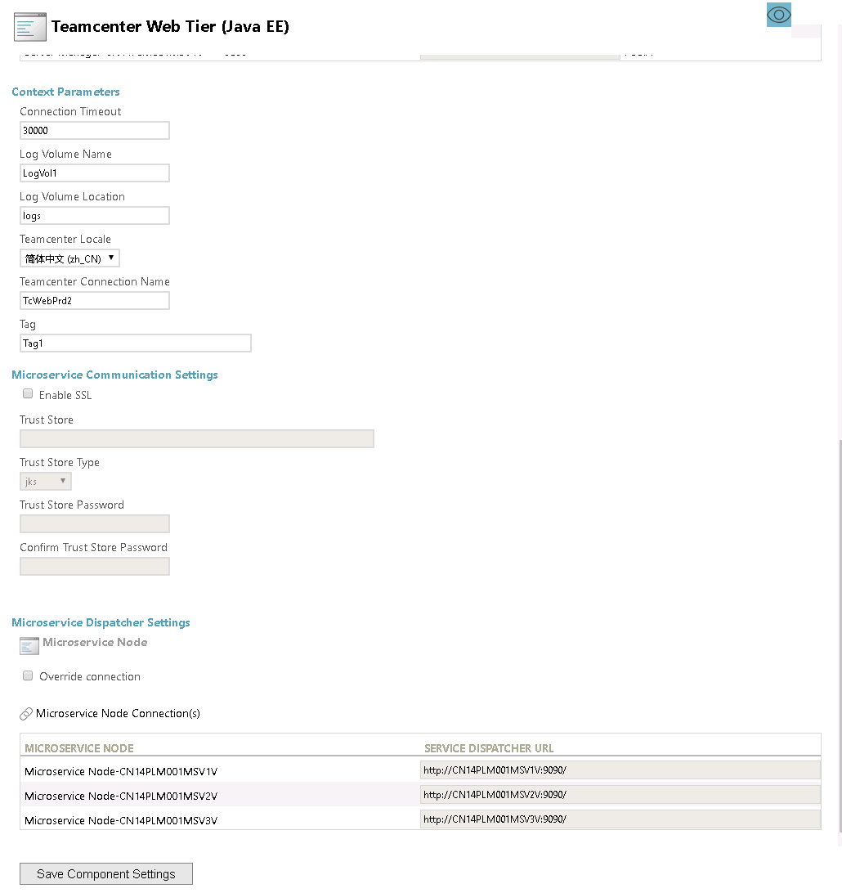

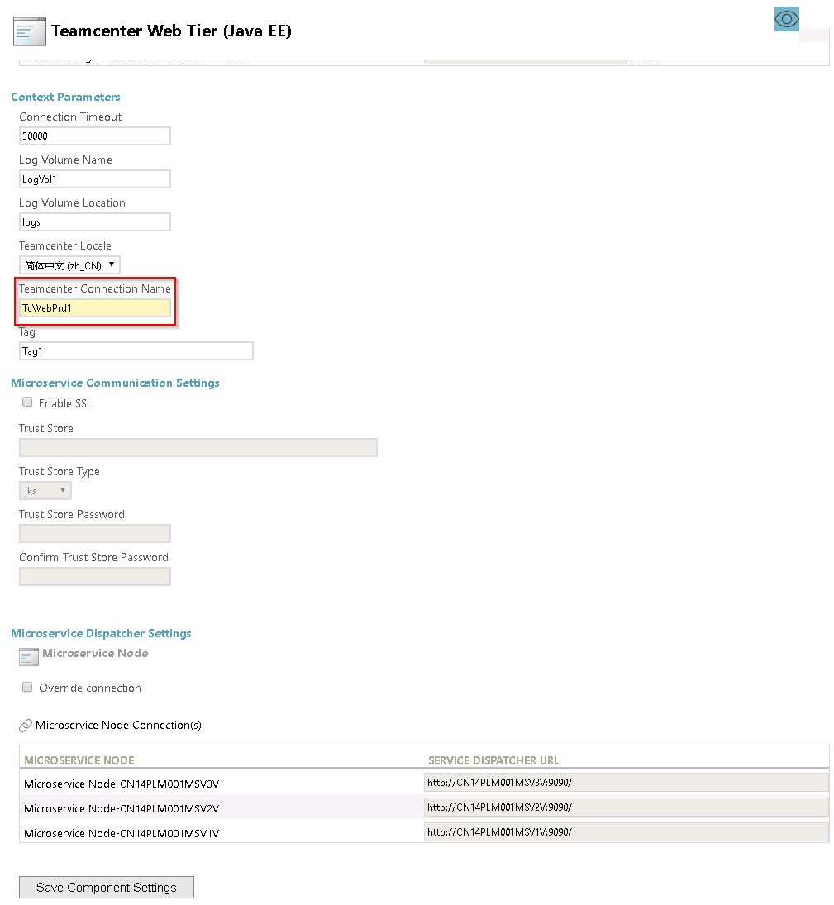

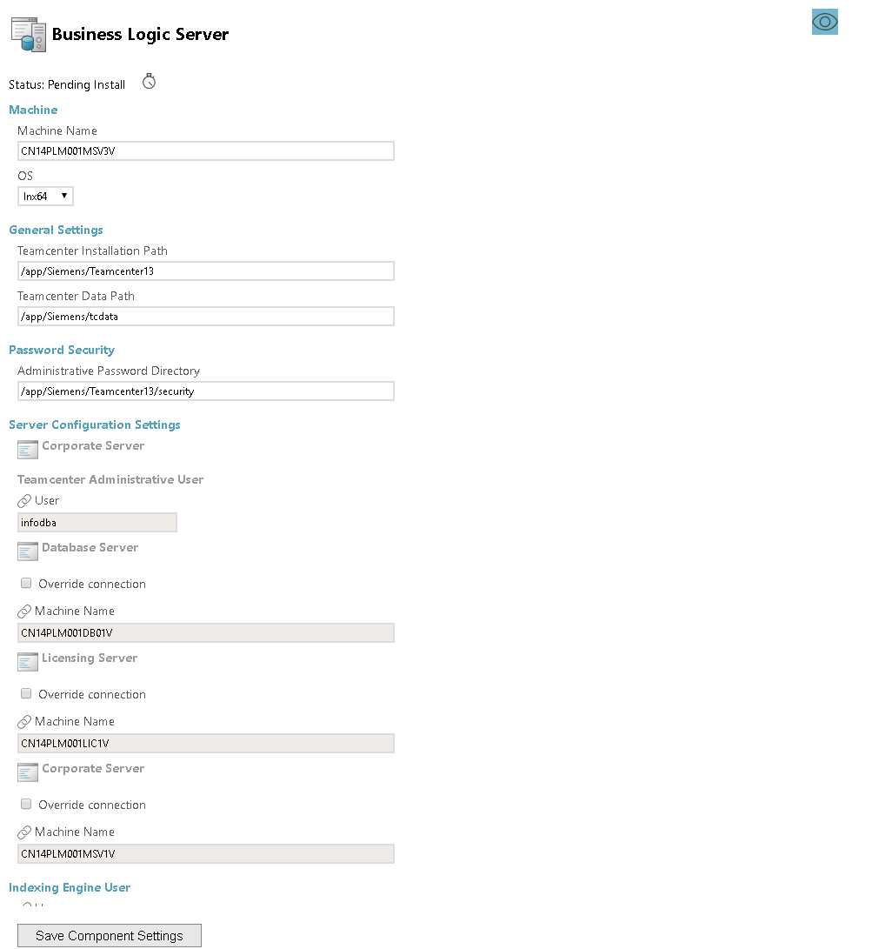
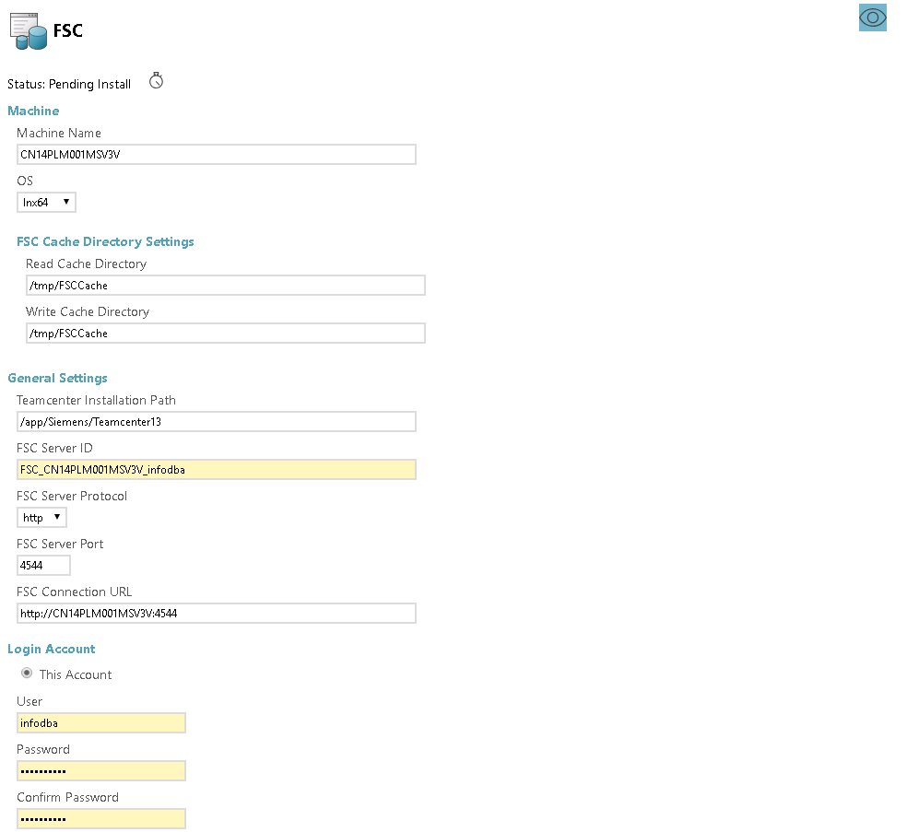
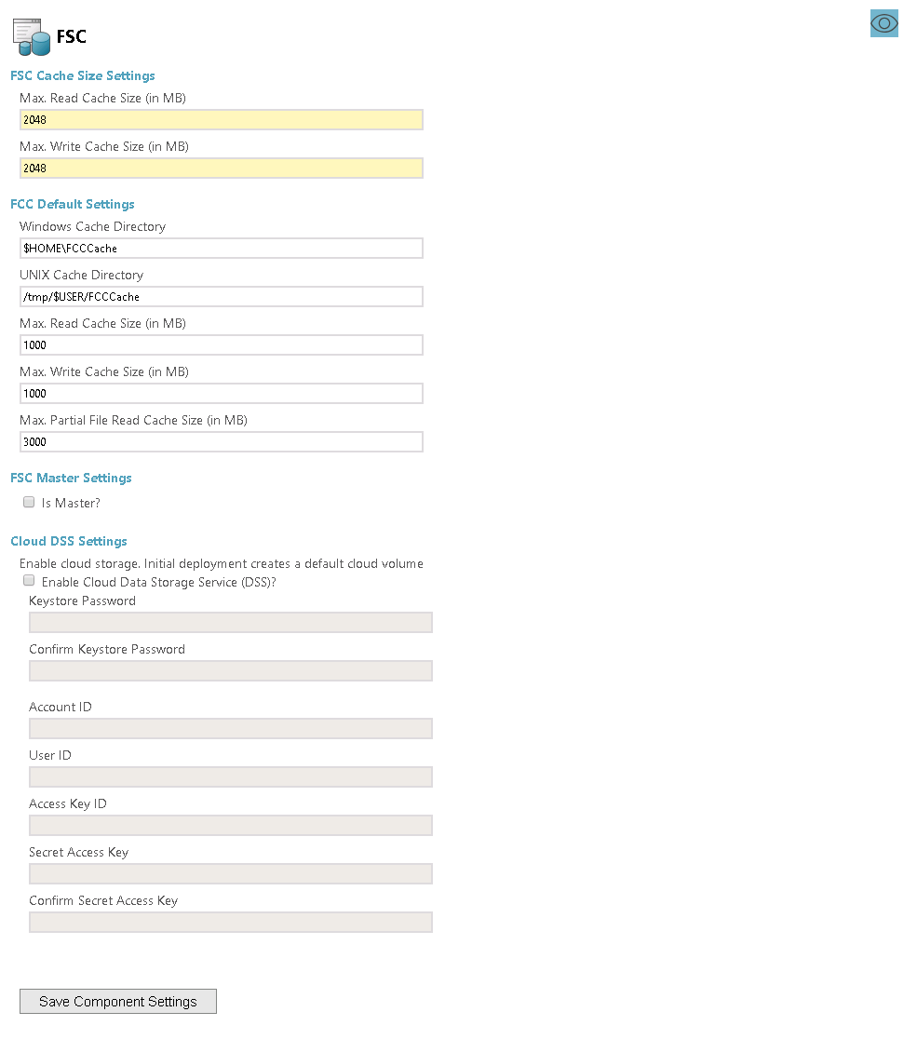
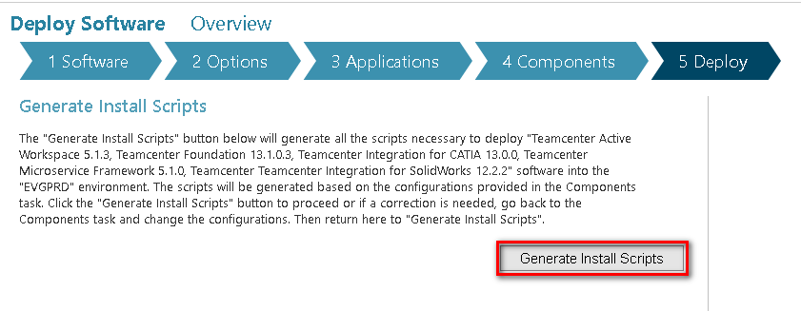

Deploy

Deploy on FSC1 (Master)
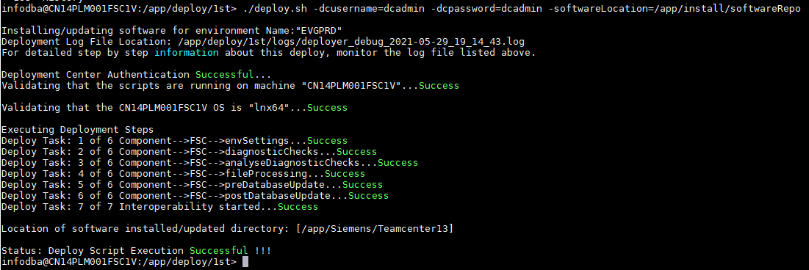

Deploy on FSC2
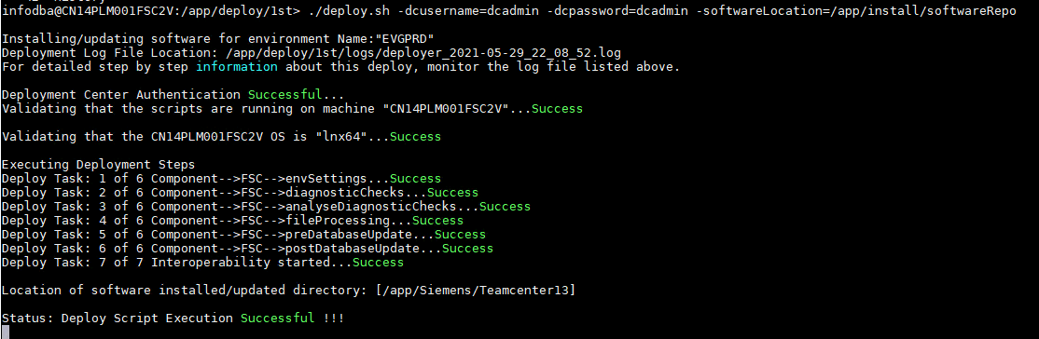

Deploy on PoolA (43)
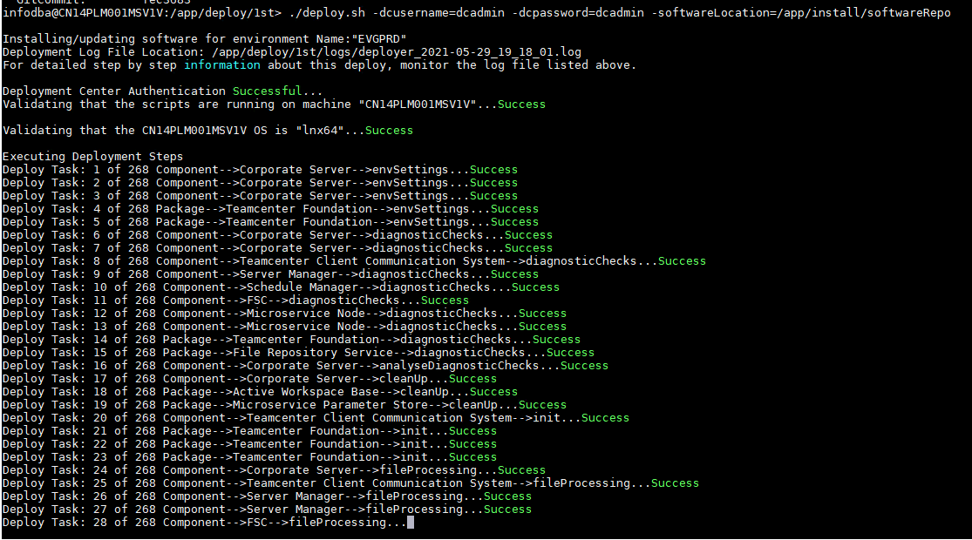
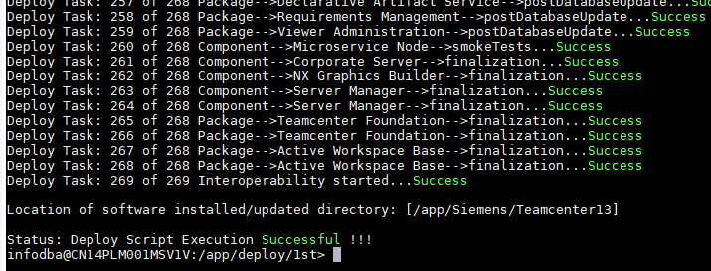

Deploy on PoolB (44)
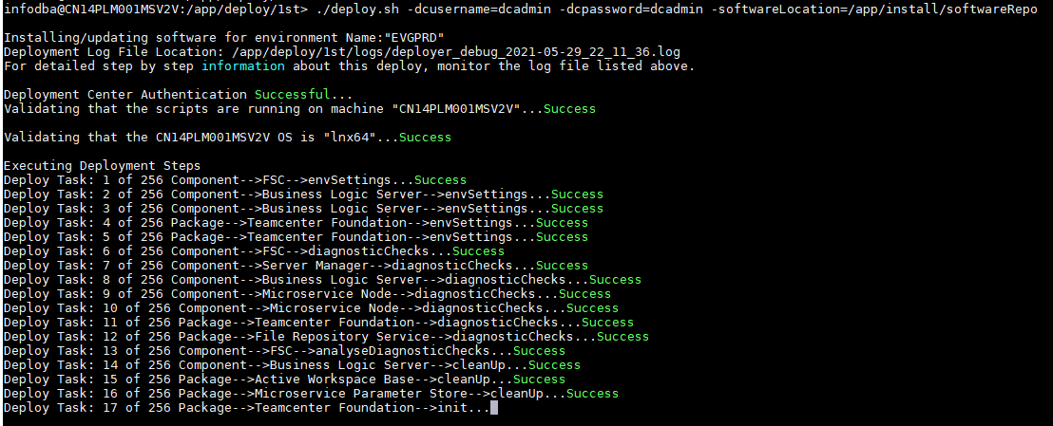
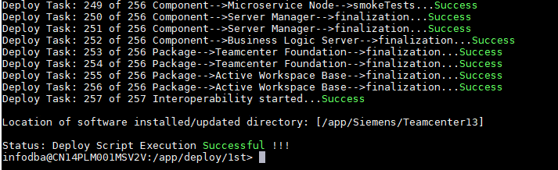

Deploy on PoolC (45)
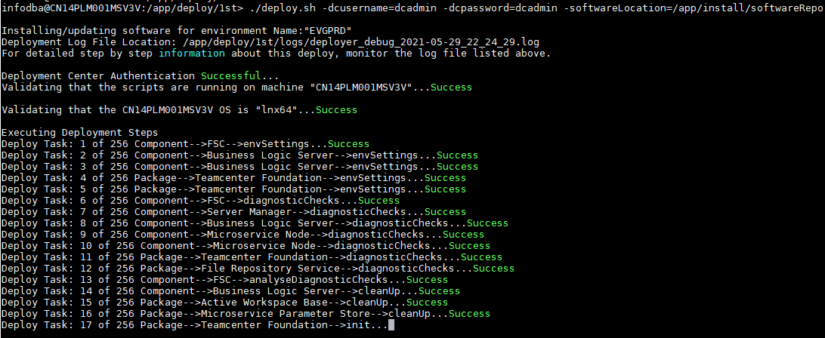
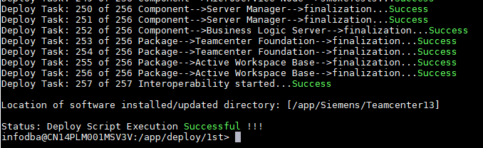

Deploy Microservices

Deploy Docker software for Pool and AW Gateway servers
enable Ipv4 forwarding with SUSE Linux’s yast2
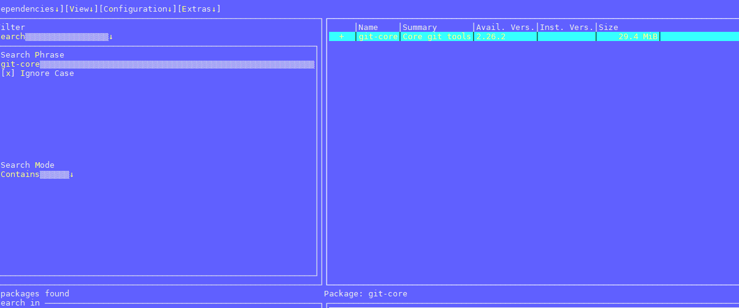
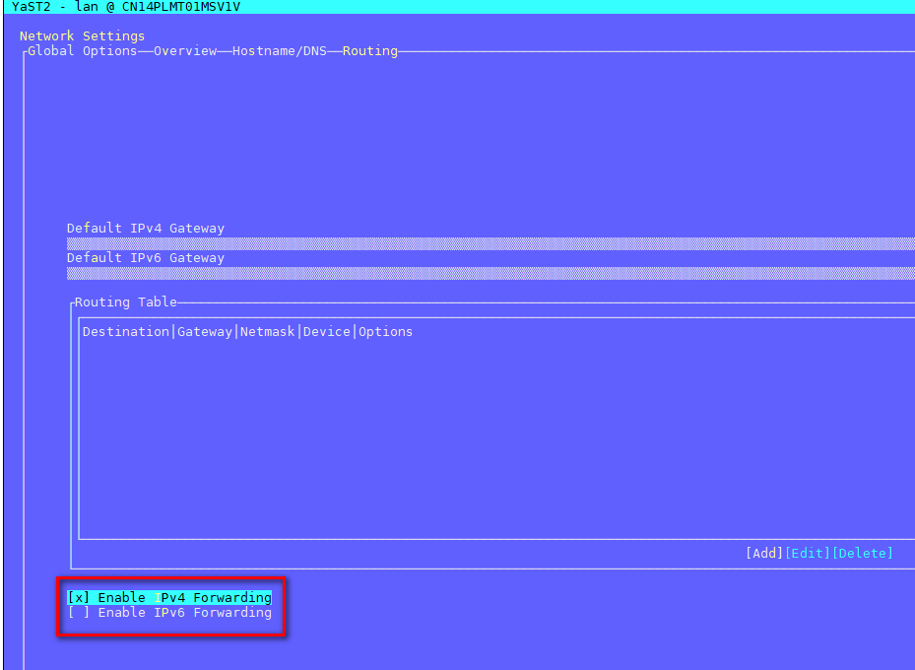
add docker group
add infodba user to docker group
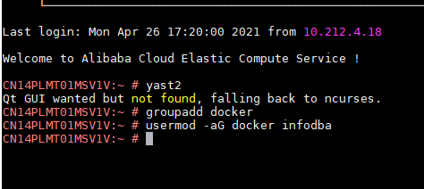
configure docker
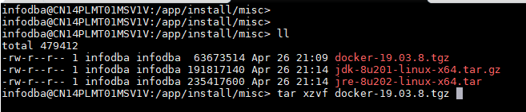
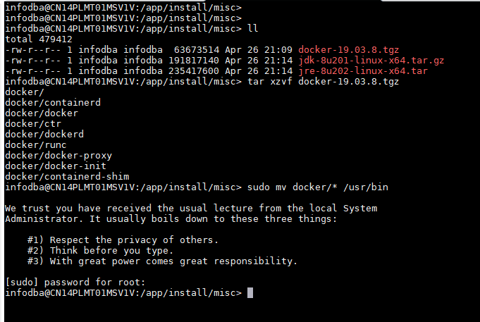
add docker services to systemd
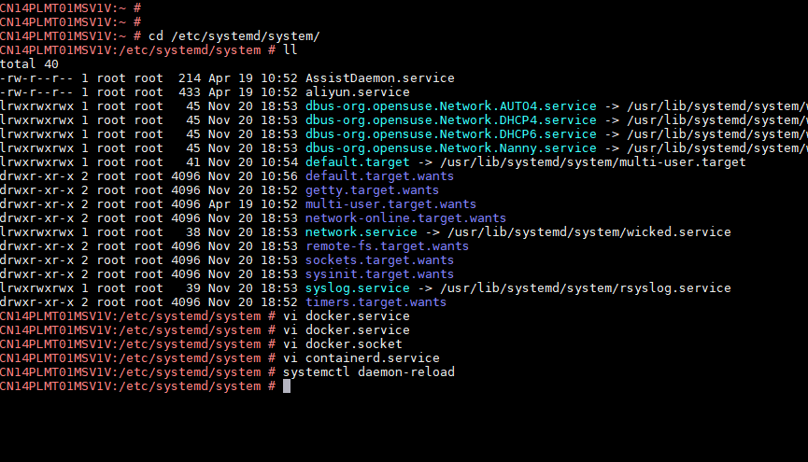
start docker
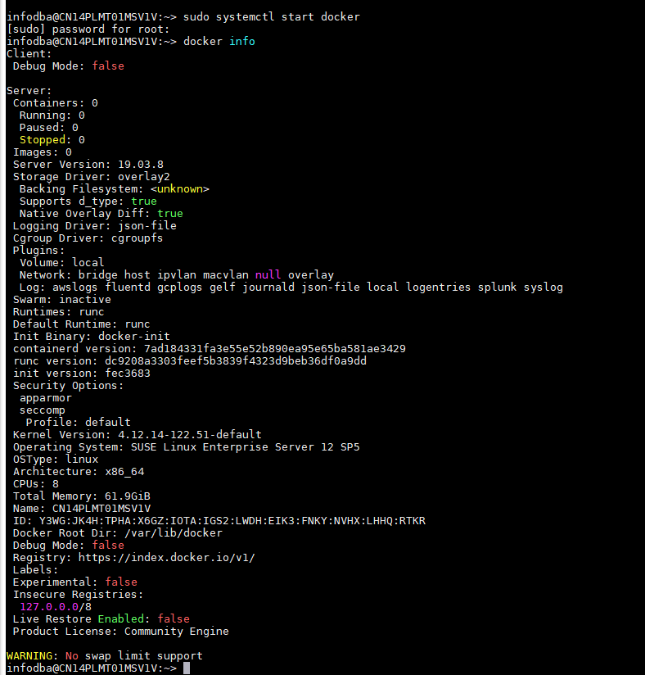

Deploy on PoolA (43)
add extra_hosts to all yml configuration files
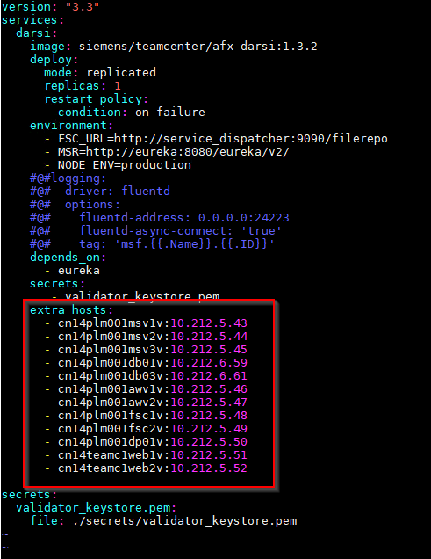
init docker swarm and get the manager join token
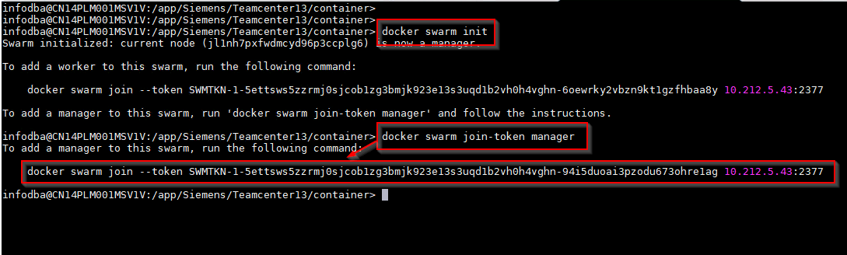
deploy microservices to prd_pool_stack
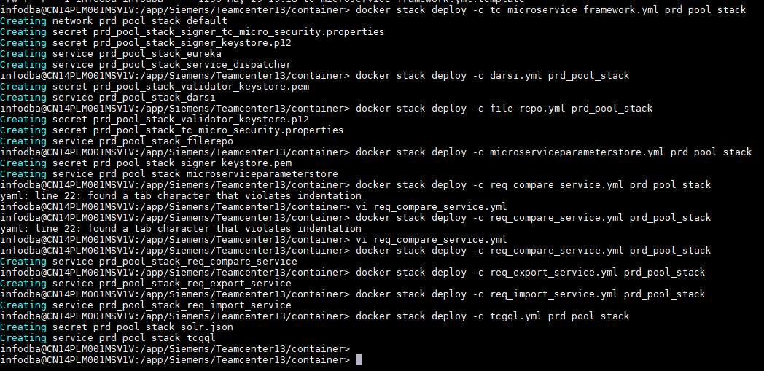
docker stack deploy -c tc_microservice_framework.yml prd_pool_stack
docker stack deploy -c darsi.yml prd_pool_stack
docker stack deploy -c file-repo.yml prd_pool_stack
docker stack deploy -c microserviceparameterstore.yml prd_pool_stack
docker stack deploy -c req_compare_service.yml prd_pool_stack
docker stack deploy -c req_export_service.yml prd_pool_stack
docker stack deploy -c req_import_service.yml prd_pool_stack
docker stack deploy -c tcgql.yml prd_pool_stack

Deploy on PoolB (44) and PoolC (45)
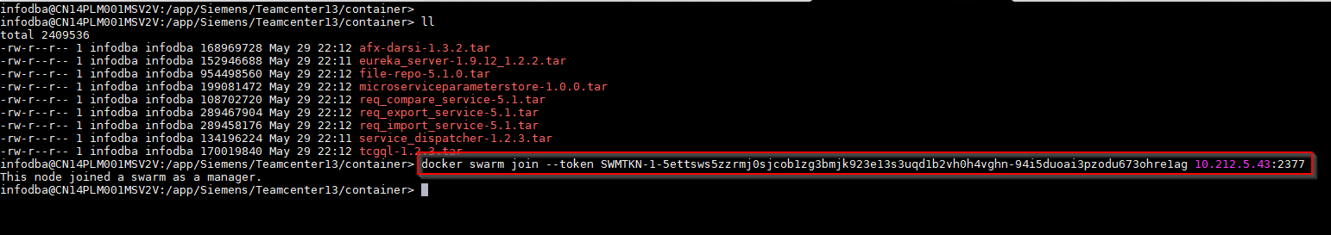
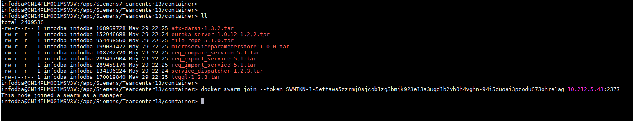

Deploy on Web1 (51)
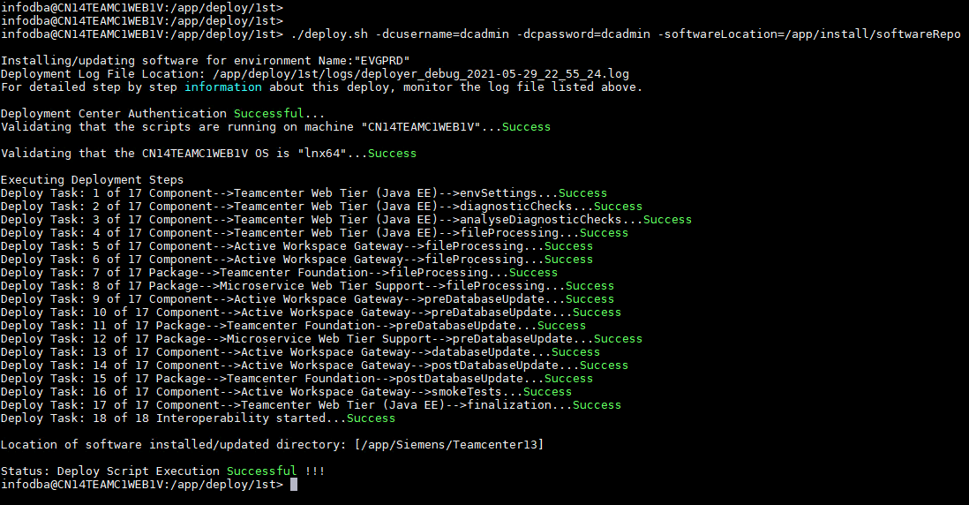

init aw gateway 1
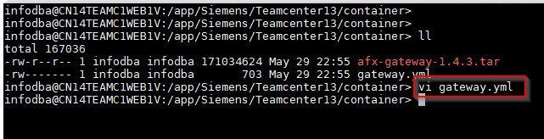
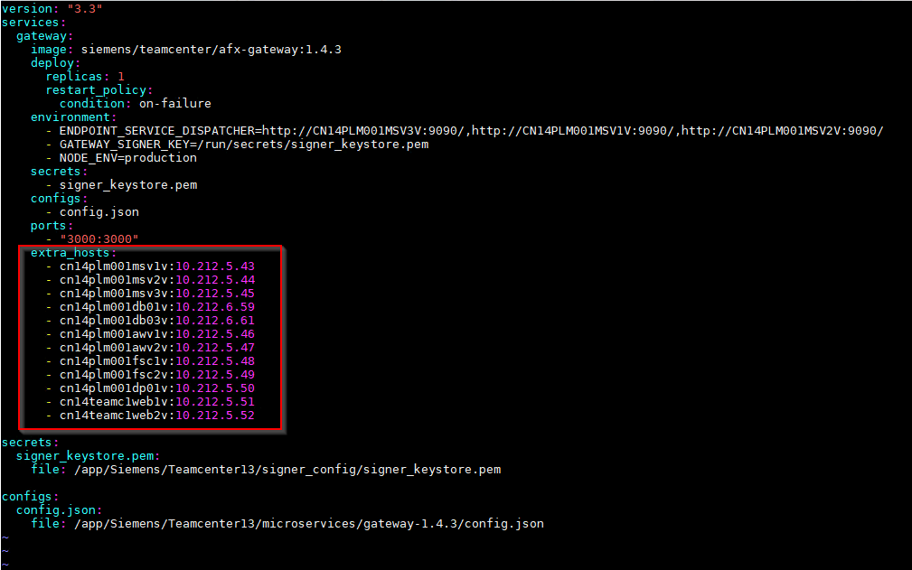
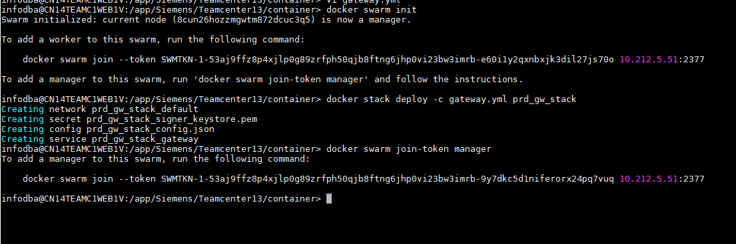

Deploy on Web2 (52)
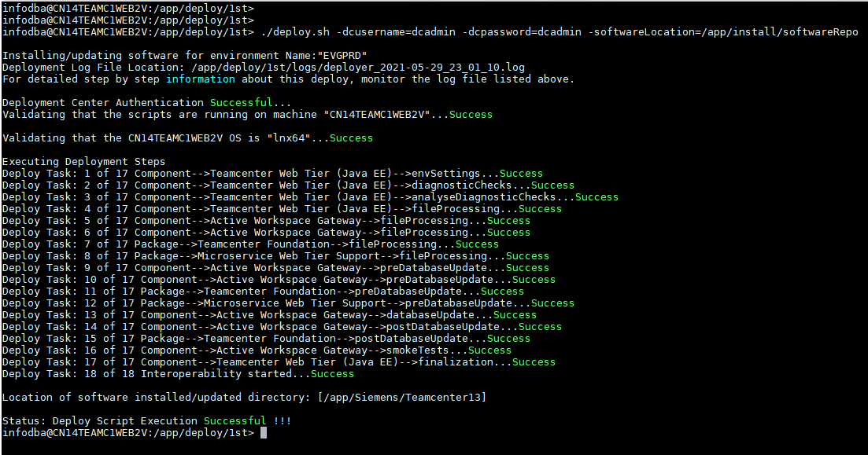

init aw gateway 2
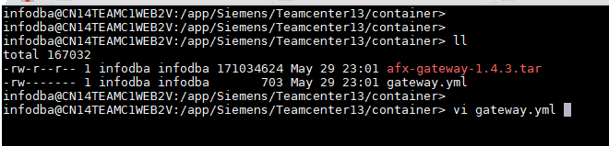
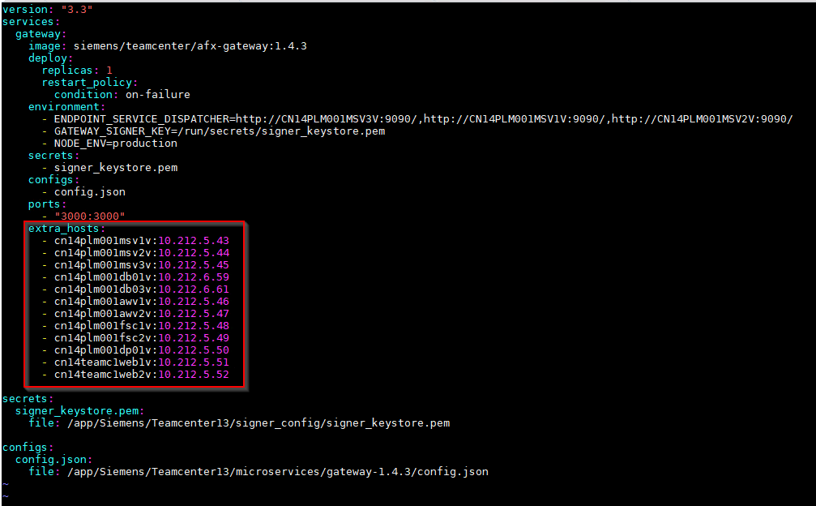
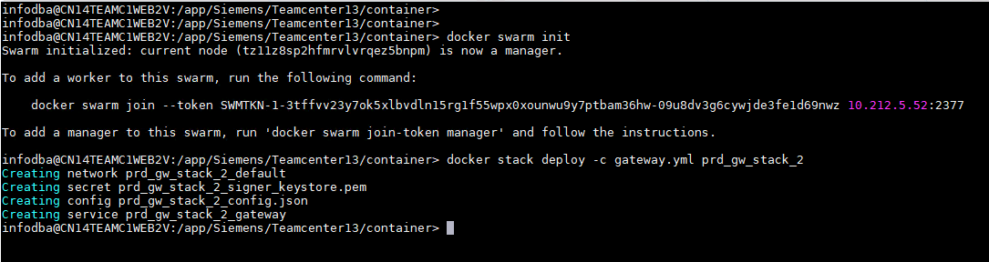

Deploy tc.war to Tomcat on Web servers
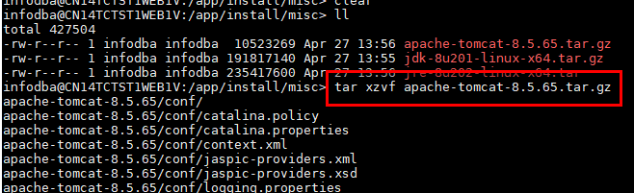
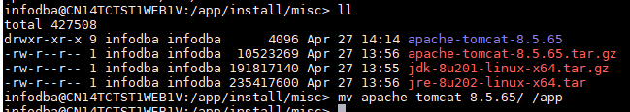
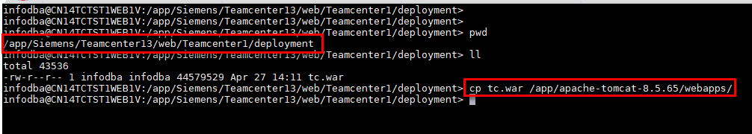
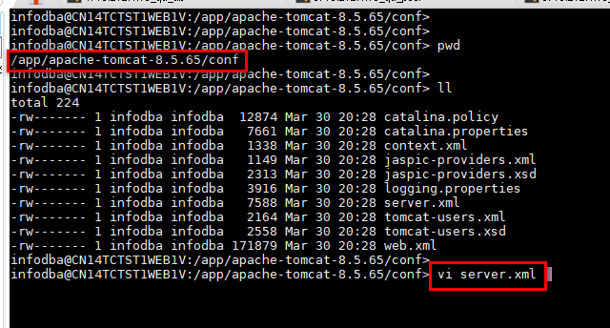
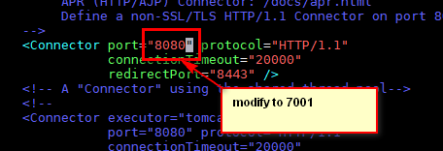
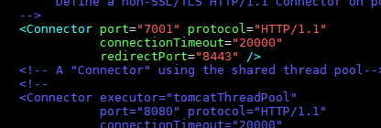

Deploy on Dispatcher (50)
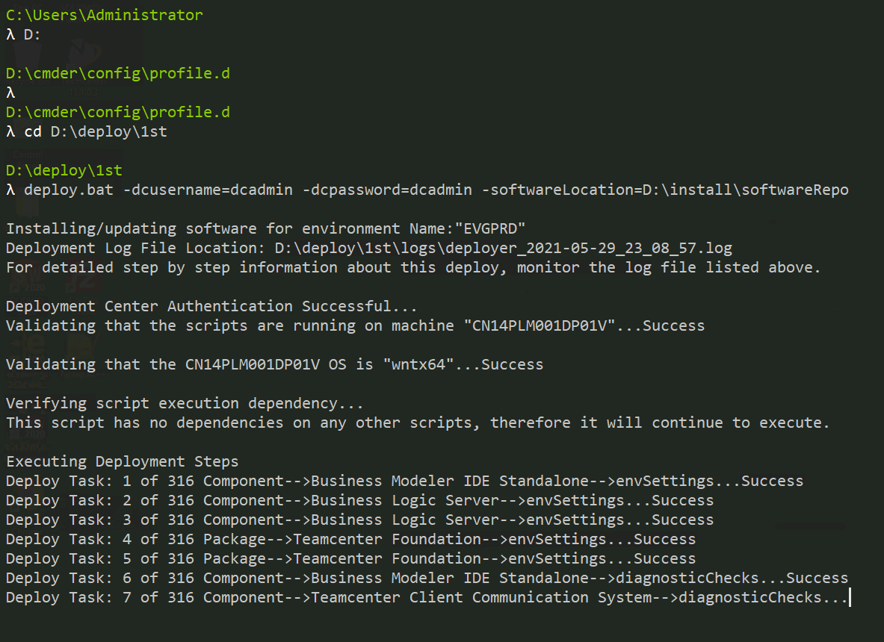
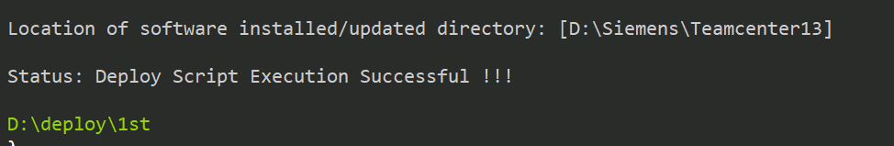

Deploy on Vis 1 (46)
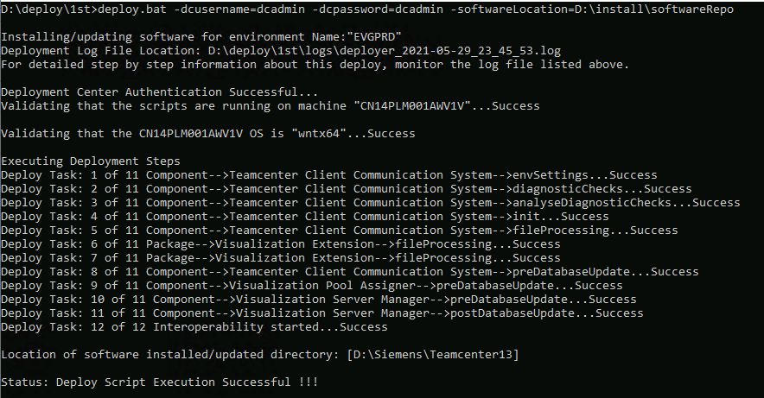

Deploy on Vis 2 (47)
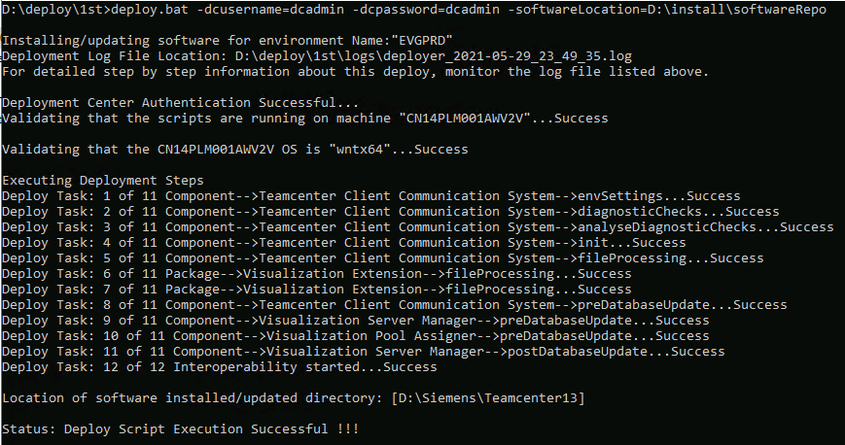

Deploy on AW Index (6.61)
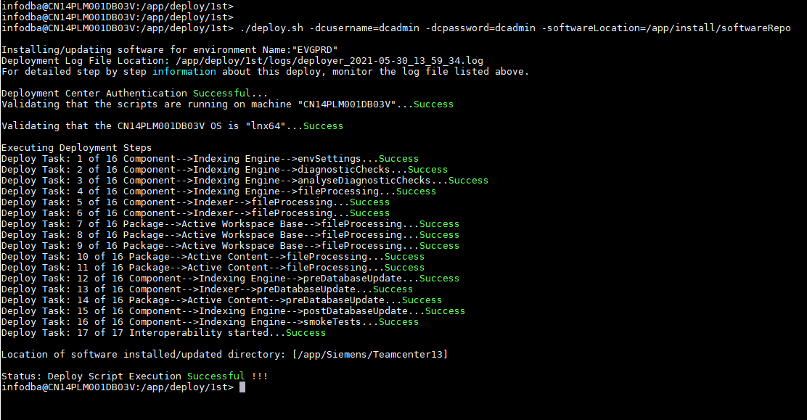

Deploy TCIC Server Library on Pools
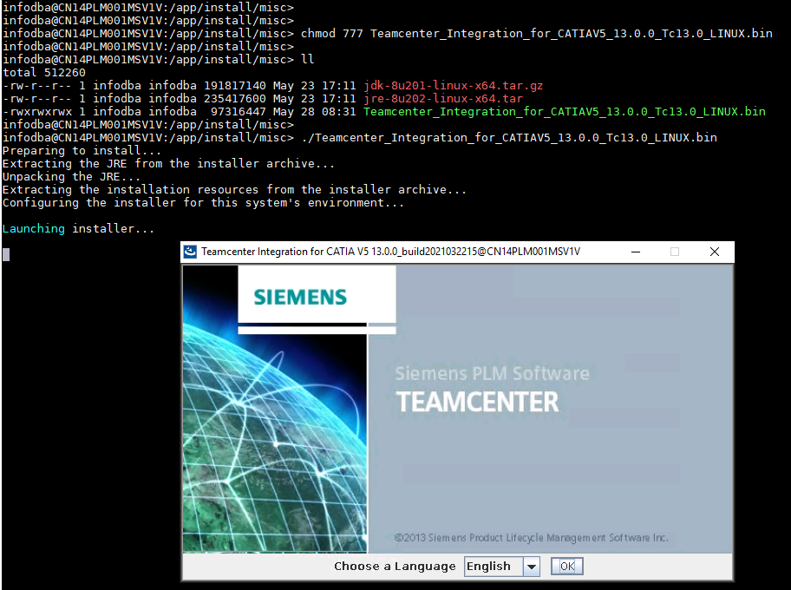
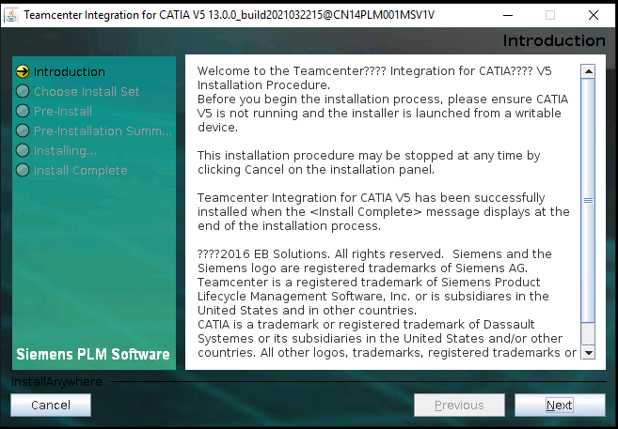
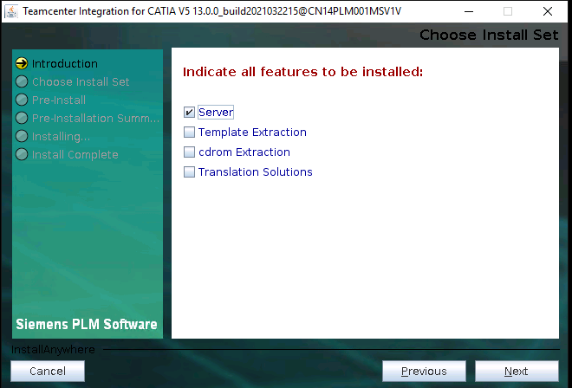
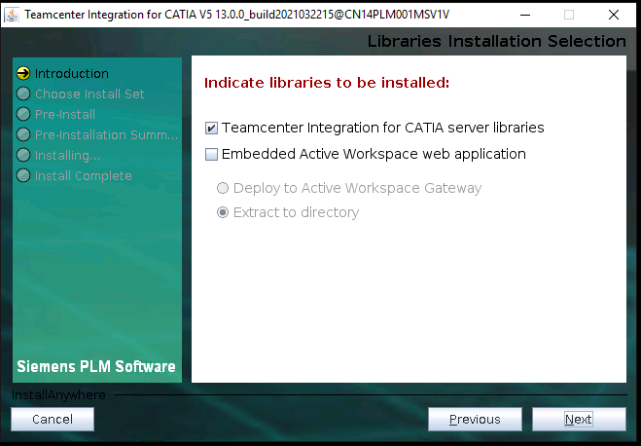
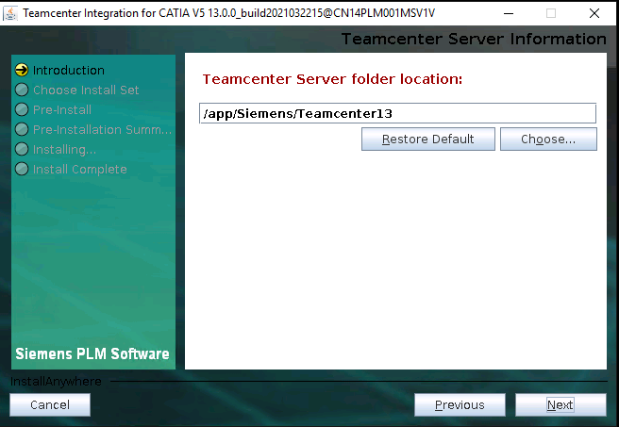
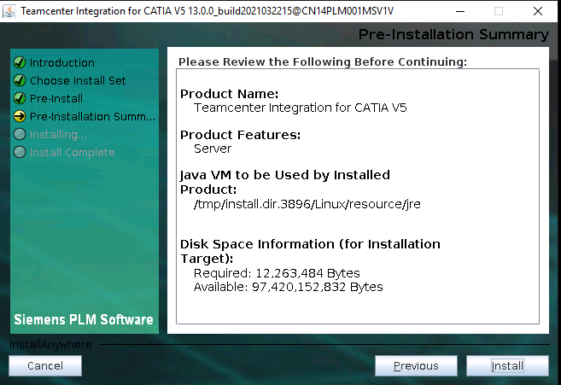
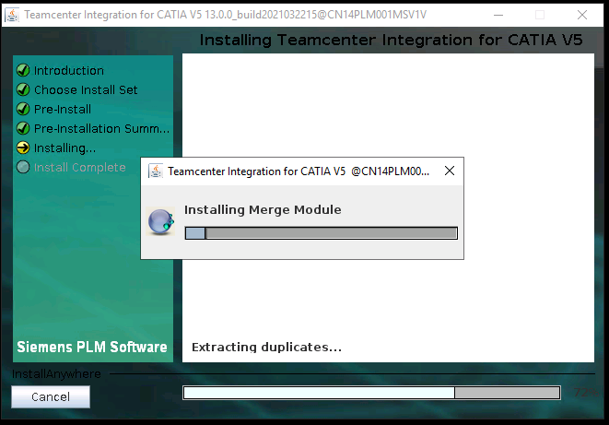
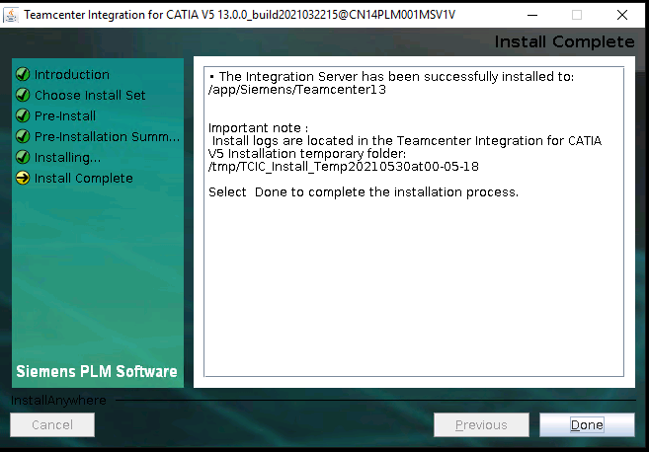

Deploy CATIA Translation on Dispatcher (50)

Deploy TCIC Integration
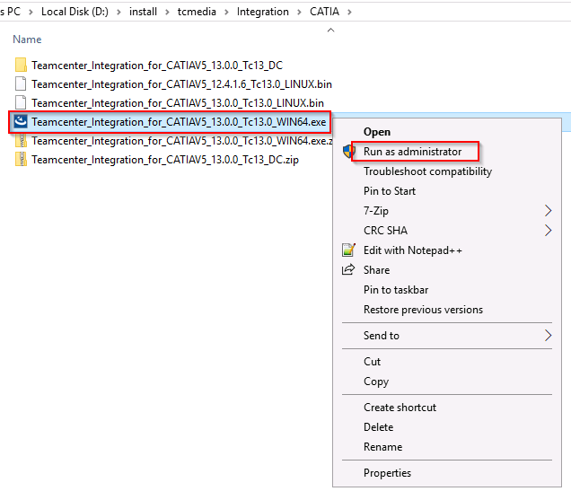
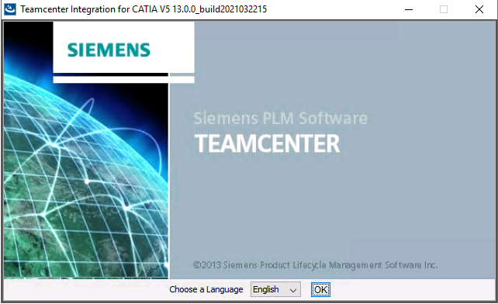
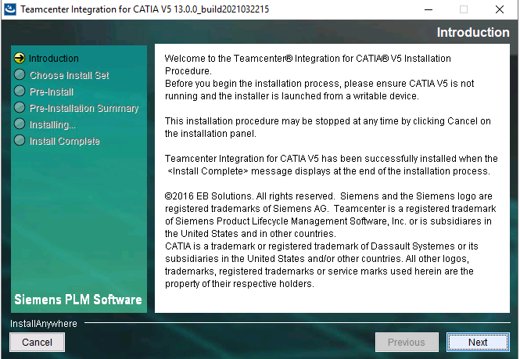
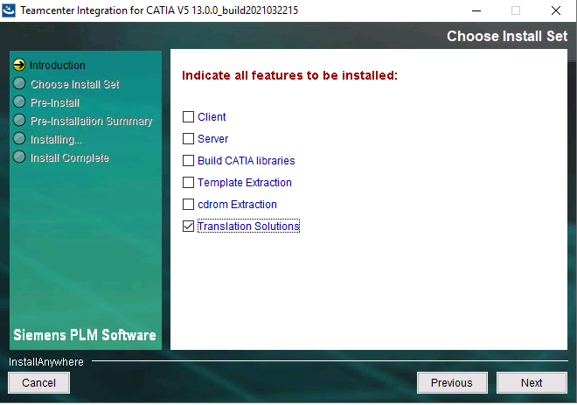
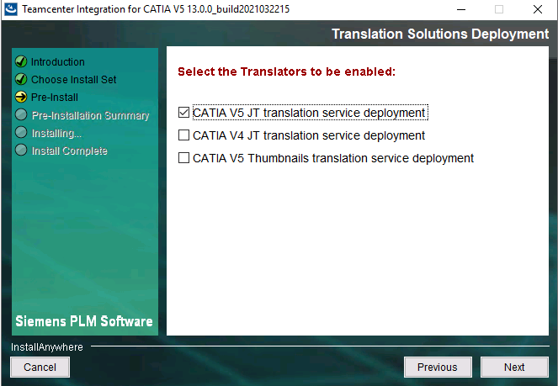
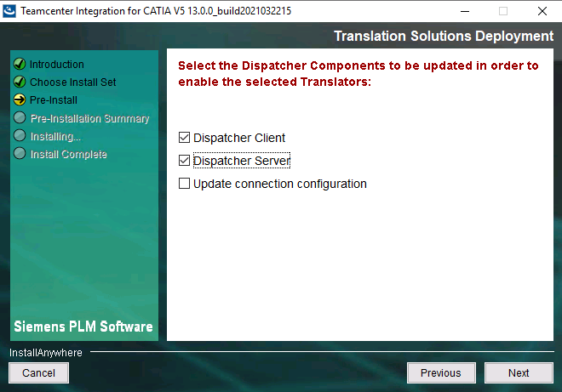
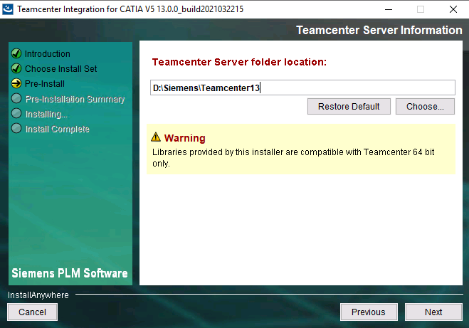
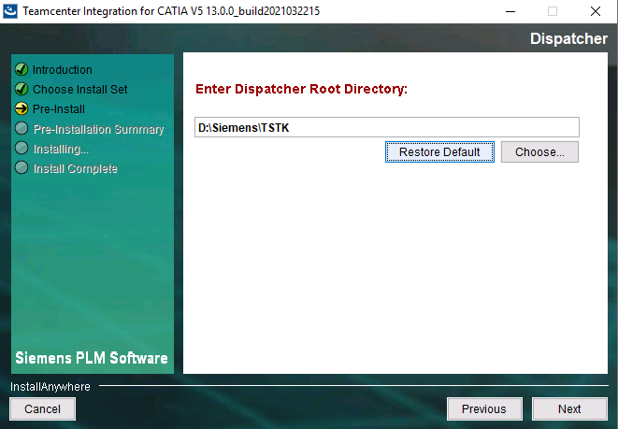
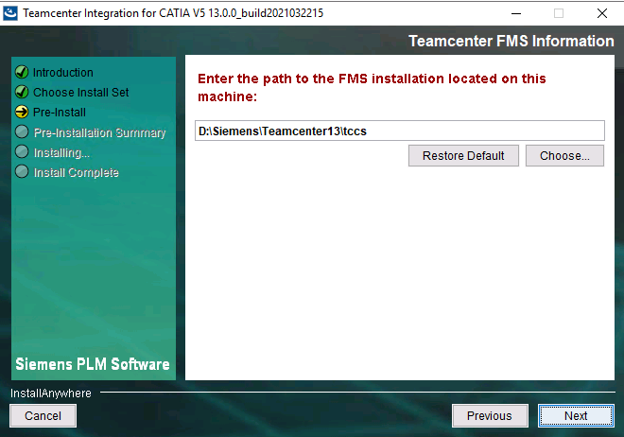
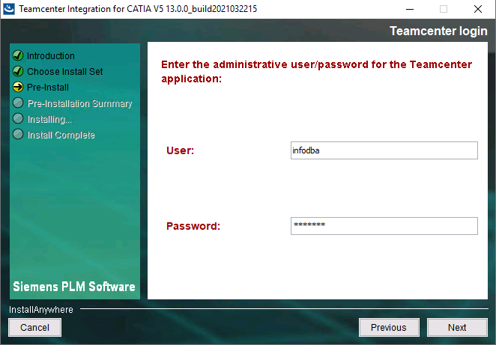
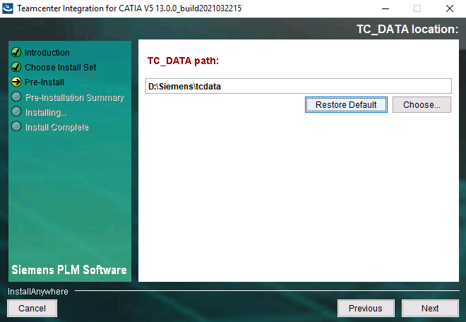
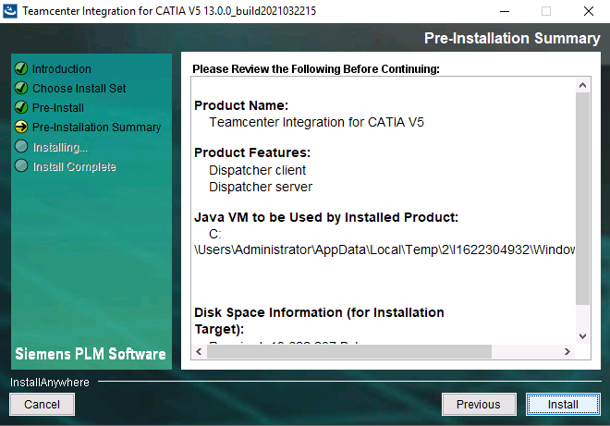
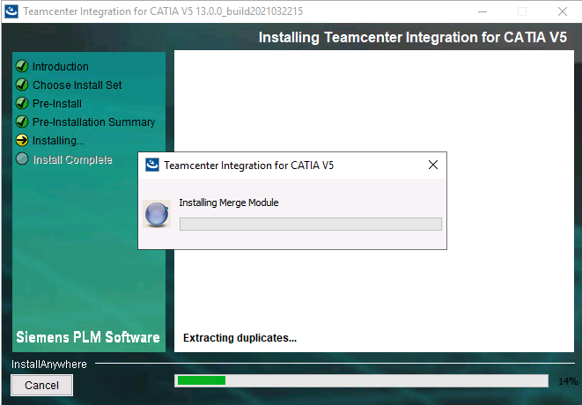
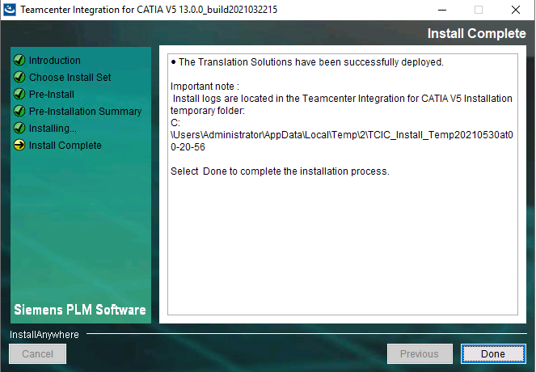

Deploy CATIA JT Translation
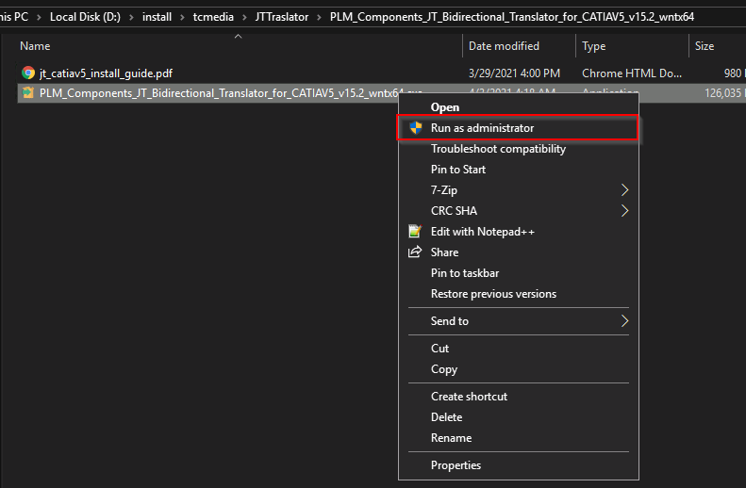

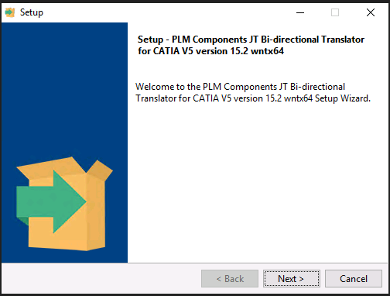
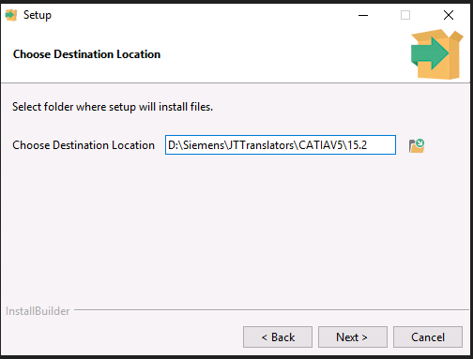
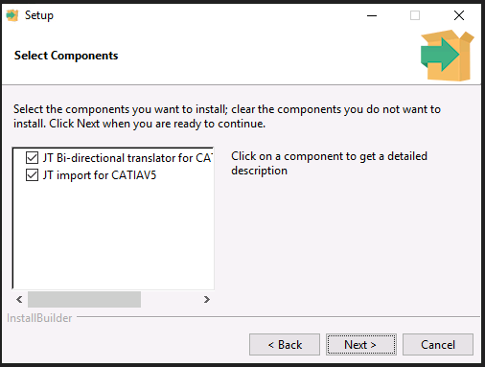
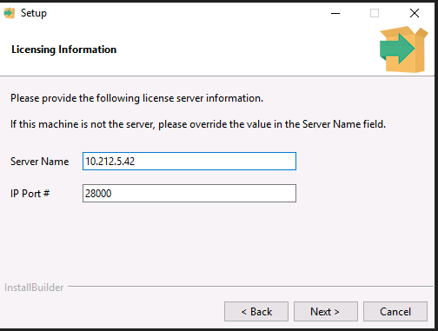
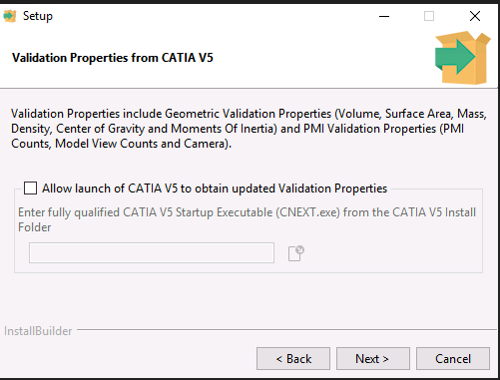
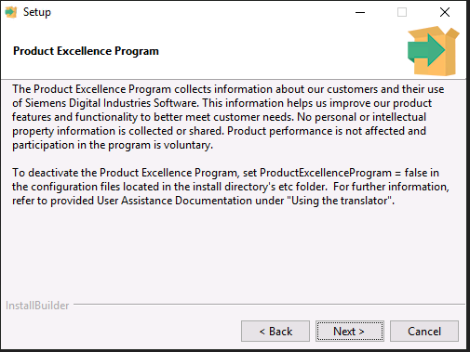
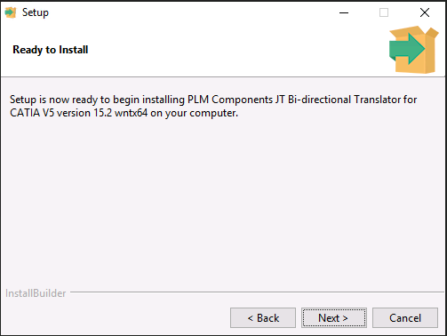
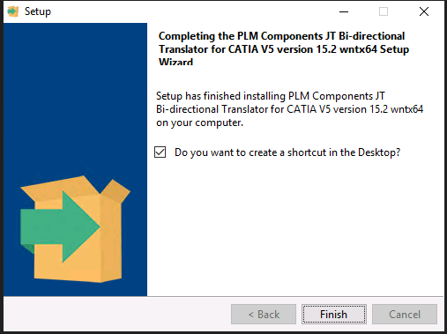
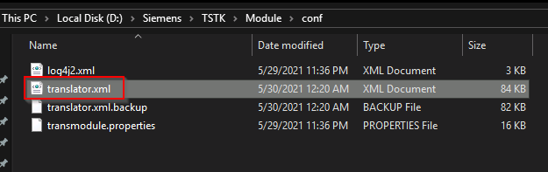
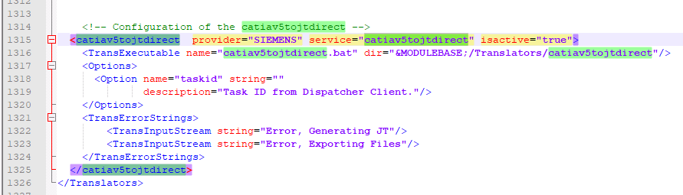
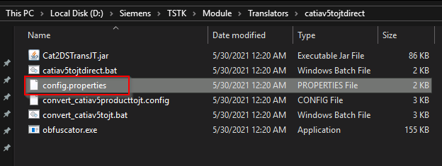
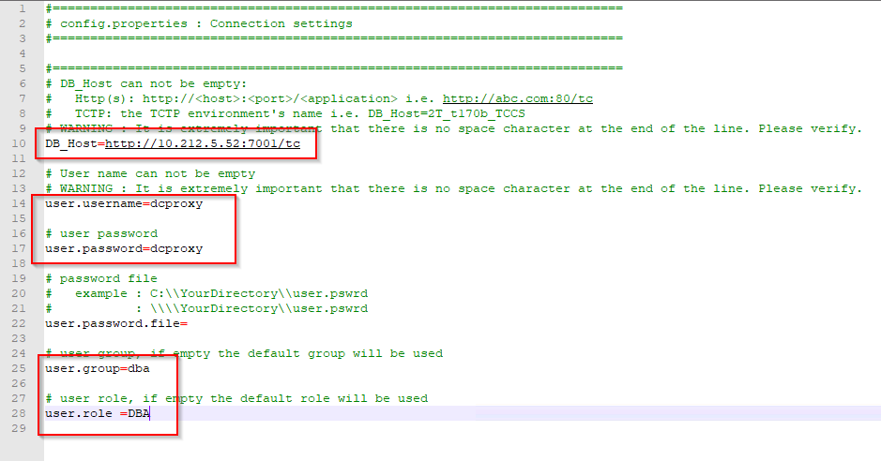
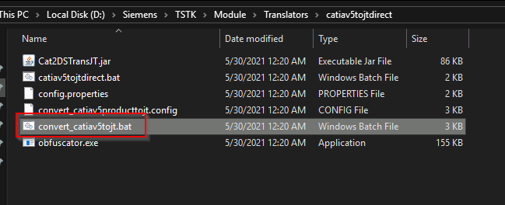
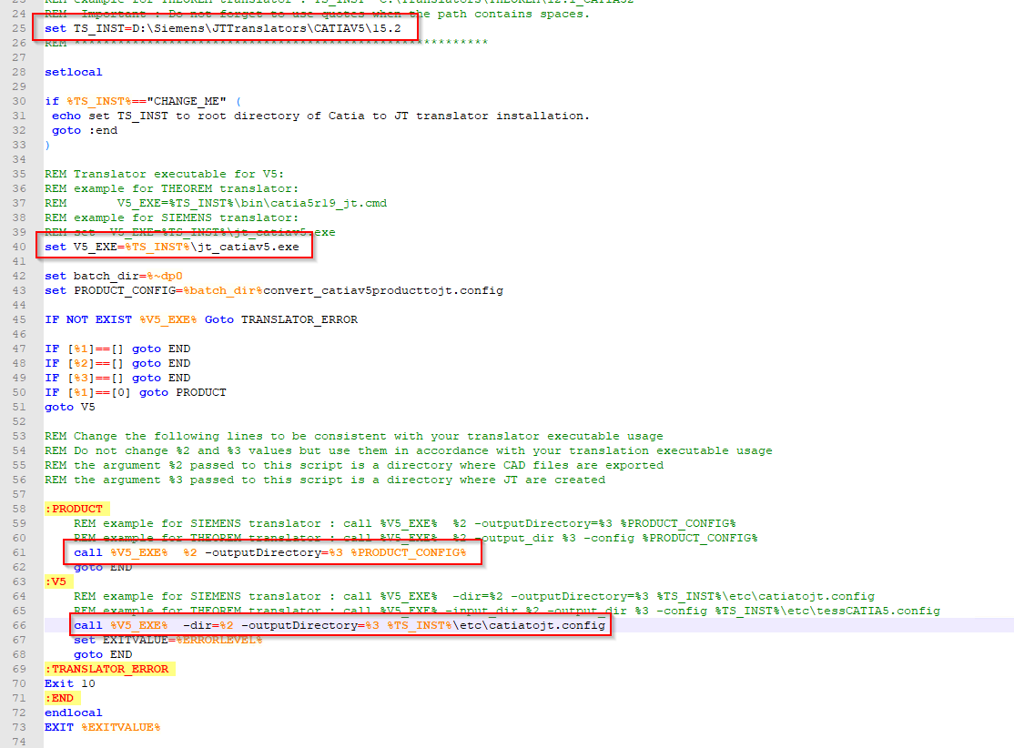

Deploy SolidWorks JT Translation
Modify these files
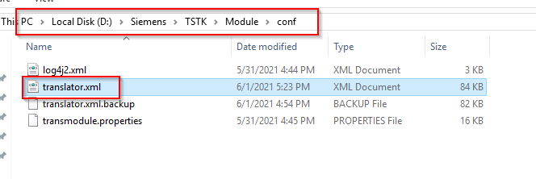
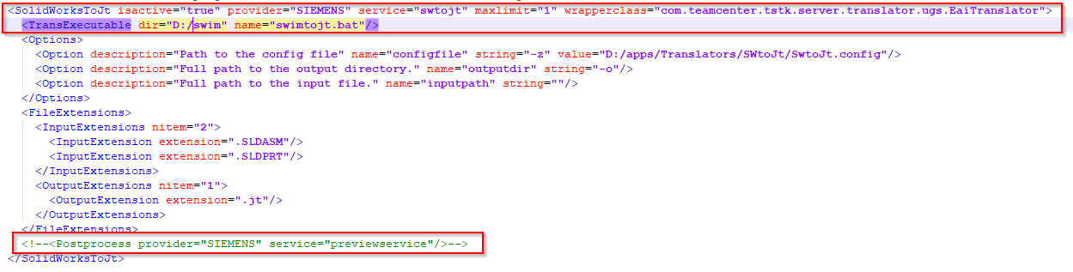
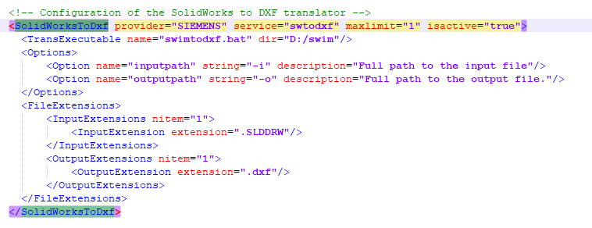
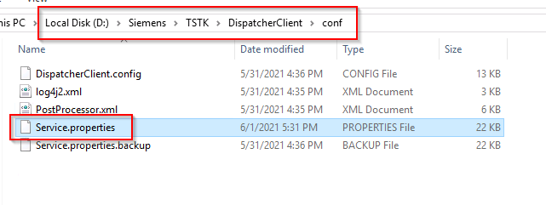
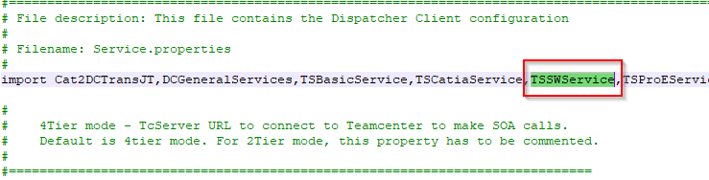
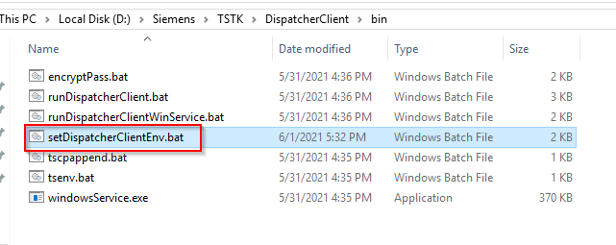
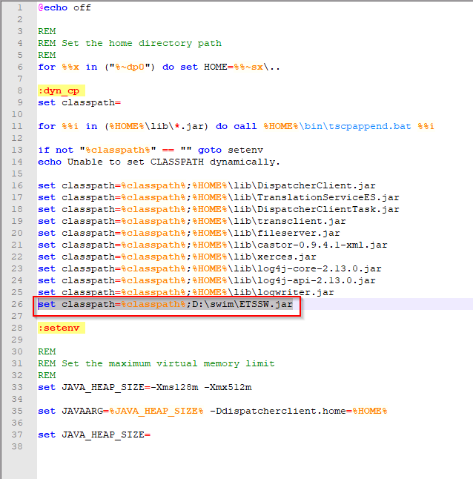
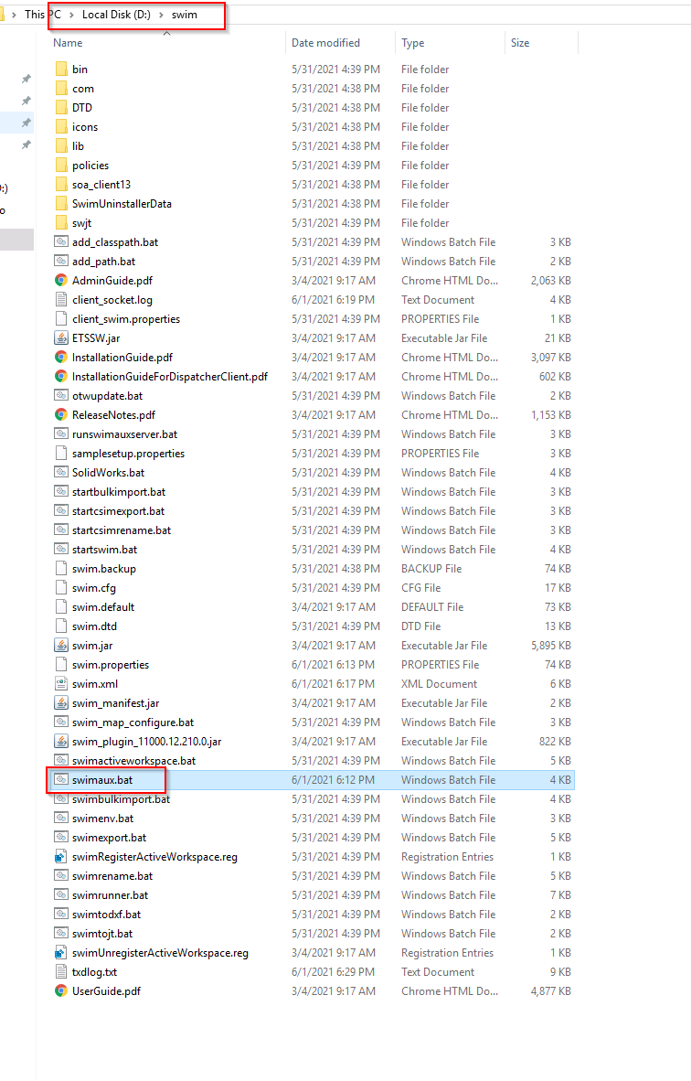
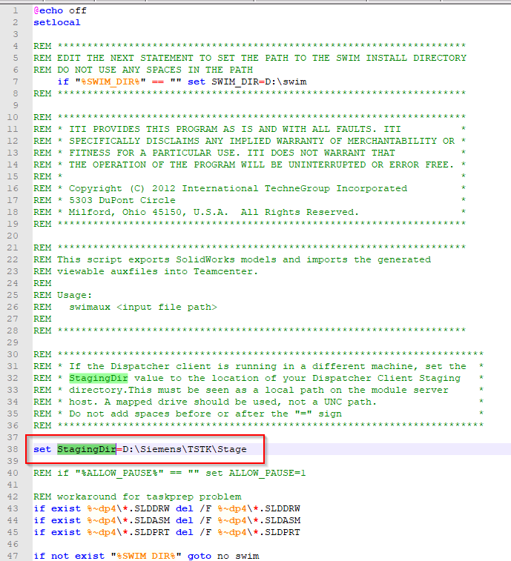
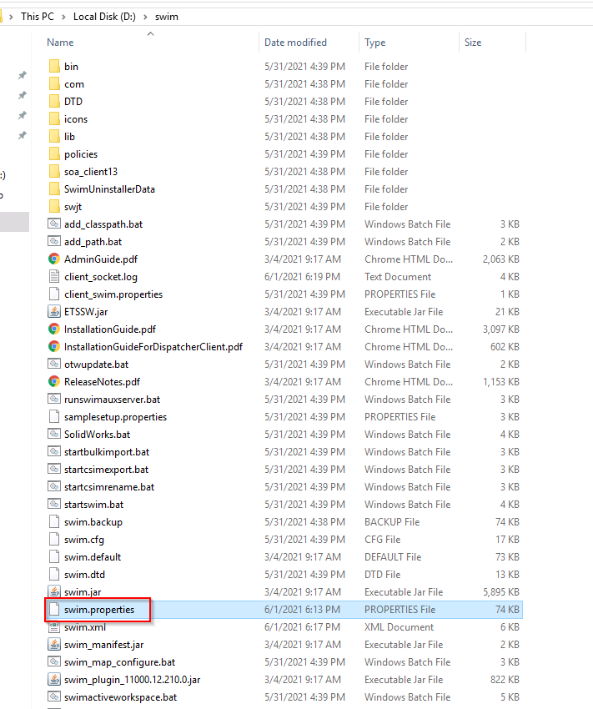
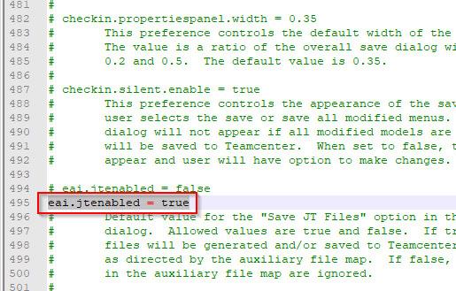
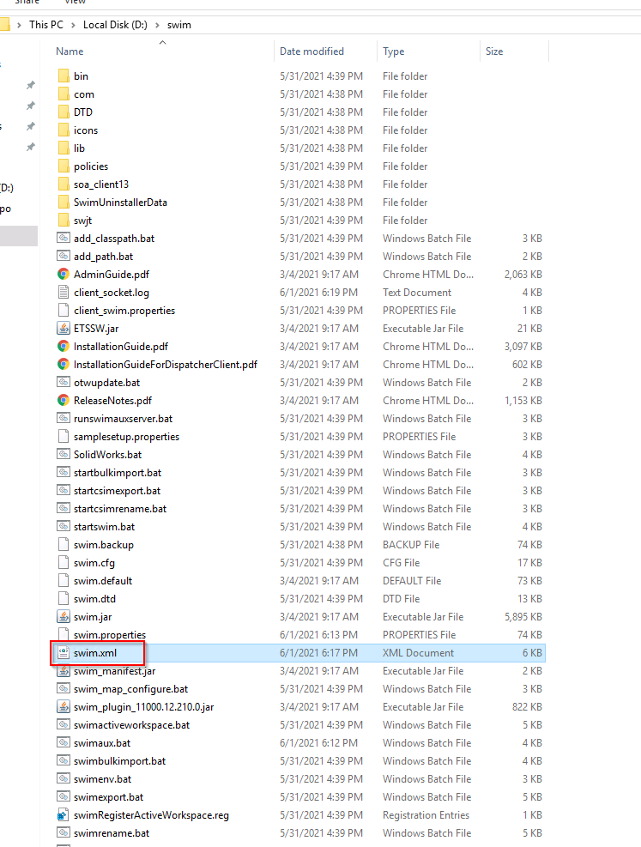
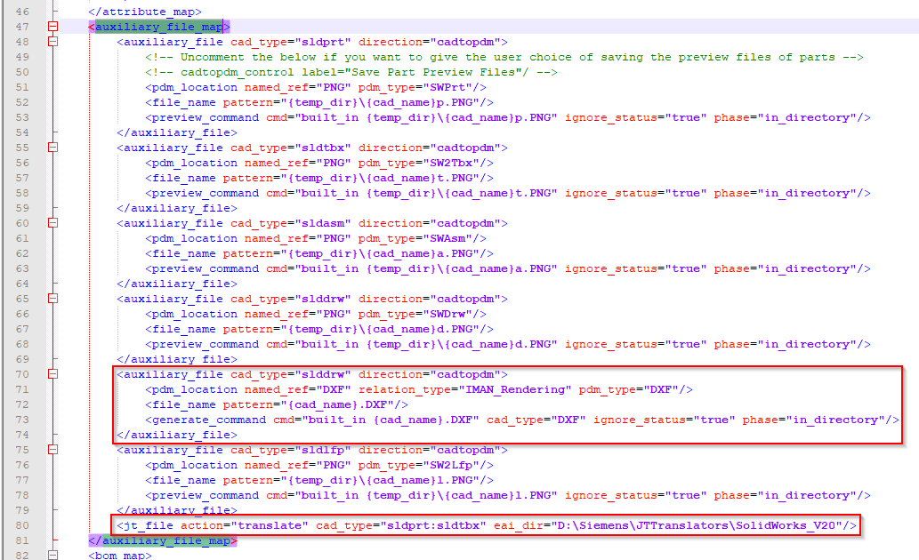
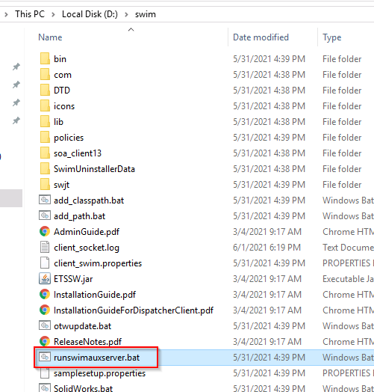
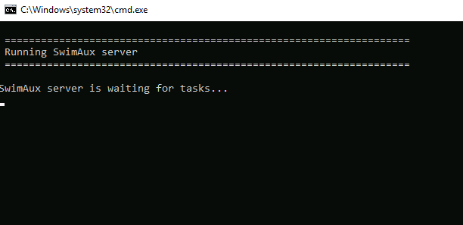

Add FSC Cache Servers

Configure in DC
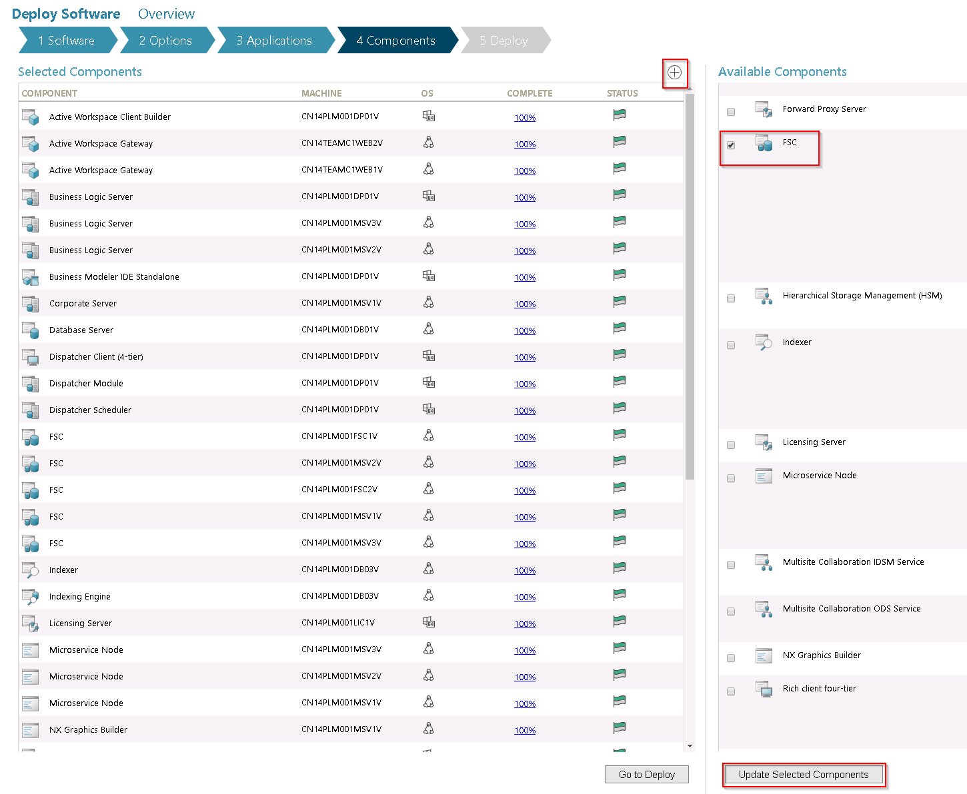
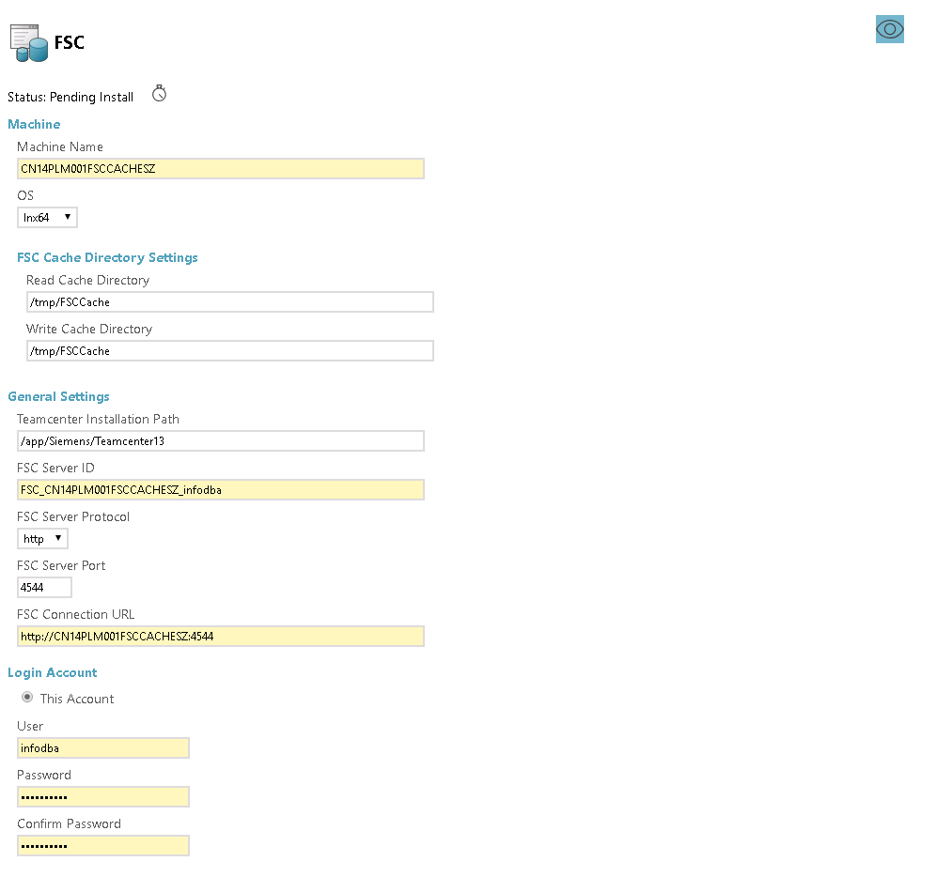
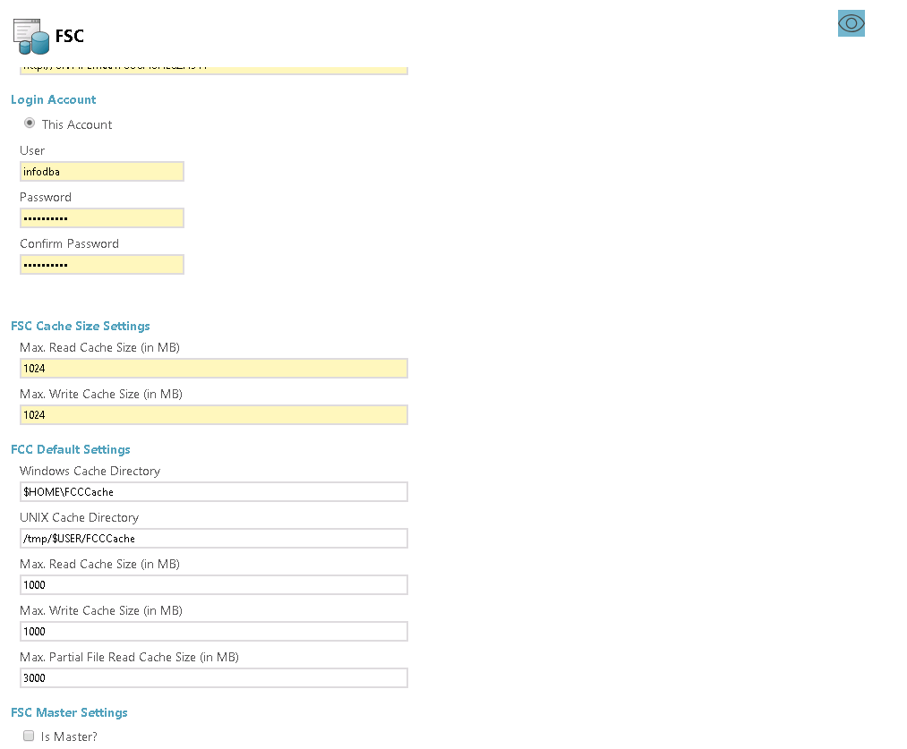
add another fsc cache server
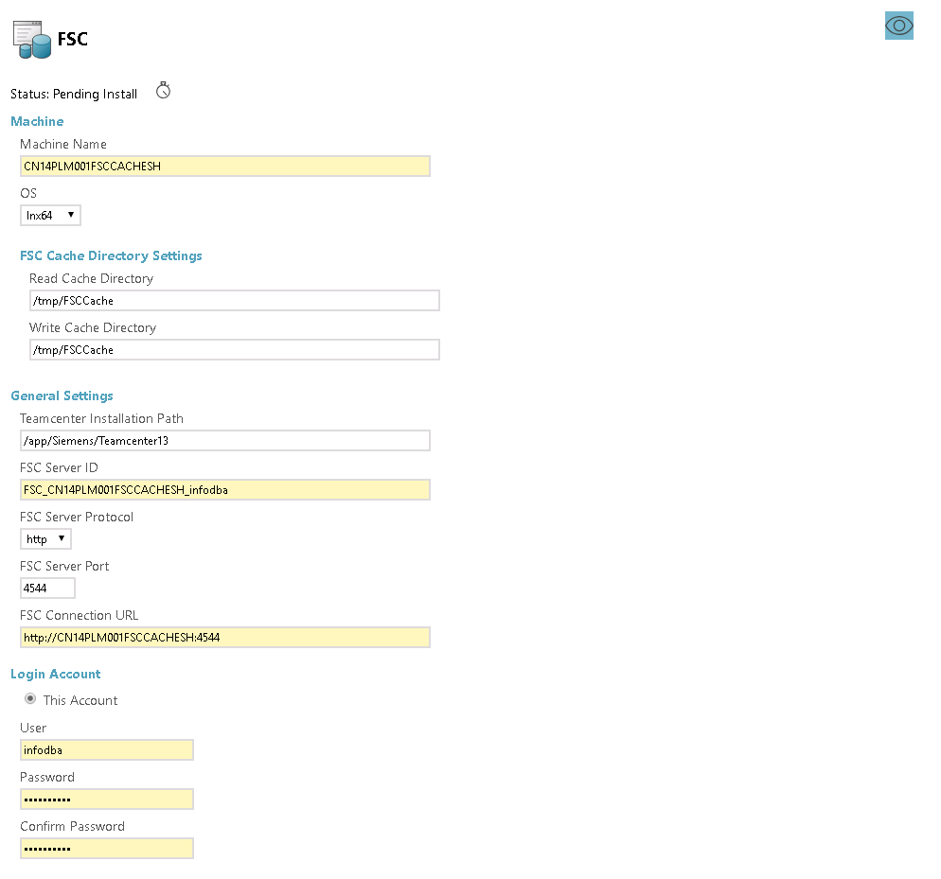
Remember to remove unnecessary fsc entries from other components, basically aw gateway and vis server manager
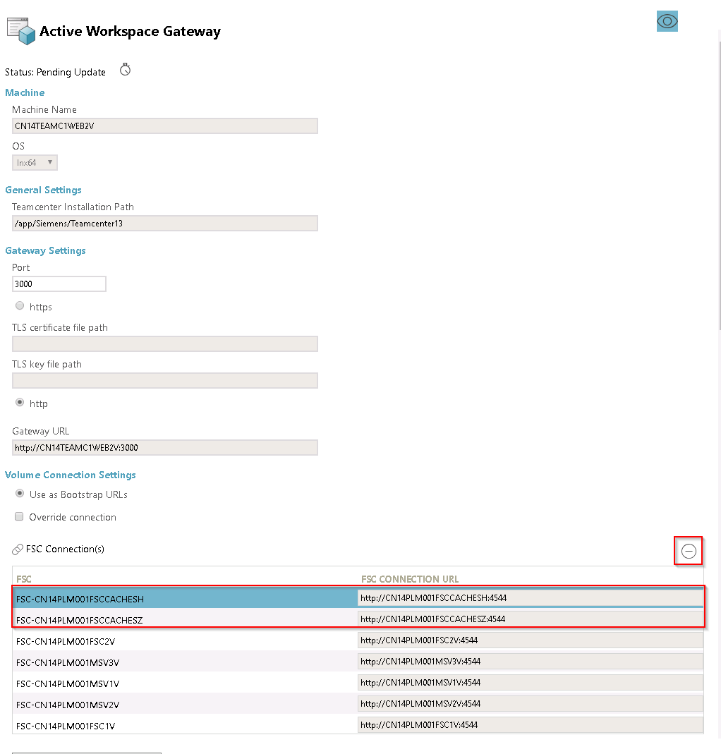
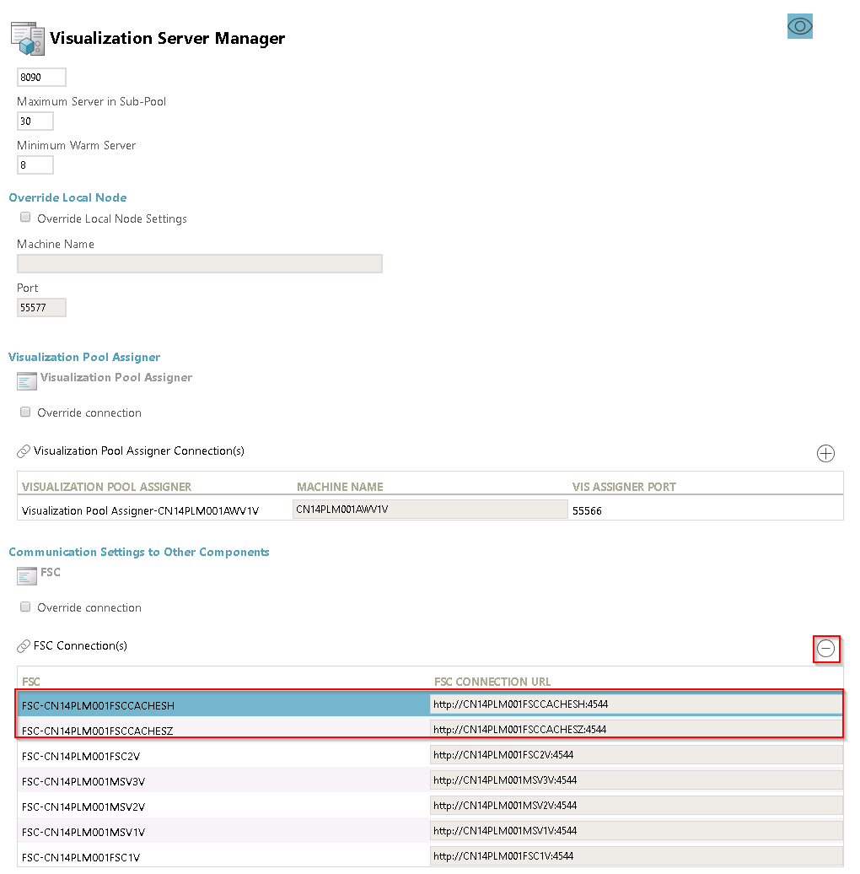

Deploy
generate deploy scripts and deploy following the instructions
on FSC1
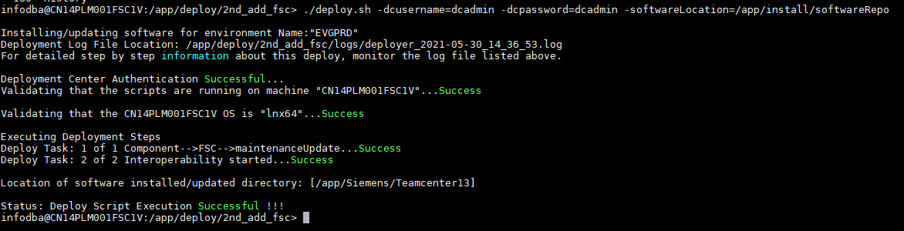
on FSC2
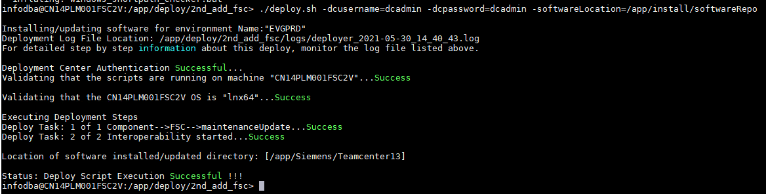
on PoolA
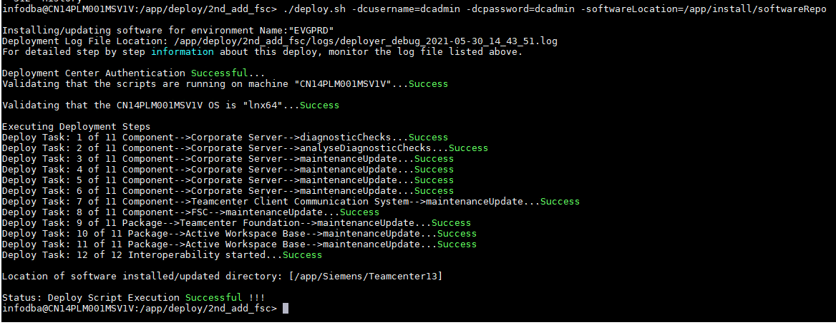
on PoolB
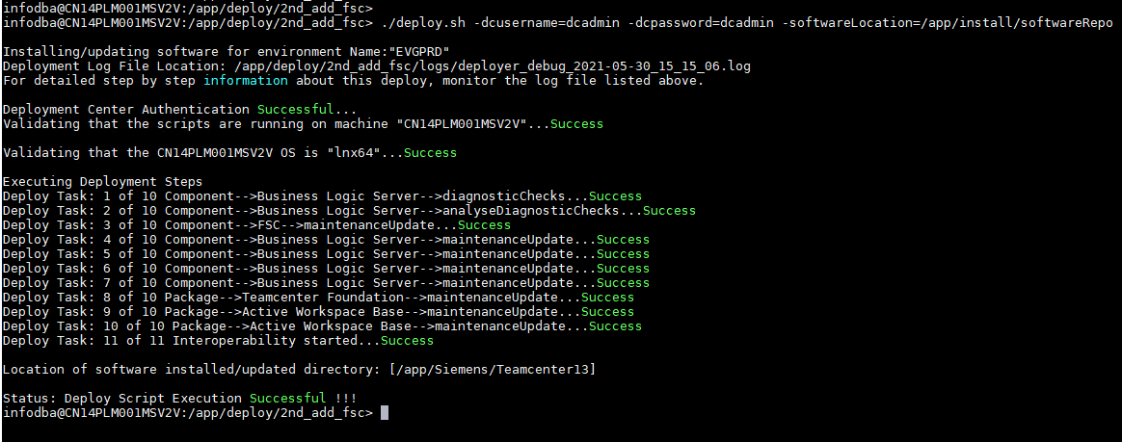
on PoolC
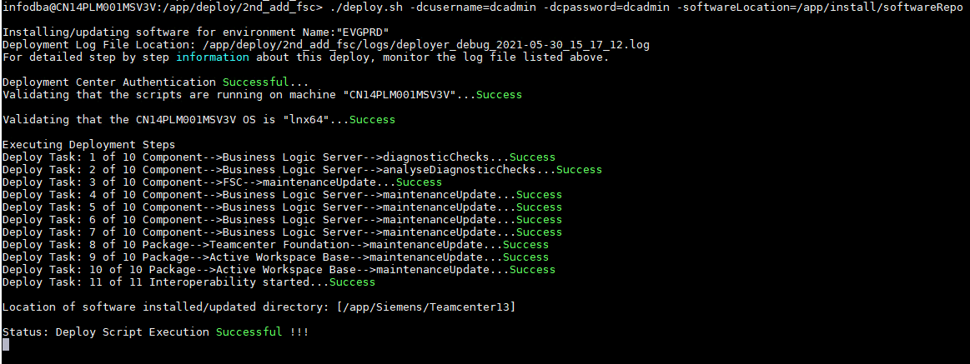
on Dispatcher
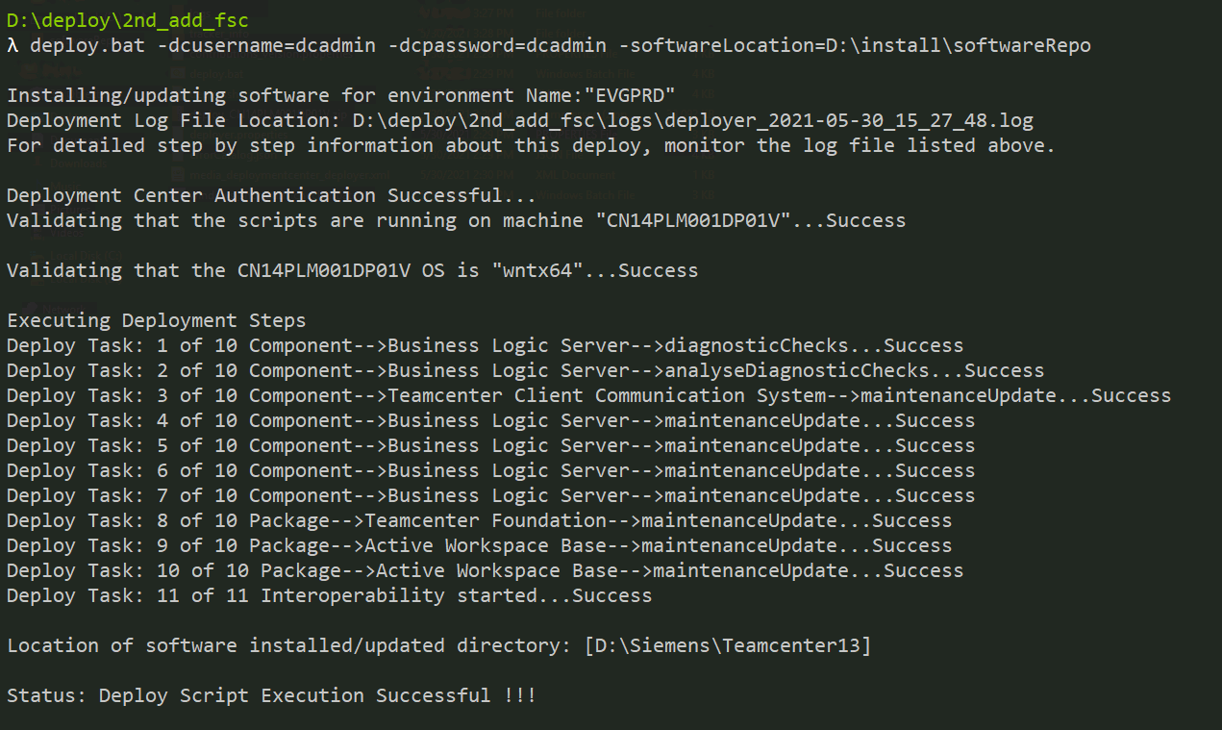
on Shenzhen FSC Cache
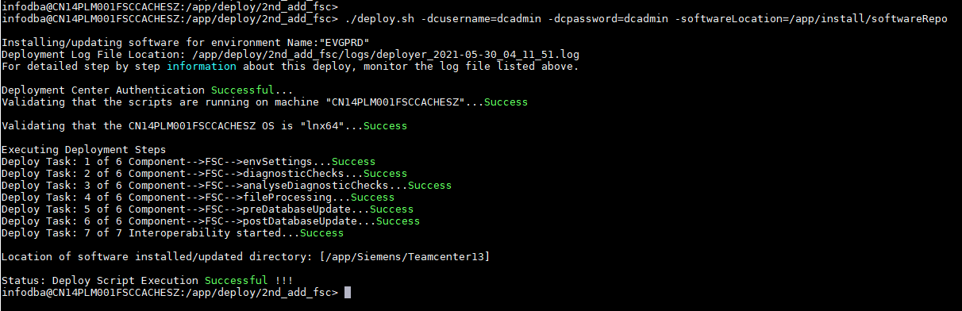
on Shanghai FSC Cache
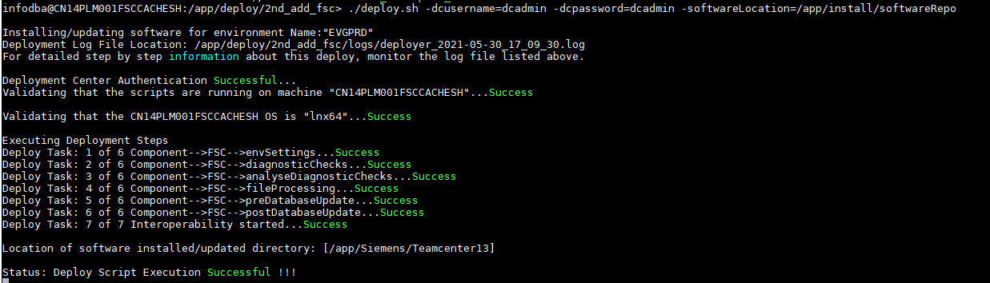
on Web 1
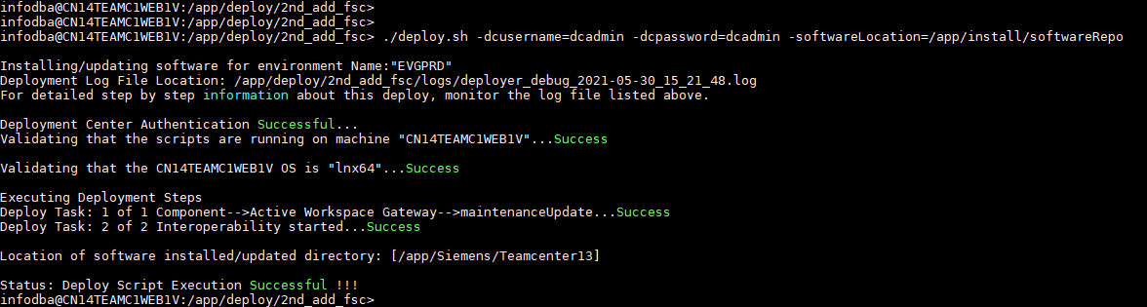
on Web 2
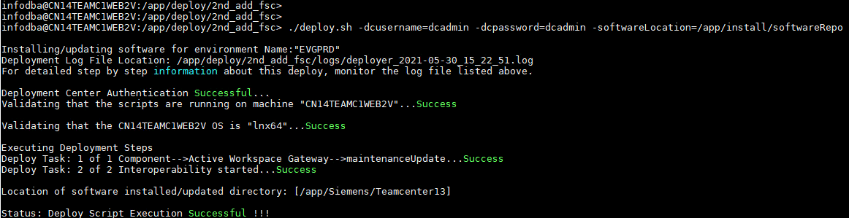
on Vis 1
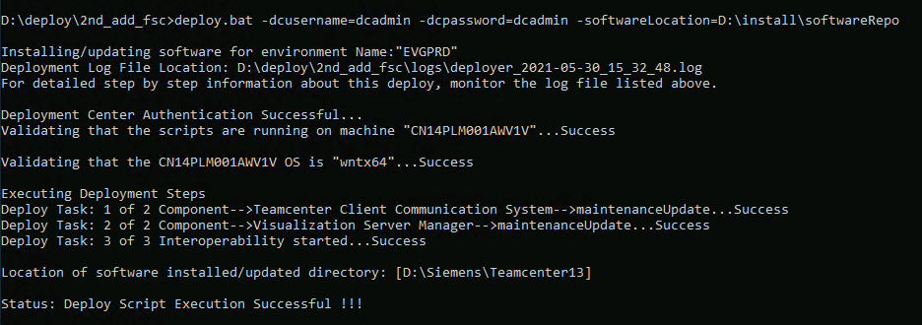
on Vis 2
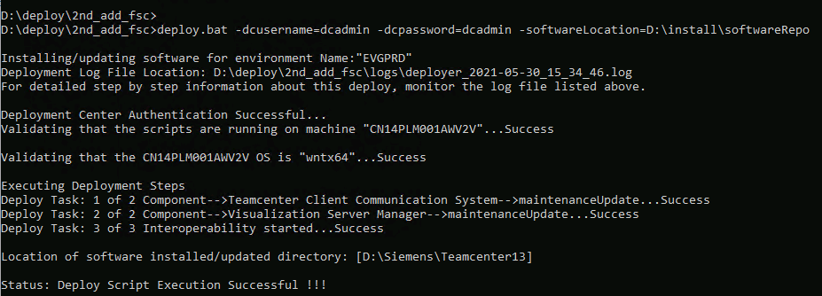

Install EWI with TEM

Avoid TEM Installation Errors
the <TC_ROOT>/install/configuration.xml may contain error after the deployment with dc. and it is used during the TEM installation, as well as running send_configuration_to_dc utility. typically errors are:
- missing “foundationSettings” information in configuration.xml
- missing “transdata” information in configuration.xml on Dispatcher server
- wrong Teamcenter Oracle Database connection information in configuration.xml
- wrong Server Manager Cluster Database information in configuration.xml
the right order to fix them is:
- correct the information on all necessary servers
- deploy features with TEM on all necessary servers
- run send_configuration_to_dc utility to scan the updated servers
Fix the errors following below screenshots:
- missing “foundationSettings” information in configuration.xml
this error may exist on all servers with Teamcenter Foundation installed. but the configuration could be right on the first installed TC server, AKA ‘Corporate Server’
if the error exists, copy below xml snippets to configuration.xml
<foundationSettings guid="LHBY67ZYMYHSKED26FHDNDHFJTZD84I7">
<productionEnvironment value="true" />
<updateDatabase value="true" />
<requestMetaCacheRebuild value="true" />
<targetkit value="" />
<emailCharSet value="ISO-8859-1" />
<connectionSecurity value="None" />
<genServCache value="" />
<emailServerPort value="25" />
<sslProtocol value="TLSv1" />
<genClientCache value="generate all" />
<enableGenServCache value="true" />
<templatesToBeInstalled value="" />
<forceUpdateDatabase value="false" />
<quickClone value="false" />
</foundationSettings>
the snippets are all the same for Teamcenter 13.1
or you can find effective information from other versions of Teamcenter from your own VM
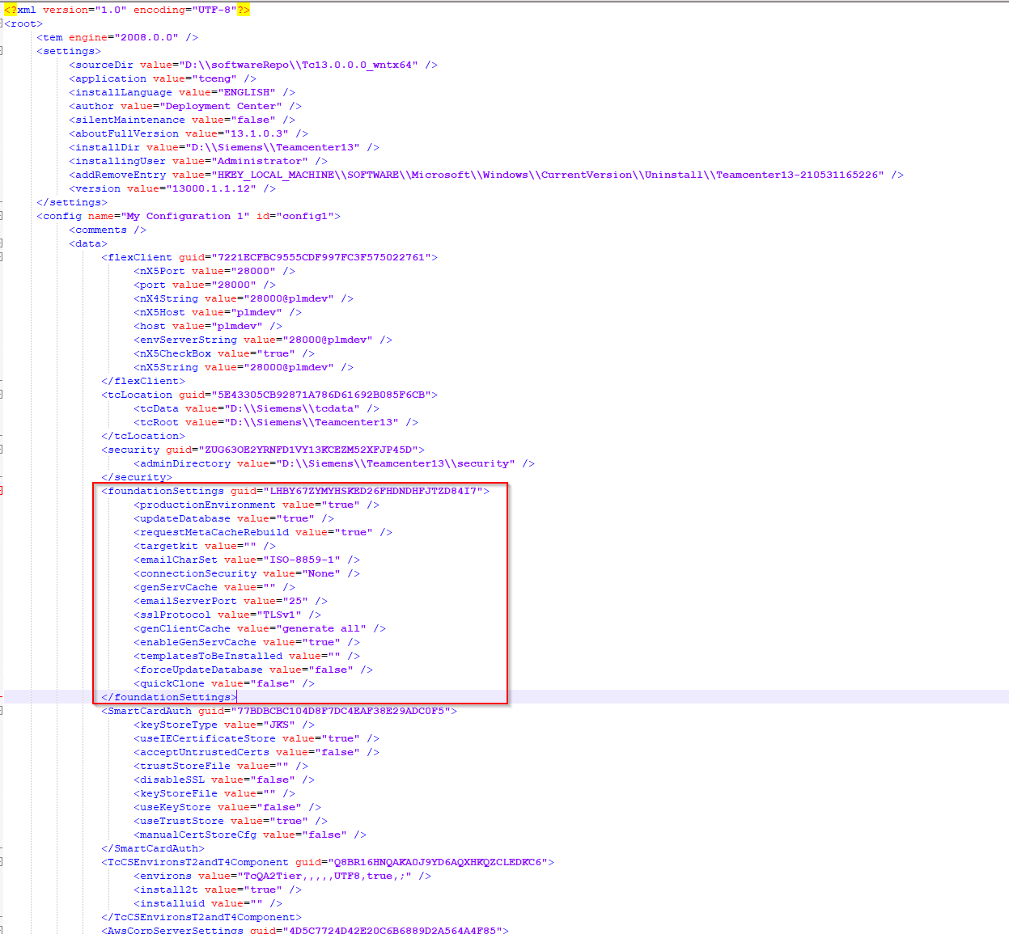
- missing “transdata” information in configuration.xml on Dispatcher server
this error may exist on Dispatcher server only. no need to add it to Pool servers
copy below xml snippets to configuration.xml
<transdata guid="20E5BB0DBACCAC06FFFE406C68EA51AD">
<ugiiLic value="" />
<nxToPvDirectSel value="false" />
<reqMgmtHtmlToWordSel value="false" />
<publishBatchSel value="false" />
<updateMassProductViewsSel value="false" />
<watchedFolderResultDir value="" />
<proeToDxfSel value="false" />
<spatialSrchIndxrSel value="false" />
<sCFTransSel value="false" />
<subsCmplGenerateDeclarationSel value="false" />
<plmSyncSelected value="false" />
<pcbToFatFSel value="false" />
<nxTransDirectSel value="false" />
<reqMgmtPerformOperationSel value="false" />
<populateFscSel value="false" />
<cpdTranslatorSel value="false" />
<subsCmplMSDRerequestSel value="false" />
<imageCompressionSel value="false" />
<tcVisHome value="" />
<spatialSrchTransSel value="false" />
<subsCmplSel value="false" />
<fileTranslationMaxWait value="600" />
<rdvContextDbDownloadSel value="false" />
<partUtilitySel value="false" />
<cmsBasePublishTool value="false" />
<subsCmplDeclarationRemindersSel value="false" />
<prevServSel value="false" />
<nmsdPath value="" />
<ugsLicServ value="28000@tc13vm" />
<nxHome value="" />
<replicateObjsSelected value="false" />
<tcFtsIndxrFourTierUrl value="http://&lt;HOSTNAME&gt;:7001/tc" />
<sETransHome value="" />
<queryscosSel value="false" />
<createAssSelected value="false" />
<publishBatchTransHome value="" />
<sETransSel value="false" />
<storeAndForwardSel value="false" />
<proETransHome value="" />
<subsCmplMSDImportSel value="false" />
<compareContentsSel value="false" />
<mesDataGenSel value="false" />
<watchedFolderInputDir value="" />
<tcVisLic value="" />
<nxToCgmDirectSel value="false" />
<fmsTransferSel value="false" />
<tcFtsIndexerTransSelected value="true" />
<generate3DPDFReportSel value="false" />
<batchPrintSel value="false" />
<fmsTransferBootFscUris value="" />
<rdvContextNonDbDownloadSel value="false" />
<sCFTransHome value="" />
<mmvIndexGenSel value="false" />
<enableCopyUG value="false" />
<emailPollingSel value="false" />
<tcFtsIndxrTcRetryCount value="5" />
<renderMgtTranslatorSel value="false" />
<subsCmplSDValidationSel value="false" />
<importObjsSelected value="false" />
<user value="" />
<asyncServiceSel value="false" />
<proeToJtSel value="false" />
<nxCloneSel value="false" />
<reqMgmtWordToHtmlSel value="false" />
<barcodeGeneratorSel value="false" />
</transdata>
the snippets are all the same for Teamcenter 13.1 (and here you can see no translator is selected)
or you can find effective information from other versions of Teamcenter from your own VM
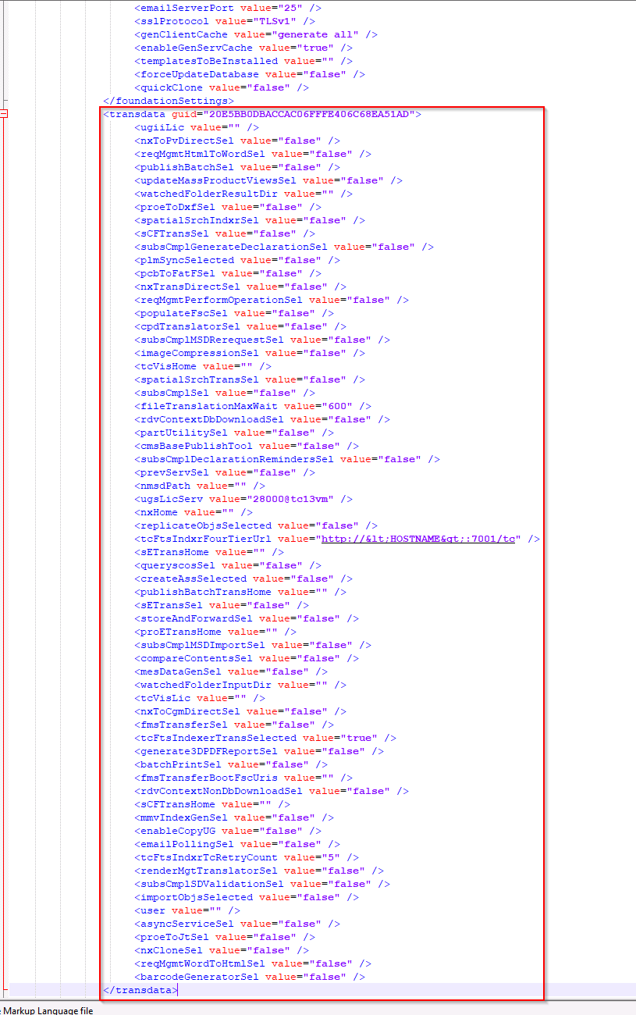

- wrong Teamcenter Oracle Database connection information in configuration.xml
If error exists, it should be like:
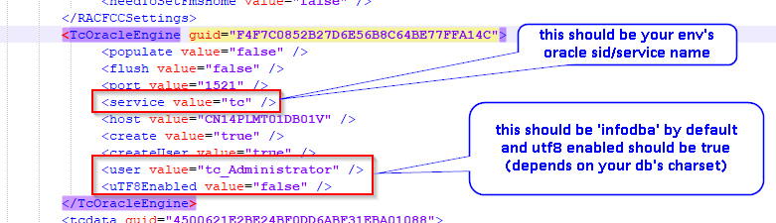
after the correction:
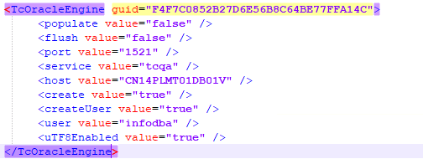
- wrong Server Manager Cluster Database information in configuration.xml
This error may exist on Pool servers only
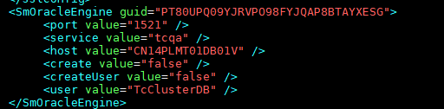
‘service’ should be your oracle sid/service
‘user’ should be your Server Manager Cluster DB user, that one you defined during the first installation. it is ‘TcClusterDB’ by default.
after the correction:
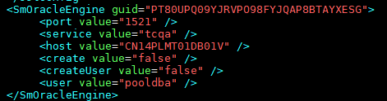

the tablespace information may be missing or mistaken:
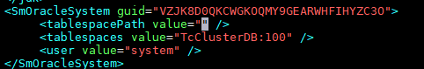
after the correction:
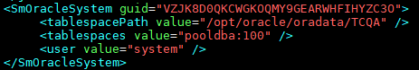

after these corrections we could install with TEM now

install on Pool servers and Dispatcher server
on Pool servers
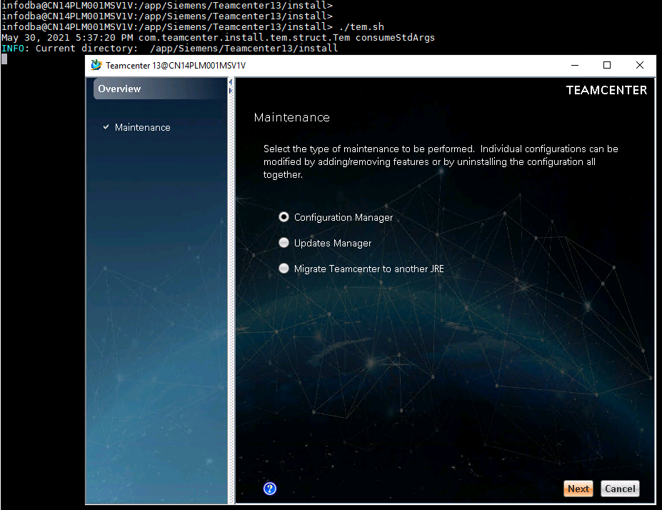
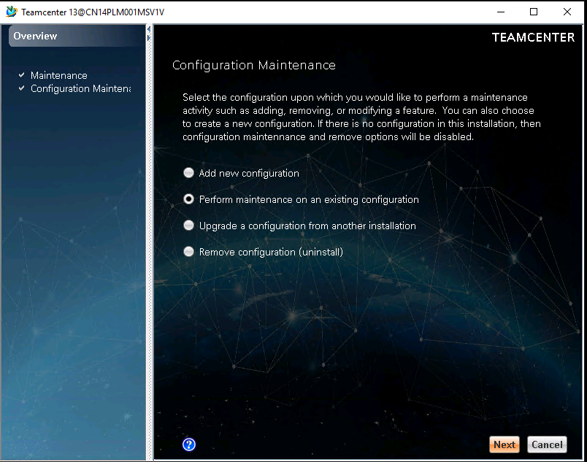
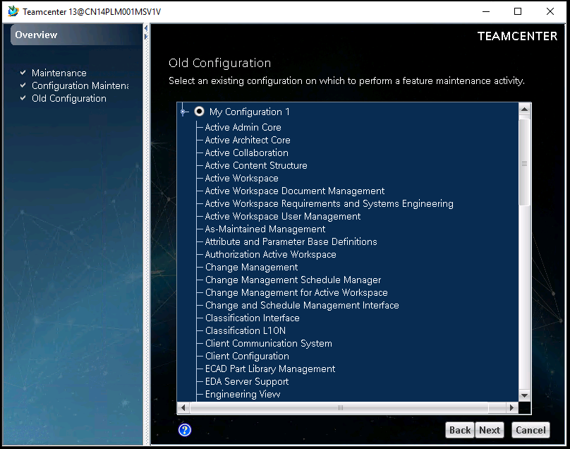
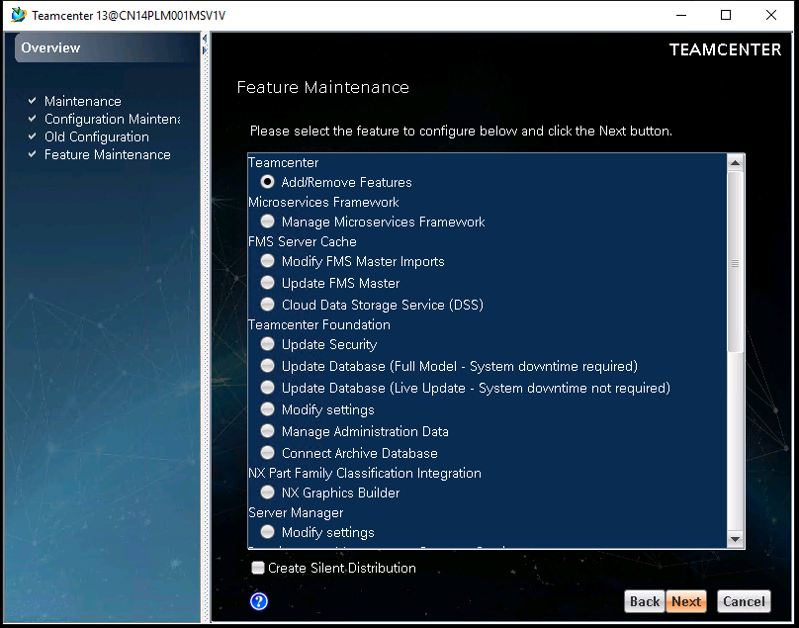
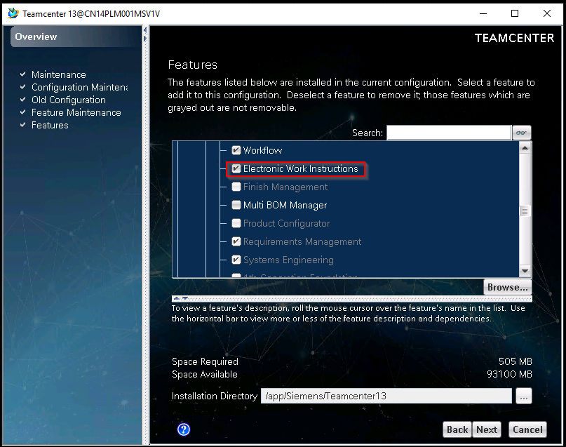
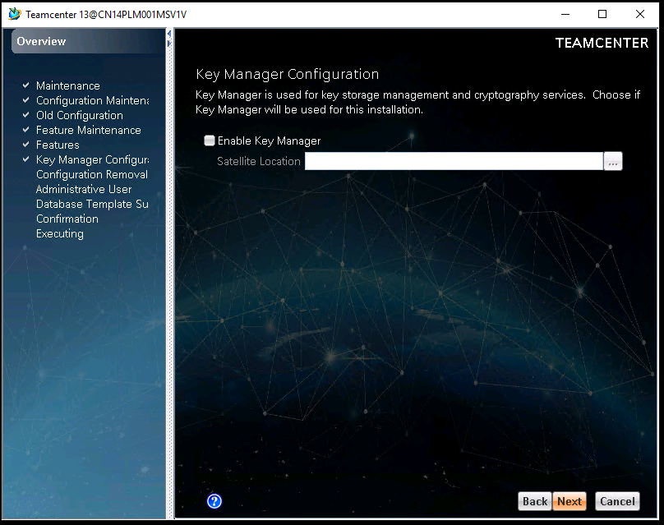
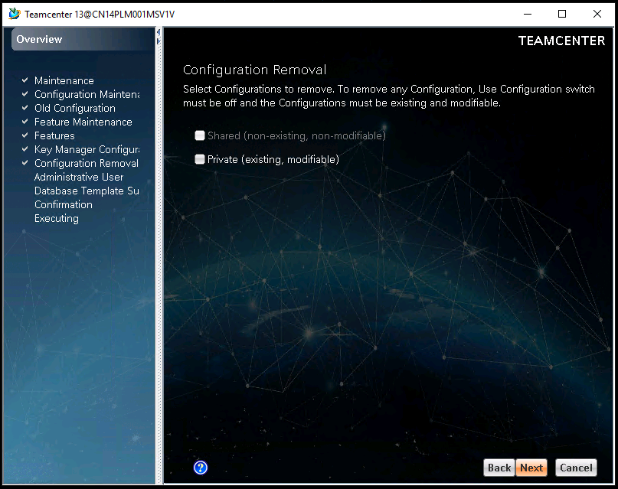
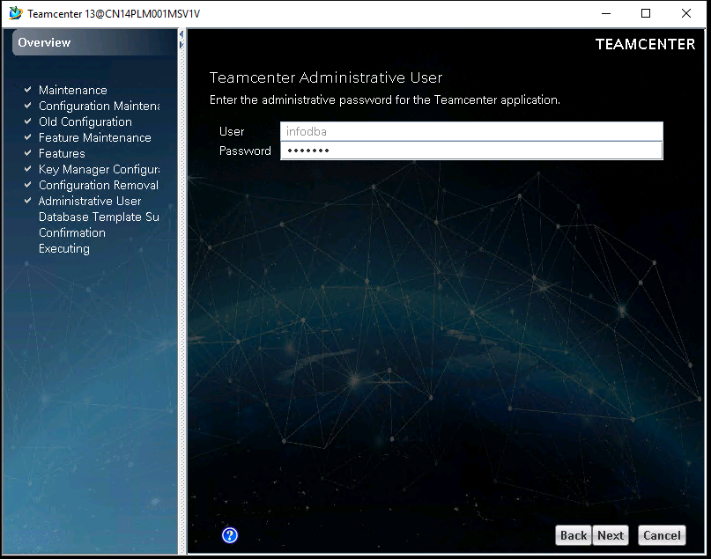
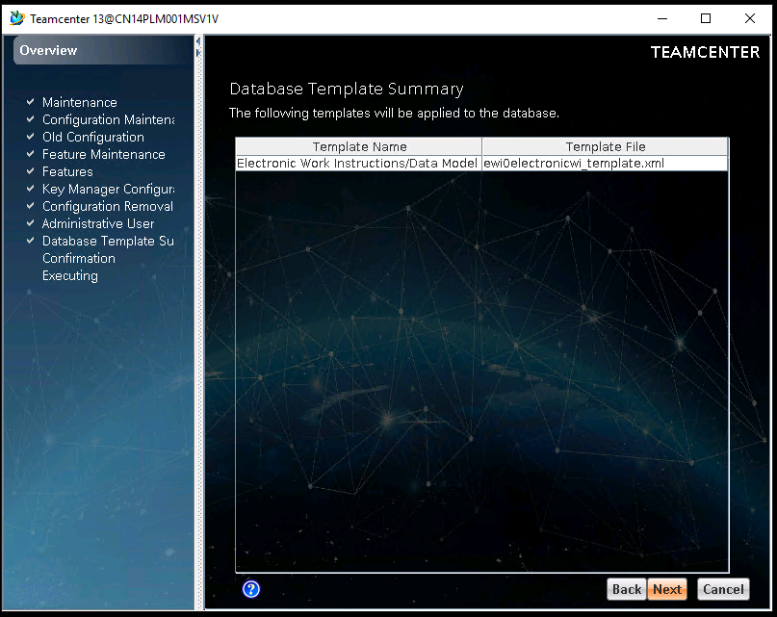
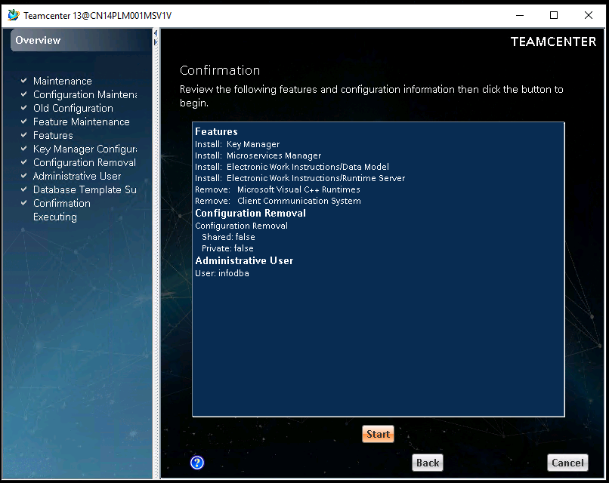
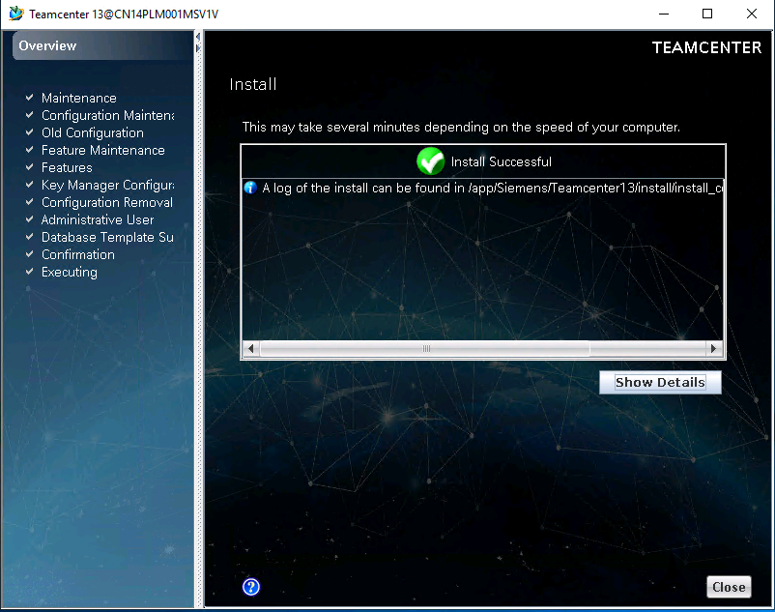
on Dispatcher
Active Workspace Client:

Active Workspace Server Extension:

after the whole installation
run send_configuration_to_dc utility on pool servers and dispatcher server to sync status with deployment center
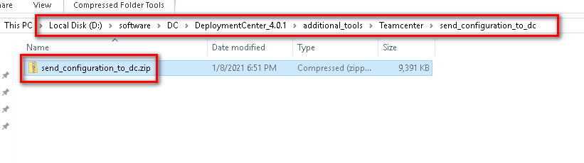
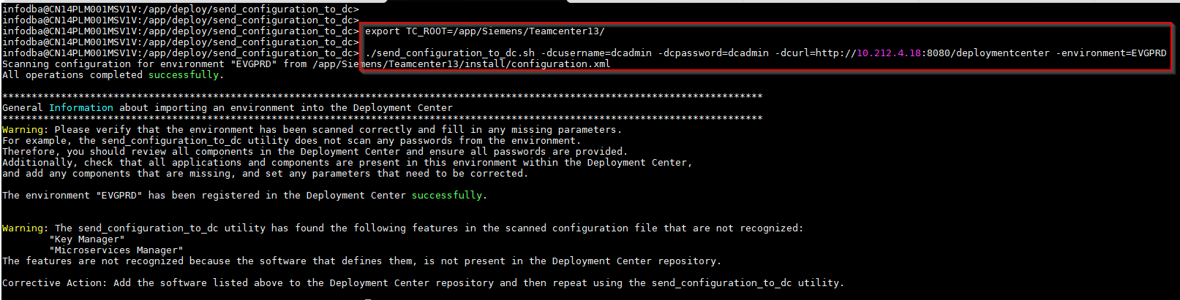
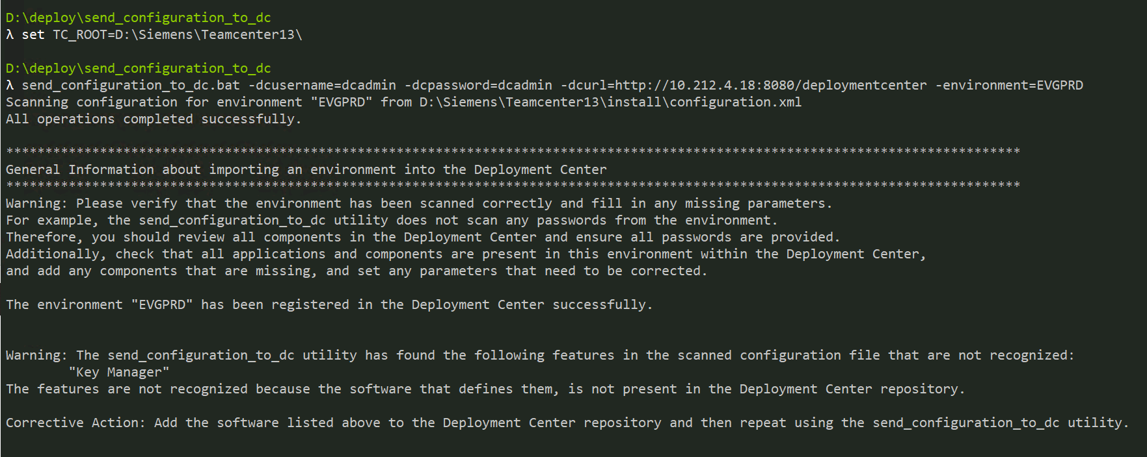
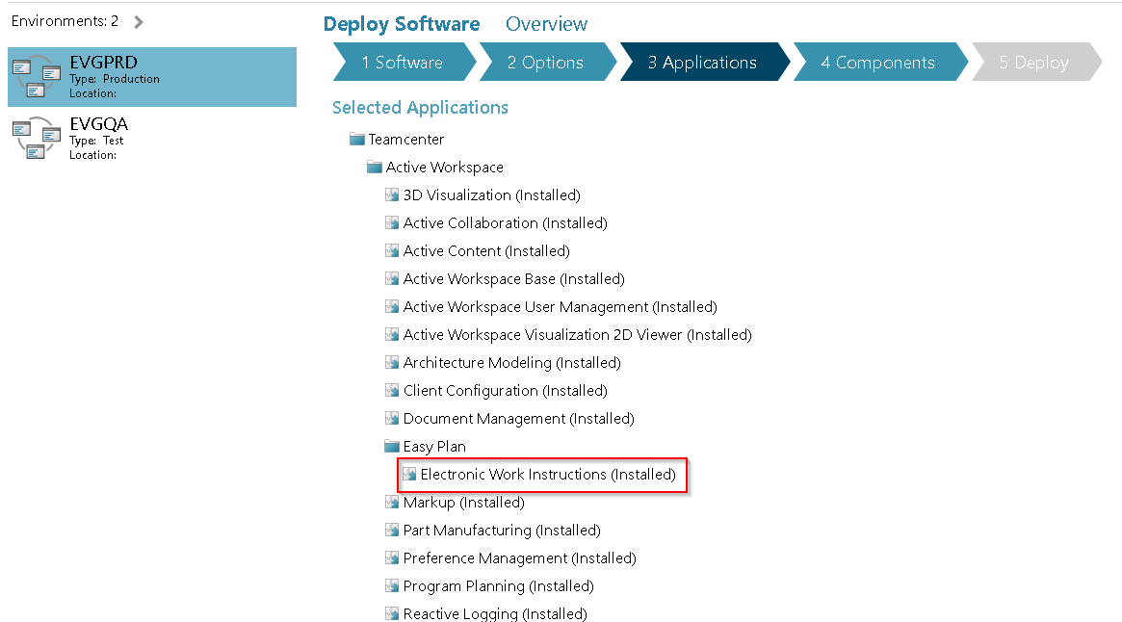
re-generate the scripts then deploy

Configuration

Create a Data Volume for users
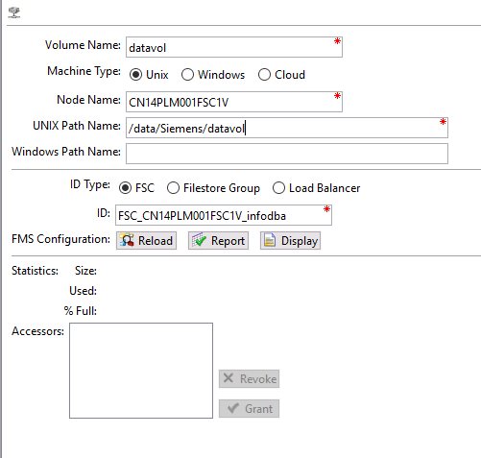
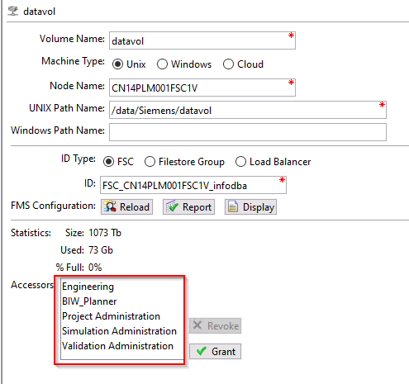
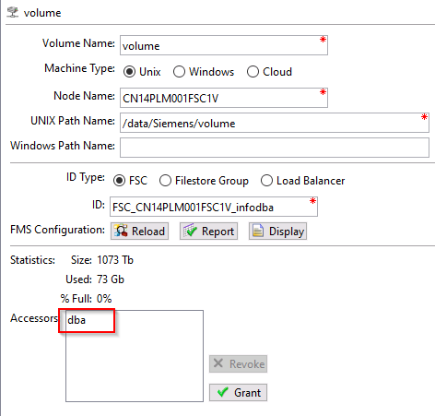

How to Update BMIDE Template
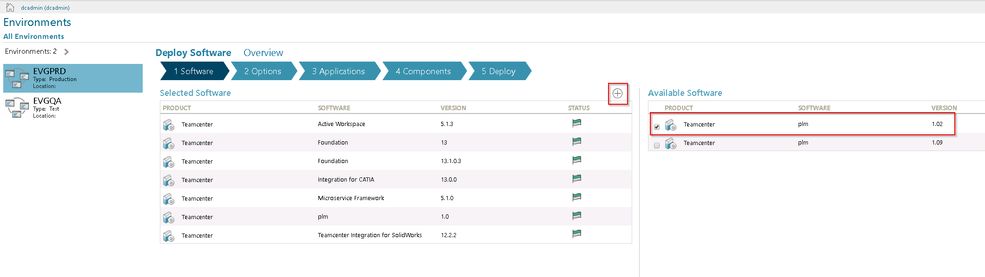
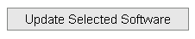
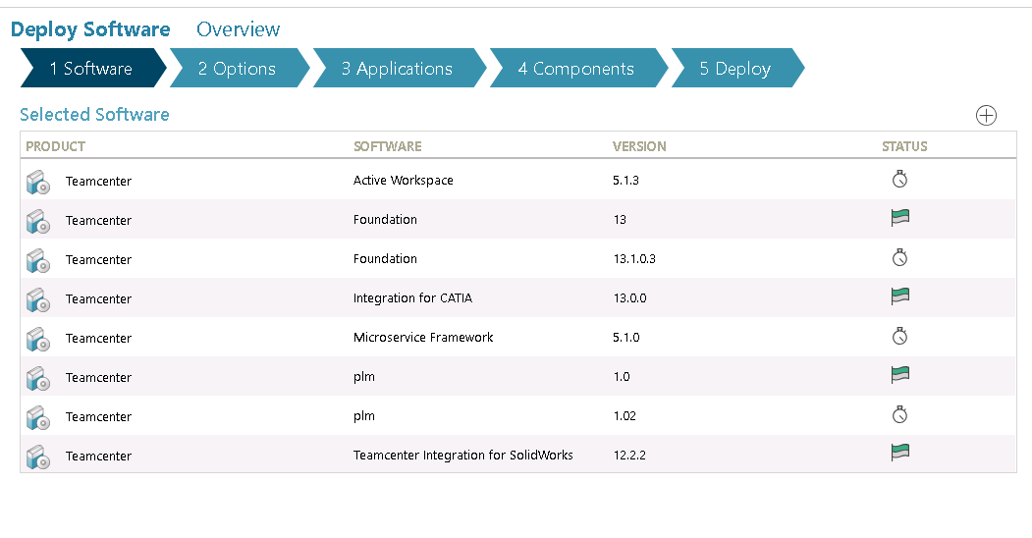
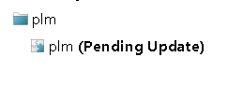
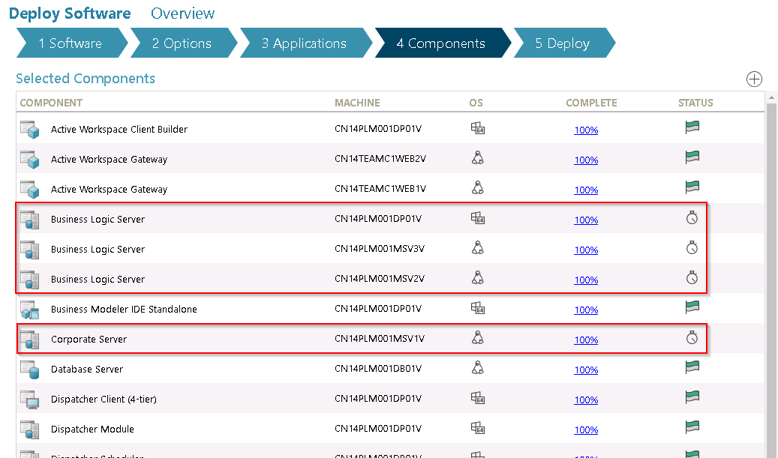
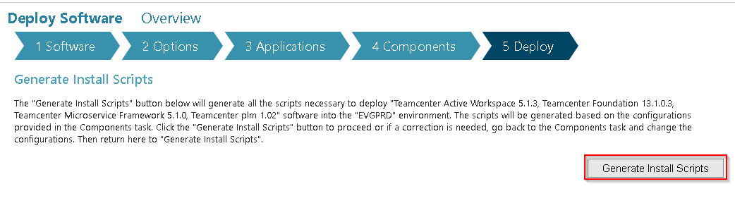
generate scripts then deploy
deploy Corporate Server (PoolA) First!!!

