

Apr 09, 2020
IR 9746658: Active workspace view office file error
A Solution Proposal to the Incident Report Provided
Active workspace view office file error
Hi All,
Thank you for reporting the IR to GTAC. With respect to your query could you please follow the below steps and if still does not work for me then please provide the requested logs at the end of the steps.

If you are using TC12.2 and above then you can use TEM to install Office Online rather DC.
Software Versions
1. Operating System - Windows Server 2012 R2
2. Deployment Center 2.0
3. Teamcenter 11.4
4. Active Workspace 3.4
5. Office Online Server 2017
NOTE:- This will not work prior to TC 11.4 AND AW 3.4. This is a paired version deployment.
Pre Reqs
• To view and edit word documents within AW we require a:
⊄ Domain Controller
⊄ Microsoft Office Online Server
§ (Microsoft Office Online Server can only be installed on a domain and must be on a separateserver)
⊄ Teamcenter Office Server
⊄ .NET4.5.2
⊄ Visual C++ Redistributable for Visual Studio 2015 {On Microsoft Office Online Server}
⊄ Visual C++ Redistributable Packages for Visual Studio 2013 {On Microsoft Office OnlineServer}
⊄ IIS on MOOS & TOOS
⊄ OS WS2012R2
⊄ Document Management feature needs to be installed for AW Server & Client.
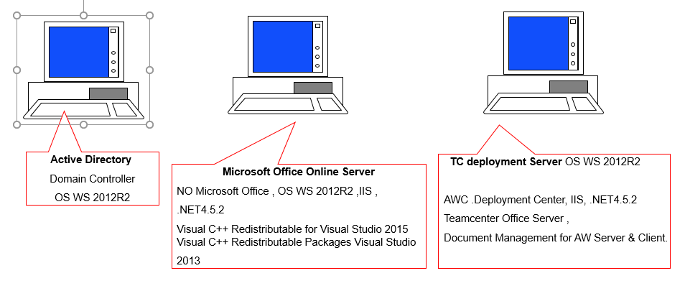
The MOOS must be installed on a server which is connected to an Active Directory (ADS) domain BUT cannot be the AD Server itself. Teamcenter and Active Workspace must be installed on a server separate from MOOS and preferably TOOS. This means you need minimally 3 servers to setup this environment unless you are connecting to a corporate AD server (assuming this is a Test Lab autonomous from the corporate installation):
Architecture (Minimum):-
Server 1: AD Server
Server 2: Microsoft Office Online Server
Server 3: Teamcenter and Active Workspace
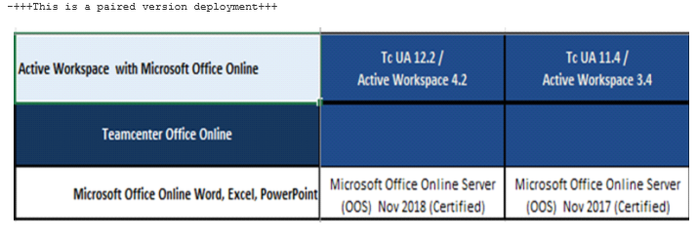
Also please check AWC_defaultViewerConfig.VIEWERCONFIG preference::
MSWordX.Awp0TcooViewer=word,Fnd0word
MSWord.Awp0TcooViewer=word
MSExcel.Awp0TcooViewer=excel
MSExcelX.Awp0TcooViewer=excel
MSPowerPointX.Awp0TcooViewer=powerpoint
MSPowerPoint.Awp0TcooViewer=powerpoint
NOTE :-Make sure there should not be any entry for MSWordViewer & MSExcelViewer. This value should be “Awp0TcooViewer” for the Tc Office Online viewer.
Remove Below Values, if below values are there in the Preference-
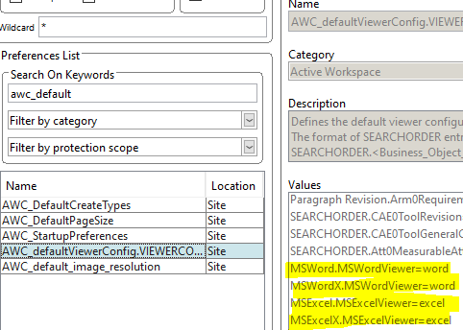
Check Teamcenter Office Online Preferences to ensure they have been set correctly
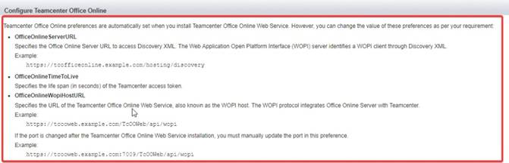
• Deployment center DID NOT set OfficeOnlineWopiHostURL correctly, it must be modified to append /api/wopi
OfficeOnlineFeatureTypes
Office:MSWordX,MSWord,MSExcelX,MSExcel,MSPowerPointX,MSPowerPoint
OfficeOnlineTimeToLive
900
OfficeOnlineWopiHostURL
<>
OfficeOnlineServerURL (required for version 11.4)
· <>
Please install IIS on both MOOS & TOOS and make sure below feature is installed-
Roles & Feature needs to be installed on OOSVR & TCOOS Under .Net 4.5.2
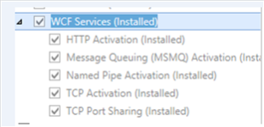
Install Microsoft Office Online on the Server
Deploy Office Online Server
<>
Office Online can be obtained from the MSDN
Domain admin user must be used in order to install office online
Install stated pre requisites for specific server
Windows Server 2012 R2 PreReq
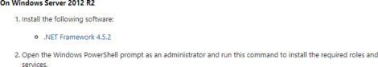
3. Deploy Office Web App Server Farm on HTTP
Here, you'll install a single-server Office Web Apps Server farm that uses HTTP. You won't need a certificate or load balancer, but you will need a dedicated physical server or virtual machine instance that isn't running any other server application.
ullet Open an administrative PowerShell and run the follow command to create a new Office Web Apps Server farm:
New-OfficeWebAppsFarm -InternalURL "-AllowHttp -EditingEnabled
(New-OfficeWebAppsFarm -InternalURL "-AllowHttp - EditingEnabled)
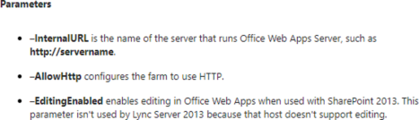
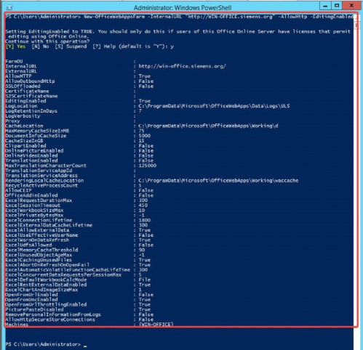
IF this is issue with some certificate then below things can be tried after updating the certificate rune below command-
New-OfficeWebAppsFarm -InternalUrl""-ExternalUrl "" -CertificateName "name of certificate" -EditingEnabled
New-OfficeWebAppsFarm -InternalUrl"https:// WIN-OFFICE.siemens.org "-ExternalUrl "https:// WIN-OFFICE.siemens.org " -CertificateName "name of certificate" -EditingEnabled
4. Verify Office Web Apps Server farm was created successfully.
Note:- TcOOWeb needs to be able to connect to OOS. You can verify these connections with the following.
1. Connection from the TcOOWeb web application to OOS
a. Test with Server Host Name>/hosting/discoveryfrom machine running TcOOWeb
Access URL to check: <>
<>
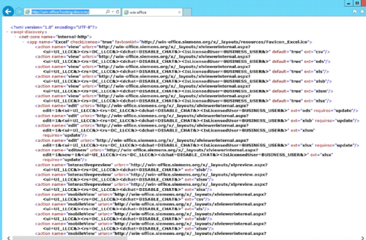
Please try the following on the OOS server from a PowerShell prompt to allow outbound http:-
1. Set-OfficeWebAppsFarm -AllowOutboundHttp:$True
2. Get-OfficeWebAppsHost
3. Get-OfficeWebAppsMachine
4. Get-OfficeWebAppsFarm
Then do "IISRESET" in Windows PowerShell prompt.
Also make sure to verify that the application pool account (TeamcenterOfficeOnline) used for the web application has permissions to the TcOOWeb location and the web.config file. For example, the security properties for web.config file should look like this:
For the security settings, when adding TeamcenterOfficeOnline, you have to specify the full value "IIS APPPOOL\TeamcenterOfficeOnline".
For proper logging and web.config permissions, perform the following permission changes on the TcOOWeb folder. This should affect all subfolders and files.
Open the Properties dialog for the TcOOWeb folder.
On the Security tab, after selecting the Edit… button, select the Add… button on the Permissions dialog.
Enter "IIS APPPOOL\TeamcenterOfficeOnline".
Note you also need to specify the local machine for the "From this location" field
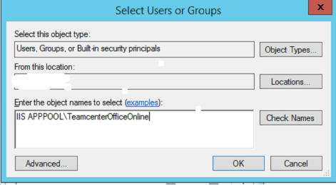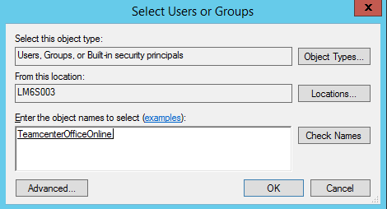
Select the Check Names button.
The name should resolve and change to the underlined TeamcenterOfficeOnline
Be sure to specify full control.
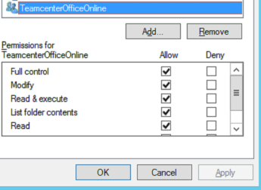
Make sure TCOOWEB folder is located to below location (C:\tcooroot folder in c drive.
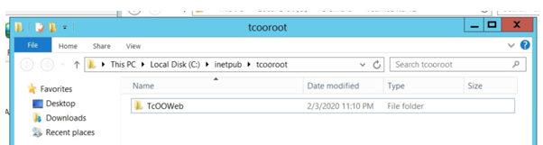
Make sure Physical Path for SITES set as below in IIS.
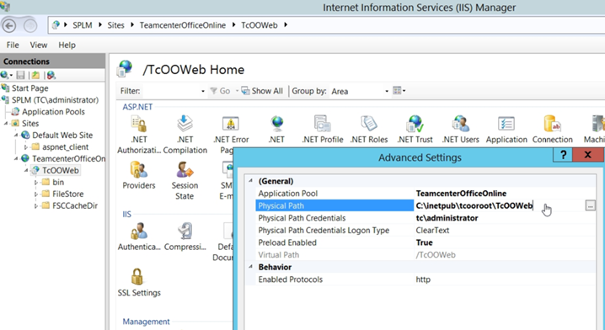
1. Please make sure "<Proof-Key>" value for the attributes within that element that are named "oldvalue", "oldexponent", and "oldmodulus" in WOPIDiscovery.XMLhas been assigned correctly (manually) in TC11.5. This has been corrected in TC11.5.0.5. From an Administrative Common Prompt window, run IISRESET.
Configuration steps should include instructions to ensure FIPS is disabled on the Office Online Server and the server where TcOOWeb is installed. These steps could be summarized as:
1. Access Local Security Policy settings from Control Panel | System and Security | Administrative Tools
2. From the left navigation area, expand the Local Policies section, and click on Security Options
3. In the detail pane, locate the Policy titled, "System cryptography: Use FIPS compliant algorithms for encryption, hashing, and signing"
4. Ensure the Security Setting value for this Policy is set to "Disabled". If it is not, double-click the Policy, select the "Disabled" option from the Local Security Setting tab, then click "OK" to save
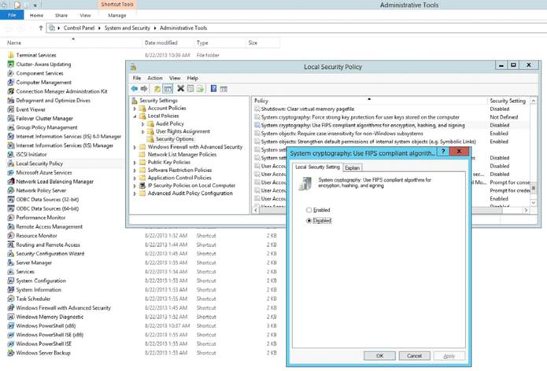
Deploy Teamcenter Office Online
• Teamcenter Office Online is only compatible with AW 3.4
• Teamcenter Office Online can only be installed with the use of deployment centre. View the documentation on deployment Center to set it up on an existing or new configuration.
• Ensure Teamcenter is installed on a different server to that of Office Online
• Ensure the Teamcenter server is able to ping the Office Online server and vice versa
1. Deploy Teamcenter Office Online
On an new or existing configuration of Teamcenter, launch Deployment center
a. In Deploy Software→Software, click Add
b. Go to Applications and click Add
c. Select Teamcenter→Active Workspace→Teamcenter Office Online.
Select Extensions→Teamcenter Office Online Web Service.
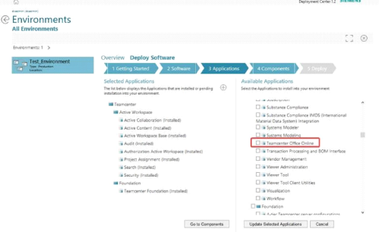
Extensions -> Teamcenter Office Online Web Service
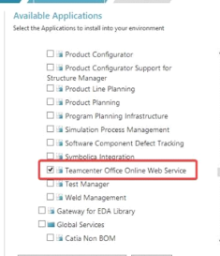
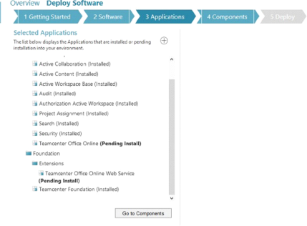
2. In the Teamcenter Office Online Web Service panel:
a. Enter Machine Name to specify the machine on which you want to deploy the web service.
b. Enter the URL in Microsoft Office Online Server Discovery URL. A sample URL is . <>[<>
c. Enter the credentials of the Teamcenter sponsor in User ID and Password. [See section 4]
d. In IIS Settings, select Create new web site.
e. In IIS Web Application Pool Configuration, select Create new application pool.
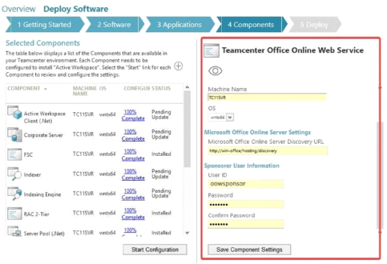
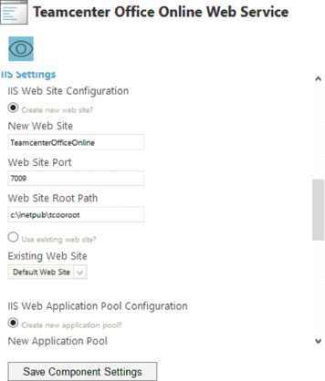
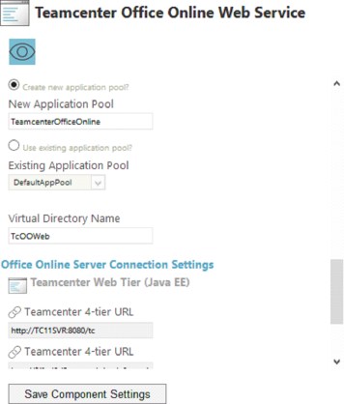
Note:- Tcserver needs to be able to connect to TcOOWeb You can verify these connections with the following.
1. Connection from the Teamcenter server to the TcOOWeb web application
a. Test with <> from machine running Teamcenter server.
Web Application Open Platform Interface (WOPI) protocol used to integrate Office Online Server with Active Workspace. The WOPI protocol enables Office Online to access and change files that are stored in Active Workspace.
TC Office Online requires sponsored authentication
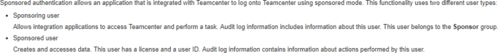
a. Create a new user within Teamcenter RAC and add them to the Sponsor group, ensure they are also part of the dba group to allow access to ALL data. [oowsponsor]
b. This user information is used above within deployment centre as the sponsored user.
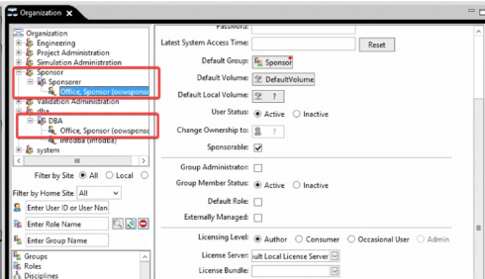
b. All users must be sponsorable to enable Office Online viewing within Active Workspace.
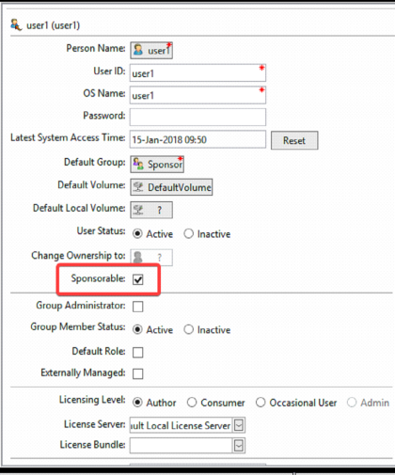
ACL Needs to be configured:-
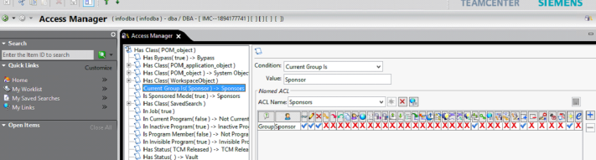
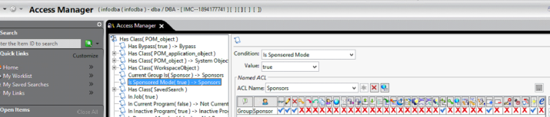
Compatibility with other workloads and services:-
Windows Server 2012 R2 PreReq
Don't install any other server applications on the server that's running Office Online Server. This includes Exchange Server, SharePoint Server, Skype for Business Server, and SQL Server. If you have a shortage of servers, consider running Office Online Server in a virtual machine on one of the servers you have.
Don't install any services or roles that depend on the Web Server (IIS) role on port 80, 443, or 809because Office Online Server periodically removes web applications on these ports.
Don't install any version of Office. If it's already installed, you'll need to uninstall it before you install Office Online Server.
Don't install Office Online Server on a domain controller. It won't run on a server with Active Directory Domain Services (AD DS).
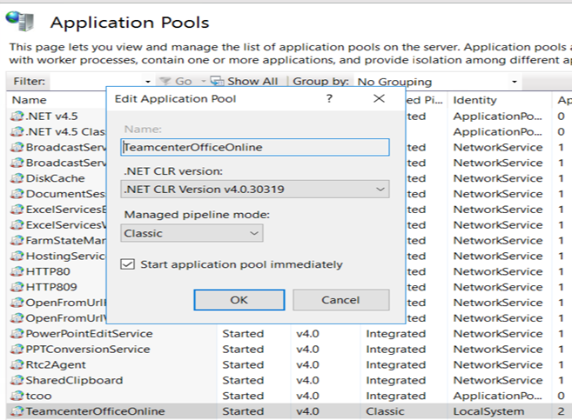
Update the Identity within IIS Application Pool for Teamcenter Office Online from
ApplicationPoolIdentity to LocalSystem
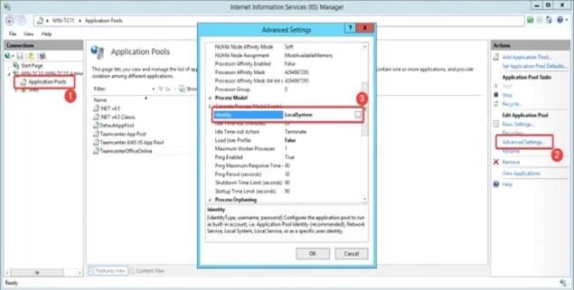
If still does not work then please send me below logs-
--Screen shot of Overview page, like how it is looking.
--AWC HAR File once issue reproduced.
--AW Console log.
--Once issue reproduced please capture the screen shot of Overview tab and Attachment tab.
--Web.config file.-- c:\inetpub\tcooroot\TcOOWeb
-OOS log.-- OOS logs can be found in this location on the OOS sever: C:\ProgramData\Microsoft\OfficeWebApps\Data\Logs\ULS
- TOOS logs can be found in this location on the TOOS sever c:\inetpub\tcooroot\TcOOWeb\logs
View IR in QTAC
Opened Date
Apr 09, 2020
Assigned To
TRIPATHY, SHUBHASHISH
Sold-To
0001632842 - SHANGHAI DIGITAL TECHNOLOGY
Sold-To Contact
ZEREN, SI (zeren.si@shrxkj.com.cn)
Sold-To Contact Phone Number
+8618852676233
End User Sold-To
0001227531 - YAPP AUTOMOTIVE PARTS CO., LTD
Software Configuration
TEAMCENTER | OFFICE_CLIENT | V12.3
Hardware Configuration
INTEL | WINDOWS | 2012_R2
Priority
2
Please Note: Email is not a secure form of data transmission, as it is possible to be viewed/accessed by unauthorized persons during its transmission and storage. Do not include any technology or technical data that is or may be subject to export control restrictions. All transmission of data that includes technology or technical data can be transmitted by uploading to Upload
Restricted © Siemens AG
Sign into Siemens PLM Support

