Play Windows Media Video Files Managed in Teamcenter

Your enterprise has produced in-house training videos in Windows Media Video (*.wmv) format to be managed and accessed via the Teamcenter Product Data Management application. The content of these instructional video files may be related product description as well as manufacturing or usage processes.
The process outlined below will enable the launch the Windows Media Player be opening a Windows Media Video file Datasets stored in the Teamcenter database. This is possible through encapsulation, defining an active mode relationship between an application and Teamcenter data. The configuration is performed in the Business Modeler IDE application by creating a Tool Option and a Dataset Business Object Type.
Assumptions:
- Teamcenter version 8.3.2.
- A working knowledge of Teamcenter Data Model Administration
- A Windows 7 or 2008 Rev 2 environment with Desktop Experience enabled.
- BMIDE Project ID: GTAC_Quarterly_Demo, Prefix: GQ4.

Create a Tool Option
- Define a new tool.
In the Extensions view, expand your project, the Options folder, and the Tool folder.
Right-click Tool and choose New Tool....
In the Name box of the New Tool dialog box, type GQ4_WindowsMediaPlayer
In the MIME/TYPE box, type video/msvideo.
In the Shell/Symbol box, type $TC_BIN/ms_video.

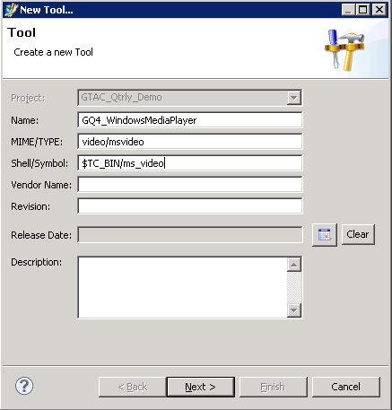
(NOTE: The $TC_BIN/ms_video does not exist. Shell/Symbol is a mandatory field and this value is used as a place holder.)
Click Next.
- Set the type of input and output the tool can accept.
Next to Input, click Add.
In the Value box, type BINARY
Click Finish.
Next to Output, click Add.
In the Value box, type BINARY
Click Finish in the Add Value dialog box. 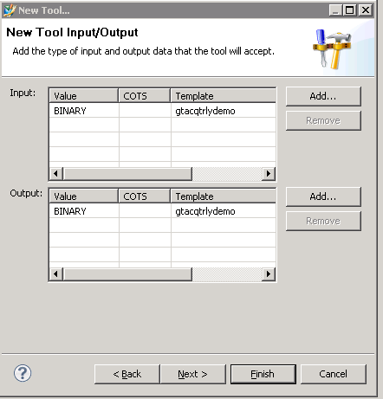
Click Finish in the New Tool dialog box.
In the Extensions view, double-click the new GQ4_WINDOWSMEDIAPLAYER to open the GQ4_WINDOWSMEDIAPLAYER view.
Confirm your settings by viewing the New Tool Type and Tool Input/Output tabs.

Create a Dataset Business Object
- Define a new dataset business object.
In the Business Objects view, use the Find Business Object button to locate Dataset.
Right-click Dataset and choose New Business Object.
In the Name box of the New Dataset dialog box, type GQ4_WindowsMediaVideo.
Leave the Parent box set to Dataset.
- Define a new dataset Tool settings.
In the Tools for Edit section, click Add.
In the filter string box of the Find Tool Object dialog box, type msword.
In the filtered list, select MSWord.
Click OK.
In the Tools for View section, click Add.
In the filter string box of the Find Tool Object dialog box, type msword.
In the filtered list, select MSWord.
Click OK.
The Tool settings should look like the following.
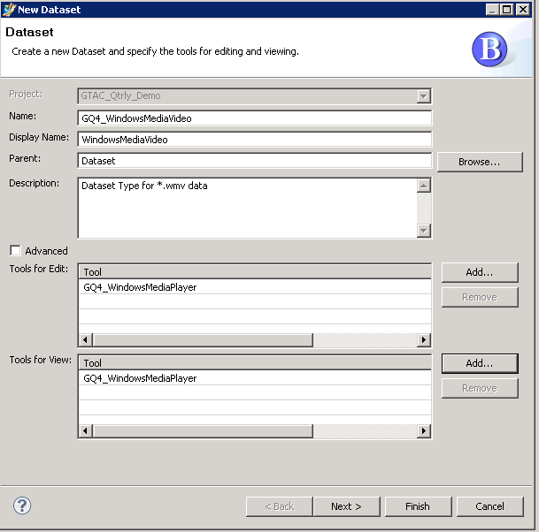
Click Next.
- Add a Reference for the file definition used with the GQ4_WindowsMediaVideo dataset business object.
In the References section, click Add.
In the Reference box of the Add Dataset Reference dialog box, type GQ4_wmv
In the File Type box, type *.doc.
In the Format box, select BINARY.
Click Finish.
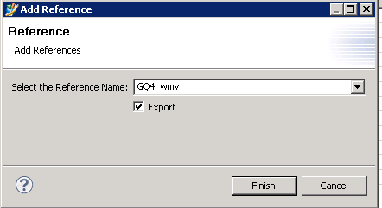
Click Next.
- Add the DatasetToolAction tool, reference, and parameter used with the GQ4_WindowsMediaVideo dataset business object.
In the Tool Action section, click Add.
In the Add/Modify DatasetToolAction dialog box, click Browse to the right of Tools.
In the Find Tool Object dialog box, select GQ4_wmv and click OK.
Only tools defined in the Tools for Edit and Tools for View sections appear.
Set Operations to Open.
To the right of References, click Add.
In the Select the Reference Name box of the Add Reference dialog box, select GQ4_wmv.
Click the Export check box .
Note:
Before you click Finish, confirm that you have Export box checked.
Click Finish.
To the right of Parameters, click Add.
- In the Enter the parameter box in the Add Parameter dialog box, select $GQ4_wmv
Click Finish.
In the Add/Modify DatasetToolAction dialog box, click Finish.
Click Finish.
- Save and Deploy the project.

Create Data in Teamcenter
To complete the demonstration, create an instance of the Document Item. Add to the Document Revision a GQ4_WindowsMediaVideo dataset. This example uses the wildlife.wmv provided by Microsoft.

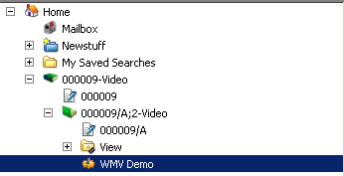
Open the dataset launch Windows Media Player display the content..
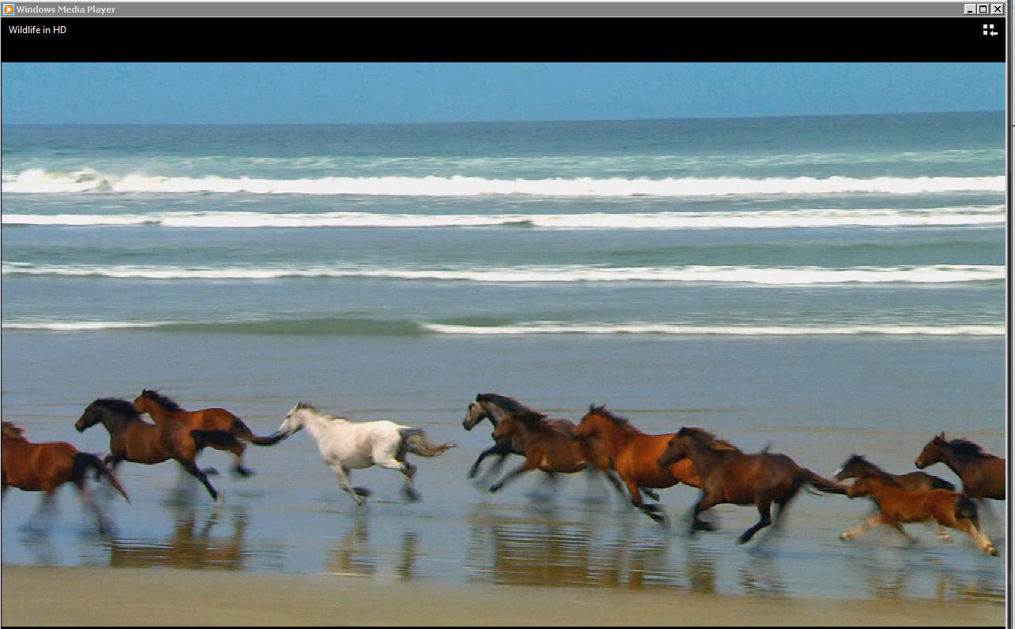
Keith Powell

