LinDon - Thank you again for participating in our interview process and your interest in becoming a part of the Arctos team.

At this stage of the process, we’d like for you to complete a case study to see both your modeling skills and also how you think about and analyze an investment opportunity. The prompt is whether, **targeting private equity returns, you would take Manchester United (NYSE:MANU) private or not and, if so, at what price and with what proposed capital structure.** And, if not, please explain the price and capital structure at which you would consider taking the company private. The analysis must include:

* Excel Financial Model
  + Please build out the attached financial model, including forecasted financials, transaction sources and uses, returns and sensitivities and proposed valuation
  + We have provided you with a pre-populated, simplified set of financials for the target. We encourage you to use all available resources to compile your written investment recommendation, but do not include any actual financial information other than the pre-populated financial information in this workbook
* Written report (strictly no more than 5 pages in PowerPoint, including exhibits)
  + Opportunity overview
  + Merits and risks
  + Transaction overview, including sources and uses, proposed valuation
  + Returns, sensitivities and investment recommendation
  + Comparable public company and private market precedent transactions

**Please acknowledge receipt of this email. You have 48 hours to complete the case study**. Please send back an Excel version of your financial model and your written report, and be prepared to discuss your thoughts on the model and investment recommendation with Arctos professionals following this exercise.

Good luck! Thank you again for your interest in pursuing a career with us.

| **Date/Time** | **Activity** | **Notes** |
| --- | --- | --- |
| 3/26 - 6:00PM | Read prompt, outline thoughts, research PE case studies for color on great performance | Key: **asking the right questions** |
| 3/26 - 10:00PM | Dig into model - push to have a v1 before bed |  |
| 3/26 bedtime | Do not go to sleep not knowing how you’re going to do anything | Use resources, quell as much anxiety as possible |
| 3/27 - 11AM Izzet | Send to Izzet at 10:30AM |  |
| 3/27 - 12:00PM Michael Kamara | Get as much out of him as possible. Interned at BX and incoming, so ask about experience + technicals + presentation | (see below) |
| 3/27- 4:30PM Murimi Nyamu | Have a draft presentation potentially? | reschedule |
| 3/27 - 6:00PM Iyobosa  7:00PM Izzet?  8:00PM other banker I can trust | Write up questions for Iyobosa | Helpful - model looks good, adjusted assumptions  Send Iyobosa deck in the AM |
| 3/27 - 10:00PM | Goal is to have FULL draft of the excel and materials!!! |  |
| 3/28 - 11:00PM Iyobosa, Izzet, Chuks, Murimi? | Send all materials for comments, say it’s due 4PM |  |
|  |  |  |
|  |  |  |

Find out what you don’t know

* Value drivers for take-private transactions
* Model for take-private transactions (they provide)
  + What kind of Model is it? **LBO - Arctos will take private via debt**
  + Key merits and risks - how they apply to a soccer team **research on internet/Youtube**
  + How to price a take-private transaction **LBO Model**
* Manchester United comps
* Assumptions for forecasting Manchester United Financials (they may provide)

Help yourself

* Do as little of the formatting or design work from scratch as possible - save time for content
* Compile and use resources - spend serious time digging through the catalogue
  + BLK materials
  + SEO materials - Blackboard? Got access earlier this year, what was it
  + WSP materials
* Ask for help

Presentation Outline

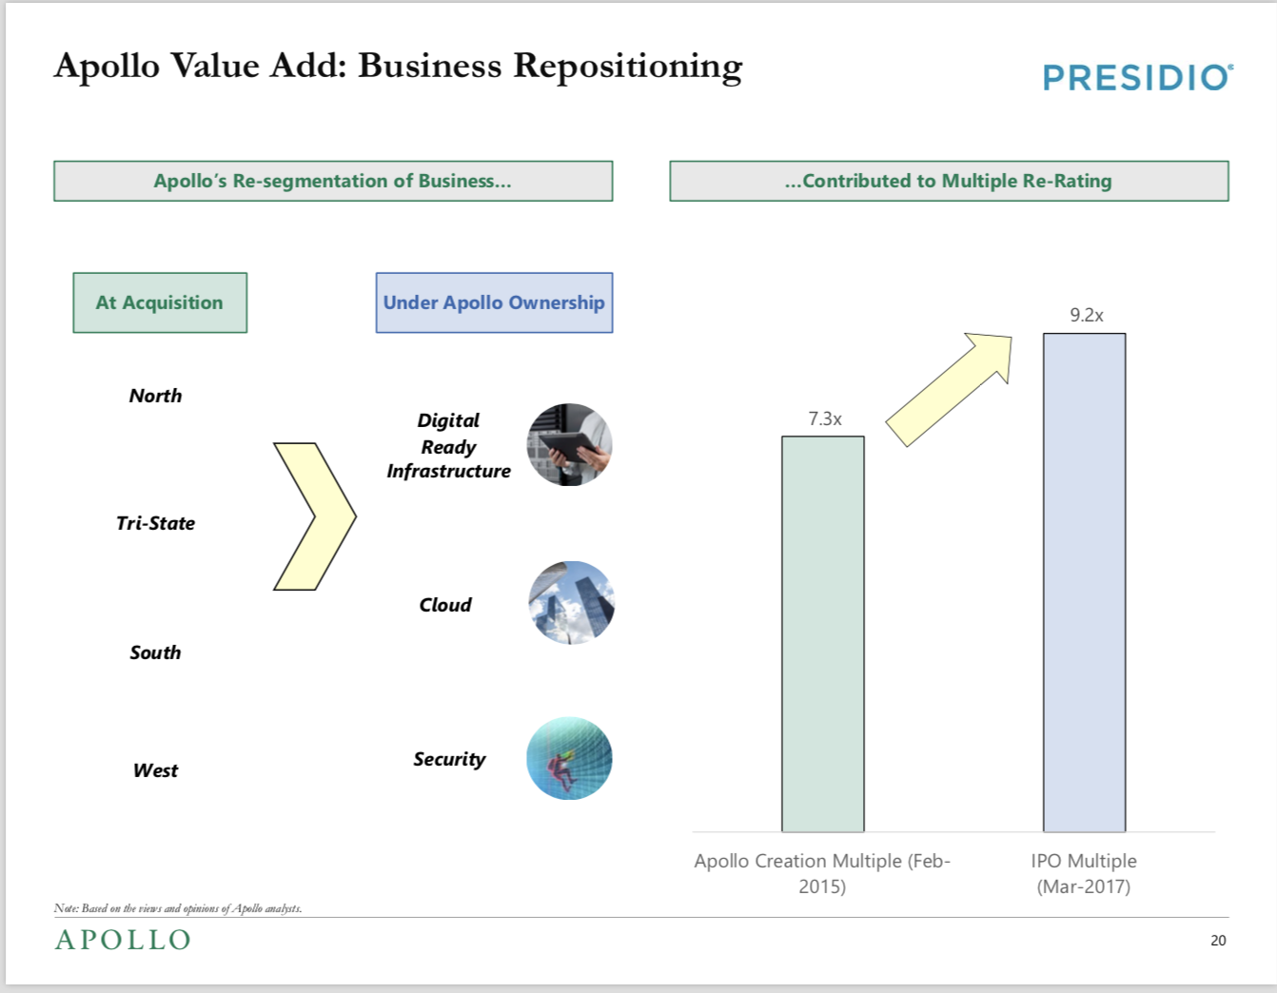

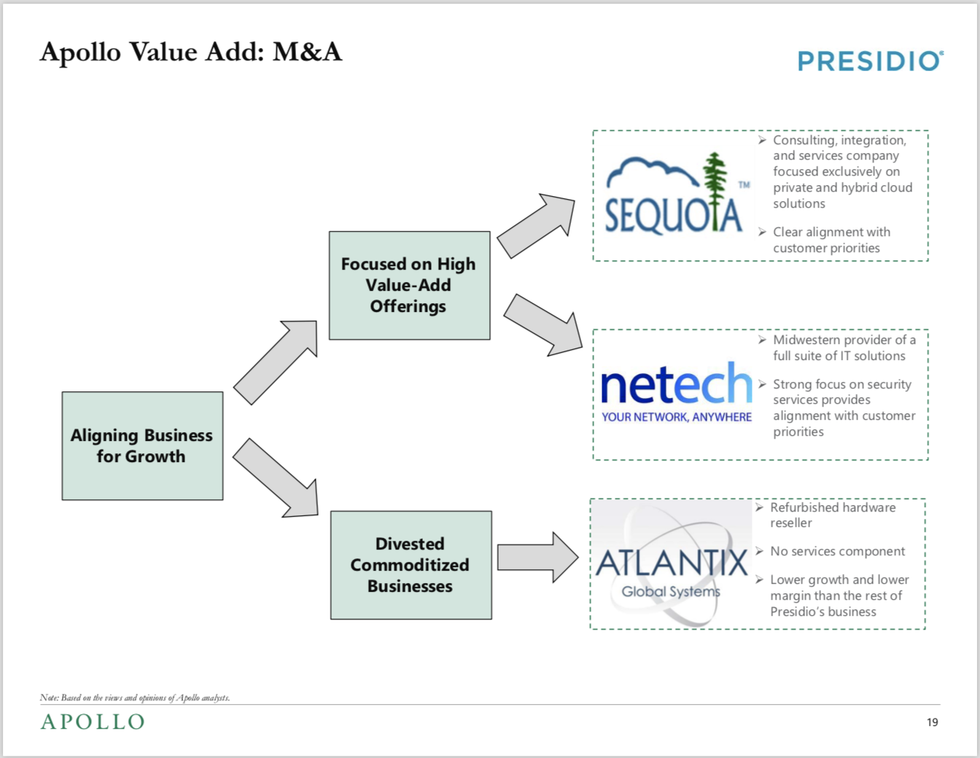

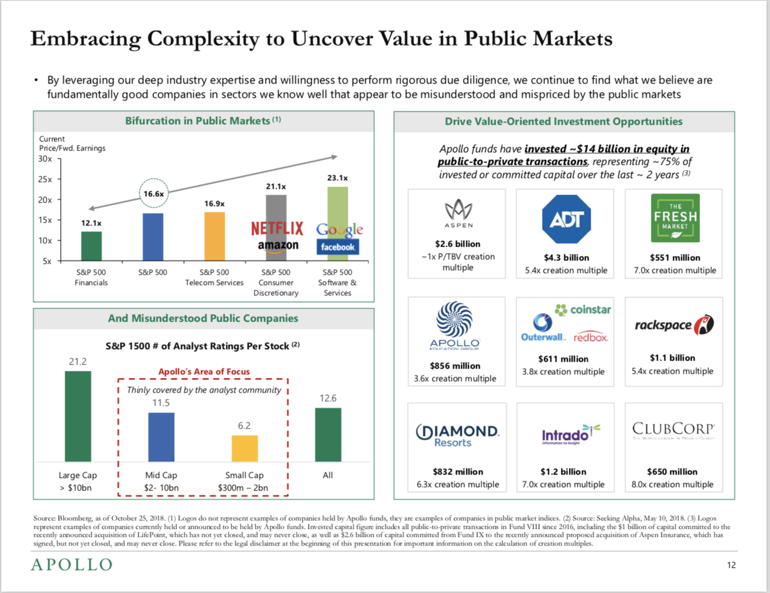

(^for color on value creation via take-private transaction)

**Presentation**

1. Opportunity overview

Shell: 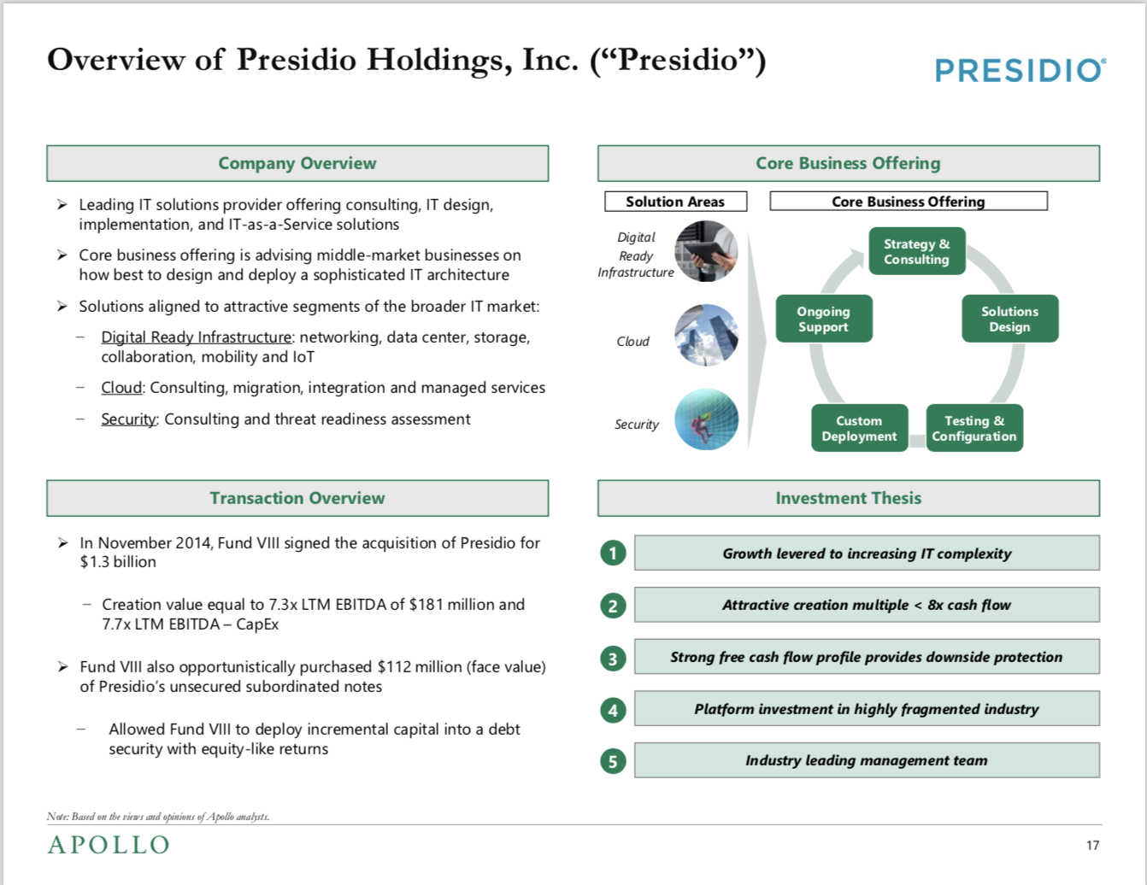

Manchester United Plc Background *be mindful about financials used...maybe ask about it?*

* Pre-2005: shares traded on UK stock exchange, debt free
* 2005: Glazer family borrowed substantial money to LBO Man U in a take-private
  + Up to 16.25% interest rate paid on this debt
  + £767MM paid to banks since acquisition
* 2012: Glazers took Man U public
  + Used to paydown debts
  + Two classes:
    - 50% - Class A shares: 1 vote each, NYSE, 3% of all votes, 25% of shares
    - 50% - Class B shares: 10 votes each, owned by Glazers, [97]% of all votes, [75]% of all shares

Arctos Sports Partners’ Value Add:

* By leveraging our deep industry expertise willingness to perform due diligence, we believe Arctos is uniquely well-positioned to drive value in a sector that is misunderstood and mispriced by public markets.

Exit Strategy

1. Sale t strategic or other sponsor
2. Dividend recap
3. Merits and risks

Merits (reword all)

* Relaxed compliance, filing rules, costs
  + Public: legal restrictions and costs for NYSE
* Analyst scrutiny
  + Private: not answerable to outside parties
* Mispriced - exacerbated by COVID
  + Idea: see if there are any anecdotal/circumstantial details about Man U that complicate this and result in mispricings.. Performance, strategic decisions, Covid, etc.
* Shareholder with a long-term investment horizon
  + Previously: Shareholders with little interest in club/industry. Now: shareholder with deep domain expertise and relationships
* No change in control for strategic/operational decisions?
* Dividend reinvestment
  + Private: Invest in stadium, marketing, gear, facilities, salaries, staff, etc
  + Public: dividends to broad shareholders

Risks

* Fewer methods of capital raising

1. Transaction overview, including sources and uses, proposed valuation

Shell?: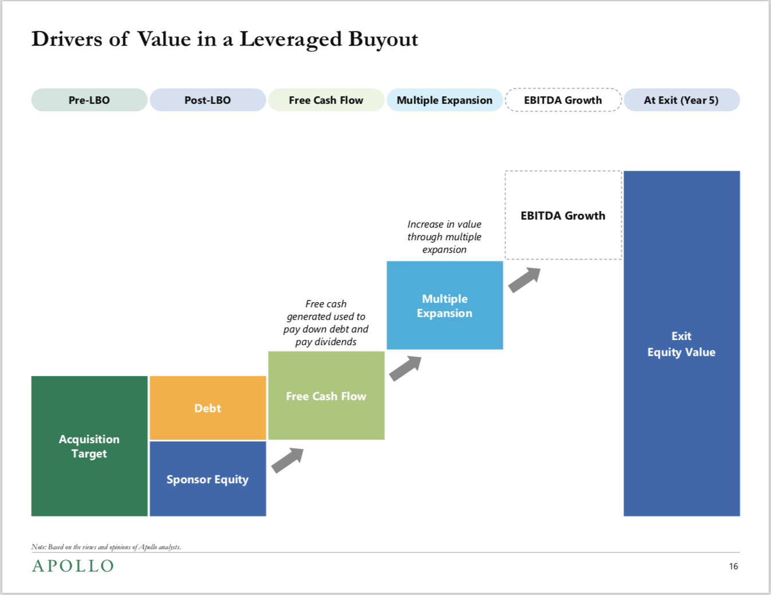

1. Returns, sensitivities and investment recommendation
2. Comparable public company and private market precedent transactions

Comps data

~~Idea: include P/Fwd Earnings chart for comps~~

*Similar product, similar geography, similar size*

*What do companies in this sector trade on?*

*What’s a median for the select peer group?*

* *Justify premium/discount paid*

Football Clubs taken private

* Private (1980s/90s) → public → private: Spurs, Millwall, Sheffield United, Southampton, Hearts

Idea: find which of the clubs taken private are the best comp for Man U

Question: metrics for best FC comp? Revenue **probably**? Fan base **probably good to show**? Valuation **probably**? What else?

Idea: for comps, include at least the above 3 metrics as available

Similar transactions in the last five years

* Madata (MS) - whole company acquisitions from the last 5 years from the last
* Ask izzet

**Modeling Notes & Questions**

Generic success drivers

1. Entry multiple
2. Levering with cheap debt
3. Margin expansion
4. Multiple expansion - exit

Debt Capital

* Leveraged loans: term loans and a revolver, syndicated to banks/institutional investors
  + L + [ ]
  + Scheduled principal amortization
  + No call protection

Equity IRR

Cash on Cash Return

Financing fees

* Upfront fees are capitalized, treated differently than transaction fees
* Amortized over the term of the borrowing

Questions

* What should be the offer price? Do we have to find that? **Pre-populated**
* Does the following mean I’m making assumptions about the current balance sheet? *Please assume whatever capital structure that you feel is appropriate at entry* **Meaghan provided answers**
* How to assume debt? 485M
* How to determine optimal capital structure?
  + Equity: Any rollover, options, or warrants?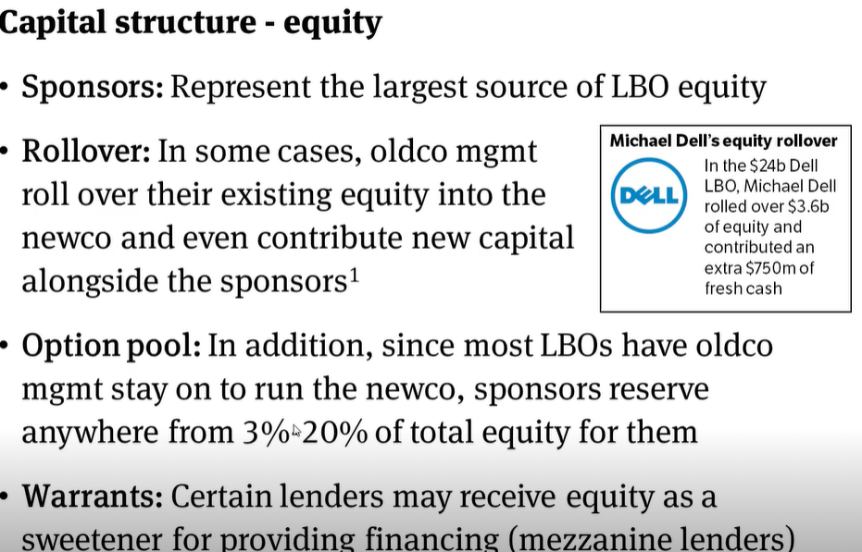
  + Debt
* What is the purpose of minimum cash? **Cash needed to remain on the BS**
* How can i sanity check? Should i read the MANU 10K for management projections?
* Need to see a model for a cross-currency LBO!!! **Meaghan provided answers**
  + What currency should the paydown schedule **GBP** (and sources and uses) reflect?

Be mindful of:

* Calcing EV from current cap structure (in Uses…)
* Noting every single assumption
* GBP:USD conversion - double check the spot rate
* Always cite sources for any hardcoded assumptions

Michael Kamara

* Can’t help now, offered to connect with his network