WILLY LINDSAY ONYANGO
C025-01-0950/2021
DEDAN KIMATHI UNIVERSITY OF TECHNOLOGY
INFORMATION TECHNOLOGY
PHOTOGRAPHIC ESSAY

INTRODUCTION- THE PROBLEM
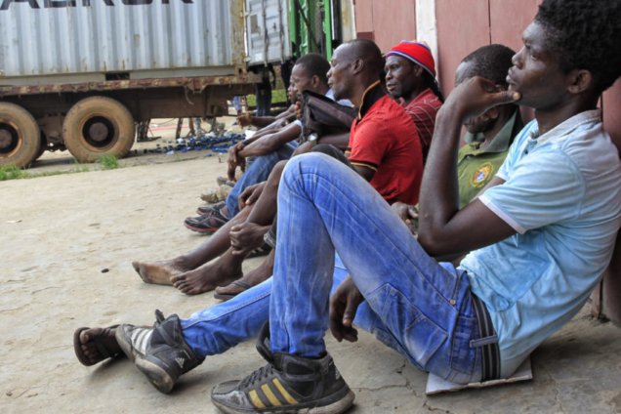
Figure 1:Youths Idling Around
Youth unemployment remains one of the most pressing challenges facing African communities today. Despite rising levels of education, many young people struggle to secure formal employment. This photograph introduces the reality od idle and uncertain youth in urban Kenya, highlighting the gap between education and available job opportunities. The lack of stable income exposes young people to poverty, stress and social vulnerability. This issue affects not only individuals but entire families and communities.

YOUTHS WAITING WITHOUT OPPORTUNITY
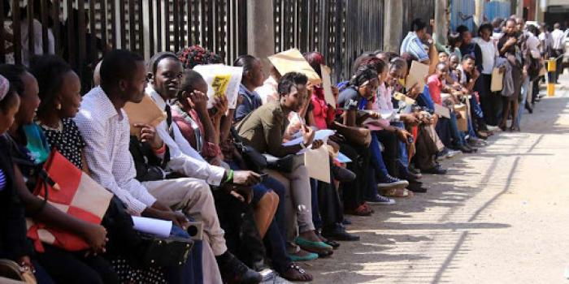
Figure 2: Youths Waiting in Long Queues for Job Interview

This image captures young people spending long hours waiting without productive engagement. For many African youths, days are filled with uncertainty due to limited employment opportunities. The absence of structured work often leads to frustration and loss of motivation. Prolonged unemployment increases the risk of involvement in crime, substance abuse and mental health challenges. This situation reflects the urgent need for sustainable youth empowerment initiatives.

INFORMAL HUSTLING AS SURVIVAL
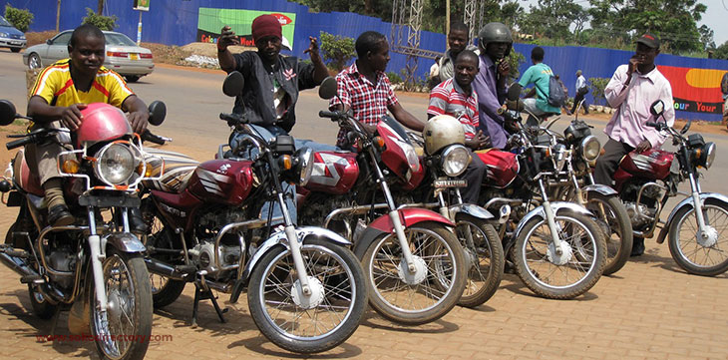
Figure 3: Informal Hustling Means

With limited formal employment, many youths turn to informal economic activities to survive. This photograph shows young people engaged in small-scale hustling such as street vending or boda boda riding. Although these activities provide daily income, they lack job security and long-term growth. Informal work exposes youths to exploitation and unsafe working conditions. Nevertheless, it demonstrates resilience and determination to survive against all odds

EDUCATION WITHOUT EMPLOYMENT

Figure 4: Youths who have graduated but unemployed

This image represents educated youths who remain unemployed despite completing their studies. Many graduates in African countries face disappointment when academic qualifications fail to translate into jobs. The mismatch between education systems and job market demands deepens unemployment. This situation raises questions about curriculum relevance and skills training. It highlights the need for practical, skill-based education aligned with market needs.

TECHNOLOGY AS A NEW HUSTLE

Figure 5: Through Technology the Youth Get a Chance of Leaving a Better Life

Technology has become a powerful tool for youth survival and innovation. This photograph shows young people using digital tools such as a computer for income generation. Online freelancing, digital marketing and software development provide alternative employment opportunities. Technology empowers youths to create opportunities where none exist. This shift demonstrates the growing importance of digital skills in modern African societies.

GENDER DIMENSION OF YOUTH UNEMPLOYMENT

Figure 6:Young Woman Hustling
Youth unemployment affects both men and women, but young women face additional challenges. This image highlights a young woman engaged in informal work to support herself and her family. Gender inequality, limited access to resources and social expectations often disadvantage women. Addressing youth unemployment must include gender-sensitive solutions. Empowering young women economically strengthens families and entire communities.

COMMUNITY IMPACT

Figure 7:Unemployment not only affects individuals but also communities as a whole

The effects of youth unemployment extend beyond individuals to families and communities. Many households depend on the small earnings of young people engaged in informal work. This photograph reflects shared responsibility and collective survival within African communities. Economic hardship limits access to healthcare, education and proper nutrition. Solving youth employment is therefore a community-wide concern.

HOPE FOR FUTURE
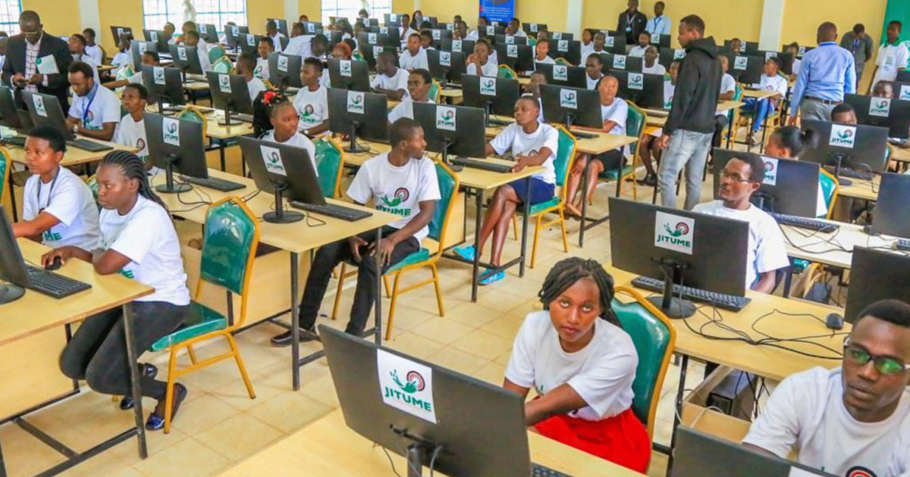
Figure 8::Youth Learning a Skill That will be Beneficial for them in the Future

Despite the challenges, African youths remain hopeful and ambitious. This photograph represents determination and optimism for a better future. With proper support, training and opportunities, young people can drive economic growth. Youth innovation has the potential to transform African societies. Investing in youth is an investment in the future of the continent.

CONCLUSION


Figure 9:Through Technology, Unemployment Rates will Reduce
Youth unemployment is a complex challenge requiring collective solutions. Governments, educational institutions and communities must collaborate to empower young people. Technology, education reform and entrepreneurship offer viable pathways forward. Addressing this issue will reduce poverty and social inequality. Empowered youths are key to sustainable development in African communities.

