1. Below is to find product record via productID “77”

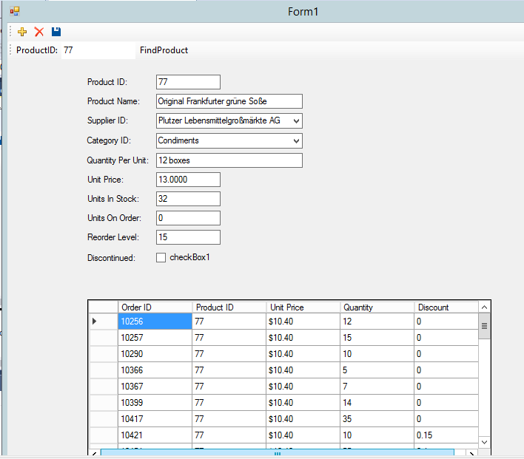

1. Two users tried to modify the Units On Stock for the product of “77” at the same time

* Below is the one who updated the data with SQL Server

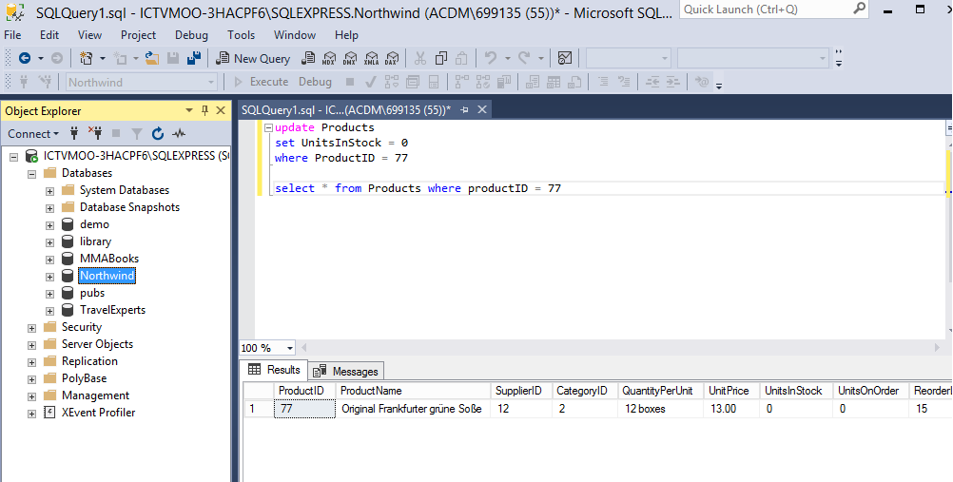

* Below is the one who tried to modify the units stock from 32 to 20. An error message was showed when save button was clicked after the one has already update it .

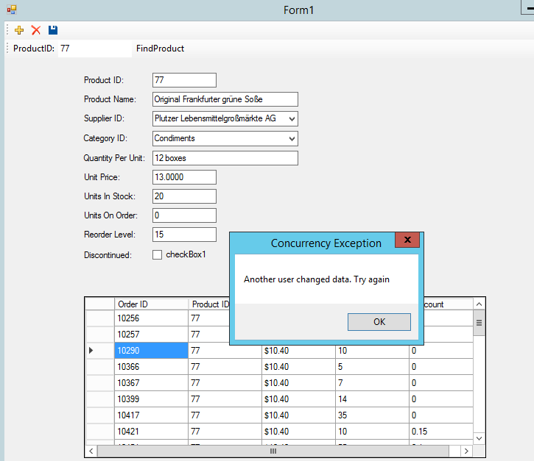

1. delete a record that is referenced

* After clicking the “X” button to delete the product record, the data were all gone, but an error message was showed as below when trying to save.

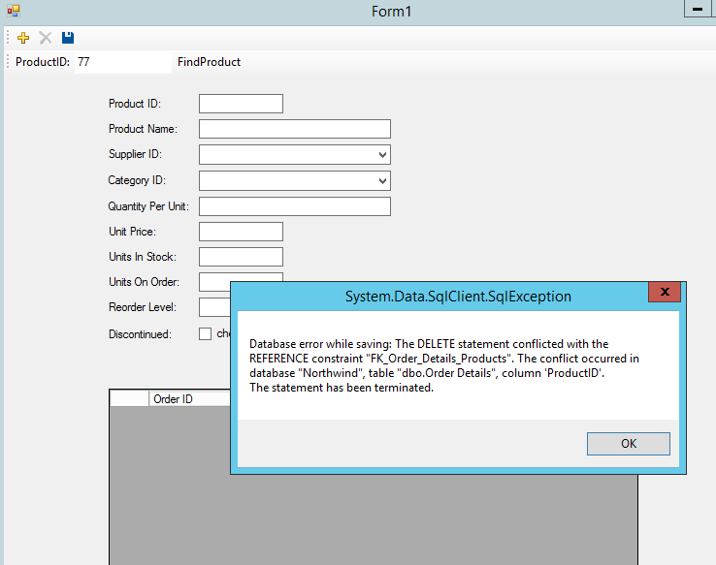

1. inserting a data row with null for a non-null column

* Below is the display after clicking on the “+” button to add new product

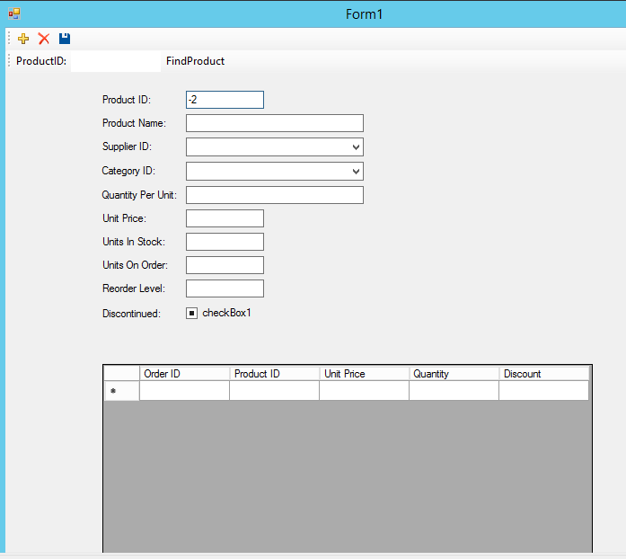

* Following is the result when trying to insert a data row with null for a non-null column.
* It is told “ProductName” does not allow nulls

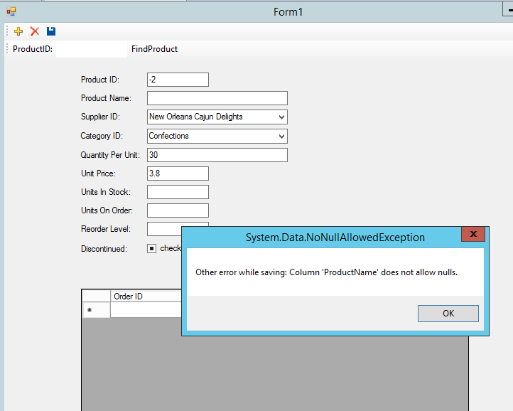

1. Find a product with null ProductID

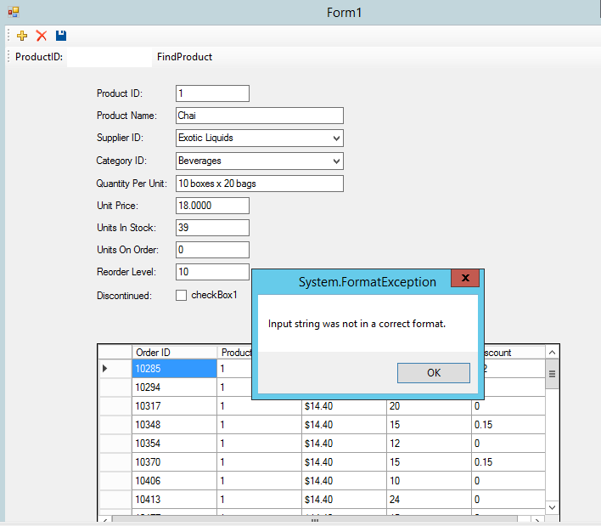

1. Successfully insert a new product record

Clicked the “ + “ button and entered a new product record

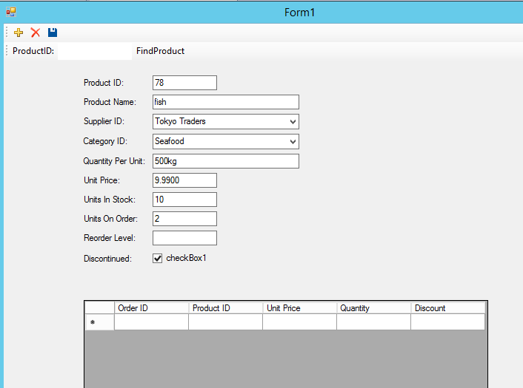

* After clicking the save button, try to find the new product record from the database in two ways

