R markdown lab

Jeff Leek

July 3, 2015

1. Try compiling this document using the "Knit HTML" button. What files are produced?
2. Edit the output to be "pdf_document" and recompile with the Knit button. What files are produced?
3. Edit the output to be "word_document" and recompile. What files are produced?
4. What does the label "chunk1" do in the following code chunk?

x = rnorm(100)  
plot(x)

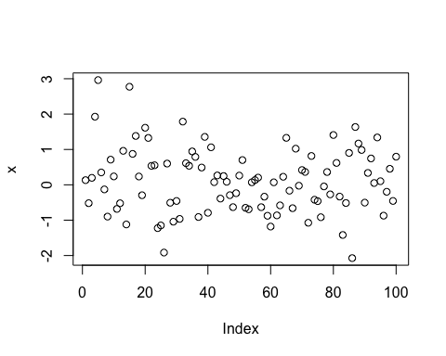

### This is a primary header. Add a secondary header with ## on the line below and recompile.

1. Change fig.height to something larger/smaller and see what happens

x = rnorm(100)  
plot(x)

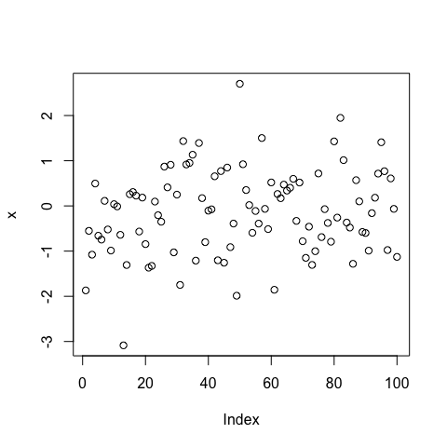

1. Add a chunk option of fig.align="center" to center this plot

x = rnorm(100)  
plot(x)

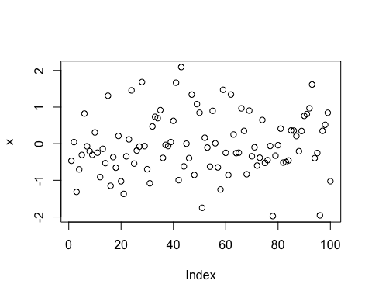

1. Add a chunk option of echo=FALSE and see what happens

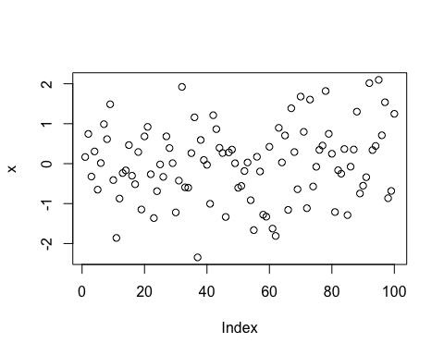

1. Uncomment this code and recompile the document. Then add a chunk command cache=TRUE and recompile. What files are created? Try compiling one more time.

Sys.sleep(10)

1. Check out the docs at: <http://rmarkdown.rstudio.com/> and look under formats. See if you can create and compile an R markdown presentation.
2. Add the command devtools::session_info() to this chunk and look at the output

devtools::session_info()

## Session info -------------------------------------------------------------

## setting value   
## version R version 3.3.2 (2016-10-31)  
## system x86_64, darwin13.4.0   
## ui X11   
## language (EN)   
## collate en_US.UTF-8   
## tz America/Chicago   
## date 2017-07-10

## Packages -----------------------------------------------------------------

## package * version date source   
## backports 1.1.0 2017-05-22 CRAN (R 3.3.2)  
## base * 3.3.2 2016-10-31 local   
## codetools 0.2-15 2016-10-05 CRAN (R 3.3.2)  
## datasets * 3.3.2 2016-10-31 local   
## devtools 1.13.2 2017-06-02 CRAN (R 3.3.2)  
## digest 0.6.12 2017-01-27 cran (@0.6.12)  
## evaluate 0.10 2016-10-11 cran (@0.10)   
## graphics * 3.3.2 2016-10-31 local   
## grDevices * 3.3.2 2016-10-31 local   
## htmltools 0.3.6 2017-04-28 CRAN (R 3.3.2)  
## knitr 1.16 2017-05-18 CRAN (R 3.3.2)  
## magrittr 1.5 2014-11-22 CRAN (R 3.3.0)  
## memoise 1.1.0 2017-04-21 CRAN (R 3.3.2)  
## methods * 3.3.2 2016-10-31 local   
## Rcpp 0.12.11 2017-05-22 CRAN (R 3.3.2)  
## rmarkdown 1.6 2017-06-15 CRAN (R 3.3.2)  
## rprojroot 1.2 2017-01-16 CRAN (R 3.3.2)  
## stats * 3.3.2 2016-10-31 local   
## stringi 1.1.5 2017-04-07 CRAN (R 3.3.2)  
## stringr 1.2.0 2017-02-18 CRAN (R 3.3.2)  
## tools 3.3.2 2016-10-31 local   
## utils * 3.3.2 2016-10-31 local   
## withr 1.0.2 2016-06-20 CRAN (R 3.3.0)  
## yaml 2.1.14 2016-11-12 cran (@2.1.14)