Primary production:
- Synthesis of organic compounds from atmospheric or aqueous CO₂
- Occurs through photosynthesis: CO2 + H2O + light → CH2O + O2
- ...and chemosynthesis (oxidation or reduction of inorganic compounds): CO2 + O2 + 4 H2S → CH2O + 4 S + 3 H2O
- Gross primary productivity: the rate at which photo- or chemosynthesis occurs
- Almost all life relies directly or indirectly on primary producers (autotrophs)
Gross primary production (GPP) (g C m⁻² yr⁻¹):
- Amount of chemical energy as biomass that autotrophs create in X time
- GPP – plant respiration = Net primary production (NPP) (g C m⁻² yr⁻¹): the rate at which all plants in an ecosystem produce net useful chemical energy. Some NPP goes towards growth and reproduction. Photic zone + mixed layer determines NPP. The maximum depth of the mixed layer in which net growth can occur is the critical depth. NPP occurs wherever the mixed layer depth < critical depth.
- Total = 56.4 Gt C yr⁻¹ (terrestrial) + 48.5 Gt C yr⁻¹ (marine) = 104.9 Gt C yr⁻¹
- While accounting for almost half of the NPP, oceanic autotrophs only account for 0.2% of the total biomass.

Abstract
Ocean upwelling systems support 45% of pelagic mesozooplankton production, but only account for 22% of ocean area and 1/3 of NPP due to shortened food webs, elevated growth efficiencies, and tight consumer-resource coupling.
Seasonally stratified systems support 41% of pelagic mesozooplankton production while accounting for 42% of ocean area and 40% of NPP due to weakened consumer-resource coupling. In these areas, export > 100 m accounts for 48% of the global total.
Oligotrophic systems support 14% of mesozooplankton production while accounting for 26% of NPP and 36% of ocean area.

Across biomes, bacterial production was maintained in nearly constant proportion to primary production due to increased partitioning of NPP to the microbial food web in oligotrophic systems and increased bacterial growth efficiencies in more productive areas.

Introduction
- Friedland et al. 2012: primary production is a poor predictor of fisheries yields. Secondary production is the generation of biomass by heterotrophic (consumer) organisms within a system. The ratio of secondary production to primary production is a better predictor of fisheries yields, as is particle-export ratio (the “biological pump” of organismal remains/feces into the ocean’s deep interior) and the [] of chlorophyll a.
- Aksnes & Wassmann 1993: effect of zooplankton grazing (G) on algae given by G/(w_{s} + G) where w_{s} is the phytoplankton sinking rate
- Legendre and Rassoulzadegan 1996: sinking of particulate organic carbon may contribute to the regulation of climate change (sequestration at depth). This is controlled in part by the temporal variations in the surface mixed layer (also Dunne et al. 2005; Eppley & Peterson 1979; Stock & Dunne 2010).
- Lagged responses of zooplankton blooms to spring phytoplankton blooms and/or variations in the size of predator-prey ratios determine whether a system is efficient at nutrient recycling or is more export-prone.
- Inverse problems start with system outputs to calculate the causes. This methodology has provided some estimate of energy flux, but simplification has limited scientific ability to explain the biological and physical processes responsible for the flows.
- Cole et al. 1988: Mean bacterial production is ~20% across vastly different systems.
- Calbet & Landry 2004: Microzooplankton are the predominant herbivores across systems.
- Banse 1993: Grazing is central to the supply of substrate for the microbial loop (food web by which DOM travels to the highest trophic levels).
- Longhurst 1995: for higher latitudes, late summer phytoplankton blooms result from relaxed grazing pressure; in mid latitudes, winter blooms represent chlorophyll a accumulation at a season when loss is lower than during peak primary productivity in spring. In the low latitude oligotrophic ocean, production and consumption are closely coupled.
- Remineralization: the breakdown of organic matter into its simplest inorganic forms. This liberates the energy stored in organic molecules and allows matter to be reused as nutrients by other organisms, particularly C, N, and P.

Methods: The planktonic ecosystem model
- The Carbon, Ocean Biogeochemistry and Lower Trophics marine ecosystem model used 33 state variables to resolve global-scale cycles of N, C, phosphate, silicate, Fe, CaCO₃, O₂, and lithogenic (terrestrial in origin, calcium-containing) material.

Planktonic food web dynamics
- Nitrogen is the biomass variable in COBALT. Assumed N:C:P is the Redfield ratio (106:16:1) that remains constant from coastal to open oceans. 13 nitrogen state variables comprise COBALT’s planktonic food web.
- Three phytoplankton groups are considered:
  - small (nsmp): < 10 µm
  - large (nlgp): > 10 µm; diatoms (assumed dominant when silicate is plentiful) + other phytoplankton
  - diazotrophs (bacteria and archaea) (ndi)
- All take up ammonia (NH₃) and nitrate (NO₃⁻). ndi take up dinitrogen (N₂, which they convert to NH₃); this is not explicitly modeled as it is assumed to be available everywhere.
- Light + the most limiting nutrient (N, P, Fe) + metabolic needs determine the primary production of each group. Note that N and P []s are ambient, while Fe depends on internal cell quota.
- NH₃ (ammonia) is a gas and sometimes called toxic or free ammonia. NH₄ (ammonium) is a nontoxic salt, the ionized form of ammonia.
- Sunda & Huntsman 1995: Fe []s in open ocean are orders of magnitude lower than coastal levels. Rates of cellular uptake of Fe are similar among species.

- Phytoplankton groups are subject to losses via…
- zooplankton grazing (jzloss)
- aggregation to sinking detritus (jaggloss): modeled as density-dependent (quadratic) loss on nlgp and nsmp. NA to ndi, which resist sinking thanks to gas vesicles.
- exudation to DOM (jexuloss): 13% of PP
- viruses (jvirloss): modeled as a weak density-dependent loss on nsmp.

- Three zooplankton groups are considered:
- small (nsmz): < 200 µm; heterotrophic; microzooplankton
- medium (nmdz): 200 – 2000 µm; small to medium copepods
- large (nldz): 2 – 20 mm; large copepods & euphausids (krill)
- nmdz and nldz comprise the mesozooplankton.
- Zooplankton feeding is modeled with a Type II Holling functional response for a single prey type with biomass-based prey switching (based on Stock et al. 2008).
  - Type II: f(R)= aR/(1+ahR) where f denotes intake rate, R denotes food or resource density, a denotes the attack rate (at which the consumer encounters food items per unit of food density), and h denotes handling time (food item processing time).
- jprod_[zooplankton group] = zooplankton production = gge_{max} x I – m_{br}
  - gge_{max} = the maximum growth efficiency, or the maximum fraction of ingestion devoted to growth = 0.4
  - I = the food ingested
  - m_{br} = basal metabolic rate
- When I is large relative to m_{br}, the realized gge (jprod_[zooplankton group]) approaches gge_{max}
- As I approaches 0, gge approaches 0 or goes negative.
- 30% of ingested material is egested = ae (assimilation efficiency) of 70%.
- Any food that is not used for growth or egested (ae – gge) is respired → remineralization of organic carbon and production of NH_{3.}
- jzloss: consumption of zooplankton by other zoos.
- jhploss: consumption of zooplankton by higher predators (the biomass of higher preds is implicitly assumed to adjust to the biomass of zooplankton, which makes this a density-dependent (quadratic) loss term).
- Biomass-specific maximum ingestion and respiration rates for zoos decrease with increasing body size. Thus, the primary trade-off between different phytoplankton sizes is nutrient uptake capacity in low nutrient areas (favoring small phytoplankton) versus defense against grazing by microzooplankton (favoring large phytoplankton).

- Three types of dissolved organic nitrogen are considered:
- semi-refractory (srdon): decays to labile don (ldon) with a timescale of 18 years (jsrdon2ldon)
- semi-labile (sldon): decays to ldon over seasonal timescales (jsldon2ldon)
- labile (ldon): taken up by free-living bacteria (bact_juptake_ldon)
- DOM has diverse origins: egestion by zooplankton (e.g., Σ_{zoos}jprod_ldon), viral lysis (e.g., vir_jprod_ldon), phytoplankton exudation (e.g., Σ_{phytos_}jexuloss) and river fluxes (e.g., riv_flux_ldon).

- One type of explicit free-living heterotrophic bacteria is considered (nbact); attached bacteria are treated implicitly (used by Fasham et al. 1990; allows bacterial production (jprod_nbact) to be resolved via passing up the food chain through consumption by small zoos (bact_jzloss_n) or shunted back to DOM through viral lysis (bact_jvirloss_n).
- The free-living bacteria function as remineralizers of DON. They do not compete with phytoplankton for inorganic nutrients.
- All material not used for growth is remineralized.
- Remineralization of organic carbon generates ammonia, and the remineralization flux from free-living bacteria (bact_jprod_nh4) is augmented by remineralization of sinking detritus (jremin_ndet), remineralization by zooplankton (zoos jprod nh4) and higher predators (hp_jprod_nh4) and atmospheric deposition (atm_dep_nh4).
- Ammonia sinks:
  - Σ_{phytos}_juptake_nh4: phytoplankton uptake
  - jnitrif: nitrification
- Nitrate sources:
  - jnitrif
  - atm_dep_no3: atmospheric deposition
  - riv_flux_no3: river fluxes
- Nitrate sinks:
  - jdenitrif: denitrification
  - Σ_{phytos}_juptake_no3: phytoplankton uptake

Particle sinking and remineralization
- ndet: nitrogen detritus sinks at 100 m per day, is produced by phytoplankton, some zoos and higher predators. In the absence of recalcitrant (decompose very slowly) minerals (e.g., silica, calcite, aragonite, and lithogenic material), it is remineralized at 188 m. rates of remineralization are further decreased below an oxygen threshold of 2 mmoles m⁻³.

Phosphorus dynamics
- Five phosphorus compartments are considered:
- phosphate (po4)
- dissolved organic pool (ldop)
- dissolved organic pool (sldop)
- dissolved organic pool (srdop)
- phosphorus detritus (pdet)
- Phosphorus is held at the Redfield ratio of 1:16 relative to nitrogen in all living organic pools (phytoplankton, zooplankton, bacteria) except for nitrogen-rich diazotrophs (1:40).
- Phosphorus sources and sinks are mostly analogous to those for nitrogen.
- dop and pdet pools allow COBALT to accommodate this stoichiometric difference in the N:P ratio for diazotrophs.

Iron dynamics
- Five iron compartments are considered:
- internal iron pool for small phytoplankton (fesmp)
- internal iron pool for large phytoplankton (felgp)
- internal iron pool for diazotrophs (fedi)
- dissolved iron (fed)
- iron detritus (fedet)
- External sources of dissolved iron include atmospheric deposition of soluble iron (atm_dep_fed), a sediment source (ffe_sed), and coastal source (ffe_coast) of similar magnitude to the sediment source to compensate for the res of continental shelves in coarse global models.
- All ingested phytoplankton iron is distributed to the dissolved (Σ_{zoos}_jprod_fed) and detrital components (Σ_{zoos} _jprod_fedet) in fractions consistent with ingested nitrogen.
- Iron scavenging (jfe_ads) is modeled using a single ligand model. Light is assumed to greatly reduce the effectiveness of ligand binding through the production of oxygen free radicals. This impact is assumed to decay at light levels below 10 W/m in a manner consistent with the observed decline of hydrogen peroxide in the water column.
- A ligand is a moleule that binds to another (usually larger) molecule to serve a biological purpose.
- A remineralization efficiency of 0.1 relative to organic material was found to yield iron profiles consistent with those observed below the euphotic zone.

Oxygen and carbon
- Oxygen is exchanged between the ocean and the atmosphere. It is produced during photosynthesis and it is assumed lost during all respiratory reactions.

The effect of temperature on model rates
- Most estimates cluster around an approximate doubling in biological rates for each 10 °C temperature increase (Q₁₀). A Q₁₀ of 1.88 per Eppley (1972) was adopted for biologically-driven interactions. Exceptions (all given Q₁₀ = 0):
  - remineralization of sinking detritus (controlled by mineral ballasting)
  - aggregation (physically driven)
  - the timescales for the decay of long-lived DOM (due to poorly understood chemical and photo-chemical reactions)

Model calibration
- The half-saturation constants for all zooplankton feeding rates were uniformly calibrated within their broad observed ranges to reproduce plankton biomass and turnover rates consistent with those observed.
- Mean zooplankton BMRs were tuned to preserve zooplankton populations in oligotrophic subtropical gyres while maintaining allometric relationships across size classes.
- The Fe scavenging rate was calibrated to reproduce observed surface and subsurface Fe []s+.

Ocean-ice simulation
- In fluid mechanics, a fluid is said to be in hydrostatic equilibrium/balance when it is at rest, or when the flow velocity at each point is constant over time. This occurs when external forces such as gravity are balanced by a pressure gradient force.
- Boussineq approximation: in fluid dynamics, this is an approximation for weakly non-linear and fairly long water waves. It was developed in 1872 and takes into account the vertical structure of the horizontal and vertical flow velocity, which results in non-linear partial differential equations (Boussineq-type equations) which incorporate frequency dispersion (waves of different wavelengths travel at different phase speeds, or the velocity at which one frequency component of the wave travels in space.
- The COBALT marine ecosystem model was implemented into the Modular Ocean Model version 4p1 (Griffies 2012) with sea-ice dynamics as described in Winton (2000).
- The MOM: The Modular Ocean Model (MOM) is a hydrostatic generalized level coordinate numerical ocean code with mass conserving non-Boussinesq or volume conserving Boussinesq kinematics. The model equations are discretized with generalized horizontal coordinates on the sphere using either an…
  - Arakawa B-grid: "staggered", separates the evaluation of the two sets of quantities. e.g., one might evaluate velocities at the grid center and masses at grid corners
  - Arakawa C-grid: “staggered”, separates evaluation of vector quantities compared to the Arakawa B-grid; e.g., instead of evaluating both east-west (u) and north-south (v) velocity components at the grid center, one might evaluate the u components at the centers of the left and right grid faces, and the v components at the centers of the upper and lower grid faces.
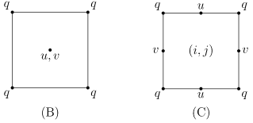

- COBALT uses 50 vertical layers with a nominal resolution of ~10 m at the surface 200 m.
- Simulations are forced using the Common Ocean-Ice Reference Experiment (CORE-II) data set (Large and Yeager 2009). For CORE-II, the air–sea fluxes of momentum, heat, freshwater and their components have been computed globally from 1948 at frequencies ranging from 6-hourly to monthly.

Model assessment
- Assessment and diagnosis is carried out in two steps:
  - Comparison against a ‘‘standard’’ set of physical and surface chemical and biological observations.
  - Comparison against global-scale estimates of the energy/carbon flow through the planktonic food web.
- We rely heavily on published expert compilations for each observation type that average over many sites to elucidate large-scale patterns.
- Comparisons focus on annual mean patterns, though analysis of biome-scale seasonality for a number of key fluxes is also provided to ensure that consistent annual mean patterns do not arise from erroneous seasonal dynamics.
- Three primary skill metrics quantify model-data fits:
  - Correlation coefficient (r): used as a measure of relative spatial agreement.
  - Mean bias: used as a measure of model-data offset. When model residuals were skewed (i.e., long tails), variables were log₁₀ transformed and the mean bias was replaced with F_{med} = 10median(log(Model) – log(Observed)). This quantity has the advantage of translating logarithmic biases to a factor separating the model and data. (i.e., F_{med} = 2.0 implies that the model is ~2x the observed value).
  - Root mean square difference (RMSD): used to quantify the scale of the difference between the model and the data at any point.

Phys, chem, bio properties
X compared against Y...
- Modeled mixed-layer depths: observation-based estimates in Montegut et al. (2004)
- Macronutrients (N, P, Si): 2009 World Ocean Atlas (Garcia et al., 2010)
- Surface Fe []s: combined compilations of Moore and Braucher (2008) and Parekh et al. (2004) Chlorophyll: NASA’s SeaWiFS satellite climatology.

Global-scale patterns in C and energy flows
- NPP: a compilation of 5055 ¹⁴C and ¹³C uptake measurements extracted from published studies that span major oceanic biomes; estimates from three satellite-based algorithms
- Productivity of large vs. small phytoplankton: satellite-based techniques of Uitz et al. (2010)
- Microzooplankton grazing on phytoplankton: Calbet and Landry (2004) compiled 788 paired observations of autotrophic growth and grazing mortality from 66 dilution studies
- Microzooplankton consuming bacteria: compilation of 17 studies (Strom 2000)
- Viruses accounting for 10 – 40% of bacterial production: Fuhrman (2000) and Suttle (2005)
- Primary production explains 57 – 77% of the variation in bacterial production (Cole et al. 1988); mean ratio of bacterial production:primary production in the euphotic zone < 0.2
- Mesozooplankton production is estimated using observed biomass fields from the NOAA/National Marine Fisheries Service COPEPOD database (O’Brien 2005)
- Temperature + surface chlorophyll estimates: SeaWIFS + COPEPOD biomass data

Biome-specific comparisons and diagnostics
- Three ocean biomes:
  - Low chlorophyll (LC): < 0.15 mg Chl m⁻³
  - Elevated chlorophyll, continuously stratified (ECCS): > 0.15 mg Chl m⁻³, mixed layer < 75 m. Corresponds to Banse’s low seasonality, nutrient rich, low seasonality zone (subtropical gyres)
  - Elevated chlorophyll, seasonally stratified (ECSS): > 0.15 mg Chl m⁻³, mixed layer > 75 m. Corresponds to Banse’s high seasonality zone.

- Fluxes were integrated over the top 100 m for all budgets.
- < 100 m were omitted from the biome analysis. They were resolved by the 1° ocean model.

Results
- This simulation captures large-scale spatial patterns in the maximum mixed layer depth (MLD) and seasonal MLD changes.
- Discrepancies:
  - Winter mixing depth in the NW Pacific (near Japan) is too deep
  - Strength and spatial patterns of deep mixing in the subarctic North Atlantic
  - Mixing along northern edge of Southern Ocean is too deep, too far north
- In all three cases, macronutrient []s are underestimated in the high latitude North Pacific and overestimated in the Southern Ocean.
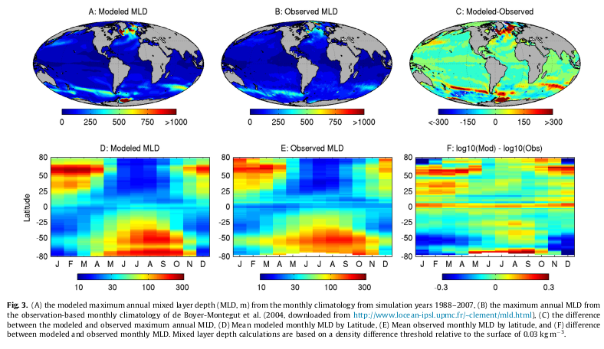

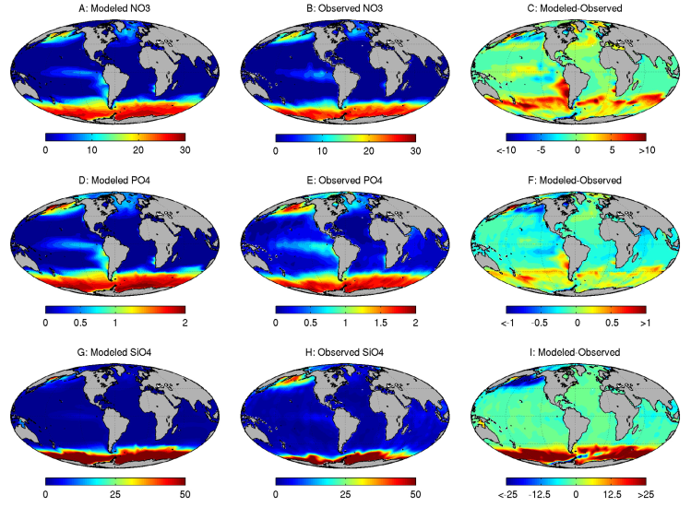

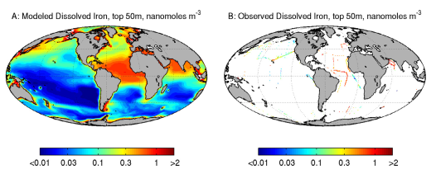

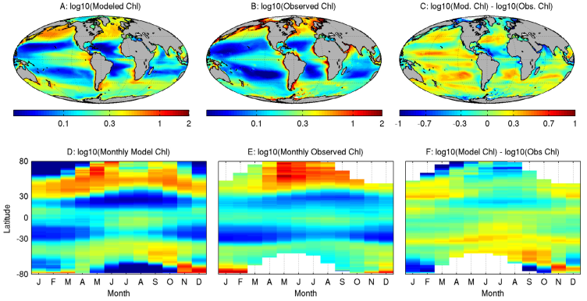

Assessment of global patterns of C flow through the planktonic food web; the microbial loop
- Modeled NPP = 51.9 Pg C yr⁻¹
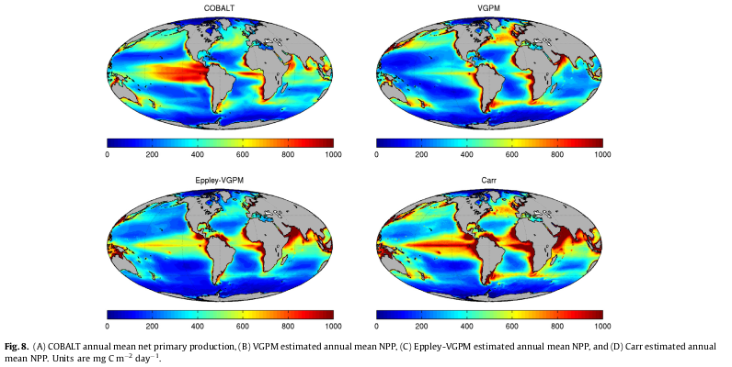

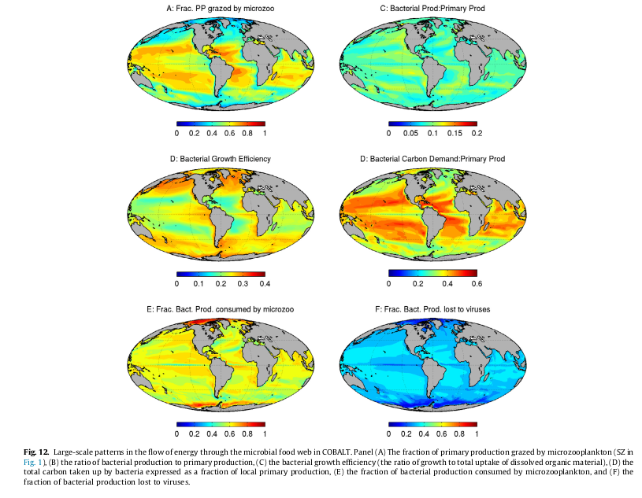
Discussion
- This comprehensive, novel, flux-centered model assessment includes numerous metrics (energy flows through the microbial food web and mesozooplankton production) that have not been considered in past global modeling studies yet are central to the credibility of the modeled food web.
- The total respiration by mesozooplankton in COBALT (7.5 Pg C) falls within the Hernandez-Leon and Ikeda (2005) range (10.4 ± 3.7 Pg C yr⁻¹) for the top 200 m.
- All of the broadly defined biomes were net autotrophic over the 20 year averaging period.
- Three factors linked to cross-biome variations in the relationships between NPP, mesozooplankton, and C export from the eutrophic zone:
  - Size-structure of the phytoplankton community and its impact on the mean trophic level of zooplankton;
  - Seasonal stability of the water column and its implications for consumer-prey interactions;
  - Gross growth efficiencies of each trophic link.
- “Ryther (1969) invoked factors (1) and (3) to estimate cross- ecosystem differences in fisheries productivity. Stock and Dunne (2010) also identified factors (1) and (3) to explain global-scale variations in the ratio of mesozooplankton production to primary production. Meanwhile, Legendre and Rassoulzadegan (1996) identified (1) and (2) as primary determinants of export from the pelagic ecosystem. Simultaneous consideration all three factors in a coupled physical–biological context herein provides an opportunity to revisit these arguments.”

