**EC327 Fall 2019 Project Timeline**

**Team Name:** C(++)’s Get Degrees

**Team Members:** Lindsey Volk, Kevin Arseneault, Shaurya Atal, Ashley Hamlin, Kathryn Lewis, Cooper Salmon

**Team Meetings, Milestones, & Objectives:**

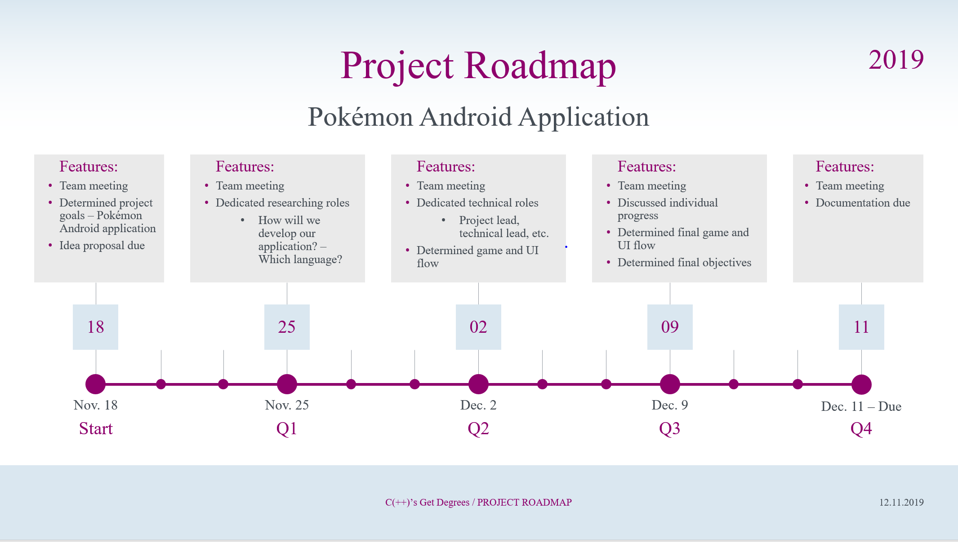

*Figure 1. This figure illustrates the four milestones (Q1, Q2, Q3, Q4), objectives, and timeline that our team has abided by.*

**11/18/19:** Team meeting. Project goals discussed. **Objective:** PA3 must be completed by 11/25/19.

**11/18/19 – 11/25/19:** Individual progress on PA3 and knowledge of the Pokémon game.

**11/25/19:** Team meeting. Researching roles dedicated. **Objective:** Knowledge of Android application development must be completed by 12/02/19.

**11/25/19 – 12/02/19:** Individual research progress.

**12/02/19:** Team meeting. Technical roles dedicated – Lindsey: UI development, Ashley: UI development, Katie: catch Pokémon algorithm, Kip: API call for Pokémon images, Shaurya: battle class, Cooper: Pokémon class. **Objective:** UI 100% completed by 12/09/19 and 75% of backend development completed by 12/09/19.

**12/02/19 – 12/09/19:** Individual technical progress.

**12/09/19:** Team meeting. Individual technical progress discussed. Final technical roles dedicated. **Objective:** 100% of technical progress completed by 12/11/19.

**12/09/19 – 12/11/19:** Individual technical progress.

**12/11/19:** Team meeting. Documentation and video completed.