Air Traffic Control System Project Report 2

Team SegFault

Sadie Sorenson and Lindsey Wingate

CSCI 363, Fall 2016

Due November 14, 2016

Updated Interface Screenshot

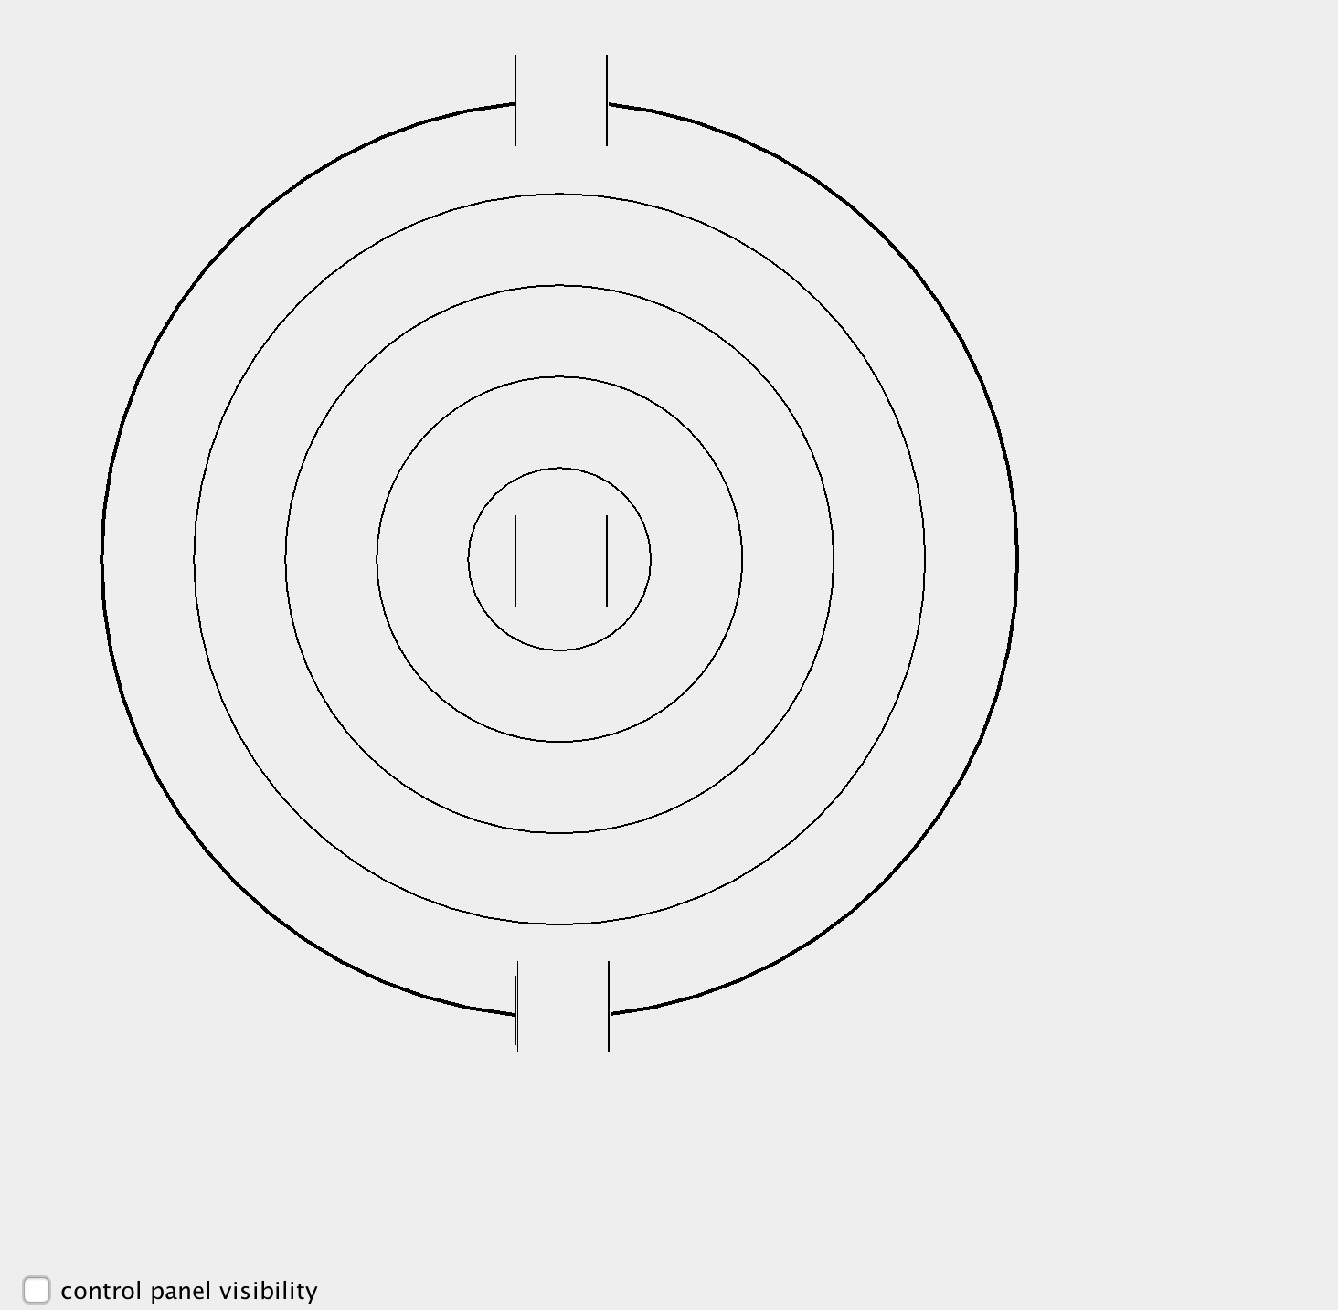

When the control panel visibility is clicked, there is drop down menu that allows you to enter information to change the airplanes path once it enters the controlled airspace.

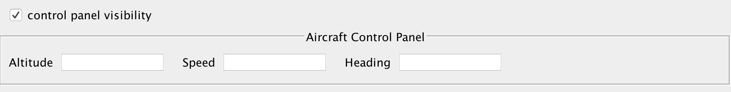

UML Class Diagram

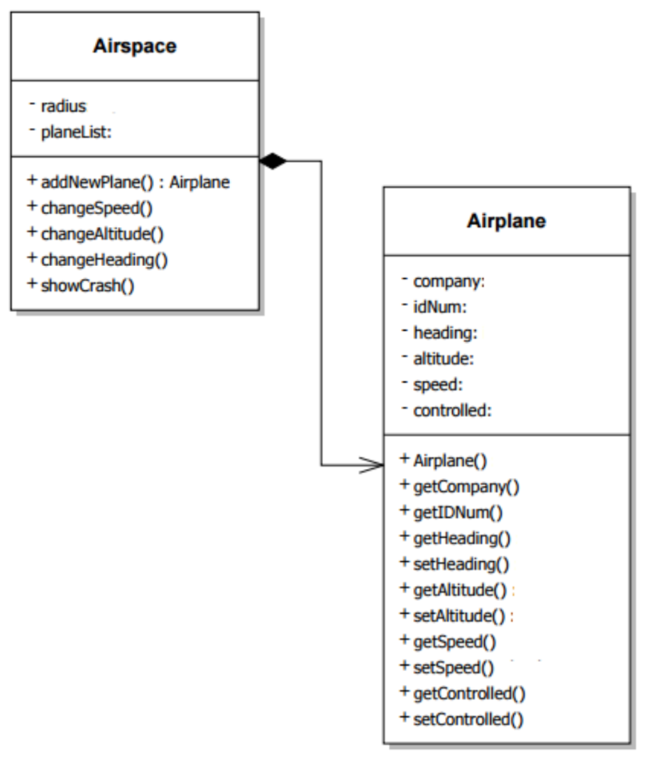

Issues Encountered and Solutions

Using NetBeans vs. personally writing all code involved

We decided to use the NetBeans interface to design the GUI. If we ever have difficulty with the pre-coded components, we can write our own code and it allows us to add it to our ATC design.

NetBeans takes some work to draw circles

To solve this issue, we wrote our own code for a circle class and added it as a component instead of attempting to use a drag-and-drop method with NetBeans.

Expectations for Next Report

For the coming reporting period, we will verify that all components in our static system are to the specifications of the contractor. We will center the components and update the menu. We will also begin implementing the components for airplanes and actions of those airplanes.