Lindsey Wingate

User Interface Design, 363

October 10, 2016

Assignment #5

Fall 2016

Design from Homework #3:

r

Title

All

ç

ç

ç

No

Yes

Adjacent Words

Library Search

Cancel

Reset

Search

Keyword or Phrase

Choose Collection

Search Using

My new interface appears as the following:

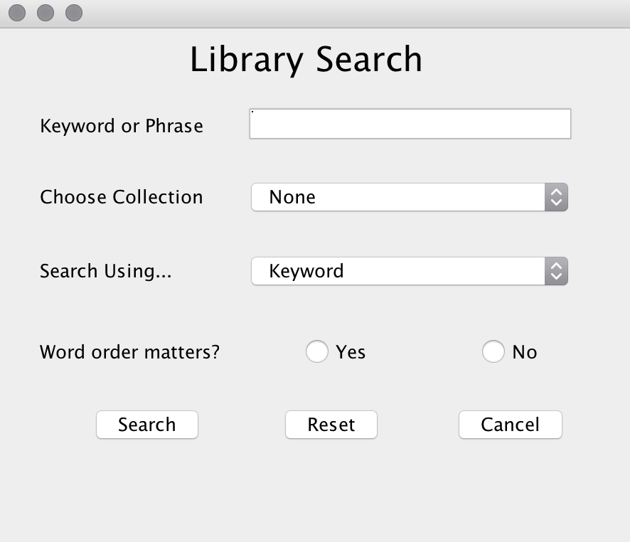

The default settings are shown above. To search, a user enters a word or multiple words in the Keyword or Phrase box. They may choose a collection (None, Children, Young Adult, or Advanced). Then, they may also change the search from Keyword to Book Title, Author’s Name, Genre, or Year Published. The radio box for word order is not required but may be entered to speed up the search.

Clicking the Search button produces a positive result if the user enters “kitties”. A notification pops up with a search result. If it is any other search, a notification informs the user there are no matches. The reset button resets all the fields and the Cancel button exits out of the program.