Lindsey Wingate

User Interface Design, 363

October 10, 2016

Assignment #6

Fall 2016

Design from Homework #6:

r

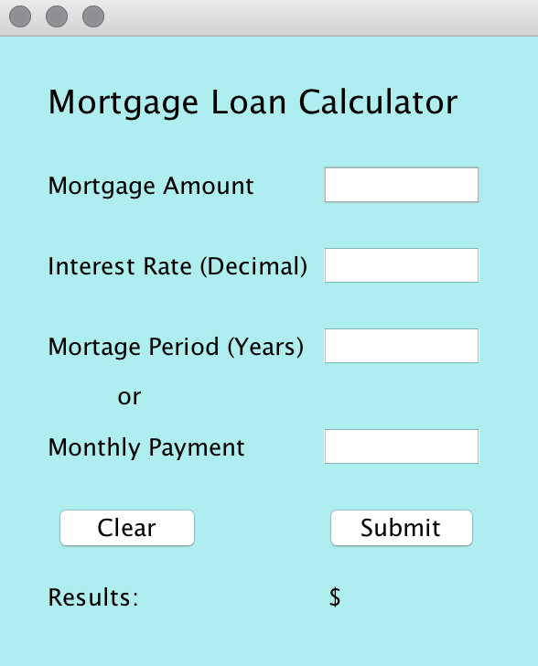

My Mortgage Loan Calculator is simple. A user enters their Mortgage Amount, the interest rate (in decimal form), and the mortgage period or monthly payment they wish to make. When they submit, It will calculate the amount for them. If they enter the mortgage period, the result will be their monthly payment. If they enter the monthly payment, it will give them the amount of years it will take to pay off the mortgage.

If they click the clear button, they may begin again with new values. This interface assumes the user will not be using dollar signs or extra symbols of any kind (such as commas).