Lindsey Wingate

CSCI 397 Term Paper

January 12, 2017

**North Dakota Wildlife**

For my Co-op credit I designed and implemented a minor search engine for wildlife photos provided by North Dakota Game and Fish. I worked with Susan Felege, the biology professor in communication with ND Game and Fish and Cheyenne Letourneau, a biology student minoring in computer science.

Initially, the plan was to design a searchable database for wildlife photos taken by George Rohde. He was a native North Dakotan who studied biology and business at UND. He passed away in 2011 and his family donated his collection of digital and film photographs. Cheyenne and I discussed the options for web layouts and came up with a simple layout as seen below.

1.1 The homepage of the North Dakota Wildlife search engine-csgrid.org/csg/wildlife_lwingate/flora_and_fauna.php

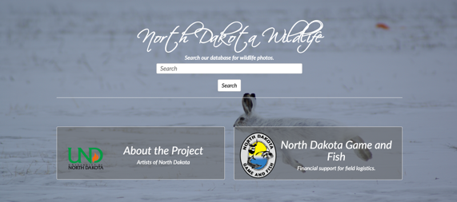

1.2 About the project

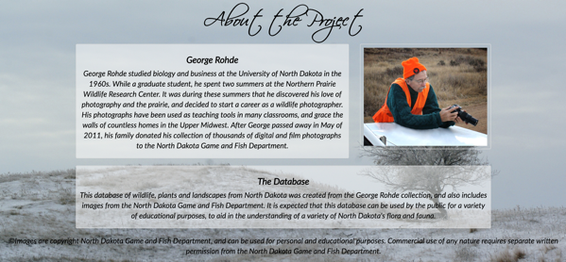

The website went up within the first two months of the project. It was created on the CSGrid server run by Travis Desell. It was coded from scratch using HTML (bootstrap), JavaScript, and basic CSS.

One challenging aspect of this project was job roles. Cheyenne was responsible for scanning in the photographs from the George Rohde collection. Once they were scanned and recorded in a google excel sheet, she had to email wildlife specialists to be sure the photos were classified correctly. I was also invited to use the excel spreadsheet and have access to the pictures on Google drive. In order to have a working, consistent dataset I should have requested only pictures with confirmed data be forwarded to me. Instead, I copied over the incomplete excel data chart into a MySQL to begin testingSometimes I would color coordinate things, only to find out we were not on the same page with where the pictures were at in the process. . Even today a few of the pictures are still waiting on correct classifications and descriptions in the database that is queried with searches from the website.

I copied the data as it existed mainly to start testing the search bar. The back end of Travis’ server is all coded in PHP. In order to query the database, I grabbed the search word or words using JavaScript and passed the variables to a PHP script. With proper forsight, using a server that was run on Node would have been much better for this project. It would make passing variables from JS to JS much easier. I had a little bit of trouble hooking up the search bar with my PHP script and returning results. Eventually I was able to return individual pictures from the database when searching specifically for the common name of the animal.

Originally the hope was to have a search similar to Google. You could search keywords and have pictures appear on the screen. If you wanted to view a full picture, you could click on it and have a larger view with the description and classification of the wildlife specimen.

I learned this was very difficult and Google made it look easy. MySQL does not have a query that will search the database entirely for keywords. Instead, you must search where *something* is equal to *something*, or in other words where a specific column is equal to the keyword the user is searching. As mentioned earlier, I was able to get one picture returned from the database based on the common name of the animal.

In order to have more success, I needed to add more queries. A lot of my work on the query bar was learned on the spot because I had never done a project searching a database before. In my 260 Perl class, I will be searching a MySQL database with a Perl script depending on what the user requests. I think designing it with a specific column in mind would have been easier instead of a free search for any keyword in the table.

About this time, I realized the site needed a few upgrades. I had designed it using strictly JavaScript. Whenever a search was made JavaScript would remove DOM elements, such as the background and wells to make way for the pictures that were returned with an AJAX call without needing to refresh the page. I liked this layout, however it didn’t allow the usage of back arrows in the browser to take you back to the previous search. I had a few people test the site and requested this be changed. Also, Susan mentioned that more photos would eventually be scanned in from different collections. I decided to redesign the webpage to accommodate further growth to the project in the future.

The new webpage appeared as follows:

1.4 Homepage (http://csgrid.org/csg/wildlife_lwingate/ff_home.php)

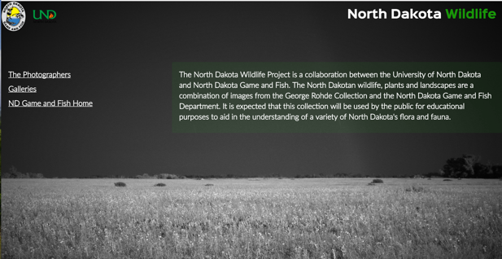

1.5 Photographers page (http://csgrid.org/csg/wildlife_lwingate/photographers.php)

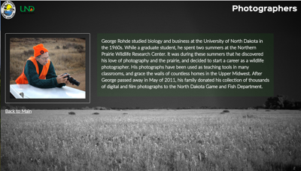

1.6 Navigation and Future search bar page-http://csgrid.org/csg/wildlife_lwingate/ff_galleries.php

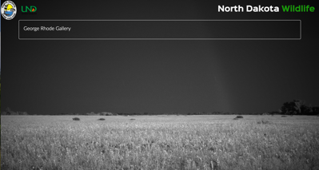

1.7 George Rohde Photo Gallery - http://csgrid.org/csg/wildlife_lwingate/ff_gallery.php

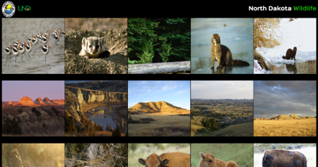

Susan and I preferred this layout because it was professional and left further room for the project to grow. New pages and links can be added easily, unlike the original page whose layout limited expansion; if another well was added, it would require the user to scroll. I prefer designing webpages that avoid scrolling because it allows the users to focus their attention on simple elements.

Besides having individual pages for the photographers, I anticipated adding search bars to each individual collection page. Also, I planned on transitioning the search bar from the original site onto the navigation page to allow users to search the table for various pictures from different artists. I had other ideas for simple searches, such as keywords along the side of the page that could be clicked and only the corresponding pictures would stay on the page.

An issue I ran into was how slowly the pictures were loading on the gallery site. I realized to increase the efficiency of the webpage I would need to optimize the pictures so they would load quickly and then have the option for the user to click on them and download or see the full version with additional information. Once this was done, I planned on advancing the search bar and focusing more on the back end work (PHP and database work). I was able to optimize a few of the photos for the next student. Unfortunately, my project was cut short due to leaving the country and being restricted by NATO laws-spouses are not allowed to work unless it is a USAJOBS approved position. I was disappointed to leave a few things unfinished, but I feel confident I left good groundwork for the next student working on the project.

I learned a great deal working on this project. Starting your project and having a plan of attack should always be a priority. A lot of times I prefer to dive into a project without a solid plan, but this can cause a lot of issues. On this project specifically I could have benefitted from more planning when it came to the design of the website itself and the future of the project. Also, Cheyenne and I could have come up with a more effective way to communicate and pass data between us without dealing with an inconsistent Google excel sheet.

In 363, User Interface Design, we learned about different project planning methods. I prefer the Agile method because it allows users to get results in phases without requiring all the coding be completely done. I feel I was somewhat successful in my attempt to do small, short sprints and release different aspects of the project over time. Susan and I had good communication as to what was being done on the project.

Working with Cheyenne ended up being a little different than planned. In the beginning, Susan had hoped Cheyenne would get a bit more experience with coding and web design for her minor. We planned to get together twice a week to work on designing the website. We did the best we could to meet, but eventually the meetings stopped happening due to conflicting schedules. I attempted at keeping Cheyenne in the work loop by offering little tasks. In the end, we both fell into the rolls where we were most comfortable. Cheyenne worked on the Biology side and I worked on the coding and design side.

If I went back to redo this project, I would focus more on detailed code planning. I was planning on having the whole year for the project but I feel I could have accomplished a lot more the first semester if I had a detailed coding plan. In my other classes I usually make a small outline of what the coding assignments goals are and how I plan on getting them done. I did this for the project, but because of it’s size I should have planned more details such as specific MySQL queries. I would also read papers on projects completed previously similar to what I was trying to accomplish.

Additionally, I could have focused on the functionality of the search bar and improve my knowledge of MySQL queries. It was easy for me to get caught up in a beautiful web page and spend all my time designing the CSS. I learned it is also a lot easier to show off a beautiful project and promise results with just a little more time. I learned people respond better to a beautiful website than to an ugly, functional one. In the future I need to focus more on having a pretty *and* functional product.

I really enjoyed the overall co-op experience. Susan is a great professor that has a lot of ideas and I enjoyed being able to help her work on these projects. Of the goals I set when I started this project, I feel I accomplished a lot of them. I ran out of time to integrate the search bar work I had done on the previous site to the new site, but I was able to develop a clean site with future add-on search capabilities. In the future I will have a better vision of what goes into a long term project rather than a short assignment because of this co-op.