**Please enter the following:**

Class Time: 9:30 Team (Table) No. 18 Trio Letter (A, B, or C): B Recorder: Lindsey Wingate

**ALA – KIDNEY FUNCTION**

Please work on this **in trios**. Add your answers to this file (please keep it as a Word file if possible—convert to PDF if you are unable to save as a Word file. **Mac user? Please do NOT submit ALAs as a “Pages” file**.), **save to desktop or some other location**, then attach when submitting your assignment through Blackboard **(be sure you submit this assignment ONLY when you are asked to do so during class)**. Only one person **per trio** should submit. All team members should write a copy of your answers so you have them to study from (or the recorder might email the completed file to other members of your trio). You may use your book, internet, or any other resources you wish to answer these questions. Be sure to ask Dr. C or one of the teaching assistants if you need help!

**NOTE: YOU MUST BE IN CLASS AND COMPLETE THE IN-CLASS SURVEY TO RECEIVE CREDIT.**

1. Consider the nephrons below. Match the regions with their numbers.

Distal tubule = 4

Proximal tubule = 2

Loop of Henle = 3

Vasa Recta = 6

Renal Corpuscle = 1

Collecting Duct = 5

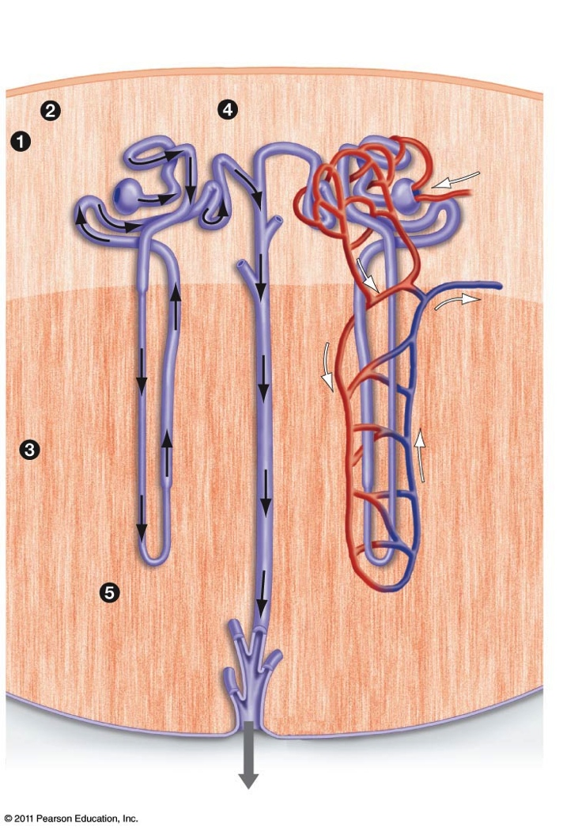

**6**

1. Consider the renal corpuscle below. Will filtration increase or decrease if blood vessel “A” were constricted? increase - applies more pressure and increases
2. How about it blood vessel “B” were constricted? decrease

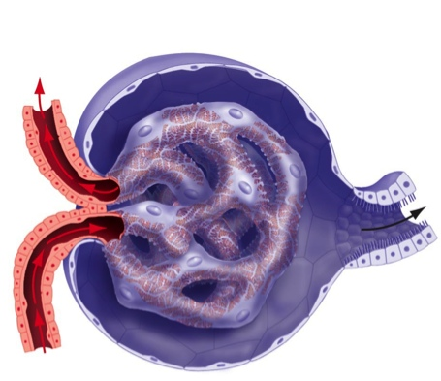

**B**

**A**

The two solutions below (A and B) are separated by a membrane. The red dots represent solutes.

1. Which direction will water tend to flow by osmosis? towards B
2. Which direction will the solutes tend to move by diffusion? towards A

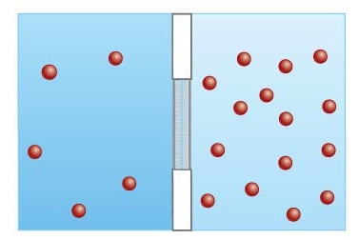

**B**

**A**

The image below illustrates active transport and cotransport.

1. As more active transport occurs below, what will tend to happen to the concentration of the red disaccharides in region “B”? The concentration will increase
2. As more active transport occurs below, what will tend to happen to the concentration of the yellow solutes in region “B”? They will decrease

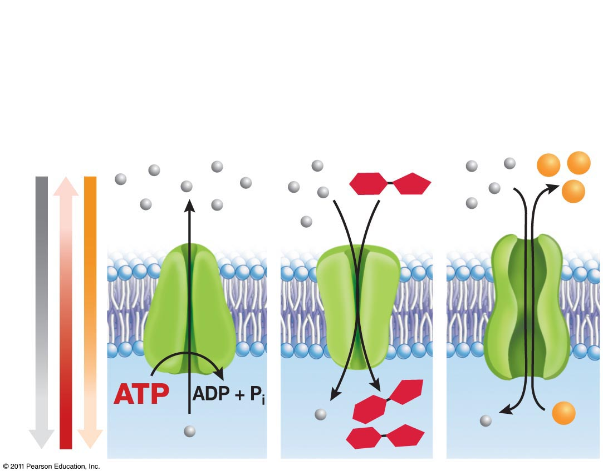

**Active**

**Transport**

**Symporter**

**Antiporter**

**Cotransporters**

**A**

**B**

Reabsorption occurs in the proximal tubule and results in nutrients moving from the filtrate (found in the tubule lumen) back into the bloodstream (via the vasa recta). Imagine a nephron being treated with a poison that **prevents active transport of Na+ out of the tubule epithelium** (see step 1 below). Indicate whether the poison would increase or decrease each of the following:

1. Amount of glucose retained in the bloodstream. decrease
2. Amount of vitamins retained in the bloodstream. decrease
3. Amount of water retained in the bloodstream. decrease
4. Amount of Cl- moving from the filtrate into the epithelial cells. decrease
5. Which plays a larger role in reabsorption- **symporters** or **antiporters**? symporters

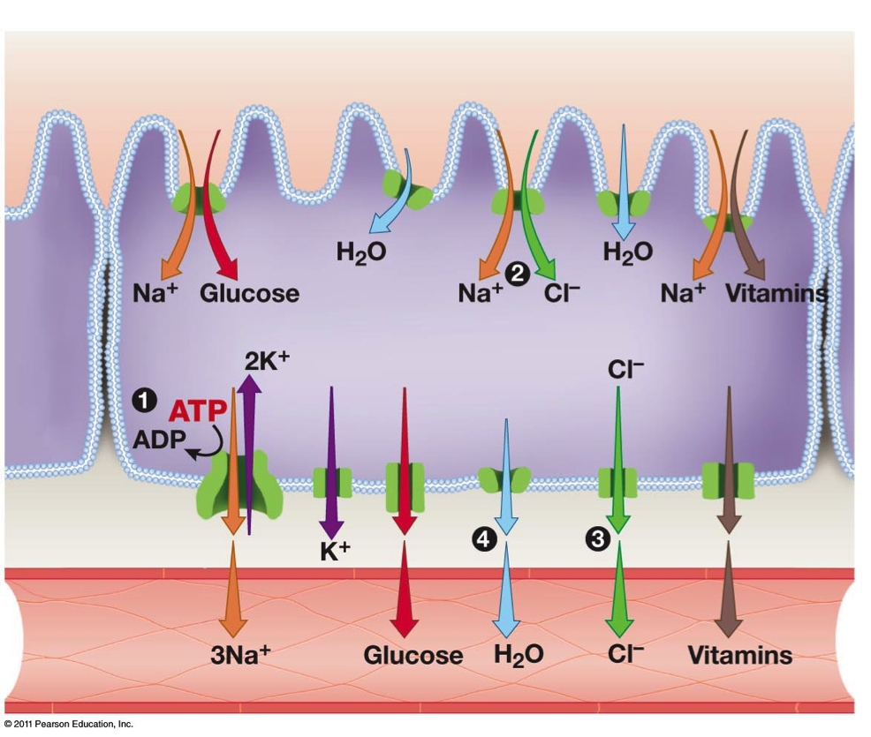

Tubule Lumen

Epithelium

Vasa Recta

The diagram below illustrates a nephron and a collecting duct. Region “A” (descending limb) is permeable to water while region “B” is permeable to salt. The concentration of solutes (mostly salt) in the tissues **surrounding** **the nephron** is shown below toward the left (in milliosmoles). The filtrate begins its journey through the proximal tubule with a concentration of 300 milliosmoles.

1. Will water move into or out of “A” by osmosis? out
2. Will the filtrate become more or less concentrated as it travels through “A”? more
3. Will salt move into or out of “B”? out
4. Will the filtrate become more or less concentrated as it travels through “B”? less
5. Will water move into or out of “C” by osmosis? out
6. Will the urine become more or less concentrated as it travels through “C”? more
7. Antidiuretic hormone (ADH) makes “C” more permeable to water. Does ADH tend to increase or decrease urine production? decrease
8. Alcohol tends to inhibit ADH. What impact does this have on urine production? Many people experience this after having a bit too much to drink…. Increases production

ADH makes the duct more permeable by triggering production of aquaporins that make the membranes more permeable.

Xylem pulls water under negative pressure – water evaporates from leaves and pulls up

Sugars move through phloem under positive pressure – pressure gradient formed

Shoot tips produce hormones that stimulate the growth axillary buds – false

Apical meristems are found only at the tips of branches in trees – false, found on roots as well

Growth rings in tree trunks form as a result of seasonal activity of apical meristems – false

Sugars are actively transported into phloem cells, but not out of them – false

Signal amplification refers to the formation of multiple hormones from one g protein – false

Blood is filtered in the glomerus – true

Adh tends to decrease the amount of urine produced – true

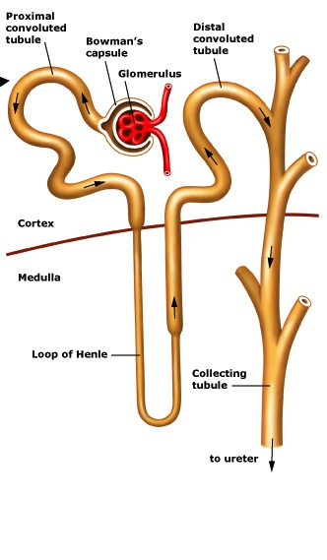

**600**

**900**

**1200**

**300**

**C**

**B**

**A**