**Please enter the following:**

Class Time: 9:30 Team (Table) No. 18 Trio Letter (A, B, or C): B Recorder: Lindsey Wingate

**ALA – PLANT FORM AND FUNCTION**

Please work on this **in trios**. Add your answers to this file (please keep it as a Word file if possible—convert to PDF if you are unable to save as a Word file. **Mac user? Please do NOT submit ALAs as a “Pages” file**.), **save to desktop or some other location**, then attach when submitting your assignment through Blackboard **(be sure you submit this assignment ONLY when you are asked to do so during class)**. Only one person **per trio** should submit. All team members should write a copy of your answers so you have them to study from (or the recorder might email the completed file to other members of your trio). You may use your book, internet, or any other resources you wish to answer these questions. Be sure to ask Dr. C or one of the teaching assistants if you need help!

1. Xylem consists of cells specialized for conducting water. Which region (s) below contain xylem?

A, B, C

1. Phloem consist of cells specialized for conducting sugars formed during photosynthesis. Which region (s) below contain phloem?

A, B, C

1. Consider region “C”. In general, which direction does water tend to move?

Water moves up the stem generally.

1. Consider region “C”. In general, which direction does sugar tend to move?

Sugar generally moves down the roots.

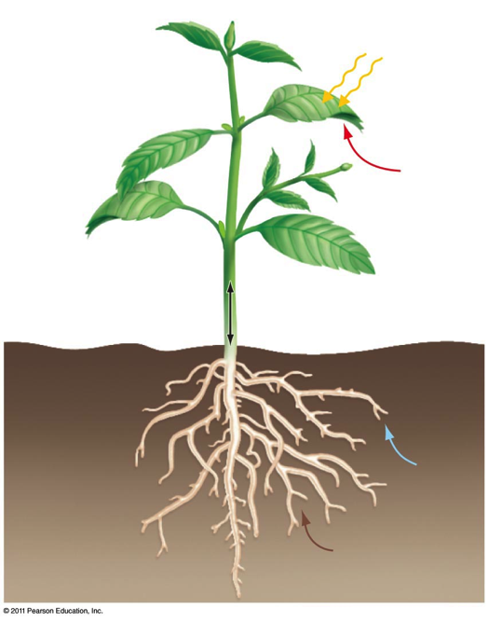

**B**

**A**

**C**

The image below shows a close-up view of stomates—the small pores on the surface of leaves that allow for gas exchange and loss of water through evaporation.

1. Which of these likely came from a tree that experienced hot, dry, drought-like conditions?

A

1. Considering your answer to the previous question, will the Calvin cycle likely be taking place to any significant extent in this tree? Explain.

The Calvin Cycle is likely to be minimal because H20 is a necessary element and it is readily available.

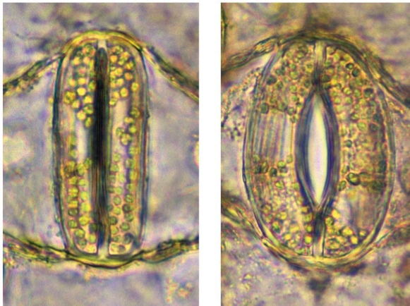

**A**

**B**

The image below shows two leaves from the same tree. One was grown in the shade (toward the bottom of the tree) while the other was grown in the sun (toward the top of the tree).

1. Which was likely grown in the sun?

B

1. How can you explain this difference in growth (think about which leaf would be more likely to loose water through evaporation)?

The leaves towards the top of the tree tend to have complex edges and lobes, whereas the bottom leaves require more surface area to get more sun because they are in the shade.

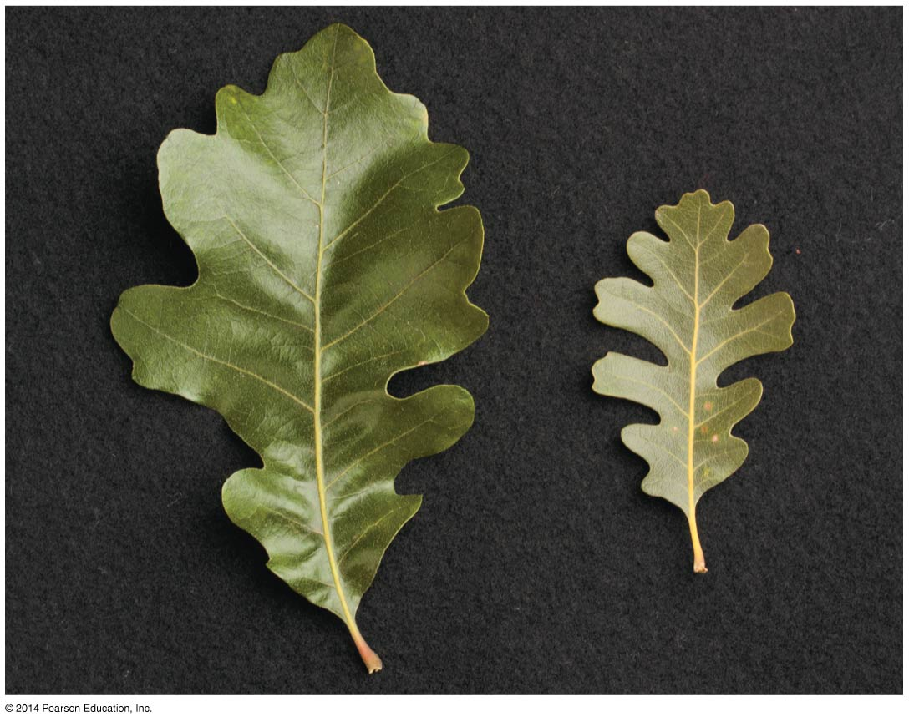

**A**

**B**

The image below shows a longitudinal view of a root.

1. Identify the structures labeled “A”.

Root hairs

1. What important role do these structures play?

Root hairs collect water and minerals from the soil for the rest of the plant.

1. What would happen to those structures if they differentiated in region “B”?

The root hairs probably wouldn’t be as effective because the growth in region C would hurt the root hairs since they are delicate.

1. “C” represents the root cap. What is the function of this structure?

The root cap protects the apical meristem as it grows.

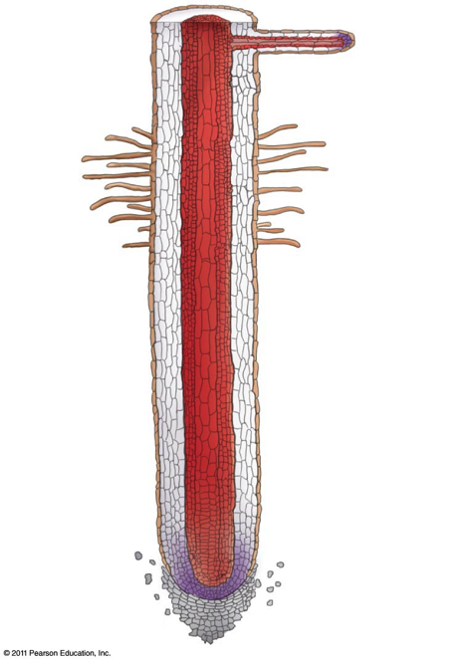

**B**

**A**

**C**

Consider the images below. The pictures on the right are sections through the roots on the left.

1. What role might the statoliths (small, free-floating starch grains) play in root growth?

Statoliths act as a gravity sensor for the plant.

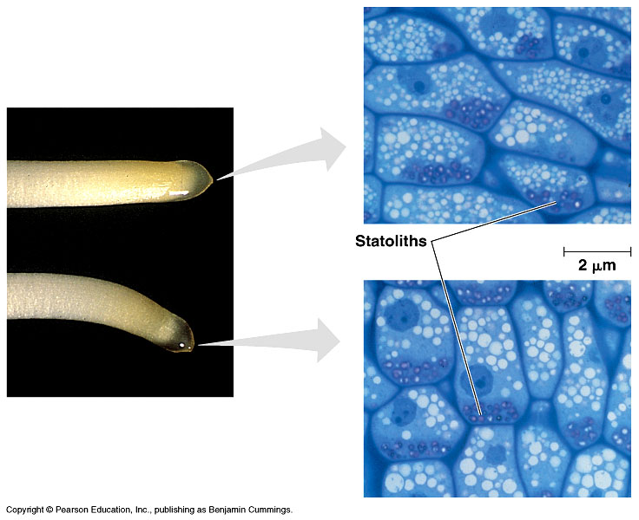

The vascular tissue of plants consists of xylem (cells specialized for conducting water) and phloem (cells specialized for conducting sugars). The image below illustrates the two types of xylem cells (short, wide vessels and long, narrow tracheids) as well as the most common type of phloem (sieve elements). As part of figuring out how water and sugars are transported through plants, investigators measured the average diameters of xylem and phloem cells in plants growing on a warm spring day. Those results are provided below.

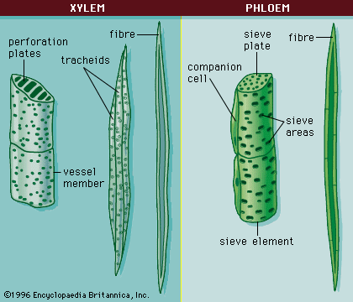

|  |  |  |  |  |  |  |
| --- | --- | --- | --- | --- | --- | --- |
| Average Diameter of Xylem and Phloem (μ) | | |  |  |  |  |
| **Time of Day** | **Xylem** | **Phloem** |  | **Time of Day** | **Xylem** | **Phloem** |
| Midnight | 6.0 | 4.0 |  | Noon | 4.8 | 5.0 |
| 1 a.m. | 6.0 | 4.0 |  | 1 p.m. | 4.4 | 5.4 |
| 2 a.m. | 6.0 | 4.0 |  | 2 p.m. | 4.0 | 5.8 |
| 3 a.m. | 6.0 | 4.0 |  | 3 p.m. | 4.0 | 6.2 |
| 4 a.m. | 6.0 | 4.0 |  | 4 p.m. | 3.8 | 6.2 |
| 5 a.m. | 6.0 | 4.0 |  | 5 p.m. | 3.8 | 6.0 |
| 6 a.m. | 5.6 | 4.0 |  | 6 p.m. | 3.8 | 6.0 |
| 7 a.m. | 5.4 | 4.2 |  | 7 p.m. | 4.0 | 5.8 |
| 8 a.m. | 5.4 | 4.3 |  | 8 p.m. | 4.5 | 5.5 |
| 9 a.m. | 5.2 | 4.5 |  | 9 p.m. | 5.0 | 5.0 |
| 10 a.m. | 5.2 | 4.6 |  | 10 p.m. | 5.7 | 4.7 |
| 11 a.m. | 5.2 | 4.8 |  | 11 p.m. | 5.9 | 4.2 |

1. What trends do you observe regarding the relationship between the diameter of each of the cell types and the time of day? How does the change in diameter correlate with relative amount of sunlight and amount of water likely evaporating from the leaves?

Xylem generally has a larger diameter than Phloem at Midnight but Phloem has a larger diameter the opposite times (Noon is it’s peak).

1. Based on these results, develop a hypothesis regarding the mechanism by which water is transported from the roots up through the rest of the tree. Is water likely pumped through the xylem under positive pressure (i.e., like forcing water through a garden hose), or, is it pulled under negative pressure (i.e., like drinking through a straw)?

Water is pumped through xylem because of the negative water pressure produced when water transpires through leaves, much like drinking through a straw.

1. Based on these results, develop a hypothesis regarding the mechanism by which sugars are transported from the leaves down through the rest of the tree. Is sugar likely pumped through the phloem under positive pressure, or, is it pulled under negative pressure?

Phloem is transported under positive pressure.

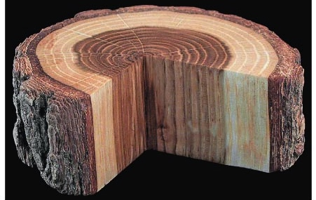

**VC**

Lateral meristems are responsible for secondary growth in woody plants. One type of lateral meristem, the vascular cambium (labeled “VC” above), adds girth to woody plants by adding secondary xylem toward the interior and secondary phloem toward the exterior. The secondary xylem, commonly called wood, accumulates as the plant grows. The activity of the vascular cambium varies throughout the seasons and is responsible for growth rings in temperate trees. Notice that the vascular cambium is a single layer of cells located just underneath the bark of the tree.

1. Which of the following represents a cross section of a four-year-old tree trunk that experienced drought conditions for the first two years of the tree's life and wet conditions for the most recent two years?

**B**

**A. 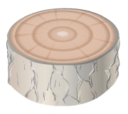 B. 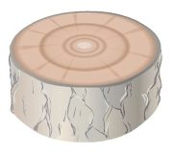 C. 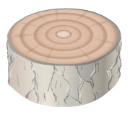 D.** 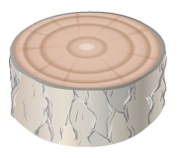

1. Why do trees that grow in tropical rain forest often lack growth rings?

They lack growth rings because the temperature varies less and they continuously grow, unlike trees in regions where the climate changes more frequently.

1. What is the record for the longest length of time that a vascular cambium has lived and produced new wood (in other words—how old is the oldest tree)?

About 5,000 years old.

1. The tree below will likely die. Why?

The bark was stripped and along with it went the phloem. Without the phloem, the tree cannot transport sugars to other areas and will die.

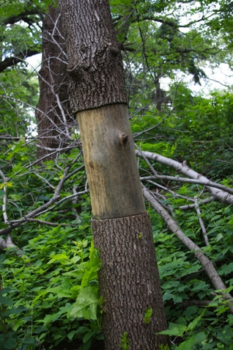

**How is plant growth impacted by acid rain?**

Plants experience a vast array of conditions that can alter their growth and development, including temperature and availability of water, nutrients, and light. How does pollution, such as acid rain, impact plant growth?

Acid raid slows growth, often causing plants to lose their leaves and needles, sometimes killing trees.

1. Develop a hypothesis that explains possible effects of acid rain on primary and secondary growth in trees.

Acid rain causes the tree to lose leaves and important nutrients in the soil, limiting possible growth.

QUANTITATIVE Researchers tested the effects of acid rain on two different hardwood species, camphor tree (*Cinnamomum camphora*) and bead tree (*Melia azederach*). Results of the experiments are shown below.



Fan, H. B. and Y. H. Wang. 2000. Forest Ecology and Management 126: 321–-329.

1. What was the approximate percentage growth reduction observed in the bead tree treated with acid rain?

About 10%

1. Which meristem was likely affected in the bead tree?

The Apical meristem.

1. Provide a plausible explanation for the differential effect of acid rain on height in camphor and bead trees (i.e., what structural features might provide more protection from acid rain in one species versus another?).

The camphor tree could have stronger, more protective bark, enabling the apical meristems to continue with primary growth. The Bead Tree probably has thinner bark, weakening the apical meristems ability to produce more cells. (Roots suck up acid raid)

1. Based on the results presented here, predict the impact of acid rain on the vascular cambium in the two species. How would that effect manifest in the amount of wood produced in the tree trunks?

The Camphor Tree would produce more wood than the Bead Tree. s