Continuous Random Variables and Probability Distributions.

Every CRV has a probability density function associated with it, pdf.
If X is a CRV call the pdf f(x).
Properties of any pdf:
f(x) ≥ 0 for all real x
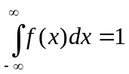

For CRV’s we associate probability with the area under the pdf (or density curve) more specifically, if X is a CRV with pdf f(x) then
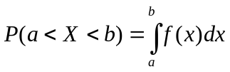
Draw curve!

Note that this implies some very important results:

Let f(x) be the pdf of X and y be any number: P( X = y) = 0
We never consider the probability that a CRV X is equal to any number.
We always talk about P(X < y) or P(X > y) or P(a < X < b).
Note because the P(X = y) = 0 means that
P(X < y) = P(X ≤ y) and P(X > y) = P(X ≥ y)

Typically CRV’s are used for measurements and not counting. However, because DRV’s can get difficulty to work with when dealing with many values, CRV’s are used to approximate the DRV’s.

Let X be a CRV with pdf f(x).
To find the P(a < X < b) we integrate f(x) from a to b. The area under f(x) the pdf from a to b is the P(a < X < b)
Associated with each CRV is also a cumulative distribution function, F(x).
For any value b, F(b) is the P(X ≤ b), which we get by integrating f(x) from – infinity to b.
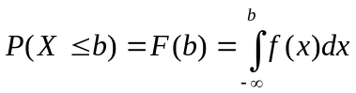

The Uniform Random Variable or distribution:
X has a uniform distribution on the interval [A, B] if the pdf of X is:
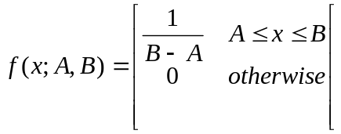
Two parameters A and B.

E(X) = μ = (A + B) / 2
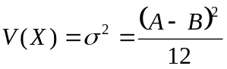

The pdf for the uniform rand variable is just a horizontal line. So finding probabilities (integrating) simply involves finding the area of rectangles.

Ex. Let X ~ Uniform (0, 2).
draw picture!
f(x) = ½ for 0 ≤ x ≤ 2
f(x) = 0 otherwise
Note that the area of the entire rectangle is 1 = P(0 ≤ X ≤ 2)
μ = 1 σ² = 4/12 = 1/3
Find the P(X < .25) = P(0 < X < .25) = ½ * .25 = .125 = 1/8
Find the P(X > .5) = P(.5 < X < 2) = ½ * 1.5 = .75 = 3/4

Generic pdf:
pg 135 Ex # 5 College professor finishes lecture
X = time that elapses between end of hour and end of lecture (minutes)

f(x) = kx² for 0≤x≤2
f(x) = 0 otherwise

a. Find k.
b. P(X < 1)
c. P(1< X < 1.5)
d. P(X > 1.5)

a. 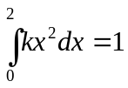
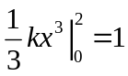

8k/3 = 1
k = 3/8 = .375

b. P(X < 1) = 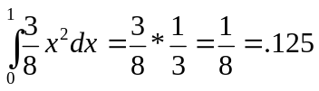

c. P(1 < X < 1.5) = 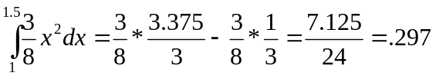

d. P(X > 1.5) = 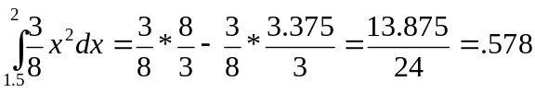

Cumulative Distribution Functions and Expected Values

The CDF F(x) for a CRV X is defined for any real number x by
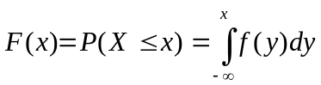
where f(y) is the pdf for X. F(x) is the area under the curve to the left of x.

Let X ~ Unif(0, 2)
f(x) = ½ for 0 ≤ x ≤ 2
f(x) = 0 otherwise

x F(x)
x < 0 0
0 ≤ x < 2 x * ½
x ≥ 2 1

In general for any Unif(A, B)
x F(x)
x < A 0
A ≤ x < B (x –A) / (B – A)
x ≥ B 1

Proposition:
Let X be a CRV with pdf f(x) and cdf F(X). For any number a:
P(X > a) = 1 – F(a)
for any numbers a and b with a < b
P(a ≤ X ≤ b) = P(a < X < b) = F(b) – F(a)

For every x where F´(x) exists, F´(x) = f(x)
F´(x) is the derivative of F with respect to x.

Let p be a number between 0 and 1. The (100p)th percentile of the distribution of the CRV X is denoted by η(p) is defined by
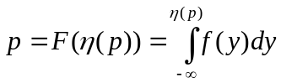

Percentiles are uniquely defined for CRV. For discrete RV’s there seems to be some argument.

The median is (still) the 50th percentile. μ~ is the value that satisfies F(μ~) = .5 and also 1 – F(μ~) = .5

The expected value or mean of a CRV X with pdf f(x) is
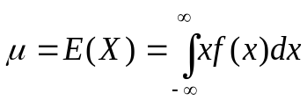

in addition, if h(X) is any function of X then
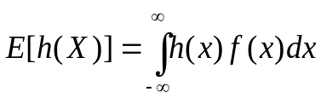
so the variance of X is
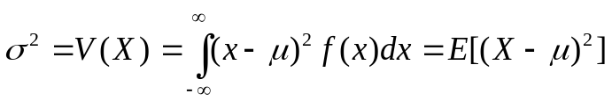
The standard deviation of X or σ is the square root of the variance.
As with DRV we can show that
σ² = E(X²) – [E(X) ²]

pg 142 Ex. 11.
x F(x)
x < 0 0
0 ≤ x ≤ 2 x²/4
x ≥ 2 1

P(X ≤ 1) = F(1) = ¼
P(.5 ≤ X ≤ 1) = F(1) – F(.5) = ¼ - .25/4 = .25 - .0675 = .1875
P(X > .5) = 1 - .0675 = .9375
μ~ = ? →.5 = F(μ~)
.5 = x²/4 → 2 = x² →x = √2 = 1.414
F´(x) = f(x) = x/2 = ½ * x for 0 < x < 2
Note that this is not Uniform, but is still easy to integrate, draw picture!
E(X) = ∫ x²/2 dx for 0 < x < 2
E(X) = x³/6 evaluated at 2 and 0
E(X) = 8/6 = 1.333
V(X) = E(X²) – [E(X)²] =
E(X²) = ∫ x³/2 dx for 0 < x < 2
E(X²) = x⁴/8 evaluated at 2
E(X²) = 2
V(X) = 2 – 1.333² = .222
σ = .471
E[h(X)) = E(X²) = 2

Other examples pg 142: 13, 17, 19, 23
19.
P(X ≤ 1) = F(1) = ¼ (1 ln4) = .597

P(1 ≤ X ≤ 3) = F(3) – F(1) = .9658 - .5966 = .369

F(x) = (x/4) + (x/4)*(ln(4/x))

F(x) = (x/4) + (x/4)*(ln4) – (x/4)*lnx

f(x) = F´(x) = ¼ + ¼ ln(4) -1/4 ln x – ¼

f(x) = ¼ ln4 – ¼ ln x when 0 < x < 4
f(x) = 0 otherwise

23.
E(C) = 120 σ(C) = 2
E(F) = 1.8 (120) + 32 =248
σ(F) = |1.8| * 2 = 3.6

The Normal or Gaussian Distribution.

Let X be a Normal RV, then X has two parameters: μ = mean and σ = standard deviation.
All Normal RV’s look very similar: a bell curve.
Mound shaped distribution centered around its mean μ.
The pdf for a Normal Random Variable is given in your text on page 145. It is ugly! Lucky for us we do not have to integrate it.

The most famous and often used distribution is called the Standard Normal Distribution or Z-Distribution, it is a Normal RV with μ=0 and σ = 1.
I will always use Z to mean N(0, 1)
The possible values for Z are -∞ to +∞, any real number.
Z-table (Table A3)
It gives an table-ized version of the Normal CDF.
The way the table works:
The z-scores are given by looking first at the ones and tenths digits of the z-score, the first column and then the hundredths digit of the z-score, the other columns. The 4 digit number given is the P(Z<z-score)

For example: P(Z < 1.96) = .9750
(Find +1.9 in the left column of the table, then find .06 in the top row,
where they meet is .9750)
This also means that the P(0 < Z < 1.96) = .4750
because P(Z < 0) = P(Z > 0) = .5
P(Z > 1.96) = 1 - .9750 = .0250
Since Z is symmetric around 0
P(Z < -1.96) = .0250 = P(Z > 1.96)
P(Z > -1.96) = .9750 = P(Z < 1.96)
P(-1.96 < Z < 0) = .4750

Verify that the probability that Z is between -1 and 1, then -2 and 2 and then -3 and 3. Draw the pictures!
P(-1 < Z < 1) = .6826
P(-2 < Z < 2) = .9544
P(-3 < Z < 3) = .9974

There is actually an easier way to find Standard normal probabilities or any other Normal probabilities for that matter.

There are three normal distribution functions on your calculator:
normalpdf, normalcdf, invNorm
normalpdf is useless!
normalcdf is the one we will use for finding probabilities when we are given values.
invNorm is the one we will use to find values given probabilities.

Normalcdf takes 4 inputs
The 4 inputs are (min, max, mean, standard deviation)
The mean and standard deviation inputs are optional. If you do not use them the calculator assumes mean = 0 and standard deviation = 1.
To get the normalcdf hit [2nd] [DIST] 2: normalcdf

Ex. Let Z ~ N(0,1) which means Z is Normally distributed with mean = 0 and the standard deviation is 1
Find
P(0 < Z < 1.5) = .4332 normalcdf(0,1.5,0,1) or normalcdf(0,1.5)
P(-1 < Z < 1.5) = .7745 normalcdf(-1,1.5,0,1)

Draw pictures!

P(-2.78 < Z < 0.45) = .6709 normalcdf(-2.78, .45)
P(Z < 1.25) = .8943
What do you put in for the min?
It is well known that P(Z < -10) ≈ 0, so the
P(Z < 1.25) ≈ P(-10 < Z < 1.25)
This is because in general for any numbers a and b
P(a < Z < b) = P(Z < b) – P(Z < a)
Draw picture!
To find P(Z < 1.25) = .8943 normalcdf(-10, 1.25)
You could use any number smaller than -10 like -11, -100,
-100000000, they will all give you the same answer.
Find P( Z > 1.65) = .0495 normalcdf(1.65, 10)
I used +10 here as the max because P(Z < 10) ≈ 1
So the P(Z > 1.645) ≈ P(Z < 10) – P(Z < 1.645)
Draw the picture.
Note that Z is symmetric about its mean, 0
This means that:
P(Z <-10) = P(Z > +10) ≈ 0
P(Z < -1.23) = P(Z > +1.23) = .1093

A new type of problem:
Find the 95th percentile of Z.
Now we want to find the value, w such that P(Z < w) = .95
For this type of problem we use invNorm, which takes 3 inputs, the percentile, the mean and the standard deviation.
To get the invNorm hit [2nd] [DIST] 3: invNorm

invNorm(.95,0,1)
P(Z < 1.645) = .95 w = 1.645

Note that I could have alternatively asked:
Find the value v such that 5% of Z values are greater than v.
P(Z > v) = .05 → P(Z < v) = .95 → v = 1.645

Without a calculator you can look up 0.9500 in the body of the table and find the corresponding z-score.
Unfortunately you cannot find 0.9500.
You can find 0.9495 → z=1.64 and 0.9505 → z = 1.65. Interpolating we find that 0.9500 → 1.645

Normal probability problems other than standard normal:
In the past (and present if you wish) you would standardize the Normal X to Z and use the table.
For example, if X ~ N(μ, σ) then Z = (X – μ)/σ is distributed as N(0, 1).
P(a < X < b) = P((a-μ)/σ < Z < (b-μ)/σ)) = P(Z < (b-μ)/σ)) - P(Z < (a-μ)/σ)

Ex 2. Let X ~ N(80, 10) Find the:
a. P(68 < X < 87)
Table Way: P(68 < X < 87) = P(Z < .70) – P(Z < -1.2) = .7580 - .1151 = .6429
Calculator = normalcdf (68, 87, 80, 10) = .6430
b. P(X < 92) = normalcdf(-100, 92, 80, 10) = normalcdf (-10, 1.2) = .8849
z = 1.2 = (92 – 80) / 10
c. P(X > 100) = 1 – P(X < 100) = 1 - normalcdf(-100, 100, 80, 10) = .0228
normalcdf(100, 1000, 80, 10) = .0228

d. Find the 90 percentile of X.
invNorm(.90, 80,10) = 92.8155 or
Look up .9000. It is not there so use 1.28 → .8997
x = 1.28 * 10 + 80 = 92.8

For part b you need to pick a number that is very much smaller than the mean
(more than 10 standard deviations below the mean)
For part c you need to pick a number that is very much bigger than the mean
(more than 10 standard deviations above the mean)

The concept of a Z score:
Let X be a RV with a mean of μ and a standard deviation of σ, then the z-score for any value of x is:
z = (x – μ ) / σ

In the previous ex, X has μ = 80 and σ = 10 so the z-scores for
a. 90 z = (90 – 80)/10 = 1
b. 70 z = (70 – 80)/10 = -1
c. 92.5 z = (92.5 – 80) / 10 = 1.25

The Z-score tells us how many standard deviations the x value is from its mean and in what direction (a positive z-score means that x > μ and a negative z-score means that x < μ).

Ex. The time required for Marge to bake a pretzel is normally distributed with mean 15 minutes and a standard deviation of 3 minutes.
a. What is the probability a pretzel takes longer than 19 minutes?
b. What is the probability a pretzel takes between 12 and 19 minutes?
c. Find the time t, such that 97.5% of pretzels take less than t.

Answers:
X = time for the pretzel to bake. X ~ N(μ = 15, σ = 3)
a. P(X > 19) = normalcdf (19, 1000, 15, 3) = .0912
b. P(12 < X < 19) = normalcdf (12, 19, 15, 3) = .7501
c. P(X < t) = .9750 = invNorm(.9750, 15, 3) = 20.8799
P(X < 20.8799) = .9750
or
Convert everything to Z = (X – μ) / σ
a. P(X > 19) = P(Z > (19 – 15)/3) = P(Z > 1.333) =
normalcdf (1.333, 10) = .0913
b. P(12 < X < 19) = P(-1.00 < Z < 1.333) =
normalcdf (-1.000, 1.333) = .7501
c. P(Z < s) = .9750 = invNorm(.975) = 1.96
so t = 1.96 * 3 + 15 = 20.88

The advantages to using Z are that you can always use -10 as -∞ and +10 as +∞ and you do not have to put in the mean and standard deviation.

In the previous example, when we found the
P(X > 19) = P(Z > 1.333) we can rephrase this is what is the probability that a normal random variable is more than 1.333 standard deviations above its mean. The z-score counts the number of standard deviations from the mean and the direction: + = above and - = below.
For X ~ N(μ, σ) find:
a. P(|X – μ | < σ) b. P(|X – μ | < 2σ) c. P(|X – μ | < 3σ)

Page 154: 33, 40, 35
Ex. 33 Force acting on a column
X ~ N(μ = 15, σ = 1.25)
a. P(X ≤ 18) = P(Z ≤ 2.4) = .9918
b. P(10 ≤ X ≤ 12) = P(Z < -2.4) – P(Z < -4) = .00812
c. P(12.5 < X < 17.5) = P(-2 < Z < 2) = .9544

Assessing Normality
1. Construct a histogram of the data. If the data is normal, the histogram should look mound shaped.

2. Compute the intervals (x-bar – s, x-bar + s),
(x-bar – 2s, x-bar + 2s), (x-bar – 3s, x-bar + 3s).
If the data is normal, they should contain approximately 68%, 95% and 100% of the data points, respectively.

3. Find the IQR and s for the data. For Normal data IQR/s = 1.34

4. Make a Normal probability plot (Q-Q). For normal data the points should fall on a straight line with slope 1.
y-axis = actual values sorted
x-axis = expected normal score

The Normal distribution can also be used to approximate the binomial distribution.
This was very useful before calculators and computers became so powerful.

Ex
Let X be Bin(n=1000, p = .3)
Find P(X ≤ 275) = .0446
Your calculator can do this, but realize you are calculating things like 1000 C 275, which is enormous.

np = μ = 300 √npq = σ = 14.491
Let Y ~ N(μ = 300, σ = 14.491)
P(Y ≤ 275) = .0422
Close but you can actually do better.

P(Y ≤ 275.5) = .0454. Why?
What is P(X = 275) = .0062
How would you approximate that with Y?
P(Y = 275) = 0
P(274.5 < Y < 275.5) = .0062

The .5 is called the continuity correction.
Show picture from binapprox.xls

Ex. Let X be Bin(n=1000, p = .3)
X = the number of penguins on ice shelf who have a cold.
Is it rare to find (at least) 310 penguins with a cold?

P(X ≥ 310) = 1- P( X < 310) = 1 – P(X ≤ 309) =.255
1 – binomcdf(1000, .3, 309) = 1 - .745 = .255
Approximation: Y ~ N(300, 14.491)
P(Y > 309.5) = .256 Not rare.
Note we do not find P(X = 310) = .021

Is it rare to find 380 penguins with a cold?
P(X ≥ 380) = 1 – P (X < 380) = 1- P(X ≤ 379) = 0.0000004
Approximation:
P(Y > 379.5) = .00000002

When is it proper to use the approximation?

Different books give different guidelines, I like:
when npq > 5, but your text uses when np ≥ 10 and nq ≥ 10.
Most times these will coincide. Another criterion that is common is
(μ – 3σ, μ + 3σ) is inside [0, n]

Obviously 100% of the probability for a Binomial RV falls between 0 and n and approximately 100% will fall within 3σ of μ for the Normal RV.
In the previous example when n = 1000 and p = .3
npq = 210 > 5 and note that
(300 – 45, 300 + 45) = (255, 345) is inside [0, 1000]

