**Searching Location for Opening Japanese Restaurant in Midtown Manhattan**

1. **Introduction:**

Due to Coronavirus pandemic, a lot of restaurants have to shut down their business. And some of them only offer take-out and delivery services. The government is planning to reopen the business in NYC. If someone wants to open a Japanese restaurant in midtown Manhattan during this time, and provides both take-out and delivery service to the office building nearby, where should him/her open this restaurant?

To think of this question, this location should satisfy several conditions. First, this location must have a cluster of office buildings, and lack of Japanese restaurant, therefore a new Japanese restaurant should be a new choice for the people working nearby. Second, this location has other restaurants who also provide take-out and delivery service, in this case, we can make take-out and delivery become possible.

1. **Data acquisition and cleaning**
   1. Data Source:
      1. NYU Geojson data( <https://geo.nyu.edu/catalog/nyu_2451_34572> ) including geolocation coordinates about the neighborhood in midtown Manhattan.
      2. Foursquare API location data: including restaurants information, such as type of restaurant, whether provide take-out or delivery service, their venue category and geolocation coordination. Also provide information about office building location.
   2. Data Cleaning:

For selecting geolocation information only located in Midtown Manhattan, I first selected the neighborhood information that only in the Borough, and then define the upper bound and lower bound latitude of the midtown area, which located between 14th street and 59th street, only 11 neighborhoods fall inside this area.

I used foursquare API to collecting data for restaurants and office building inside 500 meters radius for each neighborhood. Due to search limitation, only about 50 results for each search appeared in our dataset, and 549 restaurants and 526 office in total. I used dummy variable for those restaurants who provide delivery service.

To choose the business office in our dataset, I selected the venue categories that are serve as business purpose and get rid of other type such as residential building or hotel. Then search the Japanese restaurant for each office location inside 50 meters radius and count the total number.

1. **Exploratory Data Analysis**
   1. Midtown Manhattan selection:

According to Wikipedia, Midtown Manhattan is the area between 14th street and 59th street. To select neighborhoods in the area, I set up the upper bound latitude of 59th street, which is 40.761559, and the lower bound latitude of 14th street, which is 40.735. The final result has 11 neighborhoods, which shows in the table and folium map below.

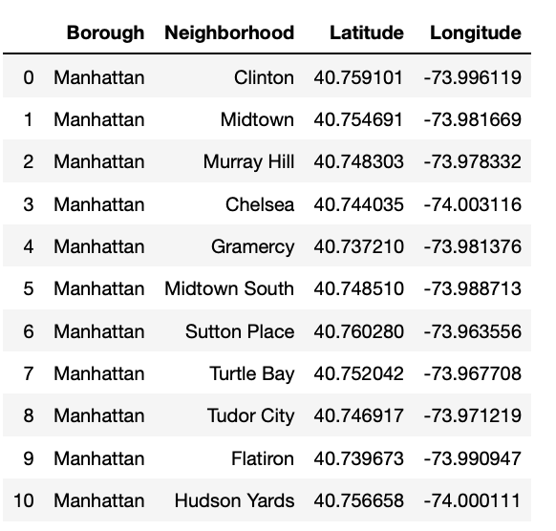

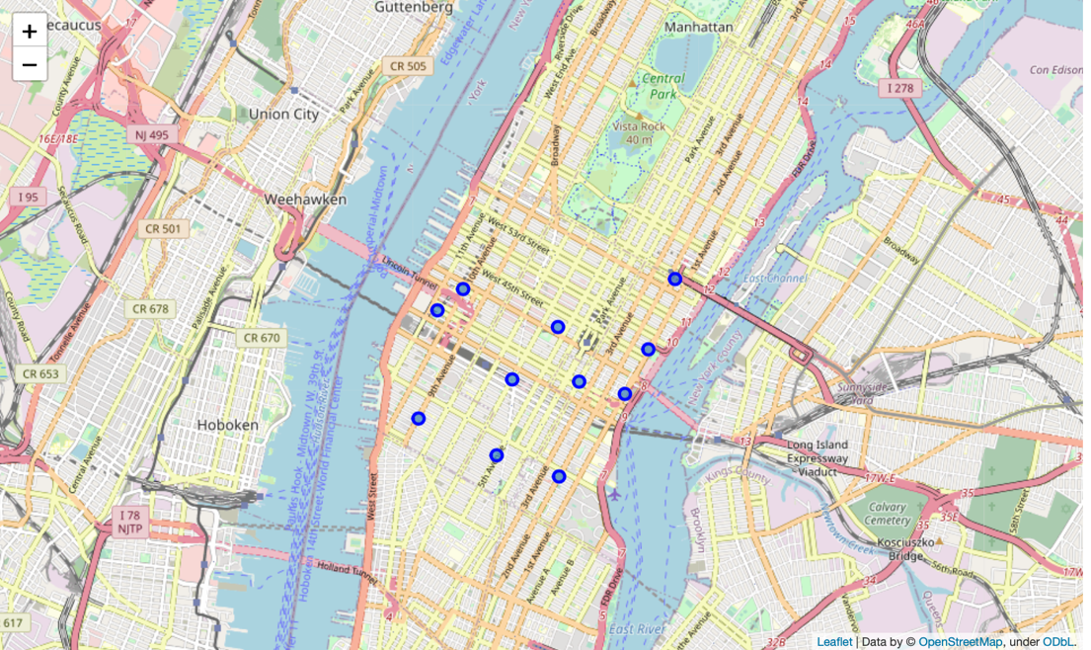

* 1. Restaurant and Office Building

Each neighborhood search contains 50 trending result in each area. Here is a folium map result that shows all the restaurants (blue spot) and office building (pink spot) in our dataset.

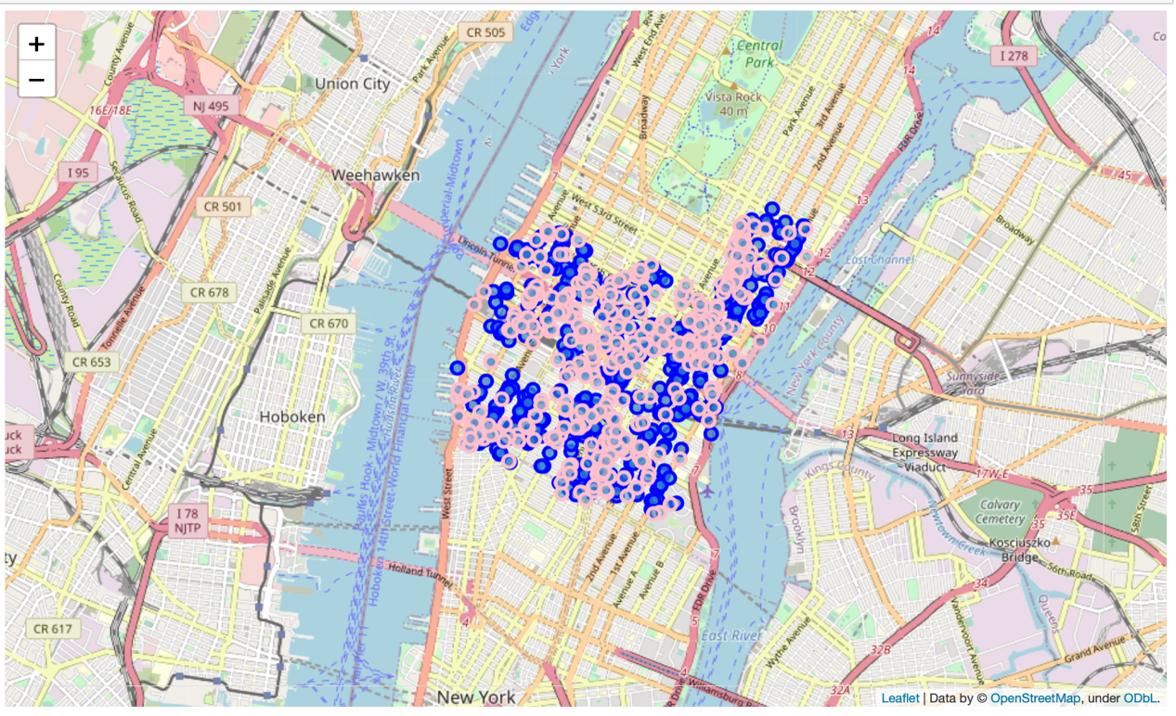

* 1. Japanese restaurant near office building

Count the number of Japanese restaurants for each office building in a 50 meters radius. It might have duplicate when two office building are very close to each other. We can ignore those duplicate since the amount is small.

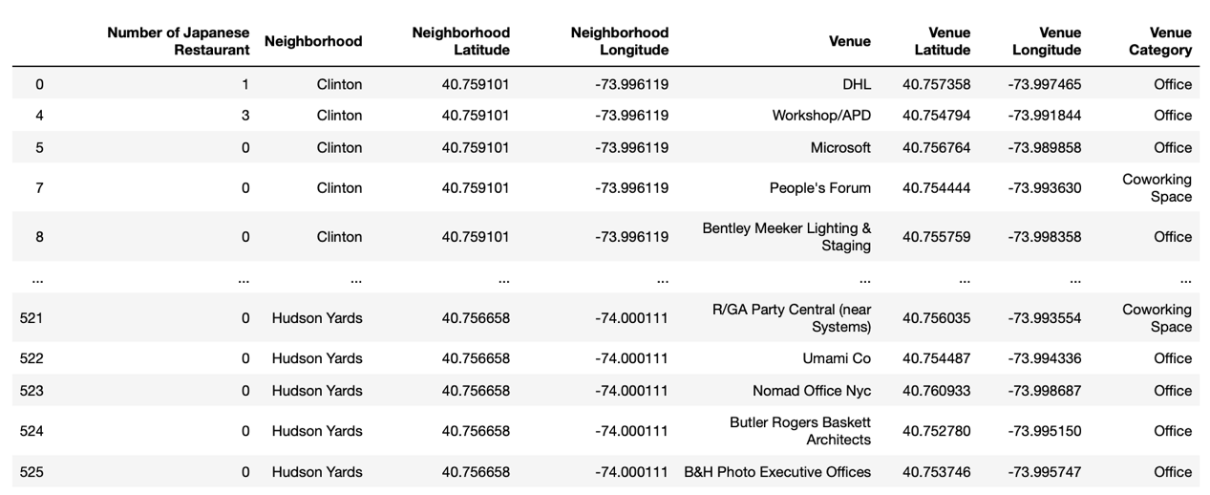

* 1. Ratio

We are looking at two ratios here. First is the delivery ratio, which is calculated by the total number of restaurants that provide delivery services over the total number of restaurants. Second ratio is the ratio of Japanese restaurant to office building.

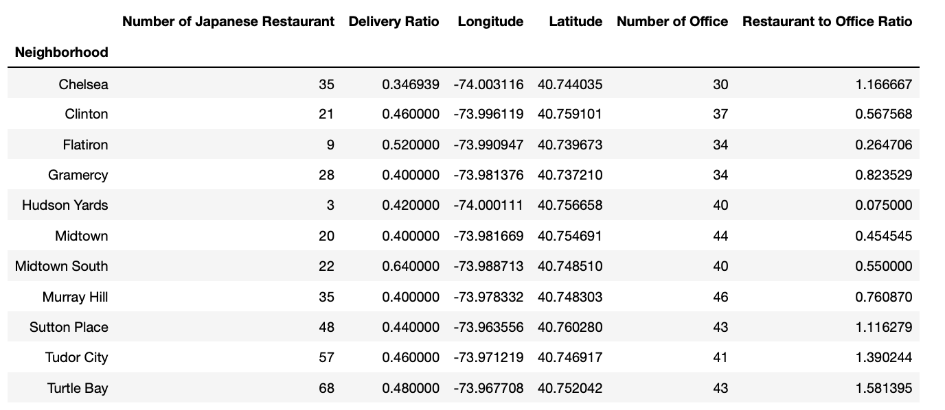

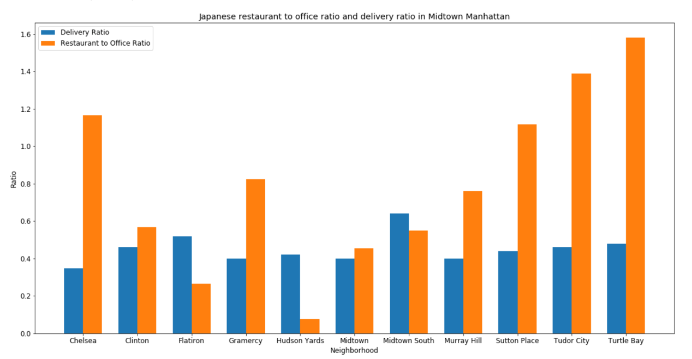

1. **Result Discussion**

Through calculation, the average delivery ratio is about 0.4515, which means in average, about 45.15% of restaurants provide delivery service in midtown Manhattan. Midtown South has the highest rate of delivery and Chelsea has the lowest ratio. But overall, most neighborhoods have a delivery ratio over 40%, that means most neighborhood are available for delivery service and that is very accessible for a lot of restaurant. There are 5 neighborhoods that has a delivery ratio above the average.

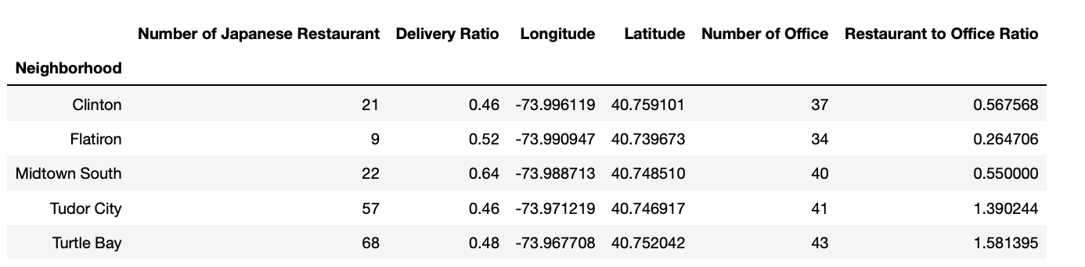

The restaurant to office ratio shows for each office, how many restaurants are there in the neighborhood. We can find on the chart that Hudson Yards has the lowest ratio of Japanese restaurant to office, that means the density of Japanese restaurant in Hudson Yard is relatively lower than any other neighborhood in the midtown Manhattan. While for Turtle Bay, the ratio is 1.58, which mean for each office building, there are 1.58 Japanese restaurant in Turtle Bay. Therefore, in this neighborhood, the number of Japanese restaurants is higher than the number of office building. The average ratio is 0.7955, and there are 6 neighborhoods have a ratio below the average.

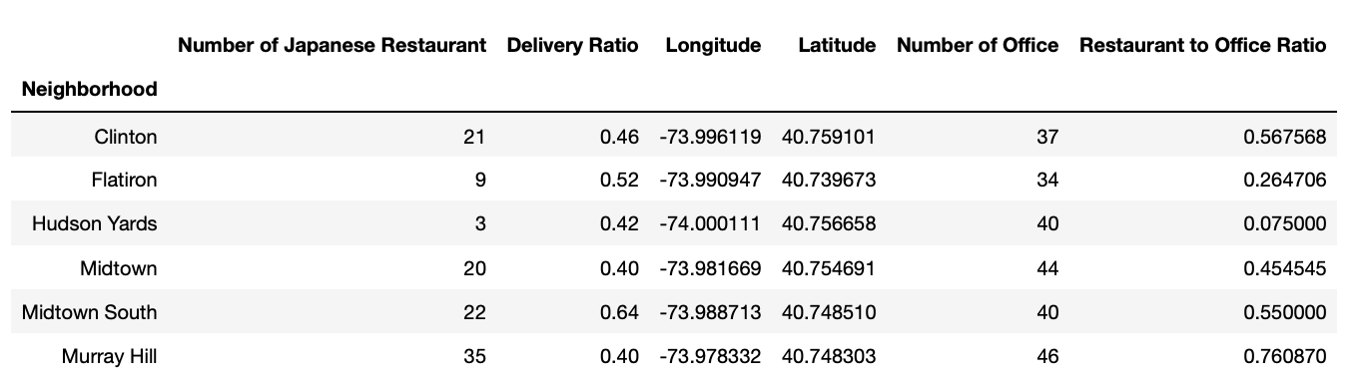

Combining those two conditions that we have discussed above, we have three neighborhoods that have a delivery ratio above average and a Japanese restaurant to office ratio below average.

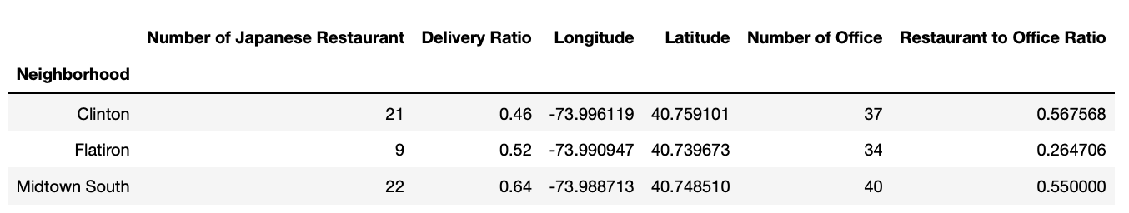

To recommend a neighborhood to open a Japanese restaurant, those three neighborhoods may be a good choice to open since they don’t have a high concentration of Japanese restaurant, and a high accessibility for delivery service. This satisfy our assumption at the beginning of the introduction that what we need to consider for opening a Japanese restaurant during the pandemic that provide a delivery service.

1. Conclusions

In this research, I explored the information of restaurant and office building in midtown Manhattan and analyzed the accessibility of delivery service for restaurant in different neighborhoods in Midtown via Foursquare API. What’s more, to analyzed possible location for a new Japanese restaurant, I collected the Japanese restaurant amount around the office buildings we have in our dataset. Through analyzed two important ratios: delivery ratio and Japanese restaurant to office ratio, I find three possible neighborhoods that might be suitable for a new Japanese restaurant during this time, they are Clinton, Flatiron and Midtown South. For a small business owner who wants to open a Japanese restaurant in Midtown may find this research useful.