R&D activities on the FPCCD vertex detector

Yasuhiro Sugimoto

KEK, High Energy Accelerator Research Organization

1. **Introduction**

Fine pixel CCD (FPCCD) is one of the candidate sensor options for the vertex detector of ILD detector at ILC[1,2,3]. In the present design, FPCCD sensors for the innermost layer of the vertex detector have the pixel size of 5 m and the fully depleted epitaxial layer with a thickness of 15 m. Because of the small size of the pixels, the pixel occupancy is acceptably low even if the hits are accumulated for one bunch train (~1ms).

The efforts of the FPCCD collaboration are currently focused on pixel characterization and development, while we also pursue developments to the cooling system (led by KEK), electronics downstream of ASICs (led by Shinshu University) and the reconstruction software (led by Tohoku University)[4].

1. **Recent developments**

R&D activity for the FPCCD vertex detector at present is mainly focused on FPCCD sensors and a detector cooling system using 2-phase CO2.

One of the achievements of FPCCD sensors after DBD is the fabrication of real size (12.3×62.4mm2) sensors with 50 m total thickness. Figure 1 shows the real size prototype sensor. It has 8 readout nodes, and each channel has different pixel sizes of 12 m, 8 m, and 6 m.

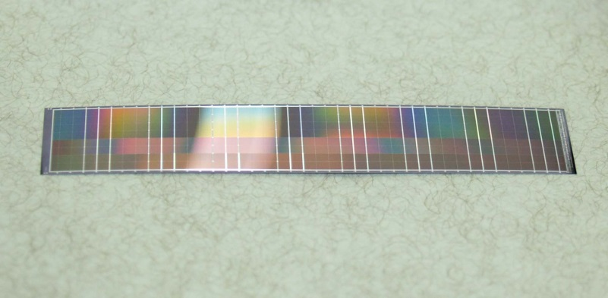

Figure 1. Real size FPCCD sensor thinned down to 50m

We have started neutron damage test using small (6mm×6mm) FPCCD prototypes [5]. A prototype sensor was irradiated by a neutron beam of few tens of MeV at CYRIC in Tohoku University. Detailed analysis on the irradiated sensor is still on-going.

In order to increase the radiation immunity of FPCCD sensors, particularly to reduce the transfer inefficiency due to radiation damage, the sensors should be cooled down to −40°C. We have started R&D on two-phase CO2 cooling system for this purpose[3]. There are several examples of utilizing two-phase CO2 cooling system for high energy physics experiments. For these cases, the CO2 coolant is circulated using liquid pumps. This method is, however, not so efficient for very low temperature cooling of −40°C. Therefore, we adopted CO2 gas compressor for the circulation of CO2 coolant. Figure 2 shows a simplified schematic diagram of the system. A prototype system has been constructed, and cooling between −40°C and +15°C has been successfully demonstrated using this system.



Figure 2. A simplified schematic diagram of the two-phase CO2 cooling system

1. **Engineering challenges**

In the present design of ILD vertex detector, two sensor layers are mounted on both sides of a light-weight ladder of ~2 mm thick. Our goal of the material budget of this ladder is 0.3%X0/ladder = 0.15%X0/layer. This goal would not be so easy, and we need a lot of R&D effort.

The ladders have to be cooled down to −40°C. We plan to achieve this cooling by heat conduction to the end-plate on which thin cooling tubes for 2-phase CO2 are attached. The design of this structure is not trivial, and we need R&D including thermal simulation.

There are challenges both in mechanical structure and in electronics circuit for the ladder R&D. We have not started this effort yet.

1. **R&D plans for the coming years**

We have been doing our R&D on the FPCCD vertex detector based on a Grant-in-aid for science research which expires at the end of FY2015. By that time, we plan to carry out the following R&D items:

* Characterization of FPCCD sensors including beam tests and radiation damage tests
* Development of FPCCD sensors with the pixel size of 5m, which is our ultimate goal
* Construction of prototype ladders for inner layers
* Development of readout electronics downstream of ASICs

If new funding is secured in future, the following R&D items have to be done:

* Development of larger FPCCD sensors and prototype ladders for outer layers
* Development of readout electronics which can fit in the small space of real experiment
* Construction of real size engineering prototype and its cooling test

1. **Participating institutes**

The following institutes are participating in this project:

* KEK, High Energy Accelerator Research Organization
* Tohoku University
* Shinshu University
* JAXA, Japan Aerospace Exploration Agency

1. **Applications beyond ILC**

Because of the relatively slow readout speed, application of FPCCD sensors to other high energy physics would be limited. However, high spatial resolution of small pixel size must be applicable to measurements of X-ray imaging in material science.

Two-phase CO2 cooling system can be applied to any other detectors which require efficient cooling between −40°C and near room temperature. Our system, which uses a CO2 gas compressor, has great advantage for low temperature operation near −40°C compared with systems using liquid pumps for circulation.

**References**

[1] Y. Sugimoto, “Fine Pixel CCD Option for the ILC Vertex Detector”, eConf C050318 (2005) 0804, LCWS-2005-0804.

[2] Y. Sugimoto, H. Ikeda, A. Miyamoto, T. Nagamine, Y. Takubo, H. Yamamoto, “R&D status of FPCCD VTX”, arXiv:0902.2067[physics.ins-det].

[3] Y. Sugimoto, H. Ikeda, D. Kamai, E. Kato, A. Miyamoto, H. Sato, H. Yamamoto, “R&D Status of FPCCD Vertex Detector for ILD”, arXiv:1202.5832[physics.ins-det].

[4] T. Mori, D. Kamai, A. Miyamoto, Y. Sugimoto, A. Ishikawa, T. Suehara, E. Kato, H. Yamamoto, “Study of Tracking and Flavor Tagging with FPCCD Vertex Detector”, arXiv:1403.5659[physics.ins-det].

[5] S. Ito, “R&D status of FPCCD vertex detector”, talk at LCWS2014.