“KRISHI CHAKRA”: SMART INTEGRATED FARMING SYSTEM FOR NEPAL
Name of Student 1; Name of Student 2 and Mentor* (TNR, 12 pt)
Nepal Police School (Italic, 10 pt)
Hari.prashad2014@gmail.com (10 pt)
YSS-2025
Life Science/Indigenous knowledge and Technology
- INTRODUCTION
Agricultural productivity in Nepal is often limited by underutilized farmland, monoculture practices, and limited technological adoption. Farmers frequently face challenges in maximizing yields due to lack of integration between crops, livestock, and modern agricultural technologies.
Traditional rice monocropping underutilizes land, while agricultural waste such as rice husks and straw is often discarded rather than used productively. This study proposes “Krishi Chakra”, is a conceptual integrated farming system designed to combine wet-season rice-fish-hen farming with dry-season mushroom cultivation, leveraging waste recycling, smart monitoring, and AI guidance to maximize output and promote sustainable agriculture with environmental and technological synergy.
- MATERIALS AND METHODS
Figure:1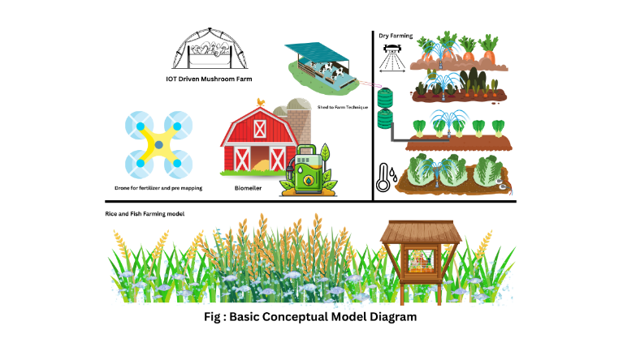
2.1 Wet-Season Farming (Monsoon)
Components: Paddy fields, fish ponds, elevated hen coop.
Design Steps: During paddy planting season after paddy is planted and field is filled with water fishes are introduced to the field.
Expected Outcome: Multi-layered productivity through rice, fish, and hen, utilizing the full land area efficiently, Fishes circulate oxygen through the field increasing the crop yield by up to 20%.
2.2 Dry-Season Farming (Mushroom Cultivation)
Components: Mushroom Beds Using Waste Straw, IoT sensors (temperature, humidity), LCD Screen.
Design Steps: After the harvesting of paddy the waste straws and hays are used to make mushroom farm . The farm is continuously monitored by IOT sensors and the data is displayed into LCD screen .
Expected Outcome: Sustainable use of waste, optimized mushroom growth, and monitored environmental conditions.
2.3 Biomeiller
Components: Plant wastes, Wood husks , Pipes, Net wires.
Working :Biomeiler works by the concept of aerobic combustion where the collected husks and wooden chips are decomposed and while decomposing that process produces heat which is used to heat the pipe and which can be used as a natural biocompost maker and a heater . Jean pain the initial inventor of Biomeiler was able to make working fuel by the help of Biomeiler and generate electricity as well .
Expected Outcome: To fully utilize the waste before using it as a compost manure .
2.4 Natural Fertilizer and Resource Management
Components: Sloped collection system for livestock urine, storage tanks, soil sensors, AI advisory system.
Design Steps: Livestock waste is collected, diluted, and applied as natural fertilizer and biopesticide. Soil pH, moisture, and nutrients are monitored and fed to AI advisory for chat-based guidance.
Expected Outcome: Circular nutrient flow, reduced chemical fertilizers, improved soil health.
2.5 IOT Driven Farm And Ai
Components :DHT-11,Arduino UNO, PH sensor, Moisture Sensor, LDR
Working steps: Sensors collect real time data and feed it to AI via Arduino where the data is processed by a Ai model which provides farmers with real time updated personal information and tips about the best farm practices and land optimization tips .Not like other general Ais . IT gives personalized data for each farm and sustainable farming tips . it recommends local sustainable fertilizers and indigenous ways to boost farm result
Expected outcome : This IOT based farm season is introduced to reduce farm underutilization and help farmers with their daily farm practices and queries. And provide natural available alternatives to chemical fertilizers .
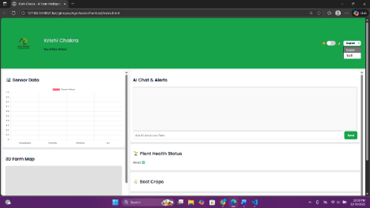
2.6 Drone-Based 3D Mapping
Components: Drone with camera, software for 3D Mapping , LIDAR
Design Steps: Drone captures aerial images to generate 3D maps for optimizing planting layouts, irrigation, and resource allocation.
Expected Outcome: Enhanced precision farm planning, optimized land use.
3. RESULTS AND DISCUSSION
3.1 Expected Productivity Comparison
The integrated “Krishi Chakra” system is designed to increase total output compared to traditional rice monocropping. Expected benefits include:
Rice yield maintained and improved.
Additional profit from fish and hens
Mushroom yield from agricultural waste utilization.
3.2 Circular Resource Management
“Krishi Chakra” promotes sustainability through a circular flow of waste and resources.
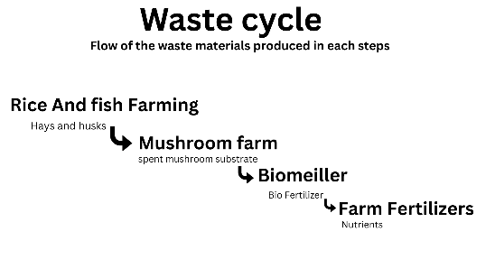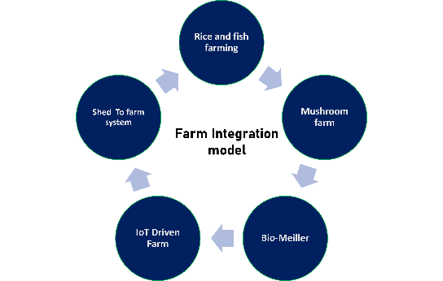
3.3 Technological Integration
IoT sensors and AI advisory systems provide real-time monitoring and guidance, enabling farmers to make informed decisions. Drone-based 3D mapping supports precision layout planning and efficient resource allocation.
4. CONCLUSION
“Krishi Chakra” represents a conceptual, technology-driven integrated farming system that combines rice, fish, hens, and mushroom cultivation with AI advisory, and drone mapping. The system is expected to enhance productivity, optimize land use, and promote sustainable agricultural practices in Nepal. Future work includes prototype development, field testing, and quantitative validation of outcomes.
5. ACKNOWLEDGEMENT
We sincerely thank Polymer Nepal and Young Scientists Summit organizers for providing the platform and guidance for this research project Our school NPS for letting us participate and our Mentor ……………….
6. REFERENCES
Smith, J., et al. (2025). Smart farming for sustainable agriculture using IoT and AI. Bulletin of National Research Centre, 49(1), 1–12.
Sharma, A. (2024). Circular agriculture and resource recycling in sustainable farms. Sustainability Journal, 8(2), 120–130.
Nguyen, T., et al. (2021). IoT-based monitoring in mushroom cultivation. Journal of Smart Agriculture, 15(2), 75–85.
Patel, R. (2023). Integrated rice-fish farming systems: Review and case studies. Journal of Agricultural Innovations, 12(3), 45–53.

