Deployment
- UML DEPLOYMENT DIAGRAM

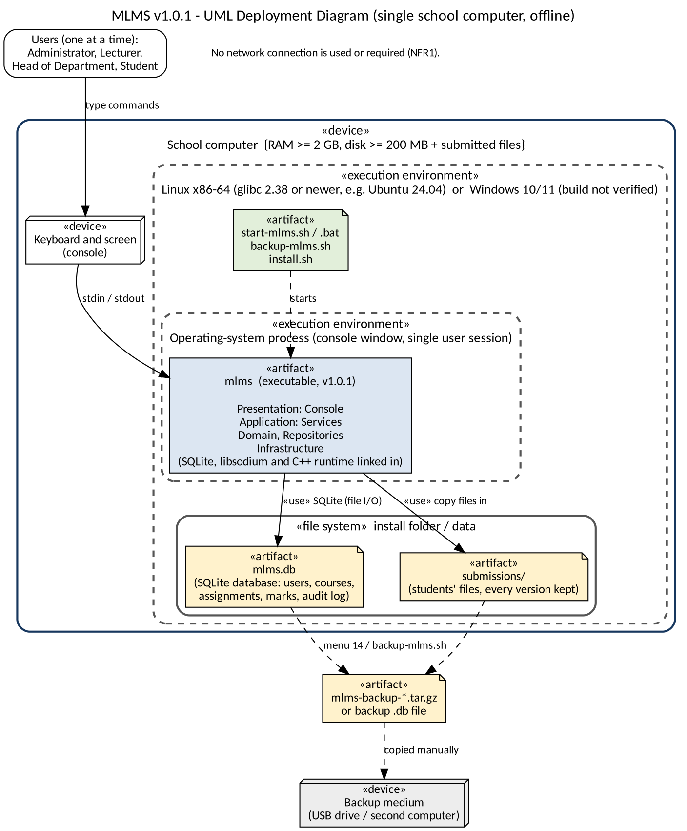

- INSTALLATION GUIDE
  - BEFORE INSTALLATION
- Use a supported windows 10/11 or Linux desktop
- Allow sufficient free disk space for the database
- Choose one secured school cmputer to be the host
2.2 Software needed to build the source:
- C++17 compiler
- CMake 3.16 or later
- SQLite development library
- OpenSSL development library
- Git
  - Linus or Ubuntu installation
sudo apt update
sudo apt install build-essential cmake libsqlite3-dev libssl-dev git
cd/opt/Moderated Learning System-source
cmake -S .-B build -DCMAKE_BUILD_TYPE=Release
cmake --build build --parallel
ctest --test-dir build --output-on-failure
sudo install -m 0755 build/Moderated Learning System / usr/local/bin/Moderated Learning System
Cd “$HOME/Moderated Learning System-data”
Moderated Learning System school.db

- USER MANUAL
  - ADMINISTRATOR USER MANUAL
How to use
- Sign in with an administator account
- Create each department using the department-management option. Use consistent department names
- Create user accounts and assign the correct role: Lecturer, HOD or Student. Use unique usernames and follow password policy
- Associate each HOD with the correct department
- Create courses under the correct department
- Assign lecturers to the courses they teach
- Enrol each student in the correct courses. Check enrolment before the lecturer creates or marks work
- Use the available audit-history function to review recorded mark changes
- Sign out or close the application when finished
  - LECTURER USER MANUAL
- Sign in with lecturer account
- Select the course assigned to them and only work with the course they teach
- Create an assignment. Enter a clear title, deadline and maximum mark. Check the deadline before saving
- Open the submission list for the assignment. Review the latest submitted version for each student
- Open or export the submitted file as supported by the application and read the work
- Enter the valid raw mark within the maximun mark and provie written feedback
- Review the late penalty calculation shown by the system
Save/ Confirm the mark. The submission becomes marked and is sent to the HOD for moderation
- To grant an individual extension, select the student, enter a later deadline and provide a reason
- For a class wide extension , use the class extension option, choose later deadline and enter a reason.
  - HOD USER MANUAL
- Sign in using their HOD account
- Open the moderation queue for their department
- Review the marked submission, including the raw mark, penalty, final mark and lecturer feedback
- They should not moderate the course the they teach
- Approve a submisssion when the mark and feedback are back
- If a correction is needed, enter the adjusted mark and a clear reason
- Review the moderated items and select the approved submission for release
- Confirm release, and only after the release can the student view the mark and feedback
- Use the audit history to trace who changed a mark and why

  - STUDENT USER MANUAL
- Sign in using their student account
- Open the enrolled courses and assignment list
- Check the displayed effective deadline
- Prepare the correct file and save it somewhere easily accessible. Ensure the file is not empty
- Choose the assignment submission option and enter the file path when prompted. Confirm the submission
- Keep the submission receipts/details
- If resubmission is permitted, submit the replacement before the effective deadline
- Open released results to view the mark and feedback

- RELEASE NOTES

5.1 Version 1.0.1 (2 November 2026)
First release that passes the full verification described in the Phase 5 and Phase 6 reports. It is the version to install. Do not install the earlier tag v1.0: it holds the Phase 4 code, .
What Moderated Learning System 1.0.1 does
All 15 functional requirements :role-based login, user and course administration, assignment creation with deadlines and per-student extensions, file submission with receipts and up to five versions, late penalties (10% of the maximum per day for days 1 to 3, zero from day 4), marking with feedback, Head of Department moderation (approve, adjust, return), release of marks to students, an audit log of every mark change, and database backup. It runs offline on one computer

