Maintenance

1. THE CHANGE REQUEST
FIELD | CONTENT
ID | CR1
Raised by | The school (client), after the v1.0 release
Text | “A lecturer should be able to extend the deadline for a whole class, not just an individual student, and extensions should be shown on the student’s assignment list.”
Split into | CR1a whole-class extension; CR1b extensions visible on the student’s assignment list
Priority | Should (the Lecturer stakeholder asked for “flexible extensions” in the original requirements; individual extension, FR6, was a Must)
Baseline | v1.0.1 (the first fully verified release; v1.0 holds the unverified Phase 4 code)
Result | Implemented in v1.1.0, tags v1.1.0 and v1.1

2. CLASSIFICATION AND JUSTIFICATION
The four types of maintenance (ISO/IEC 14764) were compared with CR1.
TYPE | MEANING | FITS CR1? | REASON
Corrective | Repair a defect | No | v1.0.1 does what the SRS says. FR6 says “individual extension”, so a missing class extension is not a defect, and the Phase 5 tests found no fault here.
Adaptive | Keep working in a changed environment | No | The operating system, libraries, hardware and laws are unchanged.
Preventive | Restructure to prevent future problems | No | The code is not being reorganised. Behaviour for existing users is unchanged.
Perfective | Improve or add features at the users’ request | Yes | Users asked for new user-visible behaviour (a class-wide action) and a better display (extensions on the list).

3. IMPACT ANALYSIS
Method: start from the words of the request (“extend”, “whole class”, “shown on the list”), trace each through the Requirements, the System Design (traceability tables 5.1 to 5.4), the code (search for grantExtension, effectiveDeadline, listForStudent, AssignmentView, extension), the tests (search for the same names and for menu numbers) and the documents. Each item is marked N (new), C (changed) or U (checked, unchanged, with the reason).

3.1 Requirements
ITEM | EFFECT | DETAIL
“The lecturer shall grant an individual extension” | U | Still true and still tested. Not widened, so existing tests keep their meaning.
“The lecturer shall extend the deadline of an assignment for every student enrolled in the course in one action.” | N | Priority Should. Verification: integration, system and acceptance tests.
new) “The student’s assignment list shall show an extended deadline together with the original deadline.” | N | Priority Should. Verification: integration and system tests.
Business rule 3.4 “Effective deadline” | C | Added: a class extension is applied to each enrolled student under the same rules as an individual one. A student whose work is already marked is skipped (rule D-02 from Phase 5). A student who already has the new or a later deadline is skipped. The new deadline must be later than the assignment deadline.
Business rule “Penalty from the extended deadline” | U | Works unchanged because every extension is stored as a per-student extension. Tested (IT_CR1_09).
Use case “Grant extension” | U | Kept for one student.
Use case “Extend deadline for whole class” | N | See 5.1.
Use case “Submit assignment”, alternative flow “An extension is given: the extended deadline is shown and used” | C | Now: “shown with the original deadline”.
Use case “View courses and assignments” | C | The list shows (extended from ...).
offline, NFR3 to NFR7 (size, speed, hashing, SQL) | U | The new action runs two small SELECTs per enrolled student; a course has far fewer than the 800 students of the whole school. All SQL is parameterised.
all marks auditable | U | Important: skipping marked students keeps the guarantee that no mark changes silently.
tag and release notes, NFR9 clean build | C | New tag, new release notes, build re-verified from a clean folder.
Stakeholder statement (Lecturer: “flexible extensions”) | U | Now better satisfied.

3.2 Design (System Design)
ITEM | EFFECT | DETAIL
1.2 Component diagram (five layers) | U | No new component or dependency.
2.1 Class diagram (Figure 2) | C | Adds ClassExtensionResult, ExtensionRow, AssignmentView.extended(), AssignmentService.extendForClass, AcademicRepository.studentsOf, AssignmentRepository.insertExtensions. See 5.2.
2.2 Design patterns | U | Repository and layering followed; no new pattern.
2.3 Services and operations | C | AssignmentService gains extendForClass.
3.1 State machine | U | The submission life cycle does not change.
3.2 Activity diagram (swimlanes) | U | The marking flow is not changed.
3.3 Sequence “Submit assignment” | U | The service call is unchanged; only the list output differs.
3.4 Sequence “Moderate and release” | U | Not involved.
New sequence diagram “Extend deadline for class” | N | See 5.3.
4.1 ERD, 4.2 normalisation, 4.3 data dictionary, 6 SQL schema | U | No table or column changes. The existing extension table already stores assignment, student, granter, old and new deadline, reason and time. One row per student keeps the “effective deadline” query and every existing report unchanged. Section 7 explains why a separate class-level table was rejected.
4.4 Mapping of tables to classes | U | extension still maps to Extension.
5.1 FR to design traceability | C | Rows added for FR16 and FR17 (5.4 below).
5.4 Use cases to design models | C | “Extend deadline for whole class” maps to AssignmentService, Figures 2 and the new sequence diagram.
5.6 Consistency check | C | Re-run: every new class appears in the class diagram; no new table.
Use case diagram | C | One new use case for the Lecturer, one changed description. See 5.1.
Deployment diagram (Phase 7) | U | Only the version label changed.

3.3 Code
FILE | EFFECT | CHANGE
src/Repositories.h/.cpp | C | AssignmentView::extended(), ExtensionRow, AcademicRepository::studentsOf, AssignmentRepository::insertExtensions (one transaction).
src/Services.h/.cpp | C | ClassExtensionResult, AssignmentService::extendForClass.
src/Console.cpp | C | classExtensionFlow, new item “Grant an extension to the whole class”, and the list shows (extended from ...) in printAssignments.
CMakeLists.txt | C | Version 1.1.0; new test file added.
src/Domain.*, src/Database.*, src/Infrastructure.*, src/main.cpp | U | Not touched. The late-penalty rule and the effective-deadline SQL are reused as they are.
Existing functions that were read to check for side effects | U | grantExtension, effectiveDeadline, hasBeenMarked, SubmissionService::check and viewMarks, listForLecturer.

New code: 60 added lines in src/. Net effect on the architecture: none.

3.4 Menus and users (a ripple effect found by the tests)
The console menus are numbered. Adding an item to the lecturer menu changes later numbers. To keep the ripple small the new item was appended after the existing teaching items, so lecturer items 1 to 7 keep their numbers. Items after it move by one:
MENU | ITEM | V1.0.1 | V1.1.0
Lecturer | Grant an extension to the whole class | not present | 8
Lecturer | Change my password | 8 | 9
Head of Department | View audit log | 12 | 13
Head of Department | Change my password | 13 | 14
Lecturer who is acting HoD | Moderation items | 8 to 11 | 9 to 12
Administrator, Student | all items | unchanged | unchanged

3.5 Tests
TEST | EFFECT | REASON
IT_ASG_03 to 06, IT_REP_04, IT_REP_05, IT_SUB_12, IT_SUB_13, ST_SA_05, AT_LE_02 | U (re-run) | They cover extensions and the student list; they must still pass.
AT_HD_04 | C | Types menu number 12 for “View audit log”; it is 13 in v1.1.0. The expectation was updated (one number).
tests/ConsoleScripts.h | C | Comment on menu numbers updated.
IT_RBC_01 (every method refuses wrong roles) | U | extendForClass is covered by new test IT_CR1_06.
All other existing tests (unit, integration, system, acceptance, non-functional) | U (re-run) | Run unchanged as the regression suite.
19 new tests | N | Section 6.

3.6 Documents and release items
DOCUMENT | EFFECT
Requirements and System Design (Word files) | C: revised sections in section 5 of this report
Lecturer manual | C (new item 8, class extension, new messages)
Student manual | C (extended display)
Head of Department manual | C (menu now includes the class extension)
Administrator manual | U (version only)
Installation guide, deployment diagram | C (version and file names only)
Release notes | C (v1.1.0 section; K-7 resolved; K-9, K-10 added)
Phase 5 and 6 reports | U (they describe v1.0.1 and stay true for that version)

3.7 Risks of the change, and how each was handled
RISK | HANDLING
A class extension silently changes marks of work already marked (the Phase 5 defect D-02, again) | Marked students are skipped and counted. Test IT_CR1_03, ST_CR1_04.
A class extension shortens a student’s existing individual extension | Students with the same or a later deadline are skipped. Test IT_CR1_04.
Half the class extended if an error occurs midway | All rows are written in one transaction. Test IT_CR1_10.
Another lecturer or a student extends a class they should not | requirePermission and requireTaught. Test IT_CR1_06.
Penalty counted from the wrong deadline after extension | Penalty reuses the existing effective-deadline query. Test IT_CR1_09.
Wrong menu numbers after the new item | Appended at the end of the teaching items; one test updated; manuals updated.
The old database does not work in the new version | No schema change; upgrade test performed (section 6.5).
Student enrolled after the extension is not covered | Accepted and documented as K-9.

4. DESIGN DOCUMENT UPDATES
These are the revised parts of the Requirements and System Design documents. They are ready to be inserted at the sections named.

4.1 Requirements: new requirements, use case and rule
Section 2 (functional requirements), two rows added
REQUIREMENT | PRIORITY | VERIFICATION
The lecturer shall extend the deadline of an assignment for every student enrolled in the course in one action. | Should | Integration, system and acceptance tests
The student’s assignment list shall show an extended deadline together with the original deadline. | Should | Integration and system tests

Section 3.4 (business rules), “Effective deadline” replaced by: The effective deadline is the later of the assignment deadline and any extension for that student. An extension needs a clear reason and must be later than the current effective deadline. A class extension gives the same new deadline to every enrolled student, except (a) a student whose work has already been marked, because the final mark would change without an audit entry, and (b) a student whose effective deadline is already the same or later. The new class deadline must be later than the assignment deadline.
Use case specification (new): Extend deadline for whole class (Actor: Lecturer; also usable by a Head of Department or acting Head who teaches the course)
LECTURER | SYSTEM
Chooses “Grant an extension to the whole class” | Lists the lecturer’s assignments
Selects the assignment, gives the new deadline and a reason | Checks the role, that the lecturer teaches the course, the reason, and that the deadline is later than the assignment deadline
Confirms | For each enrolled student: skips if marked or already later; otherwise records an extension (old and new deadline, reason, who, when). All records are stored together. Reports how many students were extended and how many skipped, and why

Alternative flows: the lecturer answers “n” at the confirmation (nothing saved). Exception flows: the date is not in the format YYYY-MM-DD HH:MM, or is not later than the assignment deadline, or the reason is empty, or the course has no students: a message explains and nothing is saved. A lecturer of another course, a student or an administrator is refused.
Postcondition: every extended student’s effective deadline is the new deadline; marks are unchanged.
Use case “Submit assignment”, alternative flow changed: “An extension is given: the extended deadline is shown with the original deadline and is used for the lateness check.”

4.2 System Design: class diagram (Figure 2, changed part)
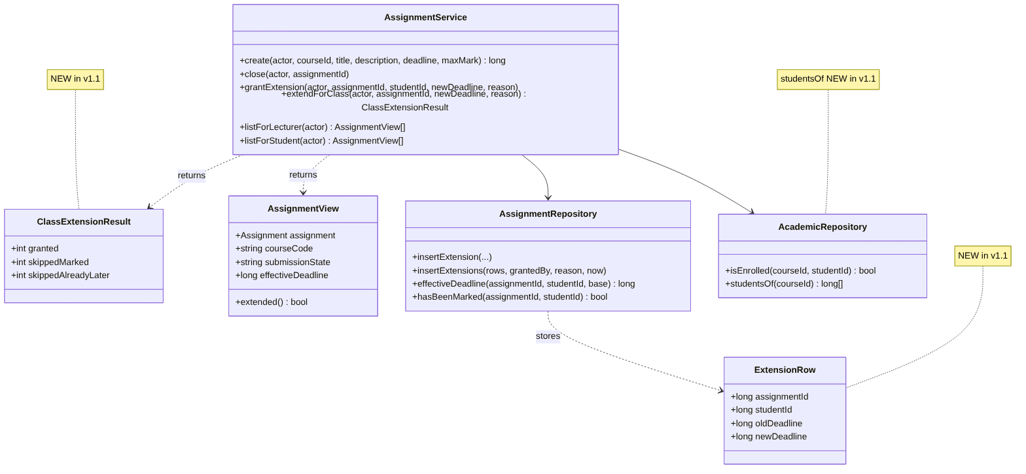

4.3 System Design: new sequence diagram (Figure 9)
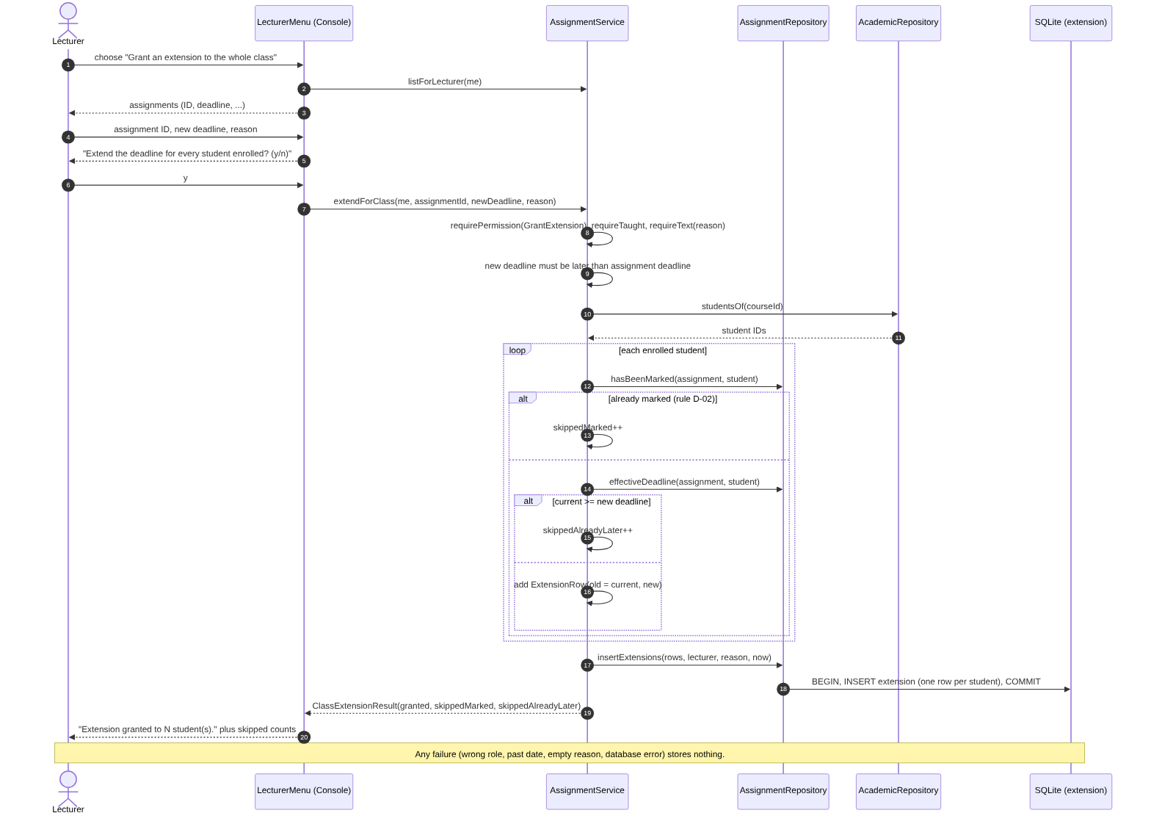4.4 System Design: use case diagram and traceability
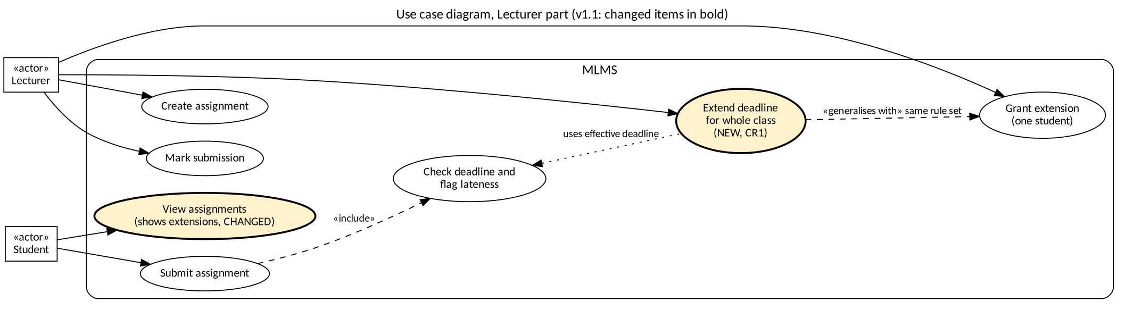
Section 2.3 (services): AssignmentService: create, close, grantExtension, extendForClass, listForStudent, listForLecturer.
Section 5.1, rows added
REQUIREMENT | PRIORITY | DESIGN ELEMENT | TABLES
Lecturer extends the deadline for a whole class | Should | AssignmentService.extendForClass; AcademicRepository.studentsOf; AssignmentRepository.insertExtensions | extension, enrolment
Extended deadline shown on the student’s list | Should | AssignmentView.extended(); AssignmentService.listForStudent; printAssignments | extension, assignment

Section 5.4, row changed: “Create assignment, Grant extension, Extend deadline for whole class, Close assignment, …” maps to AssignmentService, Figures 2, 8 and 9 of the System Design.
Sections 4.1 to 4.4 and 6 (database): no change. Note to add under 4.4: “An extension for a whole class is stored as one extension row per enrolled student.”

5. IMPLEMENTATION AND REGRESSION TESTING

5.1 Design decisions
DECISION | CHOICE | ALTERNATIVE REJECTED, AND WHY
How to store a class extension | One extension row per enrolled student | A new class_extension table plus a change to the effective-deadline query. That changes the schema, needs a migration for existing databases, touches the penalty path used by marking and moderation, and adds risk for no user-visible gain.
Students already marked | Skip and report | Refuse the whole action. This would block lecturers when one student was marked early. Extending anyway would break NFR8.
Students with a later deadline | Skip and report | Overwrite. This would shorten a deadline the lecturer had granted.
Atomicity | Single transaction in insertExtensions | Extend student by student. A failure would leave a half-extended class.
Menu position | Appended after existing teaching items | Placed next to the single-student item. More natural to read, but it renumbers items 4 to 7 and breaks more tests and manuals.
Display | deadline (extended from original) inside the existing column | A new column. This would change the layout that the system tests and manuals describe, for every student.

5.2 The 19 new tests
ID | WHAT IT CHECKS
IT_CR1_01 | Every enrolled student is extended, the assignment itself and other courses are not changed, one row per student
IT_CR1_02 | Each row has the lecturer, old deadline, new deadline, trimmed reason and time
IT_CR1_03 | A student whose work is marked is skipped and nothing changes for them (D-02 rule)
IT_CR1_04 | A student with a later individual extension keeps it; equal deadline is also skipped (boundary)
IT_CR1_05 | New deadline equal to or earlier than the assignment deadline is refused; one second later is accepted (boundary)
IT_CR1_06 | A student, a lecturer of another course and an administrator are refused; nothing stored
IT_CR1_07 | Empty, blank and 501-character reasons and an unknown assignment are refused
IT_CR1_08 | A course with no students is refused
IT_CR1_09 | Work submitted after the old deadline but before the new one has no penalty; one day after the new deadline is one day late
IT_CR1_10 | If one row cannot be stored, none is (rollback)
IT_CR1_11 | The student list marks only extended assignments; the original deadline is available; the lecturer list is not marked
IT_CR1_12 | An individual extension also shows as extended, and only for that student
IT_CR1_13 | studentsOf returns exactly the enrolled students, none for an empty or unknown course
ST_CR1_01 | Lecturer uses the menu; both students then see (extended from ...) on their lists
ST_CR1_02 | Answering “n” at the confirmation saves nothing
ST_CR1_03 | A bad date and an earlier deadline give clear messages and save nothing
ST_CR1_04 | The screen reports a marked student as skipped
ST_CR1_05 | The existing one-student extension still works and shows on the list
AT_CR1_01 | School scenario: one action for the class, a student submits after the old deadline and is on time with no warning

5.3 Regression test results
LEVEL | V1.0.1 (BEFORE) | V1.1.0 (AFTER) | OF WHICH NEW
Unit | 54 | 54 | 0
Integration | 116 | 129 | 13
System | 48 | 53 | 5
Acceptance | 15 | 16 | 1
Total | 233 | 252 | 19

The 233 existing tests were rerun against v1.1.0: 233 passed, 0 failed. The first run, before any change to the tests, gave 232 passed and 1 failed: AT_HD_04 (HodCanCorrectAMark...Traceable), because it selects “View audit log” by typing menu number 12, which is now 13. The cause is the intended menu change (section 4.4), not a fault in the change. Only that one number was changed in the test (12 to 13); all its checks on the audit log are unchanged and pass. This shows why the regression run is needed: the impact analysis predicted the menu ripple, and the test run confirmed it was limited to one test.
CHECK | RESULT
Compiler -Wall -Wextra -Wpedantic | 0 warnings
cppcheck (--enable=all, project suppressions) | 0 findings
clang-tidy (project policy, warnings as errors) | 0 findings
Lizard | 249 functions, no function above CCN 15; highest 13
Line coverage, business logic | 98.5% (603 of 612)
Line coverage, whole library | 95.6% (1,340 of 1,402)
Function coverage, business logic | 100% (131 of 131)

5.4 Release procedure
Version set to 1.1.0 in CMakeLists.txt (mlms --version prints MLMS 1.1.0). Branch phase8-maintenance. The Linux package was rebuilt with deploy/package.sh. Annotated tags v1.1.0 and v1.1 were placed on the release commit (the second is the name used in the assignment). Earlier tags v1.0 and v1.0.1 were not moved.

5.5 Upgrade test (v1.0.1 database opened by v1.1.0)
A school database was created with the v1.0.1 program: administrator, one department, one lecturer, two students, one course, enrolments. The v1.1.0 program was then started on the same file. The lecturer created an assignment due in 3 days and chose “Grant an extension to the whole class” with a deadline 8 days ahead: the screen said Extension granted to 2 student(s). A student then viewed the assignment list and saw:
1 | SCI101 | Essay 1 | 2026-11-10 17:00 (extended from 2026-11-05 17:00) | 100 | no | -

