System Design

1. ARCHITECTURE DESIGN

1.1 Chosen architecture
The system uses a layered architecture with five layers: Presentation, Application, Domain, Data access and Infrastructure. Each layer may call only the layer below it, and the services reach the database, the clock, the password hasher and the file store only through interfaces.
Why this suits the project
- Testability. Services are tested with fake repositories and a fake clock, so the late-penalty and moderation rules are tested without a database. This supports the V-model testing in Phase 6.
- Security. Role checks are made in the Application layer, so no menu can bypass them (role-based access control). SQL is written only in the Data access layer, which makes parameterised queries easy to enforce and review.
- Offline and simple. There is no server and no network code. This meets the offline requirement, the 2 GB machine limit and the IT officer’s wish for easy installation and backup.
- Replaceable parts. The penalty rule, the hash algorithm and the storage sit behind interfaces. Phase 2 showed that the penalty rule was ambiguous, so it must be changeable in one place.
- Build. Each layer is a CMake library and the program links them, so the project builds from a clean clone with one CMake command.

1.2 Component diagram
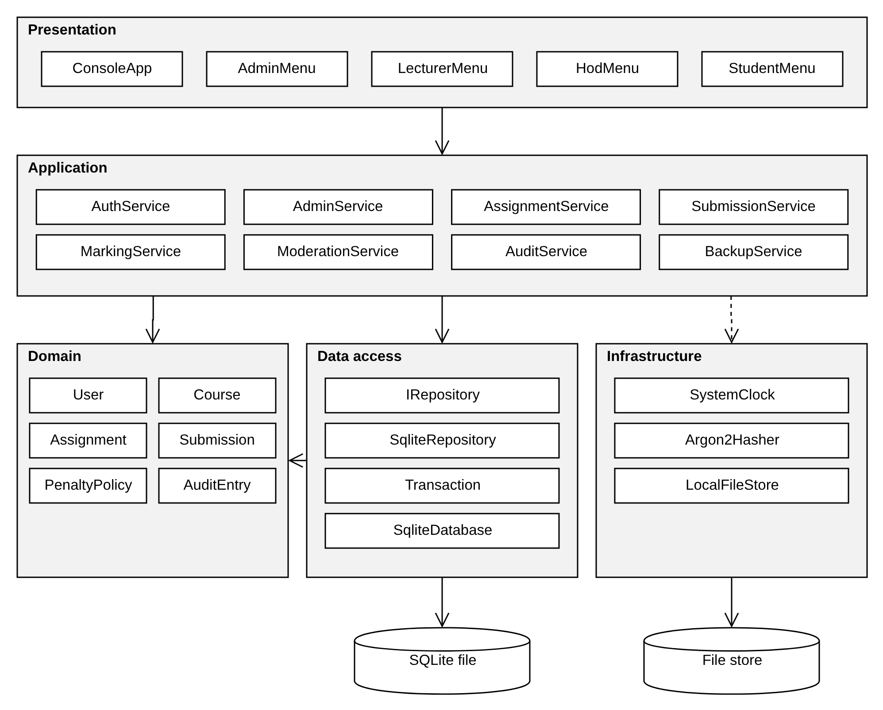
Figure 1. Component diagram: the five layers, their components and the external stores.
LAYER | COMPONENTS | RESPONSIBILITY | MAY DEPEND ON
Presentation | ConsoleApp, AdminMenu, LecturerMenu, HodMenu, StudentMenu | Show the role menus, read input, check its format and show results and errors. No business rules. | Application
Application | AuthService, AdminService, AssignmentService, SubmissionService, MarkingService, ModerationService, AuditService, BackupService | One method per use case. Checks permission and rules, controls the transaction and calls the repositories. | Domain and interfaces
Domain | User and its four roles, Department, Course, Assignment, Submission and its state classes, AuditEntry, PenaltyPolicy, DaysLateCalculator, UserFactory | Business objects and rules that need no database or screen. | Nothing
Data access | I*Repository interfaces, Sqlite*Repository, SqliteDatabase, Statement, Transaction | Convert between objects and SQL rows, bind parameters and roll back on failure. | Domain
Infrastructure | IClock / SystemClock, IPasswordHasher / Argon2Hasher, IFileStore / LocalFileStore | Time, salted password hashing and storing submitted files. | Nothing

All errors use one exception hierarchy (AppException with ValidationException, AuthorizationException, NotFoundException, BusinessRuleException and DatabaseException). The Presentation layer catches them and shows one clear message, so invalid input does not crash the program.

1.3 Alternatives considered and rejected
ALTERNATIVE | WHY IT WAS REJECTED
MVC with model classes that read and write the database themselves | Rules and SQL would sit inside the model classes, so the penalty and moderation rules could not be tested without a database. A console program has no real view to separate. The layered design keeps the model idea (the Domain layer) but isolates data access.
Client-server with a network database server | The requirements say the system runs offline on one school computer or a local network and must be easy for the IT officer to support. A server needs a network, an administrator and a second installation, and it raises the security risk for no benefit at 800 students.

2. CLASS DESIGN

2.1 Class diagram
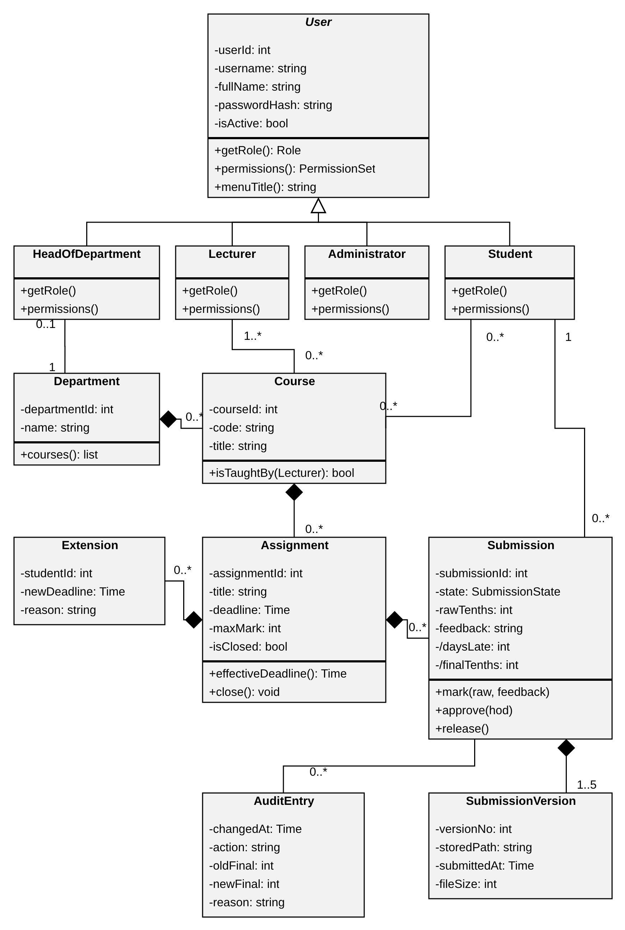

Design decisions
- Marks are whole tenths. The mark rule allows at most one decimal place, so a mark of 40.5 is stored as 405. The penalty is then exact integer arithmetic and there are no rounding errors.
- Derived values are not stored. daysLate and finalTenths are calculated from the submission time, the effective deadline, the raw mark and the maximum mark. The audit entry stores the final mark at the time of each change.
- Penalty rule. For 1 to 3 days late, final = raw − (10% of the maximum mark × days late), never below zero. In tenths, 10% of the maximum mark is exactly maxMark, so final = max(0, raw − maxMark × days). For 4 or more days the final mark is zero.
- Value types such as Time, Role, PermissionSet and SubmissionState are simple types and are not drawn in detail.

2.2 Design patterns
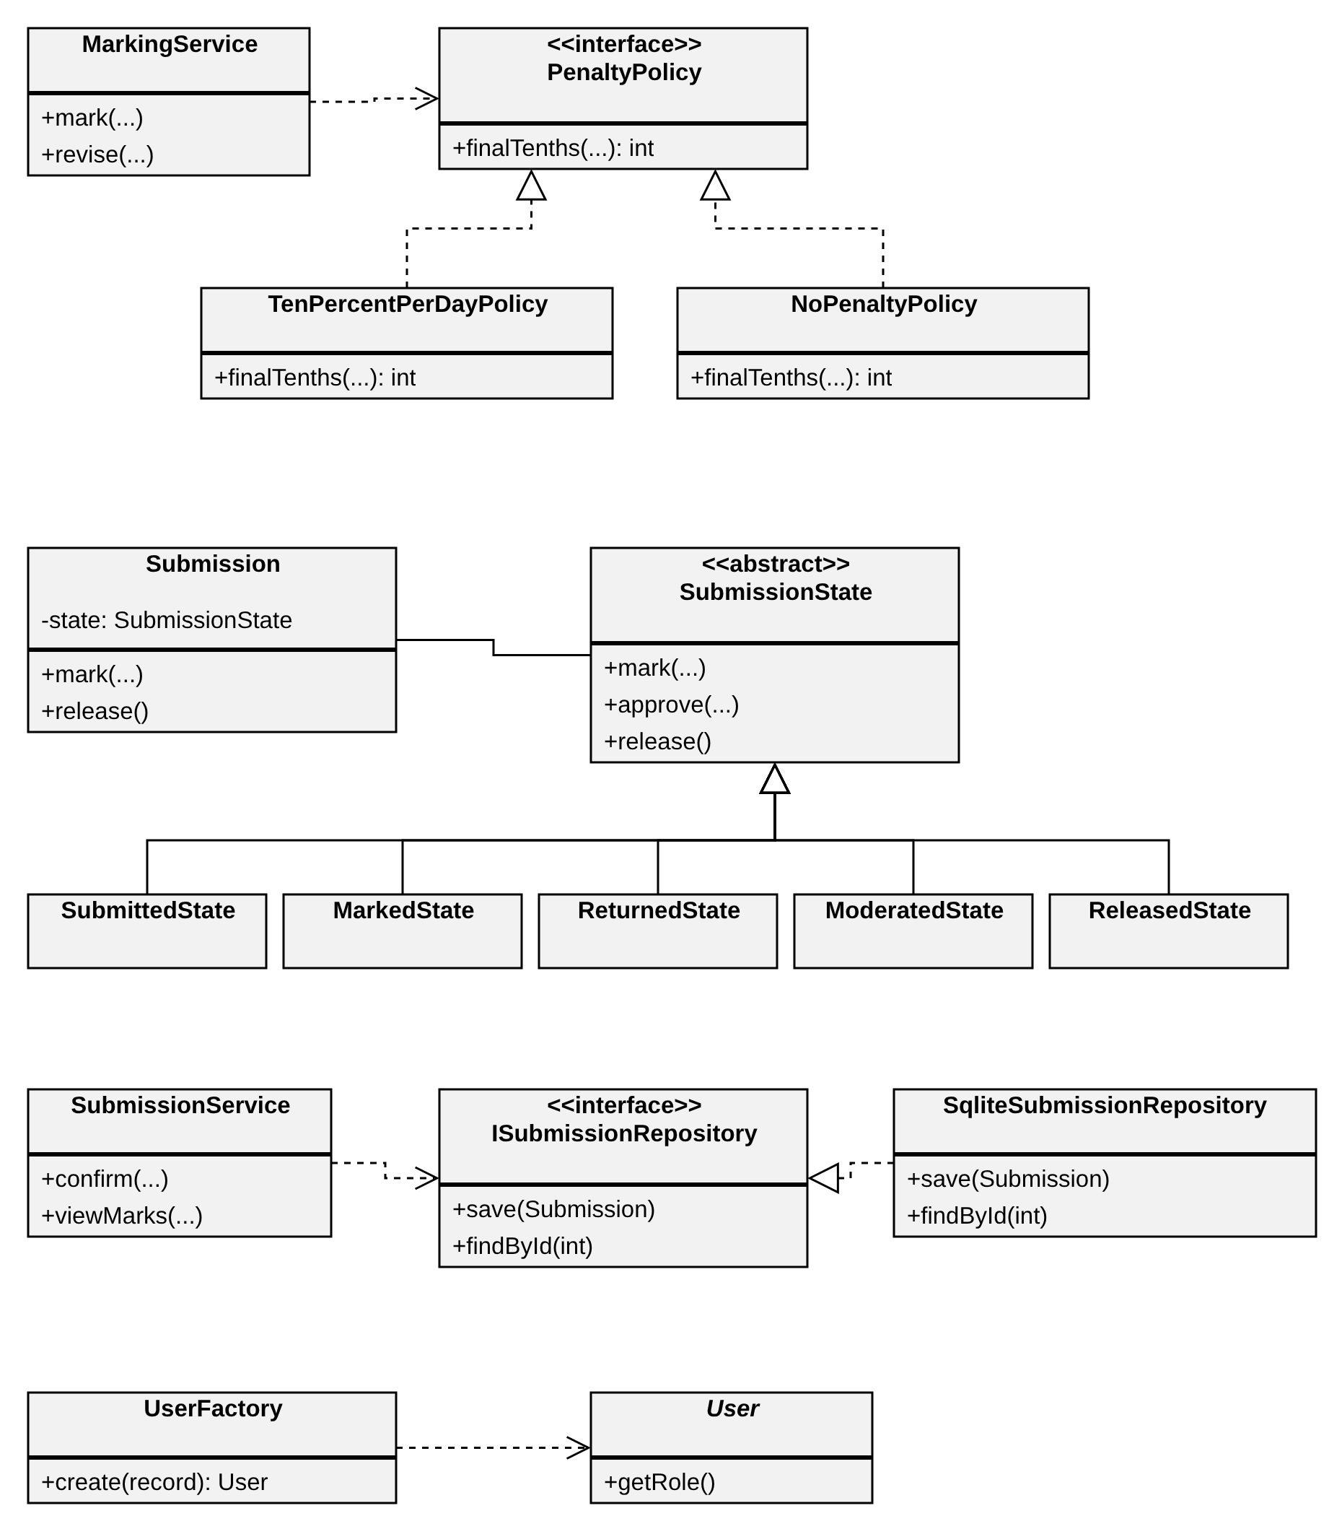
PATTERN | PROBLEM IT SOLVES | WHERE | REQUIREMENT
Strategy | The late-penalty rule was ambiguous in Phase 2 and may change. It must be replaceable without editing the marking code. | PenaltyPolicy with TenPercentPerDayPolicy and NoPenaltyPolicy. Used by MarkingService and ModerationService. | Late penalty rule; late submission requirement
State | What a submission may do depends on its state. If-statements spread through the code would allow illegal changes such as releasing an unmarked submission. | SubmissionState and five concrete states. Each implements only its legal transitions; any other call throws IllegalTransitionException. | Life cycle rule; no mark shown before Released
Repository | Services must not contain SQL, and tests must be able to replace the database. | I*Repository interfaces with Sqlite* classes sharing one generic SqliteRepository helper. | Parameterised queries; project risk R4
Factory Method | A row of app_user must become an Administrator, Lecturer, HeadOfDepartment or Student without switch statements in the services. | UserFactory::create(record). | Role-based access control

2.3 Services and their operations
CLASS | MAIN OPERATIONS | USES
AuthService | login, changePassword, logout, checkIdle | IUserRepository, IPasswordHasher, IClock
AdminService | createUser, deactivate, resetPassword, createCourse, assignLecturer, enrol, importCsv, designateActingHod | IUserRepository, ICourseRepository, UserFactory, IPasswordHasher
AssignmentService | create, close, grantExtension, listForStudent, listForLecturer | IAssignmentRepository, IClock, AuditService
SubmissionService | prepare, confirm (submit and resubmit), viewMarks | ISubmissionRepository, IFileStore, IClock, DaysLateCalculator, Transaction
MarkingService | mark, revise, listOwnSubmissions | ISubmissionRepository, PenaltyPolicy, AuditService
ModerationService | queue, decide (approve, adjust, return), release, amend | ISubmissionRepository, PenaltyPolicy, AuditService, Transaction
AuditService | record, view. There is no update or delete operation. | IAuditRepository
BackupService | backup(path) using the SQLite backup interface | SqliteDatabase
Transaction | Begins in its constructor and rolls back in its destructor unless commit() was called (RAII). | SqliteDatabase

2.4 SOLID principles applied
PRINCIPLE | HOW THE DESIGN APPLIES IT
Single responsibility | Each service handles one group of use cases. DaysLateCalculator only counts days, PenaltyPolicy only calculates the penalty and the menus only handle input and output.
Open/closed | A new penalty rule or hash algorithm is added as a new class that implements PenaltyPolicy or IPasswordHasher. Existing code is not edited.
Liskov substitution | Any User subclass can be used where a User is expected. Any PenaltyPolicy returns a mark between 0 and the raw mark, so NoPenaltyPolicy can replace TenPercentPerDayPolicy without breaking MarkingService.
Interface segregation | Small interfaces (IClock, IFileStore, IPasswordHasher and one repository per aggregate), so a service depends only on what it uses.
Dependency inversion | Services depend on interfaces. The concrete SQLite, Argon2 and file classes are created once in main() and passed in through constructors.

3. BEHAVIOURAL MODELS

3.1 State machine: submission life cycle
The states follow the life cycle business rule: Submitted, Marked, Returned, Moderated and Released. Late is a flag calculated from the times, not a state.
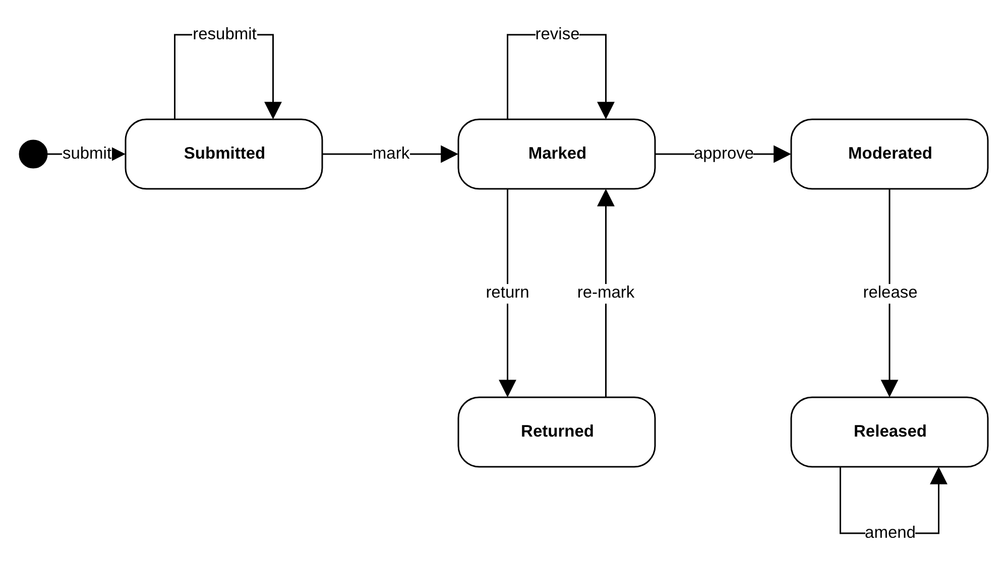
FROM | EVENT | GUARD | TO
(start) | Student submits | Enrolled, assignment open, file exists and is not empty | Submitted
Submitted | Student resubmits | Effective deadline not passed; fewer than 5 versions | Submitted
Submitted | Lecturer marks | Lecturer of the course; mark in range with one decimal; feedback 1 to 2000 characters | Marked
Marked | Lecturer revises | Reason recorded in the audit entry | Marked
Marked | HoD approves (or adjusts with a reason) | HoD of the department who does not teach the course | Moderated
Marked | HoD returns | Comment given | Returned
Returned | Lecturer re-marks | Same as marking | Marked
Moderated | HoD releases | All selected submissions in one transaction | Released
Released | HoD amends | Reason recorded; audit entry written; state stays Released | Released

3.2 Activity diagram with swimlanes
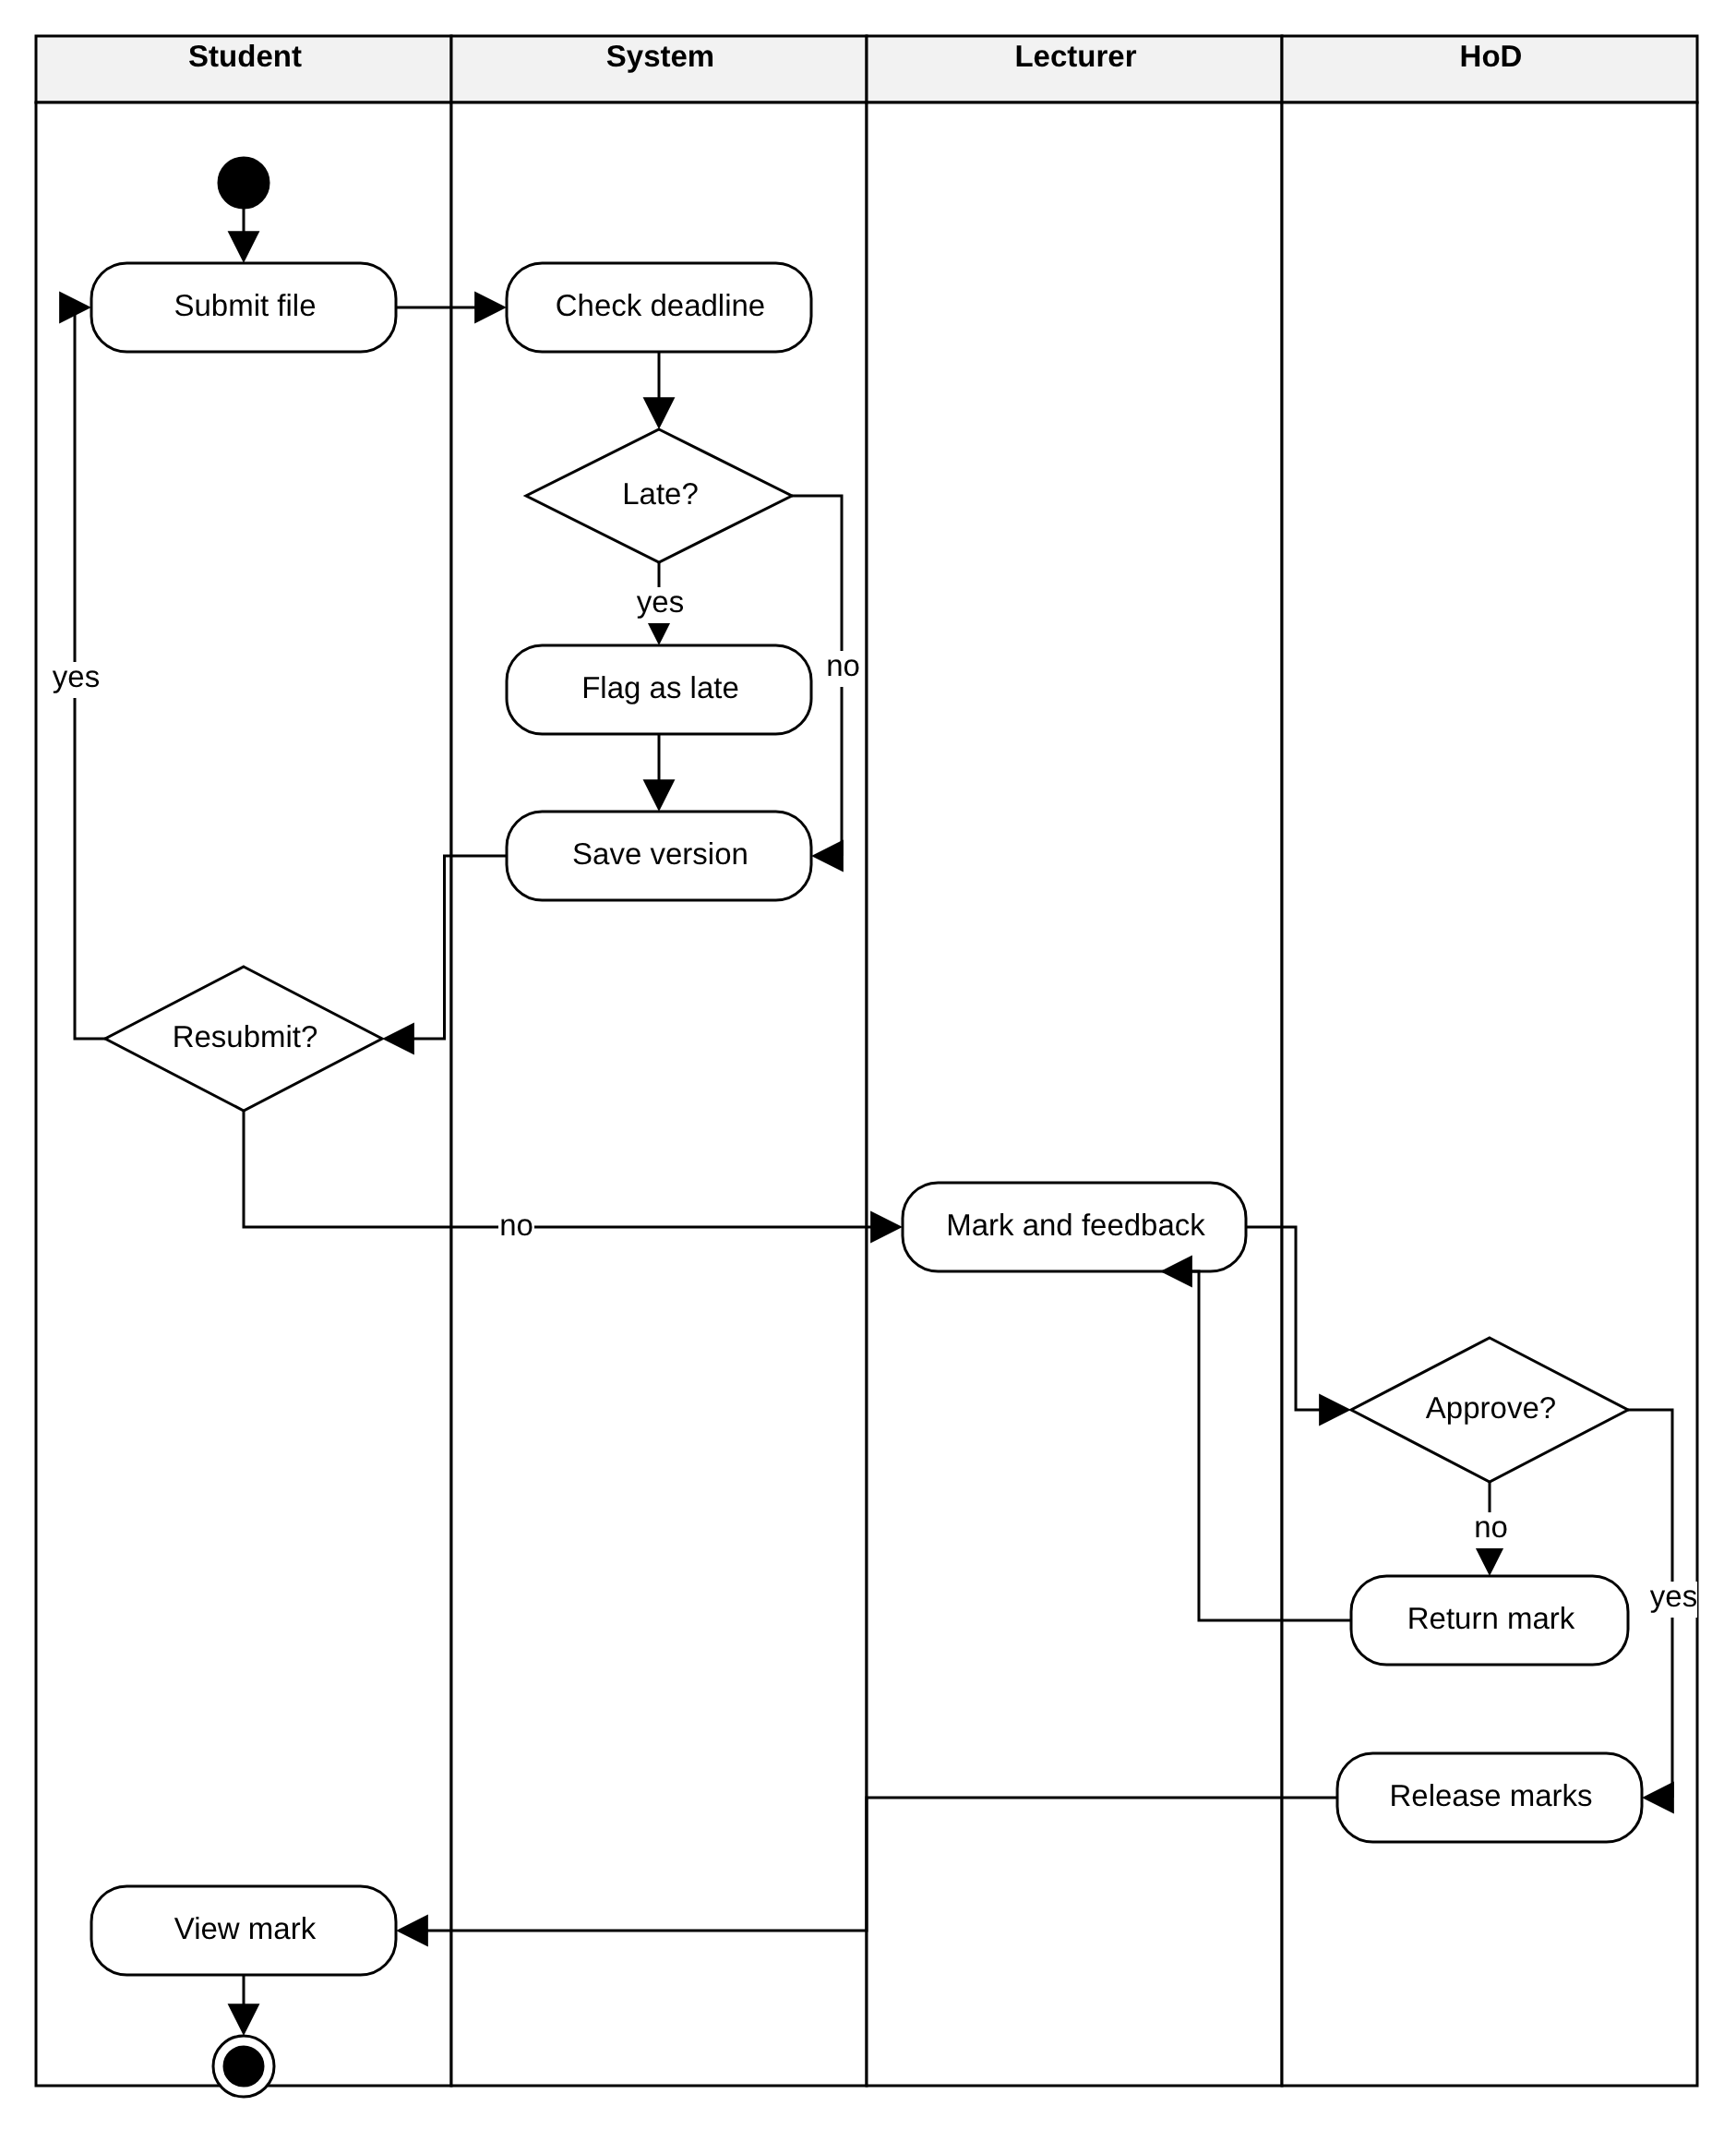

3.3 Sequence diagram: Submit assignment
This follows the main flow of the Submit assignment specification. The first fragment is the late path, where the student is warned and must confirm. The second fragment separates a normal submission or resubmission from a refused one (deadline passed or five versions already stored).
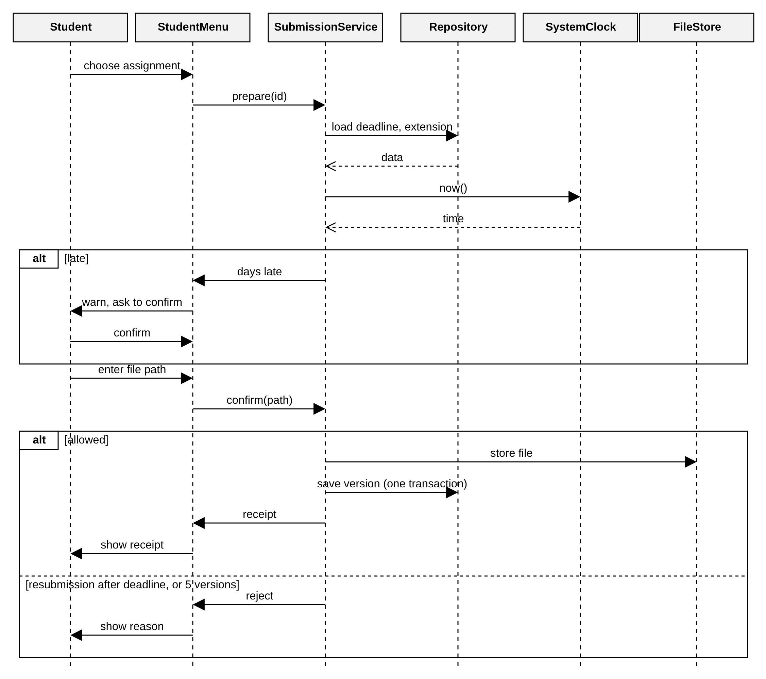

3.4 Sequence diagram: Moderate and release marks
The first fragment shows the three decisions the HoD can make for a marked submission. The last fragment is the release, which is all or nothing: if any step fails, the transaction is rolled back and no submission is released.
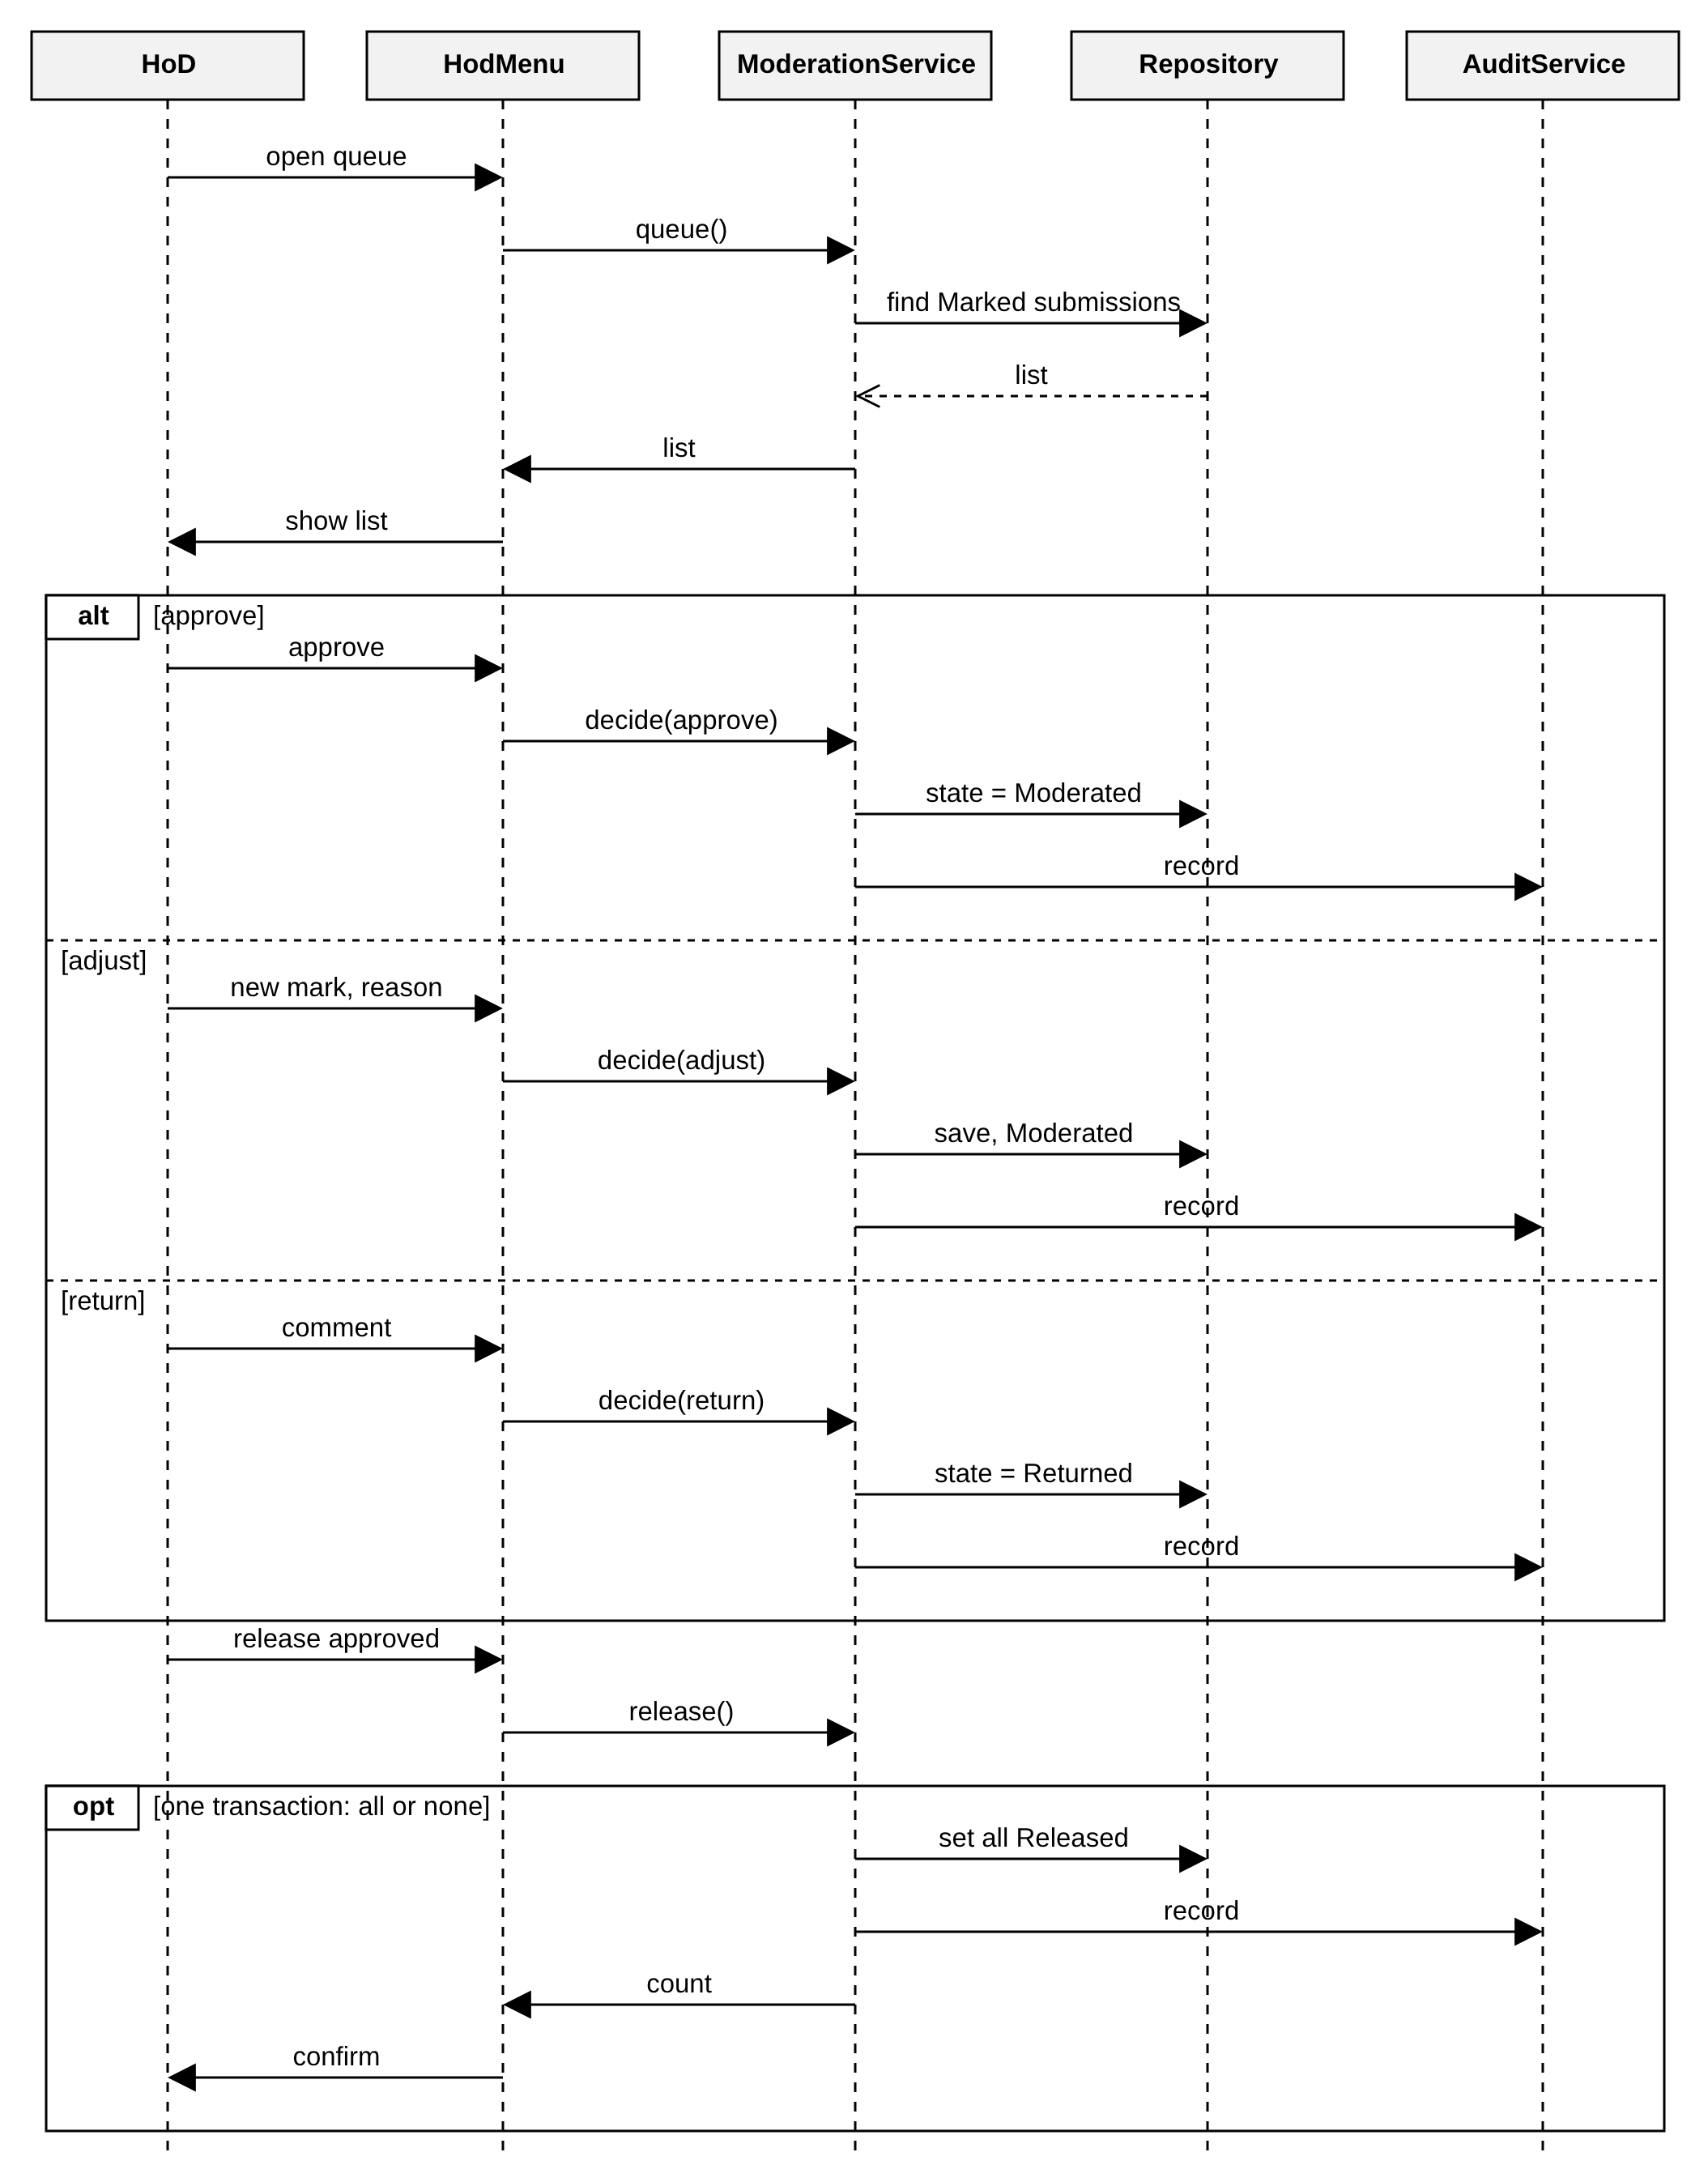

4. DATABASE DESIGN

4.1 Entity relationship diagram
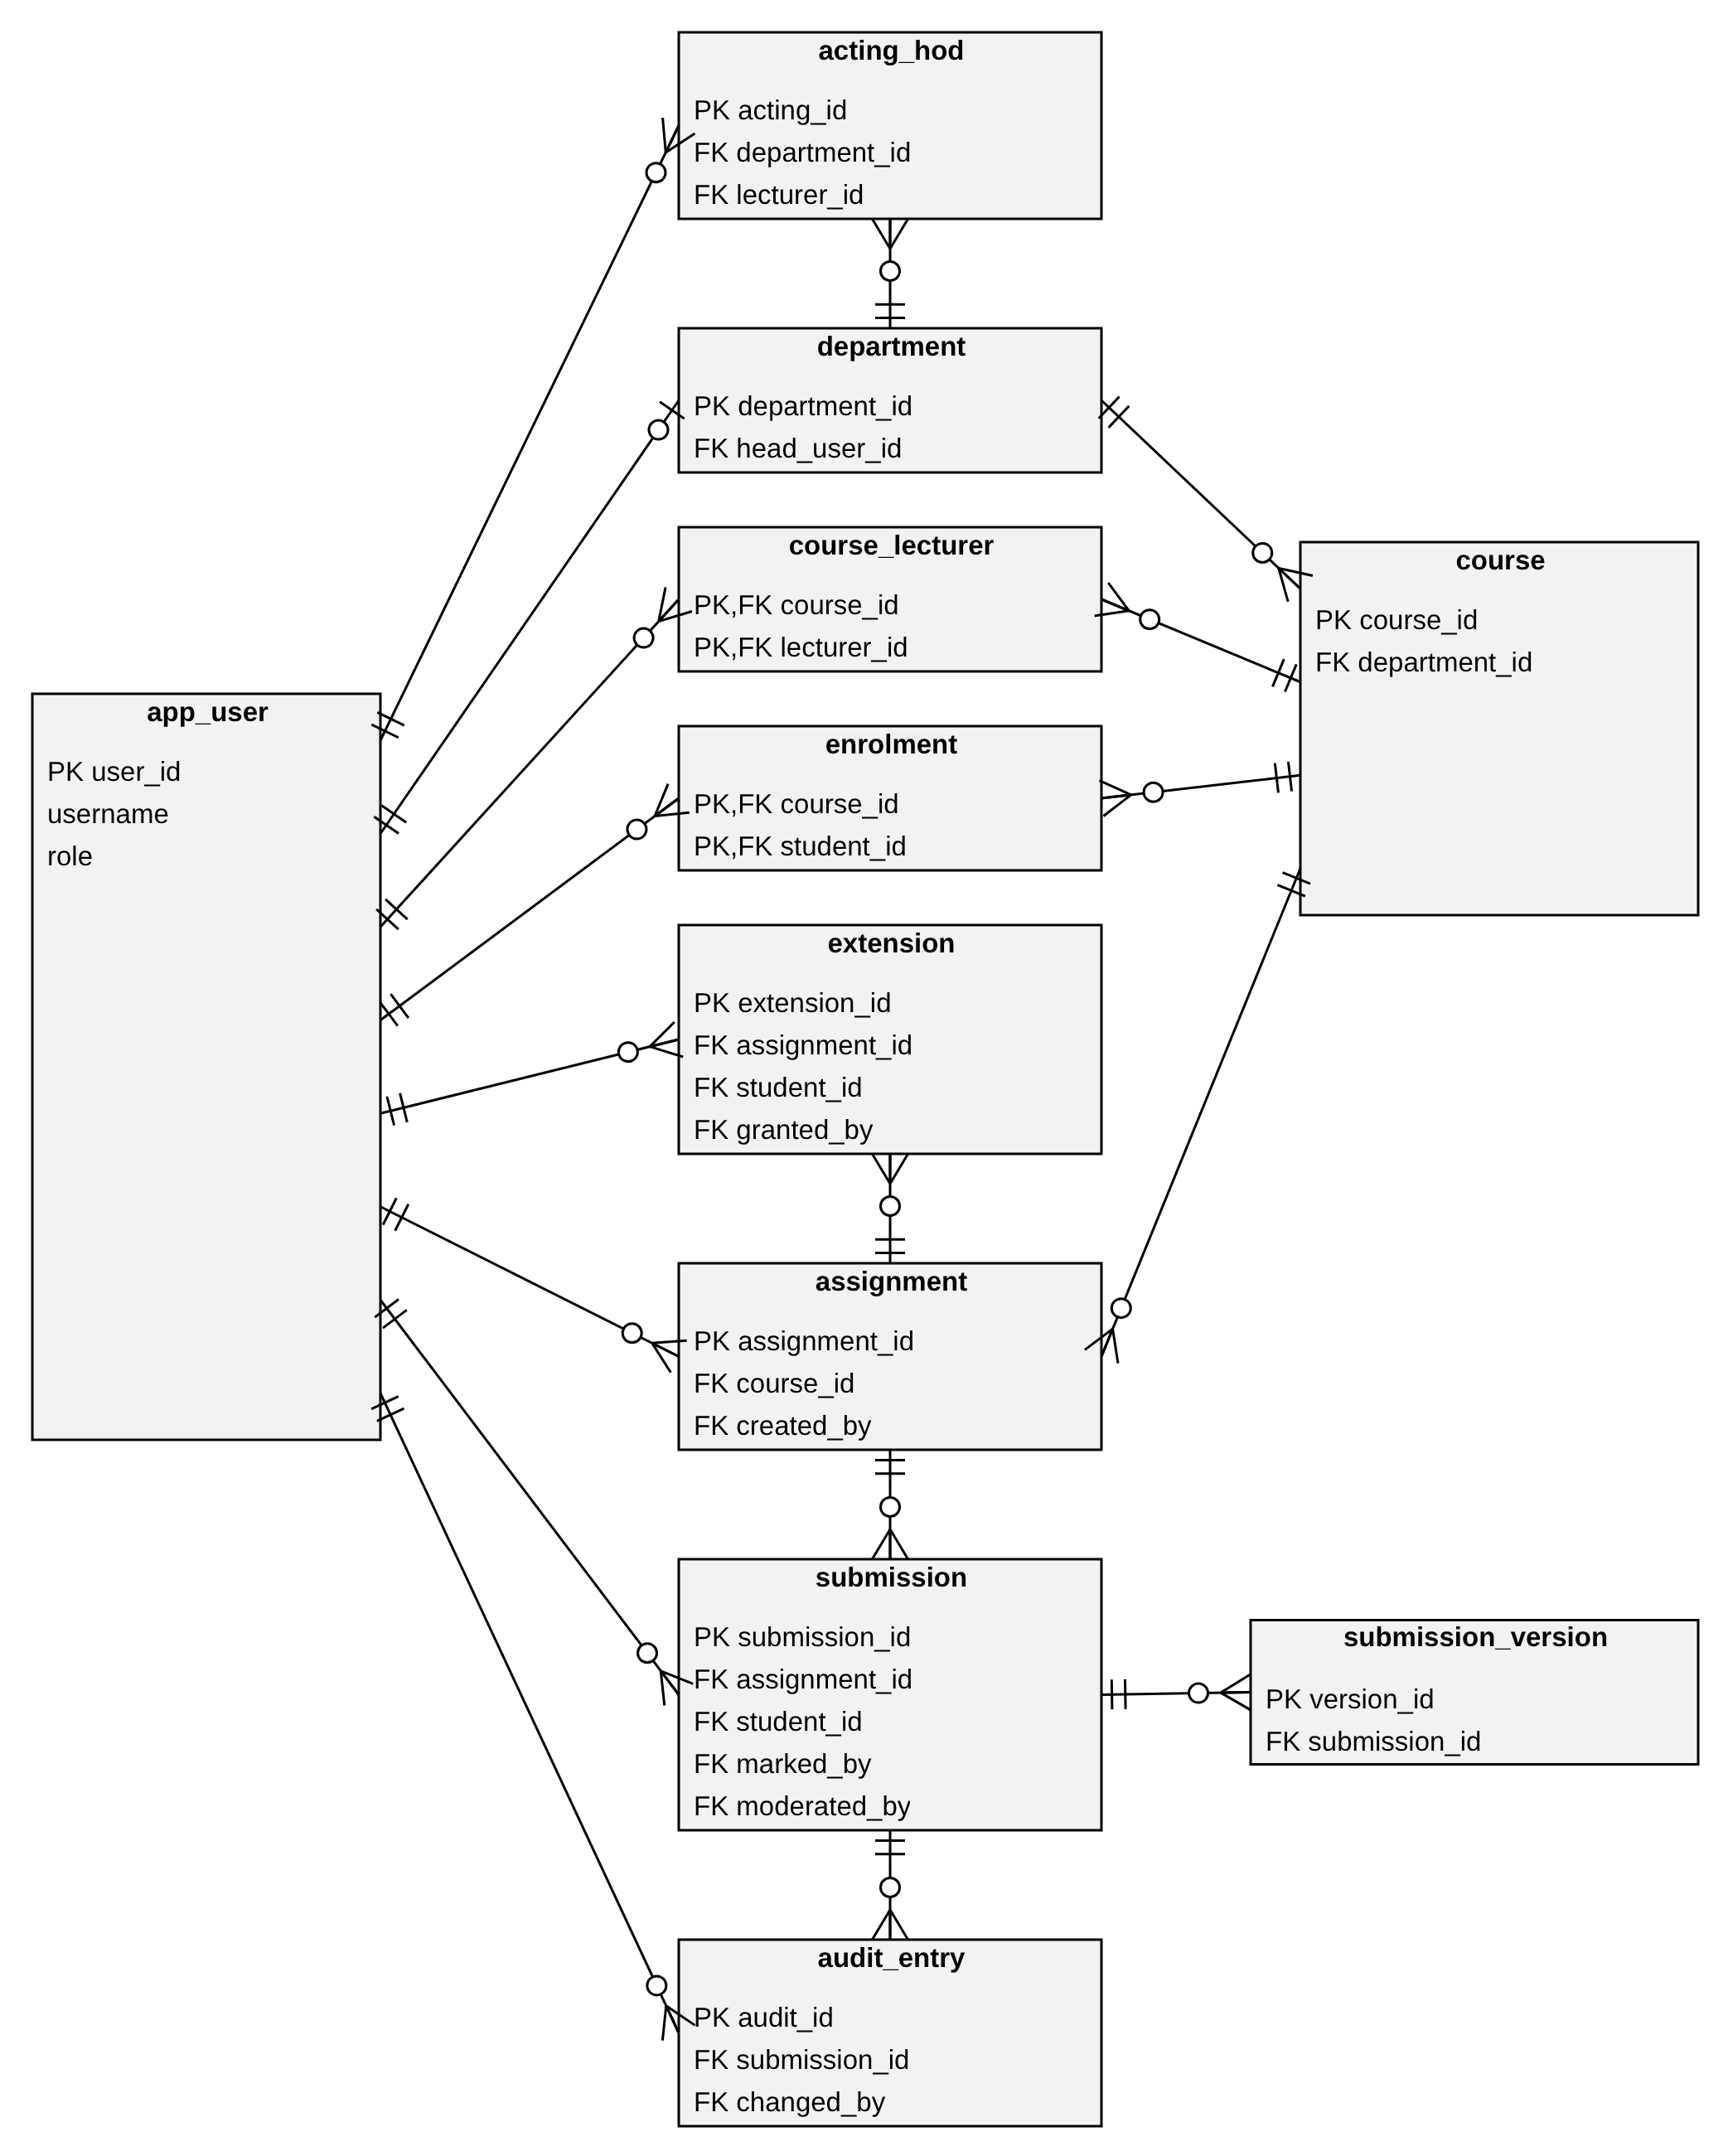

4.2 Normalisation (third normal form)
Every table has a primary key and every non-key column depends on the whole key and on nothing else. The main decisions that keep the design in third normal form are:
DECISION | REASON
Departments, courses and users are separate tables | Department name, course title and user name depend on their own keys, not on the submission that mentions them (no transitive dependency).
course_lecturer and enrolment are link tables with composite keys | A lecturer teaches many courses and a course has many lecturers; the same holds for students. These many-to-many relationships cannot be stored in one column without breaking first normal form.
Versions are rows in submission_version | Columns file1 to file5 would be a repeating group. The limit of five is a CHECK on version_no.
days late, late flag and final mark are not stored | They depend on the deadline, extension, submission time, raw mark and maximum mark, which are stored elsewhere. Storing them would be a transitive dependency and could become inconsistent.
audit_entry stores old and new marks | These are facts about one event at one moment, not copies of current data. The audit trail needs them, so they are not redundancy.
One app_user table with a role column | All roles share the same attributes. Role-specific facts (teaching, enrolment, head of department) are in their own tables.

Functional dependencies checked, for example: user_id → username, full_name, role, password_hash; course_id → department_id, code, title; assignment_id → course_id, title, deadline, max_mark; (assignment_id, student_id) → all submission columns; (course_id, student_id) → enrolled_on. Each determinant is a candidate key of its table.

4.3 Data dictionary
The dictionary was generated from the schema in section 6, so it lists exactly the columns in the SQL. PK = primary key, FK = foreign key, NN = not null. Times are UTC seconds since 1970.
TABLE.COLUMN | TYPE | KEYS / CONSTRAINTS | DESCRIPTION
app_user.user_id | INTEGER | PK | Surrogate key
app_user.username | TEXT | UNIQUE, NN | Login name, unique ignoring case
app_user.full_name | TEXT | NN | Display name
app_user.role | TEXT | NN | ADMIN, LECTURER, HOD or STUDENT
app_user.password_hash | TEXT | NN | Salted hash with its parameters, never the password
app_user.must_change_password | INTEGER | NN, default 1 | 1 until the user sets their own password
app_user.is_active | INTEGER | NN, default 1 | 0 = deactivated, cannot log in
department.department_id | INTEGER | PK | Surrogate key
department.name | TEXT | UNIQUE, NN | Department name
department.head_user_id | INTEGER | FK app_user.user_id, UNIQUE | Head of Department; must have role HOD
course.course_id | INTEGER | PK | Surrogate key
course.department_id | INTEGER | FK department.department_id, NN | Owning department
course.code | TEXT | UNIQUE, NN | Course code
course.title | TEXT | NN | Course title
course_lecturer.course_id | INTEGER | PK, FK course.course_id | Course taught
course_lecturer.lecturer_id | INTEGER | PK, FK app_user.user_id | Lecturer who teaches it
enrolment.course_id | INTEGER | PK, FK course.course_id | Course
enrolment.student_id | INTEGER | PK, FK app_user.user_id | Enrolled student
enrolment.enrolled_on | INTEGER | NN | Time of enrolment
acting_hod.acting_id | INTEGER | PK | Surrogate key
acting_hod.department_id | INTEGER | FK department.department_id, NN | Department covered
acting_hod.lecturer_id | INTEGER | FK app_user.user_id, NN | Lecturer acting as HoD
acting_hod.start_at | INTEGER | NN | Start of designation
acting_hod.end_at | INTEGER |  | End; NULL while active (one active per department)
assignment.assignment_id | INTEGER | PK | Surrogate key
assignment.course_id | INTEGER | FK course.course_id, NN | Course
assignment.title | TEXT | NN | Title, unique within the course
assignment.description | TEXT | NN, default '' | Instructions
assignment.deadline | INTEGER | NN | Original deadline; fixed once created
assignment.max_mark | INTEGER | NN | Maximum mark in whole marks, 1 to 1000; fixed once created
assignment.is_closed | INTEGER | NN, default 0 | 1 once closed to submissions
assignment.created_by | INTEGER | FK app_user.user_id, NN | Lecturer who created it
extension.extension_id | INTEGER | PK | Surrogate key
extension.assignment_id | INTEGER | FK assignment.assignment_id, NN | Assignment
extension.student_id | INTEGER | FK app_user.user_id, NN | Student who received the extension
extension.granted_by | INTEGER | FK app_user.user_id, NN | Lecturer who granted it
extension.old_deadline | INTEGER | NN | Effective deadline before the extension
extension.new_deadline | INTEGER | NN | Later deadline
extension.reason | TEXT | NN | Required reason
extension.granted_at | INTEGER | NN | When it was granted
submission.submission_id | INTEGER | PK | Surrogate key
submission.assignment_id | INTEGER | FK assignment.assignment_id, NN | Assignment
submission.student_id | INTEGER | FK app_user.user_id, NN | Submitting student
submission.state | TEXT | NN, default 'SUBMITTED' | SUBMITTED, MARKED, RETURNED, MODERATED or RELEASED
submission.raw_tenths | INTEGER |  | Mark before penalty in tenths (405 = 40.5); NULL until marked; not above 10 x max_mark
submission.feedback | TEXT | NN, default '' | Written feedback, at most 2000 characters
submission.marked_by | INTEGER | FK app_user.user_id | Marking lecturer
submission.moderated_by | INTEGER | FK app_user.user_id | Moderating HoD, who must not teach the course
submission.moderator_comment | TEXT | NN, default '' | Comment on approval, adjustment or return
submission.released_at | INTEGER |  | Release time; set only when state is RELEASED
submission_version.version_id | INTEGER | PK | Surrogate key
submission_version.submission_id | INTEGER | FK submission.submission_id, NN | Owning submission
submission_version.version_no | INTEGER | NN | 1 to 5, unique per submission
submission_version.original_name | TEXT | NN | File name as entered
submission_version.stored_path | TEXT | NN | Location in the file store
submission_version.file_size | INTEGER | NN | Bytes; at least 1 (not empty)
submission_version.submitted_at | INTEGER | NN | Time of this version; used for lateness
audit_entry.audit_id | INTEGER | PK | Surrogate key
audit_entry.submission_id | INTEGER | FK submission.submission_id, NN | Submission changed
audit_entry.changed_by | INTEGER | FK app_user.user_id, NN | User who made the change
audit_entry.changed_at | INTEGER | NN | Time of the change
audit_entry.action | TEXT | NN | MARK, REVISE, ADJUST, RETURN, RELEASE or AMEND
audit_entry.old_raw_tenths | INTEGER |  | Raw mark before; NULL for the first mark
audit_entry.new_raw_tenths | INTEGER | NN | Raw mark after
audit_entry.old_final_tenths | INTEGER |  | Final mark before
audit_entry.new_final_tenths | INTEGER | NN | Final mark after
audit_entry.reason | TEXT | NN | Required reason
audit_entry.acting_capacity | INTEGER | NN, default 0 | 1 if done as acting HoD

Other rules enforced by the database (CHECK, UNIQUE and triggers): role values; mark between 0 and the maximum mark; maximum mark 1 to 1000; new deadline later than old deadline; reasons not empty; state consistent with marks (a marked state needs a mark and a marker, moderated or released needs a moderator, released_at is set exactly when the state is Released); one active acting HoD per department; a moderator must not teach the course; audit_entry cannot be updated or deleted; foreign keys are on.

4.4 Mapping of tables to classes
TABLE | CLASS(ES) | DIFFERENCE AND JUSTIFICATION
app_user | User, Administrator, Lecturer, HeadOfDepartment, Student | One table for the whole hierarchy because the subclasses add behaviour, not attributes. UserFactory chooses the class from the role column.
department, course, assignment | Department, Course, Assignment | Direct. The Department to HoD association is the column head_user_id.
course_lecturer, enrolment | Associations Lecturer–Course and Student–Course | Many-to-many associations become link tables. Enrolment also holds enrolled_on.
acting_hod | Acting HoD designation (Department and Lecturer) | A partial unique index allows only one active designation per department.
extension | Extension | Direct. The effective deadline is calculated as the later of assignment.deadline and the latest new_deadline.
submission | Submission and the SubmissionState classes | The state classes have no table: the state is the column submission.state and is turned back into a State object when loaded. daysLate and finalTenths are derived and have no columns. Moderation fields are columns of submission because a submission has at most one moderation.
submission_version | SubmissionVersion | Direct. Composition with multiplicity 1 to 5.
audit_entry | AuditEntry | Direct. The old and new final marks make each entry complete even after later changes.
(none) | PenaltyPolicy, DaysLateCalculator, UserFactory, services, repositories, menus | Behaviour only; there is no data to store.

5. DESIGN TRACEABILITY
The requirements are numbered in the order they appear in the tables of the Requirements Engineering document (functional FR1 to FR15, non-functional NFR1 to NFR9).

5.1 Functional requirements to design
REQUIREMENT | PRIORITY | DESIGN ELEMENT | TABLES
FR1 Login with username and password | Must | AuthService.login; Argon2Hasher; ConsoleApp | app_user
FR2 Role-based access control | Must | User.permissions() checked in every service method | app_user.role
FR3 Lecturer marks and gives written feedback | Must | MarkingService.mark; MarkedState | submission, audit_entry
FR4 Administrator manages departments and courses | Must | AdminService.createCourse | department, course
FR5 Administrator assigns lecturers and enrols students | Must | AdminService.assignLecturer, enrol, importCsv | course_lecturer, enrolment
FR6 Lecturer grants an individual extension | Must | AssignmentService.grantExtension; Assignment.effectiveDeadline | extension
FR7 Student resubmits before the deadline | Must | SubmissionService.confirm; SubmittedState resubmit guard | submission_version
FR8 Resubmission: latest version is marked | Must | MarkingService offers only the latest version | submission_version
FR9 HoD moderates every mark before release | Must | ModerationService.queue and decide; ModeratedState | submission
FR10 No mark is shown before state Released | Must | SubmissionService.viewMarks returns only Released submissions | submission.state
FR11 Accept late work with 10% penalty per day | Must | DaysLateCalculator; TenPercentPerDayPolicy | calculated
FR12 Notify HoD when a submission is ready | Should | HodMenu shows the count from ModerationService.queue at login | submission
FR13 Lecturer dashboard of unmarked submissions | Should | MarkingService.listOwnSubmissions (state Submitted) | submission (ix_sub_state)
FR14 HoD releases approved marks | Must | ModerationService.release inside one Transaction | submission.released_at
FR15 Student views enrolled courses and assignments | Must | AssignmentService.listForStudent | enrolment, course, assignment

5.2 Non-functional requirements to design
REQUIREMENT | DESIGN PROVISION
NFR1 Fully offline | SQLite file and local file store; there is no network code.
NFR2 Git tag and release notes for every release | A process requirement with no design element. It is done at release in the project plan.
NFR3 800 students, 60 staff, 60,000 submissions | Integer keys and indexes on foreign keys (ix_sub_student, ix_sub_state, ix_assign_course, ix_enrol_student, ix_audit_sub).
NFR4 Login within 2 seconds | Unique index on username and one hash check. The Argon2 cost is tuned in the hashing spike (task 4.1).
NFR5 Single machine with 2 GB RAM | One process and SQLite. Files are copied to the file store and not held in memory.
NFR6 Salted password hashes | IPasswordHasher and Argon2Hasher; the salt is inside password_hash.
NFR7 Parameterised queries | The Statement class binds parameters; SQL is only in the Data access layer.
NFR8 All marks auditable | AuditService.record runs in the same transaction as the change; audit_entry is append-only (triggers).
NFR9 One-command CMake build | One CMake library per layer, an executable and a test target; no other build step.

5.3 Business rules to design
BUSINESS RULE | WHERE IT IS IMPLEMENTED
Late penalty | TenPercentPerDayPolicy: final = max(0, raw − maxMark × days) in tenths for 1 to 3 days; zero for 4 or more.
Days late | DaysLateCalculator: lateness divided by 24 hours, rounded up; weekends and holidays count as normal days.
Effective deadline | Assignment.effectiveDeadline: the later of the deadline and the student’s latest extension. An extension must be later than the current effective deadline (CHECK).
Resubmission | SubmittedState.resubmit guard; CHECK version_no 1 to 5; UNIQUE (submission_id, version_no).
Visibility | Services filter by role and state: the lecturer sees own courses, the HoD sees Marked submissions of the department, the student sees only Released.
Closing | assignment.is_closed checked by SubmissionService before any new version.
Passwords | AuthService checks at least 8 characters and not equal to the username before hashing.
Life cycle | State classes allow only legal transitions; CHECK on submission.state.
Independence | ModerationService check and trigger tg_sub_independence (a moderator must not teach the course).

5.4 Use cases to design models
USE CASES | SERVICE | MODELS
Submit assignment, Resubmit assignment, Check deadline and flag lateness | SubmissionService | Figures 4, 5, 6
Mark submission and give feedback, Apply late penalty | MarkingService | Figures 4, 5; Fig. 3 (Strategy)
Review moderation queue, Moderate and release marks, Amend released mark | ModerationService | Figures 4, 5, 7
Record audit entry, View audit log | AuditService | Figures 7, 8
Create assignment, Grant extension, Close assignment, View submissions, View courses and assignments, View released marks | AssignmentService, MarkingService, SubmissionService | Figures 2, 8
Log in, Change password, Log out | AuthService | Figure 1
Manage user accounts, Reset password, Manage departments and courses, Assign lecturer, Enrol student, Import students, Designate acting HoD, Back up database | AdminService, BackupService | Figures 1, 2, 8

5.5 Project risks addressed
RISK FROM THE PROJECT PLAN | DESIGN RESPONSE
R3 Inconsistent diagrams | One list of class, state and table names is used in every figure and table. The consistency check below is the gate checklist.
R4 Core implementation underestimated | One generic SqliteRepository helper is reused by all repositories, and the design uses the console interface only.
R5 Weak security implementation | A recognised hashing library behind IPasswordHasher, parameterised queries only, and role checks in one place.
R6 Data loss | BackupService, and transactions that keep the SQLite file consistent.

5.6 Consistency check
- The five state names are the same in Figure 4, Figure 3, the SubmissionState classes and the CHECK on submission.state.
- Every persistent class in Figure 2 maps to a table (section 4.4), and every table appears in the ERD, the data dictionary and the SQL schema.
- The penalty rule is implemented once, in TenPercentPerDayPolicy, and is used by the marking and moderation flows.
- The SQL schema was run in SQLite 3.45 and tested with 25 statements. It creates 11 tables; the foreign key and integrity checks are clean; an invalid role, a mark above the maximum, a sixth version, an empty file, a duplicate submission, a changed maximum mark and deletion of an audit entry are all rejected by the database.

6. SQL SCHEMA
The schema is for SQLite. Marks are whole tenths of a mark and times are UTC seconds since 1970.
PRAGMA foreign_keys = ON;
CREATE TABLE app_user (
user_id INTEGER PRIMARY KEY AUTOINCREMENT,
username TEXT NOT NULL UNIQUE COLLATE NOCASE,
full_name TEXT NOT NULL,
role TEXT NOT NULL CHECK (role IN ('ADMIN','LECTURER','HOD','STUDENT')),
password_hash TEXT NOT NULL,
must_change_password INTEGER NOT NULL DEFAULT 1 CHECK (must_change_password IN (0,1)),
is_active INTEGER NOT NULL DEFAULT 1 CHECK (is_active IN (0,1))
);
CREATE TABLE department (
department_id INTEGER PRIMARY KEY AUTOINCREMENT,
name TEXT NOT NULL UNIQUE,
head_user_id INTEGER UNIQUE REFERENCES app_user(user_id)
);
CREATE TABLE course (
course_id INTEGER PRIMARY KEY AUTOINCREMENT,
department_id INTEGER NOT NULL REFERENCES department(department_id),
code TEXT NOT NULL UNIQUE,
title TEXT NOT NULL
);
CREATE TABLE course_lecturer (
course_id INTEGER NOT NULL REFERENCES course(course_id) ON DELETE CASCADE,
lecturer_id INTEGER NOT NULL REFERENCES app_user(user_id),
PRIMARY KEY (course_id, lecturer_id)
);
CREATE TABLE enrolment (
course_id INTEGER NOT NULL REFERENCES course(course_id) ON DELETE CASCADE,
student_id INTEGER NOT NULL REFERENCES app_user(user_id),
enrolled_on INTEGER NOT NULL,
PRIMARY KEY (course_id, student_id)
);
CREATE TABLE acting_hod (
acting_id INTEGER PRIMARY KEY AUTOINCREMENT,
department_id INTEGER NOT NULL REFERENCES department(department_id),
lecturer_id INTEGER NOT NULL REFERENCES app_user(user_id),
start_at INTEGER NOT NULL,
end_at INTEGER,
CHECK (end_at IS NULL OR end_at > start_at)
);
CREATE UNIQUE INDEX ux_acting_one_active ON acting_hod(department_id) WHERE end_at IS NULL;
CREATE TABLE assignment (
assignment_id INTEGER PRIMARY KEY AUTOINCREMENT,
course_id INTEGER NOT NULL REFERENCES course(course_id),
title TEXT NOT NULL,
description TEXT NOT NULL DEFAULT '',
deadline INTEGER NOT NULL,
max_mark INTEGER NOT NULL CHECK (max_mark BETWEEN 1 AND 1000),
is_closed INTEGER NOT NULL DEFAULT 0 CHECK (is_closed IN (0,1)),
created_by INTEGER NOT NULL REFERENCES app_user(user_id),
UNIQUE (course_id, title)
);
CREATE TABLE extension (
extension_id INTEGER PRIMARY KEY AUTOINCREMENT,
assignment_id INTEGER NOT NULL REFERENCES assignment(assignment_id),
student_id INTEGER NOT NULL REFERENCES app_user(user_id),
granted_by INTEGER NOT NULL REFERENCES app_user(user_id),
old_deadline INTEGER NOT NULL,
new_deadline INTEGER NOT NULL,
reason TEXT NOT NULL CHECK (length(trim(reason)) > 0),
granted_at INTEGER NOT NULL,
CHECK (new_deadline > old_deadline)
);
CREATE TABLE submission (
submission_id INTEGER PRIMARY KEY AUTOINCREMENT,
assignment_id INTEGER NOT NULL REFERENCES assignment(assignment_id),
student_id INTEGER NOT NULL REFERENCES app_user(user_id),
state TEXT NOT NULL DEFAULT 'SUBMITTED'
CHECK (state IN ('SUBMITTED','MARKED','RETURNED','MODERATED','RELEASED')),
raw_tenths INTEGER CHECK (raw_tenths IS NULL OR raw_tenths >= 0),
feedback TEXT NOT NULL DEFAULT '' CHECK (length(feedback) <= 2000),
marked_by INTEGER REFERENCES app_user(user_id),
moderated_by INTEGER REFERENCES app_user(user_id),
moderator_comment TEXT NOT NULL DEFAULT '',
released_at INTEGER,
UNIQUE (assignment_id, student_id),
CHECK (state = 'SUBMITTED' OR (raw_tenths IS NOT NULL AND marked_by IS NOT NULL)),
CHECK (state NOT IN ('MODERATED','RELEASED') OR moderated_by IS NOT NULL),
CHECK ((state = 'RELEASED') = (released_at IS NOT NULL))
);
CREATE TABLE submission_version (
version_id INTEGER PRIMARY KEY AUTOINCREMENT,
submission_id INTEGER NOT NULL REFERENCES submission(submission_id) ON DELETE CASCADE,

version_no INTEGER NOT NULL CHECK (version_no BETWEEN 1 AND 5),
original_name TEXT NOT NULL,
stored_path TEXT NOT NULL,
file_size INTEGER NOT NULL CHECK (file_size >= 1),
submitted_at INTEGER NOT NULL,
UNIQUE (submission_id, version_no)
);
CREATE TABLE audit_entry (
audit_id INTEGER PRIMARY KEY AUTOINCREMENT,
submission_id INTEGER NOT NULL REFERENCES submission(submission_id),
changed_by INTEGER NOT NULL REFERENCES app_user(user_id),
changed_at INTEGER NOT NULL,
action TEXT NOT NULL CHECK (action IN ('MARK','REVISE','ADJUST','RETURN','RELEASE','AMEND')),
old_raw_tenths INTEGER,
new_raw_tenths INTEGER NOT NULL,
old_final_tenths INTEGER,
new_final_tenths INTEGER NOT NULL,
reason TEXT NOT NULL CHECK (length(trim(reason)) > 0),
acting_capacity INTEGER NOT NULL DEFAULT 0 CHECK (acting_capacity IN (0,1))
);
CREATE INDEX ix_course_dept ON course(department_id);
CREATE INDEX ix_cl_lecturer ON course_lecturer(lecturer_id);
CREATE INDEX ix_enrol_student ON enrolment(student_id);
CREATE INDEX ix_acting_lecturer ON acting_hod(lecturer_id);
CREATE INDEX ix_assign_course ON assignment(course_id);
CREATE INDEX ix_ext_lookup ON extension(assignment_id, student_id);
CREATE INDEX ix_sub_student ON submission(student_id);
CREATE INDEX ix_sub_state ON submission(state);
CREATE INDEX ix_audit_sub ON audit_entry(submission_id, changed_at);
-- Role integrity
CREATE TRIGGER tg_dept_head_role BEFORE INSERT ON department
WHEN NEW.head_user_id IS NOT NULL AND (SELECT role FROM app_user WHERE user_id = NEW.head_user_id) <> 'HOD'
BEGIN SELECT RAISE(ABORT, 'head_user_id must be a HOD'); END;
CREATE TRIGGER tg_dept_head_role_u BEFORE UPDATE OF head_user_id ON department
WHEN NEW.head_user_id IS NOT NULL AND (SELECT role FROM app_user WHERE user_id = NEW.head_user_id) <> 'HOD'
BEGIN SELECT RAISE(ABORT, 'head_user_id must be a HOD'); END;
CREATE TRIGGER tg_cl_role BEFORE INSERT ON course_lecturer
WHEN (SELECT role FROM app_user WHERE user_id = NEW.lecturer_id) NOT IN ('LECTURER','HOD')
BEGIN SELECT RAISE(ABORT, 'only lecturers may teach a course'); END;
CREATE TRIGGER tg_enrol_role BEFORE INSERT ON enrolment
WHEN (SELECT role FROM app_user WHERE user_id = NEW.student_id) <> 'STUDENT'
BEGIN SELECT RAISE(ABORT, 'only students may be enrolled'); END;
CREATE TRIGGER tg_acting_role BEFORE INSERT ON acting_hod
WHEN (SELECT role FROM app_user WHERE user_id = NEW.lecturer_id) <> 'LECTURER'
BEGIN SELECT RAISE(ABORT, 'acting HoD must be a lecturer'); END;
-- Assignment immutability once created (deadline moves only through extension)
CREATE TRIGGER tg_assign_immutable BEFORE UPDATE OF max_mark, deadline, course_id ON assignment
WHEN NEW.max_mark <> OLD.max_mark OR NEW.deadline <> OLD.deadline OR NEW.course_id <> OLD.course_id
BEGIN SELECT RAISE(ABORT, 'max_mark, deadline and course are fixed'); END;
-- Mark may not exceed maximum
CREATE TRIGGER tg_sub_mark_ins BEFORE INSERT ON submission
WHEN NEW.raw_tenths IS NOT NULL AND NEW.raw_tenths > 10 * (SELECT max_mark FROM assignment WHERE assignment_id = NEW.assignment_id)
BEGIN SELECT RAISE(ABORT, 'mark exceeds max_mark'); END;
CREATE TRIGGER tg_sub_mark_upd BEFORE UPDATE OF raw_tenths ON submission
WHEN NEW.raw_tenths IS NOT NULL AND NEW.raw_tenths > 10 * (SELECT max_mark FROM assignment WHERE assignment_id = NEW.assignment_id)
BEGIN SELECT RAISE(ABORT, 'mark exceeds max_mark'); END;
-- Independence: moderator must not teach the course
CREATE TRIGGER tg_sub_independence BEFORE UPDATE OF moderated_by ON submission
WHEN NEW.moderated_by IS NOT NULL AND EXISTS (
SELECT 1 FROM course_lecturer cl JOIN assignment a ON a.course_id = cl.course_id
WHERE a.assignment_id = NEW.assignment_id AND cl.lecturer_id = NEW.moderated_by)
BEGIN SELECT RAISE(ABORT, 'moderator teaches this course'); END;
-- Audit log is append-only
CREATE TRIGGER tg_audit_no_update BEFORE UPDATE ON audit_entry
BEGIN SELECT RAISE(ABORT, 'audit_entry is append-only'); END;
CREATE TRIGGER tg_audit_no_delete BEFORE DELETE ON audit_entry
BEGIN SELECT RAISE(ABORT, 'audit_entry is append-only'); END;

REFERENCES
JGraph Ltd. (2026) draw.io (diagrams.net) [Software]. Available at: https://www.diagrams.net/ (Accessed: 19 October 2026). Used to draw the diagrams in sections 1 to 4.
Anthropic (2026) Claude [Large language model]. Available at: https://claude.ai (Accessed: 19 October 2026). Used to help amend all the diagrams from draw.io
Gamma, E., Helm, R., Johnson, R. and Vlissides, J. (1994) Design Patterns: Elements of Reusable Object-Oriented Software. Reading, MA: Addison-Wesley.
Martin, R.C. (2003) Agile Software Development: Principles, Patterns, and Practices. Upper Saddle River, NJ: Prentice Hall.
Fowler, M. (2002) Patterns of Enterprise Application Architecture. Boston, MA: Addison-Wesley.
SQLite Consortium (2024) SQLite documentation. Available at: https://www.sqlite.org/docs.html (Accessed: 19 October 2026).

