**interactive_video_retrieval/presentation/Paper Presentation Interactive Video Retrieval.pdf**

https://github.com/lineojcd/interactive_video_retrieval/blob/master/presentation/Paper%20Presentation%20Interactive%20Video%20Retrieval.pdf

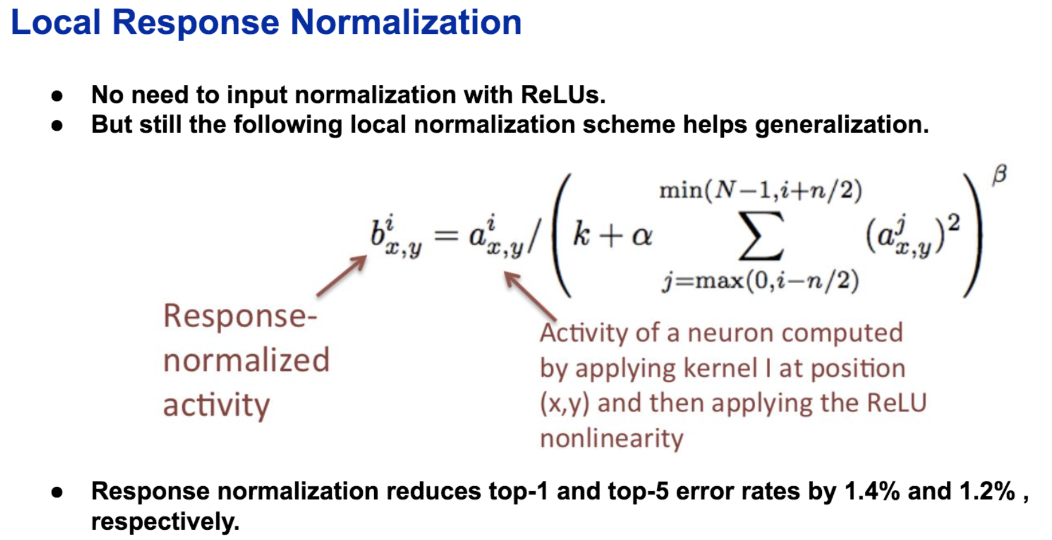

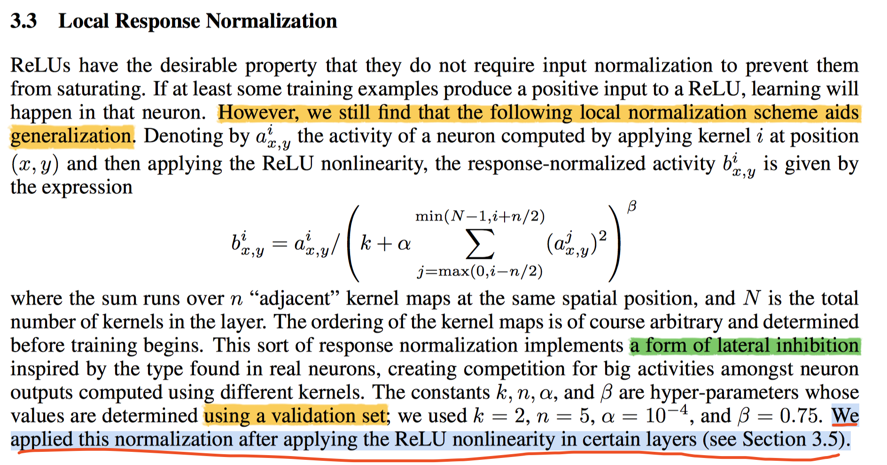

**Q： local contrast normalization**

**可能是 上式 a - mean 就是local contrast**

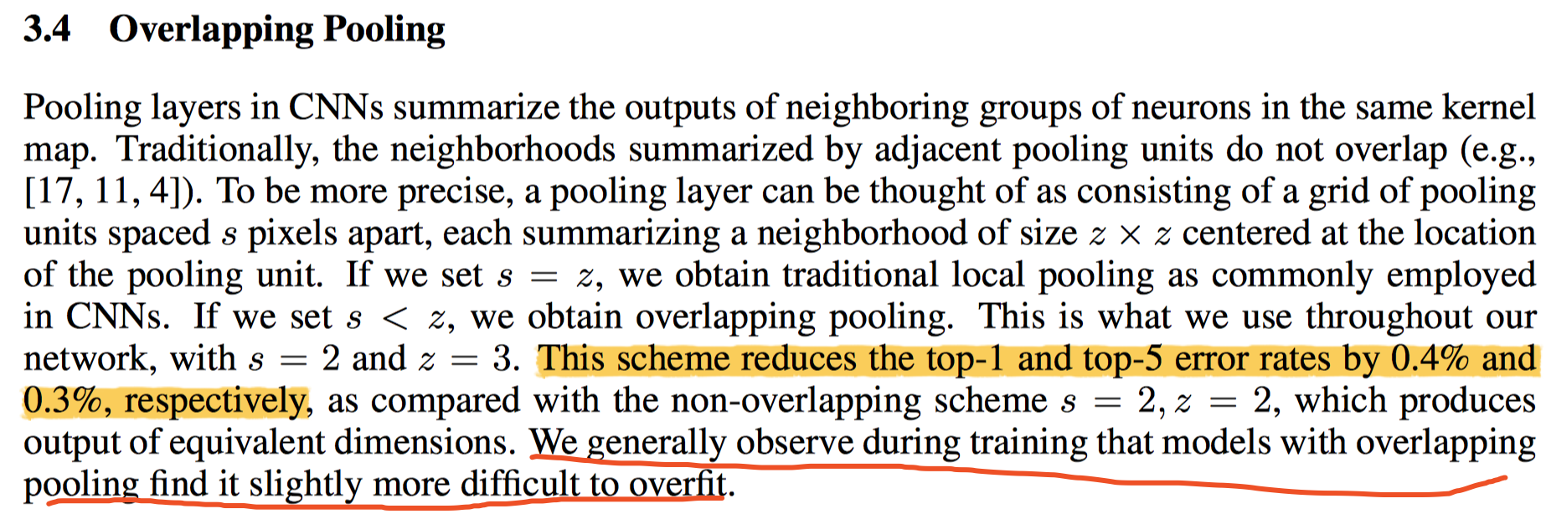

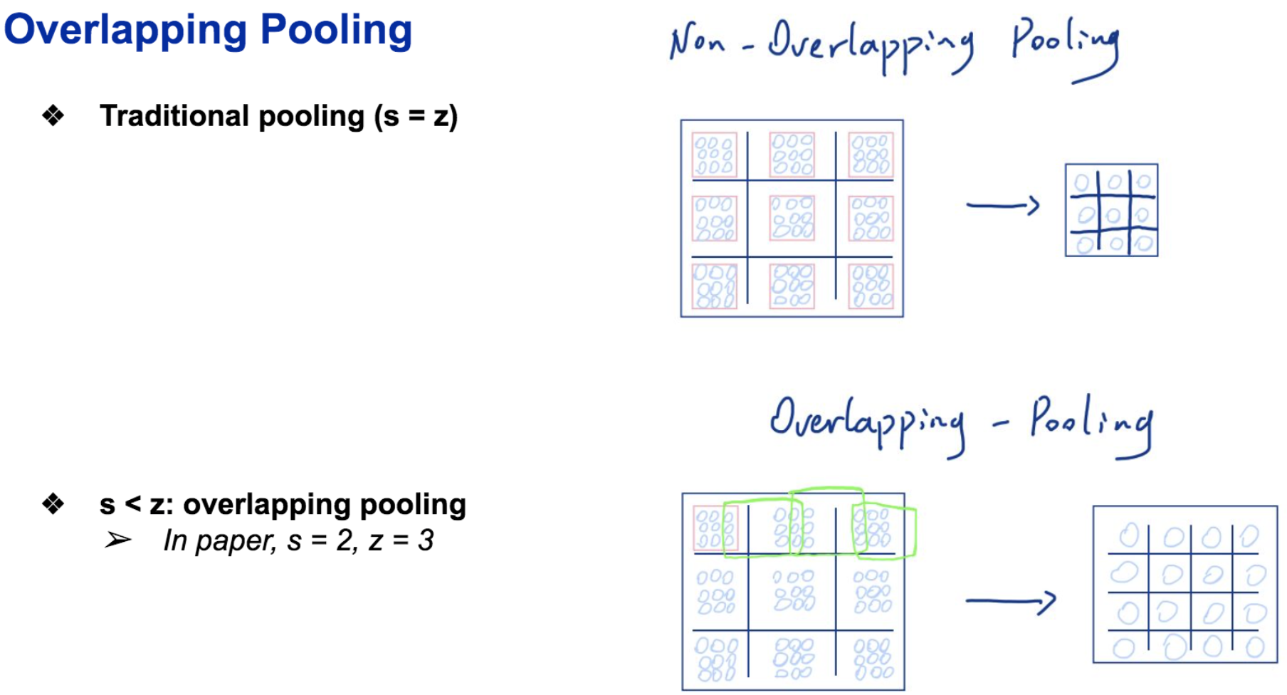

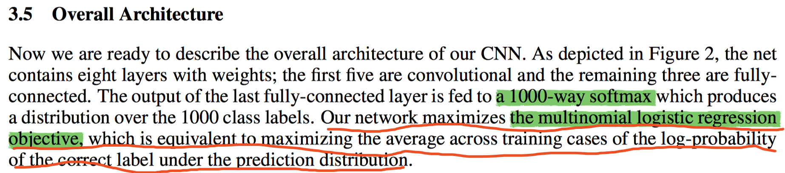

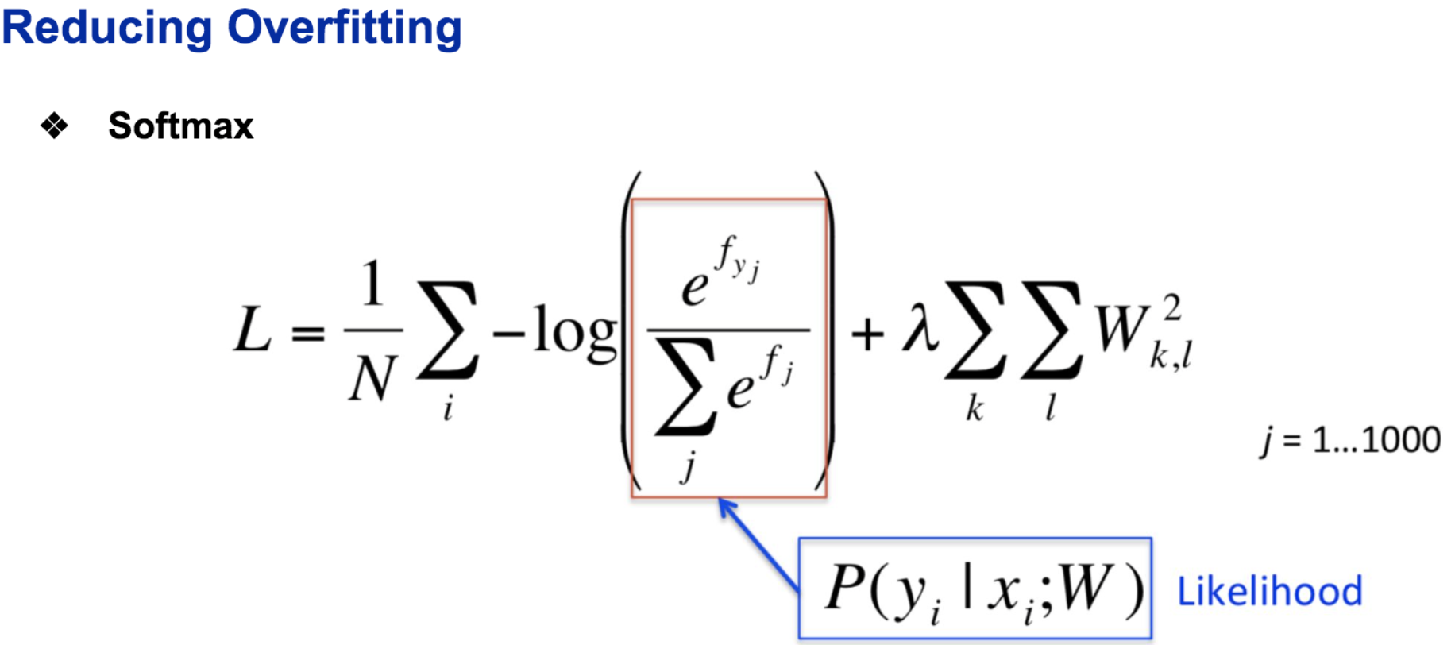

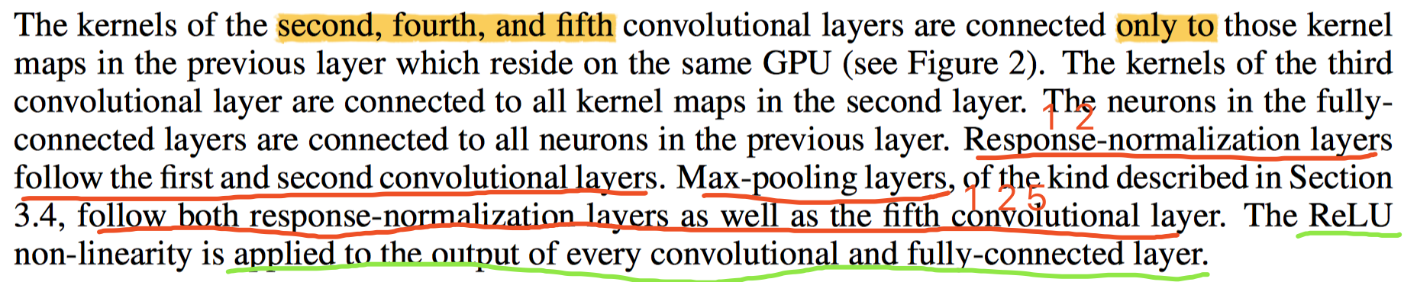

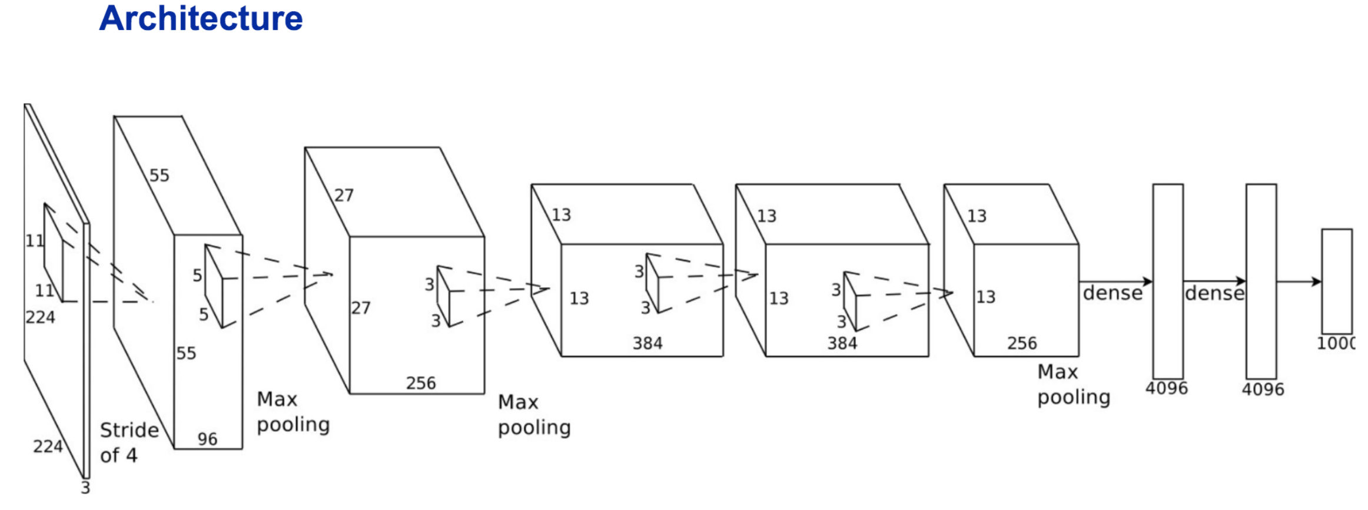



**WWYQ: 怎么计算卷积之后的output size?**

**floor( (224 - 11)/4 ) + 1 = 55**

