ONLINE CAKE AND BAKERY SHOP MANAGEMENT SYSTEM

SYSTEM DOCUMENTATION

SUBMITTED BY,
LINET NJOKI KANG’ETHU
DSE-01-0549/2025

A SYSTEM DOCUMENTATION SUBMITTED IN PARTIAL FULFILMENT FOR THE AWARD OF DIPLOMA IN SOFTWARE ENGINEERING BY ZETECH UNIVERSITY

DEC, 2026

Contents
CHAPTER ONE: PROJECT PLANNING AND ANALYSIS 1
1.1 Problem Statement 1
1.2 Justification 1
1.3 System Objectives 2
1.3.1 General Objective 2
1.3.2 Specific Objectives 2
1.4 Breakdown of Tools and Resources to Be Used 2
1.5 Project Functional Requirements and Non-Functional Requirements 3
1.5.1 Functional Requirements 3
1.5.2 Non-Functional Requirements 4
1.6 Breakdown of Project Schedule (Gantt Chart) 5
CHAPTER TWO: DESIGN AND MODELING 7
2.1 Introduction to Modelling 7
2.2 User Interface Models 7
2.2.1 Login page 8
2.2.2 Product catalogue 8
2.2.3 Cart and checkout 9
2.2.4 Order management 10
2.2.5 Product management 11
2.2.6 Reports 11
2.3 Logic Models 12
2.3.1 Login process flowchart 12
2.3.2 System flowchart 13
2.3.3 Data flow diagrams 14
2.3.4 Entity relationship diagram 15
2.3.5 Use case diagram 16
2.3.6 Class diagram 16
2.4 Chapter Summary 17

CHAPTER ONE: PROJECT PLANNING AND ANALYSIS

1.1 Problem Statement

The Cake and Bakery Shop sell cakes, cupcakes and bread, but orders are still managed manually. Customers place orders by phone calls, text messages, WhatsApp chats or by walking into the shop. A customer may order a birthday cake with a name written on it, only to find that the message was written wrongly, the date was forgotten or the cake was already sold out. Bread and cupcakes run out during the day without anyone knowing the exact stock, and customers travel to the shop only to find that their favourite item is not available.
Payments are also difficult to manage. Customers send money through M-Pesa and the staff must check the phone messages to confirm who has paid and for which order. Some orders are delivered without confirmed payment, while others are delayed because the payment message was missed. Customers cannot see the products, prices or flavors without calling or visiting the shop, and the owner has no clear record of the best-selling products or daily sales. As the number of customers grows, these manual methods lead to lost orders, wrong orders, disappointed customers and lost income.
There is, therefore, a need for a website where customers can view the cakes, cupcakes and bread, place and pay for orders online, and receive confirmation of their orders, while the owner manages products, stock, orders and sales from one secure system.

1.2 Justification
This project is justified by the need to move the Cake & Bakery Shop from manual order taking to an organized online system. Mobile phones, internet access and M-Pesa are widely used in Kenya, and customers increasingly expect to see products, choose what they want and pay from their phones without visiting the shop. A bakery that can only be reached by phone calls or physical visits risks losing customers to competitors who are easier to order from.
An online ordering system reduces the errors that come with manual order taking. Customer details, cake messages, delivery dates and quantities are captured in a standard form and saved in a database, so that nothing depends on memory or on scattered phone messages. Stock is updated automatically when an order is placed, which helps to avoid selling products that are not available. Payments through M-Pesa are linked to each order, which removes the need to check payment messages one by one.
The system also benefits the owner. Sales reports show the best-selling products, daily and monthly income, and low-stock items, helping the owner decide what to bake and when to restock. Order confirmation and status messages to customers improve communication and build trust in the shop. Overall, the system will improve accuracy, save staff time and help the business grow.

1.3 System Objectives

1.3.1 General Objective
To develop an online Cake & Bakery Shop website for selling cakes, cupcakes and bread.

1.3.2 Specific Objectives
- To develop an online catalogue and ordering system for cakes, cupcakes and bread.
- To develop a secure database for storing and managing product, order and customer records.
- To integrate M-Pesa payment and SMS notifications for timely order communication.

1.4 Breakdown of Tools and Resources to Be Used
Resource | Purpose | Cost (Ksh)
Laptop | To develop, test and run the website | 0 (already exists)
PHP 8 (server-side scripting) | Writing the system logic for orders, users, payments and notifications | 0 (free)
HTML, CSS and JavaScript | Building the user interface, cart and responsive pages | 0 (free)
MySQL Database | Storing products, orders, customers, payments and notifications | 0 (free)
Local server (Apache via XAMPP) | Providing a local environment for testing the system | 0 (free)
M-Pesa Daraja API (sandbox) | Testing M-Pesa STK push payments | 0 (free sandbox)
SMS gateway (sandbox) | Testing order confirmation and status SMS | 0 (free sandbox)
 | Total | 0
Table 1.4.1 Project tools and resources

1.5 Project Functional Requirements and Non-Functional Requirements

1.5.1 Functional Requirements
The functional requirements below describe what the system must do to achieve each specific objective. The same activities are used in the project schedule in Section 1.6.
Specific Objective | Functional Requirements
i. To develop an online catalogue and ordering system for cakes, cupcakes and bread. | - User registration and login  - Product catalogue display (cakes, cupcakes, bread)  - Search and filter products  - Shopping cart and order placement
ii. To develop a secure database for storing and managing product, order and customer records. | - Store product, order and customer data  - Update products, stock and order status  - Retrieve and manage records  - Generate sales reports
iii. To integrate M-Pesa payment and SMS notifications for timely order communication. | - M-Pesa payment  - Order confirmation and status SMS  - Order tracking
Table 1.5.1 Functional requirements

1.5.2 Non-Functional Requirements
Specific Objective | Non-Functional Requirements
i. To develop an online catalogue and ordering system for cakes, cupcakes and bread. | - Ease of use and mobile-friendly design  - Fast page loading speed
ii. To develop a secure database for storing and managing product, order and customer records. | - Database security  - Password encryption  - Data backups
iii. To integrate M-Pesa payment and SMS notifications for timely order communication. | - Payment security (HTTPS)  - Notification delivery speed
Table 1.5.2 Non-functional requirements

1.6 Breakdown of Project Schedule (Gantt Chart)
The Gantt chart maps each specific objective to the project activities (the functional requirements in Table 1.5.1) and shows the weeks of the September–December 2026 semester in which each activity will be carried out. Shaded cells show the planned weeks.
Specific Objective to Project Activity Mapping | Project Activities | Sep-Dec 2026 Semester
Specific Objective to Project Activity Mapping | Project Activities | 1  06-12 Sep | 2  13-19 Sep | 3  20-26 Sep | 4  27 Sep-03 Oct | 5  04-10 Oct | 6  11-17 Oct | 7  18-24 Oct | 8  25-31 Oct | 9  01-07 Nov | 10  08-14 Nov | 11  15-21 Nov
Plan refinement
S01: To develop an online catalogue and ordering system for cakes, cupcakes and bread. | User registration and login
 | Product catalogue display (cakes, cupcakes, bread)
 | Search and filter products
 | Shopping cart and order placement
S02: To develop a secure database for storing and managing product, order and customer records. | Store product, order and customer data
 | Update products, stock and order status
 | Retrieve and manage records
 | Generate sales reports
S03: To integrate M-Pesa payment and SMS notifications for timely order communication. | M-Pesa payment
 | Order confirmation and status SMS
 | Order tracking
Table 1.6.1 Project schedule (Gantt chart)

CHAPTER TWO: DESIGN AND MODELING

2.1 Introduction to Modelling
This chapter presents the system designs and models developed to visualize the proposed Cake and Bakery Shop online ordering system before the actual implementation begins. The diagrams and models illustrate how the system will function, how customers and the shop administrator will interact with it, how orders for cakes, cupcakes and bread will be placed, paid for and stored, and how data will flow between the system, the customers and the M-Pesa payment service. Modeling the system prior to development helps to clarify the requirements stated in Chapter One, identify potential challenges early, and ensure that all system components are well organized. This approach reduces development errors, improves planning and provides a clear blueprint that guides the implementation process, resulting in an efficient, reliable and well-structured system that meets the three specific objectives of the project: an online catalogue and ordering system, a secure database for products, orders and customers, and M-Pesa payment with SMS notifications.

2.2 User Interface Models
The user interface models below are design mock-ups of the main screens that customers and the administrator will use. They show the layout, the data to be displayed and the actions available on each screen. The system will be built with PHP and a MySQL database, and the screens will be refined during implementation.

2.2.1 Login page
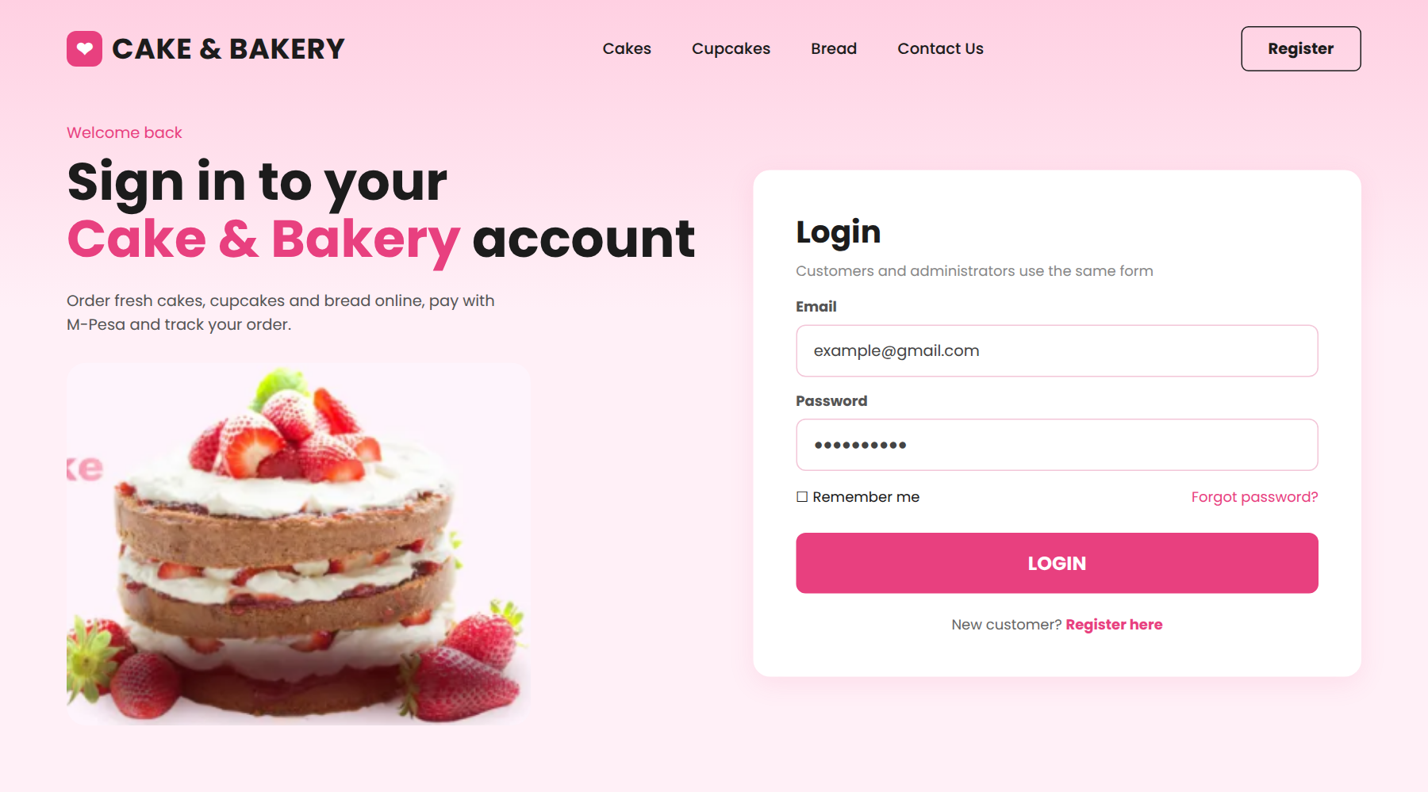
Figure 2.2.1 Login page
The login page illustrates a simple and secure interface where registered users (customers and the administrator) enter their email and password to access the system. New customers can register from the same page. Passwords are stored in encrypted form, which supports the database security and password encryption requirements.

2.2.2 Product catalogue
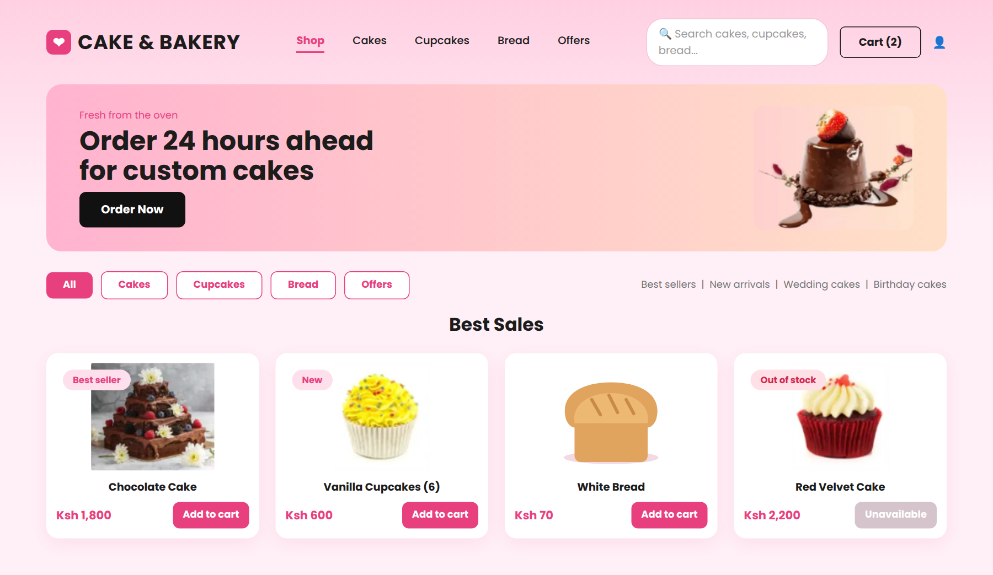
Figure 2.2.2 Product catalogue page
The product catalogue page shows the cakes, cupcakes and bread with their photos, prices and an Add to cart button. Customers can search by name, browse by category and see offers such as best sellers and new arrivals. Items that are out of stock are marked so that customers do not order them.

2.2.3 Cart and checkout

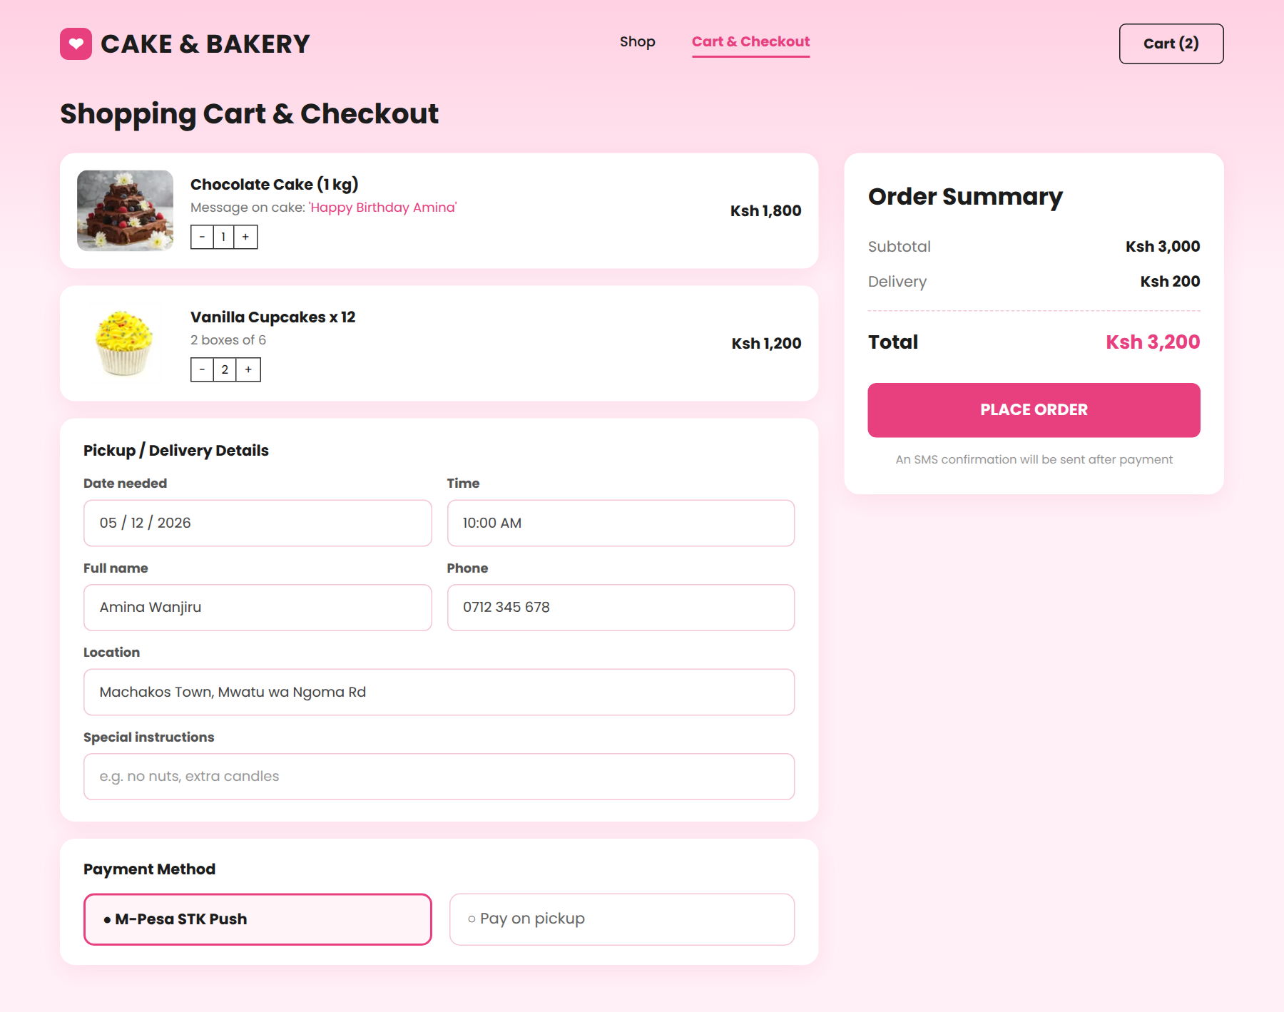
Figure 2.2.3 Cart and checkout page
The cart and checkout page lists the selected items and allows the customer to add a message to be written on a cake, choose the pickup or delivery date and time, and enter contact details. The order summary shows the subtotal, delivery fee and total, and the customer pays through M-Pesa STK push or chooses to pay on pickup.

2.2.4 Order management
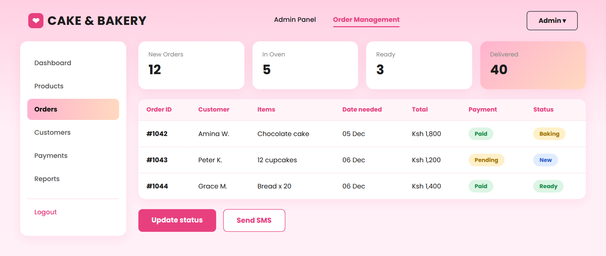
Figure 2.2.4 Order management form
The order management form shows how the administrator views new, in-progress, ready and delivered orders, checks the payment status and updates the status of each order. When the status changes, an SMS can be sent to inform the customer, which supports the objective of timely communication.

2.2.5 Product management
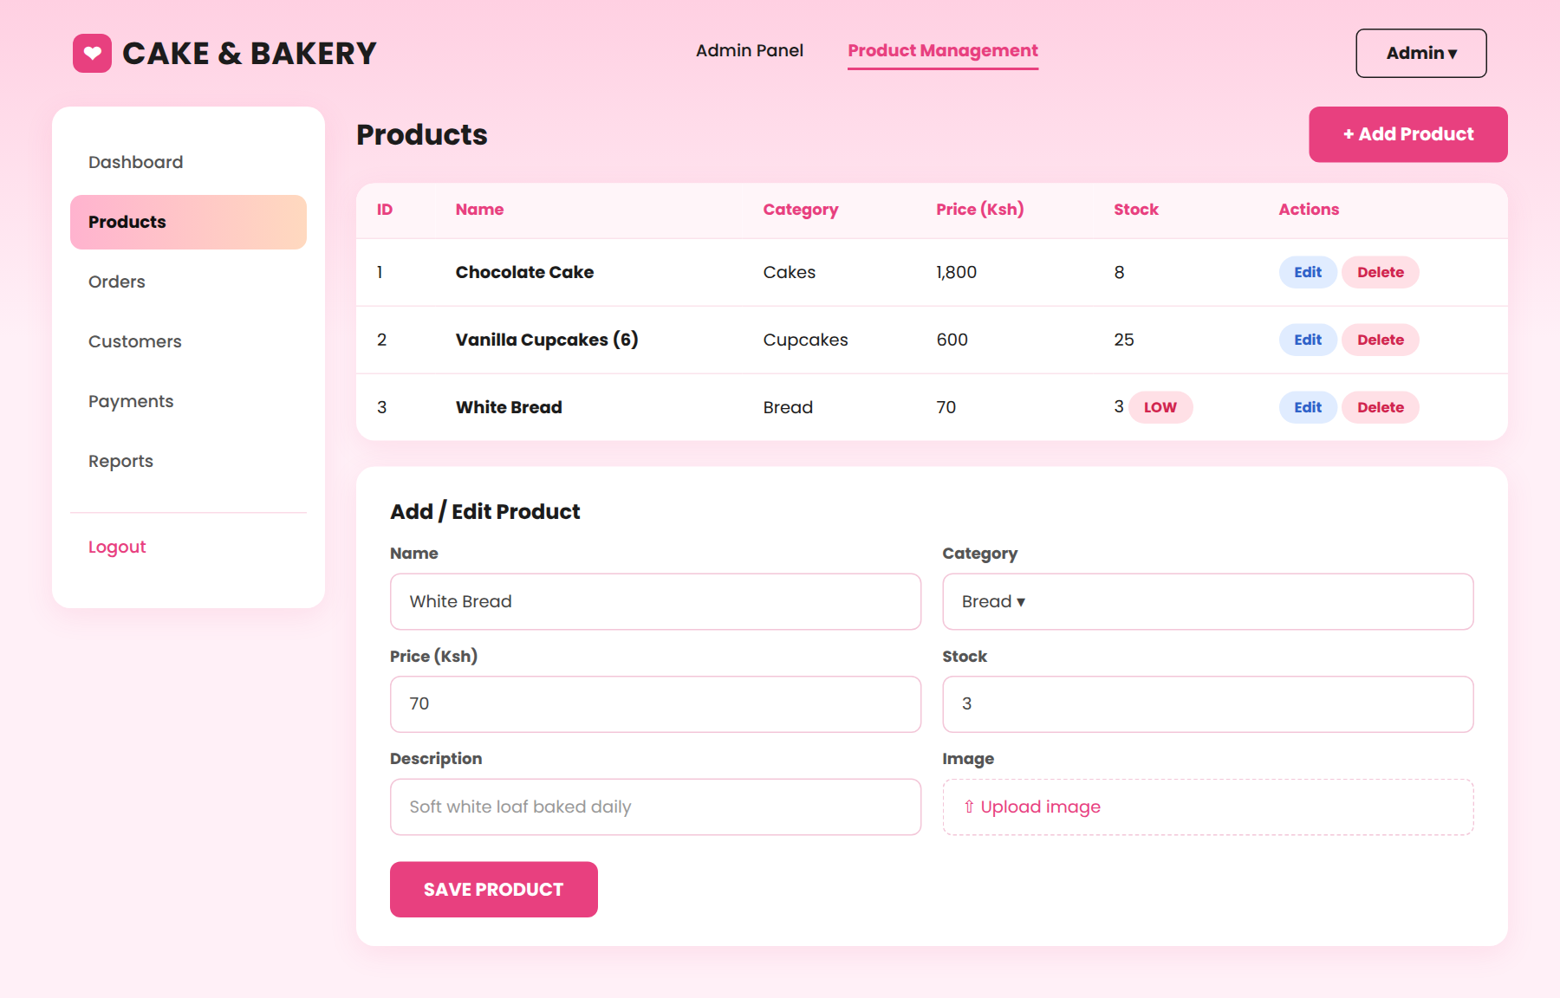
Figure 2.2.5 Product management form
The product management form allows the administrator to add, edit and delete products, change prices and update stock quantities. Products with low stock are flagged so that they can be baked or restocked in time.

2.2.6 Reports
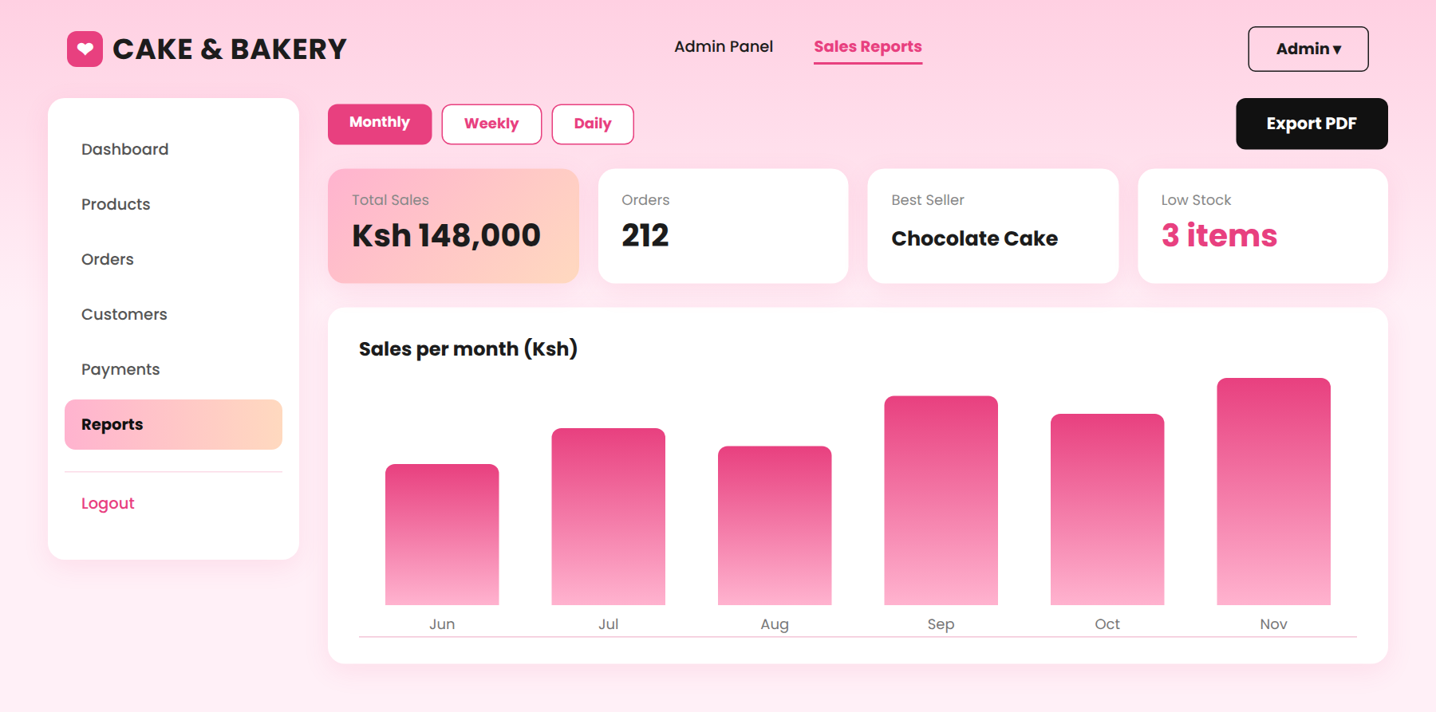
Figure 2.2.6 Reporting form
The reporting form illustrates how the system generates daily, weekly and monthly sales reports. It summarizes total sales, number of orders, best-selling products and low-stock items, helping the owner analyze trends and make informed decisions.

2.3 Logic Models

2.3.1 Login process flowchart
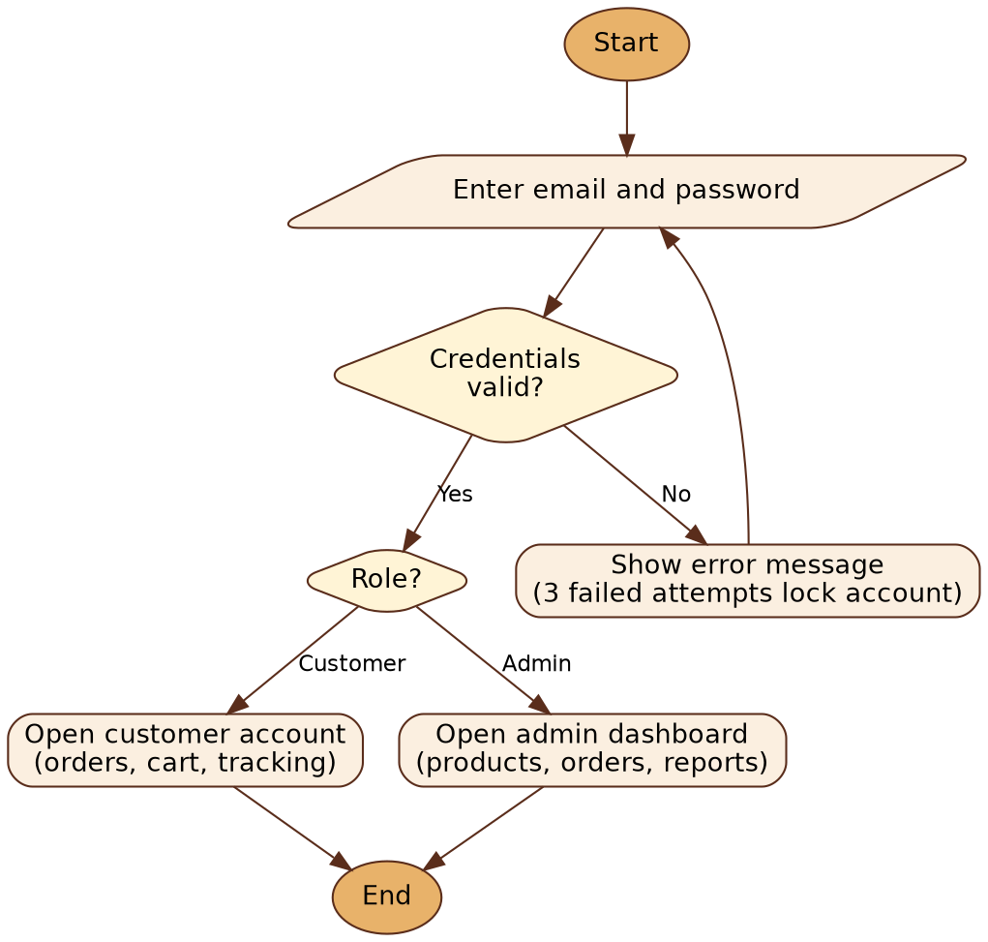
Figure 2.3.1 Login process flowchart
This flowchart illustrates the steps involved when a user logs into the system. The user enters an email and password, which are submitted and validated against the Users table in the MySQL database. If the credentials are valid, the system checks the user's role and opens either the customer account or the admin dashboard. If they are invalid, an error message is shown; after three failed attempts the account is locked, otherwise the user is asked to try again.

2.3.2 System flowchart

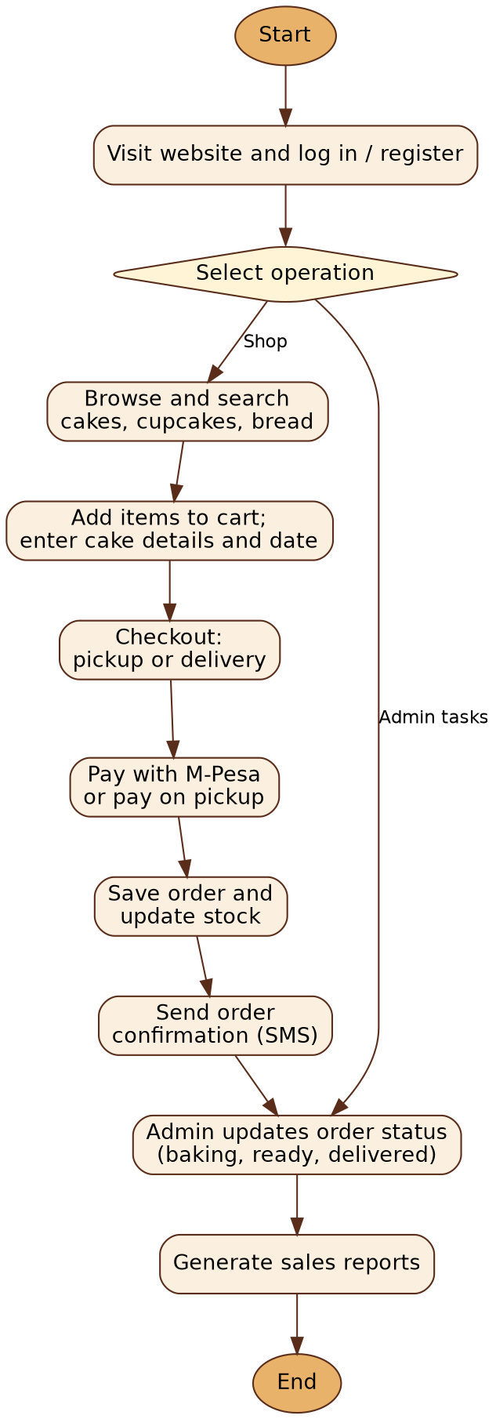
Figure 2.3.2 System flowchart
The flowchart illustrates how the online ordering system operates from start to finish. The process begins with the user visiting the website and logging in or registering. The user then selects an operation. A customer browses and searches for cakes, cupcakes and bread, adds items to the cart together with cake details and the date needed, and proceeds to checkout where pickup or delivery is selected. The customer pays with M-Pesa or chooses to pay on pickup, after which the order is saved, the stock is updated and a confirmation SMS is sent. The administrator then updates the order status as the items are baked, made ready and delivered, and can generate sales reports from the stored data. After finishing an operation, the user may select another one or log out, at which point the process ends.

2.3.3 Data flow diagrams
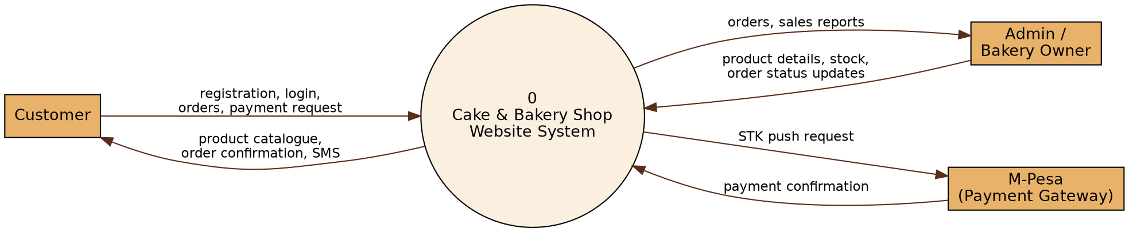
Figure 2.3.3(a) Level 0 DFD (context diagram)
The Level 0 Data Flow Diagram (context diagram) shows the Cake & Bakery Shop website as a single process and the three external entities that interact with it. Customers send registration details, orders and payment requests and receive the product catalogue, order confirmation and SMS messages. The administrator sends product details, stock updates and order status changes and receives orders and sales reports. The M-Pesa payment service receives the STK push request from the system and returns a payment confirmation.
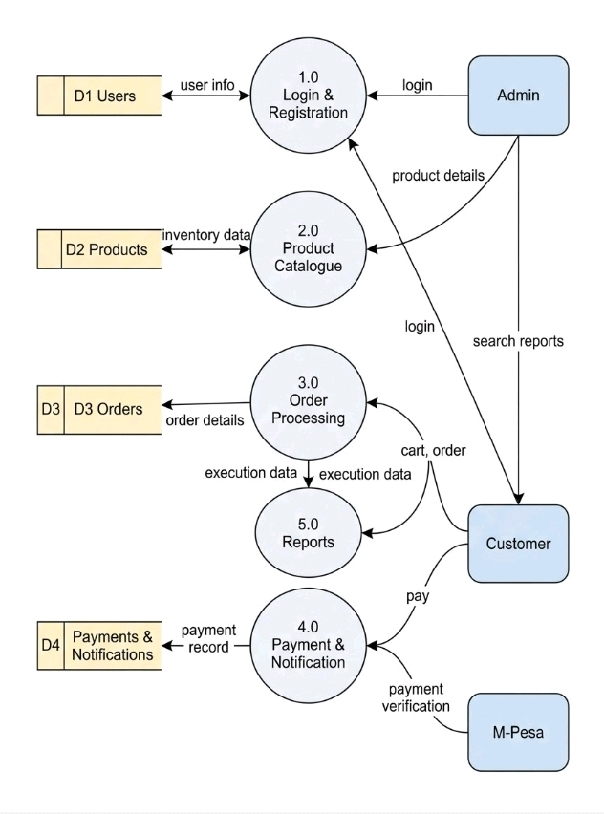
Figure 2.3.3(b) Level 1 DFD
The Level 1 Data Flow Diagram divides the system into five main processes: login and registration, product catalogue, order processing, payment and notification, and reports. These processes exchange data with four data stores, namely Users, Products, Orders, and Payments & Notifications. Order processing reads the available stock from the Products store, saves each order in the Orders store and passes the order total to the payment process. The payment process sends the STK push to M-Pesa, records the confirmation and sends the SMS to the customer. The reports process reads from the data stores to produce sales reports for the administrator, ensuring proper data storage, retrieval and system functionality.

2.3.4 Entity relationship diagram
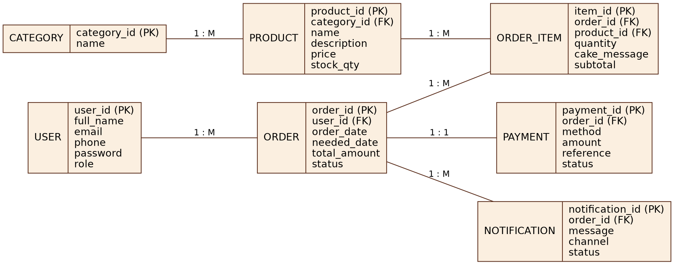
Figure 2.3.4 ER diagram
The Entity Relationship Diagram (ERD) represents the database structure of the system. It consists of seven entities: User, Category, Product, Order, Order_Item, Payment and Notification. The User entity stores login credentials, contact details and roles for customers and the administrator. The Category entity groups products into cakes, cupcakes and bread, and the Product entity holds the name, price and stock quantity of each item. The Order entity records each order with its date, the date needed, total amount and status, while the Order_Item entity stores each product ordered with its quantity and any message to be written on a cake. The Payment entity records the method, amount and M-Pesa reference, and the Notification entity records every SMS sent and its delivery status. The relationships show that one category has many products, one user can place many orders, one order has many order items and one payment, and one order can trigger many notifications. Foreign keys (category_id, user_id, order_id, product_id) link the tables, ensuring data integrity and proper tracking of orders.

2.3.5 Use case diagram
The use case diagram for the online ordering system illustrates the interactions between the actors and the system. The Customer can register or log in, browse and search products, add items to the cart, place an order, pay with M-Pesa, track the order and receive SMS notifications. The admin can log in, manage products and stock, update order status, manage users and view sales reports. Each function is represented as an oval inside the system boundary, and the lines show which actor uses it. This diagram helps visualize the system's main features and each user's role.
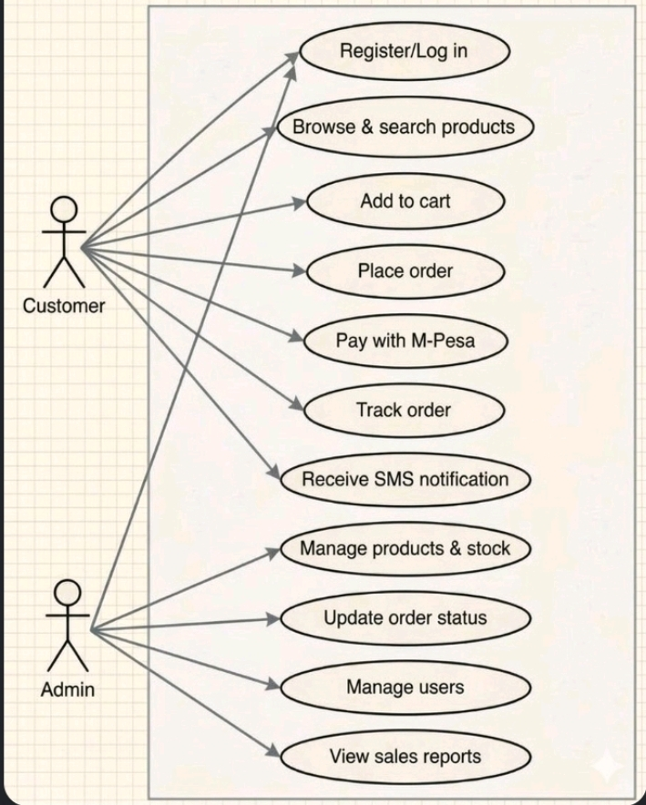
Figure 2.3.5 Use case diagram

2.3.6 Class diagram
The class diagram for the online ordering system shows the main classes and how they relate to each other. The User class represents customers and administrators who register and log in. A user places many Orders, and each Order contains one or more Products. An Order is settled through a Payment and can trigger Notification objects that are sent to the customer by SMS. The Report class reads order data to produce sales reports. The attributes, methods and multiplicities provide a clear structure of how the system functions.
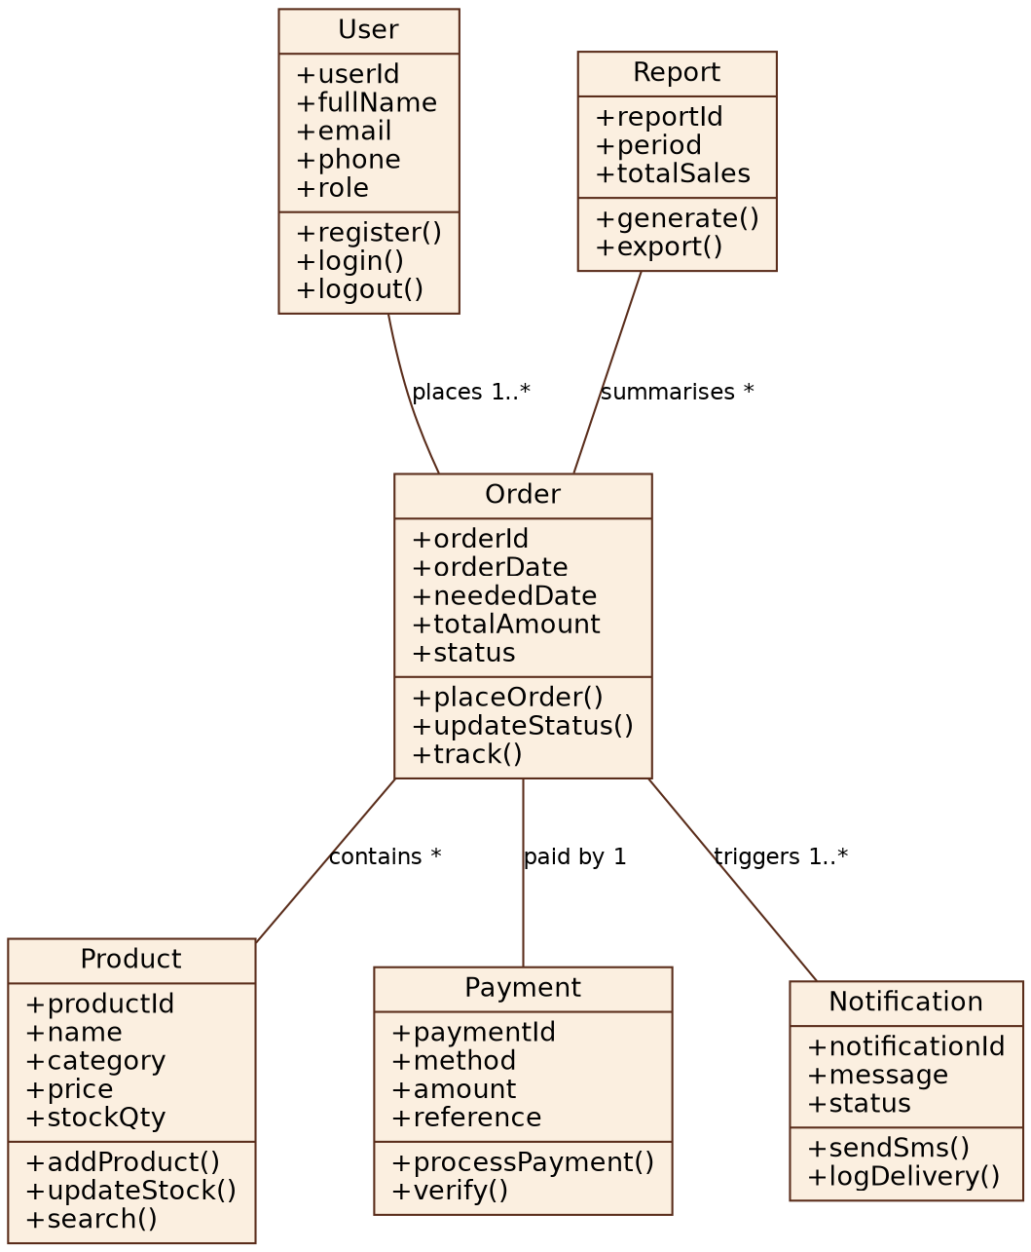
Figure 2.3.6 Class diagram

2.4 Chapter Summary
This chapter has presented the user interface models and logic models for the Cake & Bakery Shop online ordering system. Together, the login and system flowcharts, data flow diagrams, entity relationship diagram, use case diagram and class diagram describe how customers will browse and order cakes, cupcakes and bread, how orders will be paid for and stored, how customers will be notified by SMS, and how the administrator will manage products, orders and reports. These designs form the blueprint for the implementation phase in the next milestone.

CHAPTER THREE: SYSTEM IMPLEMENTATION

3.1 Introduction
This chapter explains how the designs in Chapter Two were turned into a working Online Cake and Bakery Shop Management System. The system was implemented with PHP, MySQL, HTML, CSS and JavaScript and runs on an Apache and MySQL server provided by XAMPP. Every screen was built to follow the user interface models in Section 2.2, and every table follows the entity relationship diagram in Section 2.3.4. The chapter is organised around the three specific objectives of the project.

3.2 Development Environment and Tools
Tool | Purpose in the implementation
PHP 8 | Server-side logic: login, cart, order placement, payment handling, reports
MySQL / MariaDB (XAMPP) | Stores users, products, orders, payments and notifications; accessed through PHP Data Objects (PDO) with prepared statements
HTML5, CSS3 and JavaScript | Responsive pages in the pink design of Chapter Two; JavaScript for the live delivery fee, order selection and dialogs
Apache (XAMPP) | Local web server used for development and testing
M-Pesa Daraja API (sandbox) | STK push payment request and payment confirmation callback
Africa's Talking SMS (sandbox) | Order confirmation and status messages
Google Chrome | Testing on desktop and on a phone-sized screen

3.3 System Architecture
The system follows a simple layered structure. Pages in the project folder handle the screens the user sees. Shared code for sessions, security and page layout is kept in the includes folder, and the business rules (placing an order, changing its status, taking payment, sending SMS) are kept in the services folder so that they are used in the same way by every page and by the automated tests.
Folder / file | Role
index.php, cart.php, login.php, register.php, my_orders.php, track.php | Customer pages: catalogue, cart and checkout, account, order list and order tracking
admin/ (index, orders, products, customers, payments, reports) | Administrator pages shown in Figures 2.2.4 to 2.2.6 and the sidebar, plus delivery areas
includes/ (helpers.php, auth.php, header.php, footer.php) | Sessions, CSRF protection, input escaping, login logic and the shared page layout
services/ (OrderService, Mpesa, PaymentService, Sms) | Business rules and the connections to M-Pesa and the SMS gateway
config/ (config.php, db.php) | Database settings, delivery fee, login-lock settings and API keys
sql/schema.sql | Creates the database, the seven tables and the sample products
install.php | One-time installer that creates the database and the administrator account
mpesa_callback.php | Address that Safaricom calls to confirm a payment
assets/ (css, js, img) | Styles that reproduce the Chapter Two designs, JavaScript and product photos
tests/ and tools/ | Automated tests and the database backup scripts

3.4 Database Implementation
The database cakebakery contains the seven entities of the ERD in Figure 2.3.4 and one small supporting table, delivery_zones, which stores the delivery areas and their fees. Foreign keys connect the tables and database rules prevent invalid data, for example a negative price or stock quantity.
Table | Purpose | Important rules
users | Customers and the administrator | Unique email; password stored only as a hash; role (customer or admin); failed-login counter and lock time
categories | Cakes, Cupcakes, Bread | Unique name
products | Items for sale | price >= 0 and stock_qty >= 0 checks; low-stock level; badge (best seller, new); is_active flag so deleted products stay in old orders
orders | One row per order | Date needed, contact details, delivery address, delivery fee, total and status (new, in_progress, ready, delivered, cancelled)
order_items | Products inside an order | Quantity > 0; unit price copied at the time of purchase; message to write on a cake
payments | One payment per order | Method (M-Pesa or pay on pickup); M-Pesa receipt; status (pending, paid, failed)
notifications | Every SMS sent | Message, phone number and delivery status (queued, sent, failed)
delivery_zones | Delivery areas and fees | Unique area name; fee >= 0; is_active flag so an area can be hidden without deleting it

Part of the orders table definition is shown below.
CREATE TABLE orders (
order_id INT AUTO_INCREMENT PRIMARY KEY,
user_id INT NOT NULL,
order_date TIMESTAMP DEFAULT CURRENT_TIMESTAMP,
date_needed DATETIME NOT NULL,
contact_name VARCHAR(100) NOT NULL,
contact_phone VARCHAR(15) NOT NULL,
fulfilment ENUM('pickup','delivery') NOT NULL DEFAULT 'pickup',
delivery_address VARCHAR(255) NULL,
special_instructions VARCHAR(255) NULL,
delivery_fee DECIMAL(10,2) NOT NULL DEFAULT 0,
total_amount DECIMAL(10,2) NOT NULL,
status ENUM('new','in_progress','ready','delivered','cancelled') NOT NULL DEFAULT 'new',
FOREIGN KEY (user_id) REFERENCES users(user_id)
) ENGINE=InnoDB AUTO_INCREMENT=1001;
Indexes on order status, order date and product category keep the report and catalogue queries fast.

3.5 Implementation of Objective (i): Online Catalogue and Ordering System

3.5.1 User registration and login
Customers register with their name, email, Kenyan phone number and a password of at least eight characters. Phone numbers such as 0712 345 678 are converted to the international form 254712345678 that M-Pesa requires. Passwords are stored with PHP's password_hash function, so they cannot be read from the database. The login page follows the flowchart in Figure 2.3.1: invalid credentials show a generic message, an account is locked for 15 minutes after three wrong attempts, and a successful login sends customers to the shop and the administrator to the admin dashboard. Every form carries a hidden security token (CSRF token) and a new session is created at login to prevent session theft.
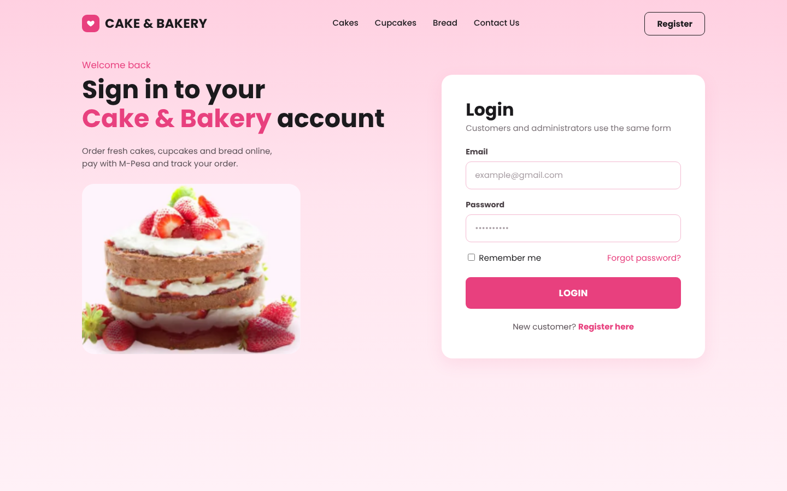
Figure 3.1 Login page (implementation of Figure 2.2.1)
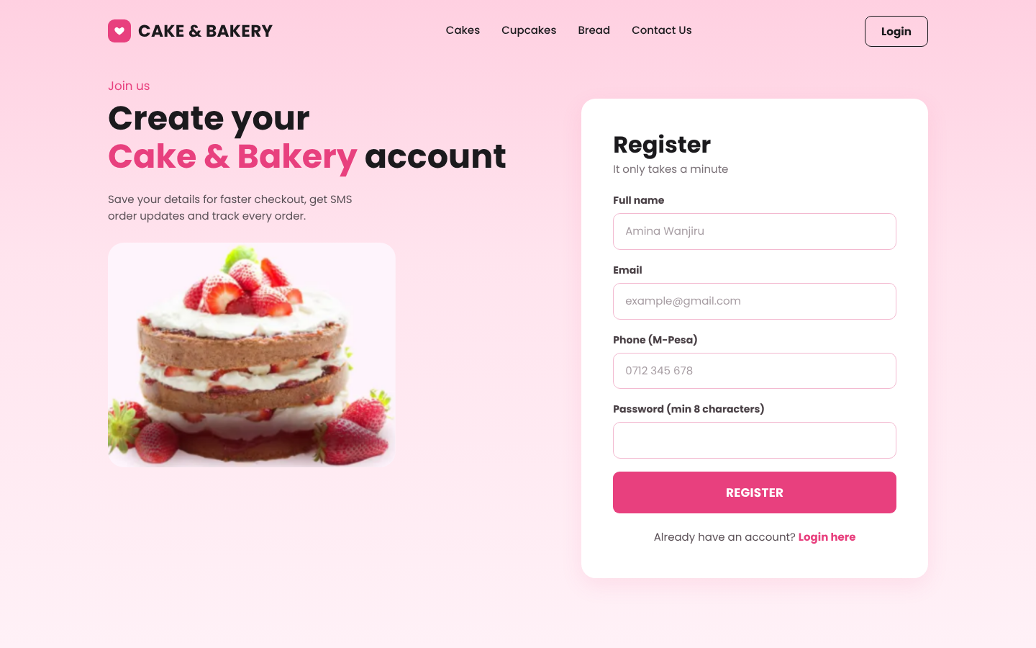
Figure 3.2 Registration page

3.5.2 Product catalogue, search and filters
The catalogue shows each product with its photo, price and an Add to cart button. Customers can search by name, filter by Cakes, Cupcakes, Bread or Offers, and use the quick links for best sellers, new arrivals, wedding cakes and birthday cakes. Products with no stock show an Out of stock label and a disabled Unavailable button so they cannot be ordered.
switch ($f) {
case 'cakes': case 'cupcakes': case 'bread': $where[] = 'LOWER(c.name)=?'; $args[] = $f; break;
case 'offers': $where[] = 'p.is_offer=1'; break;
case 'best': $where[] = "p.badge='best_seller'"; break;
case 'new': $where[] = "p.badge='new'"; break;
case 'wedding': $where[] = "p.occasion='wedding'"; break;
case 'birthday': $where[] = "p.occasion='birthday'"; break;
default: $f = 'all';
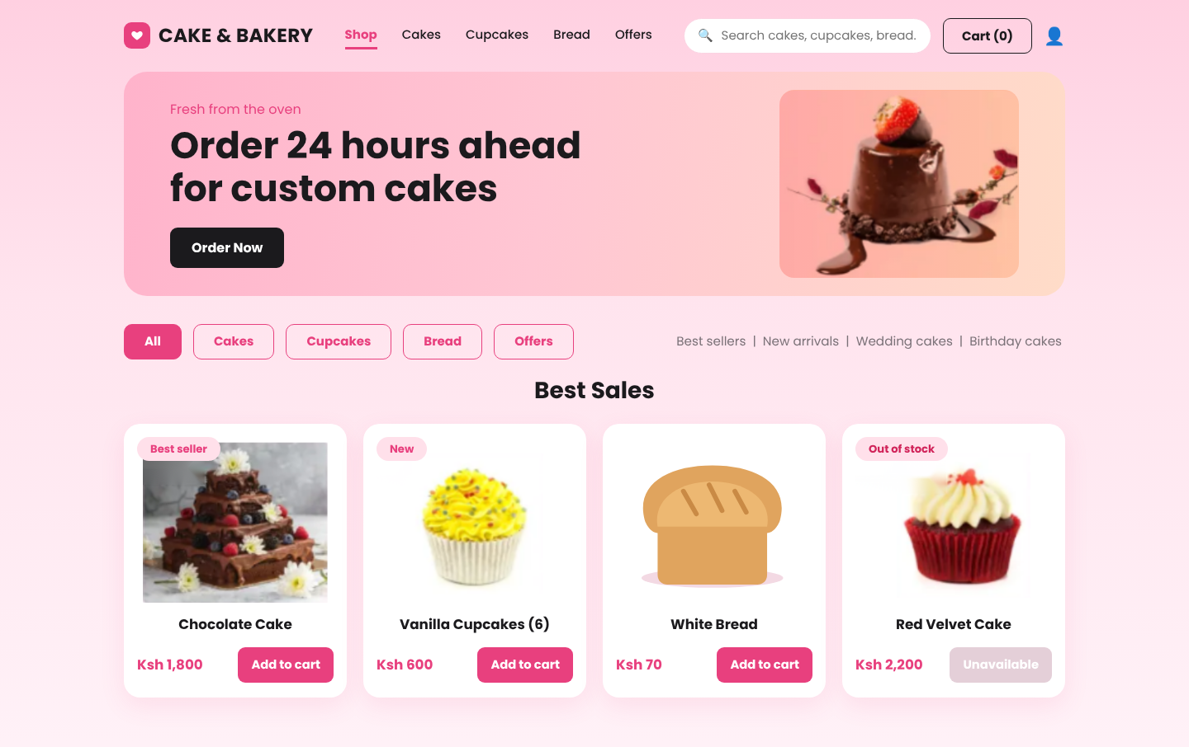
Figure 3.3 Product catalogue (implementation of Figure 2.2.2)

3.5.3 Shopping cart and checkout
The cart and checkout are on one page as designed in Figure 2.2.3. Customers change quantities with the plus and minus buttons, type the message to be written on a cake, choose the date and time, and enter a location for delivery. The customer picks a delivery area from a list (for example Machakos Town CBD, Athi River / Mlolongo or Nairobi) and types the street or landmark. The delivery fee depends on the area chosen, so a customer nearer the shop pays less than one who is far away, and the order summary updates the fee immediately. Choosing Pickup at the shop is free. The fee is always read from the database on the server, so it cannot be changed from the browser. The system applies these business rules before an order is accepted:
• Cakes must be ordered at least 24 hours ahead; other items at least one hour ahead.
• Orders must be for a time between 7:00 AM and 7:00 PM.
• The phone number must be a valid Kenyan number.
• The quantity cannot be more than the stock available.
• A delivery order needs a valid delivery area and a street or landmark.
• The price is always read from the database, never from the browser, so it cannot be changed by the customer.
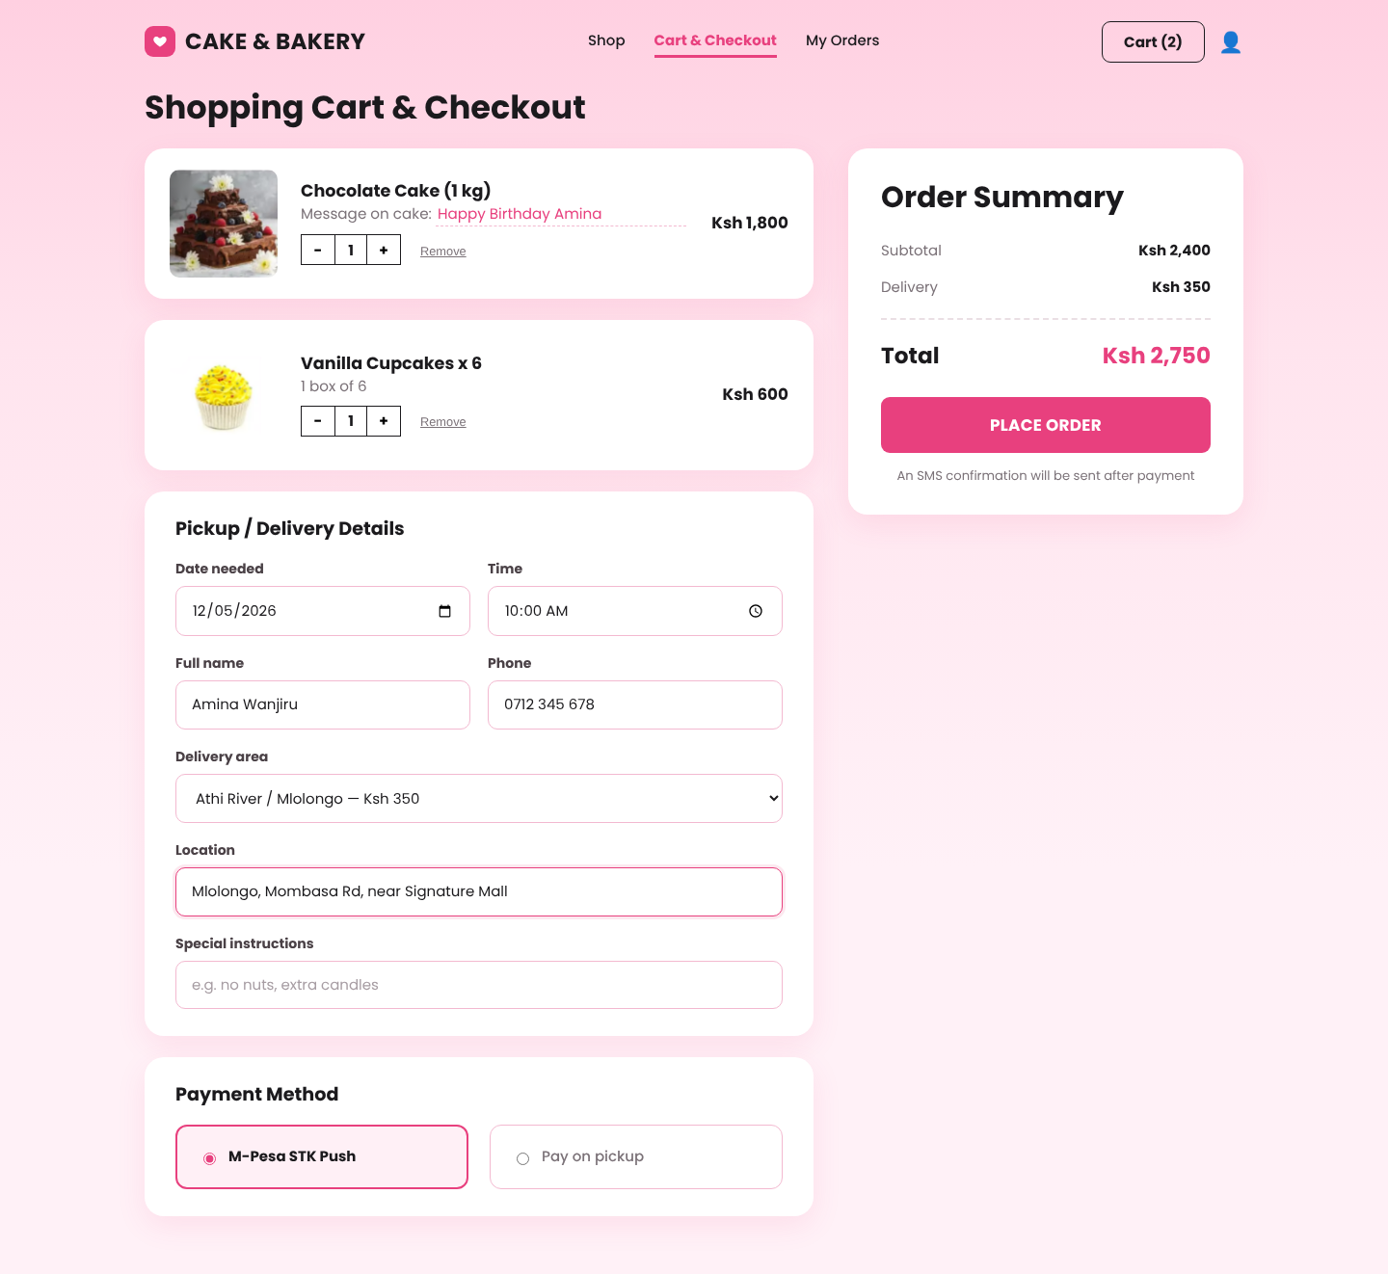
Figure 3.4 Cart and checkout page with the delivery area list (implementation of Figure 2.2.3)

3.6 Implementation of Objective (ii): Secure Database and Management Functions

3.6.1 Placing an order safely
When the customer presses Place Order, the system saves the order, its items and its payment record, and reduces the stock, all inside one database transaction. The product rows are locked while the order is processed, so two customers cannot buy the last cake at the same time. If any step fails, the transaction is rolled back and nothing is saved.
$pdo->beginTransaction();
try {
$total = 0; $rows = []; $hasCake = false;
foreach ($cart as $pid => $row) {
$st = $pdo->prepare('SELECT * FROM products WHERE product_id=? AND is_active=1 FOR UPDATE');
$st->execute([$pid]); $p = $st->fetch();
if (!$p || $p['stock_qty'] < $row['qty']) throw new InvalidArgumentException('Not enough stock for '.($p['name'] ?? 'an item').'.');
if ($p['category_id'] == 1) $hasCake = true;
$total += $p['price'] * $row['qty'];
$rows[] = [$p, $row];
}
$minLead = $hasCake ? 24*3600 : 3600;
if ($needed < time() + $minLead) throw new InvalidArgumentException($hasCake ? 'Cakes must be ordered at least 24 hours ahead.' : 'Choose a time at least 1 hour from now.');
$fee = $zone ? (float)$zone['fee'] : 0.0; $total += $fee;
$pdo->prepare('INSERT INTO orders(user_id,date_needed,contact_name,contact_phone,fulfilment,delivery_address,special_instructions,delivery_fee,total_amount) VALUES(?,?,?,?,?,?,?,?,?)')
->execute([$userId, date('Y-m-d H:i:s',$needed), $name, $phone, $fulfil, $address, $instr ?: null, $fee, $total]);
$orderId = (int)$pdo->lastInsertId();
foreach ($rows as [$p,$row]) {
$pdo->prepare('INSERT INTO order_items(order_id,product_id,quantity,unit_price,cake_message) VALUES(?,?,?,?,?)')
->execute([$orderId,$p['product_id'],$row['qty'],$p['price'],($p['category_id']==1 && $row['message']!=='') ? $row['message'] : null]);
$pdo->prepare('UPDATE products SET stock_qty=stock_qty-? WHERE product_id=?')->execute([$row['qty'],$p['product_id']]);
}
$pdo->prepare('INSERT INTO payments(order_id,method,amount) VALUES(?,?,?)')->execute([$orderId,$method,$total]);
$pdo->commit();

3.6.2 Product management
The administrator adds, edits and deletes products and updates prices and stock (Figure 2.2.5). The server checks that the price and stock are valid numbers and that an uploaded image is a JPG, PNG or WEBP file of less than 2 MB. Deleting a product only hides it from the shop, so old orders that contain it remain correct. Products at or below their low-stock level show a LOW label.
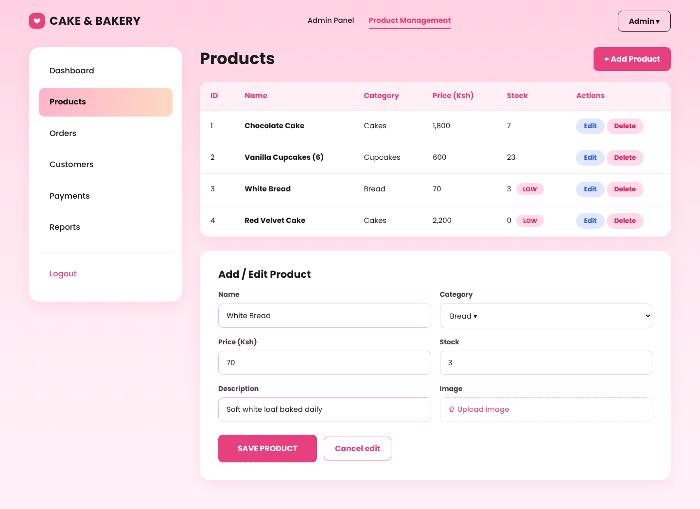
Figure 3.5 Product management with the Add / Edit form (implementation of Figure 2.2.5)

3.6.2a Delivery areas and fees
The administrator sets the delivery fee for each area under Delivery in the sidebar. Areas can be added, edited and hidden, and a change applies to every new order at once. The sample areas and prices that come with the system are examples that the shop replaces with its real charges.
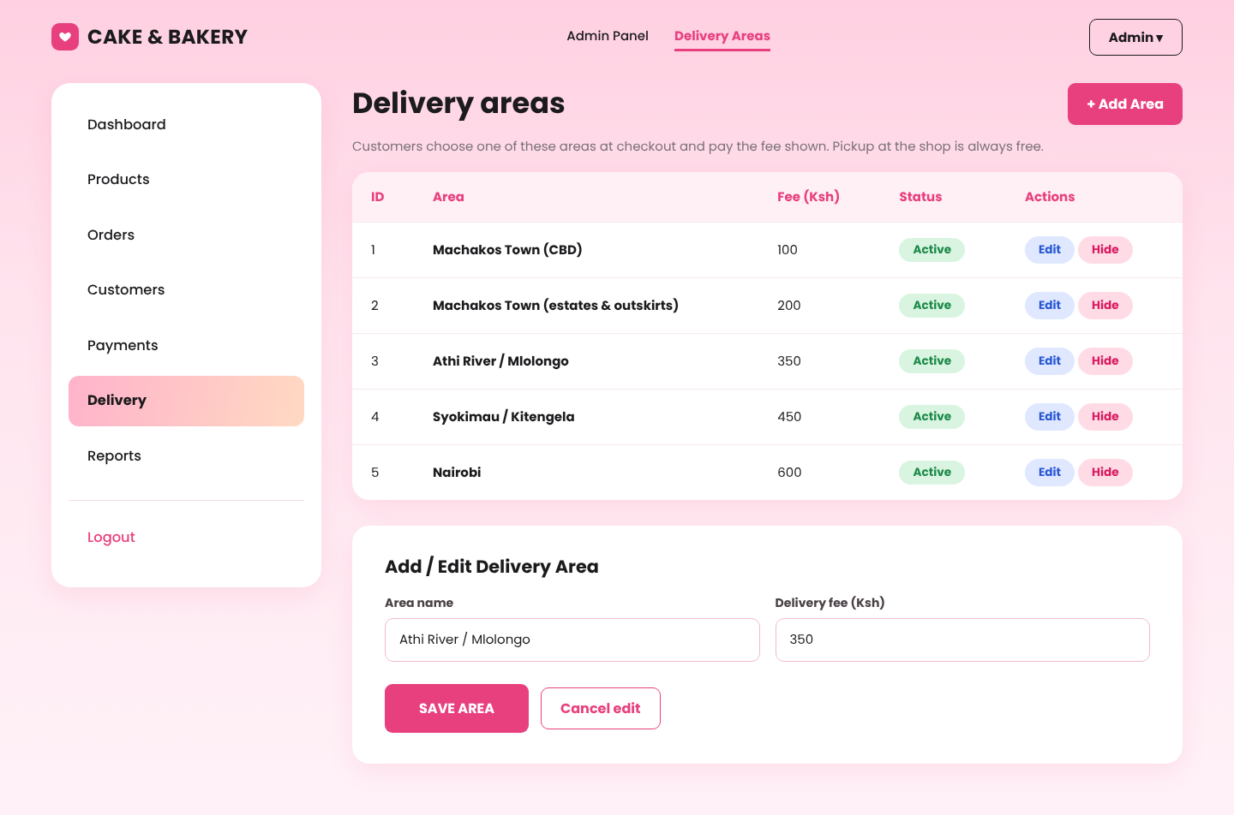
Figure 3.5a Delivery areas and fees (administrator)

3.6.3 Order management
The order management page (Figure 2.2.4) shows the number of new, in-oven, ready and delivered orders and a table of recent orders with coloured payment and status labels. The administrator selects an order and presses Update status or Send SMS. A status change sends an SMS to the customer, and cancelling an order returns its items to stock.
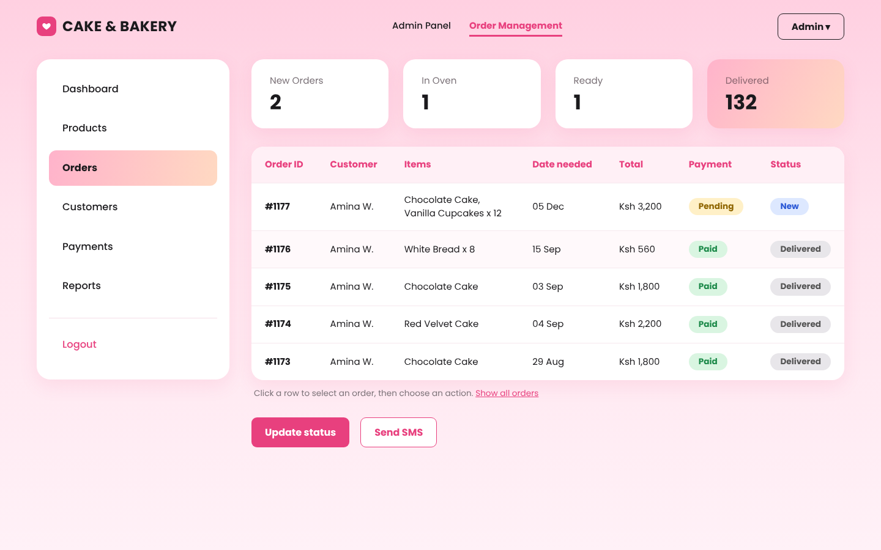
Figure 3.6 Order management (implementation of Figure 2.2.4)
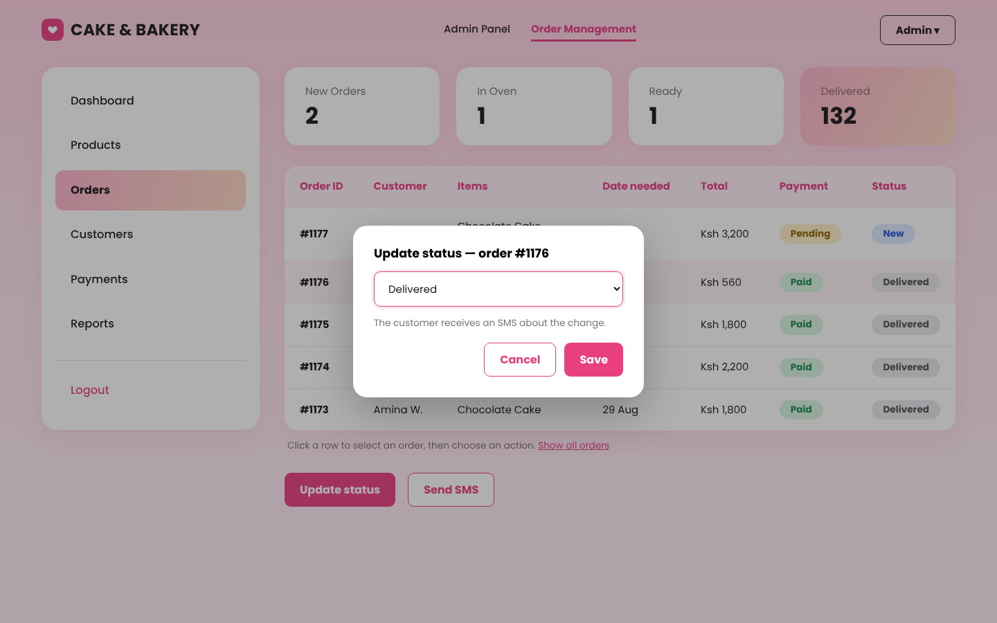
Figure 3.7 Updating an order status

3.6.4 Reports
The reports page (Figure 2.2.6) summarises total sales, number of orders, the best-selling product and the number of low-stock items for the last six months, six weeks or seven days, with a bar chart of sales per period. The Export PDF button prints the page to PDF from the browser. Cancelled orders are not counted.
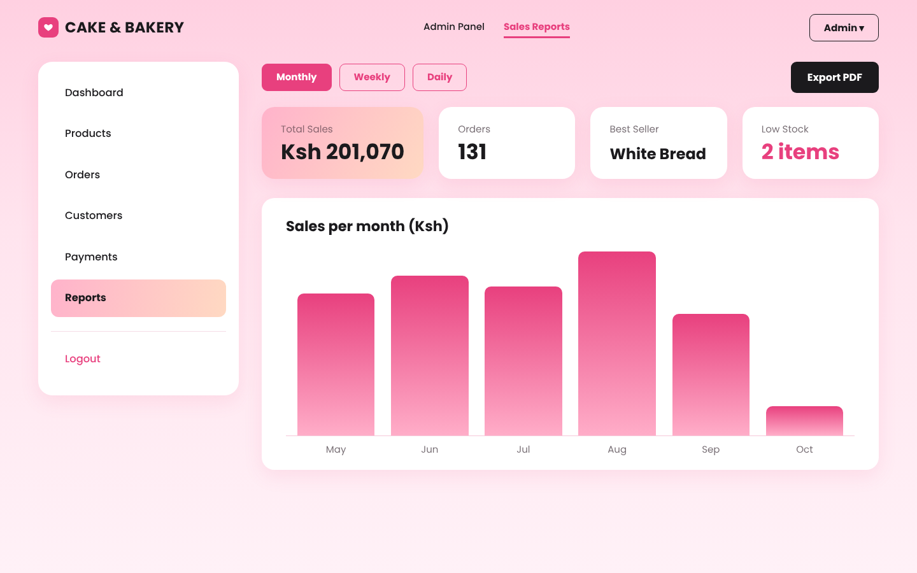
Figure 3.8 Sales reports (implementation of Figure 2.2.6)

3.6.5 Dashboard, customers and payments
The sidebar pages complete the administrator tools: the dashboard shows today's orders and sales and the low-stock list, the Customers page lists customers with their number of orders and total spending, and the Payments page lists every payment with its M-Pesa receipt and status.
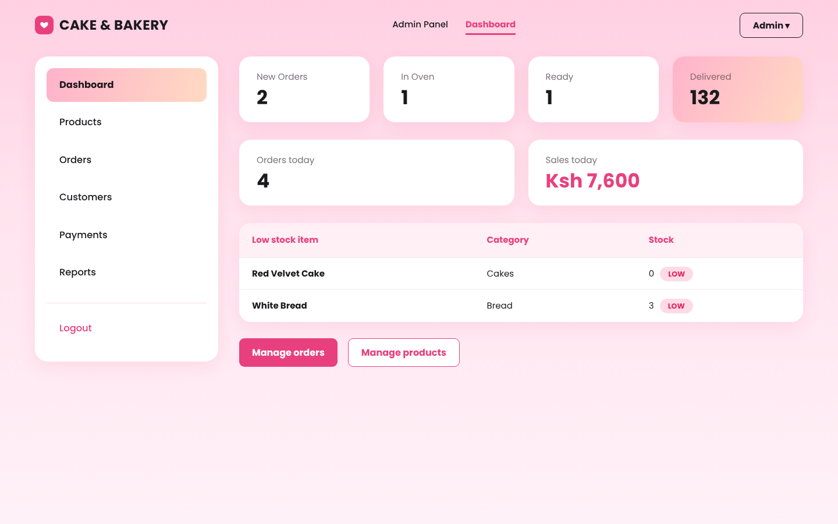
Figure 3.9 Administrator dashboard
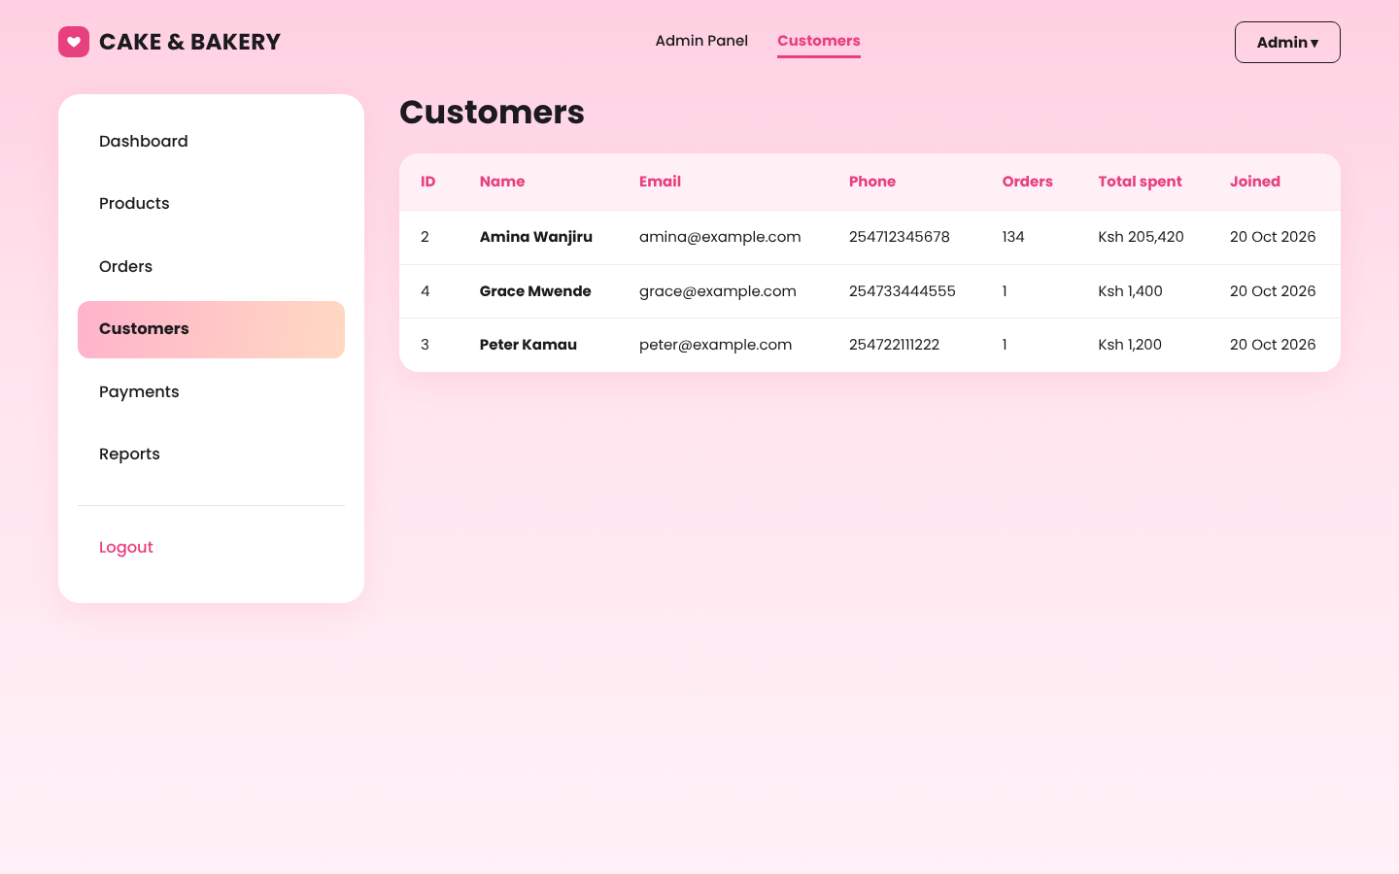
Figure 3.10 Customers page

3.7 Implementation of Objective (iii): M-Pesa Payment and SMS Notifications

3.7.1 M-Pesa STK push
When a customer chooses M-Pesa STK Push, the system saves the order and sends a payment request for the order total to the customer's phone number, and the customer is taken to the order page to complete the payment. The M-Pesa service works in three modes that are chosen in config.php:
Mode | What it does | Used for
simulate | No keys are needed. The order page shows a demo phone prompt with Enter PIN & Pay and Cancel buttons. Pay marks the payment as paid and saves a receipt number; Cancel marks it as failed. | Development, demonstrations and project presentation
sandbox | Uses the Safaricom Daraja sandbox: an access token is requested, an STK push is sent, and the result is read back from Safaricom with an STK query, so it works on a laptop without a public web address. | Proving the real integration
live | The same as sandbox but with the shop's approved Paybill or Till number and production keys. | After Safaricom go-live approval

In every mode the payment goes through the same states: pending, then paid (with an M-Pesa receipt number) or failed if the customer cancels. Safaricom can also call mpesa_callback.php with the result; this is safe to repeat because only a payment that is still pending can change, so a repeated message cannot create a second confirmation SMS. If the prompt cannot be sent (for example the keys are missing), the order is still saved and the customer sees the reason and a button to try again. The administrator can press Test M-Pesa connection on the Payments page to check the keys. All requests and responses are recorded in logs/mpesa.log.
The customer sees the exact amount and the shop name on the prompt (on the phone in live mode, in the demo box in demo mode), types the M-Pesa PIN and presses Send. The order page then changes to Paid by itself. At the same moment the administrator receives a payment alert: a green message on the dashboard such as "QWE123RTY Confirmed. Ksh 1,900 received from Amina Wanjiru (0712 345 678) for order #1200", plus an SMS to the administrator's phone when ADMIN_PHONE is set in config.php. If the customer cancels or the payment times out, a red alert is shown instead. The alerts are stored in the notifications table, and the dashboard refreshes every 20 seconds.
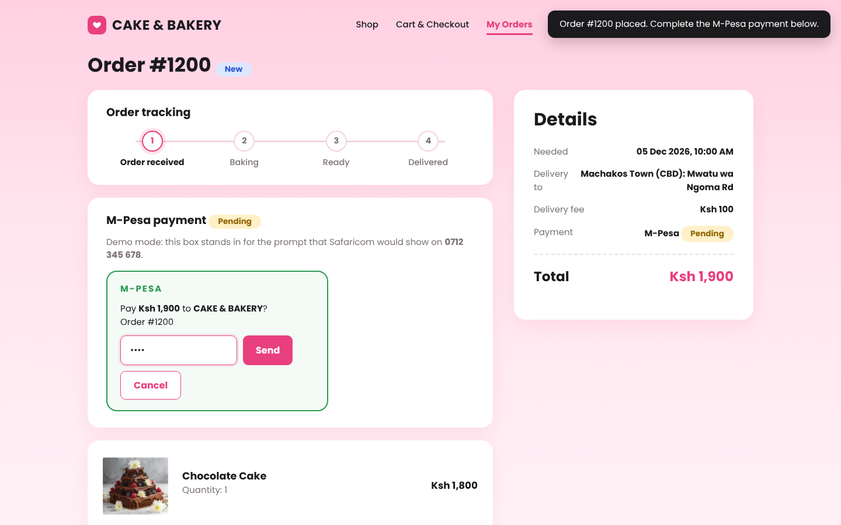
Figure 3.10a Customer enters the M-Pesa PIN (demo mode)
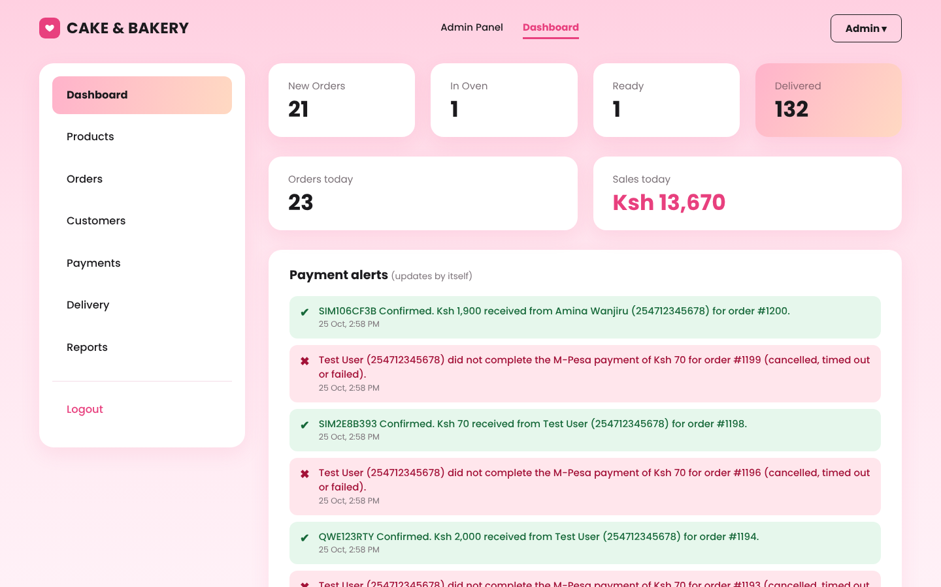
Figure 3.10b Payment alerts on the administrator dashboard
$n = db()->prepare("UPDATE payments SET status='paid', mpesa_receipt=?, paid_at=? WHERE checkout_request_id=? AND status='pending'");
$n->execute([$receipt, date('Y-m-d H:i:s'), $checkoutId]);
if ($n->rowCount()) {
$ph = db()->prepare('SELECT contact_phone FROM orders WHERE order_id=?'); $ph->execute([$orderId]);
Sms::send($orderId, $ph->fetchColumn(), "Cake & Bakery: payment received for order #$orderId.".($receipt ? " M-Pesa ref $receipt." : '')." Thank you!");
self::alertAdmin($orderId, 'paid', $receipt, $paidAmount, $payerPhone);
}

3.7.2 SMS notifications
An SMS is sent when an order is received, when payment is confirmed and when the administrator changes the order status, as well as when the administrator sends a custom message. Every message is saved in the notifications table with its delivery status. If the SMS gateway is unavailable the order is still saved, because sending happens after the order has been completed.

3.7.3 Order tracking
Customers can open My Orders to see all their orders and press Track to see a progress bar (Order received, Baking, Ready, Delivered or Collected), the items, the delivery details and the payment status. If an M-Pesa payment is still pending or has failed, a Pay with M-Pesa now button sends the payment prompt again.
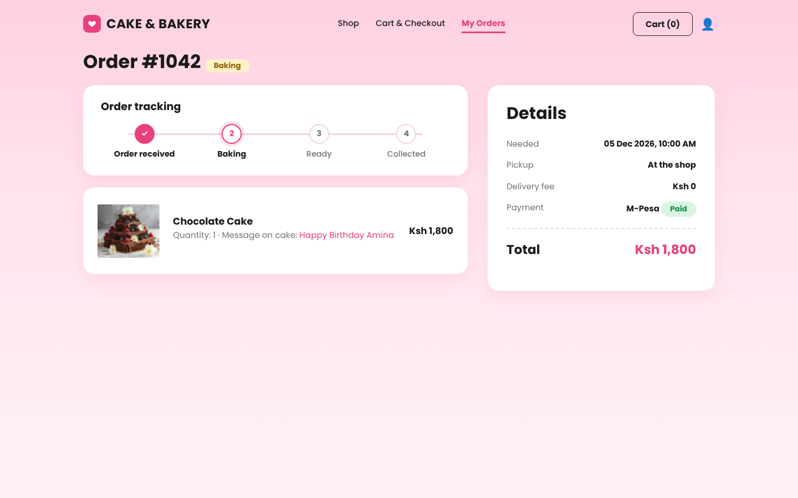
Figure 3.11 Order tracking page
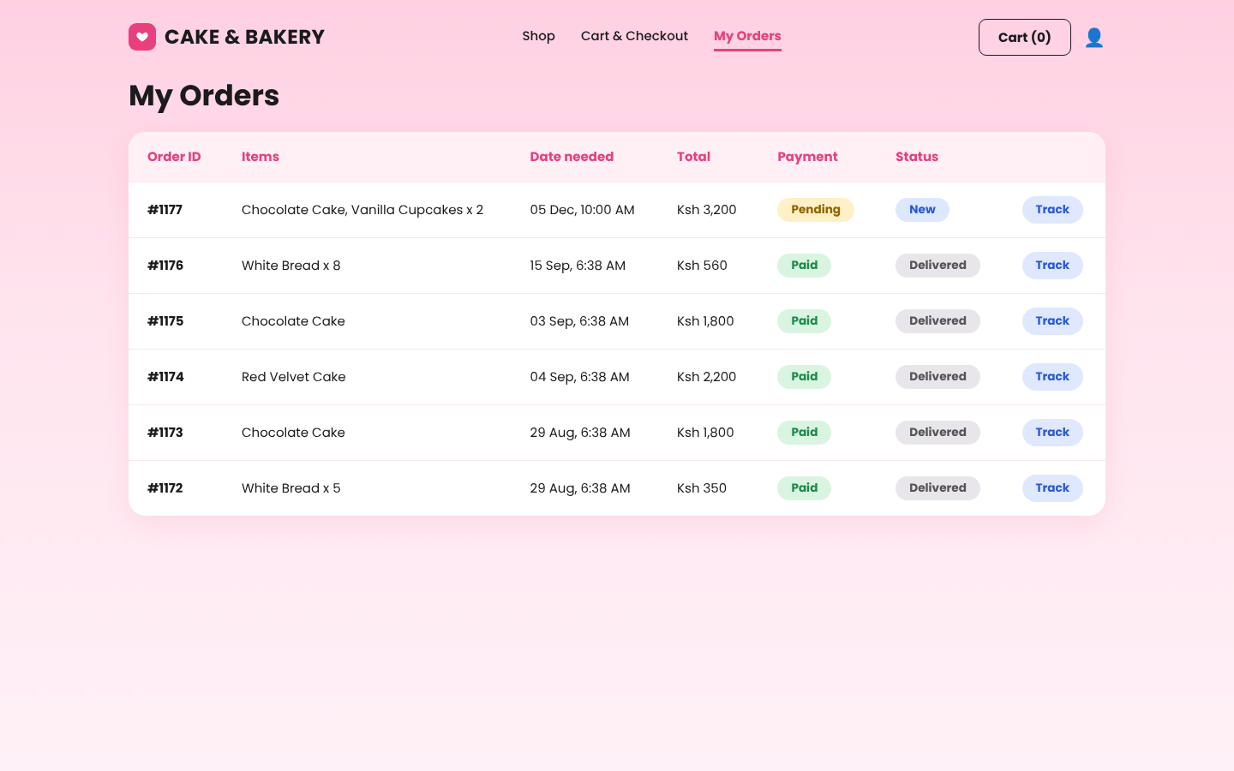
Figure 3.12 My Orders page

3.8 Security and Error Handling
Risk | Control implemented
Stolen or guessed passwords | Passwords stored as hashes; account locked for 15 minutes after three failed attempts; minimum password length of eight characters
SQL injection | Every database query uses PDO prepared statements
Cross-site scripting (XSS) | All data shown on a page is escaped with the e() function
Forged form submissions (CSRF) | A secret token is checked on every form that changes data
Session theft | Session cookie is HttpOnly and SameSite; a new session id is created at login
Unauthorised access | Admin pages check the user role and return a Forbidden error to customers; customers can only open their own orders
Unsafe file uploads | Only JPG, PNG and WEBP images under 2 MB are accepted and they are saved under a random name
Price tampering / overselling | Prices are read from the database; stock is checked and locked inside a transaction
Technical errors shown to users | Errors are written to a log file and the visitor sees a friendly page; secret keys are kept in config.php
Data loss | tools/backup.sh and backup.bat create a dated mysqldump backup of the database

3.9 Traceability of Requirements
The table below shows where each requirement from Chapter One was implemented.
Requirement (Table 1.5.1 / 1.5.2) | Implemented in
User registration and login | register.php, login.php, includes/auth.php
Product catalogue display, search and filter | index.php
Shopping cart and order placement | cart.php, services/OrderService.php
Store product, order and customer data | sql/schema.sql and the seven tables
Update products, stock and order status | admin/products.php, admin/orders.php
Retrieve and manage records | admin/customers.php, admin/payments.php, my_orders.php
Generate sales reports | admin/reports.php
M-Pesa payment | services/Mpesa.php, services/PaymentService.php, track.php, mpesa_callback.php
Delivery fee by customer location | delivery_zones table, admin/delivery.php, cart.php, services/OrderService.php
Order confirmation and status SMS | services/Sms.php, OrderService::updateStatus
Order tracking | track.php, my_orders.php
Ease of use and mobile-friendly design | assets/css/style.css (responsive layout for phones and tablets)
Fast page loading | Light pages with one stylesheet and one small script; indexed queries
Database security and password encryption | Prepared statements, hashed passwords, role checks (Section 3.8)
Data backups | tools/backup.sh, tools/backup.bat
Payment security (HTTPS) | Daraja traffic uses HTTPS; the site must be served over HTTPS when hosted online (Section 5.6)
Notification delivery speed | SMS is sent immediately after each event; failures are recorded without blocking the order

3.10 Installation
1. Copy the project folder to C:\xampp\htdocs\cakebakery.
2. Start Apache and MySQL in the XAMPP Control Panel.
3. Open http://localhost/cakebakery/install.php, enter the administrator name, email and password and press Install. The installer creates the database, the tables and the sample products. It locks itself once an administrator exists.
4. Delete install.php and open http://localhost/cakebakery/ to use the system.

3.11 Chapter Summary
This chapter showed how the three specific objectives were implemented: an online catalogue and ordering system, a secure database with administrator tools, and M-Pesa payment with SMS notifications. The screens match the user interface models of Chapter Two, and each requirement of Chapter One was traced to the part of the system that satisfies it. The next chapter presents the testing carried out on the system.

CHAPTER FOUR: SYSTEM TESTING

4.1 Introduction
This chapter presents the testing carried out on the Online Cake and Bakery Shop Management System. Testing was done at two levels: (i) an automated test script (tests/run_tests.php) that exercises the business rules of registration, login, ordering, M-Pesa payment callbacks and order management directly against the database, and (ii) manual user-interface tests carried out in the browser against the screens designed in Chapter Two. Each test case lists the steps, the expected result, the actual result and the status.

4.2 Test Environment
Item | Details
Server | Apache + PHP 8.x (XAMPP/WAMP) on a laptop
Database | MySQL / MariaDB
Browsers | Google Chrome (desktop) and Chrome on an Android phone
Payments / SMS | Safaricom Daraja sandbox, Africa's Talking sandbox
Test data | Demo data from seed_demo.php; test records created by tests/run_tests.php

4.3 Automated Test Cases
Run with: php tests/run_tests.php (all 46 cases passed when the script was executed). Re-run it on your own MySQL database before submission and record the date: ____ / ____ / 2026.
ID | Test case | Expected result | Actual result | Status
T01 | Register with valid details | Account created | As expected | Pass
T02 | Password storage | Stored as a bcrypt hash, never plain text | As expected | Pass
T03 | Register with an existing email | "Email already registered" error | As expected | Pass
T04 | Register with a short password (<8) | Rejected with message | As expected | Pass
T05 | Register with an invalid phone number | Rejected with message | As expected | Pass
T06 | Register with an invalid email | Rejected with message | As expected | Pass
T07 | Login using SQL injection text (' OR '1'='1) | Login refused (prepared statements) | As expected | Pass
T08 | Login with a wrong password | Generic "Invalid email or password" | As expected | Pass
T09 | Three wrong passwords in a row | Account locked for 15 minutes | As expected | Pass
T10 | Correct password while locked | Still refused | As expected | Pass
T11 | Correct login | Session created with the user's role | As expected | Pass
T12 | Place an order with an empty cart | Rejected | As expected | Pass
T13 | Checkout with an invalid phone number | Rejected | As expected | Pass
T14 | Checkout with no date | Rejected | As expected | Pass
T15 | Date needed in the past | Rejected | As expected | Pass
T16 | Cake ordered with less than 24 hours notice | Rejected | As expected | Pass
T17 | Time outside 7:00 AM - 7:00 PM | Rejected | As expected | Pass
T18 | Quantity above available stock | Rejected; stock unchanged | As expected | Pass
T19 | Valid cake order (pay on pickup) | Order created | As expected | Pass
T20 | Stock after the order | Reduced by the quantity ordered | As expected | Pass
T21 | Order total for pickup | Price x quantity, no delivery fee | As expected | Pass
T22 | Message on the cake | Saved with the order item | As expected | Pass
T23 | Payment record | Created with status "pending" | As expected | Pass
T24 | Confirmation SMS | Logged in notifications table | As expected | Pass
T25 | Order with a delivery location | the fee of the chosen area delivery fee added | As expected | Pass
T26 | HTML/script typed into text fields | Output is escaped (XSS prevented) | As expected | Pass
T27 | Successful M-Pesa callback | Payment "paid" with receipt number saved | As expected | Pass
T28 | Same callback received twice | Ignored; no duplicate SMS | As expected | Pass
T29 | Failed / cancelled STK push | Payment set to "failed" | As expected | Pass
T30 | Callback for an unknown request | Ignored safely | As expected | Pass
T31 | Admin sets an invalid status | Rejected | As expected | Pass
T32 | Admin changes status to Baking | Saved and SMS sent to customer | As expected | Pass
T33 | Admin cancels an order | Stock restored | As expected | Pass
T34 | Re-opening a cancelled order | Rejected | As expected | Pass
T35 | Cancelling the same order twice | Stock not restored twice | As expected | Pass
T36 | Order to a farther area (Nairobi) | Delivery fee Ksh 600 is charged | As expected | Pass
T37 | Choose a delivery area but leave the location empty | Rejected with message | As expected | Pass
T38 | Type a location but choose no delivery area | Rejected with message | As expected | Pass
T39 | Send an unknown / tampered area id | Rejected; fee cannot be changed from the browser | As expected | Pass
T40 | Pickup order (no area chosen) | No delivery fee | As expected | Pass
T41 | M-Pesa order in demo mode | Payment "pending" with a checkout id | As expected | Pass
T42 | Approve the demo M-Pesa prompt | Payment "paid" with a receipt number | As expected | Pass
T43 | Cancel the demo M-Pesa prompt | Payment "failed" | As expected | Pass
T44 | Sandbox mode without keys | Clear message that the keys are missing | As expected | Pass
T45 | Customer pays by M-Pesa (PIN entered) | Admin dashboard shows a PAYMENT ALERT with receipt, amount and customer | As expected | Pass
T46 | Same confirmation arrives twice | Only one alert and one SMS are created | As expected | Pass

4.4 Manual User-Interface Test Cases
Carry out each test in the browser, then complete the Actual result and Status columns and attach a screenshot (Figure 4.x) for each.
ID | Test case | Expected result | Actual result | Status
M01 | Open the login page | Layout matches Figure 2.2.1 (heading, cake photo, login card)
M02 | Login as a customer | Redirected to the catalogue; header shows Cart and user icon
M03 | Login as admin | Redirected to the admin dashboard
M04 | Customer opens /admin/orders.php | "Admins only" (403) page
M05 | Catalogue loads | Banner, filter chips and product cards match Figure 2.2.2
M06 | Search for "choc" | Only chocolate products shown
M07 | Click the Cupcakes chip and "Wedding cakes" | List filters correctly
M08 | Open an out-of-stock product | "Out of stock" tag and disabled Unavailable button
M09 | Add two products to the cart | Cart (2) shown in header
M10 | Change quantity with + and -; remove an item | Totals update; item disappears when removed
M11 | Type a message on the cake | Message saved and shown after reload
M12 | Choose a delivery area and type a location at checkout | Delivery changes from Ksh 0 to the fee of that area (e.g. Ksh 350 for Athi River / Mlolongo) and the total updates
M13 | Choose M-Pesa STK Push and place the order | You are taken to the order page; the M-Pesa prompt is approved (demo box, or sandbox/phone) and the payment shows Paid
M14 | Enter the M-Pesa PIN | Payment shows Paid; payment SMS received
M15 | Choose Pay on pickup | Order placed with payment Pending
M16 | Admin: select an order row, click Update status | Dialog opens; status and badge colour change; SMS sent
M17 | Admin: click Send SMS | Custom message sent and logged
M18 | Admin: add a product with an image | Appears in the table and in the shop
M19 | Admin: upload a .php or oversized file as product image | Rejected with an error
M20 | Admin: edit price/stock; stock below limit | Product shows the LOW badge
M21 | Admin: delete a product | Hidden from shop; old orders still show it
M22 | Reports: Monthly, Weekly, Daily | Cards and chart change; totals match the orders
M23 | Reports: Export PDF | Browser print dialog opens; PDF saves without the menus
M24 | Open the site on a phone (360 px wide) | No sideways scrolling; buttons usable
M25 | Open a wrong URL | Friendly "Page not found" page

4.5 Security Checks
Check | Result
SQL injection (login and search boxes) | Prevented: all queries use PDO prepared statements
Cross-site scripting (cake message, names) | Prevented: all output escaped with htmlspecialchars
Cross-site request forgery | Every form carries a CSRF token that is verified on submit
Password protection | password_hash() / password_verify(); lock after 3 failed attempts
Access control | Admin pages check the role on every request
Session security | HttpOnly and SameSite cookies; session ID renewed on login
Folder protection | .htaccess blocks config, sql, services, logs and tests folders; PHP cannot run in the uploads folder
Errors | Visitors see a friendly message; details go to logs/php_errors.log
Transport (HTTPS) | Required on the live server; M-Pesa production callbacks must use HTTPS

4.6 Defects Found and Fixed
No. | Defect | Fix
1 | Checkout accepted an empty date (treated as today) - found by test T14 | Date and time now validated against strict formats before use
2 | Customer phone numbers appeared as 2547... in the form | Displayed in the 07xx format and normalised on save

4.7 Chapter Summary
The automated and manual tests show that the system meets the three specific objectives: customers can browse and order cakes, cupcakes and bread; data is stored securely in the database; and M-Pesa payments and SMS notifications work as designed. Defects discovered during testing were corrected and the tests repeated.

CHAPTER FIVE: CONCLUSIONS AND RECOMMENDATIONS

5.1 Introduction
This chapter summarises the work done, shows how the objectives were achieved, and gives the limitations, recommendations and possible future improvements of the Online Cake and Bakery Shop Management System.

5.2 Summary of the Work
The project began by analysing how the Cake and Bakery Shop handled orders manually through phone calls, text messages and walk-ins, and the wrong orders, unconfirmed payments and unknown stock levels that resulted. A system was then designed with user interface models, flowcharts, data flow diagrams, an entity relationship diagram, a use case diagram and a class diagram. The design was implemented as a website built with PHP, MySQL, HTML, CSS and JavaScript, and it was tested with 46 automated test cases and manual tests of every screen.

5.3 Achievement of the Objectives
Specific objective | How it was achieved | Evidence
i. To develop an online catalogue and ordering system for cakes, cupcakes and bread | Registration and login, catalogue with search and filters, cart with cake messages, and checkout with pickup or delivery | Sections 3.5.1 to 3.5.3; Figures 3.1 to 3.4
ii. To develop a secure database for storing and managing product, order and customer records | Seven related tables with integrity rules; transactional order placement; administrator pages for products, orders, customers, payments and reports; hashed passwords and protection against common attacks | Sections 3.4, 3.6 and 3.8; Figures 3.5 to 3.10
iii. To integrate M-Pesa payment and SMS notifications for timely order communication | M-Pesa STK push with a payment callback, SMS on every order event, and an order tracking page with payment retry | Section 3.7; Figures 3.11 and 3.12

The general objective, to develop an online Cake and Bakery Shop website for selling cakes, cupcakes and bread, was therefore achieved.

5.4 Challenges Encountered
• Matching the designs. The screens had to look like the models drawn in Chapter Two. This was solved by building a shared stylesheet and layout from the designs and comparing each finished page with its model.
• Selling the same item twice. Two customers could order the last cake at the same moment. This was solved by locking the product rows and saving the order inside one database transaction.
• Testing M-Pesa on a local computer. Safaricom cannot reach a laptop directly, so a public tunnel (ngrok) is needed to receive the payment callback during testing.
• Duplicate payment messages. Safaricom may send the same callback more than once; the system only accepts a result for a payment that is still pending.
• Setting up the database. Users could meet an unknown-database error on a new computer. A one-time installer was added to create the database and administrator account automatically.

5.5 Limitations
• Real M-Pesa payments need the shop's approved Paybill or Till number and Safaricom go-live approval; until then the system was tested with the demo mode and the Safaricom sandbox, and SMS with the Africa's Talking sandbox.
• Delivery fees are fixed per area; they are not calculated from the exact distance to the customer's door.
• Password reset requires contacting the shop; there is no automatic email reset.
• The system supports one shop and one administrator role.
• Reports are summaries; there is no forecasting of how much to bake.

5.6 Recommendations
1. Host the system on a server with an HTTPS certificate before using real M-Pesa payments, because payment data must be protected in transit.
2. Apply for the Daraja production credentials and a registered SMS sender name before going live.
3. Run the backup script daily and keep a copy away from the shop computer.
4. Change the default database password and the administrator password, and delete install.php and seed_demo.php from the live server.
5. Train the shop staff to update stock and order status every day so that customers always see accurate information.
6. Run the automated tests (php tests/run_tests.php) after every change to the system.

5.7 Future Work
• A mobile application for customers and push notifications for order updates.
• Exact distance-based delivery fees using maps, and rider assignment.
• Email receipts and automatic password reset by email or SMS code.
• Customer reviews, loyalty points and discount codes for the Offers section.
• Ingredient-level stock and a baking plan based on past sales.
• Support for several shop branches and staff accounts with different permissions.

5.8 Conclusion
The Online Cake and Bakery Shop Management System replaces scattered phone calls and messages with one organised website. Customers can see products, order with a cake message and pay with M-Pesa, while the owner has accurate stock, orders, payments and sales reports in one secure place. With the recommendations above, the system is ready to be piloted at the shop and improved with real customer feedback.

REFERENCES
Safaricom PLC. Daraja API documentation (M-Pesa Express / STK Push). https://developer.safaricom.co.ke
Africa's Talking. SMS API documentation. https://developers.africastalking.com
The PHP Group. PHP Manual (PDO, password_hash, sessions). https://www.php.net/manual/en/
Oracle Corporation. MySQL Reference Manual. https://dev.mysql.com/doc/
OWASP Foundation. OWASP Top Ten Web Application Security Risks. https://owasp.org/www-project-top-ten/

