CAKE & BAKERY
Online Cake and Bakery Shop Management System
USER MANUAL
For customers and the shop administrator
Linet Njoki Kang’ethu | DSE-01-0549/2025
Zetech University, Diploma in Software Engineering, December 2026

PART A: CUSTOMER GUIDE

A1. Create an account
1. Open the shop website and click Register (top right).
2. Enter your full name, email, phone number (for example 0712 345 678) and a password of at least 8 characters.
3. Click Register. You will see a confirmation, then go to the login page.
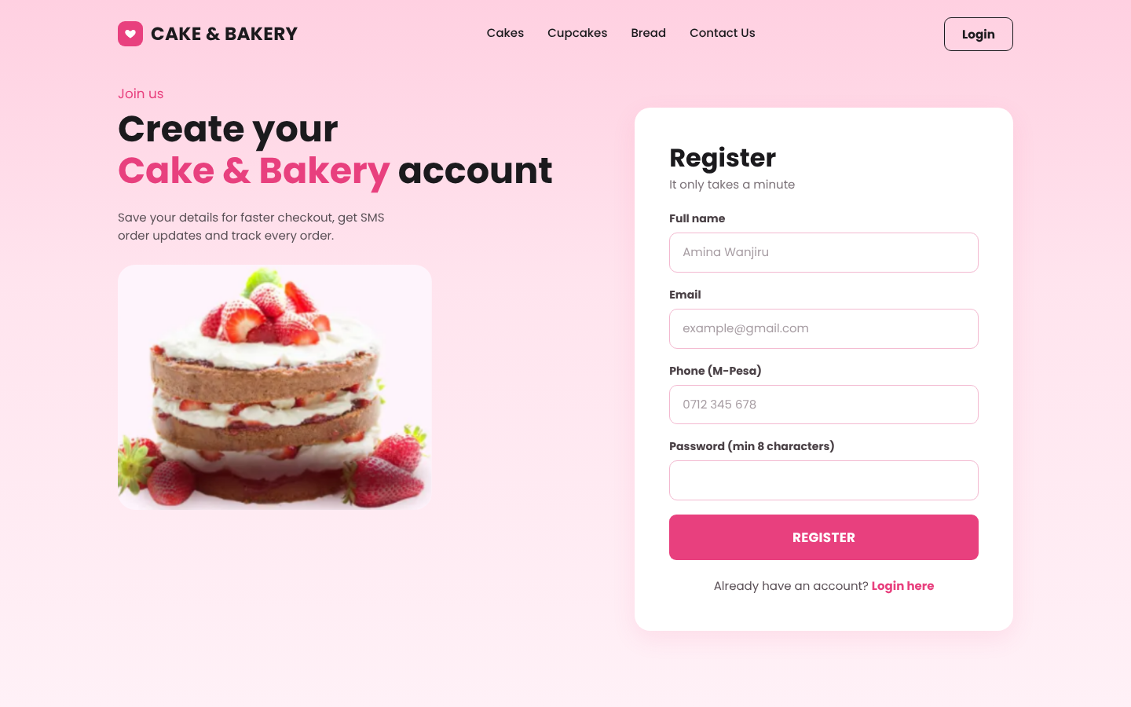
Registration page

A2. Log in
Enter your email and password and click LOGIN. Tick Remember me to stay signed in on your own device. After three wrong passwords the account is locked for 15 minutes. If you forget your password, call the shop and the administrator will help you.
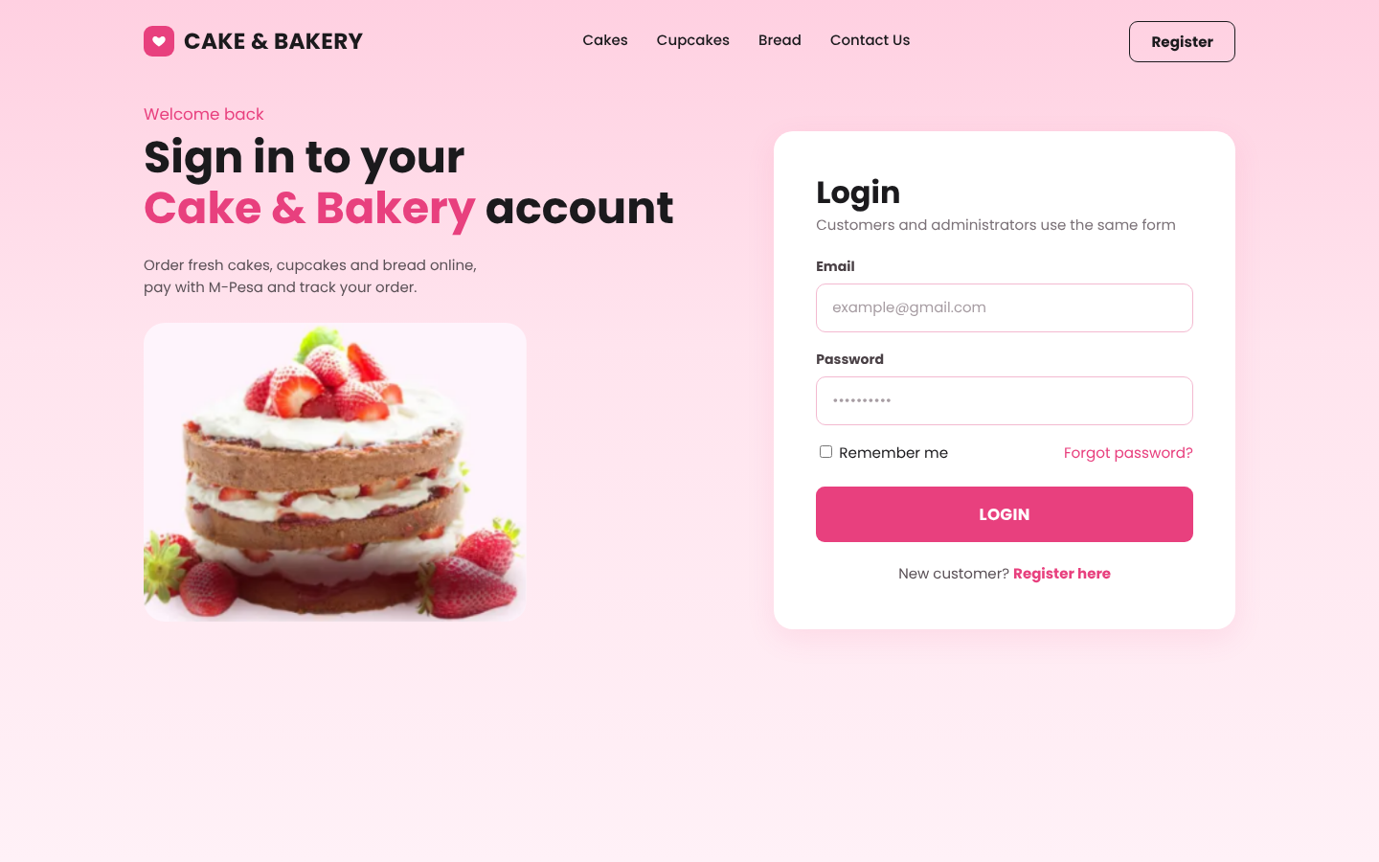
Login page

A3. Find products
• Use the search box at the top to type a name such as "chocolate".
• Click Cakes, Cupcakes, Bread or Offers to filter.
• Use Best sellers, New arrivals, Wedding cakes or Birthday cakes for quick views.
• Items marked Out of stock cannot be ordered.
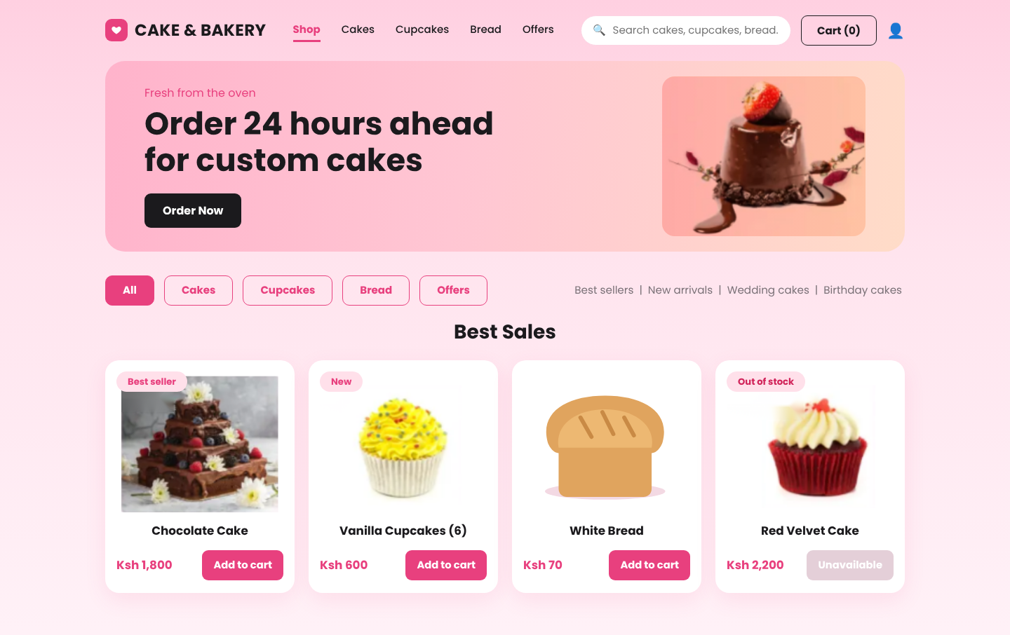
The shop

A4. Add to cart and check out
1. Click Add to cart on each product you want. The number on the Cart button shows how many items you have.
2. Open the cart. Use + and - to change quantities. For cakes, type the message to be written on the cake (for example "Happy Birthday Amina").
3. Choose the date and time you need the order. Cakes need at least 24 hours notice. We are open 7:00 AM to 7:00 PM.
4. Confirm your name and phone number. Choose your Delivery area from the list: the delivery fee depends on the area and is added to the total straight away. Then type your street, estate or landmark in Location. Choose Pickup at the shop to pay no delivery fee.
5. Add special instructions if needed, for example "no nuts".
6. Choose M-Pesa STK Push or Pay on pickup, then click PLACE ORDER.
7. If you chose M-Pesa you are taken to your order page. Enter your M-Pesa PIN when the prompt appears on your phone and the order changes to Paid; you also get an SMS. (In demo mode a green phone box appears on the page: click Enter PIN & Pay.)
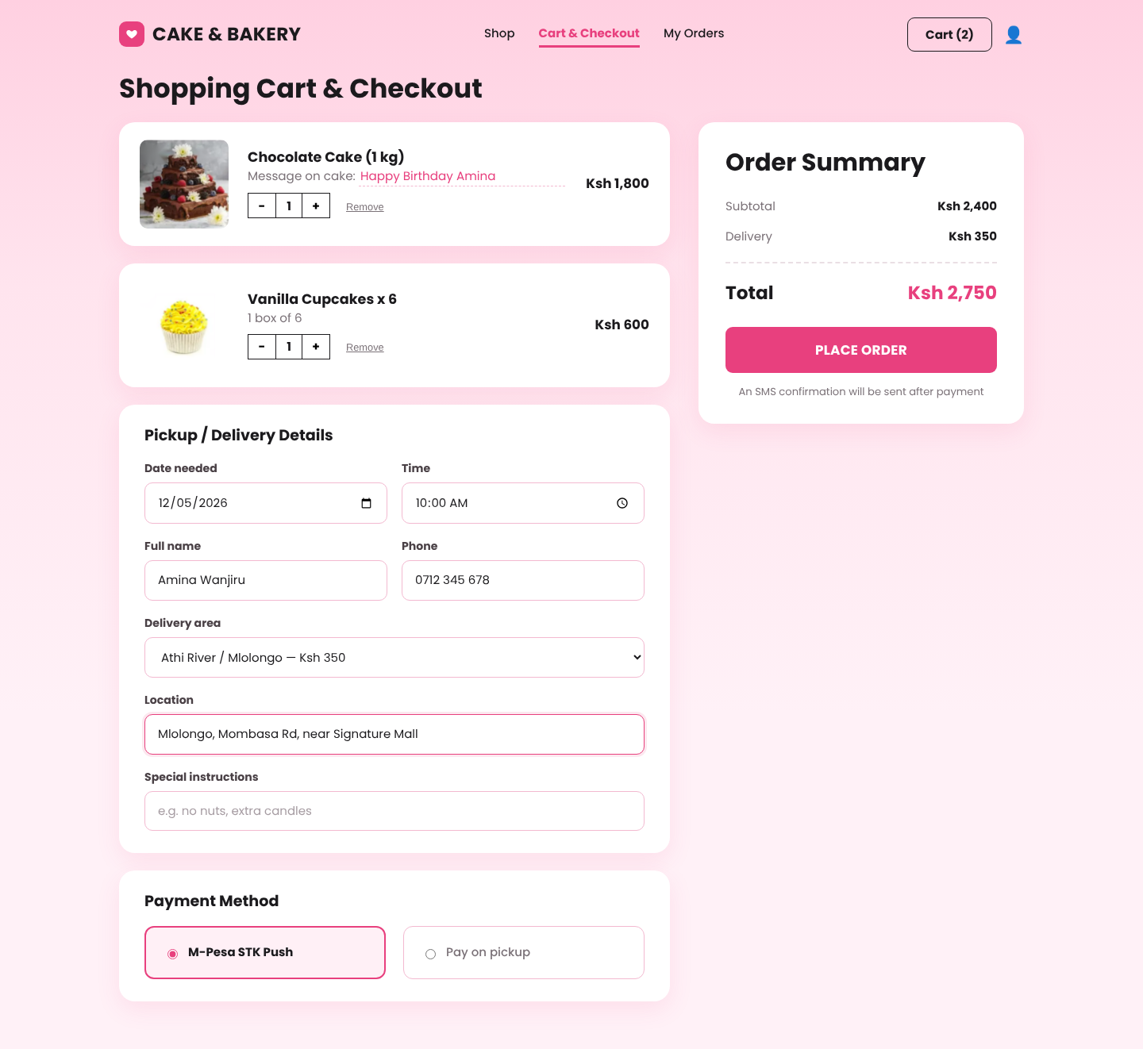
Cart and checkout with the delivery area
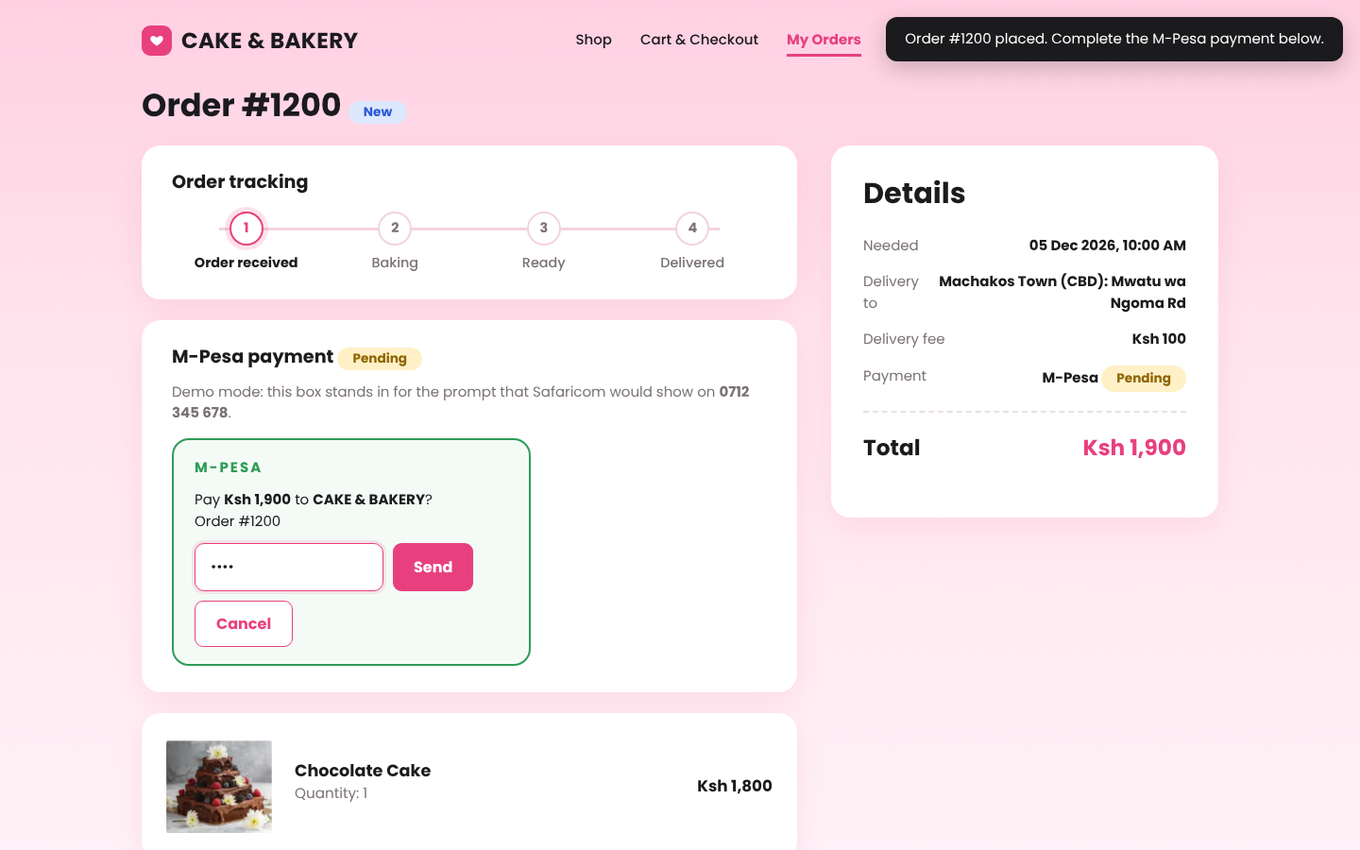
Paying with M-Pesa: the prompt shows the amount, then you enter your PIN (demo mode)

A5. Track your order
Click My Orders to see all your orders, then Track to open one. The progress bar shows Order received, Baking, Ready and Delivered (or Collected). You also receive an SMS whenever the status changes. If your M-Pesa payment shows Pending or Failed, click Pay with M-Pesa now to receive the prompt again.
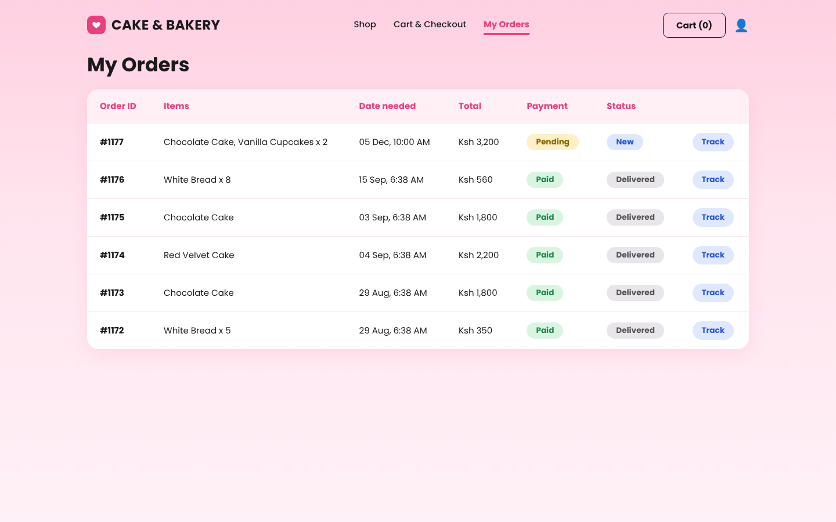
My Orders
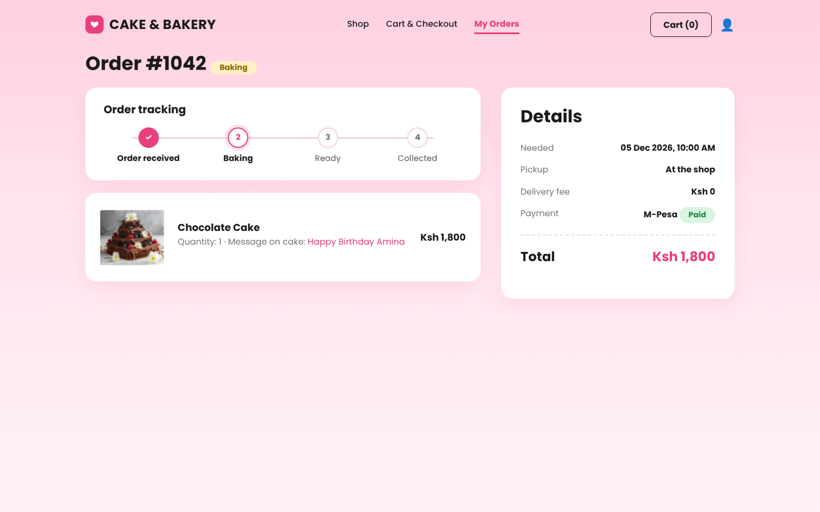
Order tracking

PART B: ADMINISTRATOR GUIDE

B1. Log in
Use the administrator email and password created during installation on the same login page. You are taken to the Admin dashboard. Use the left menu to move between Dashboard, Products, Orders, Customers, Payments and Reports. Logout is at the bottom of the menu.
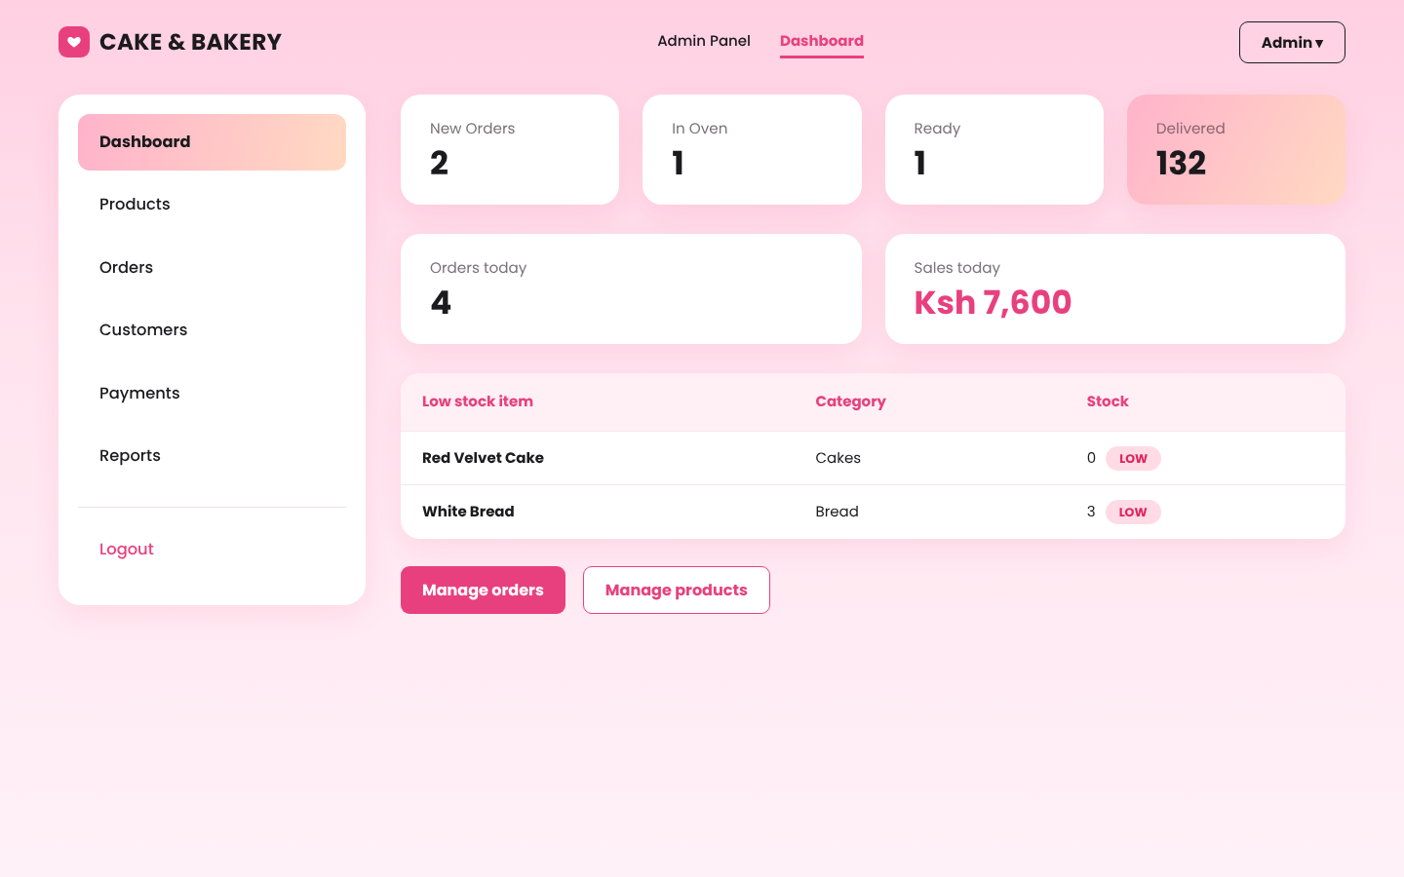
Admin dashboard
Payment alerts: when a customer enters their M-Pesa PIN, a green message appears at the top of the dashboard, for example "QWE123RTY Confirmed. Ksh 1,900 received from Amina Wanjiru for order #1200". A red message means the customer cancelled or did not complete the payment. The page refreshes itself every 20 seconds. Set ADMIN_PHONE in config.php to also receive these alerts by SMS.
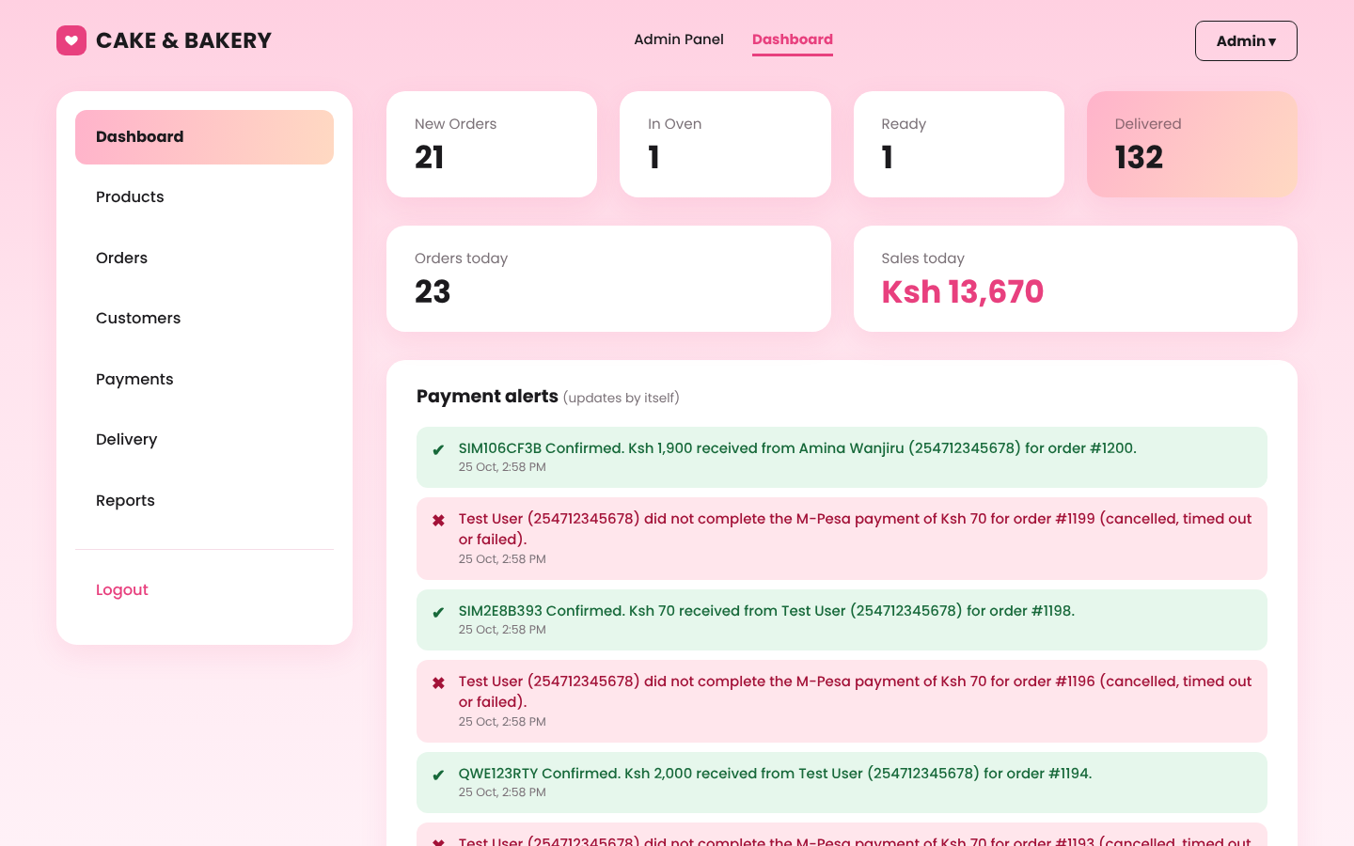
Payment alerts on the dashboard

B2. Manage products
1. Open Products. The table shows every product with its price and stock. A red LOW label means stock is at or below the warning level.
2. To add a product click + Add Product and fill in the form below the table: name, category, price, stock, description and an image (JPG, PNG or WEBP under 2 MB). Click SAVE PRODUCT.
3. To change a product click Edit, change the fields and save. Use this to update stock when you bake more.
4. Click Delete to remove a product from the shop. Old orders that contain it are not affected.
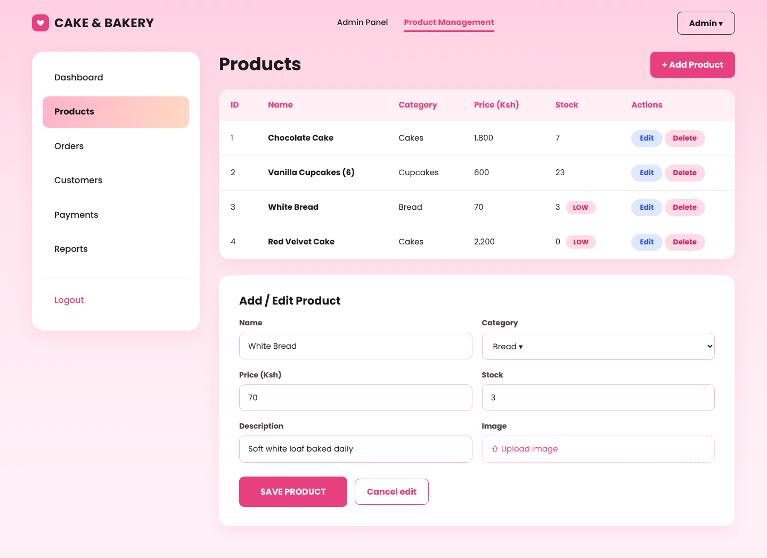
Product management

B3. Manage orders
1. Open Orders. The cards show how many orders are New, In Oven, Ready and Delivered.
2. Click a row to select an order.
3. Click Update status and choose the new status (New, Baking, Ready, Delivered or Cancelled). The customer receives an SMS. Cancelling an order returns its items to stock.
4. Click Send SMS to write a custom message to the customer of the selected order.
5. Check the Payment column: Paid orders are safe to bake and deliver; Pending means the customer has not paid yet.
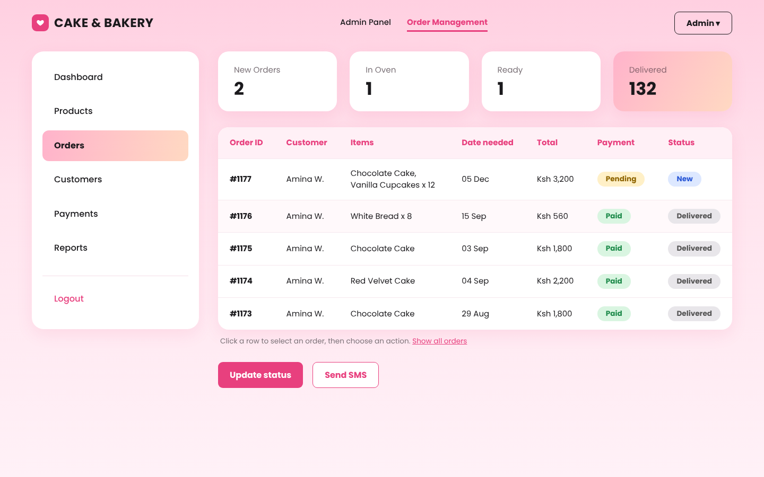
Order management
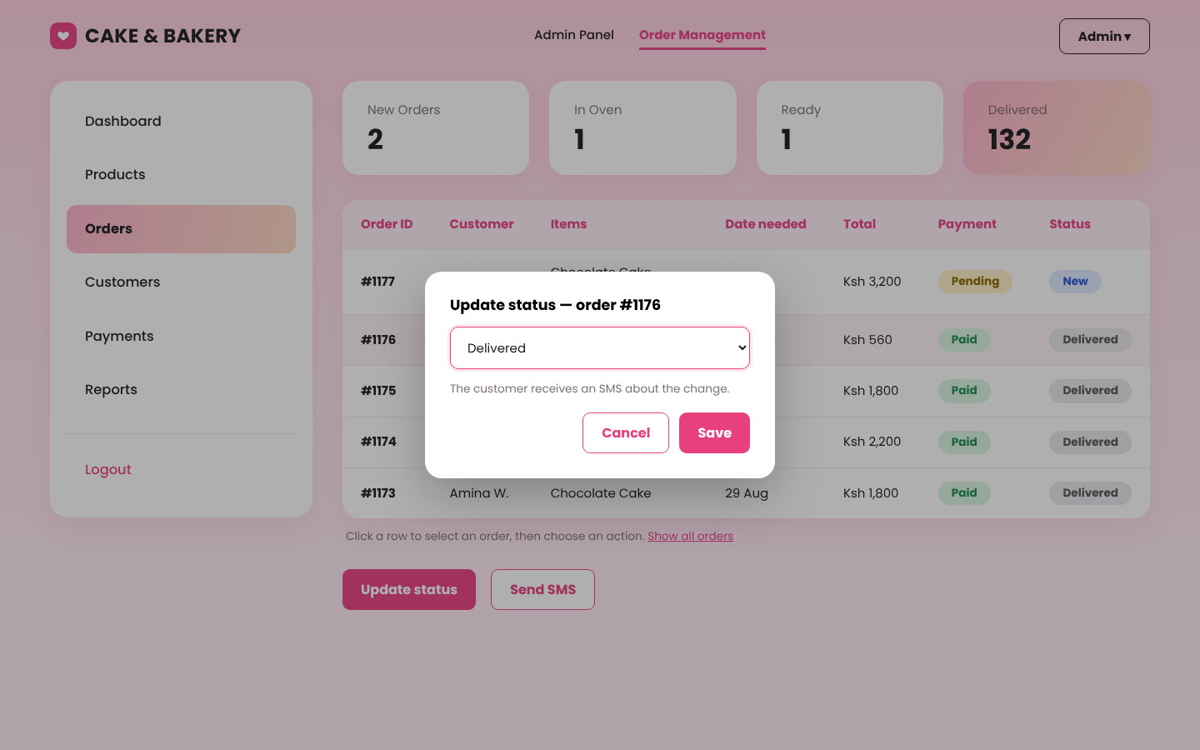
Updating a status

B3a. Delivery areas and fees
1. Open Delivery in the left menu.
2. To add an area, type its name and fee at the bottom and click SAVE AREA. To change a fee click Edit.
3. Click Hide to stop offering an area (customers no longer see it); click Show to bring it back.
4. New fees apply to new orders immediately; orders already placed keep the fee they were charged.
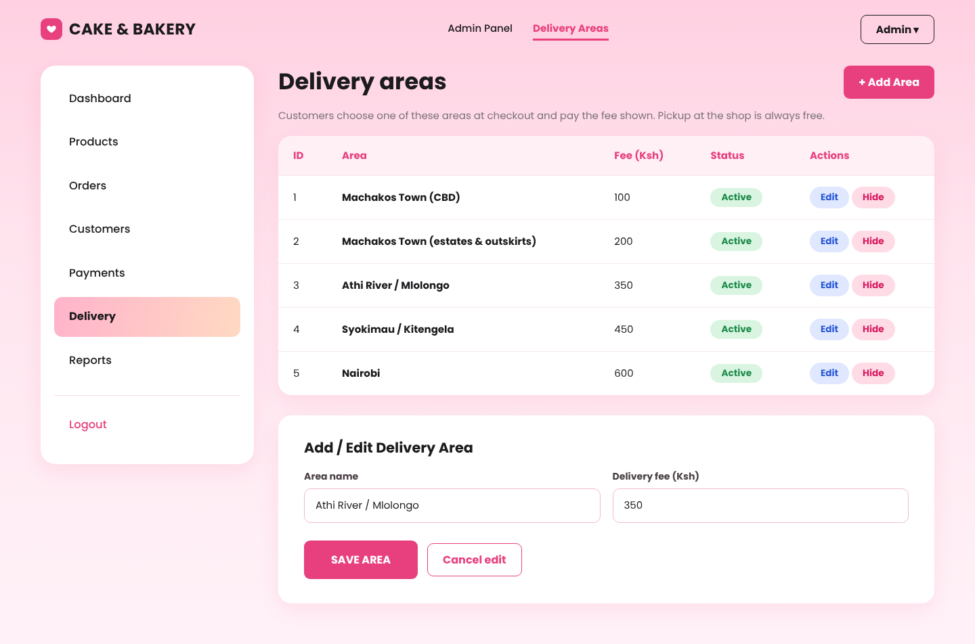
Delivery areas

B4. Customers and payments
Customers lists every registered customer with their phone, number of orders and total spending. Payments lists each payment with its method, M-Pesa receipt number and status, and the totals received and still awaited.
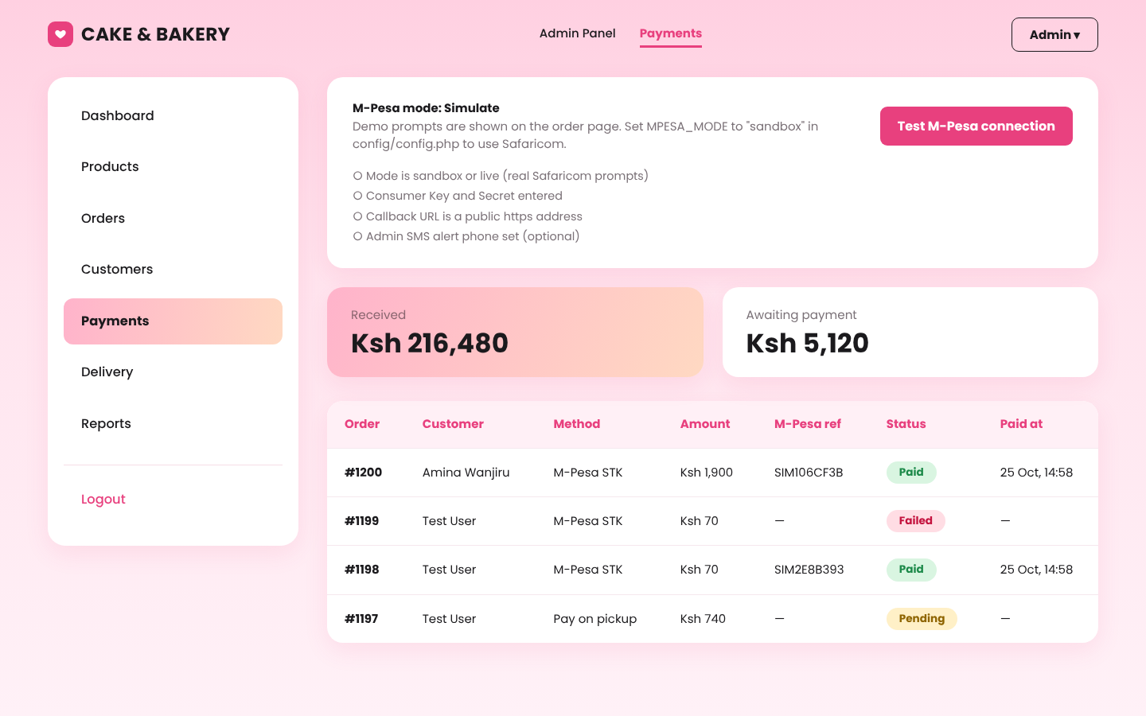
Payments

B5. Sales reports
Open Reports and choose Monthly, Weekly or Daily. The cards show total sales, number of orders, the best-selling product and the number of low-stock items. The chart shows sales for each period. Click Export PDF and choose "Save as PDF" in the print window to keep or print the report.
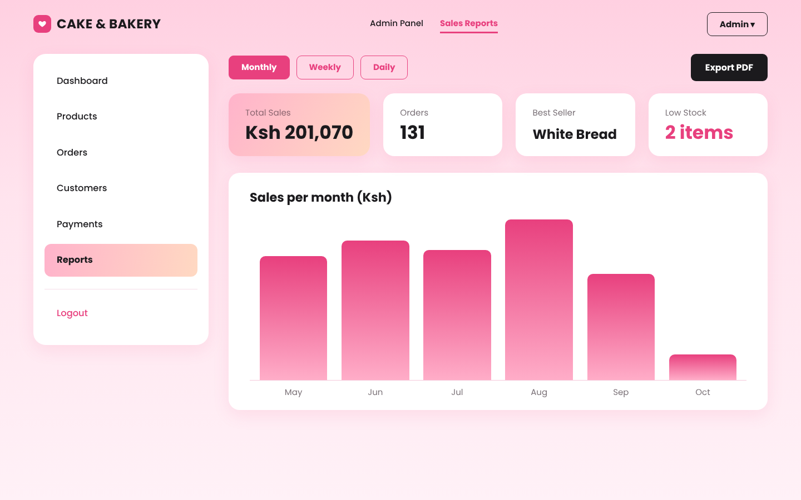
Sales report

PART C: HELP
Problem | What to do
I forgot my password | Call or WhatsApp the shop; the administrator will reset it.
My account is locked | Wait 15 minutes and try again.
The M-Pesa prompt did not appear | Check the phone number, make sure the phone has network, then open My Orders > Track > Pay with M-Pesa now.
I was charged but the order shows Pending | Wait a minute for the confirmation. If it stays Pending, call the shop with your M-Pesa message.
My area is not in the delivery list | Choose the nearest area or call the shop; the administrator can add new areas under Delivery.
(Admin) M-Pesa does not work | On Admin > Payments click Test M-Pesa connection. In config.php set MPESA_MODE to simulate (demo) or sandbox and add the Daraja keys. See README.md.
I cannot choose a date | Cakes need at least 24 hours notice and orders must be between 7:00 AM and 7:00 PM.
(Admin) "Unknown database" error | Open http://localhost/cakebakery/install.php once, or make sure MySQL is started in XAMPP.
(Admin) Backing up the data | Run tools\backup.bat (Windows) every day and copy the file to another drive.

