Failure Pattern Operational Intelligence (FPOI) in Radiation Oncology: A Versioned Ontology and Operational Knowledge Graph Framework with Public-Data Validation
Renjie He
Department of Radiation Oncology, The University of Texas MD Anderson Cancer Center, Houston, TX, USA
Correspondence: Renjie He, Department of Radiation Oncology, The University of Texas MD Anderson Cancer Center, Houston, TX, USA

Abstract
Background: Failure-pattern analysis after radiotherapy is clinically informative but difficult to reproduce because longitudinal lesion mapping, registration, dose-overlap definitions, classification rules, and quality assumptions are often embedded in study-specific workflows. Existing radiation-oncology standards provide broad semantics, but the analytical state transition from an observed lesion to a versioned failure-pattern interpretation remains poorly formalized.
Purpose: To develop and technically validate a Failure Pattern Operational Intelligence (FPOI) framework in which longitudinal lesion observations, dose evidence, registration/correspondence quality, classification rules, provenance, uncertainty, model predictions, and governed downstream actions are represented as explicit graph objects.
Methods: FPOI was implemented as an RDF/OWL-compatible application ontology with PROV-aligned provenance, SHACL constraints, SPARQL competency queries, and executable Python/Colab workflows. Validation used three complementary strata. First, nine PROTEAS treatment-course archives from seven patients were evaluated with real baseline/follow-up tumor masks and dataset-provided registered RTP dose. A post-diagnostic G0–G5 evidence cascade evaluated prescription/course reconciliation, $D_{max}$-based dose-scale fidelity, baseline treatment-target correspondence, $D_{mean}$-based prescription plausibility, cross-course pairing, and longitudinal correspondence/temporal ordering. Second, 20 OpenKBP cases supported controlled perturbation and illustrative classification-rule sensitivity. Third, five DICOM-RT packages were audited for object/reference-chain completeness.
Results: PROTEAS contained 29 follow-up observations nested within nine treatment-course archives from seven patients. At the independent archive level, one archive (P23b; one of seven patients) was eligible for normalized FailurePattern instantiation, one (P13) was indeterminate, five were assessed but did not satisfy all evidentiary gates, and two (P31 and P37) were not fully evaluable because prerequisite prescription/course evidence was unresolved or conflicting. The eligible P23b archive contributed four of 29 follow-up observations; five P13 follow-ups were AMBER and 20 observations were ineligible. $D_{max}$/$D_{max}$ scale fidelity was 0.996–1.003 for eight archives, with P31 at 1.552. G2 sensitivity localized threshold dependence mainly to the centroid criterion, whereas the G3 $D_{mean}$ result was unchanged at 0.80 and 0.90 thresholds. In OpenKBP, 1,860 perturbation evaluations showed context-dependent stability and the two illustrative rules disagreed in 19/20 high-dose-seeded cases, 2/20 low-dose-seeded cases, and 0/20 gradient-seeded cases.
Conclusions: Failure-pattern labels are better represented as evidence-gated, versioned analytical knowledge objects than as immutable recurrence attributes. Real longitudinal testing produced a positive instantiation, a threshold-sensitive indeterminate case, assessed negative evidence, and explicitly non-evaluable cases, demonstrating why unresolved prerequisites must remain distinct from empirical gate failure. FPOI provides a reproducible semantic layer for retrospective failure mapping, quality learning, and AI governance; prospective clinical validation remains necessary.
Keywords: failure pattern; recurrence; ontology; knowledge graph; radiotherapy; longitudinal imaging; provenance; uncertainty; SHACL; OpenKBP; brain metastasis; AI governance

1. Introduction
Spatial analysis of recurrent disease relative to the original radiotherapy plan is a long-standing method for investigating why treatment fails. Published approaches classify recurrence by overlap with target volumes or isodose regions, center-of-mass location, recurrent-volume dose metrics, or combined spatial-dosimetric rules [1-6]. These methods can distinguish failures that arise predominantly inside high-dose regions from those near field edges or outside the intended treatment volume, thereby informing margin hypotheses, imaging strategies, dose-intensification studies, and treatment de-escalation.
A persistent limitation is that the final label is often retained while the analytical state that produced it is lost. A recurrence can receive a different label after registration is revised, lesion segmentation changes, a dose representation is resampled, a prescription context is corrected, or another published classification rule is applied. Static spreadsheets and figures rarely preserve these dependencies in a machine-queryable form.
Radiation oncology now has substantial semantic infrastructure. The Radiation Oncology Ontology (ROO) demonstrated large-scale linked-data representation and SPARQL querying [7]. AAPM TG-263 standardized nomenclature principles for structures and dosimetric concepts [8]. The Operational Ontology for Oncology (O3) defines professional-society-driven oncology elements, attributes, value sets, and relationships for interoperable real-world data [9]. FAIR principles and W3C provenance standards further emphasize persistent identifiers, rich metadata, interoperability, reuse, and derivation history [10,15,16].
FPOI is deliberately narrower than these broad standards. Its purpose is to formalize the analytical transition from longitudinal lesion evidence to a governed, versioned FailurePattern interpretation. The contribution is not a new universal recurrence-classification rule; it is a semantic and executable architecture for preserving what was observed, how evidence was spatially related to dose, which quality gates passed, which rule version was used, and how the resulting interpretation was subsequently queried, compared, or acted upon.
This study moves the framework beyond a synthetic proof-of-concept by combining three complementary validation strata: a longitudinal brain-metastasis dataset with real follow-up segmentations and registered radiotherapy data [19], OpenKBP for controlled robustness experiments [21], and a five-package DICOM-RT test set for package/reference-chain validation. The PROTEAS stratum is explicitly evidence-gated: geometric and scale agreement alone are not assumed to establish treatment-target identity or prescription context.

2. Related Work and Design Context

2.1 Failure-pattern analysis after radiotherapy
Ferreira et al. showed that recurrence classification can depend strongly on the method used, comparing target-volume, treated-volume, and center-of-mass approaches [1]. Li et al. used dose/volume relationships to classify local failures after intensity-modulated radiotherapy for nasopharyngeal carcinoma [2]. Mohamed et al. formalized a combined spatial-dosimetric methodology for the IMRT era and applied it to postoperative oral-cavity cancer [3,4]. Nantavithya et al. incorporated recurrent-volume dosimetry and centroid information after lung SABR [5]. Recent postoperative HNSCC work continues to use combined spatial and dose-level-specific analyses [6]. The heterogeneity across these publications is precisely why a classification scheme should be represented as a versioned object rather than as an implicit script constant.

2.2 Registration, lesion correspondence, and uncertainty
Modern failure mapping often depends on rigid and/or deformable image registration. AAPM TG-132 emphasizes method validation and appropriate registration use [11], and more recent reviews emphasize characterization of deformable-registration uncertainty [12]. In longitudinal data, an additional problem precedes classification: a mask at one time point may not correspond to the same lesion at a later time point. Very large centroid changes can reflect true biological evolution, multi-lesion ambiguity, segmentation topology changes, or correspondence failure. FPOI therefore separates RegistrationAssessment from LesionCorrespondenceAssessment and UncertaintyAssessment instead of collapsing all confidence into one scalar.

2.3 Ontologies, standards, and provenance
An ontology provides formal shared semantics, whereas a knowledge graph instantiates those semantics with specific entities and relations [13,14]. FPOI is an application ontology intended to map to ROO, O3, TG-263, SNOMED CT, and other external systems rather than replicate them. PROV-O supplies a mature vocabulary for entities, activities, agents, and derivations [15,16]. SHACL provides machine-executable graph constraints [17]. These standards make it possible to represent not merely a recurrence label but the computational and governance state surrounding that label. FHIR/SNOMED CT interoperability principles and patient-centric knowledge-graph practice provide additional implementation context [18,24].

2.4 Public longitudinal radiotherapy data
The PROTEAS brain-metastasis data descriptor reports 40 patients, 744 MRI scans, 45 radiotherapy plans, 45 CT scans, and 65 segmented metastases with longitudinal follow-up [19]. The processed MRI data were transformed into BraTS space, and CT/RTP data were aligned to processed T1-weighted MRI by non-rigid registration [19,20]. This is unusually useful for FPOI because it combines real longitudinal tumor geometry with a registered radiotherapy representation in a common analysis space. OpenKBP provides open head-and-neck anatomy and three-dimensional dose distributions suitable for controlled methodological stress testing, although it does not provide observed recurrence masks [21].

3. Design Requirements and Competency Questions
The ontology was redesigned around nine requirements: (R1) separate observed longitudinal lesion state from analytical interpretation; (R2) permit optional clinical adjudication of an observation as RecurrenceEvent without assuming that every follow-up lesion is recurrence; (R3) make ClassificationScheme and PatternClassDefinition explicit and versioned; (R4) preserve computation and source provenance; (R5) represent registration, dose-scale, longitudinal lesion correspondence, and uncertainty evidence; (R6) represent treatment-target/course correspondence and prescription resolution separately from longitudinal lesion correspondence; (R7) prevent unresolved evidence from being silently forced into a FailurePattern; (R8) model downstream actions as governed human-review workflows; and (R9) make AI predictions auditable against later observations and interpretations. The competency questions are summarized in Table 1, and the operational architecture is shown in Figure 1.
Table 1. Competency questions and required graph capabilities.
Competency question | Required graph capability
Which FailurePatterns were generated under scheme X and version Y? | FailurePattern → ClassificationScheme/PatternClassDefinition with version identifiers.
Which interpretations changed after registration, correspondence, dose, or rule updates? | Versioned ComputationRun and supersedes/derivation relationships.
Which longitudinal observations are unresolved and why? | Explicit QA state on RegistrationAssessment, LesionCorrespondenceAssessment, dose-scale QA, and UncertaintyAssessment.
Which classifications are unstable under plausible perturbation? | Linked uncertainty/sensitivity results rather than a terminal label only.
Which AI predictions disagree with subsequently observed patterns? | PredictedFailurePattern + observed FailurePattern + ModelEvaluation.
Which evidence clusters triggered review and what decision followed? | ActionOrDecision linked to evidence and authorized review state.
CQ7. Which longitudinal observations have absolute dose evidence but cannot support a FailurePattern because target identity or prescription context is unresolved? | LongitudinalLesionObservation → TreatmentTargetCorrespondenceAssessment with explicit verdict/Rx source, plus absence of interpretedAs FailurePattern.

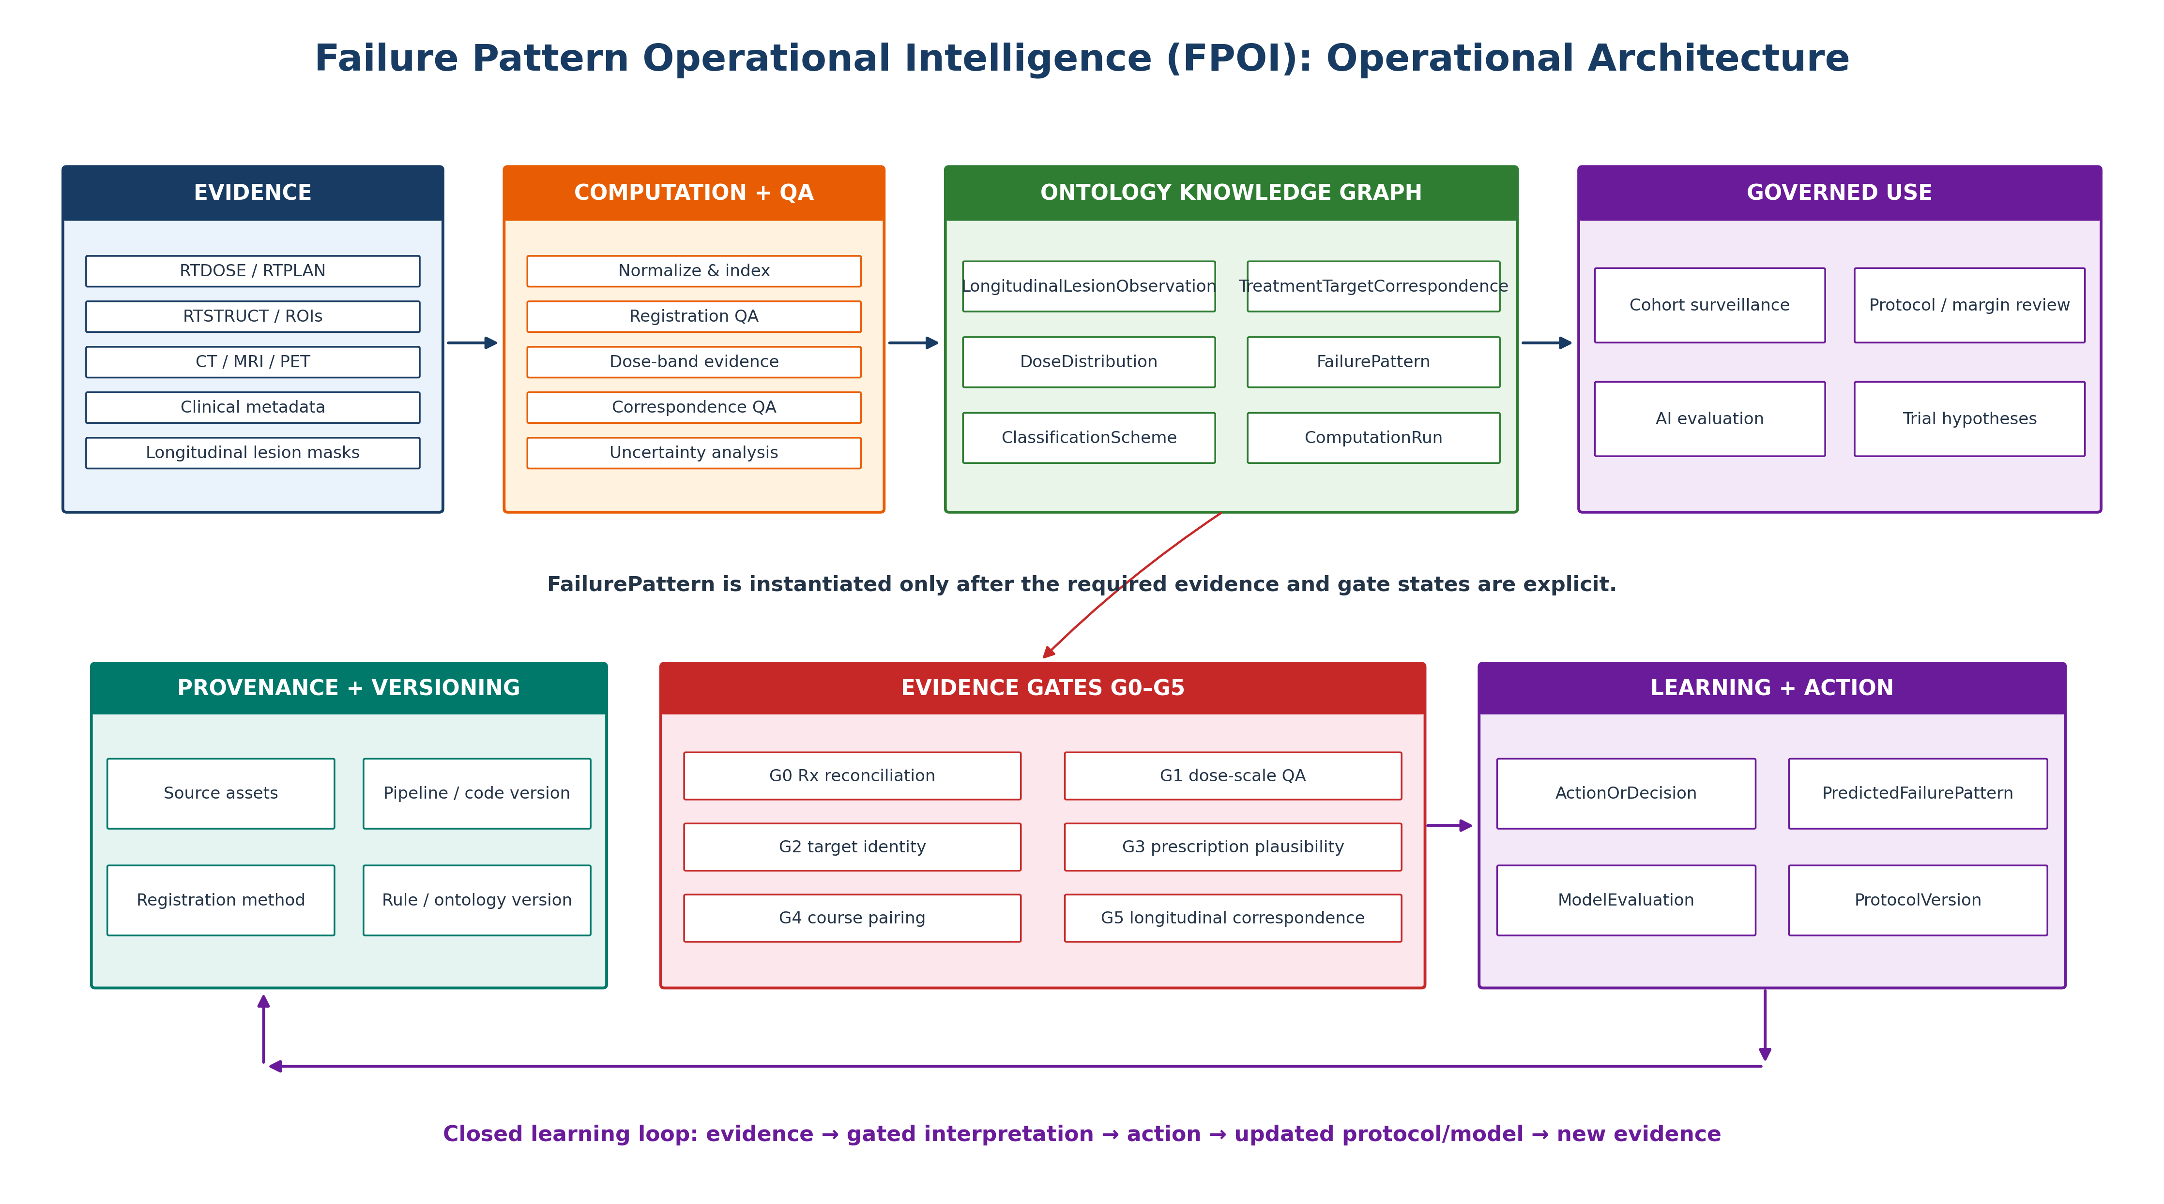
Figure 1. FPOI operational architecture. Evidence, computation/QA, ontology representation, governed use, provenance/versioning, evidence gating, and the learning/action layer remain distinct but linked.

4. Ontology Schema Specification

4.1 Observation versus interpretation
LongitudinalLesionObservation represents what is present in a specific imaging time point: a segmented lesion geometry, imaging context, date/time point, and source terminology such as stable disease or progression. RecurrenceEvent is reserved for a clinical event when the available evidence supports that interpretation. FailurePattern is a separate analytical object: an interpretation of a specified observation/event relative to a specified dose context, registration/correspondence state, computation run, and classification scheme. This separation prevents the computed class from being mistaken for an immutable property of the disease. TreatmentTargetCorrespondenceAssessment is distinct from LesionCorrespondenceAssessment: the former asks whether a lesion belongs to the target/course and prescription context being analyzed, whereas the latter asks whether two longitudinal observations represent the same lesion. Figure 2 summarizes these evidence relationships.

4.2 Core object classes
Core object classes are listed in Table 2.
Table 2. Core FPOI object classes.
Tier | Object class | Purpose
Clinical | Patient | Identity/center linkage; external identifiers should be minimized or pseudonymized.
Clinical | TumorEpisode | Disease episode/site and diagnostic context.
Clinical | TreatmentCourse | Delivered/planned radiotherapy course and protocol context.
Clinical | DoseDistribution | Dose grid or registered dose representation, units, Rx context, source URI/hash.
Clinical | StructureSet / AnatomicalStructure | Reference structures and normalized anatomy semantics.
Clinical | ImagingStudy | Baseline/follow-up imaging and acquisition purpose.
Clinical | LongitudinalLesionObservation | Observed segmented lesion at a particular time point.
Clinical | RecurrenceEvent | Optional clinically adjudicated recurrence/progression event.
Analytical | FailurePattern | Versioned analytical interpretation relative to dose and rule context.
Analytical | ClassificationScheme | Named/versioned rule system.
Analytical | PatternClassDefinition | Allowed class definition and mathematical criteria.
Analytical | ComputationRun | Pipeline version, code commit, input hashes, timestamp.
QA | RegistrationAssessment | Registration method and local quality evidence.
QA | LesionCorrespondenceAssessment | Evidence that longitudinal masks refer to the same lesion.
QA | UncertaintyAssessment | Sensitivity to spatial, segmentation, dose, or threshold perturbation.
Governance | ProtocolVersion | Protocol/margin policy context.
Governance | ActionOrDecision | Human-governed review/action linked to evidence.
AI | RiskModelRun | Versioned model execution and feature/data provenance.
AI | PredictedFailurePattern | Pre-observation prediction with probability/spatial output.
AI | ModelEvaluation | Prediction-versus-observation evaluation and calibration/performance metrics.
QA | TreatmentTargetCorrespondenceAssessment | Evidence that an observed lesion is the target treated by a specified treatment course and that the prescription context applied to it is the correct one.

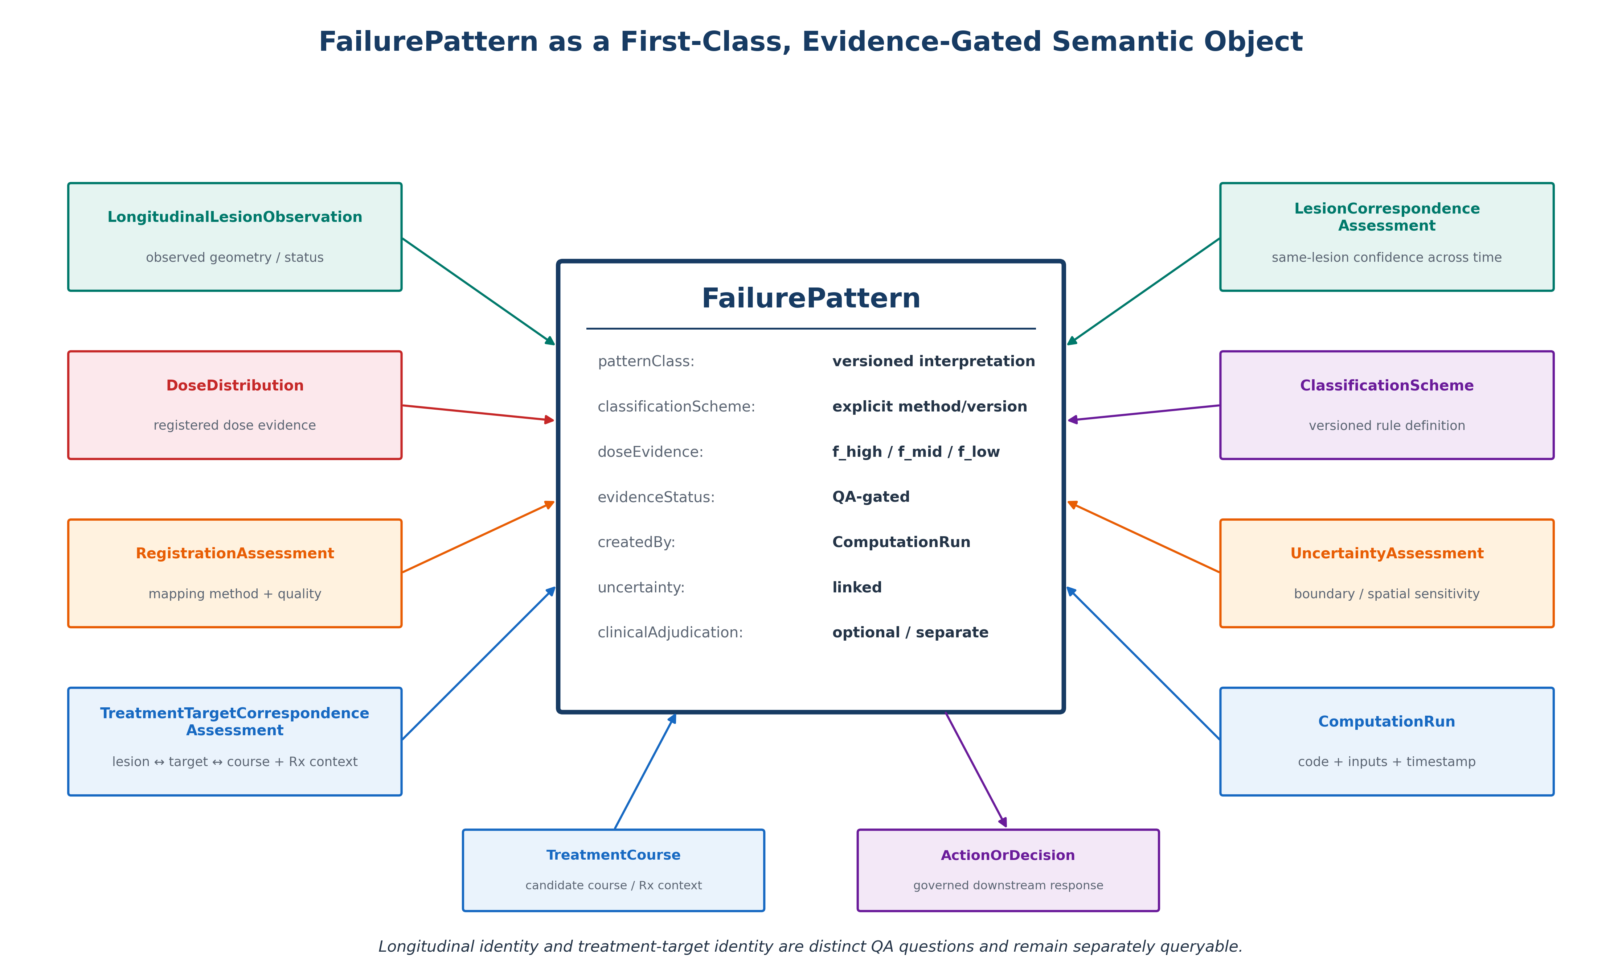
Figure 2. FailurePattern as a first-class, evidence-gated semantic object. Treatment-target/course correspondence is represented separately from longitudinal lesion correspondence, allowing absolute dose evidence to remain queryable even when the interpretation must be withheld.

4.3 Core relations and cardinality expectations
Core relations and cardinality expectations are summarized in Table 3.
Table 3. Core FPOI relations and cardinality expectations.
Source | Relation | Target | Cardinality / rule
ImagingStudy | supportsObservation | LongitudinalLesionObservation | 1..*
LongitudinalLesionObservation | maySupport | RecurrenceEvent | 0..1 per adjudication state
LongitudinalLesionObservation | interpretedAs | FailurePattern | 0..*
TreatmentCourse | uses | DoseDistribution | 1..*
FailurePattern | evaluatedAgainst | DoseDistribution | 1
FailurePattern | classifiedUnder | ClassificationScheme | 1
ClassificationScheme | defines | PatternClassDefinition | 1..*
FailurePattern | generatedBy | ComputationRun | 1
FailurePattern | supportedBy | RegistrationAssessment | 0..1 or required by workflow
FailurePattern | supportedBy | LesionCorrespondenceAssessment | 0..1 or required for longitudinal mapping
FailurePattern | hasUncertainty | UncertaintyAssessment | 0..*
FailurePattern | respondedToBy | ActionOrDecision | 0..*
RiskModelRun | generates | PredictedFailurePattern | 0..*
ModelEvaluation | compares | PredictedFailurePattern ↔ FailurePattern | 0..*
LongitudinalLesionObservation | hasTargetCorrespondence | TreatmentTargetCorrespondenceAssessment | 0..1; required before normalized FailurePattern
TreatmentTargetCorrespondenceAssessment | assessedAgainstCourse | TreatmentCourse | 1..* candidate courses scored where comparable
FailurePattern | supportedBy | TreatmentTargetCorrespondenceAssessment | 1; required for normalized interpretation
TreatmentTargetCorrespondenceAssessment | resolvesPrescription | Rx reconciliation state | 1; stores resolved prescription, clinical/DICOM source statements, fraction consistency, reconciliation verdict, and provenance

4.4 ClassificationScheme and PatternClassDefinition
The ontology does not treat InField, Marginal, and OutOfField as universal constants. ClassificationScheme identifies the governing method/version; PatternClassDefinition stores or references the mathematical decision criteria. The same dose-overlap evidence can therefore be re-evaluated under multiple schemes without overwriting historical interpretation. The OpenKBP experiment below demonstrates why this is not merely an architectural preference: two explicit schemes disagreed in 19 of 20 high-dose-seeded cases.

4.5 Provenance, uncertainty, and evidence gating
Every publishable FailurePattern is linked to a ComputationRun capturing source identifiers, preprocessing/registration state, lesion-mask version, dose representation, resolved Rx, classification version, software version, code commit, and timestamp where available. QA evidence is not decorative metadata. A normalized FailurePattern additionally requires passing registration/geometry, treatment-target correspondence, treatment-course pairing, prescription plausibility, longitudinal lesion correspondence, and uncertainty gates as applicable. If any required state is unresolved, the observation remains in the graph and the workflow withholds the FailurePattern.
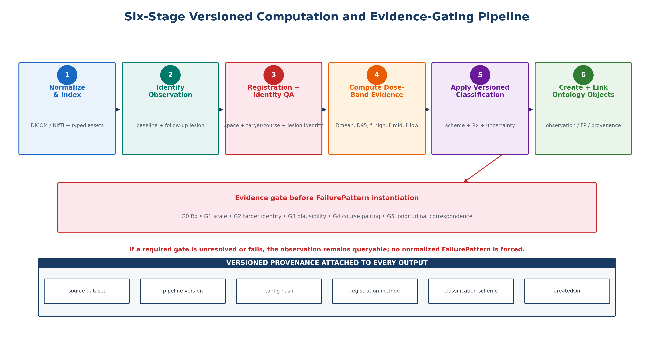
Figure 3. Six-stage versioned computation and evidence-gating pipeline. A normalized FailurePattern is instantiated only after the required prescription, scale, treatment-target/course, longitudinal correspondence, uncertainty, and rule-definition states are resolved.

5. Computational Pipeline
The executable pipeline follows six stages: (1) normalize and index source assets; (2) create ImagingStudy and LongitudinalLesionObservation entities; (3) establish registration plus longitudinal and treatment-target correspondence evidence; (4) compute absolute dose evidence and, only after prescription resolution, normalized dose-band fractions; (5) apply an explicitly versioned ClassificationScheme under the evidence-gate cascade; and (6) instantiate RDF objects, attach provenance/uncertainty state, and run SHACL validation before downstream queries. Figure 3 summarizes the six-stage workflow.

5.1 Dose-band evidence
For a lesion mask R and a resolved prescription dose $D_{Rx}$, the normalized voxel dose is r(v)=D(v)/$D_{Rx}$. The reference implementation stores three mutually exclusive, exhaustive lesion-volume fractions:
$f_{high}$ = |{v ∈ R : r(v) ≥ 0.95}| / |R|
$f_{mid}$ = |{v ∈ R : 0.20 ≤ r(v) < 0.95}| / |R|
$f_{low}$ = |{v ∈ R : r(v) < 0.20}| / |R|
By construction, $f_{high}$ + $f_{mid}$ + $f_{low}$ = 1. Absolute metrics include $D_{mean}$, $D_{median}$, $D_{min}$, $D_{max}$, and $D_{95}$.
We deliberately avoid conventional $V_{D}$ notation. In AAPM TG-263 [8] and the failure-pattern literature [1–6], $V_{D}$ denotes volume receiving at least dose D; the low-dose fraction required here is its complement, so using conventional $V_{D}$ notation for that low-dose fraction would invert the standard reading. The $f_{high}$/$f_{mid}$/$f_{low}$ names also make explicit that these are fractions of the lesion, not of a planning target volume.
These fractions are evidence. Class assignment is performed separately under a versioned rule (§4.4), and the fractions are not considered interpretable until $D_{Rx}$ has been resolved and reconciled by gate G0 (§5.2).

5.2 Evidence gates
A normalized FailurePattern is instantiated only when every required gate below is satisfied. Gates are ordered by dependency; a later gate is not treated as resolved when an earlier prerequisite is unresolved.
G0 — Prescription/course reconciliation. A single $D_{Rx}$ must be established and reconciled across clinical and DICOM sources. TargetPrescriptionDose is used when present and BeamDoseTotal is the fallback DICOM source. Dose or fraction disagreement is represented as a record-linkage/prescription conflict rather than reinterpreted as an isodose-line convention.
G1 — Dose-grid scale. The primary scale gate is registered $D_{max}$/native RTDOSE $D_{max}$, which is independent of grid support. P99.9/P99.9 is retained only as a support-dependent diagnostic because native and resampled grids differ in extent and voxel size.
G2 — Treatment-target correspondence. The baseline lesion must coincide with a treated high-dose island of the archived course. Because the DICOM-to-analysis-space transform is not distributed, this is a dose-field proxy for target identity, not an isocentre-based proof.
G3 — Prescription plausibility. For an evaluable baseline lesion/course pair, $D_{mean}$/$D_{Rx}$ is the operational gate; $D_{95}$/$D_{Rx}$ is reported diagnostically because the dataset-provided MRI tumor segmentations are not planning PTVs. The operational $D_{mean}$ threshold is 0.90.
G4 — Treatment-course pairing. For patients with multiple archived courses, each fixed baseline lesion is scored against every candidate course when those registered spaces are directly comparable. If cross-course comparison is not possible, the gate remains unresolved rather than inferring a winner.
G5 — Longitudinal correspondence and temporal ordering. Follow-up observations retain the prior spatial correspondence screen based on geometry, centroid displacement, and overlap behavior, joined by archive and follow-up index. A temporal subgate additionally requires days_from_baseline ≥ 0. This longitudinal identity question is distinct from G2 treatment-target identity.
The reported PROTEAS analysis used the authoritative post-diagnostic gate configuration provided in Supplementary Software Archive S1 (SHA-256: 2ae7ecaf8611da2cfb546f5ac4410f95234b542009aa01220f0b7fc9dfc8be18). The gate statistics were revised after diagnostic inspection to correct identifiable measurement errors and are therefore not described as prespecified. Earlier configurations are retained only as provenance history in the analysis archive.

5.3 SHACL validation
SHACL shapes enforce mandatory graph state independently of application code [17]. A TreatmentTargetCorrespondenceAssessment is itself an evidence object and may legitimately carry a passing, non-passing, or unresolved verdict; therefore the assessment-class shape does not require PASS. Instead, the FailurePattern shape uses a qualified-value constraint requiring at least one supporting TreatmentTargetCorrespondenceAssessment whose verdict is PASS. This permits withheld interpretations such as the P37 clinical/DICOM linkage-conflict assessment to remain valid graph evidence while preventing a normalized FailurePattern from being supported by a non-passing assessment. The corrected release contains two node shapes and eight sh:property constraints: seven are top-level property constraints and one is nested inside the qualified value shape that enforces the PASS requirement. Independent validation with pySHACL 0.40.1 and RDFLib 7.6.0 confirmed that the unmodified validation graph conforms and that all four malformed controls are rejected [25].

6. Validation Study Design
The closed learning-loop context for the validation strata is illustrated in Figure 4.
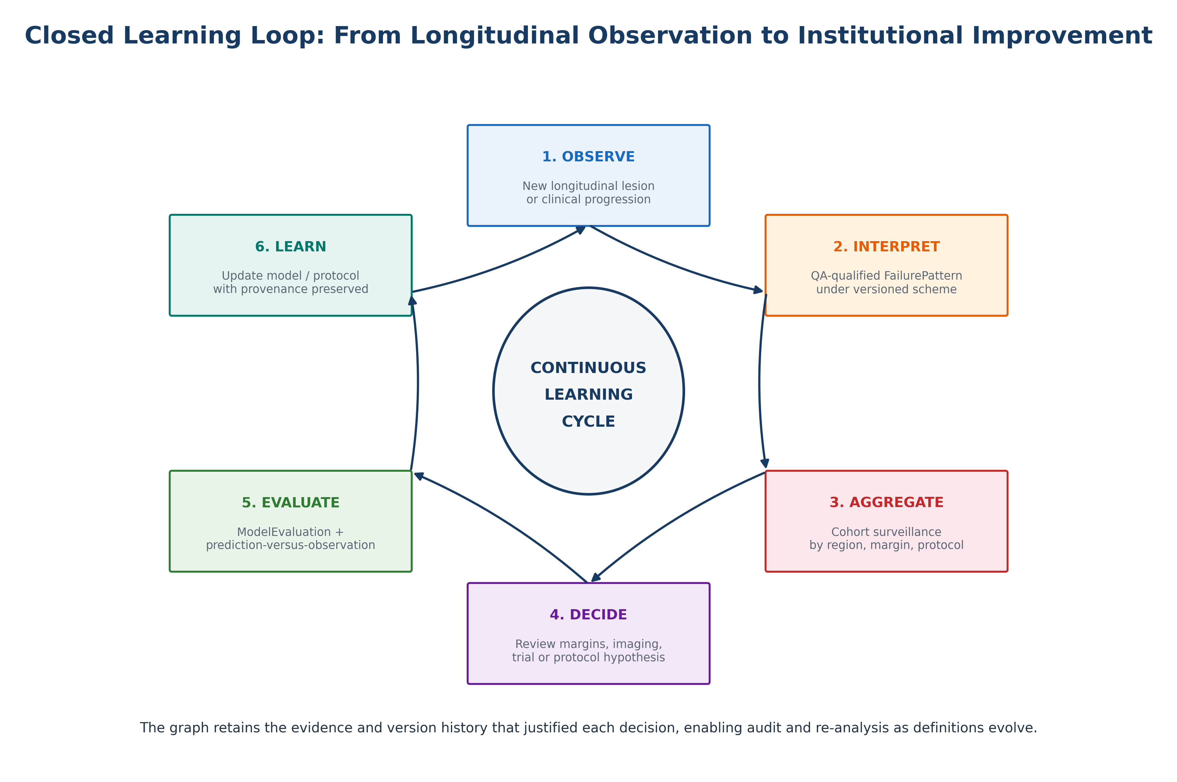
Figure 4. Closed learning loop from longitudinal observation to institutional improvement. QA-qualified interpretations can support cohort surveillance, decisions, AI evaluation, and protocol/model updates while preserving the evidence and version history that justified each action.

6.1 PROTEAS real longitudinal analysis
Nine selected PROTEAS treatment-course archives from seven patients (P13, P17a, P17b, P23a, P23b, P31, P35, P37, and P39) were processed because they provided useful longitudinal trajectories, progression-labeled clinical entries, and/or repeated treatment-course context. The source dataset provides baseline and follow-up MRI plus tumor segmentation in BraTS space and registered CT/RTP NIfTI files [19]. Twenty-nine follow-up masks were analyzed. Because P17 and P23 each contribute two archived courses, archive-level proportions are not independent patient-level estimates. This was a purposive methodological sample rather than a population-screening cohort; no prevalence or population-performance inference is made from the nine-archive subset.
All nine archives had exact RTP-mask geometry agreement. The final audit used $D_{max}$/$D_{max}$ for G1, $D_{mean}$/$D_{Rx}$ for G3, explicit treatment-target and course-pairing evidence, and indexed longitudinal correspondence plus temporal ordering. Five gates (G0–G4) are evaluated at archive/course level and inherited by follow-up observations; G5 is observation-level. Accordingly, archive-level status is the primary independent reporting unit and follow-up counts are reported as nested observations.

6.2 OpenKBP controlled stress tests
Twenty OpenKBP cases were used with real anatomy and three-dimensional dose [21]. The reported perturbation experiment used 60 dose-seeded controlled lesions from Experiment A (20 each from high-dose, gradient, and low-dose seed strategies). Lesion centers were translated by 0, 1, 2, 3, 5, and 7.5 mm in six cardinal directions, yielding 1,860 perturbation evaluations including the unshifted baseline. A separate whole-volume construction experiment was developed during method exploration but is not analyzed in the present Results and is therefore not used as evidence here. Stability was evaluated against each lesion’s baseline dominant-fraction class with patient-level bootstrap confidence intervals.
Rule sensitivity compared dominant-fraction-v1, which assigns the class with the largest of the three dose-band fractions, against an illustrative strict-overlap rule requiring the high-dose fraction to be at least 0.95 for InField and the low-dose fraction to be at least 0.95 for OutOfField, with the remainder Marginal. This pair is a mechanism demonstration rather than a test of published schemes: the high disagreement rate in high-dose-seeded lesions is expected from the deliberately different mathematical definitions. Published recurrence-classification schemes are therefore treated as external comparators for future clinical validation rather than as evidence supporting the present controlled rule experiment.

6.3 DICOM-RT package and semantic validation
A five-package DICOM-RT test set was audited for the presence of CT, RTSTRUCT, RTPLAN, and RTDOSE objects and for the reference chain RTDOSE → RTPLAN → RTSTRUCT → Frame of Reference. The purpose was to test whether the ingestion/semantic layer surfaces incomplete state rather than silently treating it as analyzable. Provenance, access terms, de-identification documentation, and shareability were not independently established for this test set, so it is treated only as an interoperability test set and is excluded from public-data availability claims. Systematic object-ablation testing was outside the scope of the present validation.

7. Results

7.1 PROTEAS: real longitudinal geometry and dose
Across nine treatment-course archives from seven patients, 29 follow-up observations were available. The genuine prior longitudinal correspondence artifact classified 25/29 spatial correspondence observations as plausible, 1/29 as amber, and 3/29 as red. Temporal-ordering review additionally identified P39 follow-up 1 as occurring 14 days before the declared baseline, converting its composite G5 state to FAIL. Follow-up intervals otherwise spanned 36–499 days. Figure 5 plots the available longitudinal dose samples against actual days from baseline rather than ordinal follow-up number.
The final post-diagnostic audit separated four archive-level interpretations. P23b was Eligible; P13 was Indeterminate; P17a, P17b, P23a, P35, and P39 were Assessed—not eligible; and P31 and P37 were Not fully evaluable because prerequisite prescription/course evidence was unresolved or conflicting. Thus, one of nine treatment-course archives—and one of seven patients—satisfied the complete cascade. Nested within those archives, 4/29 follow-up observations were FailurePattern-instantiable (P23b FU1, FU2, FU3, and FU5), 5/29 were AMBER (P13 FU1–FU5), and 20/29 were ineligible. Figure 6 summarizes the archive-level status; Table 7 gives archive-specific drivers.
The positive and boundary cases were informative. P23b passed G2 with 53.74% baseline-lesion overlap with the treated-target proxy and an 8.06-mm centroid separation; its baseline $D_{mean}$/$D_{Rx}$ was 0.917 and $D_{max}$/$D_{max}$ was 0.9991. P13 had greater overlap (74.85%) but a 12.79-mm centroid separation, making G2 AMBER under the 10-mm operational cutoff. Centroid sensitivity was 0/7, 3/7, 6/7, and 6/7 archives passing at 5, 10, 15, and 20 mm, respectively; overlap sensitivity was 2/7, 2/7, and 1/7 at 40%, 50%, and 60%. By contrast, the G3 $D_{mean}$ sensitivity result was unchanged at thresholds 0.80 and 0.90 (2 archives passing) and fell to zero only at 1.00, localizing the principal threshold dependence to G2 centroid distance.
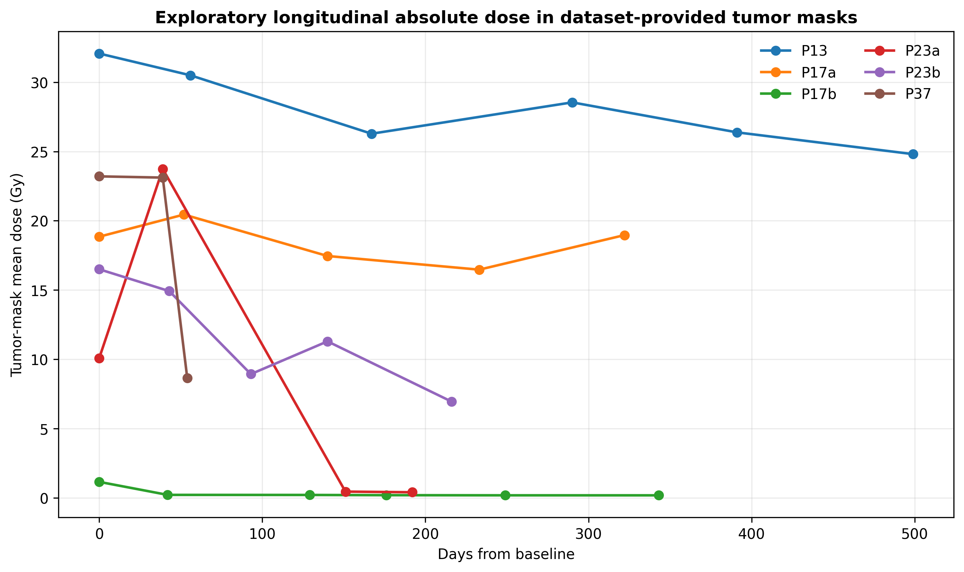
Figure 5. Exploratory absolute longitudinal tumor-mask dose plotted against actual elapsed days from baseline for the six archives with previously sampled dose trajectories. These retrospective MRI tumor masks are not treated as planning PTVs; the figure is descriptive and does not by itself establish FailurePattern eligibility.
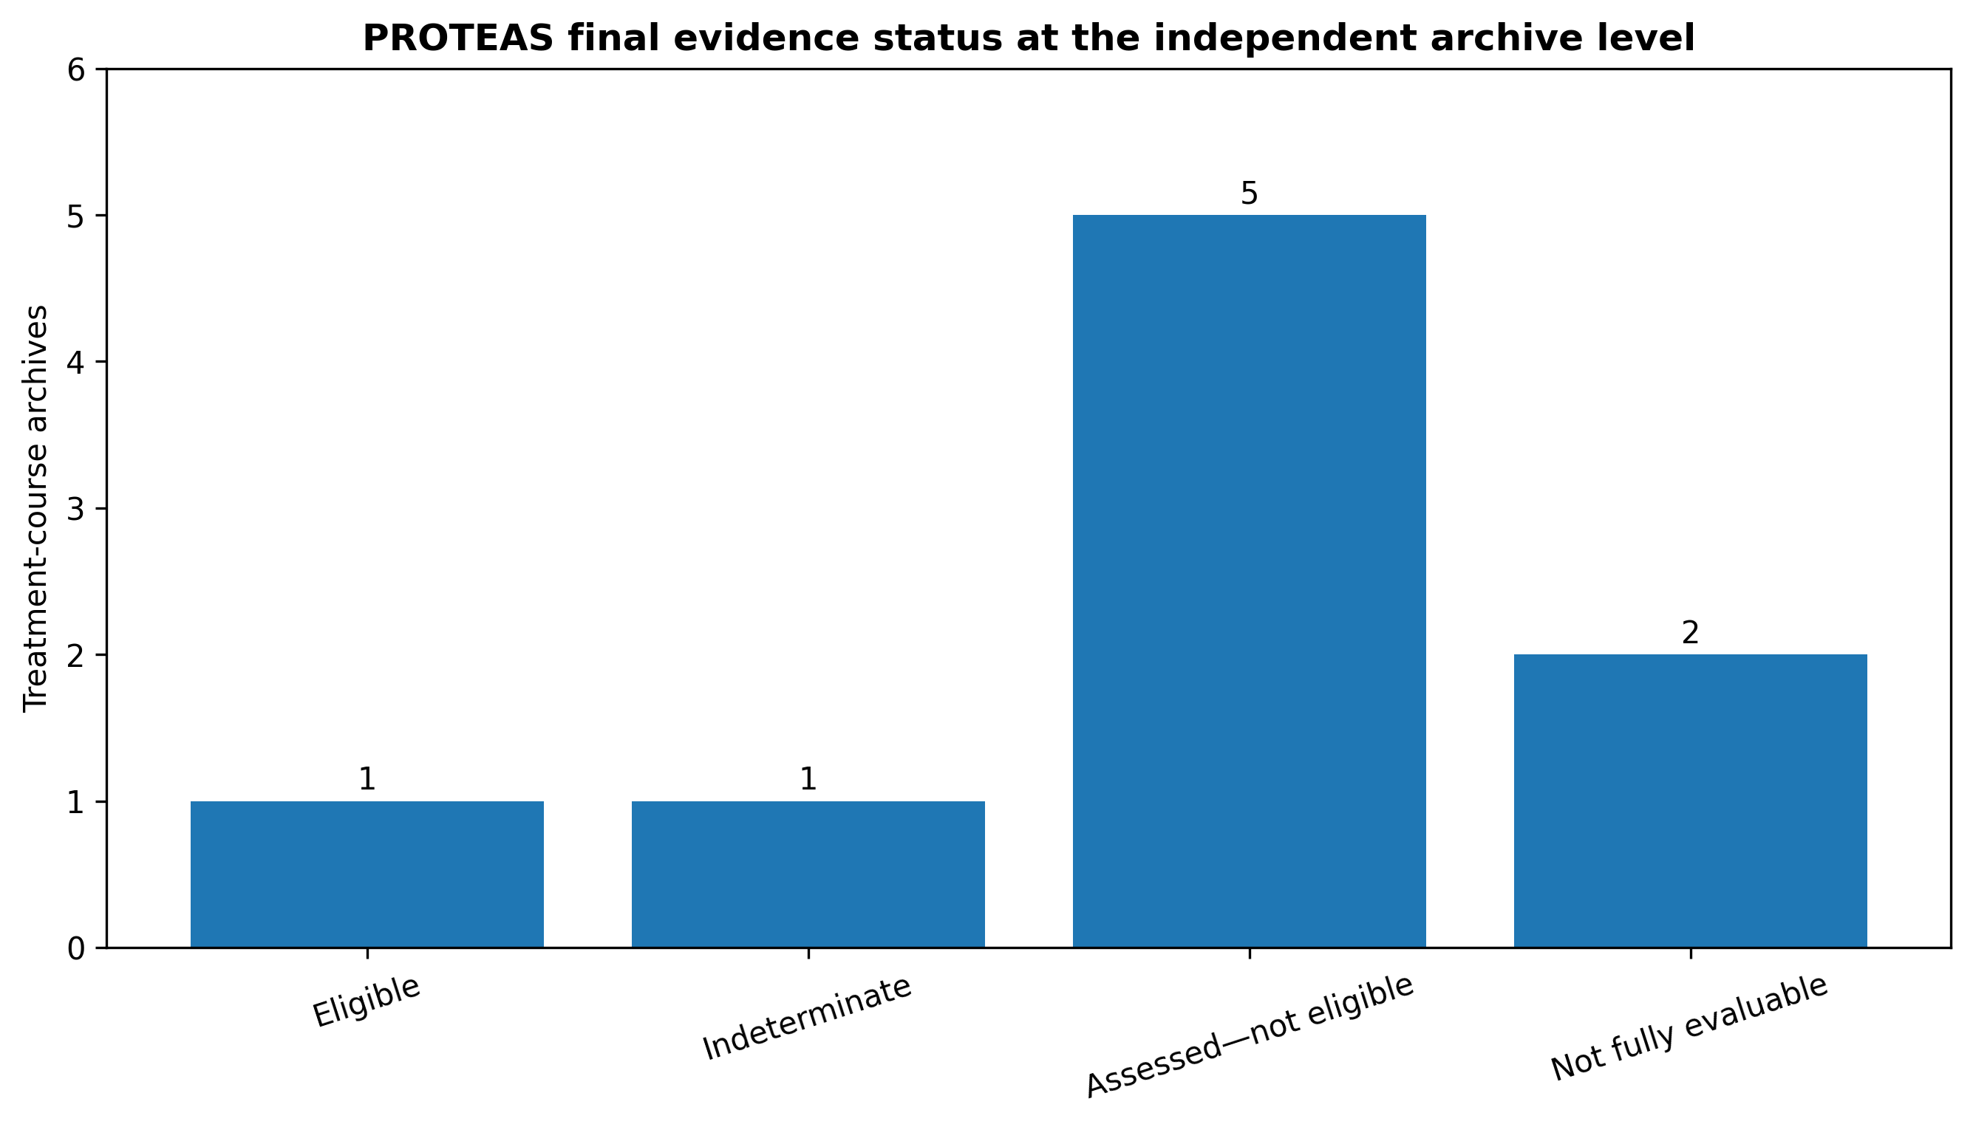
Figure 6. Final PROTEAS archive-level evidence status under the authoritative post-diagnostic G0–G5 configuration. The independent unit is the treatment-course archive: one Eligible, one Indeterminate, five Assessed—not eligible, and two Not fully evaluable.
Table 7. Final PROTEAS archive-level evidence interpretation and principal driver.
Archive | Final interpretation | Principal evidence
P13 | Indeterminate | G2 threshold-sensitive: overlap 0.748; centroid 12.79 mm.
P17a | Assessed—not eligible | G2/G3 fail; prescription reconciled via BeamDoseTotal.
P17b | Assessed—not eligible | G2/G3 fail; P17a candidate-course score is 31.8× the nominal P17b score.
P23a | Assessed—not eligible | G2/G3 fail; target-proxy overlap 0.149.
P23b | Eligible | All G0–G5 requirements satisfied; four nested follow-ups eligible.
P31 | Not fully evaluable | Clinical prescription unavailable for course reconciliation; G2/G3 not evaluable; $D_{max}$/$D_{max}$ 1.552.
P35 | Assessed—not eligible | G3 fails; later spatial correspondence includes a red large-centroid-shift observation.
P37 | Not fully evaluable | Clinical 20 Gy/1 fraction conflicts with archived RTPLAN 35 Gy/7 fractions.
P39 | Assessed—not eligible | G3 fails; only follow-up occurs 14 days before baseline.

7.2 OpenKBP: classification stability under physical perturbation
Gradient-seeded cases were highly stable: 100% at 0-1 mm, 99.2% at 2-5 mm, and 98.3% (95% bootstrap CI 95.0-100%) at 7.5 mm. High-dose-seeded stability decreased to 95.0% at 1 mm, 88.3% at 2 mm, 78.3% at 3 mm, 68.3% at 5 mm, and 65.8% (95% CI 60.0-71.7%) at 7.5 mm. Low-dose-seeded stability was 90.8%, 86.7%, 83.3%, 77.5%, and 76.7% at 1, 2, 3, 5, and 7.5 mm, respectively. Thus, classification stability was strongly context dependent even when the perturbation magnitude was standardized in millimeters. Figure 7 shows the displacement-dependent stability profiles.
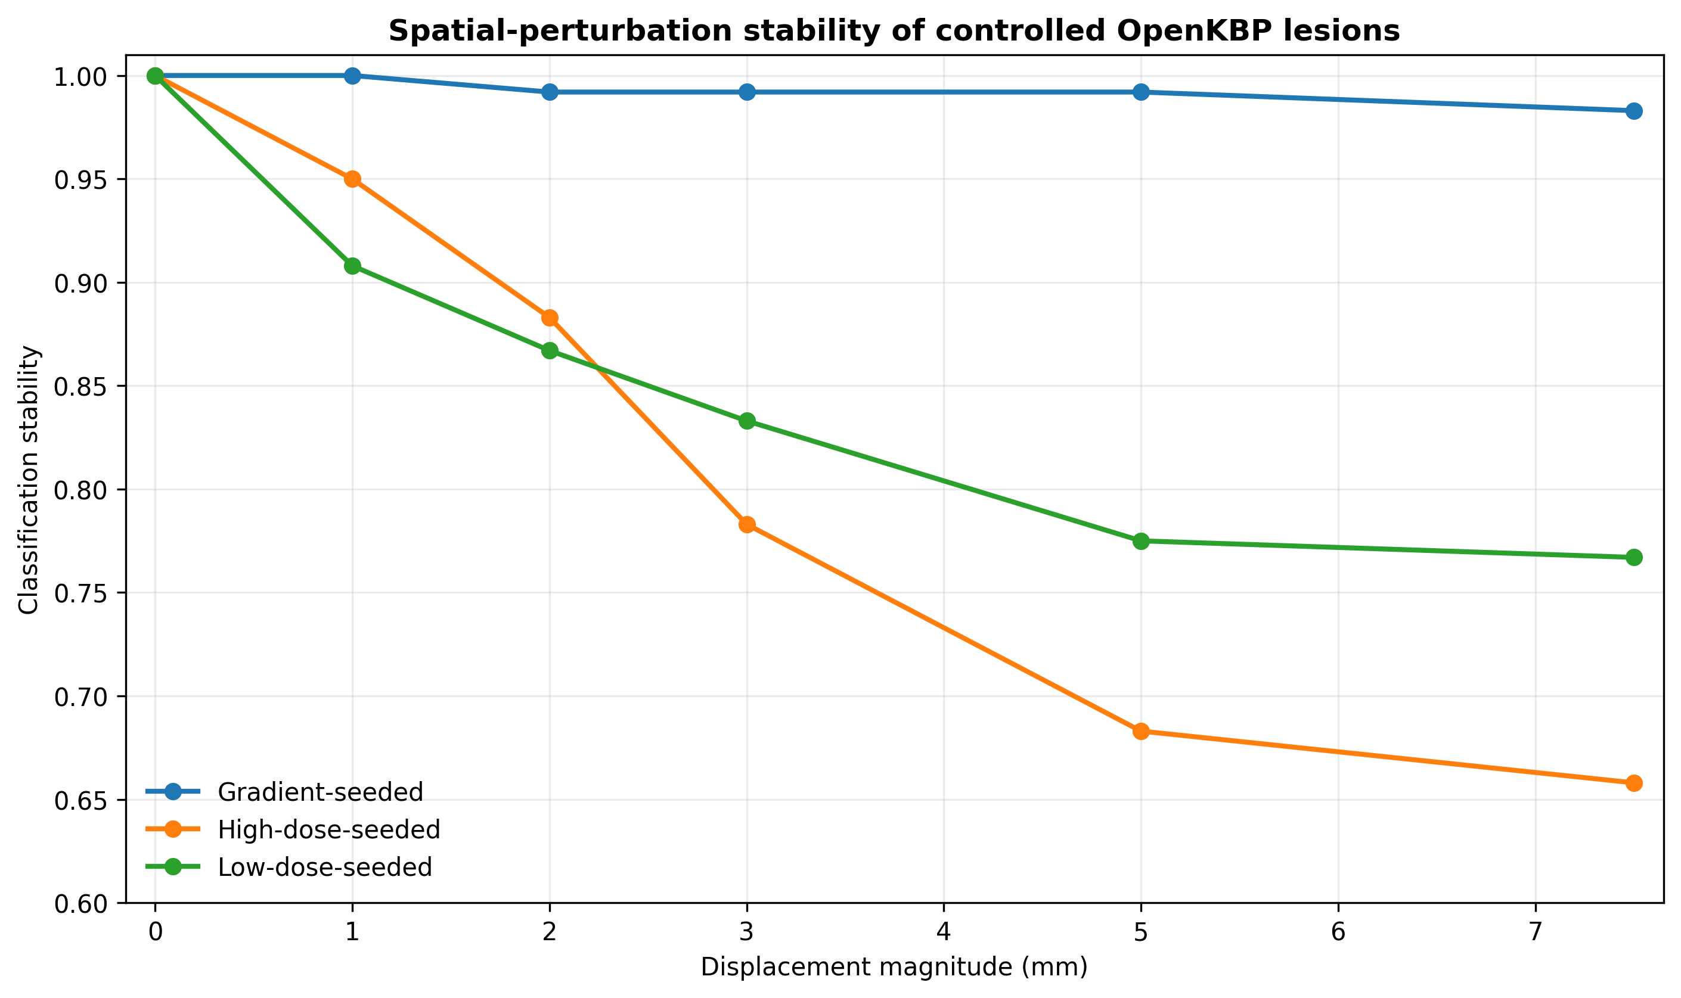
Figure 7. Spatial-perturbation stability of the dose-seeded OpenKBP controlled lesions. The y-axis is restricted to the observed stability range to expose differences among seed strategies; the perturbation experiment applies to Experiment A only.

7.3 OpenKBP: classification-scheme dependence
The dominant-fraction and strict-overlap rules disagreed in 0/20 gradient-seeded cases (0%; exact 95% CI 0-16.8%), 19/20 high-dose-seeded cases (95%; 95% CI 75.1-99.9%), and 2/20 low-dose-seeded cases (10%; 95% CI 1.2-31.7%). The high disagreement rate does not show that either rule is intrinsically incorrect; it shows that “centered in high dose” and “nearly the entire lesion volume lies in high dose” encode materially different semantics. ClassificationScheme and PatternClassDefinition therefore need to be queryable provenance. Figure 8 summarizes this illustrative disagreement analysis.
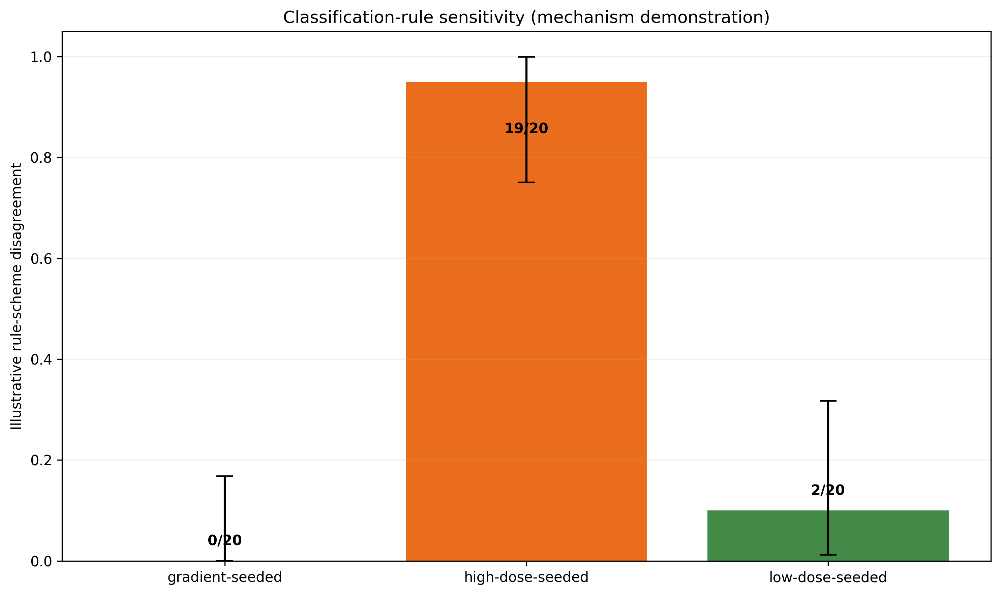
Figure 8. Illustrative classification-rule sensitivity in OpenKBP. Bars show disagreement proportions for two deliberately different mathematical schemes, with two-sided exact 95% Clopper–Pearson intervals. This experiment explains a mechanism and is not a substitute for published-rule comparison.
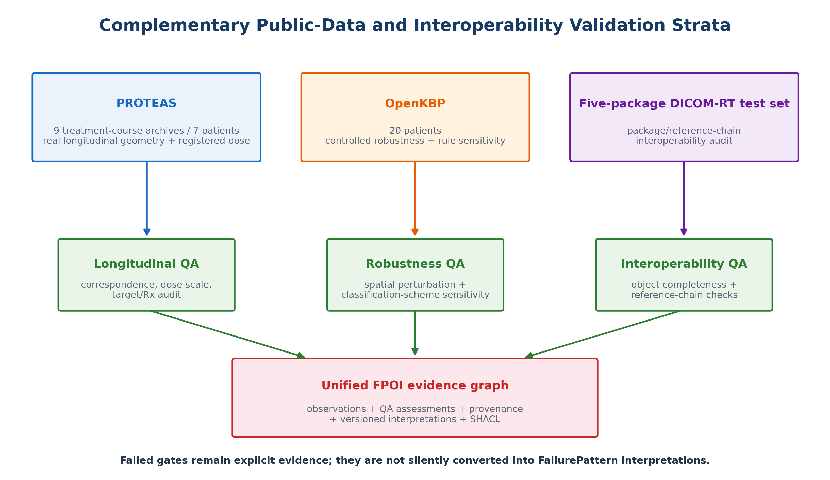
Figure 9. Complementary validation strata and evidence gating. PROTEAS provides longitudinal geometry and exploratory registered-dose evidence, OpenKBP provides controlled robustness and rule-sensitivity experiments, and a five-package DICOM-RT test set provides interoperability testing. All strata converge on a graph in which failed QA gates remain explicit evidence rather than being silently converted into FailurePattern interpretations.
The complementary validation design is intentional: no single public dataset contains every element required to test longitudinal geometry, controlled classification behavior, and multicenter DICOM-RT interoperability simultaneously. The ontology therefore represents the evidence source, QA state, and computation provenance for each derived object rather than treating heterogeneous validation evidence as interchangeable. The three validation strata and their evidence roles are summarized in Figure 9.

7.4 DICOM-RT and graph validation
Table 4. Five-package DICOM-RT object/reference-chain audit.
Package | CT | RTSTRUCT | RTPLAN | RTDOSE | Dose→Plan | Plan→Struct | Struct→FoR | Status
Center 1 | 275 | 0 | 0 | 1 | No | No | No | Incomplete
Center 2 | 236 | 1 | 1 | 1 | Yes | Yes | Yes | Complete
Center 3 | 224 | 1 | 1 | 1 | Yes | Yes | Yes | Complete
Center 4 | 229 | 1 | 1 | 1 | Yes | Yes | Yes | Complete
Center 5 | 270 | 1 | 1 | 1 | Yes | Yes | Yes | Complete

Four of five packages contained the expected CT/RTSTRUCT/RTPLAN/RTDOSE objects and all three reference-chain checks. Center 1 contained CT and RTDOSE but lacked detected RTSTRUCT and RTPLAN objects and was therefore classified as semantically incomplete. This is a desirable validation outcome: incomplete source state is surfaced rather than silently converted into a graph that appears analyzable. The package-level findings are summarized in Table 4.
The DICOM-RT audit establishes an interoperability screen rather than a complete formal ontology evaluation. The executable ontology artifact, competency-query tests, constraint negative controls, structural consistency screen, and standards mappings are reported separately in §7.5.

7.5 Formal ontology evaluation
The released FPOI v1.0.1 artifact contains 126 ontology triples, 22 OWL classes, 19 object properties, 15 datatype properties, and two explicit disjoint-class axioms; the compact validation graph contains 46 triples. The SHACL artifact contains two node shapes and eight sh:property constraints (seven top-level plus one nested within the qualified value shape). The unmodified validation graph conforms under pySHACL 0.40.1, including the non-passing P37 TreatmentTargetCorrespondenceAssessment, which remains valid evidence but supports no FailurePattern. All seven competency queries executed successfully and returned the expected evidence state. CQ1 retrieved a FailurePattern under the named classification scheme; CQ2 retrieved a superseding computation run; CQ3 retrieved an unresolved longitudinal observation; CQ4 retrieved an instability case; CQ5 retrieved a prediction/observation disagreement; CQ6 retrieved a linked review decision; and CQ7 retrieved the P37-style linkage-conflict state with dose evidence but no FailurePattern. Four malformed controls—missing target correspondence, non-passing target correspondence, missing classification scheme, and missing computation run—were all rejected by pySHACL; the corresponding validation-result counts were 2, 1, 1, and 1, while the positive control produced zero violations. An RDFLib parse plus explicit owl:disjointWith contradiction screen also passed; this is a structural OWL/RDF consistency screen, not a full OWL DL reasoner result. The artifact statistics are summarized in Table 8.
The executed SPARQL competency-query outputs are summarized in Table 9.
The selected standards mappings are summarized in Table 10. The mappings are deliberately conservative: ROO and O3 provide broad radiation-oncology and oncology semantics, TG-263 supplies standardized nomenclature context, and PROV-O supplies provenance semantics. FPOI-specific analytical classes such as FailurePattern and TreatmentTargetCorrespondenceAssessment are not asserted as owl:equivalentClass to external concepts. The complete mapping, executable ontology, corrected SHACL shapes, queries, and pySHACL validation results are included in Supplementary Software Archive S1 v1.0.1.
Table 8. FPOI v1.0.1 ontology artifact and executable-evaluation summary.
Metric | Result
Version IRI | https://w3id.org/fpoi/1.0.1
Ontology triples | 126
OWL classes | 22
Object / datatype properties | 19 / 15
SHACL node / property constraints | 2 node shapes / 8 sh:property constraints (7 top-level + 1 nested)
Validation graph triples | 46
Competency queries executed | 7/7
Malformed-graph controls rejected | 4/4 by pySHACL; positive control CONFORM
Structural consistency screen | PASS; RDF parse + explicit disjointness contradiction screen (not full OWL DL reasoning)
Table 9. Executed SPARQL competency-query results on the compact validation graph.
CQ | Rows | Representative returned state
CQ1 | 1 | fpoi:fp_P23b_FU1 | fpoi:infield
CQ2 | 1 | fpoi:run1 | fpoi:run0
CQ3 | 1 | fpoi:obs_P37_FU1 | FAIL | clinical_dicom_linkage_conflict
CQ4 | 1 | fpoi:fp_P23b_FU1 | 0.658
CQ5 | 1 | fpoi:eval1 | DISAGREE
CQ6 | 1 | fpoi:fp_P23b_FU1 | Multidisciplinary review
CQ7 | 1 | fpoi:obs_P37_FU1 | FAIL | clinical_dicom_linkage_conflict
Table 10. Selected conservative FPOI mapping intentions to external standards and ontologies; the complete mapping is provided in Supplementary Software Archive S1.
FPOI concept | External resource | Mapping relation | Implementation note
Patient | O3 / ROO | broad semantic alignment | FPOI keeps patient identity minimal/pseudonymized; no owl:equivalentClass asserted.
TumorEpisode | O3 / ROO | broad semantic alignment | Maps to oncology disease/episode concepts; exact external URI deferred to implementation profile.
TreatmentCourse | O3 / ROO | broad semantic alignment | Reuses treatment-course semantics; FPOI adds evidence-gating role.
DoseDistribution | ROO / DICOM-RT / TG-263 | broad semantic alignment | TG-263 informs naming semantics; FPOI additionally stores source/hash/Rx context.
StructureSet / AnatomicalStructure | TG-263 / ROO / O3 | nomenclature alignment | TG-263 is used for standardized structure/dosimetric naming, not as a complete ontology mapping.
ImagingStudy | O3 / FHIR ImagingStudy | broad semantic alignment | FPOI specializes baseline/follow-up purpose.
LongitudinalLesionObservation | O3 + PROV-O | FPOI specialization | No direct equivalent claimed; modeled as provenance-bearing observation.
FailurePattern | FPOI-specific | new application concept | No equivalent asserted in ROO/O3/TG-263.
ClassificationScheme | SKOS / PROV-O | design alignment | Named rule provenance; not a clinical terminology class.
ComputationRun | PROV-O Activity | rdfs:subClassOf | Explicitly aligned in ontology artifact.
TreatmentTargetCorrespondenceAssessment | FPOI-specific | new application concept | Introduced because public-data audit exposed record-linkage ambiguity.

7.6 Consolidated validation summary
The three validation strata and graph checks are summarized in Table 5.
Table 5. Consolidated validation summary across PROTEAS, OpenKBP, DICOM-RT, and semantic graph checks.
Validation stratum | Scale | Primary result
PROTEAS real longitudinal | 9 treatment-course archives from 7 patients; 29 nested follow-up observations | Final post-diagnostic G0–G5 audit: 1 Eligible (P23b), 1 Indeterminate (P13), 5 Assessed—not eligible, 2 Not fully evaluable (P31/P37). Nested follow-ups: 4 PASS, 5 AMBER, 20 ineligible. G2 centroid threshold was the principal sensitivity driver.
OpenKBP controlled | 20 patients; 60 dose-seeded controlled lesions analyzed; 60 whole-volume constructs not included in reported perturbation results | 1,860 perturbation evaluations; 7.5-mm stability 98.3% gradient, 65.8% high-dose, 76.7% low-dose; major rule-version dependence.
Five-package DICOM-RT test set | 5 packages | 4 complete reference chains; 1 incomplete package surfaced. The test set is used only for interoperability screening; systematic object-ablation testing and public redistribution were outside the study scope.
Semantic graph | FPOI v1.0.1 ontology + corrected SHACL + 7 SPARQL CQs | 126 ontology triples; 22 classes; 19 object properties; 15 datatype properties; 2 node shapes; 8 sh:property constraints (7 top-level + 1 nested qualified constraint); positive graph CONFORM; 7/7 competency queries executed; 4/4 malformed controls rejected by pySHACL; structural consistency screen PASS.

8. AI Governance and Cutting-Edge Extensions

8.1 Prediction-versus-observation loop
RiskModelRun represents a versioned model execution; PredictedFailurePattern stores a prospective probability/spatial prediction; and ModelEvaluation compares that prediction with a later validated observation/FailurePattern. Depending on the model, evaluation can include calibration, Brier score, class agreement, spatial distance, subgroup performance, or time-to-event discrepancy. This design avoids treating AI integration as an untraceable narrative add-on.

8.2 Graph-grounded agents and retrieval
A language-model or agent layer can query the FPOI graph for traceable evidence rather than infer provenance from narrative text. Appropriate use cases include cohort summarization, discrepancy detection, preparation of QA review packets, and retrieval of the exact rule/data version underlying a reported pattern. The graph is an evidence layer, not an authorization mechanism for autonomous protocol change.

8.3 Uncertainty-aware reasoning
The OpenKBP perturbation experiment shows why uncertainty should be queryable. A deterministic class can be accompanied by a stability profile or uncertainty envelope. Queries can then ask for patterns that are robust across plausible perturbations or, conversely, interpretations whose class changes under small shifts. This is more informative for quality learning than a single label detached from sensitivity evidence.

9. Comparison With Conventional Data Architectures
Table 6. Comparison of FPOI with conventional data architectures.
Capability | Static table | Relational warehouse | Passive knowledge graph | FPOI operational graph
Raw metrics | Yes | Yes | Yes | Yes
Shared explicit semantics | Limited | Schema-dependent | Yes | Yes
Rule/version as first-class object | Rare | Possible | Possible | Core
Computation provenance | Rare | Possible | Possible | Core / PROV-aligned
QA gates linked to interpretation | Rare | Possible | Possible | Core
Preserve unresolved observations without forced label | Ad hoc | Possible | Possible | Explicit design
Prediction-versus-observation audit loop | Rare | Custom | Possible | Core
Human-governed action linkage | Manual | Workflow-specific | Usually passive | Core

A normalized relational database can store most of the same values. The argument for FPOI is not that graphs are inherently superior to tables; it is that the meaning, provenance, versioning, QA state, and cross-system relationships are explicit and reusable. The graph representation also allows incomplete evidence to remain queryable without masquerading as a completed interpretation. The architectural comparison is summarized in Table 6.

10. Discussion
The principal conceptual result is that a FailurePattern should be treated as a versioned analytical knowledge object rather than an intrinsic attribute of a recurrence. PROTEAS makes the distinction concrete: one archive supported a positive normalized interpretation, one remained threshold-sensitive/indeterminate, five provided assessed negative evidence, and two could not be fully evaluated because prerequisites were unresolved. OpenKBP shows that identical evidence can yield different labels under different rules, while the DICOM-RT test set shows that partially present source state can be semantically incomplete. These states should remain distinguishable in the graph.
PROTEAS substantially strengthens the validation because its masks are real longitudinal tumor segmentations rather than synthetic recurrence spheres. The registered and native dose maxima agreed closely in eight archives ($D_{max}$/$D_{max}$ approximately 0.996–1.003); P31 was the single scale anomaly at 1.552. The support-dependent P99.9/P99.9 ratio was therefore retained only as a diagnostic. Baseline $D_{95}$/$D_{Rx}$ was low across the evaluable cohort (approximately 0.004–0.386), demonstrating that dataset-provided MRI tumor segmentations are not semantically interchangeable with planning PTVs and supporting the decision to treat $D_{95}$ as diagnostic rather than a PTV-style eligibility gate.
The audit also exposed distinct linkage and correspondence failure modes. P17b's baseline lesion scored 0.0875 against the P17a dose field but only 0.00275 against its nominal P17b field—a 31.8-fold separation favoring the other course—while neither candidate satisfied absolute target identity, so the system correctly retained G4 as unresolved rather than silently reassigning the lesion. P17a illustrates successful prescription reconciliation through BeamDoseTotal when TargetPrescriptionDose is absent. P31 contains a DICOM prescription without a matching clinical course value, whereas P37 contains a direct linkage conflict: clinical 20 Gy/1 fraction versus archived RTPLAN 35 Gy/7 fractions. P39 demonstrates a different failure mode: spatial correspondence was plausible, but its only follow-up preceded baseline by 14 days. These cases justify separate TreatmentTargetCorrespondenceAssessment, prescription/course evidence, and longitudinal temporal QA objects.
First, PROTEAS is a longitudinal brain-metastasis resource, not a prospectively adjudicated local-recurrence cohort; source terminology is preserved and not automatically equated with local recurrence. Second, nine treatment-course archives derive from seven patients and were selected for methodological richness rather than representativeness; repeated courses are non-independent. Third, G2 is a dose-field proxy because the DICOM-to-analysis-space transform is not distributed. Fourth, the final gate configuration is post-diagnostic, not prespecified; the revisions corrected support-dependent scale comparison and inappropriate PTV-style coverage gating. Fifth, G2 centroid sensitivity was material between 5 and 15 mm, so the 10-mm value is an operational setting rather than a validated biological cutoff. Sixth, OpenKBP controlled lesions support robustness and mechanism testing, not clinical recurrence-accuracy claims. Seventh, the DICOM-RT experiment is an interoperability screen rather than a public multicenter validation cohort. Finally, SHACL conformance and malformed-control rejection establish executable structural constraints but not clinical correctness, and the OWL/RDF consistency screen is not a full OWL DL reasoner validation.
FPOI is complementary to ROO and O3. ROO supplies broad radiation-oncology semantic coverage [7], while O3 provides consensus operational concepts and relationships [9]. FPOI contributes a purpose-built analytical/governance layer for failure mapping: observation, correspondence, dose evidence, rule version, provenance, uncertainty, prediction, and downstream review. Production deployment should map FPOI identifiers and value sets to those broader standards rather than build a parallel closed vocabulary.

10.1 Limitations
First, PROTEAS is a longitudinal brain-metastasis resource, not a prospectively adjudicated local-recurrence cohort; source terminology is preserved and not automatically equated with local recurrence. Second, nine treatment-course archives derive from seven patients and were selected for methodological richness rather than representativeness; repeated courses are non-independent. Third, G2 is a dose-field proxy because the DICOM-to-analysis-space transform is not distributed. Fourth, the final gate configuration is post-diagnostic, not prespecified; the revisions corrected support-dependent scale comparison and inappropriate PTV-style coverage gating. Fifth, G2 centroid sensitivity was material between 5 and 15 mm, so the 10-mm value is an operational setting rather than a validated biological cutoff. Sixth, OpenKBP controlled lesions support robustness and mechanism testing, not clinical recurrence-accuracy claims. Seventh, the DICOM-RT experiment is an interoperability screen rather than a public multicenter validation cohort. Finally, the ontology evaluation demonstrates executable SPARQL queries, encoded constraints, negative-control rejection, and structural consistency, but it does not constitute a full OWL DL reasoner validation or prospective clinical ontology evaluation.

10.2 Next validation steps
The next clinical study should use a curated cohort with original RTPLAN/RTDOSE/RTSTRUCT, adjudicated recurrence/progression imaging, longitudinal lesion segmentation, and documented treatment/outcome status. It should pre-register at least two published classification schemes, quantify registration and segmentation uncertainty, and compare independent implementations. A second phase should map the same graph to O3/ROO/TG-263 terms across institutions and test query portability. Prospective evaluation should then ask whether evidence-linked review improves reproducibility, timeliness, or interpretability of quality-learning decisions rather than merely demonstrating that a graph can be built.

11. Conclusion
Failure-pattern studies need not terminate as a label in a spreadsheet. FPOI represents observed lesions, dose evidence, registration QA, longitudinal correspondence, treatment-target/course correspondence, prescription evidence, rule definition, provenance, uncertainty, prediction, and downstream review as distinct but connected objects. In real PROTEAS data, the framework produced one eligible archive with four nested interpretable follow-ups, one threshold-sensitive indeterminate archive, five assessed but ineligible archives, and two not fully evaluable archives. This separation is the intended behavior: negative evidence and unavailable evidence are both retained without being conflated. The framework is intended to support reproducible retrospective failure mapping and governed learning while keeping uncertainty and human decision authority explicit.

Code and Data Availability
Supplementary Software Archive S1 v1.0.1 accompanies this manuscript and contains the FPOI ontology in Turtle/RDF, corrected SHACL constraints, seven SPARQL competency queries, the compact validation graph, query results, positive/negative SHACL validation results, ontology artifact statistics, the ROO/O3/TG-263/PROV-O mapping table, a pySHACL reproducibility script, and the PROTEAS gate/audit workflow. The ontology and semantic validation artifacts are released under the Creative Commons Attribution 4.0 International license (CC BY 4.0). The archive does not redistribute patient imaging. PROTEAS source data are available from Zenodo under the originating dataset terms [19], and OpenKBP is publicly available as described by Babier et al. [21]. The five-package DICOM-RT test set is excluded from the public-data availability claim because its provenance and redistribution status were not independently established.

Ethics Statement
This work performs secondary technical analysis of publicly released/de-identified PROTEAS and OpenKBP research data and software-validation artifacts. Use of source datasets remains subject to their original licenses, data-use terms, and institutional requirements. The five-package DICOM-RT test set requires explicit provenance/de-identification documentation before it can be described as public or ethically equivalent to those datasets. The study does not claim clinical recurrence adjudication beyond terminology supported by source records.

References
1. Ferreira BC, Marques RV, Khouri L, et al. Assessment and topographic characterization of locoregional recurrences in head and neck tumours. Radiat Oncol. 2015;10:41. doi:10.1186/s13014-015-0345-4.
2. Li JX, Huang SM, Jiang XH, et al. Local failure patterns for patients with nasopharyngeal carcinoma after intensity-modulated radiotherapy. Radiat Oncol. 2014;9:87. doi:10.1186/1748-717X-9-87.
3. Mohamed ASR, Rosenthal DI, Awan MJ, et al. Methodology for analysis and reporting patterns of failure in the era of IMRT: head and neck cancer applications. Radiat Oncol. 2016;11:95. doi:10.1186/s13014-016-0678-7.
4. Mohamed ASR, Wong AJ, Fuller CD, et al. Patterns of locoregional failure following post-operative intensity-modulated radiotherapy to oral cavity cancer: quantitative spatial and dosimetric analysis using a deformable image registration workflow. Radiat Oncol. 2017;12:129. doi:10.1186/s13014-017-0868-y.
5. Nantavithya C, Gomez DR, Chang JY, et al. An improved method for analyzing and reporting patterns of in-field recurrence after stereotactic ablative radiotherapy in early-stage non-small cell lung cancer. Radiother Oncol. 2020;145:209-214. doi:10.1016/j.radonc.2020.01.002.
6. Schröter P, Lau HH, Stritzke F, et al. Combined Spatial and Dosimetric Recurrence Pattern Analysis in Head and Neck Squamous Cell Carcinoma Following Postoperative (Chemo)radiotherapy. Radiat Oncol. 2025;20:63. doi:10.1186/s13014-025-02641-8.
7. Traverso A, van Soest J, Wee L, Dekker A. The radiation oncology ontology (ROO): Publishing linked data in radiation oncology using semantic web and ontology techniques. Med Phys. 2018;45:e854-e862. doi:10.1002/mp.12879.
8. Mayo CS, Moran JM, Bosch W, et al. American Association of Physicists in Medicine Task Group 263: Standardizing Nomenclatures in Radiation Oncology. Int J Radiat Oncol Biol Phys. 2018;100:1057-1066. doi:10.1016/j.ijrobp.2017.12.013.
9. Mayo CS, Feng MU, Brock KK, et al. Operational Ontology for Oncology (O3): A professional society-based, multistakeholder, consensus-driven informatics standard supporting clinical and research use of real-world data from patients treated for cancer. Int J Radiat Oncol Biol Phys. 2023;117:533-550. doi:10.1016/j.ijrobp.2023.05.033.
10. Wilkinson MD, Dumontier M, Aalbersberg IJJ, et al. The FAIR Guiding Principles for scientific data management and stewardship. Sci Data. 2016;3:160018. doi:10.1038/sdata.2016.18.
11. Brock KK, Mutic S, McNutt TR, Li H, Kessler ML. Use of image registration and fusion algorithms and techniques in radiotherapy: Report of AAPM Task Group No. 132. Med Phys. 2017;44:e43-e76. doi:10.1002/mp.12256.
12. Nenoff L, Amstutz F, Murr M, et al. Review and recommendations on deformable image registration uncertainties for radiotherapy applications. Phys Med Biol. 2023;68:24TR01. doi:10.1088/1361-6560/ad0d8a.
13. Gruber TR. A translation approach to portable ontology specifications. Knowl Acquis. 1993;5:199-220. doi:10.1006/knac.1993.1008.
14. Hogan A, Blomqvist E, Cochez M, et al. Knowledge Graphs. ACM Comput Surv. 2021;54:71. doi:10.1145/3447772.
15. Moreau L, Missier P, editors. PROV-DM: The PROV Data Model. W3C Recommendation. 30 April 2013.
16. Lebo T, Sahoo S, McGuinness D, et al. PROV-O: The PROV Ontology. W3C Recommendation. 30 April 2013.
17. Knublauch H, Kontokostas D, editors. Shapes Constraint Language (SHACL). W3C Recommendation. 20 July 2017.
18. Benson T, Grieve G. Principles of Health Interoperability: FHIR, HL7 and SNOMED CT. 4th ed. Springer; 2021. doi:10.1007/978-3-030-56883-2.
19. Flouri D, Papanikas CP, Manikis GC, et al. A longitudinal MRI dataset of brain metastases with tumor segmentations, clinical & radiomic data. Sci Data. 2025;12:1828. doi:10.1038/s41597-025-06131-0. Dataset: doi:10.5281/zenodo.17253793.
20. Modat M, Ridgway GR, Taylor ZA, et al. Fast free-form deformation using graphics processing units. Comput Methods Programs Biomed. 2010;98:278-284. doi:10.1016/j.cmpb.2009.09.002.
21. Babier A, Zhang B, Mahmood R, et al. OpenKBP: The open-access knowledge-based planning grand challenge and dataset. Med Phys. 2021;48:5549-5561. doi:10.1002/mp.14845.
22. Price G, Mackay RI, Aznar M, et al. Learning healthcare systems and rapid learning in radiation oncology: Where are we and where are we going? Radiother Oncol. 2021;164:183-195. doi:10.1016/j.radonc.2021.09.030.
23. Ford EC, Evans SB. Incident learning in radiation oncology: a review. Med Phys. 2018;45:e100-e119. doi:10.1002/mp.12800.
24. Al Khatib HS, Neupane S, Manchukonda HK, Golilarz NA, Mittal S, Amirlatifi A, Rahimi S. Patient-centric knowledge graphs: a survey of current methods, challenges, and applications. Front Artif Intell. 2024;7:1388479. doi:10.3389/frai.2024.1388479.
25. Sommer A, Car N. pySHACL: a Python validator for the Shapes Constraint Language (SHACL). Zenodo. doi:10.5281/zenodo.4750840.

