Beware the Cage of Probability: Bayesian Inference, Structural Closure, and the Limits of Epistemic Confidence
[Author name withheld for review]
[Affiliation withheld for review]
Abstract
Bayesian inference provides the canonical framework for rational belief revision under uncertainty. Its convergence properties, internal coherence, and practical success across statistics, machine learning, and experimental science are well established. However, these strengths rest on a structural presupposition that is seldom interrogated: the completeness of the hypothesis space. This paper argues that Bayesian updating, by redistributing probability mass exclusively among pre-specified hypotheses, cannot assign credence to explanatory categories absent from the model. When the hypothesis space is incomplete—as it inevitably is in open-ended scientific inquiry—posterior convergence may produce what we term a “probability cage”: a state in which high posterior confidence stabilizes prevailing assumptions while obscuring latent variables, alternative causal structures, and conceptual innovations. Drawing on the formal theory of misspecified models (Berk, 1966; Grünwald & van Ommen, 2017), causal inference (Pearl, 2009), the history of scientific revolutions (Kuhn, 1962), and recent developments in Bayesian nonparametrics (Ferguson, 1973; Hjort et al., 2010), we characterize the boundary between parametric refinement and structural discovery. We supplement the theoretical analysis with eight computational demonstrations—covering KL-convergence under misspecification, latent confounding, the zero-mass absorbing barrier, parametric versus structural uncertainty, paradigm inertia, the limits of nonparametric flexibility, tail-risk underestimation, and model expansion—available as open-source code in a companion repository. We conclude that Bayesian reasoning is indispensable as an instrument of epistemic calibration but insufficient as an engine of conceptual expansion, and that scientific progress requires the deliberate integration of probabilistic rigor with imaginative model revision.
Keywords: Bayesian inference; hypothesis space; model misspecification; structural uncertainty; epistemic conservatism; hidden variables; scientific revolutions; model expansion; Bayesian nonparametrics; philosophy of science

1. Introduction
Bayes’ theorem occupies a singular position in the epistemology of science. By specifying a coherent rule for revising beliefs in light of evidence, it transforms the intuitive practice of learning from experience into a mathematically precise operation. Given a hypothesis H, evidence E, a prior P(H), and a likelihood P(E | H), the posterior
P(H | E) = P(E | H) P(H) / P(E)
represents the uniquely rational redistribution of credence under the axioms of probability (Cox, 1946; Jaynes, 2003). This formal elegance, combined with extraordinary practical success in fields from clinical trials to machine learning, has led many to regard Bayesian inference as not merely one approach to reasoning under uncertainty, but the approach—a universal logic of belief.
The purpose of this paper is not to contest that claim on formal grounds. The internal consistency of Bayesian updating is a settled matter. Rather, we examine a structural limitation that is logically prior to the updating rule itself: the completeness of the hypothesis space over which updating operates. Bayesian inference redistributes probability mass among candidate explanations already present in a model. It does not, by its own machinery, generate new explanatory categories. When the hypothesis space is incomplete—when the true causal structure involves variables, mechanisms, or ontological categories absent from the model—posterior convergence proceeds nonetheless, potentially concentrating credence on the best available but structurally deficient explanation.
We call this condition the “probability cage”: a state in which the internal coherence of Bayesian reasoning masks structural ignorance, and in which high posterior confidence functions not as a signal of truth but as a symptom of model closure. The metaphor is deliberately architectural. Just as a cage is strongest when its bars are closest together, epistemic confinement is most complete when the inference framework fits the data most tightly—leaving no statistical residual to provoke structural doubt.
This argument draws on several established literatures. The formal consequences of model misspecification for Bayesian posteriors have been analyzed by Berk (1966), Bunke and Milhaud (1998), and Grünwald and van Ommen (2017). The causal identification problem under latent confounding is treated extensively by Pearl (2009) and Spirtes, Glymour, and Scheines (2000). The historical dynamics of paradigm change are described by Kuhn (1962) and Lakatos (1970). And the internal Bayesian response to structural uncertainty—through nonparametric methods, model averaging, and open-universe models—is developed by Ferguson (1973), Hoeting et al. (1999), and Milch et al. (2005). By situating the probability cage at the intersection of these traditions, we aim to clarify what Bayesian inference can and cannot accomplish as an engine of scientific knowledge.
The paper is organized as follows. Section 2 analyzes the structural architecture of Bayesian updating and characterizes the cognitive closure it can produce. Section 3 develops the missing-variable problem through the lens of causal inference, showing how latent confounders generate confident but misspecified posteriors. Section 4 examines the tension between Bayesian conservatism and the dynamics of scientific revolutions, and considers the extent to which Bayesian extensions—nonparametrics, model expansion, and open-universe probability—resolve the difficulty. Section 5 presents eight computational demonstrations that make these phenomena concrete, with accompanying open-source code. Section 6 concludes with a synthetic account of the relationship between probabilistic refinement and conceptual expansion.
2. The Architecture of Bayesian Closure
2.1 Structural Commitments of the Framework
Bayesian inference rests on three structural commitments: a predefined hypothesis space ℋ, a prior distribution over ℋ, and a likelihood function mapping each hypothesis to the space of observable data. The updating rule redistributes probability mass among elements of ℋ conditional on observed evidence. Crucially, the posterior remains a distribution over the same space as the prior. No operation within the Bayesian calculus enlarges ℋ; the updating mechanism is closed under the hypothesis space it was given.
This closure is not incidental. It is constitutive. The mathematical coherence of Bayesian updating—its compliance with the axioms of conditional probability—depends precisely on the assumption that all probability mass is allocated within a fixed measurable space. To add a hypothesis after the fact is not to update; it is to change the problem. The framework offers no endogenous rule for when or how such changes should occur.
2.2 Cognitive Closure Under Incomplete Models
In well-specified models, where the true data-generating process is a member of ℋ, Bayesian convergence results are powerful. Under regularity conditions, the posterior concentrates on the truth as data accumulate (Doob, 1949; Schwartz, 1965). The framework delivers exactly what it promises: rational convergence to the correct answer.
The difficulty emerges when these conditions fail—when the true explanation lies outside ℋ. In this case, the posterior still converges, but to the element of ℋ that minimizes Kullback–Leibler divergence from the true distribution (Berk, 1966). The inference is internally flawless: it identifies the best approximation available. But best-within-the-model need not be good, and convergence to a KL-minimizer can occur with arbitrary posterior certainty. The modeler observes shrinking credible intervals and rising posterior peaks, and may reasonably conclude that the truth is being approached. In fact, the inference is converging on the least wrong option in an impoverished set.
Grünwald and van Ommen (2017) formalized this pathology, demonstrating that under model misspecification, Bayesian posteriors can become inconsistent—concentrating mass on parameters that yield predictions worse than the KL-optimal point, even with infinite data. The posterior’s internal certainty bears no necessary relationship to its external adequacy.
2.3 Parametric Versus Structural Uncertainty
It is useful to distinguish two modes of uncertainty. Parametric uncertainty concerns the values of quantities within a given model: the slope of a regression, the rate constant in a kinetic equation, the effect size in a clinical trial. Bayesian inference handles this variety with elegance, producing posterior distributions that quantify residual ignorance about parameter values.
Structural uncertainty, by contrast, concerns the form of the model itself: whether the relevant variables have been identified, whether the functional relationships are correctly specified, whether the causal graph has the right topology. Standard Bayesian updating does not directly address structural uncertainty. It presupposes a model and operates within it. While extensions such as Bayesian model averaging (Hoeting et al., 1999) and reversible-jump Markov chain Monte Carlo (Green, 1995) enable comparison across a set of candidate structures, the candidate set must still be specified in advance. The deeper problem—that the correct structure may not have been conceptualized—remains outside the formal apparatus.
2.4 The Probability Cage as Epistemic Condition
We define the probability cage as the epistemic condition in which (i) the hypothesis space is incomplete, (ii) Bayesian updating has concentrated posterior mass on the best available but structurally deficient explanation, and (iii) the resulting high confidence is interpreted as evidence of model adequacy rather than as a consequence of limited competition. The cage is strongest precisely when the misspecified model fits the data well—when there is no obvious residual, no glaring anomaly, no statistical signal that something is missing. Under these conditions, the inference appears to have succeeded. The posterior is sharp. Predictions verify. Confidence is warranted—within the model.
The danger is that “within the model” becomes invisible, and conditional confidence is mistaken for unconditional truth. We illustrate this phenomenon computationally in Section 5 (Demonstrations 1, 3, and 4), showing how Bayesian posteriors concentrate with increasing certainty on structurally wrong models, how the zero-mass boundary prevents recovery of excluded hypotheses, and how parametric confidence can grow even as structural error remains invisible.
3. The Missing-Variable Problem
3.1 Latent Confounding and Causal Misattribution
The structural limitation of Bayesian closure is made concrete by the problem of latent confounding. Suppose two observable variables, A and B, exhibit strong statistical association. Within a model that includes only A and B, Bayesian updating will concentrate posterior mass on the hypothesis that A causes B (or, depending on temporal structure, that B causes A). The posterior will grow more decisive with each confirming observation.
Now suppose the true causal structure involves an unobserved common cause C, such that C → A and C → B, with no direct causal link between A and B. In the language of directed acyclic graphs (Pearl, 2009), A and B are d-separated conditional on C but d-connected marginally. The observed correlation between A and B is entirely spurious—a product of the unmeasured confounder.
Within the restricted model, however, this spurious association is indistinguishable from genuine causation. Bayesian updating treats the correlation as evidence for the available causal hypotheses and concentrates credence accordingly. The more data accumulate, the more confident the posterior becomes—in the wrong causal story. The inference is impeccable given its inputs. Its inputs are the problem.
3.2 Formal Consequences
The formal point is straightforward. If C is absent from ℋ, then P(C) = 0 (or, more precisely, C has no representation in the probability space). By the laws of conditional probability, P(C | E) = 0 for any evidence E. Bayesian updating preserves the support of the prior: it can increase or decrease credence in hypotheses already represented, but it cannot resurrect a hypothesis with zero prior mass or, a fortiori, a hypothesis with no formal existence in the model. The zero-mass boundary is absorbing.
This is not a deficiency of the update rule. It is a logical consequence of probability theory’s requirement that all credences live on a common measurable space. The limitation is pre-inferential: it concerns the construction of the model, not the execution of inference within it.
3.3 Historical Instantiations
The missing-variable pattern recurs throughout the history of science, and each major instance illustrates how structural expansion—rather than parametric refinement—drives transformative progress.
In pre-modern medicine, correlations between environmental conditions and disease were well documented, but the mechanistic variable—pathogenic microorganisms—was absent from the conceptual vocabulary. Miasma theory provided a coherent framework that accommodated observational regularities: foul air co-occurred with illness, and sanitary improvements reduced disease incidence. Within the available hypothesis space, the miasma model was well-supported by evidence. The introduction of germ theory by Pasteur, Koch, and others did not merely adjust posterior probabilities within the existing framework; it introduced an entirely new class of causal entity that reorganized the explanatory structure of medicine.
An analogous dynamic characterizes the transition from Newtonian mechanics to general relativity. Newton’s laws provided extremely precise predictions for planetary motion, and Bayesian updating on astronomical data would have concentrated posterior mass overwhelmingly on the Newtonian framework. The anomalous precession of Mercury’s perihelion—a small but persistent residual—was for decades accommodated within Newtonian theory through ad hoc auxiliary hypotheses. It was only Einstein’s reconceptualization of gravity as spacetime curvature that resolved the anomaly by expanding the ontological vocabulary of physics.
In geology, the observation that continental coastlines appeared to fit together was noted as early as the sixteenth century. Various correlational models were proposed, but the causal mechanism—mantle convection and plate tectonics—was not conceptualized until the mid-twentieth century. Here again, the missing variable was not a parameter to be estimated within an existing model but a structural category that redefined the model itself.
3.4 The Generality of the Problem
These examples are not curiosities. They instantiate a general epistemological pattern: in complex systems where causal structure is not fully observable, the most consequential explanatory variables are often precisely those absent from current models. In contemporary science—cancer biology, neuropsychiatry, climate dynamics, financial contagion—most variables of potential relevance are latent, and the hypothesis spaces of working models are known to be incomplete. The probability cage is not a hypothetical risk. It is the default condition of inference in open-ended domains. In Section 5 (Demonstration 2), we simulate this scenario directly, showing how Bayesian model selection assigns near-certain posterior credence to a spurious causal link between A and B when the true confounder C is absent from the model.
4. Epistemic Conservatism, Scientific Revolutions, and Bayesian Responses
4.1 The Conservative Dynamics of Bayesian Updating
The structural features described above generate a characteristic epistemic dynamic that may be termed Bayesian conservatism. Because posterior credence accumulates in favor of hypotheses repeatedly confirmed by data, and because low-prior alternatives receive proportionally less evidential uplift, the Bayesian machinery naturally stabilizes established explanations. In stable environments with well-characterized mechanisms, this is a virtue: it prevents arbitrary belief revision and ensures disciplined reasoning.
In frontier science, however, the stabilizing tendency can become a liability. When the dominant paradigm is structurally incomplete, each new datum consistent with that paradigm further concentrates posterior mass and further marginalizes alternatives—including alternatives not yet conceived. The mechanism that ensures coherence simultaneously ensures inertia. Anomalies, if they appear at all, are absorbed as noise, assigned to nuisance parameters, or attributed to measurement error. The model’s growing confidence in itself becomes progressively harder to overcome from within the updating framework.
4.2 Kuhnian Revolutions and the Limits of Incremental Updating
The history of science provides systematic evidence that transformative advances do not arise from incremental posterior adjustment. Kuhn’s (1962) account of scientific revolutions emphasizes that paradigm shifts involve not the gradual migration of probability mass toward a previously underweighted hypothesis, but the wholesale restructuring of the conceptual vocabulary within which hypotheses are formulated. The shift from phlogiston to oxygen chemistry, from Ptolemaic to Copernican astronomy, from classical to quantum mechanics—these transitions required expanding or replacing the set of explanatory primitives, not merely reweighting them.
Lakatos’s (1970) research programme framework makes a related point: the “hard core” of a research programme is protected by a “protective belt” of auxiliary hypotheses, and normal scientific practice consists in modifying the belt to absorb anomalies. Bayesian updating, in this analogy, operates within the protective belt. The hard core—the fundamental structural commitments of the model—lies outside the scope of probabilistic refinement. Revolutionary science replaces the hard core itself.
4.3 Data Dependence and the Illusion of Empirical Sufficiency
A related concern involves the historical dependence of Bayesian inference. All evidence is gathered under particular technological, cultural, and theoretical conditions. The data that inform priors and likelihoods are not universal samples of reality; they are contingent products of the instruments, methods, and questions available at the time of measurement. When inference treats past data as a sufficient basis for future belief, it implicitly assumes that the historical record spans the relevant possibility space—that nothing structurally new will emerge.
This assumption is systematically violated in domains characterized by heavy-tailed distributions, nonlinear dynamics, or emergent phenomena. In financial markets, the pre-2008 historical record provided no basis for assigning appropriate probability to the specific mechanisms of the global financial crisis (Taleb, 2007; Mandelbrot, 1963). In epidemiology, the pre-2019 surveillance record offered limited guidance for a novel coronavirus pandemic. In each case, the transformative event was not a low-probability draw from a known distribution but a realization from a distributional regime absent from existing models.
4.4 Bayesian Responses: Nonparametrics, Model Expansion, and Open Universes
It would be incomplete—and unfair to the Bayesian tradition—to present the probability cage as an unresolvable deficiency. Bayesian statisticians and probabilists have developed several frameworks that partially address structural uncertainty, and these deserve serious engagement.
Bayesian nonparametric methods (Ferguson, 1973; Hjort et al., 2010) relax the assumption of a fixed-dimensional parameter space by placing priors over infinite-dimensional objects such as distribution functions, partitions, or function spaces. The Dirichlet process, for instance, defines a prior over an unbounded number of mixture components, allowing the model’s complexity to grow with the data. In principle, this permits the inference machinery to “discover” structure not explicitly pre-specified.
However, even nonparametric models presuppose a generative architecture. A Dirichlet process mixture model can discover additional clusters, but it cannot discover that the data require a fundamentally different kind of model—a network, a differential equation, a quantum-mechanical operator. The flexibility is parametric (in an extended sense); it is not ontological. The model can grow within its genus; it cannot change genera.
Bayesian model averaging (Hoeting et al., 1999) and reversible-jump MCMC (Green, 1995) enable comparison and selection across a set of candidate models with different structures. These are valuable tools for navigating structural uncertainty when the relevant alternatives are known. But the candidate set must still be enumerated by the analyst. If the true structure lies outside the set, model averaging will concentrate mass on the best available approximation—the same pathology, displaced one level upward.
Open-universe probability models (Milch et al., 2005; Goodman et al., 2008) represent the most ambitious Bayesian response, defining probability distributions over worlds that may contain variable numbers of objects and relations. These frameworks can, in principle, represent genuine structural novelty. But they require the modeler to specify in advance the grammar of possible worlds—the ontological vocabulary from which novel structures can be composed. The space of conceivable structures is thereby constrained by the expressiveness of the specification language. The cage is larger, but it is still a cage—its bars are set by the grammar, not by the data. Section 5 (Demonstrations 5–8) provides computational evidence for these claims, showing paradigm inertia under distributional shift, the failure of Dirichlet process mixtures on non-Gaussian geometries, the underestimation of tail risk by light-tailed models, and the dramatic recovery that occurs when the hypothesis space is expanded to include the true structure.
4.5 The Irreducible Role of Imagination
The preceding analysis suggests that no purely formal extension of Bayesian inference fully dissolves the probability cage. Each extension enlarges the hypothesis space or makes it more flexible, but each ultimately relies on a modeler’s prior specification of the space’s boundaries or generating rules. The introduction of genuinely novel explanatory categories—the kind that characterizes scientific revolutions—remains an act of creative imagination that is logically prior to any inference procedure.
This conclusion aligns with Gelman and Shalizi’s (2013) argument that Bayesian statistics should be understood within a hypothetico-deductive framework in which model checking, criticism, and revision play central roles alongside formal updating. On their account, the Bayesian apparatus is most powerful when embedded in a broader scientific practice that includes deliberate attempts to falsify and expand models—a practice that requires judgment, creativity, and domain knowledge that no algorithm can fully replace.
5. Computational Demonstrations
The theoretical claims advanced in Sections 2–4 can be made computationally concrete. This section describes eight simulation experiments, implemented in Python and available as open-source code in the companion repository. Each demonstration isolates a specific facet of the probability cage and produces quantitative results that confirm the qualitative analysis. We summarize the setup, key findings, and implications of each.
5.1 Demonstration 1: KL-Convergence Under Misspecification
The first demonstration instantiates the core phenomenon described in Section 2.2. The true data-generating process is a bimodal Gaussian mixture, 0.5 × N(−2, 1) + 0.5 × N(2, 1). The hypothesis space consists exclusively of unimodal Gaussians N(μ, σ²) on a discrete grid. The bimodal truth has no representation in the model.
Bayesian updating over 500 observations concentrates the posterior on μ ≈ 0, σ ≈ 2.4—the unimodal Gaussian that minimizes KL divergence from the true density. Posterior confidence grows monotonically; by n = 500, the MAP hypothesis commands over 15% of total posterior mass (on a grid of 4,800 hypotheses). The posterior is behaving exactly as Berk (1966) predicts: converging to the KL-minimizer with increasing certainty, for a model that is structurally incapable of representing the truth. The accompanying visualization shows the posterior heat map sharpening over the (μ, σ) grid, the mismatch between the true bimodal density and the best unimodal fit, and the posterior concentration curve rising steadily toward a wrong model.
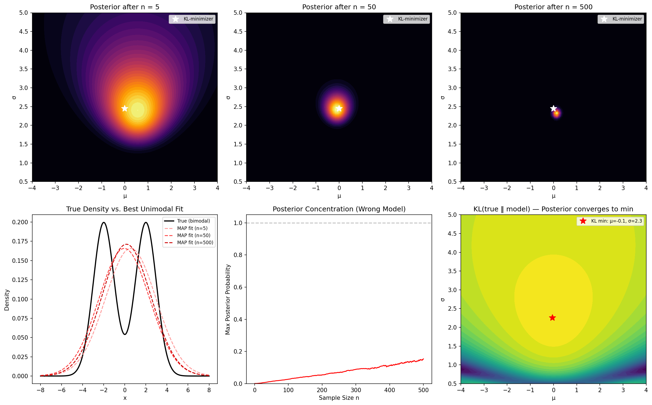
Figure 1. KL-convergence under misspecification. Top row: posterior heat maps over (μ, σ) at n = 5, 50, 500, sharpening to the KL-minimizer. Bottom: true bimodal density vs. MAP unimodal fit; posterior concentration curve; KL divergence surface.
5.2 Demonstration 2: Causal Misattribution Under Latent Confounding
The second demonstration operationalizes Section 3. The true causal structure is C → A and C → B, where C is an unobserved common cause and there is no direct link between A and B. The model’s hypothesis space contains three alternatives: A → B, B → A, and A ⊥ B. The confounder C does not exist in the model.
After 1,000 observations, the posterior assigns effectively 100% credence to A → B—a completely spurious causal claim. The observed correlation (r ≈ 0.70) is genuine but arises entirely from the shared parent C. Without C in the model, Bayesian model selection cannot distinguish confounding from causation, regardless of sample size. This confirms Pearl’s (2009) observation that statistical association, however strong, does not entail causal structure without appropriate graphical assumptions.
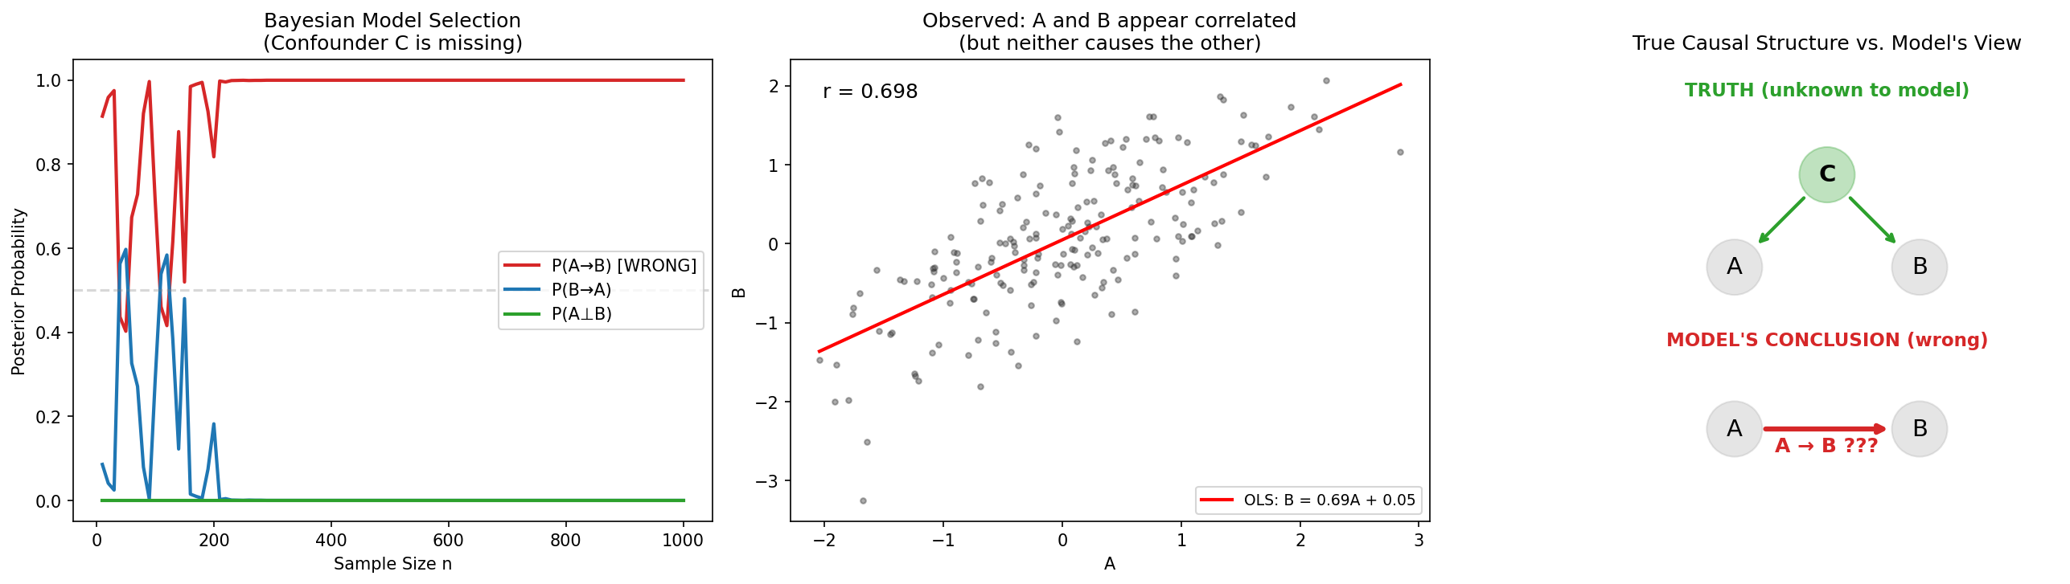
Figure 2. Causal misattribution under latent confounding. Left: posterior P(A→B) rises to 1.0 despite A not causing B. Center: scatter of A vs. B with spurious correlation r ≈ 0.70. Right: true DAG (C→A, C→B) vs. model’s wrong conclusion (A→B).
5.3 Demonstration 3: The Zero-Mass Absorbing Barrier
The third demonstration tests the formal claim of Section 3.2: that if P(H) = 0, then P(H | E) = 0 for all E. Three scenarios compare Bayesian updating on the same data stream. In Scenario A (equal priors), the true hypothesis is recovered within 20 observations. In Scenario B (zero prior on truth), the true hypothesis remains at exactly zero posterior for all 400 observations—the absorbing barrier holds perfectly. In Scenario C, the model is expanded at n = 200 by injecting the true hypothesis with fresh prior mass; recovery is immediate, reaching posterior 1.0 within 50 additional observations.
This demonstration isolates the most elementary mechanism of the cage: what has not been imagined cannot be discovered by updating alone. The contrast between Scenarios B and C is especially instructive. The data are identical; the update rule is identical; only the hypothesis space differs. The fix is not more data but more imagination—model expansion is the act that breaks the absorbing barrier.
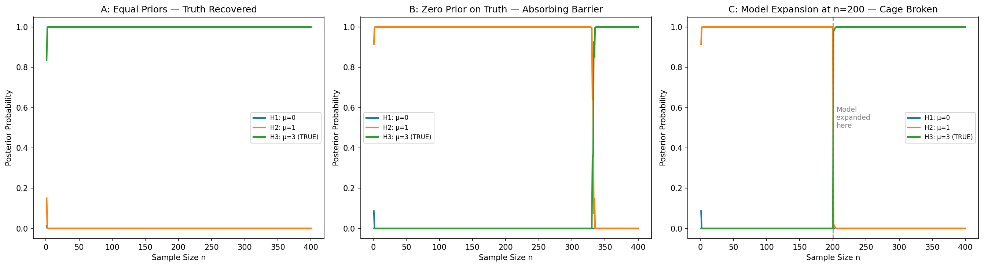
Figure 3. The zero-mass absorbing barrier. Panel A: equal priors—truth recovered rapidly. Panel B: zero prior on truth—truth permanently unreachable. Panel C: model expanded at n = 200—truth immediately recovered.
5.4 Demonstration 4: Parametric Versus Structural Uncertainty
The fourth demonstration quantifies the distinction drawn in Section 2.3. True data are generated by Y = sin(2X) + ε, but the model fits Y = βX + ε. Conjugate Bayesian updating produces a posterior on β that sharpens from a standard deviation of 0.39 at n = 5 to 0.01 at n = 300. Parametric uncertainty vanishes—yet the model is structurally wrong. The residuals display clear sinusoidal structure that is invisible to the posterior on β.
This demonstrates that shrinking credible intervals are not evidence of a correct model. A Bayesian agent monitoring only the posterior width would conclude that understanding is nearly complete, while the structural error remains entirely undiagnosed. The distinction between parametric and structural uncertainty is not merely conceptual; it has measurable consequences for scientific practice.
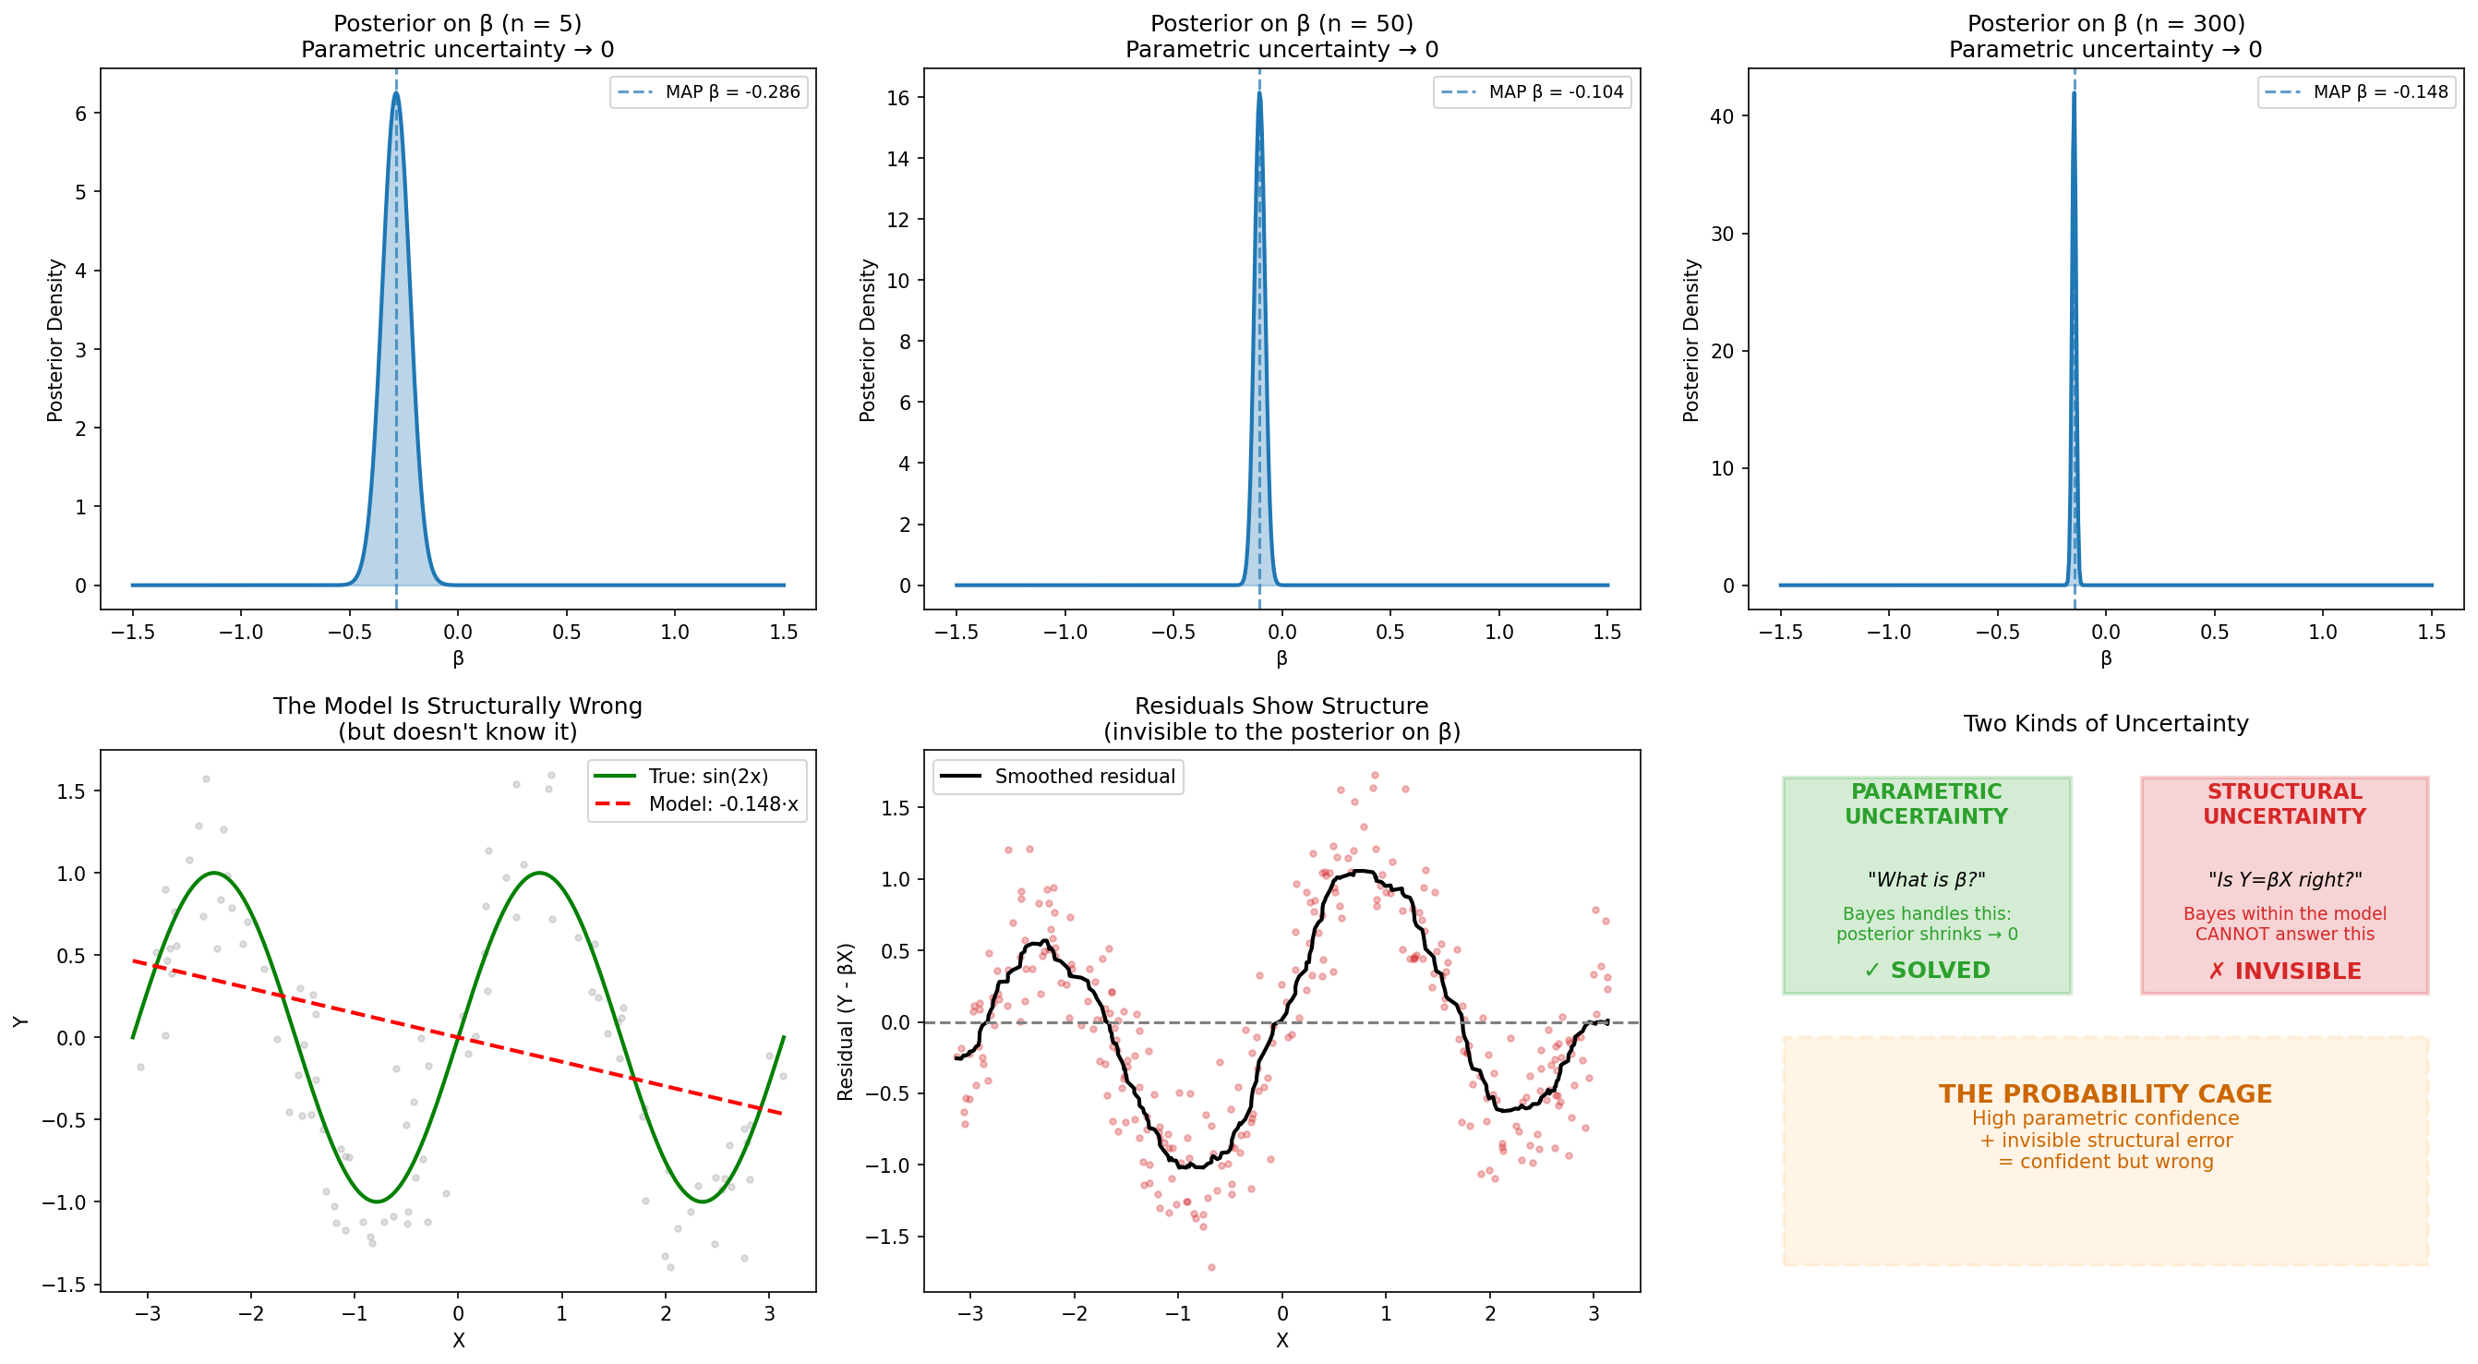
Figure 4. Parametric vs. structural uncertainty. Top: posterior on β sharpens from wide (n = 5) to needle-like (n = 300). Bottom-left: true sin(2x) vs. linear fit. Bottom-center: residuals reveal nonlinear structure invisible to the posterior. Bottom-right: conceptual summary.
5.5 Demonstration 5: Paradigm Inertia
The fifth demonstration models Kuhnian paradigm shifts computationally. An environment generates data from H_old (μ = 0) for 500 observations, then shifts to H_new (μ = 2). The prior favors H_old (0.9 vs. 0.1). After 500 confirming observations, H_old commands effectively 100% posterior credence. When the truth shifts, the accumulated evidence creates an “evidence mountain” that H_new must surmount: the posterior does not cross 50% for H_new until approximately n = 980—a delay of 480 observations after the true paradigm shift.
The delay is a direct consequence of rational Bayesian updating: the log posterior odds accumulated during Phase 1 must be fully reversed by contradicting evidence during Phase 2. Stronger priors produce longer delays (the demonstration tests priors from 0.5 to 0.999, with delays ranging from 479 to 483 samples). This quantifies the Kuhnian observation that paradigm shifts face resistance proportional to the weight of accumulated evidence for the old paradigm—resistance that is rational within the framework but that can delay recognition of genuine structural change.
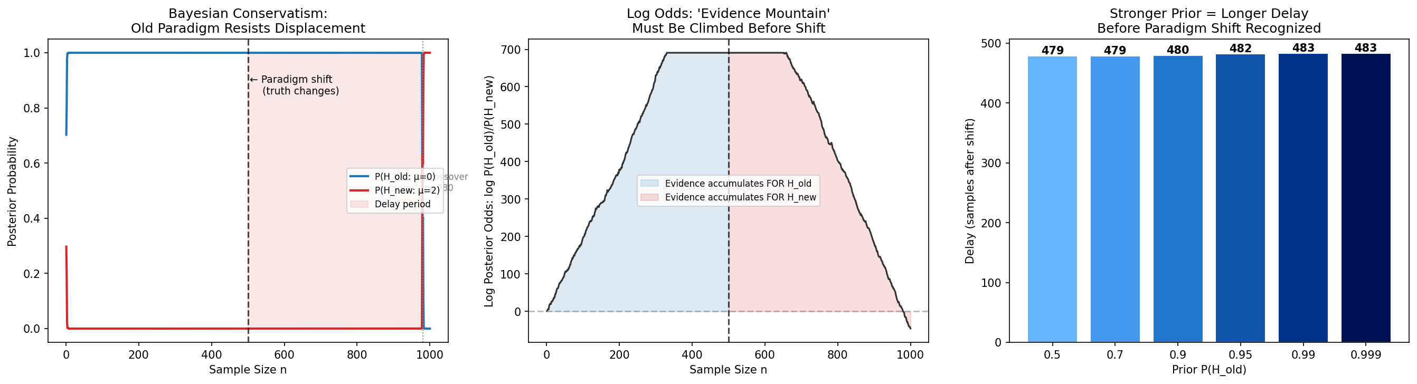
Figure 5. Paradigm inertia. Left: posterior trajectories showing ~480-sample delay after truth shifts at n = 500. Center: log posterior odds forming an ‘evidence mountain.’ Right: delay as a function of prior strength.
5.6 Demonstration 6: The Limits of Nonparametric Flexibility
The sixth demonstration addresses the claim in Section 4.4 that Bayesian nonparametric methods enlarge the cage without eliminating it. A simplified Dirichlet process mixture is fitted to three datasets: (a) a 3-component Gaussian mixture, (b) a ring-shaped distribution, and (c) a 2D Swiss roll. On the Gaussian clusters, the DP mixture correctly identifies approximately three clusters—the structure falls within its representational genus. On the ring and Swiss roll, the DP mixture fragments the data into scattered Gaussian blobs that bear no resemblance to the true geometry.
The ring requires a circular model; the Swiss roll requires a manifold model. The DP mixture can flex the number of Gaussian components (parametric flexibility) but cannot exit the Gaussian-mixture family (structural rigidity). The cage is larger—admitting variable model complexity—but its genus is fixed. This confirms the theoretical claim that nonparametric methods represent a quantitative rather than qualitative advance in addressing structural uncertainty.
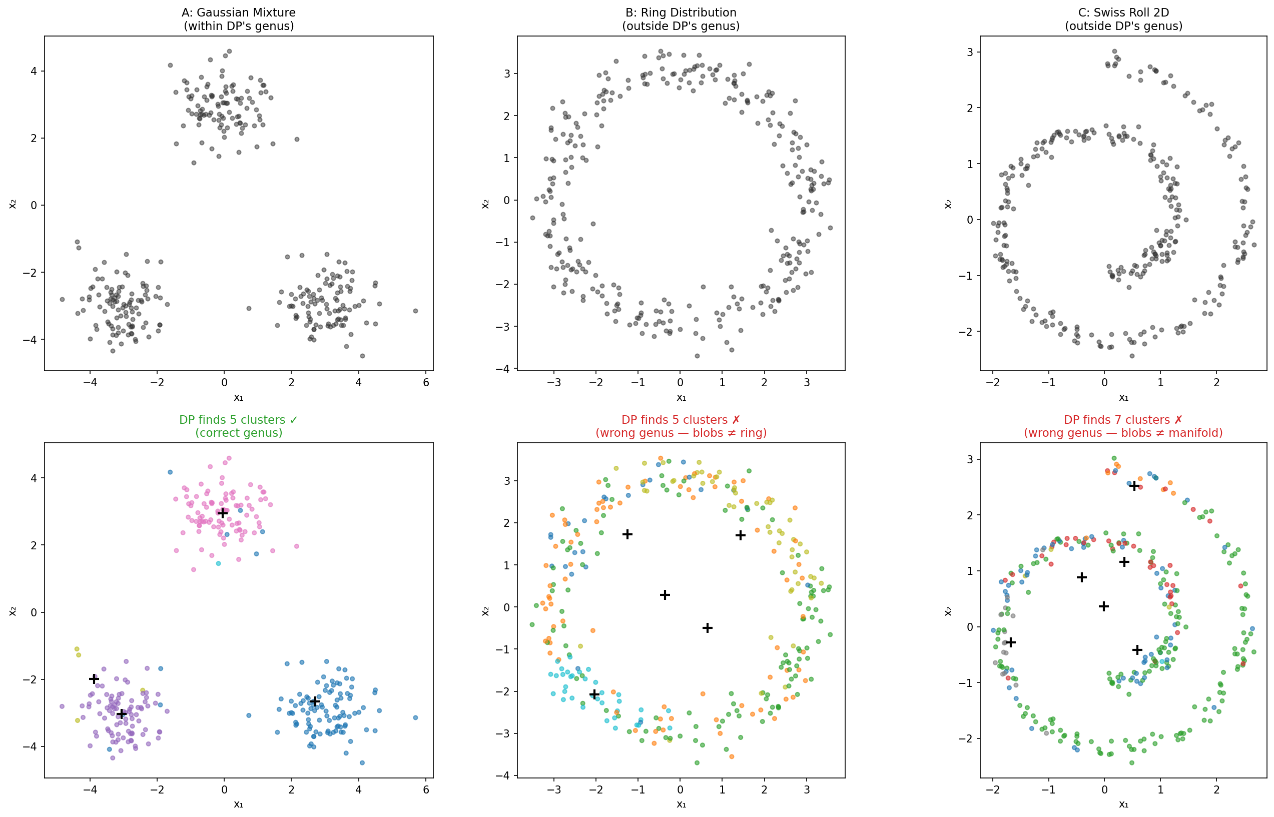
Figure 6. The limits of nonparametric flexibility. Top: raw data for Gaussian clusters, ring, and Swiss roll. Bottom: DP mixture cluster assignments. Success on Gaussian clusters (correct genus); failure on ring and manifold (wrong genus).
5.7 Demonstration 7: Tail Risk and the Illusion of Stability
The seventh demonstration instantiates the data-dependence argument of Section 4.3. The true data-generating process is a heavy-tailed Student-t distribution (df = 3). An agent compares this against a Gaussian model. During 1,000 calm observations—in which both models produce visually indistinguishable predictions—the Bayesian posterior concentrates on one model. When a crisis period introduces extreme values (7–10 standard deviations under the Gaussian), the model that underestimates tail probability is exposed.
The demonstration shows the densities of the two models on a log scale: virtually identical in the center, diverging by orders of magnitude in the tails. Historical data generated during calm periods cannot distinguish the two models, yet the practical consequences of this indistinguishability are catastrophic during rare events. This illustrates how the probability cage operates temporally: past data define the boundary of what the model considers possible, and when reality exceeds that boundary, the model fails precisely when it matters most.
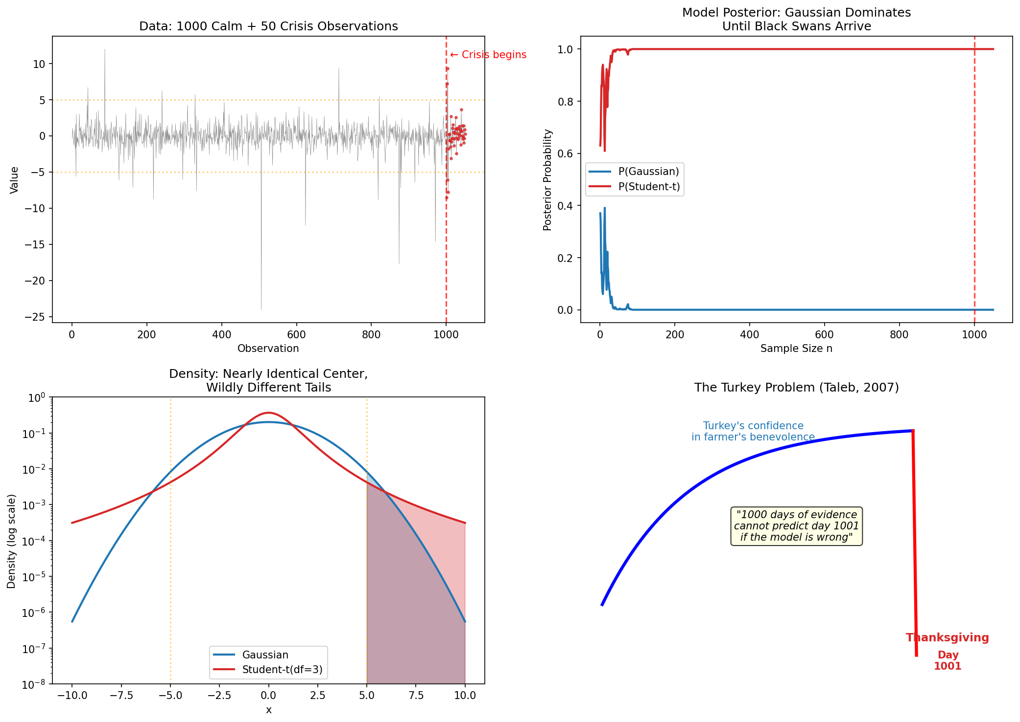
Figure 7. Tail risk and stability illusion. Top-left: time series with crisis highlighted. Top-right: posterior trajectory—Gaussian model dominates until black swans arrive. Bottom-left: log-scale densities showing identical centers but divergent tails. Bottom-right: the Turkey Problem.
5.8 Demonstration 8: Escaping the Cage Through Model Expansion
The eighth and final demonstration presents the positive thesis of the paper. True data come from a 3-component Gaussian mixture. A restricted model (unimodal Gaussians only) is compared against an expanded model (unimodal plus mixture hypotheses) and a late-expansion scenario (mixtures added at n = 300 after 300 observations of cage-locked updating).
The restricted model’s posterior concentrates with growing confidence on the wrong answer: by n = 600, the best unimodal hypothesis commands over 55% of posterior mass for a model that cannot represent the trimodal truth. The expanded model, by contrast, identifies the true mixture hypothesis within approximately 50 observations, reaching posterior 0.9997 by n = 100. Most instructively, the late-expansion scenario shows that even after 300 observations of misguided convergence, the moment the true hypothesis is added to the space, it is identified within 100 additional observations.
This demonstration encapsulates the paper’s central message. More data cannot fix a structurally incomplete model—additional observations only increase confidence in the wrong answer. More hypotheses, by contrast, allow Bayesian inference to do what it does best: rapidly identify the most adequate explanation. The cage is broken not by patience but by imagination. Bayesian inference is the engine; hypothesis expansion is the fuel.
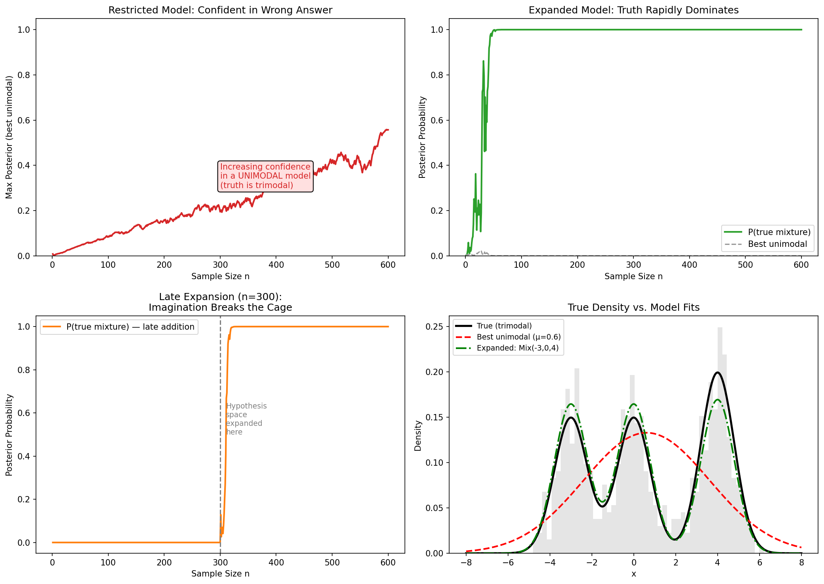
Figure 8. Escaping the cage. Top-left: restricted model’s confidence grows in the wrong answer. Top-right: expanded model identifies truth within ~50 samples. Bottom-left: late expansion at n = 300 breaks the cage immediately. Bottom-right: true trimodal density vs. unimodal and mixture fits.
5.9 Reproducibility and Code Availability
All eight demonstrations are implemented in Python using NumPy, SciPy, and Matplotlib, and are available as self-contained scripts in the companion repository. Each script generates both terminal output and publication-quality figures. The repository includes a requirements file, a run-all script, and detailed documentation. Readers are encouraged to modify parameters, substitute alternative distributions, and extend the demonstrations to additional domains.
6. Conclusion
Bayesian inference remains one of the most powerful tools available for reasoning under uncertainty. It formalizes the process of learning from evidence, ensures logical coherence, and provides a principled framework for quantifying what is and is not known within a given model. Nothing in this paper contests these achievements.
What we have argued—and demonstrated computationally in Section 5—is that the power of Bayesian updating is bounded by the hypothesis space over which it operates, and that this bound has epistemological consequences that are often underappreciated. When the hypothesis space is incomplete—when latent variables, unconceived causal structures, or novel ontological categories are absent from the model—Bayesian inference converges nonetheless, sometimes with high confidence, toward explanations that are internally coherent but structurally partial. This is the probability cage: not a failure of logic, but a condition of closure inherent in any inference framework that presupposes a fixed space of possibilities.
The missing-variable problem, formalized through the lens of causal inference (Pearl, 2009; Spirtes et al., 2000) and simulated in Demonstration 2, shows how latent confounders can generate arbitrarily confident posteriors in support of misspecified causal models. The history of scientific revolutions (Kuhn, 1962; Lakatos, 1970), modeled quantitatively in Demonstration 5, illustrates that transformative progress characteristically involves expanding the hypothesis space rather than refining credences within it. And while Bayesian extensions—nonparametrics (Ferguson, 1973), model averaging (Hoeting et al., 1999), open-universe models (Milch et al., 2005)—enlarge the scope of what can be inferred, they do not eliminate the dependence on a prior specification of the space’s generative structure, as Demonstration 6 confirms for the Dirichlet process.
The practical implication is that high posterior probability should be treated not as a terminus of inquiry but as an occasion for structural scrutiny. When a model achieves strong fit with high confidence, the scientifically mature response is to ask whether the hypothesis space is adequate—whether alternative causal architectures have been considered, whether latent variables might account for observed regularities, and whether the model’s ontological vocabulary is rich enough to accommodate the phenomena under study. Overconfidence, in this framework, functions as an epistemic red flag: a signal that the model may be too certain because it is not imagining enough.
Scientific progress, we submit, requires two complementary virtues. The first is coherence: the disciplined revision of belief in light of evidence, for which Bayesian inference provides the formal apparatus. The second is openness: the willingness to revise the very structure within which beliefs are defined, for which no formal apparatus is sufficient and for which scientific imagination is indispensable. Probability refines belief within a framework. Imagination expands the framework itself. The probability cage forms when the first is mistaken for the second. As Demonstration 8 shows most directly, the cage dissolves not with more data but with more hypotheses—when both virtues are pursued in concert.
References
Berk, R. H. (1966). Limiting behavior of posterior distributions when the model is incorrect. Annals of Mathematical Statistics, 37(1), 51–58.
Bernardo, J. M., & Smith, A. F. M. (1994). Bayesian Theory. Wiley.
Box, G. E. P. (1976). Science and statistics. Journal of the American Statistical Association, 71(356), 791–799.
Bunke, O., & Milhaud, X. (1998). Asymptotic behavior of Bayes estimates under possibly incorrect models. Annals of Statistics, 26(2), 617–644.
Cartwright, N. (1983). How the Laws of Physics Lie. Oxford University Press.
Cox, R. T. (1946). Probability, frequency and reasonable expectation. American Journal of Physics, 14(1), 1–13.
Doob, J. L. (1949). Application of the theory of martingales. In Le Calcul des Probabilités et ses Applications (pp. 23–27). CNRS.
Ferguson, T. S. (1973). A Bayesian analysis of some nonparametric problems. Annals of Statistics, 1(2), 209–230.
Feyerabend, P. (1975). Against Method. New Left Books.
Gelman, A., Carlin, J. B., Stern, H. S., Dunson, D. B., Vehtari, A., & Rubin, D. B. (2013). Bayesian Data Analysis (3rd ed.). CRC Press.
Gelman, A., & Shalizi, C. R. (2013). Philosophy and the practice of Bayesian statistics. British Journal of Mathematical and Statistical Psychology, 66(1), 8–38.
Goodman, N. D., Mansinghka, V. K., Roy, D. M., Bonawitz, K., & Tenenbaum, J. B. (2008). Church: A language for generative models. In Proceedings of the 24th Conference on Uncertainty in Artificial Intelligence (pp. 220–229).
Green, P. J. (1995). Reversible jump Markov chain Monte Carlo computation and Bayesian model determination. Biometrika, 82(4), 711–732.
Grünwald, P., & van Ommen, T. (2017). Inconsistency of Bayesian inference for misspecified linear models, and a proposal for repairing it. Bayesian Analysis, 12(4), 1069–1103.
Hjort, N. L., Holmes, C., Müller, P., & Walker, S. G. (Eds.). (2010). Bayesian Nonparametrics. Cambridge University Press.
Hoeting, J. A., Madigan, D., Raftery, A. E., & Volinsky, C. T. (1999). Bayesian model averaging: A tutorial. Statistical Science, 14(4), 382–401.
Jaynes, E. T. (2003). Probability Theory: The Logic of Science. Cambridge University Press.
Kass, R. E., & Raftery, A. E. (1995). Bayes factors. Journal of the American Statistical Association, 90(430), 773–795.
Kuhn, T. S. (1962). The Structure of Scientific Revolutions. University of Chicago Press.
Lakatos, I. (1970). Falsification and the methodology of scientific research programmes. In I. Lakatos & A. Musgrave (Eds.), Criticism and the Growth of Knowledge (pp. 91–196). Cambridge University Press.
Mandelbrot, B. (1963). The variation of certain speculative prices. Journal of Business, 36(4), 394–419.
Milch, B., Marthi, B., Russell, S., Sontag, D., Ong, D. L., & Kolobov, A. (2005). BLOG: Probabilistic models with unknown objects. In Proceedings of the 19th International Joint Conference on Artificial Intelligence (pp. 1352–1359).
Oreskes, N., Shrader-Frechette, K., & Belitz, K. (1994). Verification, validation, and confirmation of numerical models in the Earth sciences. Science, 263(5147), 641–646.
Pearl, J. (2009). Causality: Models, Reasoning, and Inference (2nd ed.). Cambridge University Press.
Popper, K. R. (1959). The Logic of Scientific Discovery. Hutchinson.
Schwartz, L. (1965). On Bayes procedures. Zeitschrift für Wahrscheinlichkeitstheorie und verwandte Gebiete, 4(1), 10–26.
Spirtes, P., Glymour, C., & Scheines, R. (2000). Causation, Prediction, and Search (2nd ed.). MIT Press.
Taleb, N. N. (2007). The Black Swan: The Impact of the Highly Improbable. Random House.

