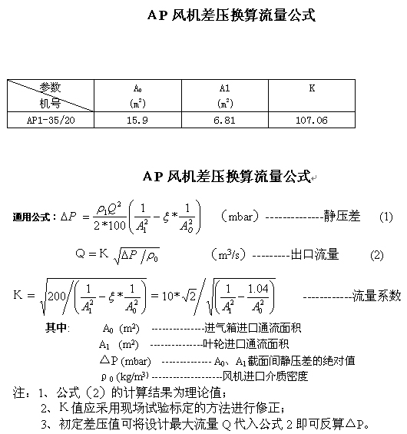

A0=28.48m²

A1=13.02m²

K=208.2
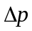=23.15mbar

Q=1092m³/s

