Who can got granted after parole interview?

Linfeng Zhou

Every year in New York State over 10,000 prisoners appear in front of the Parole Board and are denied release. Many legal experts argue that there is little reason to the way that the New York State Parole Board makes these decisions. In this paper, we will analyze factors that may affect prisoners’ interview decision by using a parole dataset collected by Nikki Zeichner. The data available for this problem has 24291 observations. To be more specifically, each row has 10 variables to provide detail of this observation.

First, we can use a bar plot to generate descriptive statistic of interview decisions (which may be the most important variable for our purpose):

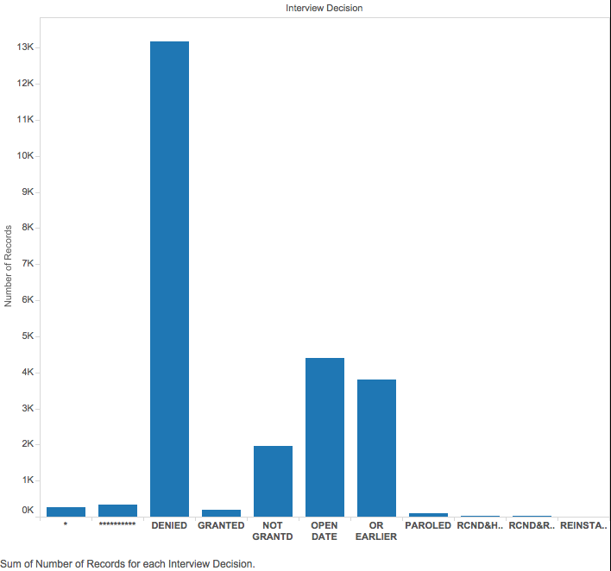

From the bar plot of interview decisions, we can see that top 5 meaningful types are denied, open date, or earlier, not granted and granted. Therefore, we only use those 5 types in the following analysis since other variables are less important because of their counts.

In order to detect which factors would influence on prisoners’ interview decisions, we generate some original idea that has chances to answer the question. The first question is whether age could significant important to interview decisions. As we can see from the chart, the overall impact of age density on interview decisions is not significant, which means peoples’ age could not affect their parole interview results.

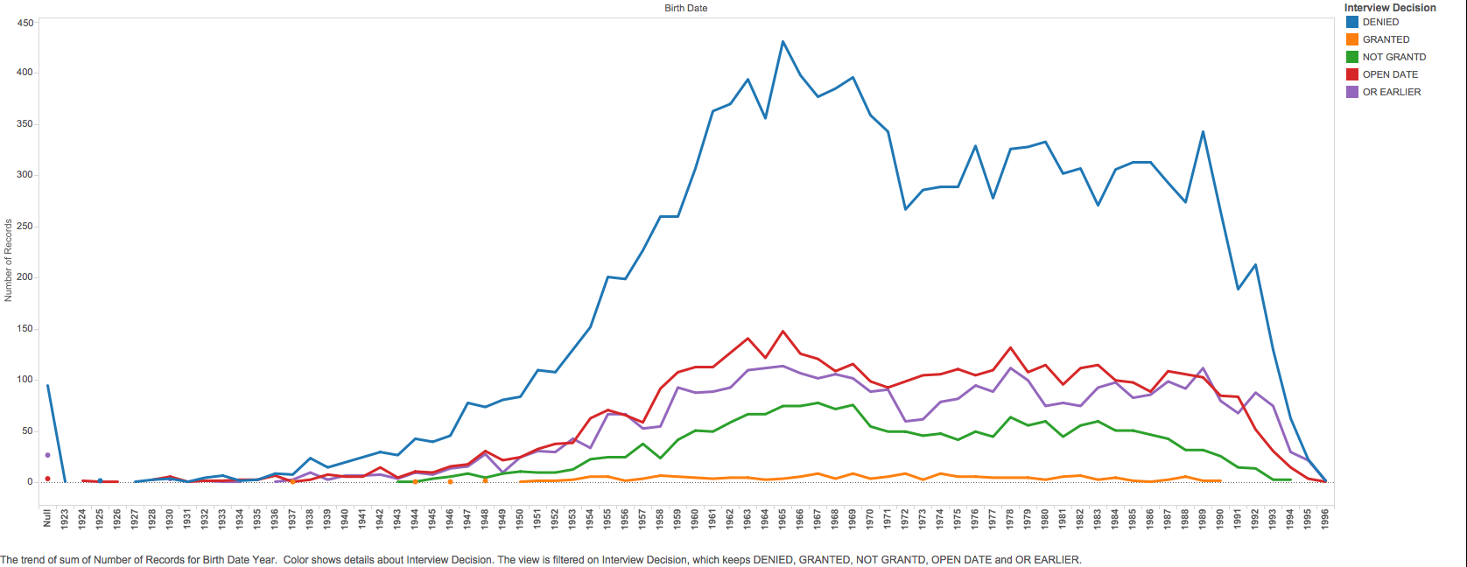

After that, we use bar plots to see interview status by gender. From following charts, we can see there is the significant difference between male and female. The denied rate (include denied, not granted) of man is more than 60%, however, the same index in female is less than 50%. Therefore, we can conclude that female is easier than male to get parole.

.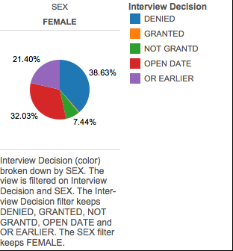 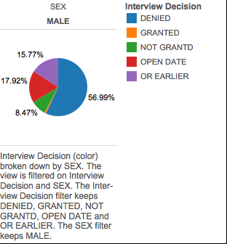

Next, we generate the relationship between interview facilities and interview decision. In general, it is hard to find any useful information. However, some particular facilities seem have different patterns with others. For example, FISHKILL and AIBION-FEMALE(As we mentioned before, women are easier to get granted).

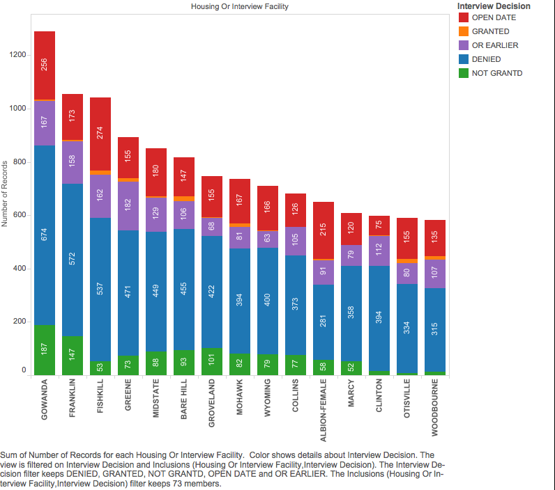

Finally, we discover whether Race/Ethnicity will affect someone’s interview decision. The pie chart is on the left. The plot showed that different race has the different ratio of each decision. Among those clear race, Asian/Pacific got highly granted rate (only about 40% of Asian/Pacific denied after the interview). However, more than 60% of African American and AMER IND/ALSK got denied.

In general, we can conclude that gender and race are significant factors affect prisoners’ interview decision. Some facilities may have a high rate of granting but not specific rules to illustrate this phenomenon.

