**Team 4 Test cases**

**Runhao Yang**

**Lin,weigang**

**Ling Fang**

**Zhongai Shi**

**May 6, 2019**

**Due: May 16, 2019**

**Running this file will create a database called group4, and create 5 tables inside the group4 database. Additionally, the admin login information will be added to the admin table.** 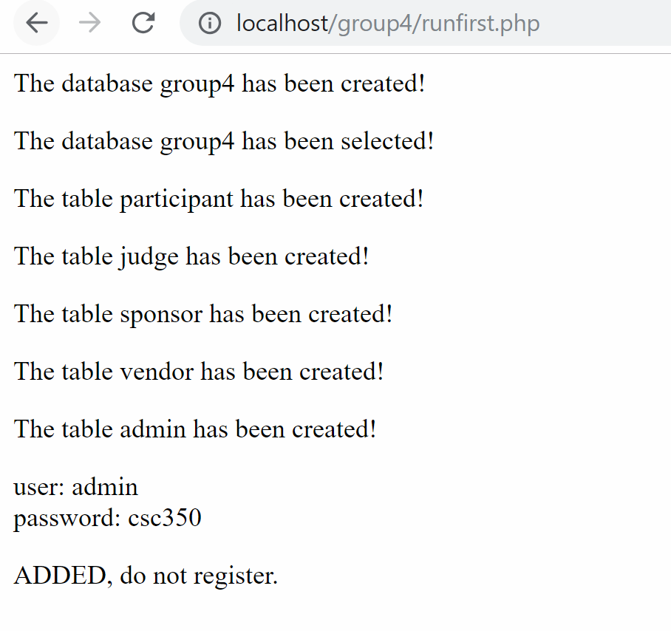

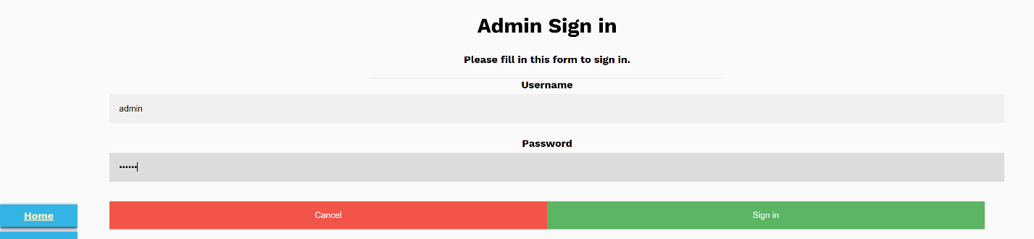

**Attempting to sign in with admin information**

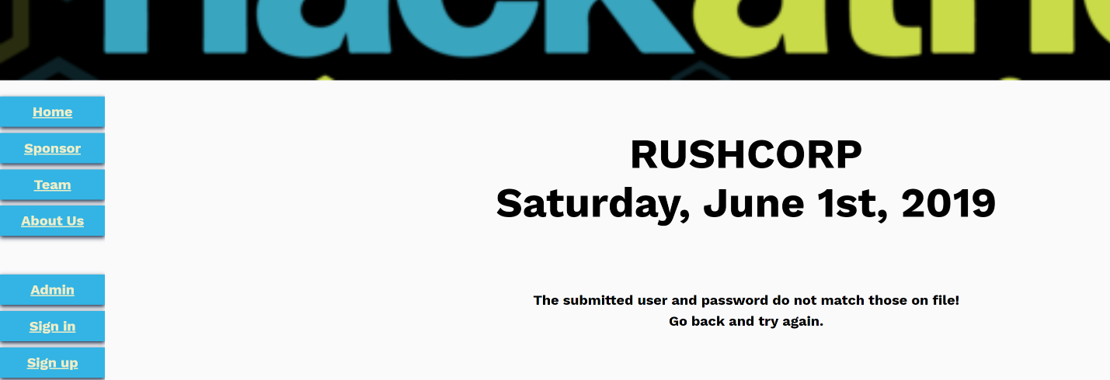

**Wrong admin password will display an error message and not redirect to the admin page**

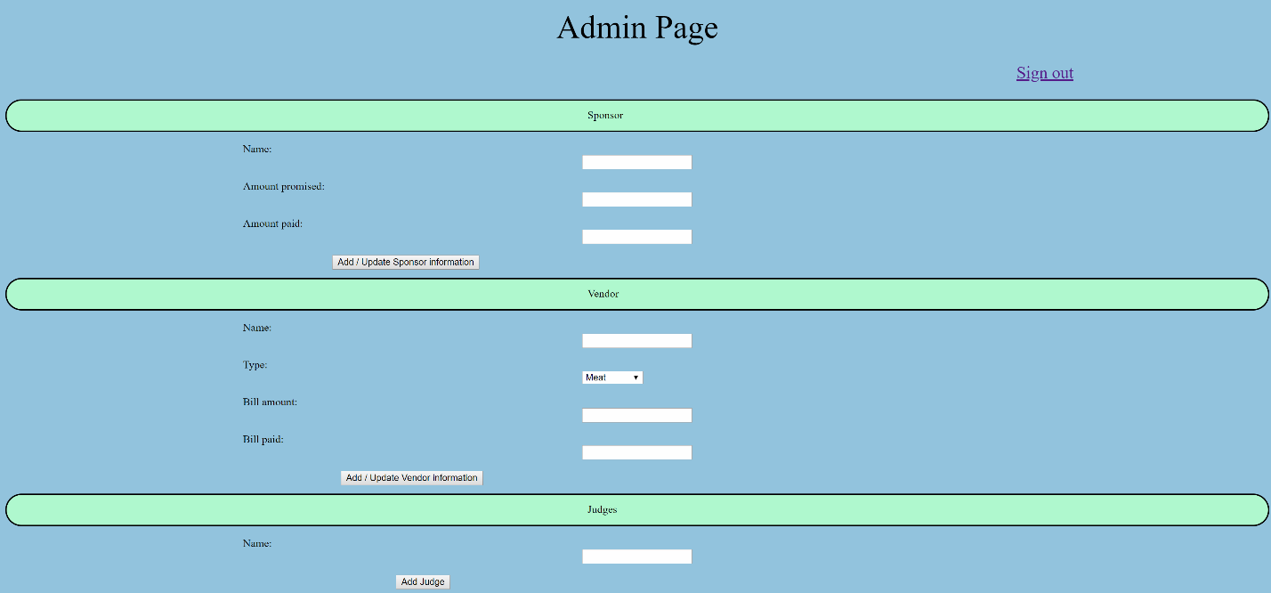

**Correct admin password will redirect to admin page**

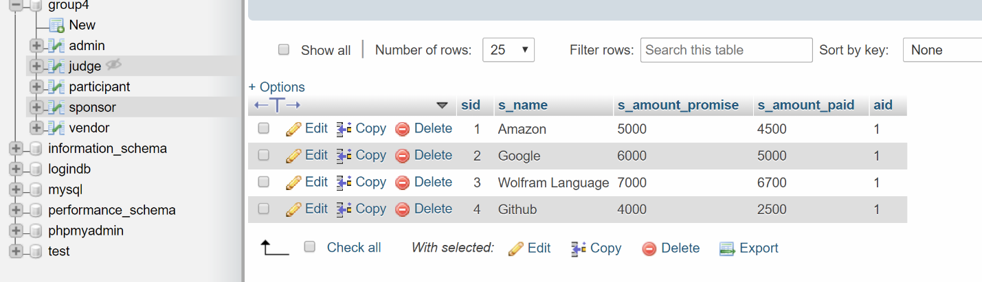

**Entering sponsor information and clicking on the Add / Update Sponsor Information sends the information to the sponsor table**

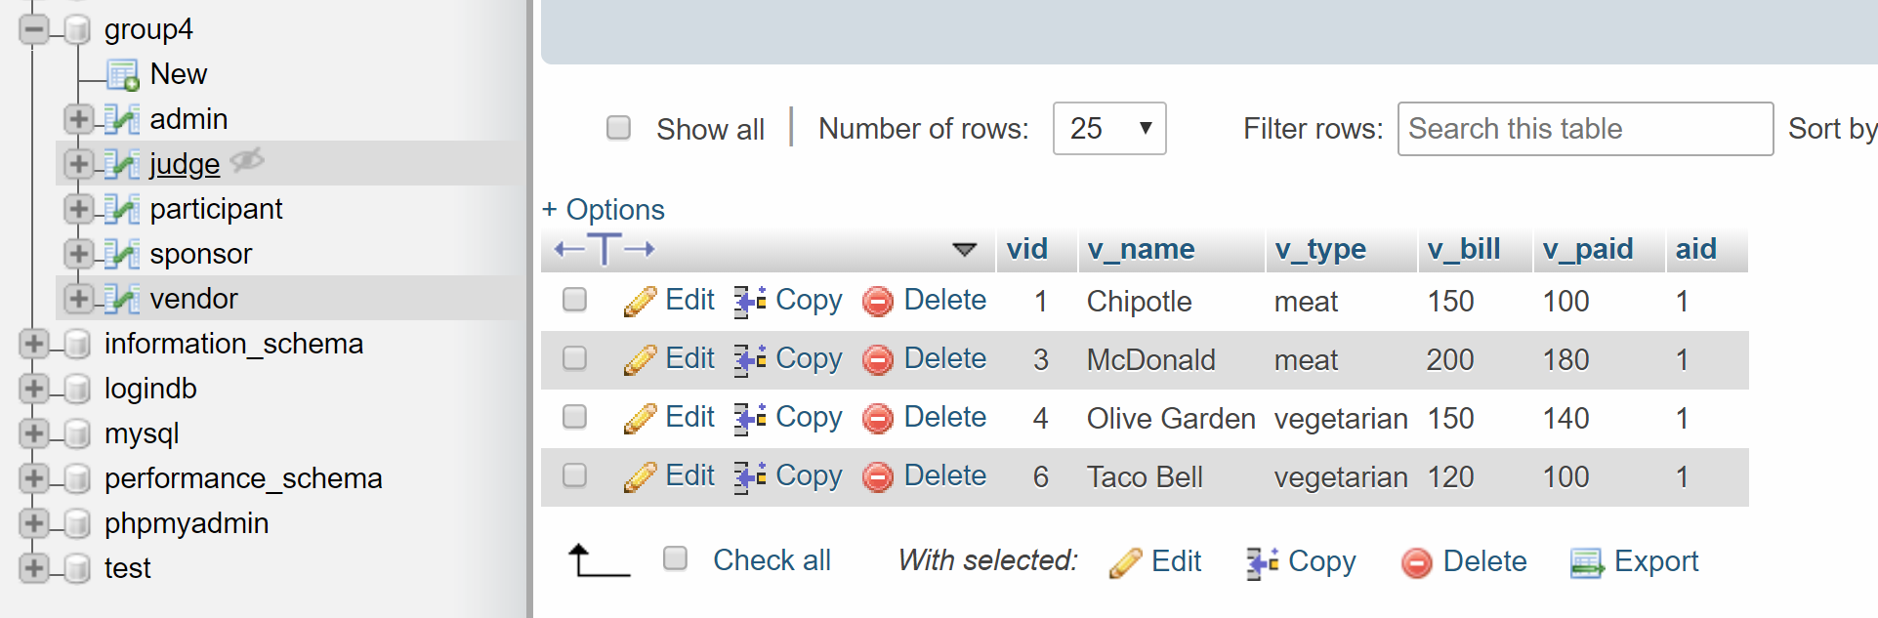

**Entering vendor information and clicking on the Add / Update Vendor Information sends the information to the sponsor table**

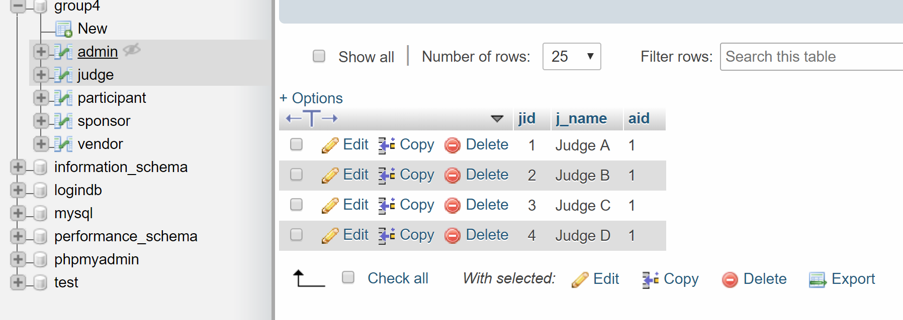

**Entering Judge information and clicking on the Add Judge sends the information to the judge table**

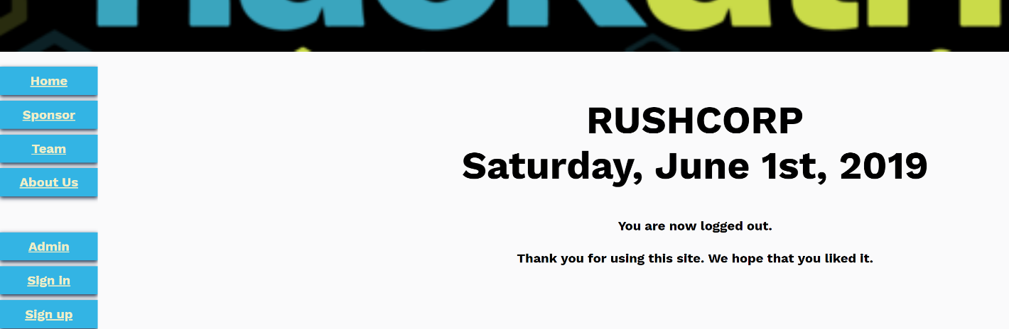

**Clicking on the Sign out button on the admin page will redirect to the sign out page, session id is destroyed**



**Attempting to click on the back button will not redirect to the admin page, as the session id is destroyed upon clicking on the sign out button, the user is directed back to the index.php page.**

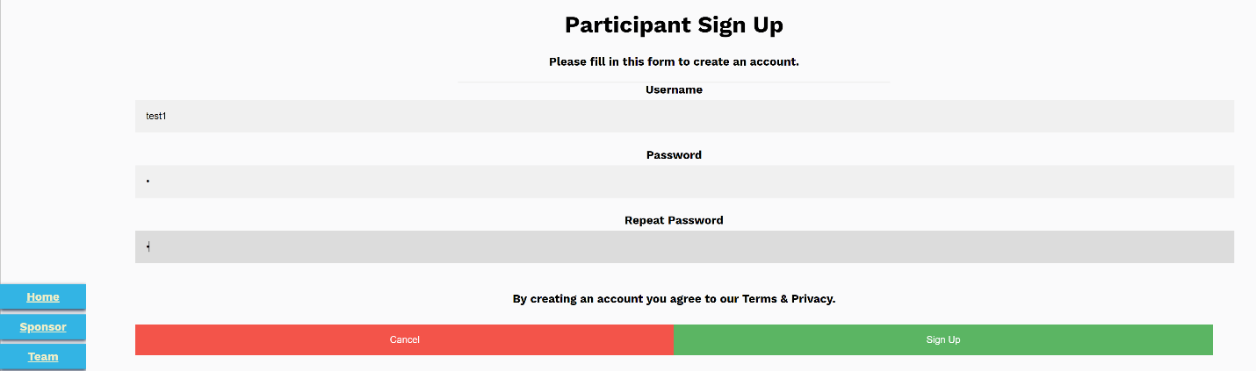

**Attempting to sign up**



**An error message will display if the username already exists in the table participant.**

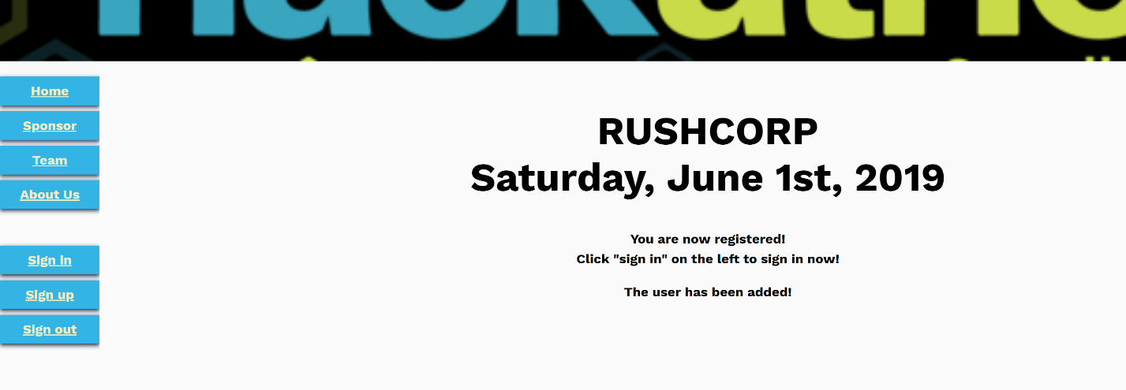

**If the username does not already exist in the table participant, then a sign up success page appears**

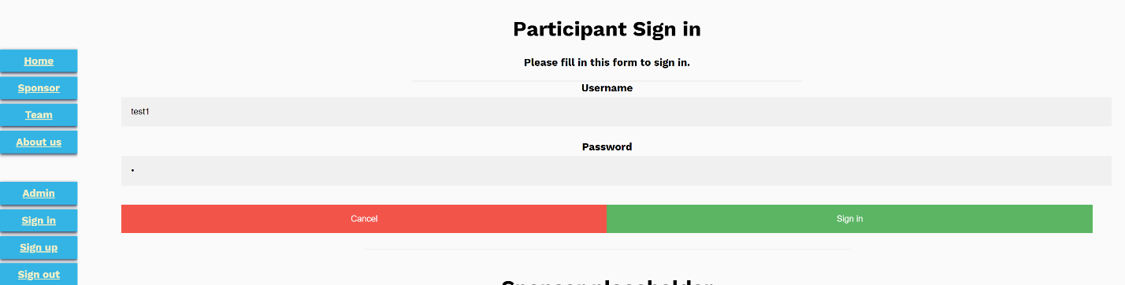

**Attempting to sign in**



**An error message will appear if the username or password is incorrect**

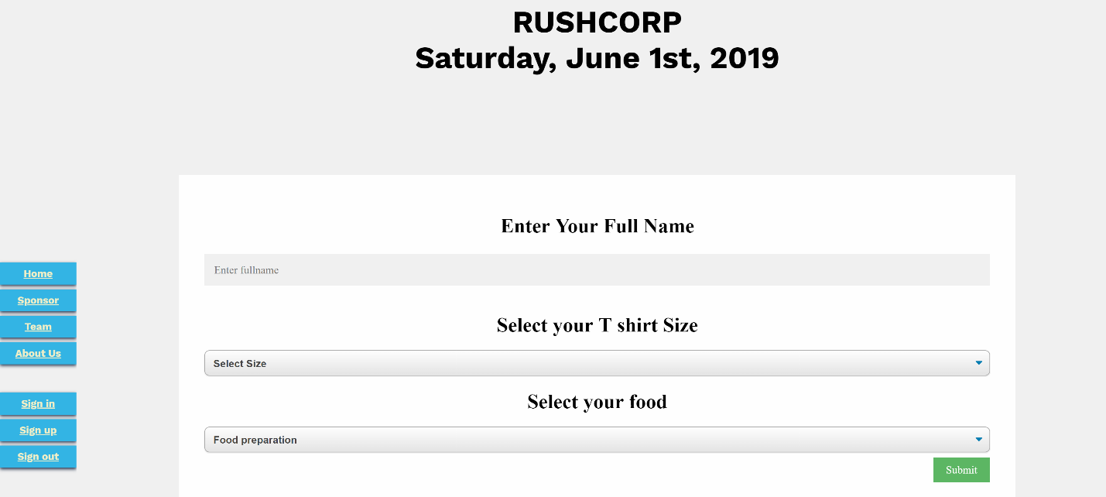

**A successful sign in will redirect the user to the participant page.**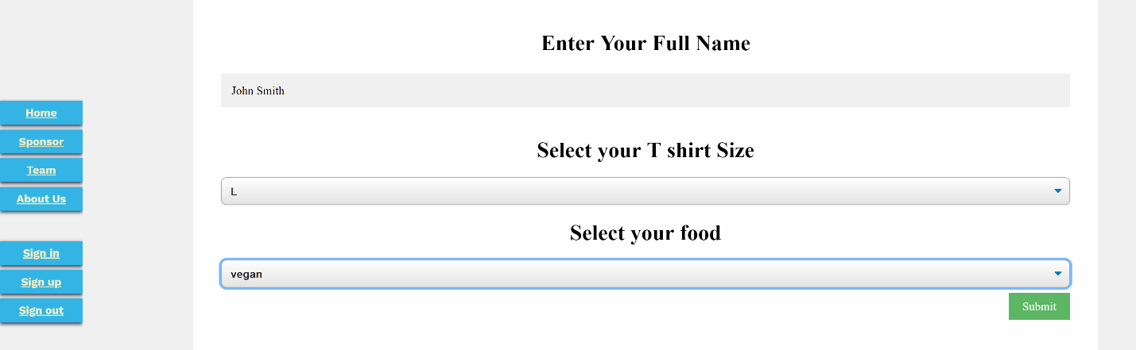

**Entering information and then clicking on the submit button**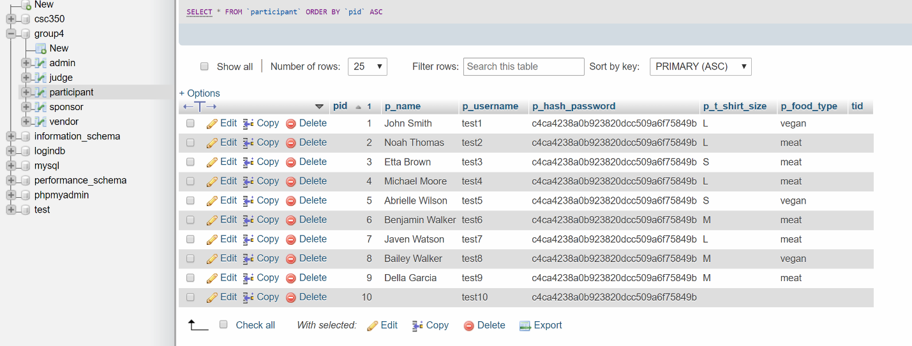

**p_name, p_t_shirt_size, and p_food_type are added/updated. Entering a new set of information will override the previous one, with the session id corresponding to the p_username of the user. **

**After clicking on the Sign out button**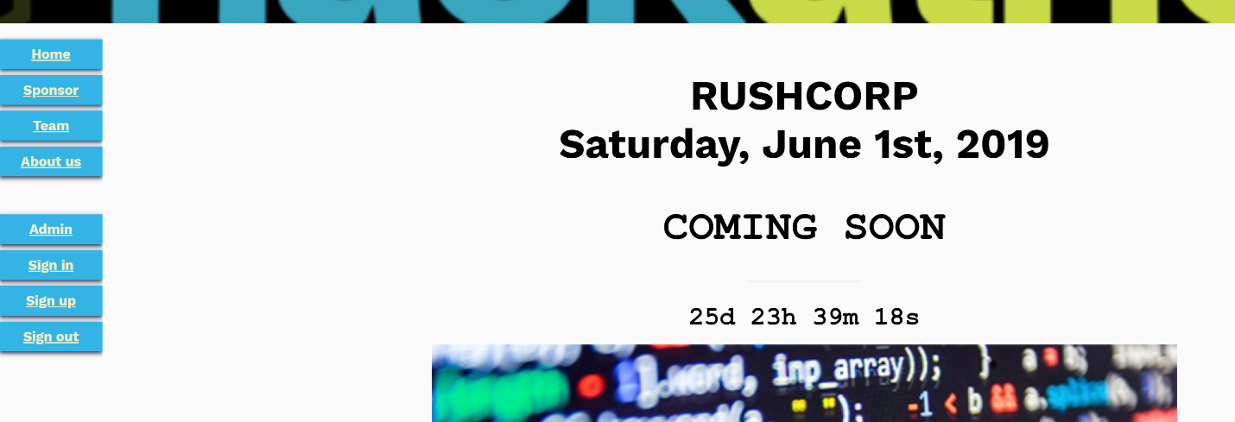

**Attempting to click on the back button will not redirect back to the participant page, as the session id is destroyed upon clicking on the sign out button, the user is directed back to the index.php page.**