Map

* Map is an Interface and it is provided by collections framework.
* Map is combination of key, values pair. Or map is data structure used to store key, value pair’s information.
* In Map if we want particular key information it won't do any iteration and it directly goes to given value and provide the information.

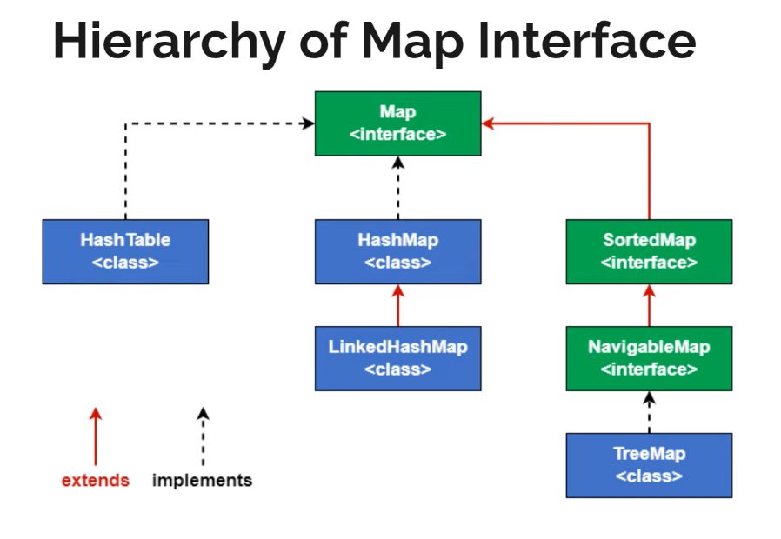

Different between list and map?

* List are used to store elements based on index position. And while retrieve elements based on index value we need to retrieve element.
* But in some cases it is not possible, if we give key means it need to provide value this type of requirement are used in Map interface.

