Queue

* Queue is interface provided by collection framework.
* Queue follows FIFO principle.
* First In First Out.

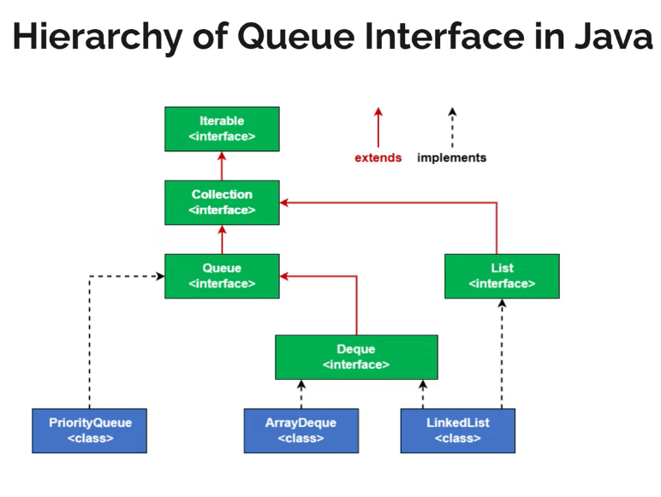

Priority queue:

* Based on priority we are outing elements called priority queue.
* It won't keep in sorted order, but head always point out to highest priority.
* Addition ->offer, add
* Retrieve -->peek
* Removal -->poll, remove

