Set

* Set concept is used to store multiple elements in java.
* Set is a data structure where used to store only unique elements.
* In set we can't do updating, for that we need to remove element and then we need to add.

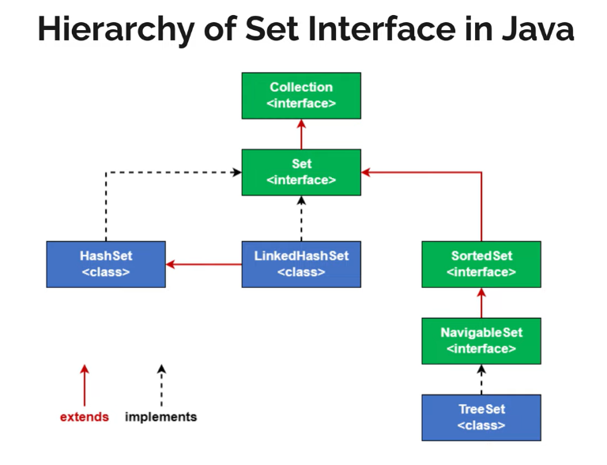

Hash set:

* Hash set is a class implements set interface.
* It won't store in insertion order based on hashing maganism hash code generated and inserted.
* While adding elements to hash set we are adding only one elements means we are not following key, value pair concept.
* After adding element hash set stores elements as keys and in place of values a dummy object is stored.
* Hash set internally use Hash map--> Array of nodes (key, values).
* Allow null values

Linkedhashset:

* It follows insertion order.
* Linkedhashset internal implementation is linkedhashmap -->link of nodes (key, values).
* Allow null values

Tree set:

* Tree set internally implements tree map-->binary tree structure.
* By default while adding elements tree set follows asc order.
* Does not allow null values

Different between list, queue and set?

In list, queue allows duplicates but set does not allows duplicates.

Set is advance version for list and queue.

Interview question

1. To store a data Array List internally what uses?

Arrays

2. To store a data in linked list internally what uses?

Nodes

3. to store a data in hash set internally what we uses?

Hash set internally use Hash map--> Array of nodes (key, values).

4. Why we are not using arrays or nodes in hash set?

Because already one implementation done in hash map that is elements should be unique. So we are implementing that class in hash set.

