Static and Non –Static

* To execute a class we need to perform some action. If we need to perform option we need some memory allocation. Without memory allocation we can't perform any operations.

We can allocate memory in two ways

1. By Object creation

2. By using Static keyword.

* First java developed without static keyword.
* E.g. In class for main method we can't create memory that's why we declare static keyword there.

Public static void main (String [] args) {

}

* After file execution class loader will check for any static key word present in the class. If class loader fined any static keyword class loader will allocate memory.

JVM Architecture Diagram

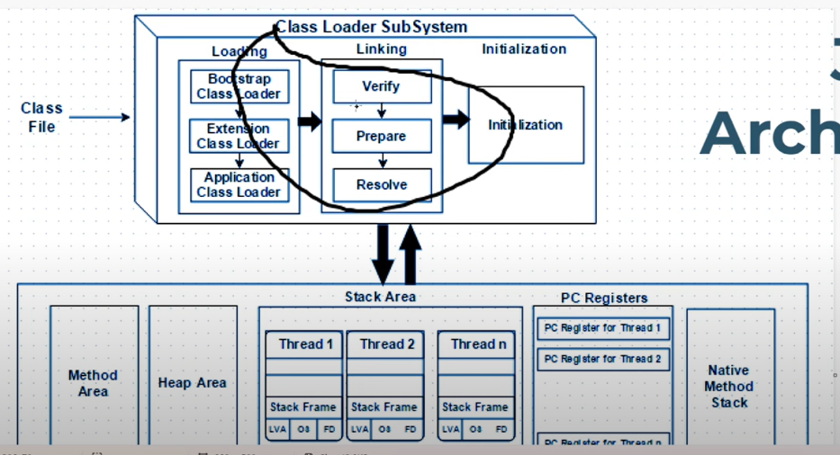

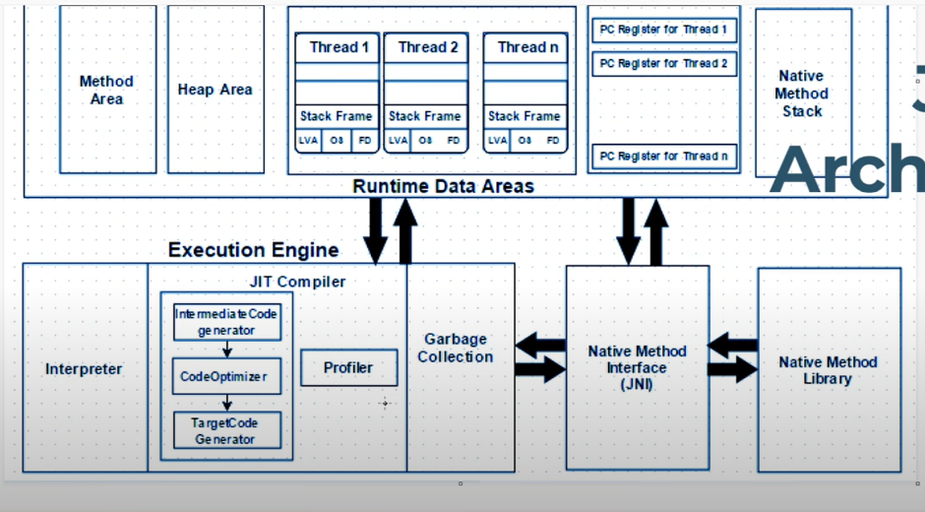

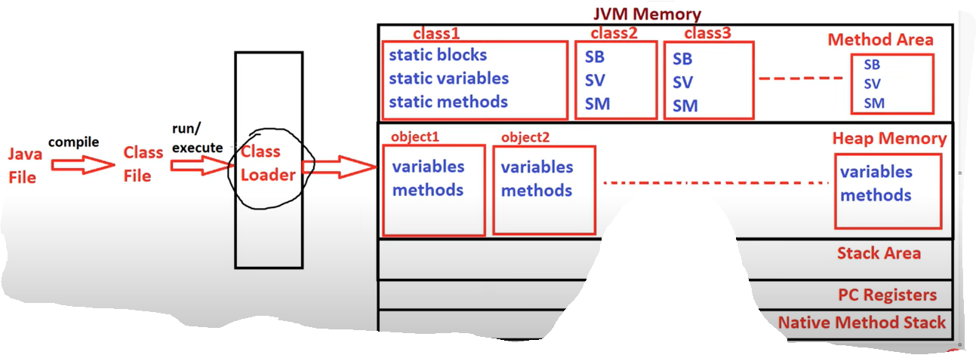

Diagram explanation:

* After execution a class, class loader will be created. Class loader will identify if any static keyword is present or not.
* For all that static fields a class block is created in method area.
* On our OS a virtual memory is created called JVM memory. Again in jvm memory we have multiple parts.

1. Method area

* Static memory store in method area.
* In method area for one class one block will be created.

2. Heap memory

* If we are creating memory using keyword new it will create in heap memory.
* Every object is a memory block in heap memory.
* In heap memory if you are creating many objects that many object blocks will be created in heap memory.

3. Stack area

4. PC register

5. Native method stack

* E.g. int number

Test1 t1 = new Test1 ();

T1.number = new Random .nextInt ();

* In above example we assigning a random number for t1. If we execute code every time a random number will be display in console.
* E.g. 2 static int number

Test1 t1 = new Test1 ();

T1.number = new Random.nextInt ();

* In above example, if we execute code same number will be assign to t1, t2, t3 objects. If we execute again different number but same values to 3 objects.
* Static methods or static variables can access by using className.

Static block:

static {

//Statements;

}

Non static block

{

//Statements;

}

Interview question:

1. In class first with block will be executed.

Ans:

* Static block.
* Main method is entry block before main method static block executed.