Predefine classes and interfaces

=================================

Sending messages via mail

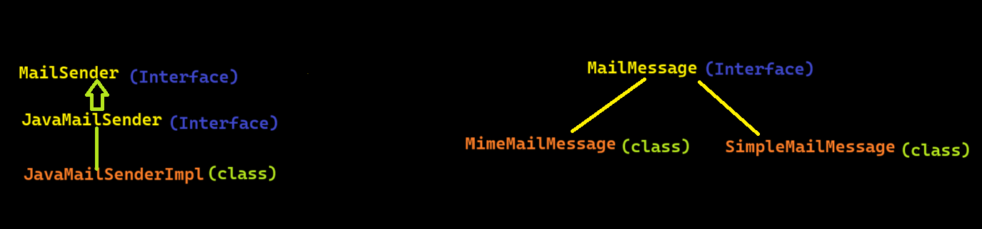

1. Mail sender to send the mail and mail message to set the subject, to, from, text, …

For Copy one class properties data into another class

BeanUtills.copyproperties(source object, target object);

Based on entity data JPA will write dynamic queries

Example. Of (entity class name)

For sending mails via spring boot

1. Java mail sender
2. Mime message
3. Mime message helper

Random password generation

1. Random
2. String buffer