 SQL is considered to be designed at a higher conceptual level of operation than procedural languages because the lower level logical and physical operations aren't specified and are determined by the SQL engine or server process that executes it.

**Data Query Language**

SELECT - Used to retrieve certain records from one or more tables.

**Data Manipulation Language**

* INSERT - Used to create a record.
* UPDATE - Used to change certain records.
* DELETE - Used to delete certain records.

**Data Definition Language**

* CREATE - Used to create a new table, a view of a table, or other object in database.
* ALTER - Used to modify an existing database object, such as a table.
* DROP - Used to delete an entire table, a view of a table or other object in the database.

**Data Control Language**

* GRANT - Used to give a privilege to someone.
* REVOKE - Used to take back privileges granted to someone.

**Commands to import data from SQL to HDFS database.**

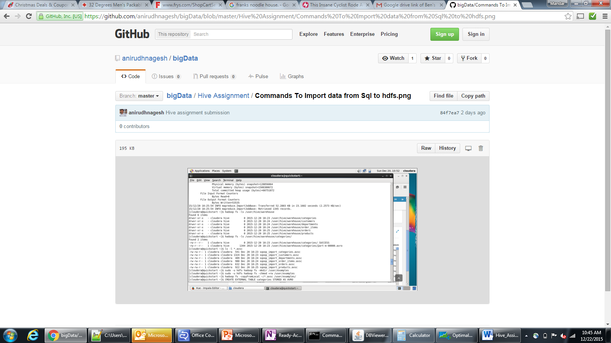

**Hive Tables and Query:**

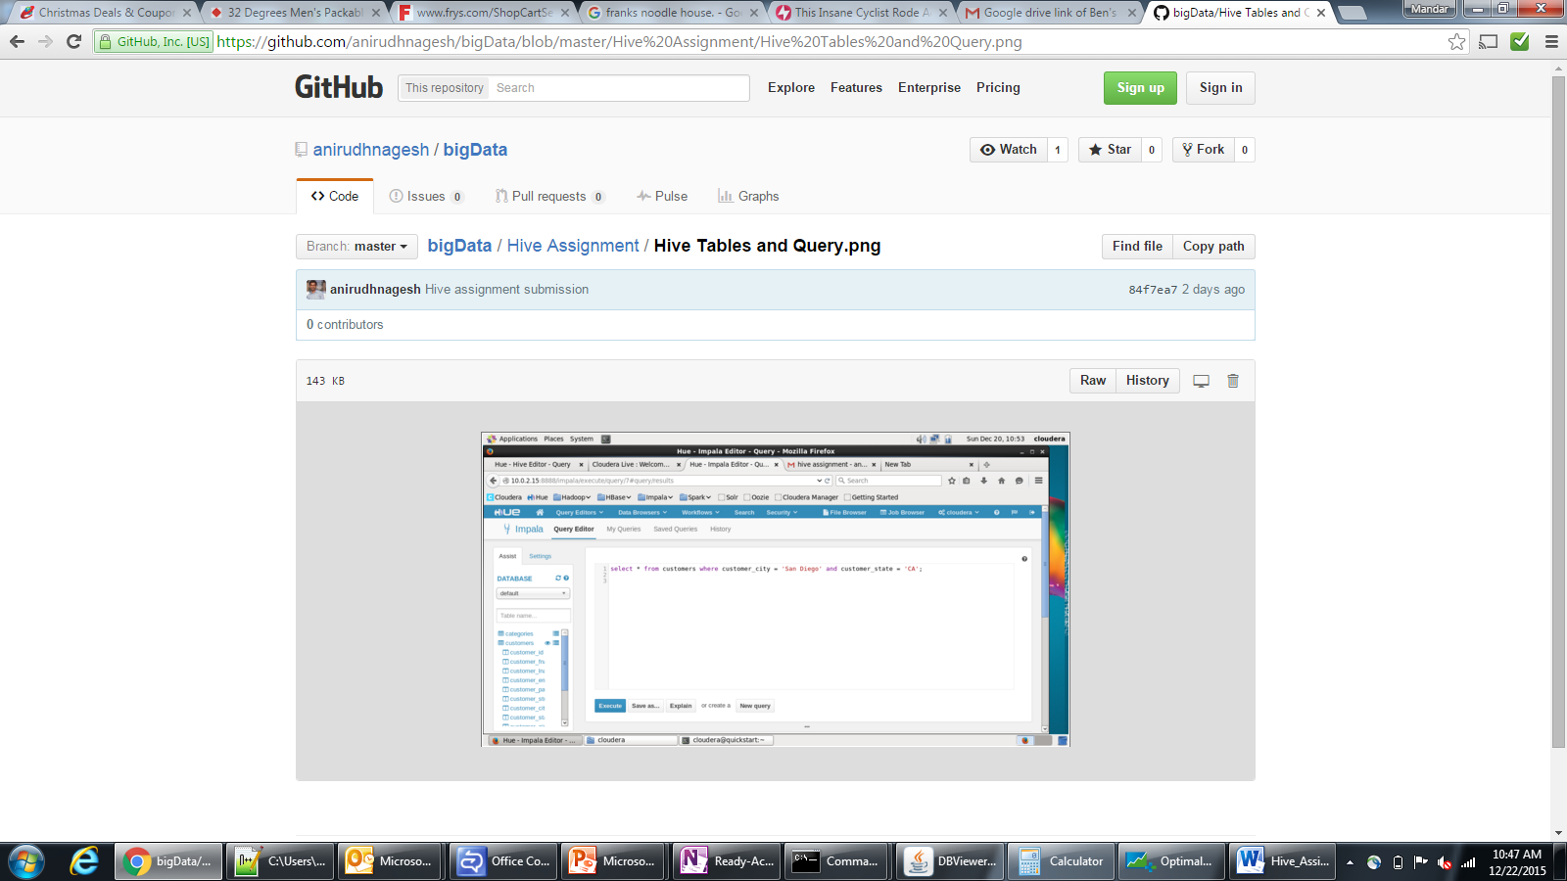

**Query Results:**

